Pamela Kotseva (2405343)
2405343@student.uwtsd.ac.uk

an ai critique and speaker notes

AI Acknowledgement
I acknowledge the use of ChatGPT (https://chatgpt.com/) to write my notes into submission format using the prompt(s):
- “Show me AI Washing visually”
- “Can you create a graph showing consumer trust in AI over the past 5 years please”
- Create a background image for my AI washing presentation
(for research not actual work and image generation. Images of all AI conversations available in “Appendices”)
I confirm that I have not presented any AI generated text as my own work. I confirm that I have copies of my drafts, notes, and other resources . I may be asked to provide in evidence.

- “Introductory speech”…according to IBM AI is defined as the
“…technology that enables computers and machines to simulate human learning, comprehension, problem solving, decision making, creativity and autonomy.” (Stryker and Kavlakoglu, 2024)
Nowadays AI comes in many different forms with wildly different functions and purposes. Explain what AI does (basic and advanced AI) and give examples – chatbots, self-driving cars, image generators
(Highlight the benefits but focus on controversies – Deepfakes, Scams, AI-washing)

- AI washing is defined as when a company uses AI in a manner that is exaggerated or misrepresenting of the actual AI use or its capabilities (Selcen Ozturkcan and Ayşe Aslı Bozdağ, 2025). This could mean that a company might present a simple automation of a process as AI or that AI is a major part of a product or a feature while it is only a minor function to make their brand more profitable, attractive, and marketable. AI washing is compared by some to greenwashing where companies exaggerate their environmental performance to appear more eco-friendly for example (Lyon and Montgomery, 2015).

- The main problem is that it could create false expectations in the customer as it makes them believe that the company or product is more advanced than it is. It could also lower the trust of the public in AI as constant failures to meet expectations makes people less likely to trust it. In 2024 two US companies were sued over their misrepresentation of AI use meaning that governments and laws are acting against AI washing (Freedman, 2024).

- Follow with an introduction to RCA – explain STEEPLE as a model that originates from the PESTLE and is used to explore external factors that have an impact on a company (CIPD, 2025). Describe “5Whys” as a model where you keep on asking why until you get to the root cause (NHS Wales, 2022).

AI Critique
After using ChatGPT to help me with researching my part of the presentation I was left with mixed feelings. The interface was very easy to use and for the most part I think that the answers provided and the way they were typed out appeared very appealing. The first thing that I noticed was that the answers provided had no sources.
Another issue I found when doing my research is that I received an answer from ChatGPT that credited an US University. On the first glance the site is legitimate, however, when looking deeper I found that the definition of AI washing was pulled from a database that was created for the university site by its students. In this database I found a statement that all definitions there should not be considered as the position or opinion of the university. Lastly, I asked ChatGPT to create an image that would fit the background for my presentation and was very happy with the results provided. In conclusion, I would say that ChatGPT was easy to use and provided information in a coherent way, but I believe it cannot substitute manual research for any academic purposes due to sources it used in my case.

Reference List

- CIPD (2025). PESTLE Analysis. [online] CIPD. Available at: https://www.cipd.org/uk/knowledge/factsheets/pestle-analysis-factsheet/.
- Freedman, R. (2024). SEC fines companies $400,000 for false AI claims. [online] Legal Dive. Available at: https://www.legaldive.com/news/sec-fines-companies-false-artificial-intelligence-claims-delphia-global-predictions-ai-washing/710694/.
- Lyon, T.P. and Montgomery, A.W. (2015). The Means and End of Greenwash. Organization & Environment, [online] 28(2), pp.223–249. doi:https://doi.org/10.1177/1086026615575332.
- NHS Wales (2022). Improvement Cymru Academy Toolkit Guide The 5 Whys A tool for root cause analysis What are the 5 Whys? [online] Available at: https://performanceandimprovement.nhs.wales/functions/quality-safety-and-improvement/improvement/improvement-cymru-academy/resource-library/academy-toolkit-guides/the-5-whys-toolkit-guide/.
- Selcen Ozturkcan and Ayşe Aslı Bozdağ (2025). Responsible AI in Marketing: AI Booing and AI Washing Cycle of AI Mistrust. International Journal of Market Research, 67(6). doi:https://doi.org/10.1177/14707853251379285.
- Stryker, C. and Kavlakoglu, E. (2024). What is artificial intelligence (AI)? [online] IBM. Available at: https://www.ibm.com/think/topics/artificial-intelligence.

Appendices
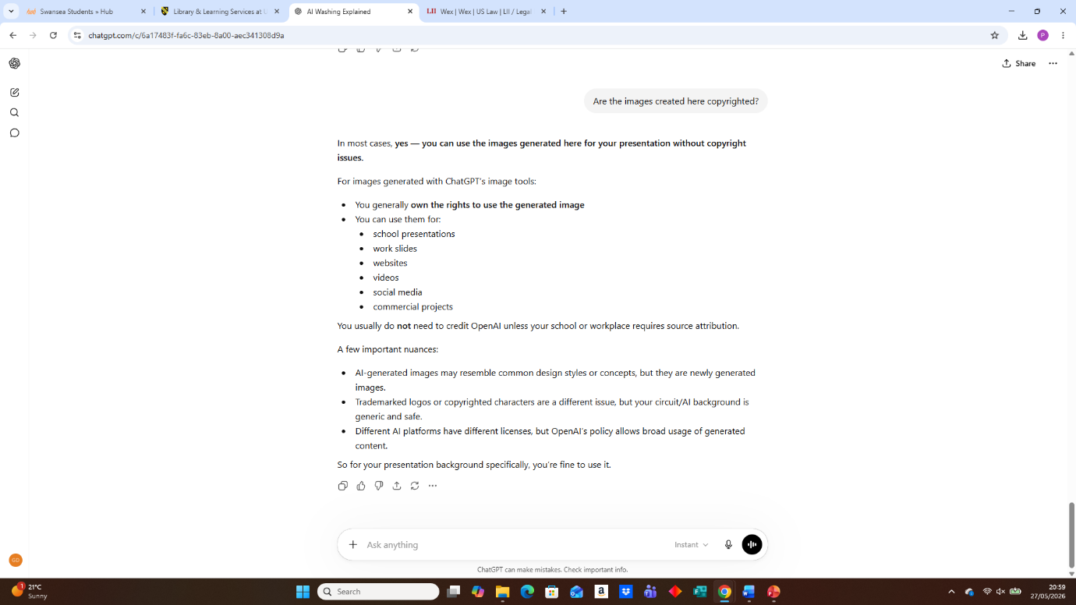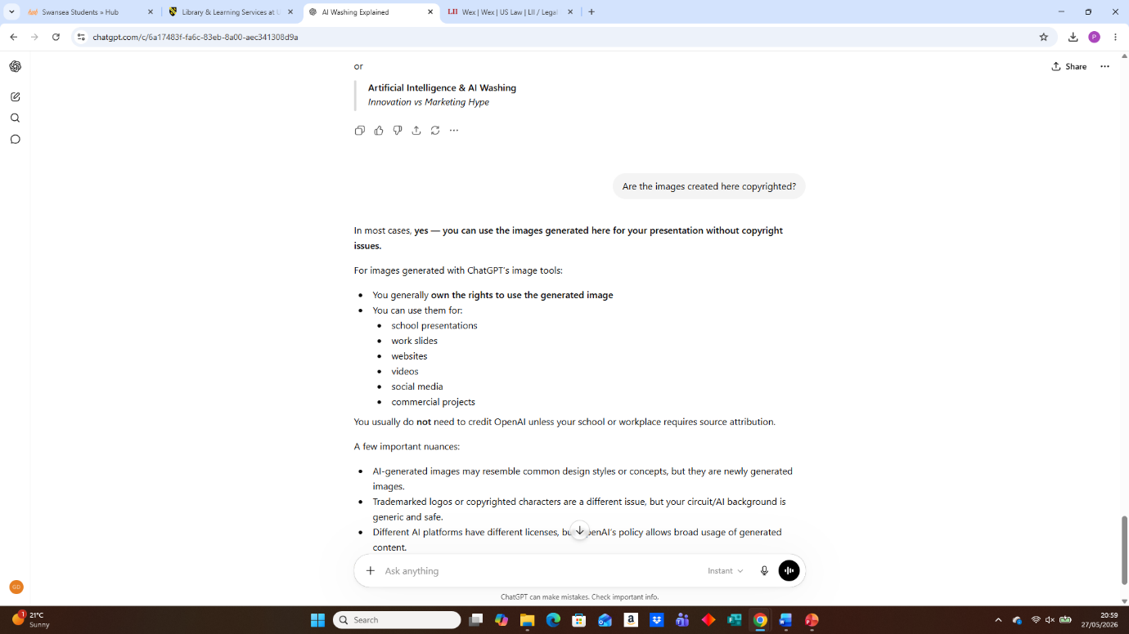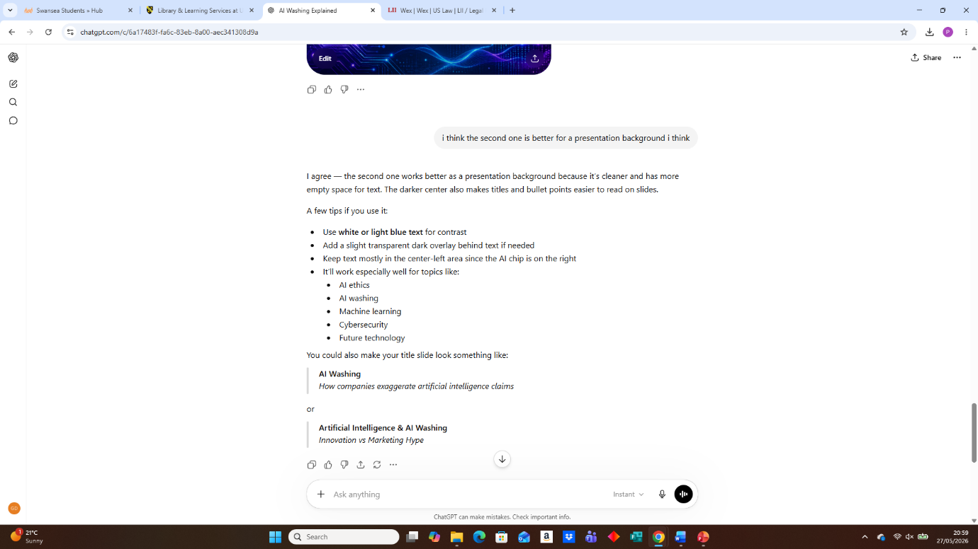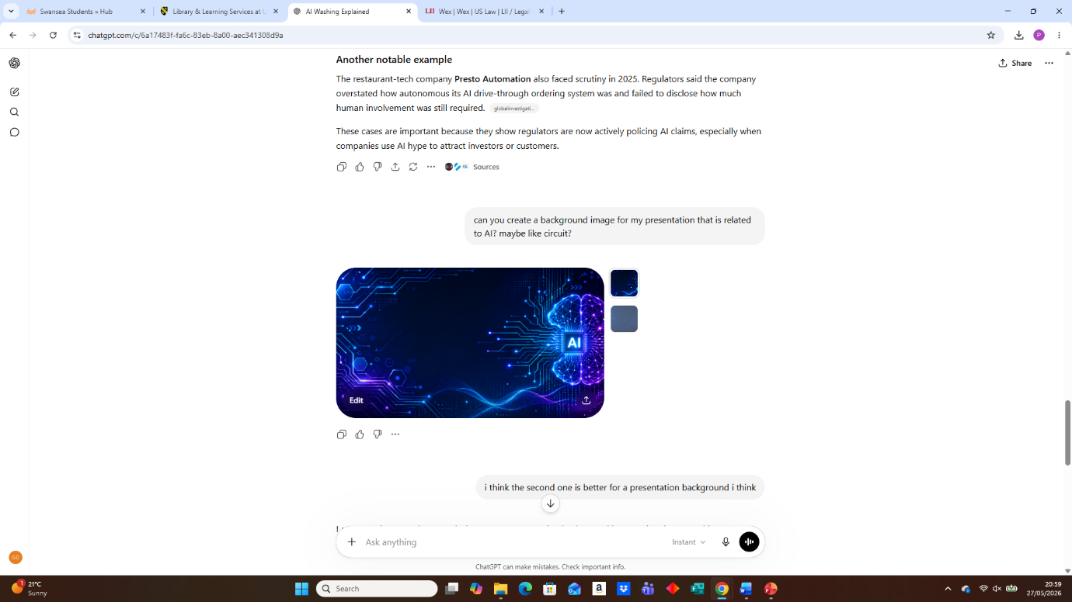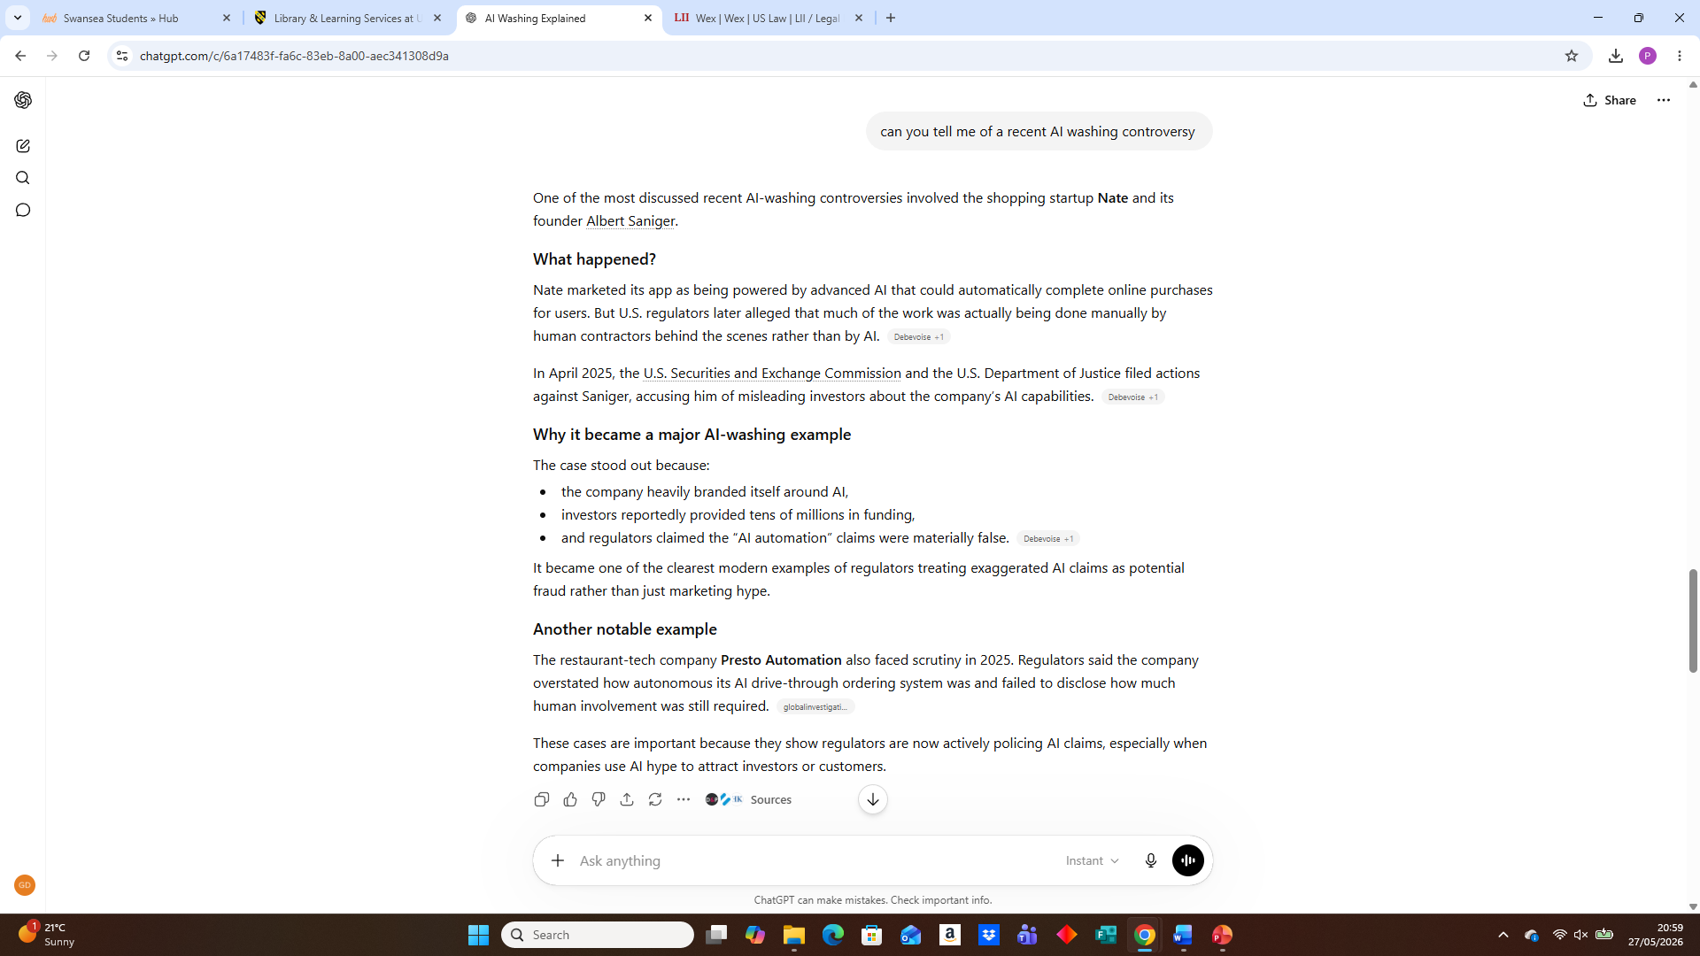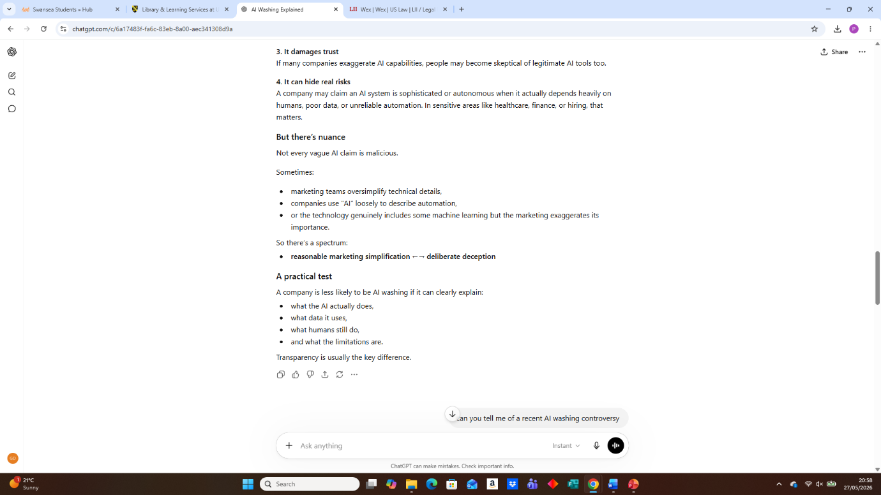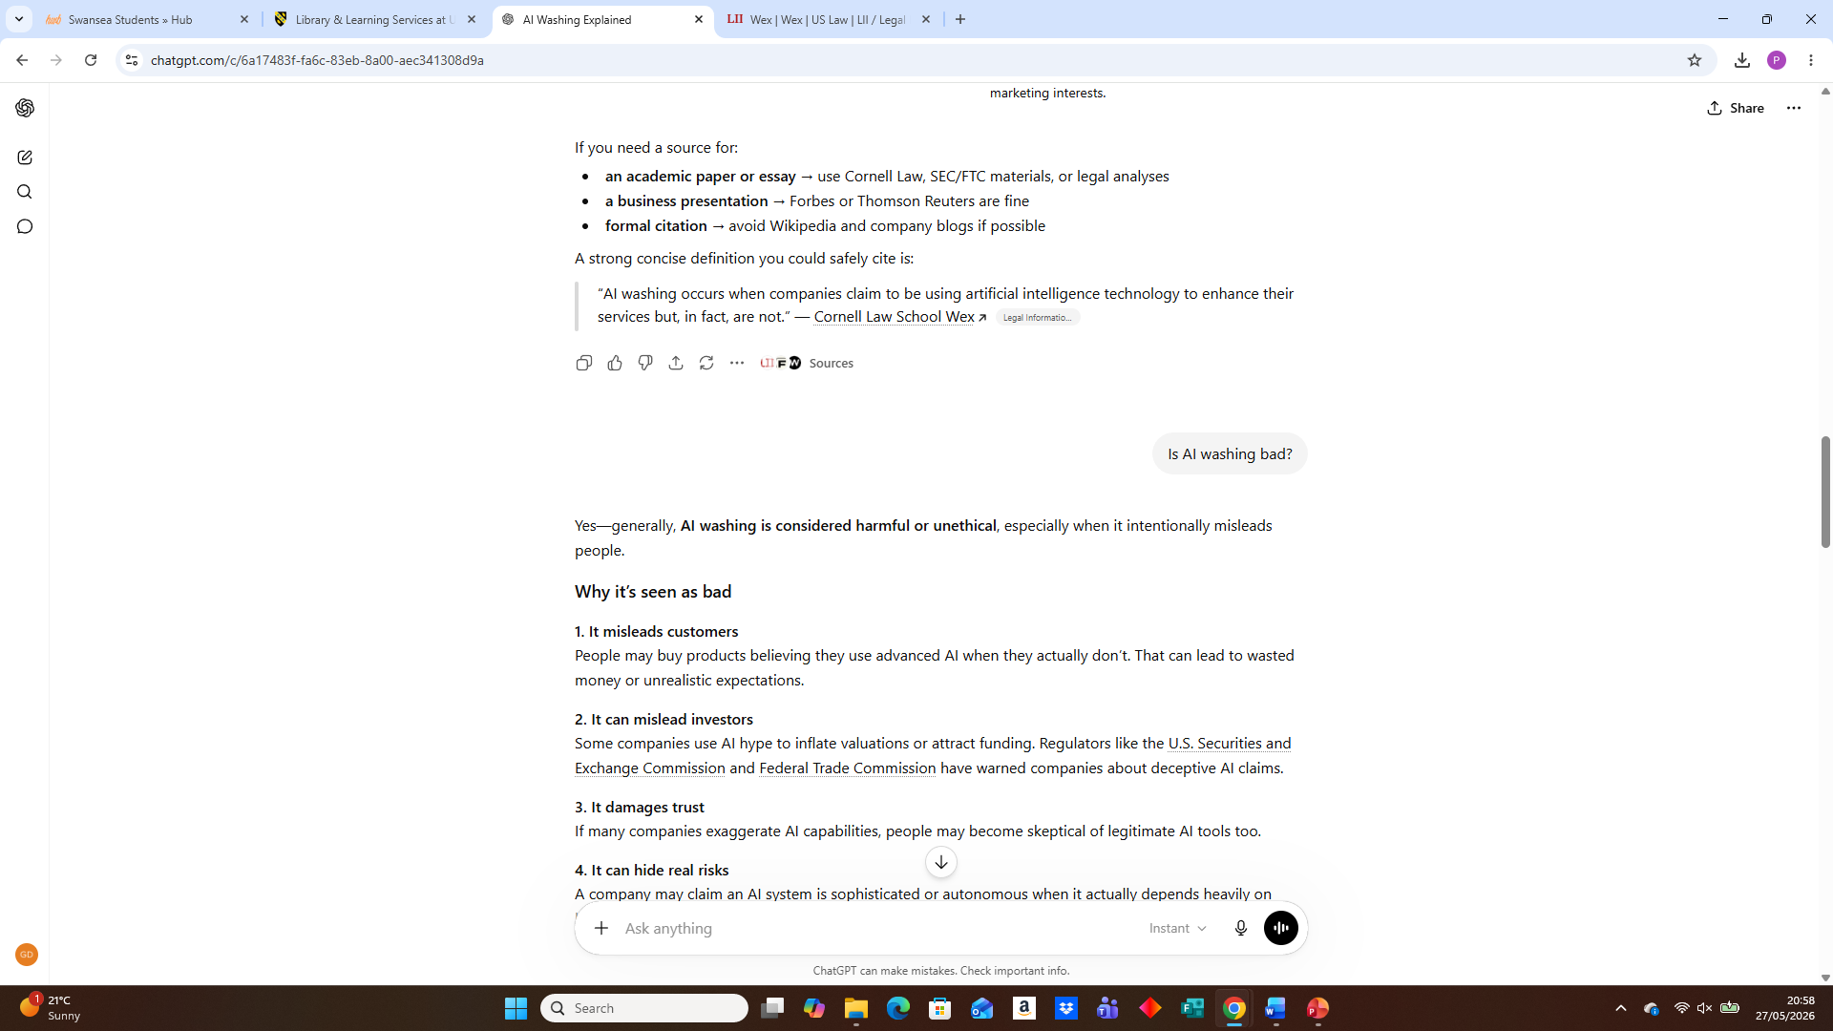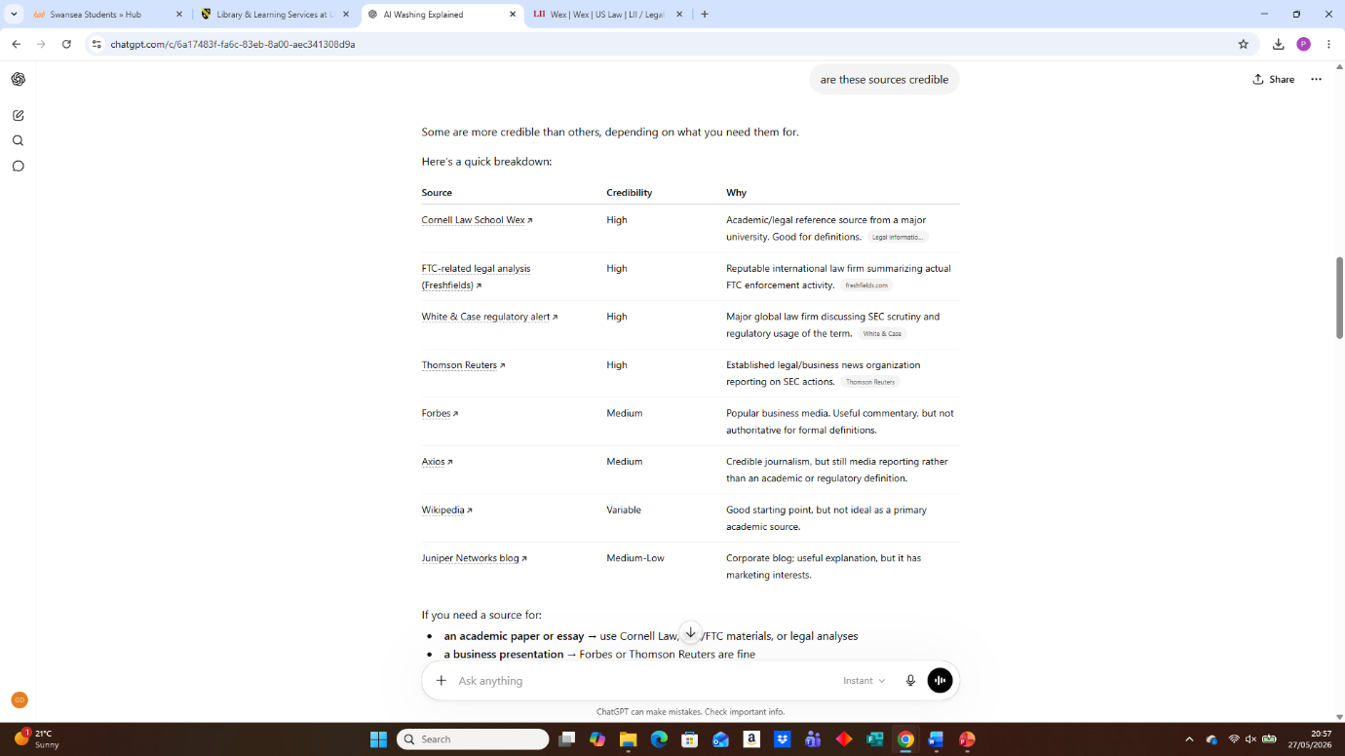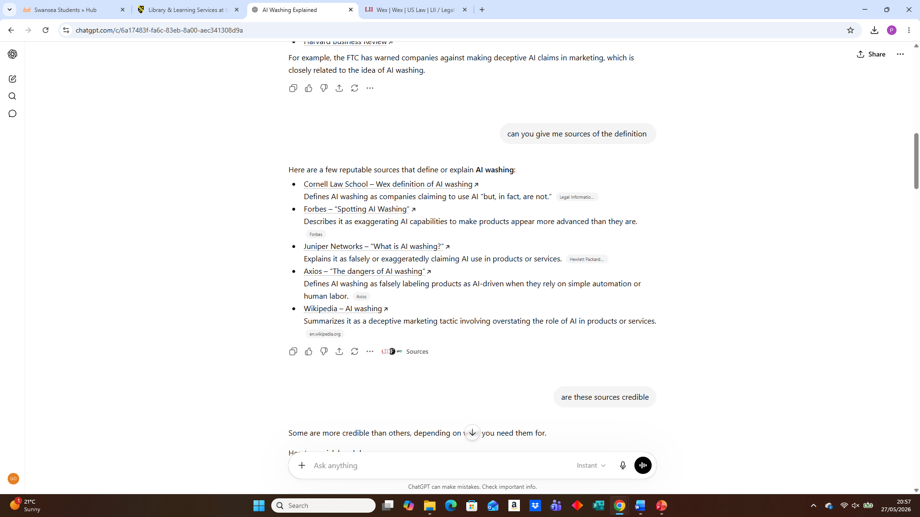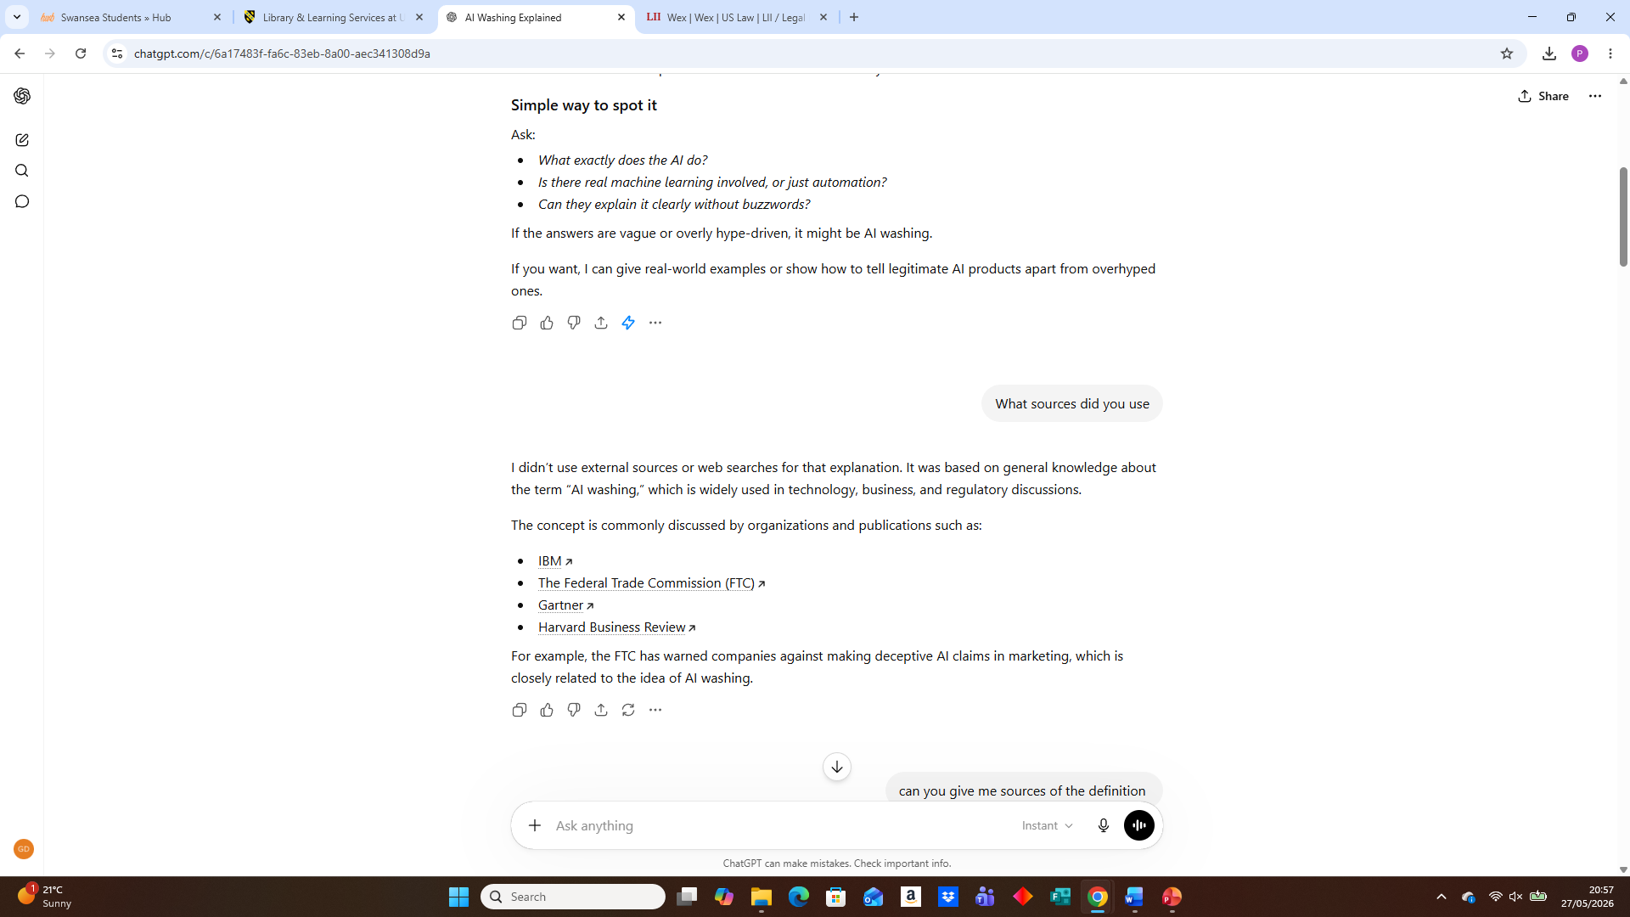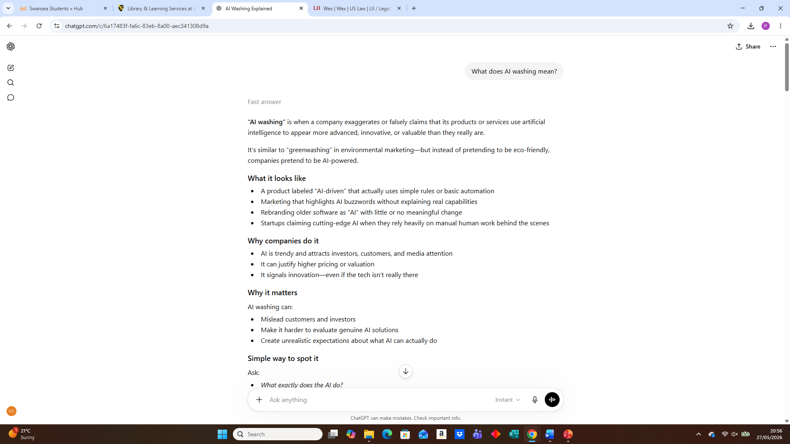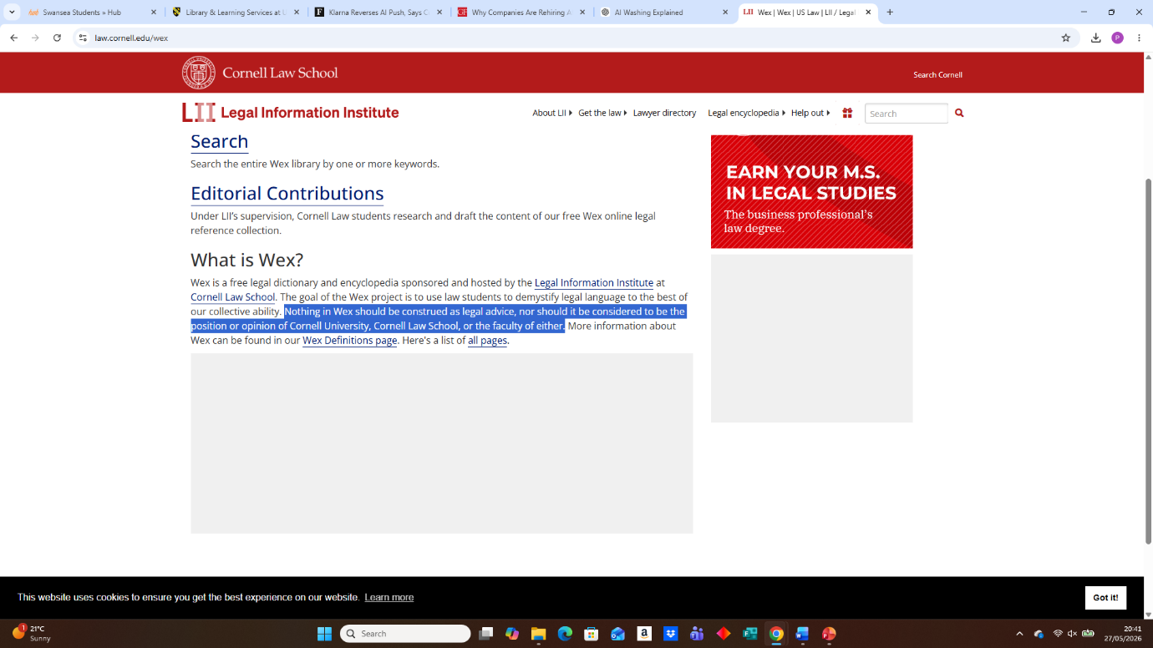

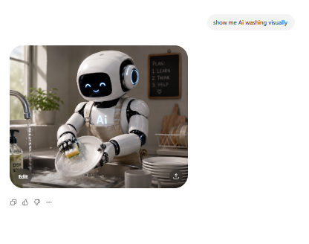
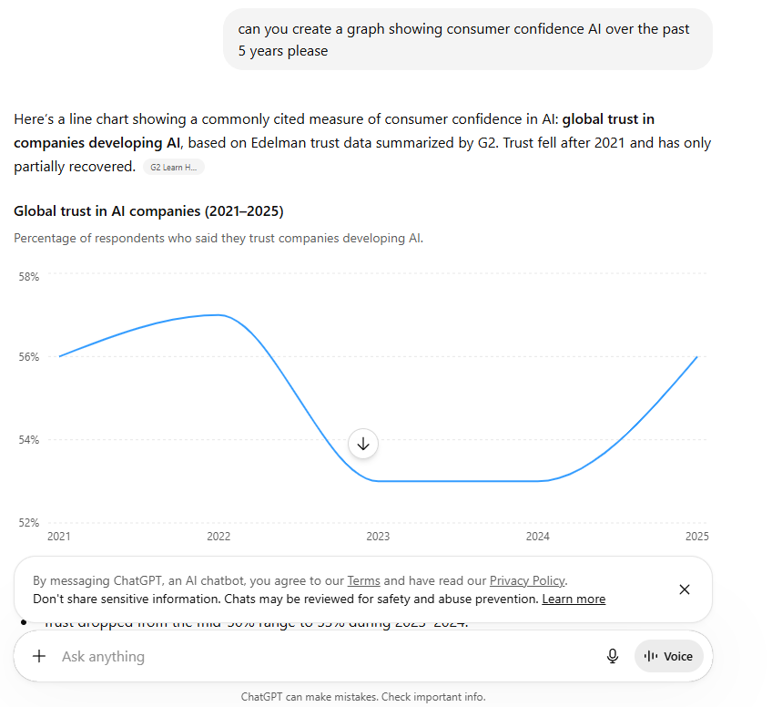

Presentation Slides


