2004100
Ernest A. Salisbury
Research in Context - ADAD5003
Paul Duerinckx
‘ESSAY’ - QUESTION FOUR
Word Count: 1935

“IN SOCIETIES dominated by modern conditions of production, life is presented
as an immense accumulation of spectacles. Everything that was directly lived
has receded into a representation.”
Debord, G. (2005) SOCIETY OF THE SPECTACLE. London: Rebel Press.

Through the intensification of image, everyday life has evolved into an autonomous illusion: one that solely focusses on the communication of an optimized symbolic sign. (Barthes, 1977) The way society presents images to people can be both positive and negative. Image can influence people in a way of learning and understanding. However, image can be a glamourised idea that even deceits the deceiver. This presents the spectacle: a world view that has materialised an inversion of reality that at first a misguided illusion then became a proposed truth of reality. Debord does not give a singular description of the spectacle, you cannot define it in a literal sense, this is due to the metaphysics of the spectacle: “the spectacle is an affirmation of appearances and an identification of all human social life with appearances.” (Debord, p. 9) However, “THE SPECTACLE is not a collection of images; it is a social relation between people that is mediated by images.”
Initially, a discussion about the many types of image & spectacles will caution that it cannot be assumed the spectacle has distraught all life and caused everything to become representation. Further, it will be shown the spectacle at its core concepts and barbaric values, including a range of imaginary persona imagery that has evolved from a tech sub-culture fuelled by materialistic desire. In Contrast, the inverted reality that not only experiences this spectacle but presents it through a unified critique of advanced capitalism, showing a wide range of medium and presentation. Finally, the sheer amount of spectacle within everyday life and how contemporary artists are critiquing this reality.
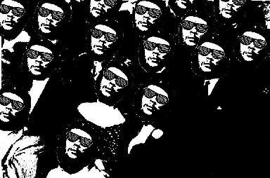
Figure 1: The Society of the Spectacle Reconsidered. Clark, J. (2015)
IMAGE
Image is an authentic individual representation of the external body, or sight within your environment, it is also an impression of general ideals presented through an object, a group, or person. The way you see an image affects how you perceive its value and ideas within relation to yourself. John Berger in Ways of Seeing writes: “The way we see things is affected by what we know or what we believe.” (1972, p. 8) You are never still to the point you do not see; you can never look at just one thing, you must see first as “Seeing comes before words.” (1972, p. 7) Then in the act of sight you must always be looking for the relation between the objectified thing and ourselves.
Your vision is continually active, searching not for a singular sight but hundreds of thousands every minute. How many images do you see every day? The constant circling of sight by holding things present as to what they are to in relation to us. Continually “constituting what is present to us as we are.” (1972, p. 9) Image can be of any medium and form, you should never directly see image as a frame on a wall but see image as an immense accumulation of spectacles.
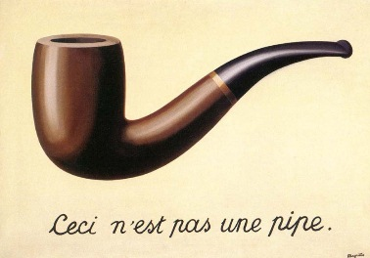
Figure 2: The Treachery of Images. René Magritte, 1929. Los Angeles County Museum of Art.
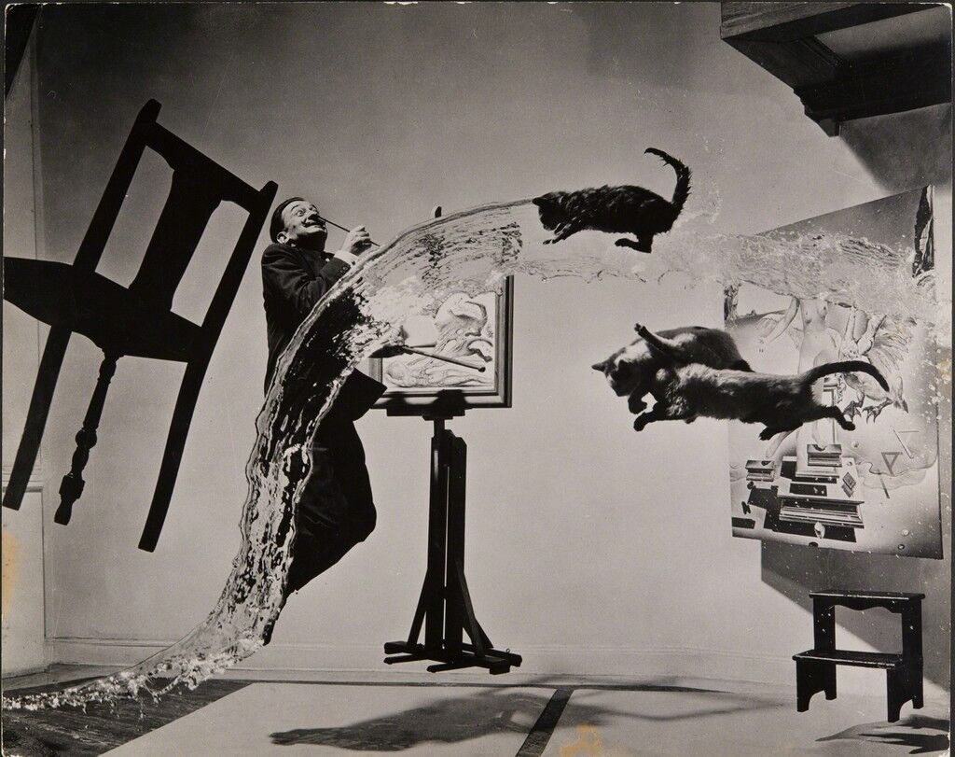
“An image is a sight which has been recreated or reproduced.” An appearance, one that’s either singular or multiple, detaching itself from the moment of appearance and then becoming a preserved representation or replication for a few moments or centuries. (1972, P. 9)
Figure 3: Philippe Halsman, Astonish Me! Dalí Atomicus, 1948. ARTSY.NET
SPECTACLE
“THE SPECTACLE is capital accumulated to the point that it becomes images.”
(Debord, 2005)
Spectacle is not an object or a unified thing, you cannot see spectacle; only reconcile with it. “It is a world view that has actually been materialised, a view of a world that has become objective.” (2005, p. 7) Debord developed his theory of the spectacle over many years, his critique is an analysis and application of Karl Marx’s concept of alienation, fetishism of commodities, and reification: in the society of the spectacle, commodities control the consumers; from this everyone becomes a passive onlooker who considers the relation to the reified spectacle. (TATE, 2021) In the general sense, the spectacle is the autonomous rule from new techniques of elite capitalist government causing an irresponsible sovereignty of constitution.
In Debords ideology the spectacle is his given term for the everyday manifestation of capitalist-driven illusion, mediation, film, and celebrity: an instrument for distracting and pacifying the masses through the sacred illusion of seeing imagery. Although Debords theory is still strong to this day, the spectacle has changed a lot since his time, to this day the spectacle can be seen on every screen. It is the posters you see on the sides of busses, cars, buildings; it is the adverts you see on television telling you if you get ‘X’ then you will become better in an optimized way. The spectacle simplifies reality down to endless fragments of materialistic desire and the signified meaning that object or thing conveys, leaving us to believe the sacred illusion of focus on appearance. Appearance of self-worth, self-value and how that then affects your social relations within the hierarchy of consumerist power. The spectacle came to be in post war 1920’s, like technology the spectacle has evolved to become a necessity in our life, it is has become part of our life so much you only see the enormity when viewing how it was in the past. (Hyperallergic, 2016)

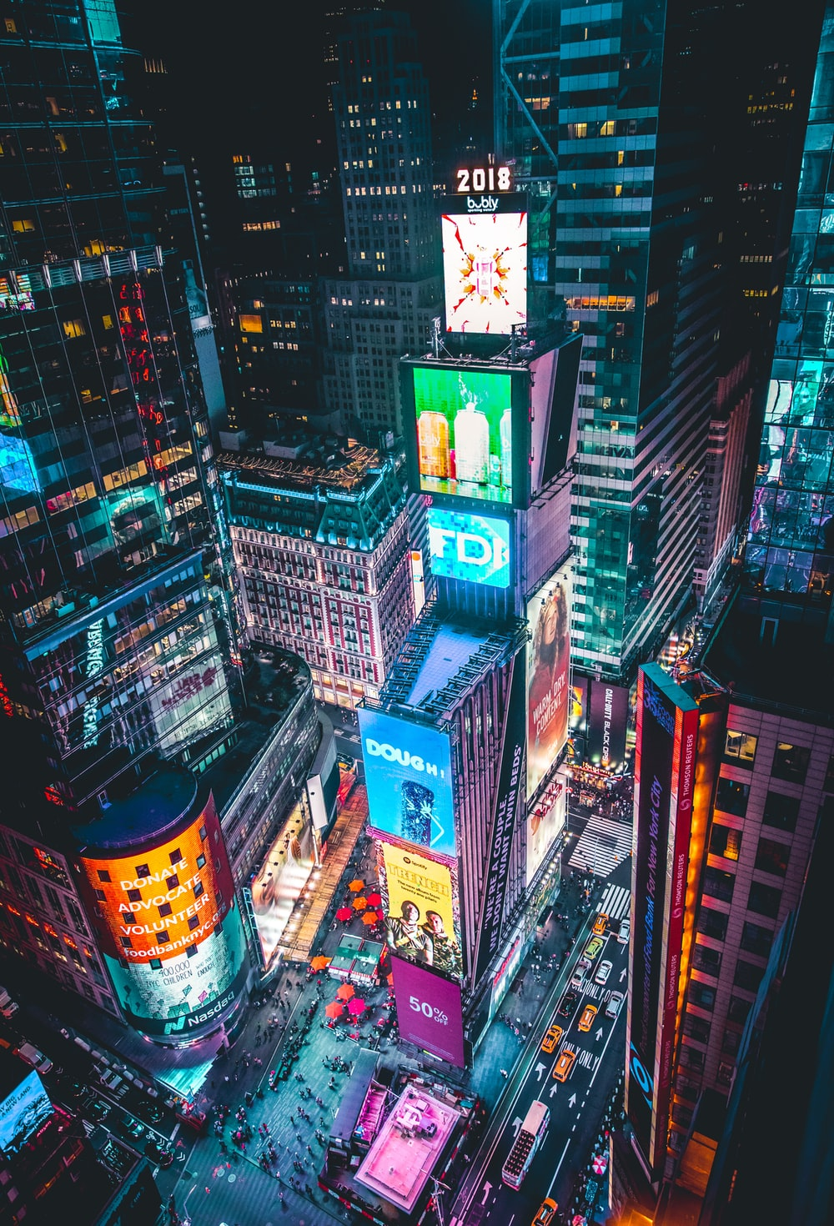
Figure 4: Times Square. Unsplash, Andre Benz. 2018, New York.

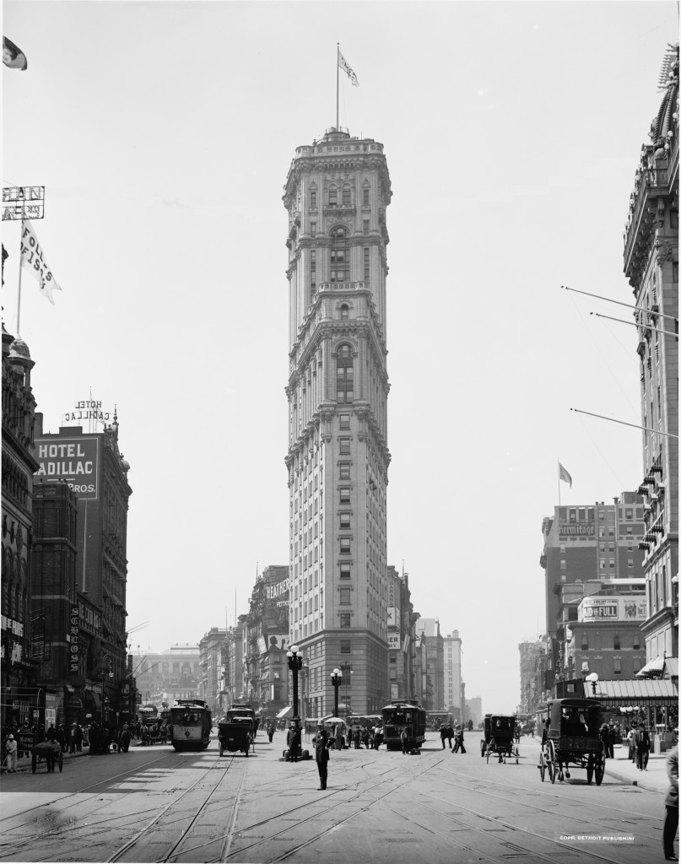
Figure 5: Times Square featuring The Times Tower 1908.

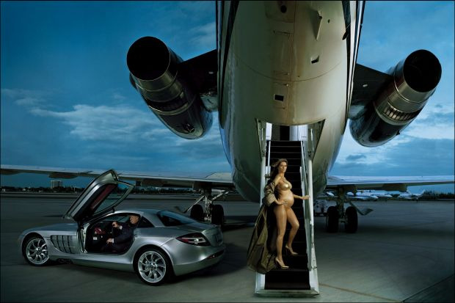
Figure 6: Donald and Melania Trump in 2006. Annie Leibovitz for Vogue.

DESIRE
Here you see an image taken by famous portrait photographer Annie Leibovitz, an image that has vast signs with multiple signifiers of a better wealthier lifestyle, generating the ideology that they are extremely powerful and successful. In this photo a heavily pregnant Melania Trump who is posing on a luxury jet resides next her husband who is also using a luxury item as a portraiture prop. Both symbolizing a sense of wealth and higher class. The nudity of Melania Trump only further pushes Karl Marx’s theory on widespread fetishism and its relation within the spectacle. This photo is the epitome of symbolized wealth, the objects presented in the image signify wealth, however, the focus of the sign is specifically its signified denotation. Producing the viewer to feel envy towards the symbols, as for the subjects who reside in their signified wealth “Being envied is a solitary form of reassurance.” (Berger, 1972)
A true spectacle in its most barbaric form of representation.
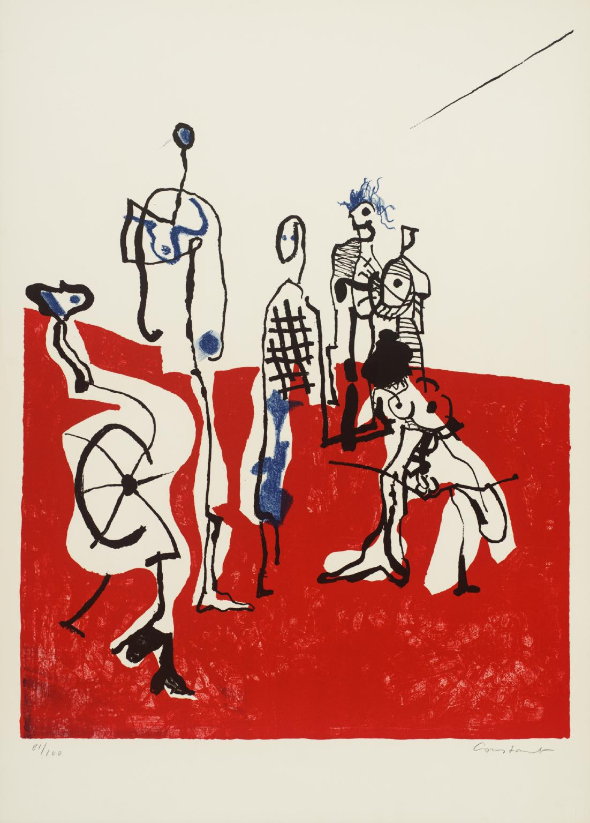
SITUATIONIST INTERNATIONAL
Figure 7: Constant, 1975. TATE.

An international organization formed upon social revolutionaries generated from avant-garde artists, political theorists and intellectuals, whose sole focus is to invert the reality of the spectacle. The intellectual foundations of the situationist international were derived from Marxism and revolutionary art movements of the time, primarily dada and surrealism. At the time this gave the situationist international a contemporary take on everyday life that would revolutionise art theory, and influence art movements into what they are today. (The ArtStory, 2021)

Guy Debord was the founding member of the group, overall Debords theory was the ideology of the spectacle and its ever-growing need for expression, and its mediation of social interaction through the glorified objects that tend to glamourise its consumer. Debord noticed this social illusion of life and through his book hoped to identify its values. Another critical concept of the situationists is to invert the reality of the spectacle. From this came situationism, the study of moments and experiences in time rather than the traits or ideal that a thing or person possesses.

Situationists follow the ideology that feelings, thoughts, behaviour, and previous experiences do not generate the individual reaction of each person within a situation, rather, the very situation produces the outcome of authentic reaction. When reacting to the present sign, you would initially consider the signified denotation within your social relation, however, you must invert it and consider the connotation of the sign’s signifier. (Barthes, 1977) The situationist international developed this critique of capitalism to consider the aspects of culture and class, giving way to the division of artists and consumers and make cultural production a part of everyday life.
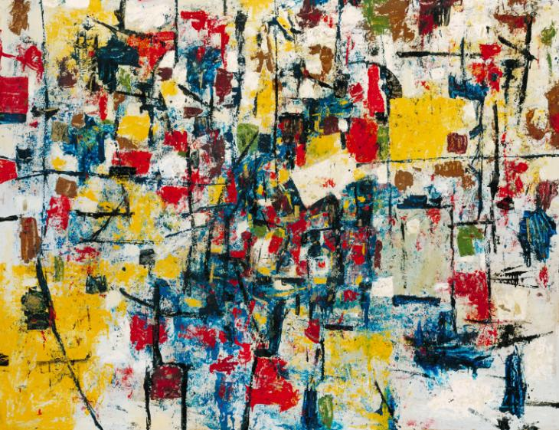
Figure 8: The Change. 1956-7. Ralph Rumney. TATE.
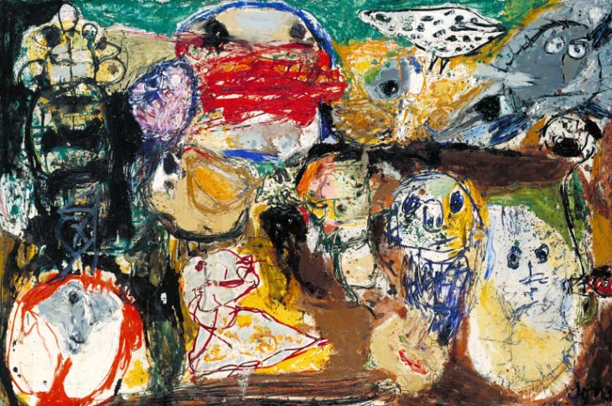
Figure 9: Letter to my son. 1956-7, Asger Jørn. TATE.
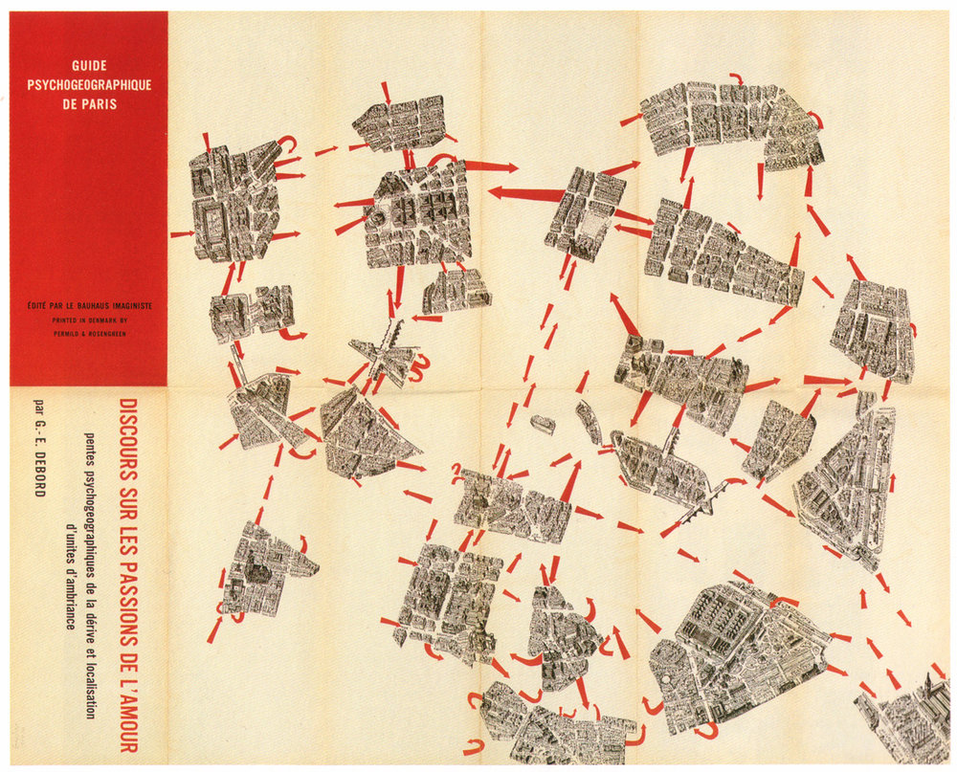
Figure 10: The Naked City, 1957.
DÉRIVE
The dérive, a revolutionary French strategy created originally by Debord who at the time was a member of the Letterist International. Debord defines the derive as “a mode of experimental behaviour linked to the conditions of urban society: a technique of rapid passage through varied ambiances.” (Debord, 1958) The above image is a dérive of Paris created by Guy Debord & Asger Jørn. It follows the basic ideology of an unplanned journey through a landscape, usually urban, in which the subject lets go of everyday spectacle, and the relations within their social fabric. Letting themselves be attracted to the terrain and the situations they find within said environment. Although solo derives are an art form and process, Debord argues that group collaboration of people and artists are the most fruitful. Taking people away from the autonomous repetitive spectacle and drawing them to the psychogeography of reality that focusses on the present, in total, a situation. (Debord, 1967)
CONCLUSION
Guy Debords book, The Society of the Spectacle; it was not to define the spectacle to a singular sentence - signpost it so the autonomous onlooker can easily understand it. Debord wished to highlight the concepts and true values of the spectacle, showing it in its purest form: a deep routed ever fluctuating process of capitalism within the everyday lives of everyday people, thriving on the act of constant sight, and the deep desire of meaning identified to objects or messages. “the spectacle is an affirmation of appearances and an identification of all human social life with appearances.” (Debord, 1967)

Image has overtaken our lives; we are flooded with representation or objects commodified to our own self-interest. “human fulfilment was no longer equated with what one was, but with what one possessed.” (Debord, p. 11) Image has become persona, then turning into an illusion of self, causing envy of the onlooker: the modern age of tech sub-culture has only evolved the spectacle even more, dawning a new era of influencers and online personalities. Debord was right in stating that life will turn into an immense accumulation of spectacles, however, life has not fully receded into representation.

In witnessing the spectacle Debord also sought to counter it, every action having its reaction. Situationism was born through the writings of Guy Debord, influencing many protests and situations within society. The idea to turn off the desire within objects or messages and recede into experiencing the present environment, reacting in an instinctual way through means of cultural history and self. To engage in life where you do not consider materialistic worth, you accept your present psychogeography, creating an authentic reaction within a situation. Finally, through true situationism, in 1957, Debord wrote his manifesto: ‘Report on the Construction of Situations and on the International Situationist Tendency’s Conditions of Organization and Action’; a revolutionary insight into the philosophies of the art world’s greatest minds at the time.

Later Debord would leave the situationist international as he believed that at its highest and most true form, situationism ceases to exist.

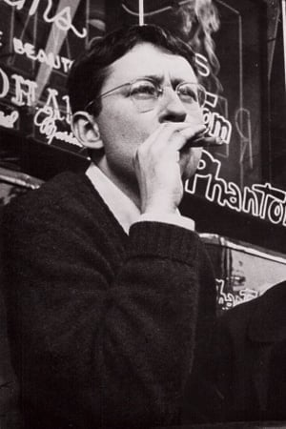
Figure 11: GUY ERNEST DEBORD. Moviefit. 2021.
BIBLIOGRAPHY
Barthes, R. (1977) IMAGE MUSIC TEXT. London: Fontana Press.
Berger, J. (1972) Ways of Seeing. London: Penguin Books.
Debord, G. (1958) Definitions. Translated by Ken Knabb. Paris: Internationale Situationiste.
Debord, G. (2005) SOCIETY OF THE SPECTACLE. London: Rebel Press.
Morgan, T. Purje, L. (2016) An Illustrated Guide to Guy Debord’s ‘The Society of the Spectacle’. [WEBSITE] Available at: https://hyperallergic.com/313435/an-illustrated-guide-to-guy-debords-the-society-of-the-spectacle/ Accessed on: 29/11/21.
TATE. (2021) SITUATIONIST INTERNATIONAL. [WEBSITE] Available at: https://www.tate.org.uk/art/art-terms/s/situationist-international Accessed on: 29/11/21
THE ART STORY. (2021) Summary of Situationist International. [WEBSITE] Available at: https://www.theartstory.org/movement/situationist-international/ Accessed on: 29/11/21

REFERENCE LIST
Figure 1: The Society of the Spectacle Reconsidered. Clark, J. (2015) Available at: https://www.fifthestate.org/archive/393-spring-2015/the-society-of-the-spectacle-reconsidered/ Accessed on: 29/11/21
Figure 2: The Treachery of Images. René Magritte, 1929. Los Angeles County Museum of Art. Available at: https://en.wikipedia.org/wiki/The_Treachery_of_Images Accessed on: 29/11/21
Figure 3: Philippe Halsman, Astonish Me! Dalí Atomicus, 1948. ARTSY.NET. Available at: https://www.artsy.net/article/artsy-editorial-story-surreal-photograph-salvador-dali-three-flying-cats Accessed on: 29/11/21
Figure 4: Times Square. Unsplash, Andre Benz. 2018, New York. Available at: https://unsplash.com/s/photos/times-square Accessed on: 29/11/21
Figure 5: Times Square featuring The Times Tower 1908. Available at: http://stuffnobodycaresabout.com/2012/09/13/old-new-york-in-photos-22/ Accessed on: 29/11/21
Figure 6: Donald and Melania Trump in 2006. Annie Leibovitz for Vogue. Available at: https://hauteliving.com/2018/01/annie-leibovitz-book-2018/649368/ Accessed on: 29/11/21
Figure 7: Constant, 1975. TATE. Available at: https://www.tate.org.uk/art/art-terms/s/situationist-international Accessed on: 29/11/21
Figure 8: The Change. 1956-7. Ralph Rumney. TATE. Available at: https://www.tate.org.uk/art/art-terms/s/situationist-international Accessed on: 29/11/21
Figure 9: Letter to my son. 1956-7, Asger Jørn. TATE. Available at: https://www.tate.org.uk/art/art-terms/s/situationist-international Accessed on: 29/11/21
Figure 10: The Naked City. 1957. Available at: https://thearchiologist.com/article/theory-of-the-derive Accessed on: 29/11/21.
Figure 11: GUY ERNEST DEBORD. Moviefit. 2021. Available at: https://moviefit.me/persons/37968-guy-debord Accessed on: 29/11/21.

