ACCA7022

ADVANCED STATISTICAL PROGRAMMING

TITLE: - VIGENÈRE MATRIX

Firstly, I created an R script called cipher.r to perform the tasks.
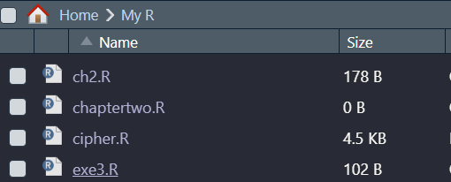

Q1 Create a matrix vigenere that contains the character data above. Display this matrix.
# Define the Vigenere Matrix
vigenere <- matrix(nrow = 26, ncol = 26)
# Define the Variable letter and Stored the Letters
letters <- c("A", "B", "C", "D", "E", "F", "G", "H", "I", "J", "K", "L", "M", "N", "O", "P", "Q", "R", "S", "T", "U", "V", "W", "X", "Y", "Z")

# Stored the data into the Vigenere matrix using 2dimensional for loop
for (i in 1:26) {
for (j in 1:26) {
vigenere[i, j] <- letters[(i + j - 2) %% 26 + 1]
}
}

# Add the label to Vigenere matrix row and column
colnames(vigenere) <- letters
rownames(Vigenere) <- letters

# Print vigenere matrix
print("Vigenere Matrix:")
print(vigenere)
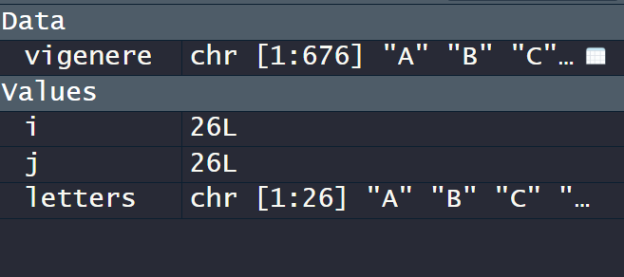
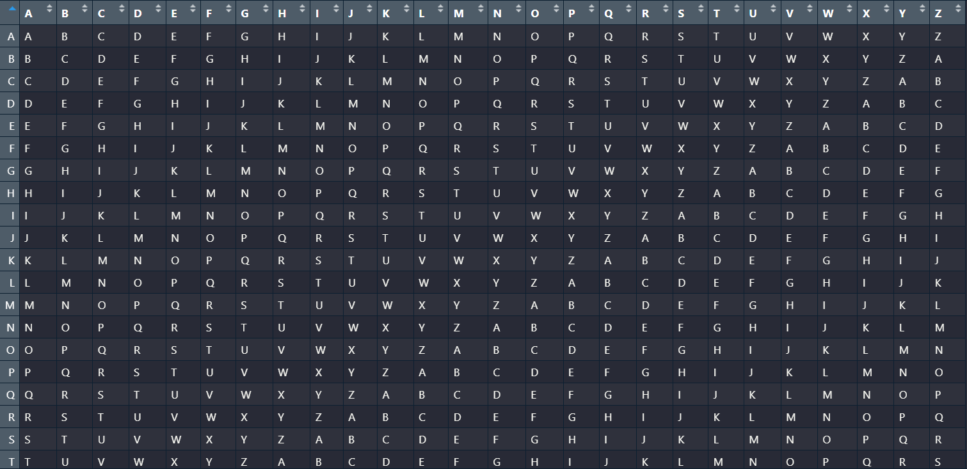
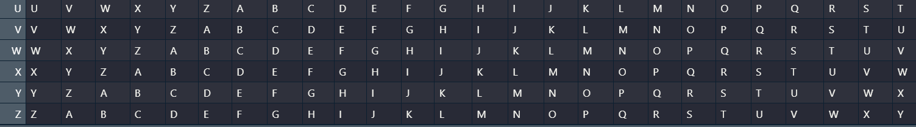

Explanation:
This code is generating a Vigenère cipher table or matrix. The Vigenère cipher is a method of encrypting alphabetic text by using a simple form of polyalphabetic substitution. Here's a breakdown of what each part of the code does:

1. Matrix Initialization:
- `vigenere <- matrix(nrow = 26, ncol = 26)`: Initializes an empty 26x26 matrix named `vigenere`.

2. Letter Initialization:
- `letters <- c("A", "B", ... "Z")`: Creates a vector containing the letters of the English alphabet from A to Z.

3. Populating the Vigenère Matrix:
- The nested `for` loops iterate through the rows and columns of the `vigenere` matrix.
- `vigenere[i, j] <- letters[(i + j - 2) %% 26 + 1]`: Fills each cell of the matrix with a letter based on the Vigenère cipher algorithm.
- `(i + j - 2) %% 26 + 1`: This expression computes the index of the letter to be placed in the matrix cell. The `-2` is used to adjust the indexing since arrays in R start at 1 and not 0. The modulo operation (`%% 26`) ensures the index remains within the bounds of the letters vector.
- `letters[(i + j - 2) %% 26 + 1]`: Accesses the letter at the calculated index and assigns it to the matrix cell.

4. Adding Row and Column Labels:
- `colnames(vigenere) <- letters` and `rownames(vigenere) <- letters`: Sets the column and row names of the `vigenere` matrix to the letters of the alphabet.

5. Printing the Vigenère Matrix:
- `print("Vigenere Matrix:")` and `print(vigenere)`: Outputs the generated Vigenère matrix.

This code essentially creates a 26x26 matrix representing the Vigenère cipher table where each cell contains a letter of the alphabet. The arrangement of letters in this matrix serves as the basis for encryption and decryption in the Vigenère cipher.

Q2 Using the keyphrase UWTSDSWANSEA, encrypt the message CAPTURETHEFLAG using the method described. You should create a vector keyphrase to hold the keyphrase, a vector plaintext to hold the plaintext and a vector ciphertext to hold the ciphertext. Display the plaintext and the ciphertext.

Source Code:
# Define the keyphrase
keyphrase <- "UWTSDSWANSEA"
# Input the plaintext message
plaintext <- "CAPTURETHEFLAG"
# Initialize an empty string for the ciphertext
ciphertext <- ""
# Perform Vigenère encryption
for (i in 1:nchar(plaintext)) {
# Get the current character from the plaintext
char <- substr(plaintext, i, i)
# Find the corresponding key character based on the keyphrase
key_char <- substr(keyphrase, (i - 1) %% nchar(keyphrase) + 1, (i - 1) %% nchar(keyphrase) + 1)
# Find the row for the key character in the Vigenère table
row <- which(letters == char)
# Find the column for the key character in the Vigenère table
col <- which(colnames(vigenere) == key_char)
# Encrypt the character and append it to the ciphertext
ciphertext <- paste(ciphertext, LETTERS[(row + col - 2) %% 26 + 1], sep = "")
}
# Output the ciphertext
print(ciphertext)
print(plaintext)

Output:
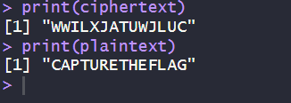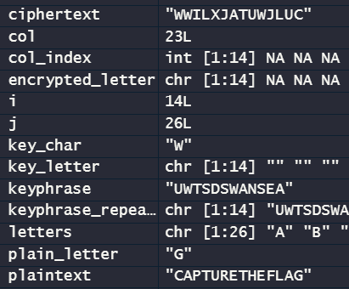

Explanation:
1. Keyphrase and Plaintext Initialization:
- `keyphrase <- "UWTSDSWANSEA"`: Defines the keyphrase used for encryption.
- `plaintext <- "CAPTURETHEFLAG"`: Initializes the plaintext message that needs to be encrypted.
2. Initialization of Ciphertext:
- `ciphertext <- ""`: Initializes an empty string to store the encrypted message (ciphertext).
3. Vigenère Encryption Process:
- The code utilizes a `for` loop to iterate through each character in the plaintext.
- `for (i in 1:nchar(plaintext))`: Iterates through each character of the plaintext.
4. Encryption Steps within the Loop:
- `char <- substr(plaintext, i, i)`: Retrieves the current character from the plaintext.
- `key_char <- substr(keyphrase, (i - 1) %% nchar(keyphrase) + 1, (i - 1) %% nchar(keyphrase) + 1)`: Retrieves the corresponding character from the keyphrase for the current position in the plaintext. It cyclically repeats the keyphrase characters to match the length of the plaintext.
- which(letters == char) is used to find the position of the character char in the letters vector. It returns the index/indices where the condition letters == char is TRUE. This index represents the row in the Vigenère table corresponding to the character in the plaintext.
which(colnames(vigenere) == key_char) finds the column index in the vigenere matrix where the column name matches the key_char extracted from the keyphrase. This column index corresponds to the key character used for the Vigenère encryption.
- `(row + col - 2) %% 26 + 1`: Calculates the new position in the alphabet matrix for encryption. The `-2` adjustment accounts for the zero-based indexing in R.
- `LETTERS[(row + col - 2) %% 26 + 1]`: Accesses the letter at the calculated position in the English alphabet and encrypts the character.
- `ciphertext <- paste(ciphertext, LETTERS[(row + col - 2) %% 26 + 1], sep = "")`: Appends the encrypted character to the ciphertext string.
5. Output:
- `print(ciphertext)`: Displays the resulting ciphertext, which is the encrypted form of the plaintext message using the Vigenère cipher with the specified keyphrase.
- `print(plaintext)`: Outputs the original plaintext message.

The Vigenère encryption process involves taking each character from the plaintext, finding the corresponding character from the keyphrase, determining their positions in the alphabet, combining them to find the new position, and then replacing the plaintext character with the encrypted character from the Vigenère table.

How I tested: (T2Q1)
In this case the plaintext ATTACKATDAWN and the keyphrase is UWTSD. will be encrypted as UPMSFEWMVDQJ.
# Define the keyphrase
keyphrase <- "UWTSD"
# Input the plaintext message
plaintext <- "ATTACKATDAWN"
# Initialize an empty string for the ciphertext
ciphertext <- ""
# Perform Vigenère encryption
for (i in 1:nchar(plaintext)) {
# Get the current character from the plaintext
char <- substr(plaintext, i, i)
# Find the corresponding key character based on the keyphrase
key_char <- substr(keyphrase, (i - 1) %% nchar(keyphrase) + 1, (i - 1) %% nchar(keyphrase) + 1)
# Find the row for the key character in the Vigenère table
row <- which(letters == char)
# Find the column for the key character in the Vigenère table
col <- which(colnames(vigenere) == key_char)
# Encrypt the character and append it to the ciphertext
ciphertext <- paste(ciphertext, LETTERS[(row + col - 2) %% 26 + 1], sep = "")
}
# Output the ciphertext
print(ciphertext)
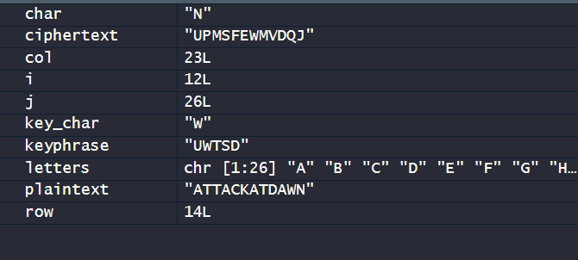
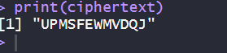

Q3 Decrypt the following ciphertext using the keyphrase RPROGRAMMING and store the result in the vector plaintext. ETMSXWISTBNHRIKZKKHMFGBAUDECZEEQPBBCZ

# Define the keyphrase for decryption
keyphrase <- "RPROGRAMMING"

# Define the provided ciphertext for decryption
ciphertext <- "ETMSXWISTBNHRIKZKKHMFGBAUDECZEEQPBBCZ"

# Initialize an empty string for the decrypted plaintext
plaintext <- ""

# Decrypting the ciphertext using the keyphrase
for (i in 1:nchar(ciphertext)) {
# Get the current character from the ciphertext
letter <- substr(ciphertext, i, i)

# Determine the index of the key character based on the keyphrase length
keyIndex <- (i - 1) %% nchar(keyphrase) + 1

# Find the column index in the Vigenère table based on the keyphrase character
col <- which(colnames(vigenere) == substr(keyphrase, keyIndex, keyIndex))

# Find the row index in the Vigenère table corresponding to the ciphertext character
row <- which(vigenere[, col] == letter)
# Append the decrypted character to the plaintext
plaintext <- paste(plaintext, rownames(vigenere)[row], sep = "")
}

# Displaying the decrypted plaintext
print("Decrypted Plaintext:")
print(plaintext)

Explanation:
This code aims to decrypt a ciphertext using the Vigenère cipher and a provided keyphrase. Let's break down each section with explanations:

1. Keyphrase and Ciphertext Initialization:
- `keyphrase <- "RPROGRAMMING"`: Sets the keyphrase that was used for encryption.
- `ciphertext <- "ETMSXWISTBNHRIKZKKHMFGBAUDECZEEQPBBCZ"`: Defines the ciphertext that needs to be decrypted.

2. Initialization for Decrypted Plaintext:
- `plaintext <- ""`: Initializes an empty string to store the decrypted plaintext.

3. Decryption Process:
- The code employs a `for` loop to iterate through each character in the ciphertext.
- `for (i in 1:nchar(ciphertext))`: Loops through each character of the ciphertext.

4. Decryption Steps within the Loop:
- `letter <- substr(ciphertext, i, i)`: Retrieves the current character from the ciphertext.
- `keyIndex <- (i - 1) %% nchar(keyphrase) + 1`: Determines the index of the key character based on the keyphrase length for decryption. It cycles through the keyphrase characters.
- `which(colnames(vigenere) == substr(keyphrase, keyIndex, keyIndex)):

colnames(vigenere) fetches the column names of the Vigenère table.
substr(keyphrase, keyIndex, keyIndex) extracts a single character at position keyIndex from the keyphrase.
col <- which(colnames(vigenere) == substr(keyphrase, keyIndex, keyIndex)) finds the index of the column in the Vigenère table that corresponds to the key character at that particular position in the decryption keyphrase.
which(vigenere[, col] == letter):

vigenere[, col] fetches the column specified by col from the Vigenère table.
which(vigenere[, col] == letter) finds the row index in the Vigenère table where the value matches the letter from the ciphertext.
row represents the row index in the Vigenère table that corresponds to the decrypted plaintext character..
- `plaintext <- paste(plaintext, rownames(vigenere)[row], sep = "")`: Appends the decrypted character to the plaintext.

5. Output:
- `print("Decrypted Plaintext:")`: Displays a label indicating the following output is the decrypted plaintext.
- `print(plaintext)`: Outputs the decrypted plaintext after the decryption process.

In essence, the code takes each character from the ciphertext, locates the respective position in the Vigenère table using the provided keyphrase, and retrieves the plaintext character from the intersection of the row and column in the Vigenère table. The decrypted plaintext is then constructed character by character as the loop progresses through the entire ciphertext.
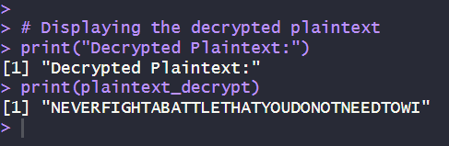

How I tested the code:(T2Q1)
I use the previous cipertext and keyphrase to test the decryption is correct or not. Eventually, here it’s the result.
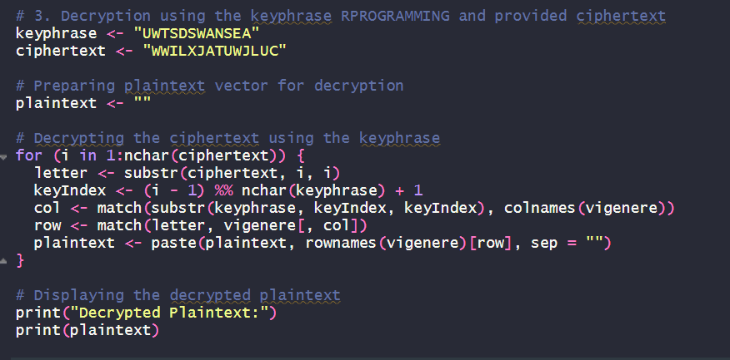
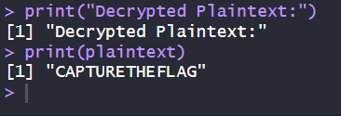

Flowchart 1
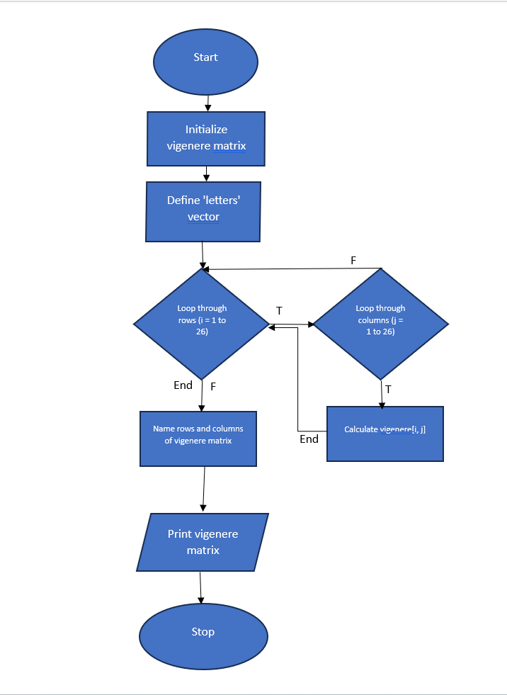

Flowchart 2

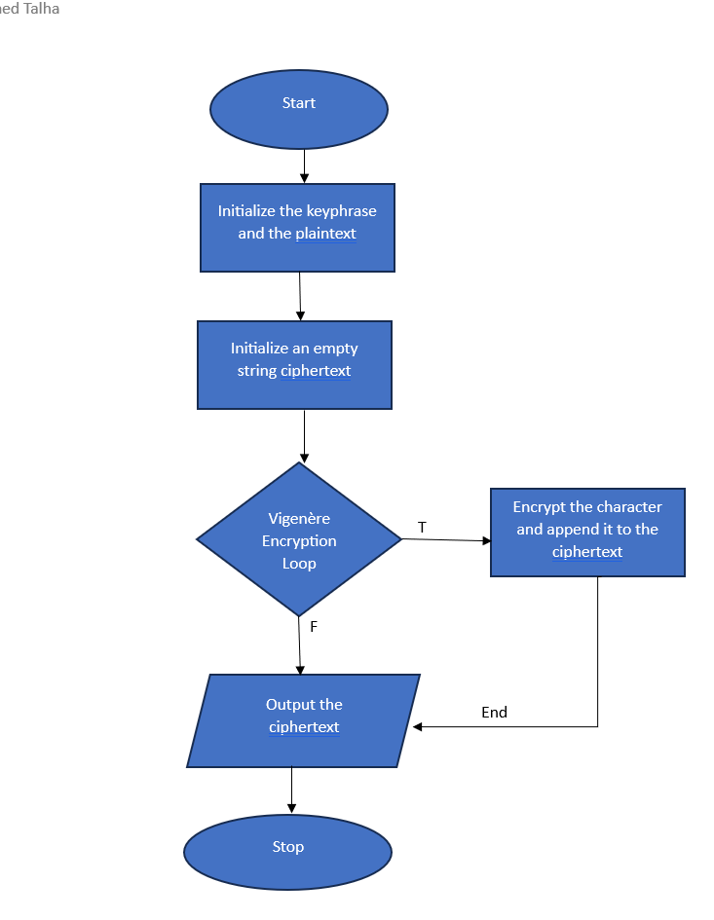
Flowchart 3
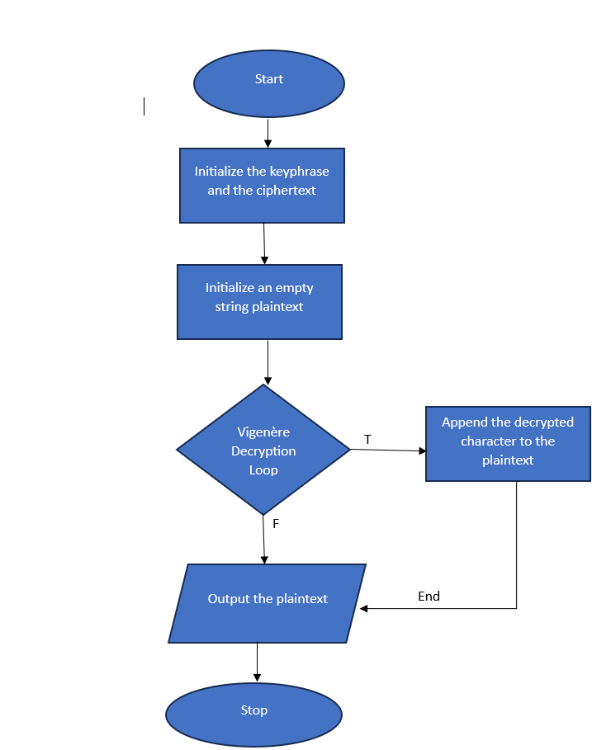

The challenges in this code: (T2Q3)
- Grasping the logic behind the Vigenère cipher encryption and decryption process. The technique involves using a keyword to determine the shift in each letter of the plaintext to create the ciphertext
- Optimizing the code for efficiency, especially with larger ciphertexts or more complex keyphrases, to ensure the decryption process runs reasonably quickly.
- Understanding and implementing the Vigenère decryption algorithm in a programming context.
- Dealing with potential errors, edge cases, and ensuring the code handles unexpected input or variations in the ciphertext or keyphrase.
- Algorithms

I've learned several aspects: (T2Q3)
- Understanding the inner workings of the Vigenère cipher encryption and decryption processes, especially regarding the use of a keyword or keyphrase to shift characters during encryption and reverse the process for decryption.
- Handling string manipulation within loops, such as extracting individual characters (‘substr’ function), concatenating strings, and managing substrings for decryption.
- Utilizing table lookups (in this case, using R's ‘which’ function) to find the indices for rows and columns in a Vigenère table or matrix, crucial for decryption based on ciphertext and keyphrase characters.
- Applying cryptographic concepts practically, understanding how to encrypt and decrypt messages using a historical cipher like the Vigenère cipher.
- Considering potential errors or edge cases, ensuring the code handles various inputs, lengths of ciphertext, and keyphrases appropriately.
- Employing loops effectively, especially when dealing with cyclic keyphrases to decrypt each character of the ciphertext.

What will I do next time: (T2Q3)
- Provide more detailed comments within the code to explain each step of the encryption/decryption process thoroughly. This helps improve readability and understanding, especially for someone reviewing or maintaining the code.
- This could involve optimizing loops, string operations, or table lookups to improve efficiency.

Bibliography
[1] W. Stallings, Cryptography and Network Security: Principles and Practice. Pearson, 2016.
[2] ChatGPT 3.5- used to understanding of algorithm and flowchart.
[3] R Studio – Used for coding the vigenere matrix program.

