
Student name | Sahara Ali
Student number | 2318212
Module code | LCLM5003
Module name | Project Management
Module lecturer | Sukhpreet Grewal
Assignment title | A project portfolio

Project Management Plan: Redevelopment of the Central Transport Hub
Part A- Project proposal poster
This poster outlines the plan for the Central Transport Hub Redevelopment—a project aimed at upgrading regional transport by 2027. The project connects train platforms, electric bus bays, cycling facilities into a single, eco-friendly hub. This presentation establishes the project's core scope, schedule, budget, and key risk management strategies.

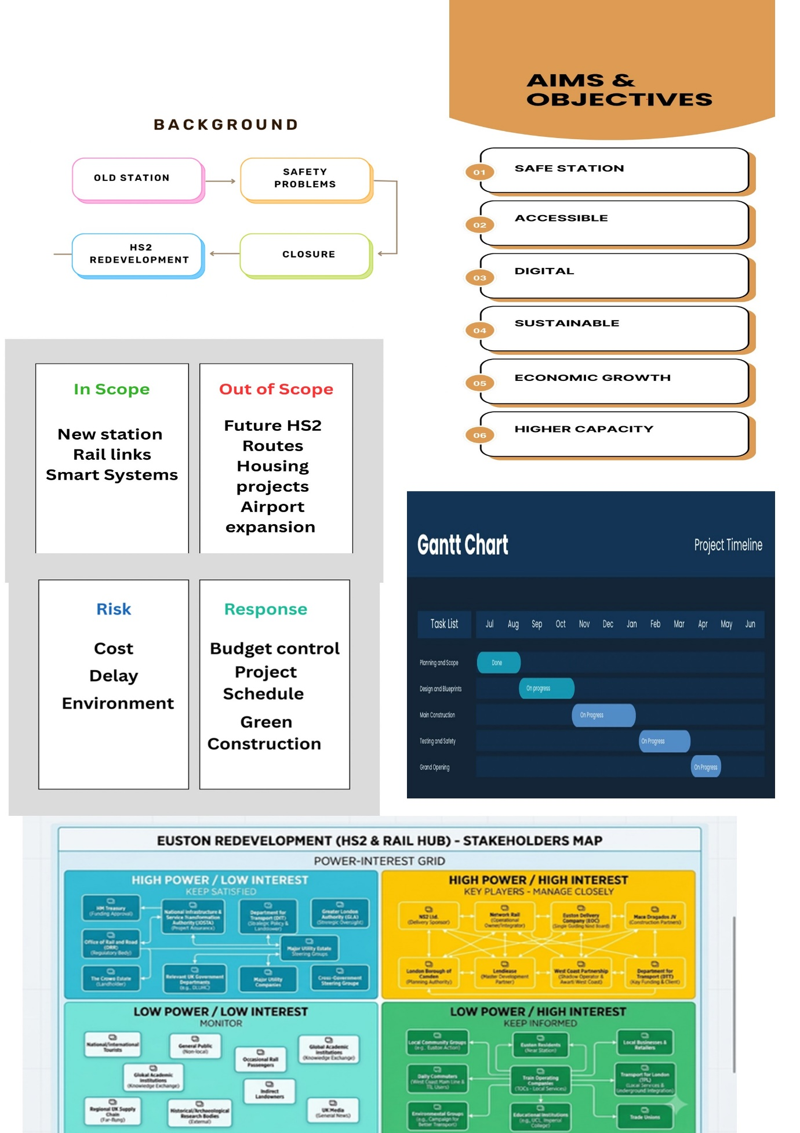

Part B – Reflection
In reflecting on my poster design, I identified a key area for improvement regarding project originality and scope alignment. While my presentation focused on "Central Transport Hub," the core ideas were heavily drawn from the real-world HS2 Euston project rather than being entirely my own original concept. In the future, I will ensure that my project is based on my own ideas. My scope was very broad and needed to be more specific. In terms of my stakeholder map it was very good and detailed. I forgot to add the RACI matrix such as who is going to be responsible and accountable. It needs to be clear as RACI matrix shows who needs to informed and consulted. My Gantt chart was a good start but it needs to be more detailed. My risks need to identify all the problems that can go wrong and the impact of what can go wrong. I need to show the potential risks and problems and also the mitigations. An example could be having separate costs so I have more money, I need to say who’s doing what in the work breakdown structure. I think my poster could have been a lot more better if I put more time into it because I know I was capable of doing it to a higher standard and could have included a lot more information. I used to be very nervous to present in front of an audience I would get bad anxiety before a presentation and feel like I could barely let out a word. I am very proud of myself for being able to present for so long standing up there alone I can see a big improvement.

Introduction

In November 2025, a major UK metropolitan city faced an immediate infrastructural crisis following the emergency closure of its central transport hub. A mandatory structural inspection revealed systemic structural deterioration in primary load-bearing members, concrete carbonation, and extensive water ingress within the 40-year-old facility. The hub failed to meet modern safety compliance under UK Building Regulations, fire safety legislation, and the Equality Act 2010.
As a key interchange handling over 120,000 daily commuter journeys across regional heavy rail, light rail, urban bus services, and last-mile freight logistics, its sudden decommissioning caused severe economic disruption. Local businesses reported revenue drops of up to 35% within the first quarter of closure, supply chains were severely bottlenecked, and public dissatisfaction surged.
This Project Management Plan (PMP) presents a comprehensive execution strategy for Option A: Redevelopment of the Central Transport Hub. Rather than implementing temporary modal patches, this project delivers a ground-up, state-of-the-art multimodal transit interchange designed to serve the city for the next 50 to 100 years.

The redevelopment directly supports local, regional, and national strategic agendas:
Economic Regeneration: Restoring seamless connectivity to the central business district (CBD) and attracting commercial investment.
Environmental Sustainability: Supporting the UK’s statutory target of net-zero greenhouse gas emissions by 2050 by integrating renewable microgeneration, embodied carbon reduction, and low-emission transit integration.
Digital Transformation: Aligning with the National Infrastructure Strategy by embedding smart transit technology, Internet of Things (IoT) sensors, and dynamic passenger flow management systems.
The project operates under a hybrid governance model combining PRINCE2 stage-gate controls for high-level decision-making and accountability with Agile/Scrum methodologies for digital and software sub-projects (e.g., smart ticketing and dynamic passenger displays).

Project Description

The new Central Transport Hub will replace the hazardous, outdated structure with a flexible, transparent, and resilient transit interchange. Designed around an expanded, light-filled central concourse, the facility unifies four distinct transport modes within a single, highly navigable footprint:
Heavy Rail Interlock: 8 fully covered, extended platforms capable of hosting high-speed regional trains, equipped with automated safety gates and overhead electrification systems.
Zero-Emission Bus Terminal: A 22-bay peripheral terminal fitted with pantograph rapid-charging infrastructure to support an all-electric municipal bus fleet.
Sub-Surface Freight & Logistics Core: A dedicated underground consolidation centre designed for zero-emission last-mile delivery vehicles, cargo bikes, and urban freight handling, removing heavy delivery vehicles from surface street level.

Active Travel & Micro-Mobility Interchange: Integrated secure storage for 1,200 bicycles, dedicated electric scooter charging docks, and direct pedestrian greenways connecting to the civic centre.

Sustainability and Energy Strategy

The project aims to achieve BREEAM "Outstanding" status through:
Embodied Carbon Reduction: Utilizing low-carbon concrete mixes, cross-laminated timber (CLT) for internal structural spans, and 85% recycled structural steel.
On-Site Energy Generation: A 1.2 MW rooftop solar photovoltaic (PV) installation coupled with a 2 MWh battery energy storage system (BESS) to supply baseline power for lighting, digital displays, and climate control.
Passive Environmental Design: Optimized building orientation, dynamic natural ventilation louvers, high-performance triple glazing, and rainwater harvesting infrastructure designed to meet 70% of non-potable water demand.

Scope

Boundaries and Work Breakdown

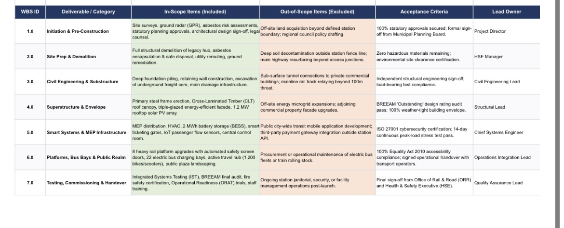

Key Deliverables
1. Site decontamination, hazardous material remediation, and safe structural demolition.
2. Reinforced concrete foundation piling and sub-surface logistics bunker.
3. Glazed structural steel canopy and modular timber roof structure.
4. Integrated smart ticketing, CCTV, passenger information, and security control room.
5. Fully commissioned rail platforms, bus bays, and active travel hub.

Acceptance Criteria

To achieve formal client sign-off, the project deliverables must meet explicit performance thresholds:
Safety & Regulatory: Zero high-risk non-conformances identified in independent Building Control and Office of Rail and Road (ORR) audits.
Environmental: Verification of BREEAM "Outstanding" rating by an accredited third-party assessor.
Accessibility: 100% compliance with the Equality Act 2010 and BSI BS 8300 guidelines, verified by a joint audit with local accessibility advocacy groups.
Operational Performance: Successful stress testing of all smart transit systems during a 14-day simulated trial featuring peak-load passenger volumes without system failure.

Work Breakdown Structure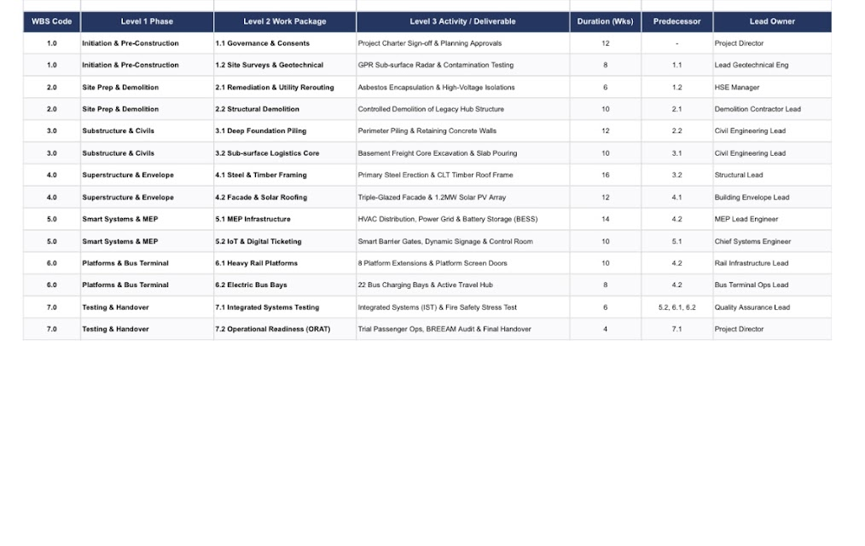

Gantt Chart
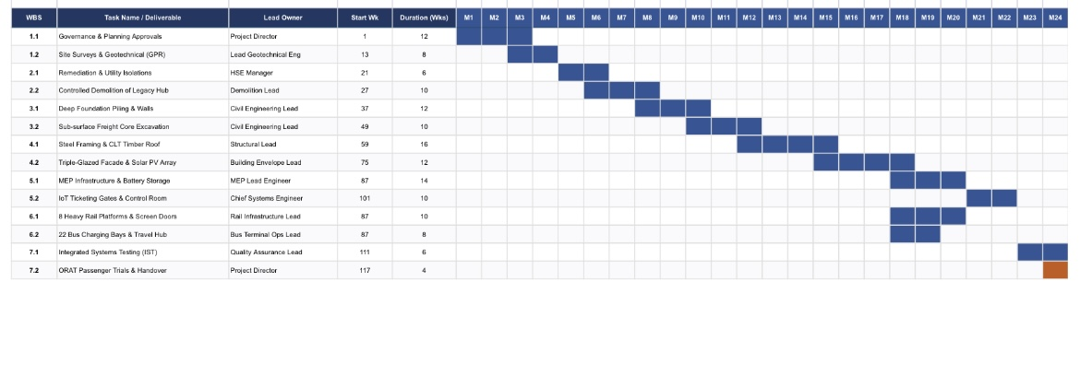

Quad Chart
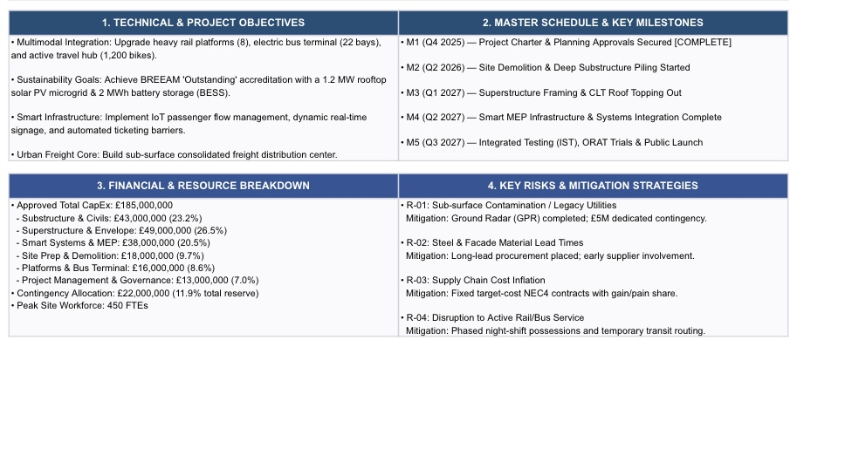Engagement Strategies
Department for Transport & Council (Manage Closely): Bi-weekly formal steering committee meetings, monthly earned value management (EVM) reporting, and mandatory gate-review sign-offs.
Health & Safety Executive / Environment Agency (Keep Satisfied): Monthly compliance audits, submitted environmental monitoring reports (noise, dust, vibration), and open-door site access.
Commuter Groups & Local Businesses (Keep Informed): Dedicated public liaison officer, digital project portal featuring live webcam updates, weekly disruption alerts, and bi-monthly town hall consultation sessions.
General Public (Monitor): Press releases, regular social media updates, and physical site hoardings featuring project timelines and architectural renders.

Stakeholders' Involvement
Stakeholder Analysis (Mendelow’s Matrix)

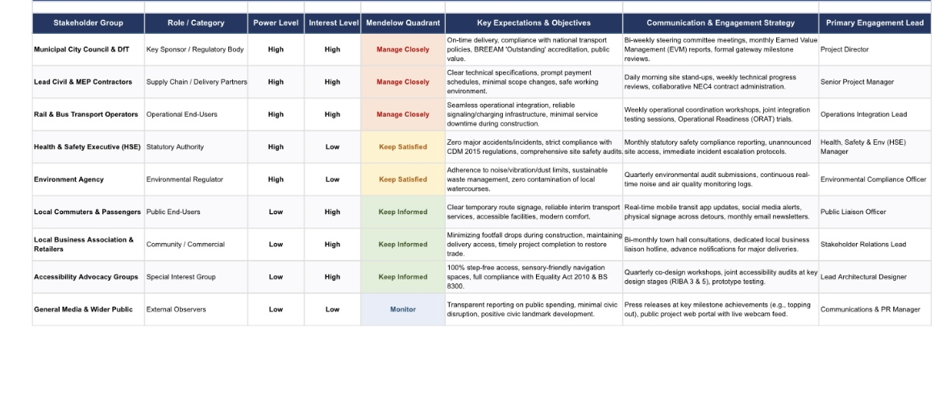

Allocation of Resources

Financial Resource Breakdown

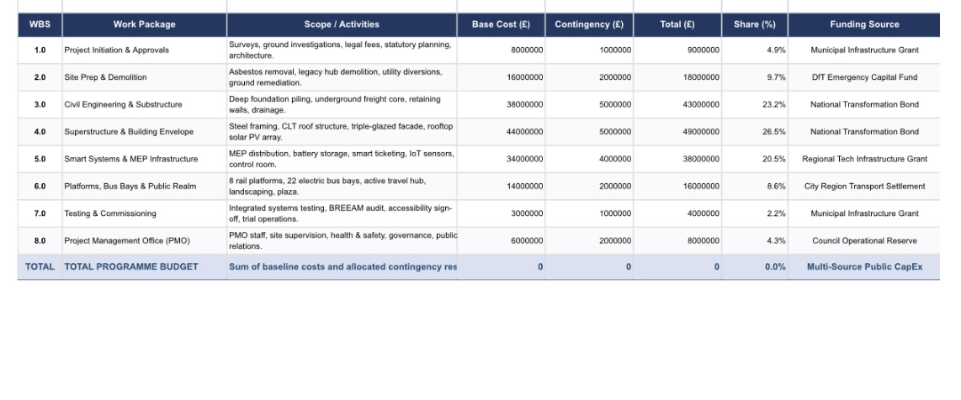

Labor and Capital Equipment Allocation

- Human Resources: Peak workforce on site is estimated at 450 Full-Time Equivalents (FTEs), including structural engineers, MEP specialists, steel fabricators, digital systems integrators, and health & safety supervisors.
- Heavy Plant Equipment: 4 x 50-ton tower cranes, 2 x deep-piling rigs, specialized mobile crushing units for concrete recycling, and battery-electric excavators to minimize on-site urban emissions.
- Materials Strategy: 100% of timber sourced from FSC-certified sustainable forests; structural steel sourced from regional UK suppliers under green steel procurement protocols to reduce Scope 3 transport carbon footprint.

Risk Analysis

Risk management follows the ISO 31000 standard, utilizing a 5x5 Likelihood and Impact matrix to score risks before and after mitigation.
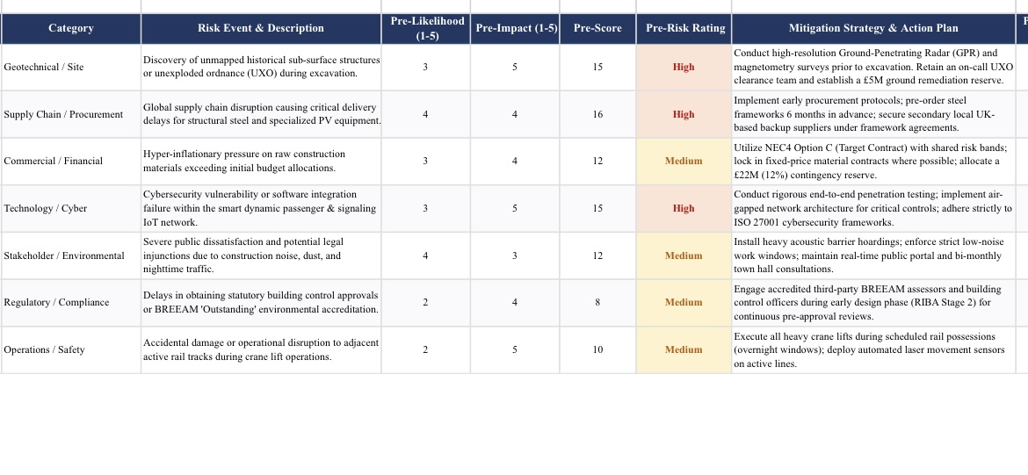

Conclusion

The redevelopment of the Central Transport Hub addresses a severe infrastructure crisis through structured, sustainable project management. By replacing an outdated, compromised facility with an integrated multimodal transit hub, the project restores vital regional transport connections across heavy rail, bus, and freight logistics networks.
Utilizing established project management frameworks—including PRINCE2 governance, APM planning standards, BREEAM environmental benchmarks, and ISO 31000 risk management—this plan provides a clear roadmap to complete the redevelopment within the 22-month timeline and £185 million budget. The resulting facility will restore public confidence, drive local economic regeneration, and provide a net-zero transport infrastructure for the city for decades to come.

References

1. Association for Project Management (APM), 2019. APM Body of Knowledge. 7th ed. Princes Risborough: Association for Project Management.
2. BSI, 2018. BS 8300-2:2018 Design of an accessible and inclusive built environment. Buildings – Code of practice. London: British Standards Institution.
3. BSI, 2021. BS ISO 21502:2020 Project, programme and portfolio management — Guidance on project management. London: British Standards Institution.
4. Building Research Establishment (BRE), 2021. BREEAM UK New Construction Non-Domestic Buildings Technical Manual. Watford: BRE Global.
5. Department for Transport (DfT), 2021. Decarbonising Transport: A Better, Greener Britain. London: HMSO.
6. Kerzner, H., 2017. Project Management: A Systems Approach to Planning, Scheduling, and Controlling. 12th ed. Hoboken: John Wiley & Sons.
7. Lock, D., 2020. Project Management. 10th ed. Abingdon: Routledge.
8. Maylor, H., 2010. Project Management. 4th ed. Harlow: Pearson Education.
9. Mendelow, A.L., 1981. 'Environmental Scanning—The Impact of the Stakeholder Concept', Proceedings of the Second International Conference on Information Systems, Cambridge, MA, pp. 407-418.
10. Meredith, J.R., Shafer, S.M. and Mantel Jr, S.J., 2017. Project Management: A Managerial Approach. 10th ed. Hoboken: John Wiley & Sons.
11. Office of Government Commerce (OGC), 2017. Managing Successful Projects with PRINCE2. 6th ed. London: TSO (The Stationery Office).
12. Project Management Institute (PMI), 2021. A Guide to the Project Management Body of Knowledge (PMBOK Guide). 7th ed. Newtown Square: Project Management Institute.
13. Transport for London (TfL), 2022. Accessible Bus Stop Design Guidance. London: TfL.

