 | Student No: | 2334177
 | Module Title: | Sustainable Hospitality
 | Module Code: | BMIH4011
 | Lecturer: | DANIEL PAYNE

AI Acknowledgement
I acknowledge the use of ChatGPT (https://chatgpt.com) and Grammarly (https://www.grammarly.com/) in the preparation of this assessment.
I used these tools to support:
- Research and identification of relevant academic sources and theories.
- Structuring the assignment, including organising headings and developing a logical argument flow.
- Proofreading my own writing for grammar, syntax and clarity, using prompts such as:
“Please check the following text for readability, grammar and syntax.”
I confirm that I have not used Generative AI to create text for direct submission. All final written content reflects my own understanding, interpretation and academic judgement.
I confirm that I retain drafts, notes and source materials used before and after the use of AI tools, which can be provided if required.

Content
1. Hotel Overview 2
2. Sustainability Vision 3
3. Sustainable Practices and Strategies 4
4. Guest Experience 5
5. Conclusion 6
REFERENCES 8

La Senda Verde ECO Hotel

1. Hotel Overview
La Senda Verde Eco Hotel is a small rural boutique eco-hotel located in Colunga, Asturias, in the north of Spain. The hotel is designed as an alternative to the traditional mass tourism model often associated with Spain, which is usually focused on beaches, nightlife and low-cost holidays. Instead, La Senda Verde promotes a slower, more responsible and community-focused form of tourism. The hotel will have a maximum capacity of 20 rooms, allowing it to offer a personalised guest experience while maintaining a low environmental impact.
The name La Senda Verde means The Green Path. It is inspired by La Senda del Oso, a well-known walking and cycling route in Asturias, while the word verde reflects the hotel’s ecological identity. Its brand identity is centred on sustainability, tranquillity and authenticity, combining responsible hospitality practices with the natural and cultural richness of the Asturian landscape. Its location also offers strategic access to routes connected to the Camino de Santiago, creating opportunities to attract pilgrims seeking sustainable, comfortable and authentic accommodation during their journey.

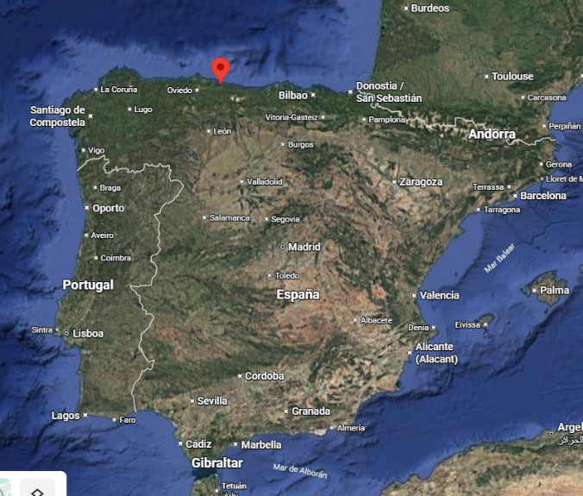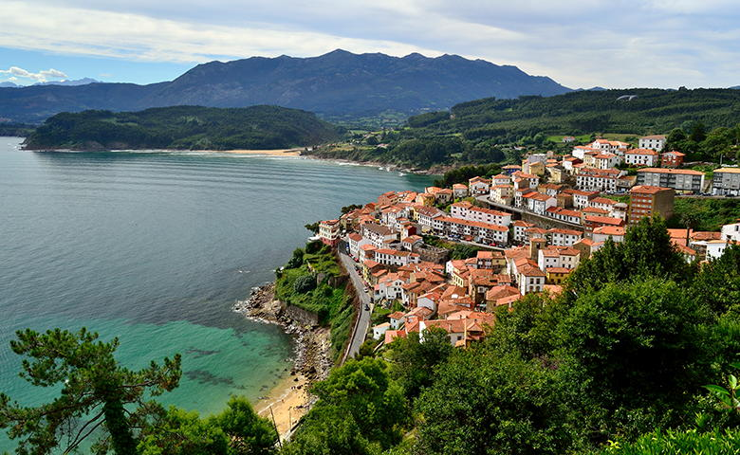
This location is particularly suitable for a sustainable boutique model because its rural-coastal setting supports low-density tourism, local supply chains and nature-based experiences, which are central to both operational sustainability and guest value.
The concept is inspired by the idea of slow tourism, encouraging travellers to spend more time in one destination, engage with local culture and environments, and focus on more meaningful and sustainable travel experiences (Lumsdon and McGrath, 2011).
The target market mainly includes environmentally conscious travellers, couples looking for a peaceful escape, and guests interested in nature, local gastronomy and sustainable tourism. The concept is designed to appeal to visitors who value comfort and quality while seeking accommodation with a lower environmental footprint.

2. Sustainability Vision
The mission of La Senda Verde Eco Hotel is to provide high-quality rural hospitality while minimising environmental impact and supporting the local community. The hotel aims to operate as a responsible tourism business that respects natural resources, promotes local culture and contributes to the long-term sustainability of the destination. This vision is also a response to the negative impacts of mass tourism in Spain. Although tourism can create income and employment, it can also increase pressure on local communities, housing, public services and natural resources. Recent reports have shown growing concern in Spain about short-term rentals, overcrowding and resident protests in popular tourist destinations (BBC News, 2025a; BBC News, 2025b).

The concept of the hotel is based on the idea that tourism development should balance environmental protection, economic benefits and social wellbeing (UNWTO, n.d.). Sustainable tourism requires tourism activities to protect ecosystems, respect local communities and ensure that tourism contributes to long-term destination development (Yachin, 2025). For this reason, La Senda Verde Eco Hotel focuses on small-scale tourism that reduces environmental pressure while creating positive economic opportunities for the local area. This approach is similar to Bhutan’s “high value, low impact” tourism principle, which prioritises quality tourism experiences and controlled visitor numbers to protect local culture, communities and the natural environment (Tourism Council of Bhutan, 2019). For La Senda Verde, this does not mean excluding visitors, but attracting guests who value sustainability, local culture and responsible travel.
The sustainability approach of the hotel is based on the principles of slow tourism and low-impact hospitality (Serdane, Maccarrone-Eaglen and Sharifi, 2020). This approach works particularly well in rural destinations, where managing the number of visitors can help protect natural ecosystems while also preserving the social and cultural character of local communities. Research shows that sustainability in rural tourism depends on protecting landscapes, involving local communities and managing development carefully, rather than simply increasing the number of tourists (Lane, Kastenholz and Carneiro, 2022).
The concept of La Senda Verde Eco Hotel also supports the wider objectives of sustainable tourism by following the United Nations Sustainable Development Goals (SDGs). These goals encourage tourism businesses to operate in ways that promote responsible consumption, protect the environment and support sustainable economic development (United Nations, n.d.), they are not used symbolically; they shape operational decisions. For example, SDG 8 is reflected in local hiring and supplier partnerships, SDG 12 in waste reduction and refillable amenities, and SDG 13 in the hotel’s focus on renewable energy and low-impact tourism.
Hospitality businesses are increasingly expected to show real commitment to sustainability, while many tourists are becoming more interested in responsible accommodation (Korstanje et al., 2020; Casado et al., 2026). Therefore, sustainability is integrated into the hotel’s daily operations and guest experience, including local food, regional suppliers and nature-based activities (Roy, Hall and Ballantine, 2020).
3. Sustainable Practices and Strategies
La Senda Verde Eco Hotel will implement a range of environmental and social practices designed to reduce its ecological impact while supporting the local community. Sustainable hotel operations can improve energy and resource efficiency, which may help reduce operating costs over time.
Energy: the hotel will use solar panels to help generate electricity and support hot water systems. Solar installations can reduce a hotel’s electricity bills by around 25–60 %, depending on the scale of the system and the energy demand of the property (British Columbia Hotel Association, 2024). In addition, the hotel will use energy-efficient technologies such as LED lighting, energy-efficient appliances and smart heating systems that help reduce energy consumption in guest rooms and public areas. The adoption of sustainable energy systems and green hotel practices can therefore reduce environmental impacts while improving the sustainability performance of hospitality businesses (Appiah, Adongo and Safo, 2023). However, renewable systems involve high upfront investment, so the hotel would need to balance environmental ambition with phased implementation and long-term return on investment.
Water: the hotel will install water-saving technologies such as low-flow showers, efficient toilets and water-efficient laundry systems. Bathroom products such as shampoo, shower gel and soap will be provided in refillable dispensers instead of small single-use plastic bottles. Guests will be encouraged to participate in towel and linen reuse programmes to reduce unnecessary water and energy consumption. According to Park et al. (2021), water conservation measures in hotels can influence guest attitudes and encourage more environmentally responsible behaviour among tourists.
Waste: hospitality businesses generate significant waste through food preparation, packaging and daily operations. Hotel guests can produce around 1 kg of waste per person per night, and food waste can represent up to half of hotel waste (Waste Direct, 2025). La Senda Verde will introduce clearly labelled recycling bins for paper, glass and plastic. Organic kitchen waste will be composted and reused in a small vegetable garden, supporting circular resource use. The hotel will also reduce single-use plastics through reusable or biodegradable alternatives. These measures reflect circular economy principles by reducing waste, reusing materials and improving resource efficiency (Jacob et al., 2025).
Materials: the hotel will prioritise sustainable and local materials in construction and daily operations, including local stone, slate and chestnut wood. This strengthens the hotel’s place identity while reducing transport emissions and supporting local suppliers. The approach is inspired by vernacular architecture, which uses local materials and traditional construction techniques adapted to the climate and territory (Hueto-Escobar, 2024). It could also be strengthened by Passivhaus principles, such as insulation, ventilation and airtightness, to reduce energy demand and improve indoor comfort (Passivhaus Trust, n.d.). Sustainable materials and circular design can support more environmentally responsible hotel operations (Taghipour et al., 2024).
Food and beverage: the hotel restaurant will prioritise locally produced and seasonal ingredients to reduce food transportation distances and support regional farmers and food producers. Sustainable practices will also be implemented in the kitchen to reduce food waste and improve resource efficiency. Studies show that sustainable practices in hotel kitchens, such as responsible sourcing and waste management, play an important role in improving the overall environmental performance of hospitality businesses (Çapaş, 2025).
Community engagement is not only an ethical commitment but also a strategic part of La Senda Verde’s sustainability model. Unlike mass tourism, where benefits may go mainly to large companies or seasonal businesses, this hotel aims to keep more value within the local area. The hotel plans to employ local residents, buy from regional farmers and artisans, and work with small businesses to support the local economy.
The hotel will also collaborate with local tourism organisations such as Turismo Colunga (https://www.turismocolunga.es/), which promotes local events, visitor information, walking routes, places to eat, local producers and cultural activities. This partnership would help La Senda Verde become part of the wider destination, rather than operating separately from the community.
Sustainable environmental management practices in hotels can contribute to local development by encouraging cooperation between tourism businesses and local stakeholders (Rassiah et al., 2024). In addition, rural tourism has the potential to stimulate local economic growth, strengthen community well-being and support long-term socio-economic development in rural areas (Singh et al., 2023).
4. Guest Experience
The hotel aims to create a space where visitors can enjoy a comfortable stay while also learning about responsible travel and more sustainable ways of living. Edgell (2020) argues that including sustainability throughout the guest journey can help tourism businesses raise environmental awareness among visitors while also creating more meaningful and memorable travel experiences.
La Senda Verde Eco Hotel is designed not only to provide accommodation, but also to challenge the common stereotype of Spain as simply a destination for beaches, nightlife and low-cost holidays. Instead, the hotel introduces guests to another side of Spain, centred on Asturias’ natural landscapes, cultural heritage, gastronomy and slower forms of travel. This allows visitors to experience a more authentic and sustainable model of Spanish tourism.
Many travellers today are increasingly interested in accommodation that demonstrates responsible environmental practices. Environmentally friendly initiatives can influence tourists’ decisions when choosing hotels and can improve guest satisfaction when sustainability is clearly communicated and integrated into the overall experience (Han, Hsu and Sheu, 2010). For this reason, La Senda Verde Eco Hotel will ensure that sustainability initiatives are visible and understandable for guests throughout their stay.
One way the hotel will enhance the guest journey is through transparent communication of its sustainability practices. Information about the hotel’s environmental initiatives, such as renewable energy use, water conservation and waste reduction programmes, will be shared with guests through digital information screens, welcome materials and the hotel website.
Dolnicar (2020) argues that encouraging environmentally responsible behaviour among tourists can play an important role in promoting sustainable tourism development. Therefore, the hotel will provide opportunities for guests to actively participate in sustainability-related activities during their stay. For example, La Senda Verde plans to organise workshops on local gastronomy, sustainable cooking and traditional Asturian food products. These activities allow visitors to learn about regional culture while also understanding sustainable food systems.
In addition, the hotel will offer guided nature-based experiences that connect guests with the surrounding environment. These may include walking routes, biodiversity tours, cycling activities linked to routes such as La Senda del Oso, or sustainable travel experiences connected to Camino de Santiago networks. Such activities strengthen the hotel’s slow tourism model while appealing to nature tourists, cultural travellers and pilgrims seeking more meaningful journeys.
Community-based experiences will also form an important part of the guest journey. Visits to local farms, artisan workshops, regional producers and cultural events promoted through organisations such as Turismo Colunga will help guests engage more deeply with the destination. Honey and Frenkiel (2021) suggest that tourism experiences that benefit both visitors and local communities are essential to more responsible tourism development.
La Senda Verde Eco Hotel will also encourage guests to take part in sustainability through simple everyday actions, such as towel and linen reuse programmes, reducing energy consumption in guest rooms and choosing local products in the hotel restaurant. Higgins-Desbiolles (2020) argues that small behavioural changes can increase environmental awareness and help tourists become more responsible travellers.

5. Conclusion
Sustainable hospitality has become increasingly important within the modern tourism industry as both businesses and travellers become more aware of environmental challenges and the need for responsible tourism development (Edgell, 2020).
La Senda Verde Eco Hotel has been designed as a small rural eco-hotel that combines high-quality hospitality with a strong commitment to sustainability. The concept focuses on providing an authentic guest experience while minimising environmental impact and supporting the local community. Through its location, design and operational practices, the hotel aims to create a tourism model that respects natural resources and promotes responsible travel.
Overall, La Senda Verde Eco Hotel presents a realistic and innovative model of sustainable hospitality by integrating environmental responsibility, community value and guest experience into one coherent concept. Its small scale, rural location and slow tourism focus make sustainability central to both operations and market positioning, supporting long-term viability in a changing hospitality industry.
Word count: 2,101

REFERENCES
- Appiah, P.A., Adongo, R. and Safo, A. (2023) ‘Sustainable energy systems and green hotel practices in hotels in Tamale metropolis, Ghana’, Journal of Environmental Management and Tourism, 14(7), pp. 2073–2087. Available at: https://doi.org/10.14505/jemt.v14.7(71).09.
- BBC News (2025a) ‘Spain clamps down on Airbnb as tourism backlash returns for summer’. Available at: https://www.bbc.co.uk/news/articles/c3wdd8lg581o (Accessed: 29 April 2026).
- BBC News (2025b) ‘The protesters and residents pushing back on tourism in Barcelona’. Available at: https://www.bbc.co.uk/news/articles/cp8d87l6lp1o (Accessed: 29 April 2026).
- British Columbia Hotel Association (2024) Harnessing the power of the sun: why hotels should invest in solar energy. Available at: https://bcha.com/harnessing-the-power-of-the-sun-why-hotels-should-invest-in-solar-energy/ (Accessed: 20 March 2026).
- Casado, R., Hube, B. and Olaru, D. (2026) ‘Beyond green promises: sustainability and the limits of employer attraction for Gen Z in tourism and hospitality’, Journal of Sustainable Tourism. Available at: https://doi.org/10.1080/09669582.2026.2628108.
- Çapaş, M., Yıldırım, F. and Sönmez, M. (2025) ‘Sustainability in large-scale hotel kitchens: a cross-sectional observational study on knowledge, attitudes, and practices’, Journal of Tourism & Gastronomy Studies, 13(4), pp. 3952–3972. Available at: https://jotags.net/index.php/jotags/article/view/2471 (Accessed: 17 April 2026).
- Dolnicar, S. (2020) ‘Designing for more environmentally friendly tourism’, Annals of Tourism Research, 84. Available at: https://doi.org/10.1016/j.annals.2020.102933.
- Edgell, D.L. (2020) Managing sustainable tourism: a legacy for the future. London: Routledge.
- Han, H., Hsu, L.T.J. and Sheu, C. (2010) ‘Application of the theory of planned behaviour to green hotel choice’, Tourism Management, 31(3), pp. 325–334. Available at: https://doi.org/10.1016/j.tourman.2009.03.013.
- Higgins-Desbiolles, F. (2020) ‘The “war over tourism”: challenges to sustainable tourism in the tourism academy after COVID-19’, Journal of Sustainable Tourism, 29(4), pp. 551–569. Available at: https://doi.org/10.1080/09669582.2020.1803334.
- Hueto-Escobar, A., Mileto, C., Vegas López-Manzanares, F. and Macchioni, N. (2024) ‘Traditional constructive techniques and their relation to geographical conditioning factors: the case of half-timbered walls in Spain’, International Journal of Architectural Heritage. Available at: https://doi.org/10.1080/15583058.2022.2155884.
- Honey, M. and Frenkiel, K. (eds.) (2021) Overtourism: Lessons for a better future. Washington, DC: Island Press.
- Jacob, M., Florido, C., Domínguez-Quintero, A. and Payeras, M. (2025) ‘Circular economy practices in the hotel industry: an urban destination versus a sun and beach island destination’, Sustainable Development, 33(4), pp. 6124–6138. Available at: https://doi.org/10.1002/sd.3432.
- Korstanje, M.E., George, B.P. and Nedelea, A.M. (2020) Strategies for promoting sustainable hospitality and tourism services. Hershey, PA: IGI Global.
- Lane, B., Kastenholz, E. and Carneiro, M.J. (2022) ‘Rural tourism and sustainability: a special issue, review and update for the opening years of the twenty-first century’, Sustainability, 14(10), 6070. Available at: https://doi.org/10.3390/su14106070.
- Lumsdon, L. and McGrath, P. (2011) ‘Developing a conceptual framework for slow travel’, Journal of Sustainable Tourism, 19(3), pp. 265–279. Available at: https://doi.org/10.1080/09669582.2010.519438.
- Park, J., Park, Y., Yoo, J. and Yu, J. (2021) ‘Can hotel companies’ water conservation management and waste reduction measures influence hotel customers’ willingness to pay more and intention to revisit?’, International Journal of Environmental Research and Public Health, 18(17), 9054. Available at: https://doi.org/10.3390/ijerph18179054.
- Passivhaus Trust (n.d.) What is Passivhaus? Available at: https://www.passivhaustrust.org.uk/what_is_passivhaus.php (Accessed: 20 April 2026).
- Rassiah, P., Nasir, N.M., Subramaniam, R.K. and Saleeth, H.M. (2024) ‘Sustainable environmental management practices: evidence from hotels in Malaysia’, Global Sustainability, 7, e29. Available at: https://doi.org/10.1017/sus.2024.28.
- Roy, H., Hall, C.M. and Ballantine, P.W. (2020) ‘Preferences and attitudes toward locally produced food among hospitality sector buyers’, Journal of Hospitality and Tourism Management, 45, pp. 94–104. Available at: https://www.sciencedirect.com/science/article/abs/pii/S1447677020302278 (Accessed: 9 March 2026).
- Serdane, Z., Maccarrone-Eaglen, A. and Sharifi, S. (2020) ‘Conceptualising slow tourism: a perspective from Latvia’, Tourism Recreation Research, 45(3), pp. 337–350. Available at: https://doi.org/10.1080/02508281.2020.1726614.
- Singh, A.S., Parahoo, S.K., Ayyagari, M. and Juwaheer, T. (2023) ‘Conclusion: how could rural tourism provide better support for well-being and socioeconomic development?’, Worldwide Hospitality and Tourism Themes, 15(1), pp. 84–93. Available at: https://doi.org/10.1108/WHATT-09-2022-0108.
- Taghipour, A., Padash, H., Etemadi, M., Khazaei, N. and Ebrahimi, H. (2024) ‘Sustainable and circular hotels and the water–food–energy nexus’, Sustainability, 16(5), 1985. Available at: https://doi.org/10.3390/su16051985.
- Tourism Council of Bhutan (2019) Tourism policy of the Kingdom of Bhutan. Available at: https://faolex.fao.org/docs/pdf/bhu211571.pdf (Accessed: 30 April 2026).
- Turismo Colunga (n.d.) Turismo Colunga. Available at: https://www.turismocolunga.es/ (Accessed: 29 April 2026).
- United Nations (n.d.) The 17 goals | Sustainable development. Available at: https://sdgs.un.org/goals (Accessed: 20 March 2026).
- UNWTO (n.d.) Tourism for SDGs. Available at: https://tourism4sdgs.org/ (Accessed: 17 April 2026).
- Waste Direct (2025) Hotel waste statistics and trends. Available at: https://wastedirect.co.uk/guides/hotel-waste-statistics-trends/ (Accessed: 10 March 2026).
- Yachin, J.M. (2025) ‘From project to venture: facilitating engagement and entrepreneurship in rural tourism’, Tourism Geographies, pp. 1–22. Available at: https://doi.org/10.1080/14616688.2025.2519331

