  Component One: Student Journal (learning log) 750 words +/- 10%  Contribution to Overall Module Assessment: 25% | Student No: | 2226554
 | Module Title: | Hotel Administration And Front Office Operations
 | Module Code: | BMIH4004
 | Lecturer: | Natalie Brailsford

Introduction
The concept of the front office door is related to the perspective of the entry experience in a hotel where the guest first enters the hotel environment and becomes familiar with different types of features provided by the hotel (Kaczmarzyket al., 2023). It has been assessed that there are different types of roles and respective responsibilities for the employee and one of the major and crucial roles can be mentioned as handling the potential customer base (Corgelet al., 2011). The identified hotel management company is Rossington Hall which provides booking services based on different criteria such as Christmas Events, accommodation and others. Extensively, this report has the purpose of evaluating different skills required by the employees and using the separate reflective model.

“Identify key skills required to work within the hotel front office”
Various sets of skills are required for working under the hotel front office and each of those skills has its significance based on the situational analysis;
Multitasking can be acknowledged as one of the important skills that should be acquired by the respective employees or the working individuals (Tesone, 2010). With this particular skill, the employee or the working individual will be able to gain the ability to maintain a large group of people or individual human beings while providing priority to each of the individual or group members (Garner and Dux, 2023). So, it can be considered as one of the key skills that should be developed by the respective individual human being for efficiency and transparency towards the specific job role or job venture.
Teamwork can be acknowledged as another skill that should be improved by the person having the desire for applying in the specified job role hotel's front door (Hammer, 2016). As there are di different types of organisations which provide multiple services, so, it is quite obvious that the customers coming to the company will have different types of requirements or needs which cannot be solved by the individual department (Tannenbaumet al., 2021). So, to handle such as large base of employees, it is very important to have a large amount of employees so they can individually address the doubts and requirements of each of the individual customers or the respective clients.
Time management has to be measured as another skill required by the person or individual who has the desire to apply for the job role of hotel front door manager or the respective employees or the working individuals (Bardi, 2011). Being working under that specific job role, it will be quite obvious that different types of job responsibilities will be required in each instance of time (Menniet al., 2020). So, the respective employee should be also able to manage between different types of provided to the employee and specify an accurate and appropriate time slot for each of the job roles. So, in this context, time-management skill becomes very important.

“Using your chosen model of reflective practice, reflect on your own skills”
As identified earlier, the chosen organisation is Rossington Hall and the selected reflective model will be Kolb’s Reflective model (Tewan, 2009). There are basically four different stages based on the overall learning experience and each of the stages has been mentioned below;
Concrete Experience is one of the first stages of the chosen reflective model which tells about the overall experience gathered through the learning situation (Watson et al., 2019). With the company profile of Rossington Hall, I must say that the organisation aims to provide different types of venue services for different types of purposive measurements such as wedding venues, accommodation venues and party venues. So, it will provide the experience based on the identification of different types of social ventures and various types of sectors in the hotel industry.
Reflective Observation is more concerned with people’s perspectives on learning overall ideas regarding the faced situation and all the other perspectives (Chiu, 2019). In a learning situation, the respective learner will learn the aspects related to different perspectives such as Patience, Objectivity, careful judgement and many more of the aspects of the respective point of view. While stating my individual situation and learning experience, I must say that I have learned about different venues providing service based on the overall industry example of Rossington Hall. I have also learnt that there are competitors such as Pavilion Knightsbridge, and Tottenham Hotspur Stadium and there are more of others.
The next stage can be considered as Abstract Conceptualisation which depicts the idea that there are different concepts which are aligned with the overall learning experiences. Those components may include an overall perspective of usage based on theories, logic and different types of ideas. I can assess, except for Kolb’s Reflective Model, there are also different types of reflective models. Those could be mentioned as the Gibbs Reflection Model and others. I can say that each of the learning models has its own significance based on the overall learning module and the respective learning activities. So, it's also important for the overall perspective of Rossington Hall to increase my teamwork skills.
Active Experimentation can be referred to as the last stage of Kolb’s Reflective Model which depicts incorporating the active experiment measurement based on the overall perspective. In terms of my personal experience with the overall job profile or job role under the respective Rossington Hall, I have gained the idea that the enterprise is providing different types of service management based on providing the services related to accommodation service, wedding venue, night party venue and many more of that. I have also discovered that the company or the respective organisation is currently operating under providing a luxurious venue which can be more acquired by the people who have strong financial management systems. So, I can also that it has significantly improved my time management skills as I have learnt about different situational perspectives based on the different types of service management perspectives.

Conclusion
Lastly, this particular section will provide a brief demonstration of the service management perspective of Rossington Hall. There are ample skills identified for the overall purpose regarding getting the respective job role as front office door management system. Moreover, the personal reflection segment has been also portrayed based on drawing the idea of Kolb’s Reflective Model and similar kinds of reflection models.

Reference List
Bardi, J. 2011 Hotel Front Office Management, Wiley, London
Chiu, S.K., 2019. Innovative experiential learning experience: Pedagogical adopting Kolb’s learning cycle at higher education in Hong Kong. Cogent Education, 6(1), p.1644720.
Corgel, JB, Sturman, MC &Verma, R. 2011. The Cornell School of Hotel Administration on Hospitality: Cutting Edge Thinking and Practice, John Wiley & Sons, Incorporated, Hoboken.
Garner, K.G. and Dux, P.E., 2023. Knowledge generalization and the costs of multitasking. Nature Reviews Neuroscience, 24(2), pp.98-112.
Hammer, J. 2016. Revenue superstar! The simple rules of hotel revenue management. Great Britain: Amazon. Solomon, M. (2018) The Heart of Hospitality. New York: SelectBooks, Inc.
Kaczmarzyk, P., Warguła, Ł., Krawiec, P., Janik, P., Noske, R. and Klapsa, W., 2023. Influence of the Positive Pressure Ventilator Setting Distance in Front of the Doorway on the Effectiveness of Tactical Mechanical Ventilation in a Multistory Building. Applied Sciences, 13(9), p.5536.
Menni, C., Valdes, A.M., Freidin, M.B., Sudre, C.H., Nguyen, L.H., Drew, D.A., Ganesh, S., Varsavsky, T., Cardoso, M.J., El-Sayed Moustafa, J.S. and Visconti, A., 2020. Real-time tracking of self-reported symptoms to predict potential COVID-19. Nature medicine, 26(7), pp.1037-1040.
Tannenbaum, S.I., Traylor, A.M., Thomas, E.J. and Salas, E., 2021. Managing teamwork in the face of pandemic: evidence-based tips. BMJ quality & safety, 30(1), pp.59-63.
Tesone, D. 2010. Principles of management for the hospitality industry. London: Routledge.
Tewan, J. 2009. Hotel Front Office: Operations and Management, Oxford Higher Education Press
Watson, M.K., Pelkey, J., Noyes, C. and Rodgers, M.O., 2019. Using Kolb’s learning cycle to improve student sustainability knowledge. Sustainability, 11(17), p.4602.

Component Two
Contribution to Overall Module Assessment: 25%
Trip Advisor Review Response 150 words +/-10%

Introduction
The following report will provide information regarding the line managers' responsibilities regarding the guest feedback and also responding positively to the trip advisor post along with the letter of complaint. Rossington Hall is one of the well-recognised hotels in the UK, which is recognised for its spectacular venues (Mark, 2023).
Dear Katie H thank you for your wonderful review, we always try to do our best and provide you with a better guest experience. Thank you for your modesty that you took the initiative to provide us with such attractive reviews. We are happy that you have enjoyed our service during our stay. I am also looking forward to having you again as a guest in our hotel. We also take great pride in catering for the needs of our guests in the best possible method we can. If you are planning or willing to visit the areas again please do not hesitate to meet us. We will be waiting to provide you with more facilities, as you are one of our loyal guests too. We always provide our guests with some kind of complementary whenever they visit for a second time. After reading your review on TripAdvisor, it helps to motivate the employees in our organisation. They are happy that their effort has been appreciated by you. Therefore, I am also sure our staff enjoyed every opportunity that you provided them to provide you with any kind of service.
Mark C is also one of our loyal customers (Figure 2). He reviewed our hotel as “Another faultless stay at Rossington Hall”. 17 of his family members have just stayed at Rossington Hall after celebrating their parent's 50th wedding anniversary (Tripadvisor, 2023).
Dear Katie H thank you for your wonderful review, we always try to do our best and provide you with a better guest experience. Thank you for your modesty that you took the initiative to provide us with such attractive reviews. We are happy that you have enjoyed our service during our stay. I am also looking forward to having you again as a guest in our hotel. We also take great pride in catering for the needs of our guests in the best possible method we can. If you are planning or willing to visit the areas again please do not hesitate to meet us. We will be waiting to provide you with more facilities, as you are one of our loyal guests too. We always provide our guests with some kind of complementary whenever they visit for a second time. After reading your review on TripAdvisor, it helps to motivate the employees in our organisation. They are happy that their effort has been appreciated by you. Therefore, I am also sure our staff enjoyed every opportunity that you provided them to provide you with any kind of service.
Mark C is also one of our loyal customers (Figure 2). He reviewed our hotel as “Another faultless stay at Rossington Hall”. 17 of his family members have just stayed at Rossington Hall after celebrating their parent's 50th wedding anniversary (Tripadvisor, 2023).

Screen shot of referenced Trip Advisor review used:
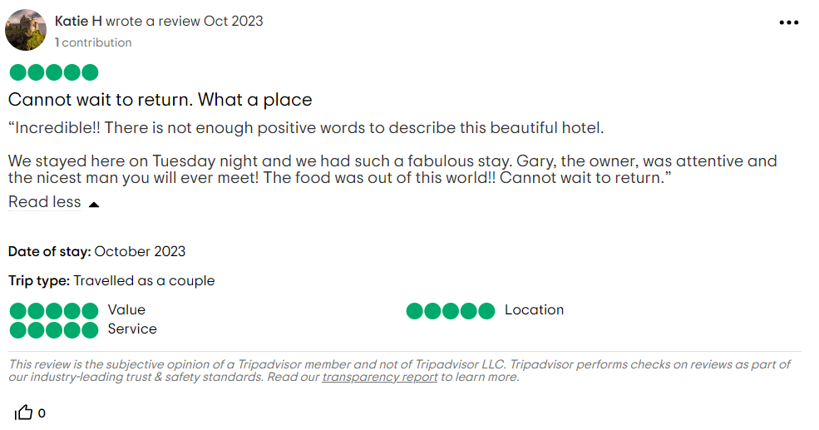
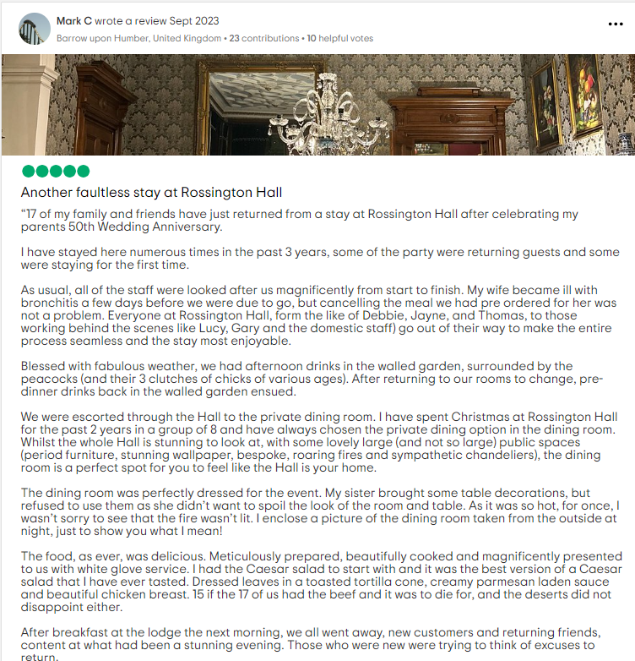
Letter of complaint response500 words +/- 10-%

“Skills required for Hotel personnel to provide better services”
Attentiveness skill is one of the major skills that is required to be developed by hotel personnel because it helps an individual to notice small things in the workplace to prevent any kind of mistakes and avoid any kind of dangerous situation (Carlisle et al., 2023). For example, as per the guest's complaint, it is found that the guest has been served with cold breakfast. In such a situation, if an individual has good attentiveness skills then it would have been noticed and provided the guest with a better breakfast. This could have increased the brand's reputation. Staff in the hotel business should always be aware of such kinds of things so that they can provide their guest with a better guest experience.
Self-awareness skill emotional intelligence is one of the important skills that hotel personnel should develop because they help in tuning in their feelings, actions and thoughts (Stoyanova-Bozhkovaet al., 2022). It is important because it helps in providing customers with better customer service. If an individual has good emotional intelligence then they will be able to control their emotion and also understand other people's emotions. For example, in case if a guest neighbour is loud then the staff can go there and communicate with them properly and try to convince them to do something to reduce the noise. Such kind of skills also helps in dealing with any kind of client properly and turns the rude or unhappy customer into a potential or loyal customer.
Problem-solving skills are also important skill because they help in understanding the problem from different perspectives (Ampountolaset al., 2019). Such kinds of skills will help in understanding the problem guests are having and creating proper action to resolve the problem they are facing. Further, these skills also help in showing the range of competency, such as creativity, logic, resiliency, determination and lateral thinning. For example, as per the complaint to the customer regarding the noise, in such a situation, the hotel staff could have used this skill to solve the problems effectively and satisfy both the guest's needs. Staff could have shifted either of the guests to a room with no noise.
Teamwork and collaboration skill is also one of the important skills that is required in the hotel industry. Such kind of skills help to perform collaboratively and meet the team objectives proficiently (Chandrashekar and Mohan, 2019). An individual with good teamwork skills shares their knowledge and skills which helps other members of the team to perform effectively. Therefore, it also helps in assigning different roles and responsibilities to the people in a team. For example, as per the complaint of the guest, it has been found that the bathroom was not clean. In such a situation, the staff could have collaboratively performed with the housekeeping staff to maintain cleanliness. The housekeeping team could have done their respective duties of cleaning and managing the room properly.

Conclusion
The above report has provided information regarding the hotel personnel's attitudes towards the guests. Further, the report has also analysed the company and demonstrated some skills which hotel personnel should develop. Emotional intelligence is one of the skills which is productive because it helps an individual staff to deal with the customer.

References
Ampountolas, A., Shaw, G. and James, S., (2019). Active learning to improve self-confidence and decision-making skills through the use of hotel simulation. Journal of Hospitality & Tourism Education, 31(3), pp.125-138.
Carlisle, S., Ivanov, S. and Dijkmans, C., (2023). The digital skills divide: evidence from the European tourism industry. Journal of Tourism Futures, 9(2), pp.240-266.
Chandrashekar, A. and Mohan, J., (2019). Preparing for the National Health Service: the importance of teamwork training in the United Kingdom medical school curriculum. Advances in medical education and practice, pp.679-688.
Mark (2023). Luxury Wedding Venue, Dining & Accommodation Doncaster, Rossington Hall. Available at: https://rossingtonhall.co.uk/ (Accessed: 10 November 2023).
Stoyanova-Bozhkova, S., Paskova, T. and Buhalis, D., (2022). Emotional intelligence: a competitive advantage for tourism and hospitality managers. Tourism Recreation Research, 47(4), pp.359-371.
Tripadvisor, T., (2023). ROSSINGTON HALL - Hotel Reviews, Photos, Rate Comparison (no date) Tripadvisor. Available at: https://www.tripadvisor.UK/Hotel_Review-g4597293-d4593802-Reviews-Rossington_Hall-Rossington_Doncaster_South_Yorkshire_England.html (Accessed: 10 November 2023).

Component Three:
Contribution to Overall Module Assessment: 50%(1000 words +/- 10%)
Writing in essay format

Element 1 – Pre-Arrival

Introduction
The Guest cycle refers to four distinct stages through which each guest passes (Hmhub, 2023). Different elements are required for better performance in the guest cycle. The following study will discuss about different elements and their importance in different stages of the guest cycle.

Element 1: Pre-arrival
Pre-arrival is the first stage where the guest makes their choices based on different factors (Hmhub, 2023). In this stage, the “Property Management system” plays a crucial role because it helps in providing better or all the required information to the consumer, which encourages them to take part in the decision making on guest while making the decision. When there is roper PMS it helps the customer to proper information regarding the services provided, and the room available, settle an invoice and stay up-to-date with the hotel. A hotel needs to provide all the required information because it helps in providing all the required information to the customer and encourages them to do business with the brand. Further, it also helps in ensuring that customers can input all the required information that is required by the hotel to provide good services to guests arriving at a hotel at a pre-arrival stage. For example, Premier Inn is a hotel brand that has good PMS. They use the “cloud-based” “Central Reservation System” (CRS) and “Property Management System” PWS to provide a real-time view of the whole business (Oppegaard, 2019). Therefore, it also helps in managing the booking, room, inventory, guest data guest communication and various other things

Element 2 – Arrival

Element 2: Arrival
Arrival is another stage in the guest cycle which deals with room assignment and registration process (Hmhub, 2023). Once the guests arrive at the hotel they develop a relationship through the front office. In such a situation, the hotel's reputation plays a crucial role in this stage of arrival. When the hotel has a good reputation it helps in attracting guests to the organisation it helps in the pre-arrival of guests. Therefore, it also helps in the arrival stage where there is face-to-face interaction with the hotel staff. For example, the smooth check-in system of an organisation. Premier Inn is recognised for having a good check-in system; they use the “check-in Kishoks” to speed up the arrival process (Premierinn, 2023). It shows that when a brand has a proper reputation then it helps in attracting potential guests to business. When the organisation has a good reputation then it also helps in increasing the confidence and trust level of customers towards the hotel organisation. When the guest visits the hotel they get the first impression. In such situations, reputable organisations ensure that guests are welcomed properly.

Element 3 –Duration of stay

Element 3: Duration of stay (Occupancy)
Duration of stay which is also known as occupancy is another stage of the guest cycle (Hmhub, 2023). People at this stage experience different things and facilities that are provided by the hotel and its staff. In this stage, the communication element plays a major role in providing a better guest experience during their stay in the organisation. Communication plays a major role in managing this cycle because communication is an activity of sharing information (Xu et al., 2020). The hotel industry needs to provide all information to the customer during the pre-arrival stage. When there is proper communication then it helps to resolve the queries of guest and understand their requirement. Furthermore, communication also helps in improving the coordination among the staff in the organisation and providing better services during their stay in the hotel. When the staff working together share information properly then they can execute the ideas in a much more effective manner. Communication also helps in developing an effective and fostering a good relationship among the staff in the hotel. Further, It also helps in developing proper rapport with the guest and creates a positive overall guest experience. The hotel industry should develop or focus more on the communication system of the organisation. For example, Marriott Hotel is one of the leading hotels in the UK that has a good communication system, which helps in providing good services. “Safer Integrated System” (SIS) is been used which has the lightest and thinnest digital portable radio system which helps in the coordination of employees together (Kolobkova et al., 2021).

Element 4 –Departure

Element 4 Departure
Departure is the last stage of a guest cycle, at this stage, the guest leaves the organisation (Hmhub, 2023). At this stage, the guest vacates the hotel rooms, receives all the settled statements accounts and returns the room keys. In such a situation, the staffing element plays a major role in providing guests with hassle-free checkout and providing services to new guests. Staffing plays a major role because it helps guide the guests while checking out and also encourages them to repetitive visits to the hotel (Dashper, 2020). They need to be skilful employees who will be convincing the customer to do business at the pre-arrival stage. Therefore, there is a need to be skilful employees at the front desk, so that guests get a good impression during their pre-arrival stage. Once the guest checks out of the hotel the front office employees update the availability of the room to the new consumer on the pre-arrival stage (Tewan, 2009). The housekeeping department is then provided with the information regarding the departure of guest and perform their respective duties. In such a situation, proper staffing helps in managing the room and other services equally. For example, Premier Inn provided online job training to their staff, such as “Duvet changing techniques”. There needs to be a proper checkout system so that guests can easily check out from the hotel. Hotels at this stage should have the right staff and show a thankful gesture which helps in improving the customer experience.

Conclusion
The above report has provided information regarding different elements which are required for providing a better guest experience. The hotel personnel should be aware of such elements to perform effectively during the guest cycle. Organisations should have a proper property management system to ensure that the guests are provided with all required information. Therefore, hotel organisations also should focus on their reputation. Communication is one of the important skills that need to be developed because it helps in collaborative performance and provides better services to guests.

References

References
Dashper, K., (2020). Mentoring for gender equality: Supporting female leaders in the hospitality industry. International Journal of Hospitality Management, 88, p.102397.
Hmhub, H., (2023). Introduction to guest cycle (2023) hmhub. Available at: https://hmhub.in/introduction-to-guest-cycle/ (Accessed: 8 November 2023).
Kolobkova, V.A., Romanov, A.A. and Frolova, E.A., (2021). Digital technologies in the hotel industry: new prospects for sustainable development. Socio-economic Systems: Paradigms for the Future, pp.387-394.
Oppegaard, E. (2019). Premier Inn Upgrades Software to Amadeus Hospitality Technology, Amadeus Hospitality. Available at: https://www.amadeus-hospitality.com/insight/premier-inn-upgrades-amadeus-hospitality-technology/ (Accessed: 30 October 2023).
Premierinn, P., (2023). Speedy check (no date) in. Available at: https://www.premierinn.com/gb/en/faq/speedy-check-in.html (Accessed: 30 October 2023).
Tewan, J. (2009) Hotel Front Office: Operations and Management, Oxford Higher Education Press
Xu, S., Stienmetz, J. and Ashton, M., (2020). How will service robots redefine leadership in hotel management? A Delphi approach. International Journal of Contemporary Hospitality Management, 32(6), pp.2217-2237.

