ACMA4003
Level 4 Advanced Manufacturing Operations
Quality & Business Improvement

Replacement of B7 reheater desuperheater spray water flow control valve (FCV)
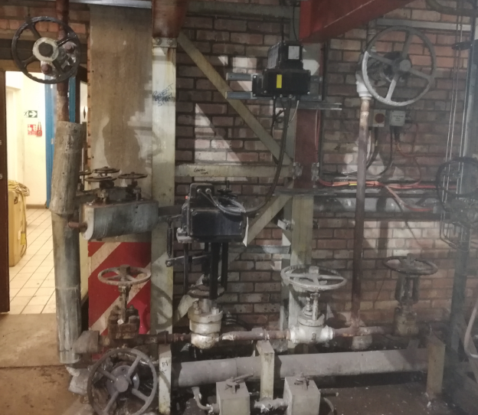


Darryl Thomas

2014853

Lecturer: R Morgan

Contents
1. Introduction / Process 3
1.1 overveiew Diagram 3
2. Problem identification/ Problem Statement 4
3. Effect on process 6
4. Data Collection 6
5. Data Analysis 6
6. Root cause analysis 11
6.1 5 Whys? 11
6.2 Fishbone diagram 12
6.3 Flow Chart 13
6.4 Valve failure 14
7. Action plan 15
8. Risk Management considerations 16
8.1 Risk Assessment 16
9. Summary 17
10. Appendix 18
11. Background Reading – bibalography 23
12. References 23

Introduction / Process

No7 EHP boiler at Margam C was manufactured by NEI International Combustion Ltd and has been in service since the early 1980’s. It is a natural circulation boiler, with a MCR capacity of 44.1Kgs of steam at 127bar and 538°C. This steam supplies No7 turbine alternator and exhausts at 44bar where the re-heater de-superheater spray reduces the temperature ready for the steam to pass back through a re-heater section of the boiler. After this reheater section the steam exits the boiler and enters 44bar main range at 44bar and the temperature should be 438°C. This in turn feeds the blowers at Margam B and the turbines at Margam A as well as some smaller auxiliaries.
Water for the boiler is taken from Margam C demineralisation (demin) plant, which in turn gets its water from The Afan and Frwydd rivers as well as domestic water. The water is treated to remove all impurities and oxygen to prevent damage and inefficiency in the boiler. After the water leaves the demin plant and enters the boiler there is still vigorous testing done to the water periodically. This is done to “Increase boiler efficiency and reliability through deposition and corrosion control” Suez Water Technologies
It is important that the feed water is of the correct standard. Through the process as it is going through the different stages of super heating this can ultimately leave residue on the tubes inside the boiler causing failures. After the steam leaves the boiler in to the 127Bar and 44Bar system it can cause issues on the turbines. “Impurities in the steam may cause deposits, scale and corrosion in steam turbines that adversely affect their operation”. (Amin Almasi 2016)
The fuels used in the boiler are Blast Furnace Gas (BFG), Coke Oven Gas (COG), Natural Gas (NG) and Heavy Fuel Oil (HFO). BFG and COG are indigenous by-products of steel and coke making facilities on site, so are much more cost effective to use where possible. NG and HFO are used to supplement BFG and COG if required. Basic Oxygen Steelmaking (BOS) Gas is another of the by-products of the site that is used but only for enrichment.

1.1 overveiew Diagram
FIG. 1 . Layout of boiler water system (NEI 1983)
FIG. 2 Layout of boiler steam system (NEI 1983)

Problem identification/ Problem Statement

The current average steam outlet temperature for number 7 boiler is 420⁰C against a design temperature of 438⁰C. The current spray control valve seems to be unfit for purpose and has several faults or variations in operation which cause the system to deviate away from the required outlet temperature.
There are occasions where this temperature has gone as low as 404⁰C. This is a valuable loss of thermal energy output from the boiler which reduces the 44bar header temperature. There would be significant gains to be made in the efficiency if a new re-heater spray valve was to be installed. It is suspected that the main reasons for the fault of this valve is the type of valve, age of valve, current set up of system (such as manual isolation valve set up) FIG. 3, valve tuning as well as different issues which will be picked up in this report.
The Boiler works at various loads (steam Output) which are dependent of the fuels available and the demand on the Port Talbot site. Due to the 14 kg/s swing in demand of the boiler the manual isolation valves need to be used to alter the spray required. After these have been set up at a certain load it has then been left when the load drops back causing a loss in steam temperature.
FIG. 4(bellow) is a screen shot of the system and the operations page the operators use to complete operate the boiler. Highlighted are the areas of the boiler being focused on.

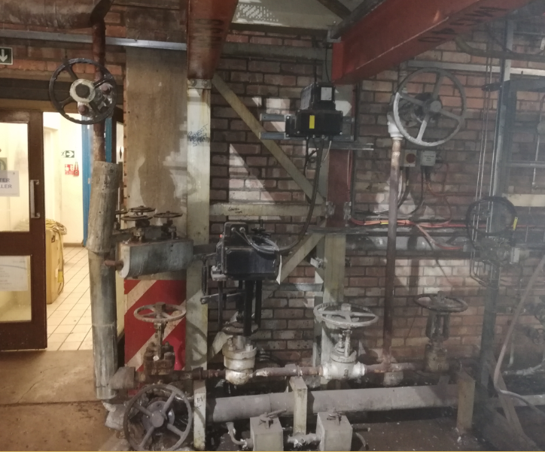
FIG. 3 Current set up of the Re-Heater De-supersheater system
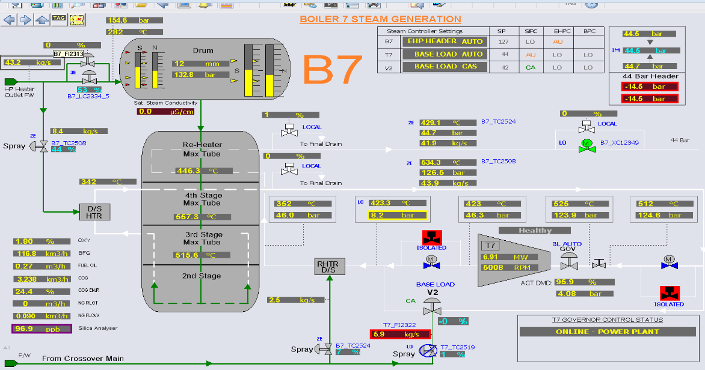
FIG. 4 Emerson Screen from the Delta V system used for control of the boiler manament system.

Effect on process

Due to the steam temperature being low coming from the re-heater, the Margam A, B and C 44 bar headers are working below the required standard and as a result this effects the efficiencies. If corrected significant savings can be achieved through steam outlet temperature increase. Having the extra thermal input into the 44 bar header would reflect in the steam inlet of the turbines thus there being increased power generation at no additional cost.
“Reducing steam inlet temperature reduces the enthalpy, which is a function of both the inlet temperature and pressure”(M.P. Boyce 2012) This means that you are required to produce a higher volume of steam to achieve the required load from your turbine, than you would with a higher steam temperature. The increase in volume of steam required to boost generation will incur the extra fuel costs to produce.

Data Collection

The Delta V system used on the boiler has a historian function allowing graphs and data to be extracted from the system. Data was taken from a 12 hour period, where 2 trials took place to identify how the control valve was performing and how the movement of the manual isolation valves were effecting the process. Table 1. This 12 hour period was used to show the trial taking place. This is where the boiler loads, fuels and valves were adjusted to identify the issues and simulate what the failings are over a longer period of time.
Trials like this are used regularly to prove or disprove issues and/or to test capabilities after an outage or maintenance procedure has taken place, providing invaluable data and information. “A performance test can help maximise plant efficiency, reduce plant emissions, and minimise operating costs by identifying any shortfalls in the efficiency and capacity of the plant and providing recommendations for recovery and performance improvement.”(tuvsud2020)
Data was also collected to identify the control standards of the steam for each turbine. This enables the set point to be increased to improve efficiencies whilst not over heating the steam. Table 2 This will also identify how far away from the set point the turbines are running, proving that the steam is not at the design temperature of the turbine loosing valuable Megawatts in generation.
Data was then collected to identify the effects of the steam increase on 7 Boiler and what effects it has on the steam turbine inlet temperatures of all the other turbines. With the increase in steam there is the potential for the turbines to reach the control standards and increase the efficiency. Table 3

Data Analysis
Whilst performing the testing of the system and the collection of the data it was clear to see that the valve has points where it sticks failing to control the temperature.

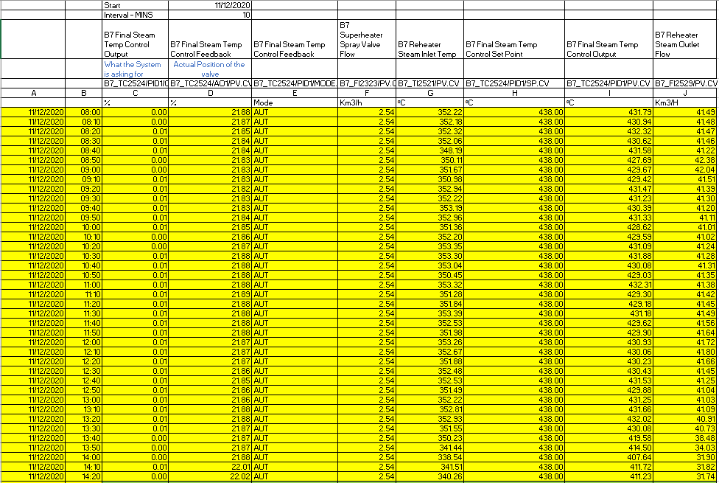

Whilst the valve is asking to close to 0% (column C) from the control system the feedback is indicating that the valve is over 21% open (column D) . With this sticking point, the manual isolation valve will then be adjusted by the operator (see Fig. 2) so that they keep the steam within a band of temperature. With a constant re-heater de-superheater spray flow of 2.54 km3/H (Column F) there is no control at any boiler loading. Throughout this period before the trial started the boiler did not reach the desired set point for an extended period of time meaning that there was a significant period where plant performance could have been improved.
Between 08:00 and 13:00 the boiler load is relatively stable with the steam temperature still low this indicates it was set up when the boiler was at its maximum continuous rating (MCR) 44.1 Kg/s. When the loading has decreased to 40-42kg/s from 44.1 kg/s the de-superheater valve cannot close past 21% and the temperature moved further away from the set point.
At 14:00 the boiler load has been reduced further to 32 Kg/s and the temperature has dropped to 411⁰C, an alarm will activate and the operator takes action with Manual intervention.
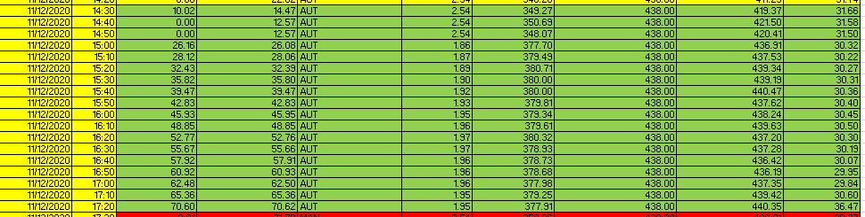

At 14:30 the control valve has been closed in FIG. 5 manually moving it away from the sticking point and the manual isolation Fig. 4 valve has been closed slightly to allow the valve to operate at a higher percentage. As can be indicated in the table the control valve has then started to operate through the various positions to allow the boiler to meet the required set point.
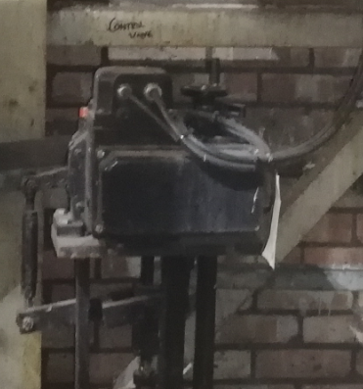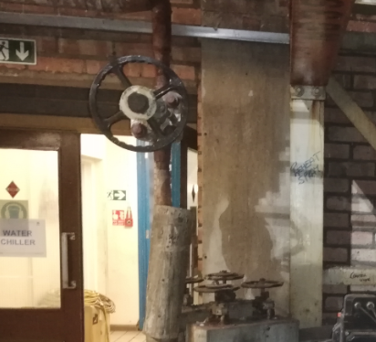
FIG. 5 The Re-Heater Control Valve
FIG. 6 Manual isolation valve

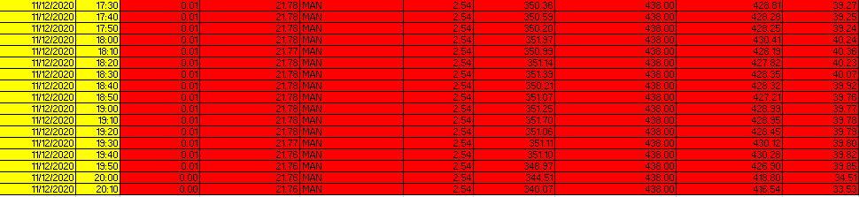
When the boiler is put back into its original position it reacts the same way. This indicates that there is a fundamental issue with the control valve. This also indicates that until the valve can be changed then there are operating parameters that can be observed to enable the set point to be achieved.
In the chart below it is clear to see that over the selected period of time that until manual intervention was taken the boiler was not reaching set point .

Manual intervention
The other aspect of the data looked at was the effects of a lower steam temperature coming from 7 boiler has on the turbines Table 3. When this is lower than set point there is a knock on effect to the possible efficiencies of the Power plant as a whole. The red line is 7 Boiler steam temp and there is an obvious increase in steam temperature

When the steam temperature from 7 Boiler is increased then there is a clear and obvious correlation to the increase in turbine performance.

Current Scenario
TA7 exhaust steam temperature | 420 | °C
TA7 exhaust steam pressure | 44 | bar(g)
Steam enthalpy | 3,266.81 | kJ/kg
TA7 average steam load | 36 | kg/s
Proposed Scenario
TA7 exhaust steam temperature | 438 | °C
TA7 exhaust steam pressure | 44 | bar(g)
TA7 average steam load | 36 | kg/s
Steam enthalpy | 3,297.38 | kJ/kg
Increased energy output | 1.1006 | MWth
Efficiency of electrical gen.(overall)* | 27% | *
Increased electrical generation | 0.30 | MW
Achieved increase (heat losses etc.) | 0.178 | MW
Operating hours | 8000 | h/a
Electricity price 2019/2020 | 55 | £/MWh
Benefit of increased steam gen. | 78,454 | £/annum

With the increase in the temperature there is the potential to make an annual saving of £78,454. There is a percentage of energy gains to be seen with this small increase.

Root cause analysis

5 Whys?

 | Question | Answer
Why? 1 | Why is are we not Reaching the set point? | A number of factors can be involved in not reaching set point.
Why? 2 | Is the manual valve isolation valve in the wrong position? | This has been left in the same position from the last adjustment and has not been monitored by the operators. This is not the main control function. Boiler loads change regularly causing the Reheater spray to be adjusted constantly. When the load is hight the operators set up the valve to work. This is not adjusted when the load drops back.
Why? 3 | Is the control valve unsuitable/ failing? | Auto valve sticking at various points, Fails to drop below 21% causing excess spray cooling the steam.
Why? 4 | Is this the correct valve? | Valve is not fit for purpose it has failed many times looking at the maintenance records.
Why? 5 | What can be done to control the steam better in the long and short term | New design as well as new manifold of valves required so manual intervention is no longer required after set up. Alarm to be set to alert the operators. Maintenance team to seek new valve and funding.

Fishbone diagram
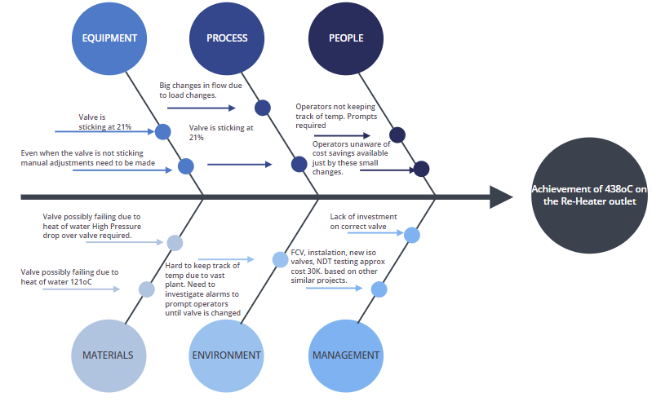

Flow Chart
This is flow chart that can be used by the operators in the short term to resolve the issues with the temperature. It depicts the process where, they currently have to open the manual isolation valves to adjust the temperature although there are other factors to consider. This will give the main checks they need to look at to enable them to reach the required set point. This flow chart allows them to check every time why the valve has stuck and address the issues.
Start
Document in shift report. Create a SAP notification
No
Wind valve manually away from sticking point and adjust Manual isolation valve so the valve is away from sticking point
yes
No
Is the control valve 100%
Is the reheater outlet temperature 438⁰C

yes
Does the valve output meet the input

Adjust manual isolation valve
If the Valve is replaced then this chart can change. With a new valve that opens and closes tight, and smoothly through its scale the manual isolation valves can be opened fully and left with the new control valve doing the designed job.
Is the valve controlling to the 438⁰C set point
yes
No
yes
No

End

Valve failure

The main reason behind the existing FCV not working is its actuator which is the rotary one on a linear valve Fig. 7 with a linkage system. This linkage increases the wearing off of the surfaces which results in the unbalanced valve and an increase in dead band within the control valve assembly. When looking at what valve to use on the system replacing the current set up. It is important to either go to rotary valve or a linear valve not a combination of the two.
Scott Telin 2015 explained “A rotary-motion valve usually weighs less and is smaller in size than a comparable linear valve. ... It should be noted that rotary valves are limited to certain pressure drops and are known to have cavitation and flashing problems. However, as technology continues to advance, these problems are becoming less common”
Through this research although the rotary valve has its benefits, replacing it with an actuator with no linkage, linear type valve will provide better control on low flow with high pressure drop across the valve that is required. Due to the varied amount of flows on the boiler as a result of boiler load changes the valve needs robust enough to cope with this variation. At the Power Plant there are other spray controllers Fig. 8 that are direct coupled liner valves that have been installed in the last few years. During this time there have been no reported issues with the valves.

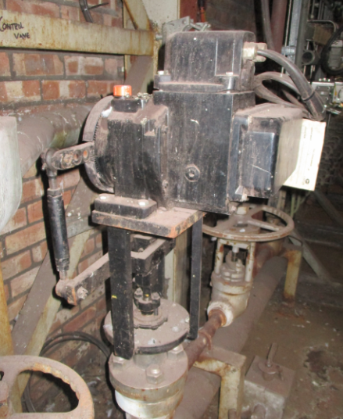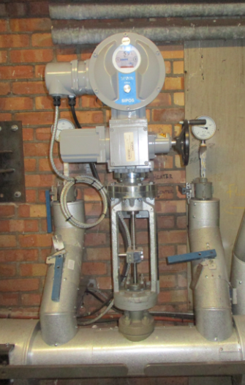
Fig. 8 Example of a control valve used on site to control the spray for one of the reducing stations
Fig. 7 Current valve shows this is a rotary actuator on a liner type valve where a linkage has been used to make the valve operate

Action plan

Action | Targets | Due date | Owner | Completed
Set low alarm to 425⁰C, This will allow the temperature to fluctuate without causing too many nuisance alarms. This alarm will alert the operator to adjust the manual valves as required | Short Term | December 2020 | PC&A
Roll out a Standard operating procedure to correspond to the operators the parameters they need to work to, also highlighting the potential savings by this small operation. | Short Term | December 2020 | Operations
Continue to monitor temperature on a weekly basis, Monitoring the valve condition until statutory outage is set to change manifold | Medium/ long Term | Until Valve is replaced | PC&A and operations
Set up spray valve at medium loading so there is ability to move up and down on the valve to try and keep the valve away from the identified sticking point. Mark the valves clearly for position. | Short Term | Jan 20201 | Operations
Identify suitable valve to use. Engineering department to approve. | Medium term | April 2021 | Mechanical Engineers
Acquire funds to put replace the whole manifold. This includes the whole manifold, FCV, and installation. Based on similar project approx.. 30K | Medium/long term | April 2021 | Engineering/ Management
Use findings from this project to use on other boilers and poor spray control. | Long term | August 2021 | Operations/ Engineering/ PC&A
After installation complete set up of control valve | Medium term | May 2021 | PC&A
Monitor performance of the new valve | Long term | August 2021 | Operations
Complete all new paperwork/ inspections after installation | Medium- long term | May-June 2021 | Engineering
Update training manuals after installation. | Medium/ long term | August 2021 | Operations

Risk Management considerations

8.1 Risk Assessment
Step1 | Step2 | Step3 | Step4
What are the potential hazards created by the change and how could they happen?  Consider Memory Jogger and Deviation Checklist! | What effect could this change have on people’s safety (S), environment (E) or process/asset (A)? | What control measures are already in place?  List what is already in place to reduce the likelihood of harm occurring should the change ‘fail’. i.e. what additional layers of protection can you rely on? | What further control measures are required (Task List)?  You need to ensure you have reduced the risks ‘so far as reasonably practicable’ by considering and implementing as many additional protection measures as is practical.
Leakage from the new FCV due to the bad welding. | (SAE) Integrity failure, which could result in water leak and ultimately lead to boiler shutdown | Approved contractor will carry out welding and shall adhere to requirements of NDT for welding work. | Ensure QA documentation is according to Tata standard (weld, material, maintenance strategy, etc).
Wrong specification of the FCV. | - Failure of valves would result in uncontrolled steam temp in 44 barg header. | Valves specification carried out according to the site valves and PSSR standards. | Manufacturer’s certification (valve flow characteristics) is required to confirm the suitability of FCV
New valves installed leading to confusion when isolation required due to new installation. | (A) Incorrect valve isolated when isolation required. | Works schematic drawings in place and valves would be installed at same places. | New valves once installed, operators need to be informed. New valves will also be numbered and labelled.
New FCV position (fully open or fully closed) in case of power failure. | (A) Inability to control spray water flow when required resulting in high/low 44 barg header temperature. | - Handwheel on new FCV to operate manually.  - There is a by-pass line which can be used for manual operation instead of auto mode. | Confirmation of “Fail in Position” from FCV supplier
Burning injury from the new pipework. | (S) Potential injury to the personnel due to hot surfaces. | Only trained and authorised personnel will operate the valves | Ensure the new pipework is insulated and cladded

Summary

In Summary there are obvious fundamental issue with the operation of this valve. Previous Changes on similar systems have cost around £30k for the full install and parts. This investment will not only allows a cost saving of approximately £78K per annum but it also eliminates the human factors relied on currently. The current valve is not fit for purpose due to the design. Feedback from the operations teams and personal experience is that it has not worked for a very long time (but due to the historian limits this cannot be demonstrated). If the funding can be secured it will allow a valuable cost saving which is very important in the current climate. There is very little scope for control with the current valve the manual operation needs to be relied on more frequently, which is easily missed. There are actions that can be performed for the short term to try and reach the set point, but a full new install is required to meet the required set point and make the money saving outlined.

Appendix

 | Start | 11/12/2020
 | Interval - MINS | 10
 | B7 Final Steam Temp Control Output | B7 Final steam Temp Control Feedback | B7 Final Steam Mode Temp Control feedback | B7 Superheater Spray Valve Flow | B7 Reheater Steam Inlet Temp | B7 Final Steam Temp Control Set Point | B7 Final Steam Temp Control Output | B7 Reheater Steam Outlet Flow
 | What the System is asking for | Actual Position of the valve
 | B7_TC2524/PID1/OUT.CV | B7_TC2524/AO1/PV.CV | B7_TC2524/PID1/MODE.  ACTUAL | B7_FI2323  /PV.CV | B7_TI2521/  PV.CV | B7_TC2524/  PID1/SP.CV | B7_TC2524/PID1/PV.CV | B7_FI2529/PV.CV
 | % | % | MODE | Km3/h | ⁰C | ⁰C | ⁰C | KM3/H
08:00 | 0.00 | 21.88 | AUT | 2.54 | 352.22 | 438.00 | 431.79 | 41.49
08:10 | 0.00 | 21.87 | AUT | 2.54 | 352.18 | 438.00 | 430.94 | 41.48
08:20 | 0.01 | 21.85 | AUT | 2.54 | 352.32 | 438.00 | 432.32 | 41.47
08:30 | 0.01 | 21.84 | AUT | 2.54 | 352.06 | 438.00 | 430.62 | 41.46
08:40 | 0.01 | 21.84 | AUT | 2.54 | 348.19 | 438.00 | 431.58 | 41.22
08:50 | 0.00 | 21.83 | AUT | 2.54 | 350.11 | 438.00 | 427.69 | 42.38
09:00 | 0.00 | 21.83 | AUT | 2.54 | 351.67 | 438.00 | 429.67 | 42.04
09:10 | 0.01 | 21.83 | AUT | 2.54 | 350.98 | 438.00 | 429.42 | 41.51
09:20 | 0.01 | 21.82 | AUT | 2.54 | 352.94 | 438.00 | 431.47 | 41.39
09:30 | 0.01 | 21.83 | AUT | 2.54 | 352.22 | 438.00 | 431.23 | 41.30
09:40 | 0.01 | 21.83 | AUT | 2.54 | 353.19 | 438.00 | 430.39 | 41.20
09:50 | 0.01 | 21.84 | AUT | 2.54 | 352.96 | 438.00 | 431.33 | 41.11
10:00 | 0.01 | 21.85 | AUT | 2.54 | 351.36 | 438.00 | 428.62 | 41.01
10:10 | 0.00 | 21.86 | AUT | 2.54 | 352.20 | 438.00 | 429.59 | 41.02
10:20 | 0.00 | 21.87 | AUT | 2.54 | 353.35 | 438.00 | 431.09 | 41.24
10:30 | 0.01 | 21.88 | AUT | 2.54 | 353.30 | 438.00 | 431.88 | 41.28
10:40 | 0.01 | 21.88 | AUT | 2.54 | 353.04 | 438.00 | 430.08 | 41.31
10:50 | 0.01 | 21.88 | AUT | 2.54 | 350.45 | 438.00 | 429.03 | 41.35
11:00 | 0.01 | 21.88 | AUT | 2.54 | 353.32 | 438.00 | 432.31 | 41.38
11:10 | 0.01 | 21.89 | AUT | 2.54 | 351.28 | 438.00 | 429.30 | 41.42
11:20 | 0.01 | 21.88 | AUT | 2.54 | 351.84 | 438.00 | 429.18 | 41.45
11:30 | 0.01 | 21.88 | AUT | 2.54 | 353.39 | 438.00 | 431.18 | 41.49
11:40 | 0.01 | 21.88 | AUT | 2.54 | 352.53 | 438.00 | 429.62 | 41.56
11:50 | 0.01 | 21.88 | AUT | 2.54 | 351.98 | 438.00 | 429.90 | 41.64
12:00 | 0.01 | 21.87 | AUT | 2.54 | 353.26 | 438.00 | 430.93 | 41.72
12:10 | 0.01 | 21.87 | AUT | 2.54 | 352.67 | 438.00 | 430.06 | 41.80
12:20 | 0.01 | 21.87 | AUT | 2.54 | 351.88 | 438.00 | 430.23 | 41.66
12:30 | 0.01 | 21.86 | AUT | 2.54 | 352.48 | 438.00 | 430.43 | 41.45
12:40 | 0.01 | 21.85 | AUT | 2.54 | 352.53 | 438.00 | 431.53 | 41.25
12:50 | 0.01 | 21.86 | AUT | 2.54 | 351.49 | 438.00 | 429.88 | 41.04
13:00 | 0.01 | 21.86 | AUT | 2.54 | 352.22 | 438.00 | 431.25 | 41.03
13:10 | 0.01 | 21.88 | AUT | 2.54 | 352.81 | 438.00 | 431.66 | 41.09
13:20 | 0.01 | 21.88 | AUT | 2.54 | 352.93 | 438.00 | 432.02 | 40.91
13:30 | 0.01 | 21.87 | AUT | 2.54 | 351.55 | 438.00 | 430.08 | 40.73
13:40 | 0.00 | 21.87 | AUT | 2.54 | 350.23 | 438.00 | 419.58 | 38.48
13:50 | 0.00 | 21.87 | AUT | 2.54 | 341.44 | 438.00 | 414.50 | 34.03
14:00 | 0.00 | 21.88 | AUT | 2.54 | 338.54 | 438.00 | 407.64 | 31.90
14:10 | 0.01 | 22.01 | AUT | 2.54 | 341.51 | 438.00 | 411.72 | 31.82
14:20 | 0.00 | 22.02 | AUT | 2.54 | 340.26 | 438.00 | 411.23 | 31.74
14:30 | 10.02 | 14.47 | AUT | 2.54 | 349.27 | 438.00 | 419.37 | 31.66
14:40 | 0.00 | 12.57 | AUT | 2.54 | 350.69 | 438.00 | 421.50 | 31.58
14:50 | 0.00 | 12.57 | AUT | 2.54 | 348.07 | 438.00 | 420.41 | 31.50
15:00 | 26.16 | 26.08 | AUT | 1.86 | 377.70 | 438.00 | 436.91 | 30.32
15:10 | 28.12 | 28.06 | AUT | 1.87 | 379.49 | 438.00 | 437.53 | 30.22
15:20 | 32.43 | 32.39 | AUT | 1.89 | 380.71 | 438.00 | 439.34 | 30.27
15:30 | 35.82 | 35.80 | AUT | 1.90 | 380.00 | 438.00 | 439.19 | 30.31
15:40 | 39.47 | 39.47 | AUT | 1.92 | 380.00 | 438.00 | 440.47 | 30.36
15:50 | 42.83 | 42.83 | AUT | 1.93 | 379.81 | 438.00 | 437.62 | 30.40
16:00 | 45.93 | 45.95 | AUT | 1.95 | 379.34 | 438.00 | 438.24 | 30.45
16:10 | 48.85 | 48.85 | AUT | 1.96 | 379.61 | 438.00 | 439.63 | 30.50
16:20 | 52.77 | 52.76 | AUT | 1.97 | 380.32 | 438.00 | 437.20 | 30.30
16:30 | 55.67 | 55.66 | AUT | 1.97 | 378.93 | 438.00 | 437.28 | 30.19
16:40 | 57.92 | 57.91 | AUT | 1.96 | 378.73 | 438.00 | 436.42 | 30.07
16:50 | 60.92 | 60.93 | AUT | 1.96 | 378.68 | 438.00 | 436.19 | 29.95
17:00 | 62.48 | 62.50 | AUT | 1.96 | 377.98 | 438.00 | 437.35 | 29.84
17:10 | 65.36 | 65.36 | AUT | 1.95 | 379.25 | 438.00 | 439.42 | 30.60
17:20 | 70.60 | 70.62 | AUT | 1.95 | 377.91 | 438.00 | 440.35 | 36.47
17:30 | 0.01 | 21.78 | MAN | 2.54 | 350.36 | 438.00 | 428.81 | 39.27
17:40 | 0.01 | 21.78 | MAN | 2.54 | 350.59 | 438.00 | 428.28 | 39.25
17:50 | 0.01 | 21.78 | MAN | 2.54 | 350.20 | 438.00 | 428.25 | 39.24
18:00 | 0.01 | 21.78 | MAN | 2.54 | 351.97 | 438.00 | 430.41 | 40.24
18:10 | 0.01 | 21.77 | MAN | 2.54 | 350.99 | 438.00 | 428.19 | 40.36
18:20 | 0.01 | 21.78 | MAN | 2.54 | 351.14 | 438.00 | 427.82 | 40.23
18:30 | 0.01 | 21.78 | MAN | 2.54 | 351.39 | 438.00 | 428.35 | 40.07
18:40 | 0.01 | 21.78 | MAN | 2.54 | 350.21 | 438.00 | 428.32 | 39.92
18:50 | 0.01 | 21.78 | MAN | 2.54 | 351.07 | 438.00 | 427.21 | 39.76
19:00 | 0.01 | 21.78 | MAN | 2.54 | 351.25 | 438.00 | 428.99 | 39.77
19:10 | 0.01 | 21.78 | MAN | 2.54 | 351.70 | 438.00 | 428.95 | 39.78
19:20 | 0.01 | 21.78 | MAN | 2.54 | 351.06 | 438.00 | 428.45 | 39.79
19:30 | 0.01 | 21.77 | MAN | 2.54 | 351.11 | 438.00 | 430.12 | 39.80
19:40 | 0.01 | 21.76 | MAN | 2.54 | 351.10 | 438.00 | 430.28 | 39.82
19:50 | 0.01 | 21.76 | MAN | 2.54 | 348.97 | 438.00 | 426.90 | 39.85
20:00 | 0.00 | 21.76 | MAN | 2.54 | 344.51 | 438.00 | 418.80 | 34.51
20:10 | 0.00 | 21.76 | MAN | 2.54 | 340.07 | 438.00 | 416.54 | 33.53
Table 1

Asset | Design Pressure | Design Temperature
Boiler 3 | 44.8 bar (a) | 455°C
Boiler 5 | 43.4 bar(g) | 443°C
Boiler 6 / TA6 | 43.1 bar(g) | 538/438°C
Boiler 7 / TA7 | 43.1 bar(g) | 538/438°C
Mitchell Boiler | 44.8 bar(g) | 449 °C
TAB1 | na | na
TA2 | na | na
TA3 | na | na
TA4 (FY20/21) | 44 bar(g) | 430°C (Max)
 | 41.65 bar(g) (Min) | 417 °C (Normal)
TA8 | 43.09 bar(g) | 437 °C
TA9 | 43 bar(g) | 440 °C
TA10 | 43 bar(g) | 443 °C
TB3 | 44 bar(a) (Max) | 430°C (Max)
TB3 | 42 bar(a) (Normal) | 405°C (Normal)
TB3 | 40 bar(a) (Min) | 380°C (Min )
TB5 | 44 bar(a) (Max) | 430°C (Max)
TB5 | 42 bar(a) (Normal) | 405°C (Normal)
TB5 | 40 bar(a) (Min) | 380°C (Min )
HLP1 | 44.8 bar(g) (Max) | 454°C (Max)
HLP1 | 37.9 bar(g) (Normal) | 400°C (Normal)
HLP2 | 44.8 bar(g) (Max) | 454°C (Max)
HLP2 | 37.9 bar(g) (Normal) | 400°C (Normal)
B6 FWP | 43.1 bar(g) 41.4 bar(g) minimum | 438°C 427°C minimum
B7 FWP | 43.1 bar(g) 41.4 bar(g) minimum | 438°C 427°C minimum
PRSs | 51.2 bar(a) (Max), 43.1 bar(a) minimum | 449°C (Max) 438°C (min)
Table 2
 | 7 SP | 7 Boiler | 2TA | 3TA | 8 TA | 9 TA | 10 TA
9/17/2020 9:00:00 | 438.00 | 416.58 | 420.30 | 421.99 | 414.10 | 422.72 | 423.32
9/17/2020 10:00:00 | 438.00 | 424.88 | 421.76 | 422.56 | 413.87 | 422.96 | 422.89
9/17/2020 11:00:00 | 438.00 | 425.60 | 407.81 | 399.15 | 423.71 | 398.75 | 418.60
9/17/2020 12:00:00 | 438.00 | 426.02 | 408.56 | 402.11 | 413.83 | 402.15 | 414.79
9/17/2020 13:00:00 | 438.00 | 417.92 | 422.19 | 424.06 | 408.17 | 423.82 | 425.97
9/17/2020 14:00:00 | 438.00 | 428.89 | 419.55 | 417.03 | 422.40 | 418.11 | 422.55
9/17/2020 15:00:00 | 438.00 | 419.68 | 415.90 | 418.46 | 415.40 | 419.33 | 423.70
9/17/2020 16:00:00 | 438.00 | 419.22 | 416.17 | 416.20 | 416.39 | 416.53 | 422.06
9/17/2020 17:00:00 | 438.00 | 419.25 | 416.62 | 418.15 | 416.04 | 418.48 | 423.39
9/17/2020 18:00:00 | 438.00 | 435.03 | 423.65 | 414.27 | 421.20 | 414.41 | 420.69
9/17/2020 19:00:00 | 438.00 | 422.17 | 416.77 | 415.73 | 417.05 | 416.02 | 421.82
9/17/2020 20:00:00 | 438.00 | 420.06 | 416.81 | 415.64 | 415.86 | 416.02 | 422.79
9/17/2020 21:00:00 | 438.00 | 419.09 | 415.78 | 415.51 | 414.51 | 415.83 | 422.81
9/17/2020 22:00:00 | 438.00 | 409.66 | 411.77 | 416.43 | 409.76 | 416.61 | 422.26
9/17/2020 23:00:00 | 438.00 | 421.12 | 416.74 | 416.39 | 416.03 | 416.78 | 423.33
9/18/2020 0:00:00 | 438.00 | 418.29 | 423.27 | 427.02 | 417.72 | 428.80 | 425.71
9/18/2020 1:00:00 | 438.00 | 429.22 | 423.96 | 423.55 | 425.15 | 429.99 | 428.99
9/18/2020 2:00:00 | 438.00 | 420.38 | 415.23 | 417.47 | 418.80 | 430.67 | 428.90
9/18/2020 3:00:00 | 438.00 | 416.27 | 414.13 | 419.48 | 419.16 | 430.59 | 429.78
9/18/2020 4:00:00 | 438.00 | 417.35 | 414.08 | 428.60 | 418.08 | 430.15 | 427.31
9/18/2020 5:00:00 | 438.00 | 420.32 | 416.30 | 424.19 | 419.71 | 429.40 | 427.16
9/18/2020 6:00:00 | 438.00 | 418.46 | 420.49 | 428.20 | 420.24 | 429.58 | 426.89
9/18/2020 7:00:00 | 438.00 | 419.72 | 415.79 | 419.35 | 418.72 | 429.86 | 428.28
9/18/2020 8:00:00 | 438.00 | 411.59 | 408.76 | 423.00 | 413.20 | 428.67 | 427.70
9/18/2020 9:00:00 | 438.00 | 419.33 | 413.04 | 414.30 | 417.15 | 429.22 | 427.54
9/18/2020 10:00:00 | 438.00 | 421.80 | 419.06 | 420.54 | 420.51 | 430.39 | 428.15
9/18/2020 11:00:00 | 438.00 | 422.28 | 416.70 | 418.23 | 418.54 | 429.78 | 428.32
9/18/2020 12:00:00 | 438.00 | 440.22 | 435.15 | 430.69 | 433.32 | 431.25 | 427.96
9/18/2020 13:00:00 | 438.00 | 434.93 | 433.17 | 430.95 | 430.48 | 430.00 | 427.04
9/18/2020 14:00:00 | 438.00 | 437.12 | 433.71 | 431.52 | 430.78 | 428.36 | 426.31
9/18/2020 15:00:00 | 438.00 | 440.57 | 436.68 | 432.85 | 433.39 | 428.70 | 425.57
9/18/2020 16:00:00 | 438.00 | 446.38 | 442.43 | 433.37 | 438.26 | 428.44 | 425.57
9/18/2020 17:00:00 | 438.00 | 442.10 | 437.50 | 431.36 | 433.69 | 429.68 | 425.95
9/18/2020 18:00:00 | 438.00 | 437.08 | 433.84 | 429.23 | 431.88 | 429.99 | 427.30
9/18/2020 19:00:00 | 438.00 | 440.51 | 437.73 | 431.83 | 433.73 | 429.92 | 426.12
9/18/2020 20:00:00 | 438.00 | 436.57 | 432.58 | 430.33 | 429.75 | 429.77 | 426.49
9/18/2020 21:00:00 | 438.00 | 439.37 | 436.51 | 430.96 | 431.53 | 429.20 | 425.87
9/18/2020 22:00:00 | 438.00 | 443.09 | 438.56 | 432.62 | 433.58 | 428.40 | 426.84
9/18/2020 23:00:00 | 438.00 | 439.78 | 436.14 | 434.24 | 432.22 | 430.68 | 427.08
9/19/2020 0:00:00 | 438.00 | 439.75 | 438.12 | 437.07 | 433.86 | 430.33 | 426.83
9/19/2020 1:00:00 | 438.00 | 440.27 | 436.51 | 432.44 | 432.55 | 429.63 | 426.98
9/19/2020 2:00:00 | 438.00 | 439.95 | 436.50 | 431.94 | 433.05 | 429.17 | 426.20
9/19/2020 3:00:00 | 438.00 | 436.99 | 434.74 | 431.81 | 431.93 | 429.31 | 427.54
9/19/2020 4:00:00 | 438.00 | 439.02 | 436.22 | 431.41 | 432.96 | 428.96 | 426.41
9/19/2020 5:00:00 | 438.00 | 439.40 | 436.05 | 432.70 | 431.89 | 428.86 | 426.04
9/19/2020 6:00:00 | 438.00 | 441.60 | 439.04 | 437.86 | 433.57 | 428.73 | 427.31
9/19/2020 7:00:00 | 438.00 | 439.53 | 435.98 | 434.85 | 431.81 | 429.95 | 426.83
9/19/2020 8:00:00 | 438.00 | 437.84 | 435.88 | 434.24 | 432.39 | 429.54 | 426.21
9/19/2020 9:00:00 | 438.00 | 438.69 | 435.97 | 433.53 | 431.83 | 429.65 | 425.99
9/19/2020 10:00:00 | 438.00 | 443.25 | 441.08 | 440.81 | 436.11 | 429.96 | 427.18
Table 3

Process flow condition of water | Min |  |  | Norm | Max
Flowrate |  |  | 1.5 | 2.21 |  | 2.94 |  | M3/h
Flowrate |  |  | 29.48 | 30.45 |  | 40.50 |  | GPM
Inlet pressure |  |  | 154 | 154 |  | 154 |  | Bar g
Outlet pressure |  |  | 56 | 56 |  | 56 |  | Bar g
Pressure drop |  |  | 98 | 98 |  | 98 |  | Bar g
Temperature |  |  | 110 - 121 | 110-121 |  | 110-121 |  | °C
Pipe inlet diameter |  | 2.07 |  | 2.07 | 2.07 |  | Inch
Pipe Outlet diameter |  | 2.38 |  | 2.38 | 2.38 |  | Inch
Existing control valve size |  | 1.5 |  | 1.5 | 1.5 |  | Inch

Table 4

Background Reading – bibalography
De superheater spray https://www.spiraxsarco.com/learn-about-steam/desuperheating/basic-desuperheater-types
Possible valve to use https://trends.directindustry.com/sipos-aktorik/project-24372-126346.html
https://www.sipos.de/uploads/media/sp-imports/betriebsanleitungen/profitron-himod_-_2s_7/ba_7-profitron-himod-en.pdf
https://www.sipos.de/uploads/media/sp-imports/betriebsanleitungen/profitron-himod_-_2s7-kurzanleitung/kurzanleitung_profitron-himod-en.pdf
Flow Rate calculator https://www.tlv.com/global/UK/calculator/water-flow-rate-through-valve.html?advanced=on
https://checalc.com/calc/desuperheat.html
CV Ratings - https://www.fujikin.co.jp/en/support/calculator/
Valve requirements - https://www.teesing.com/en/page/library/tools/flow-and-cv-calculator
Thermodynamics- https://www.brighthubengineering.com/power-plants/38111-how-long-term-overheating-tube-failures-happen-in-boilers/
https://beta.spiraxsarco.com/learn-about-steam/steam-engineering-principles-and-heat-transfer/superheated-steam
https://www.sciencedirect.com/topics/engineering/economizer

12. References

Suez Water Technologies Internal Treatment Chemicals https://www.suezwatertechnologies.com/products/boiler-water/internal-boiler-chemicals 19/01/21 15:44
Amin Almasi Processing magazine (2016) Steam turbine flow & operation https://www.processingmagazine.com/home/article/15586711/steam-turbine-flow-operation 19/01/2021 20:06
NEI International Combustion Ltd (1983) Boilers 6&7 Instructional Manual Volume 1 Book 1.
NEI International Combustion Ltd (1983) Boilers 6&7 Instructional Manual Volume 1 Book 1.
M.P. Boyce (2012) Combined Cycle Systems for Near-Zero Emission Power Generation https://www.sciencedirect.com/topics/engineering/steam-inlet-temperature#:~:text=An%20increase%20of%20about%20100,for%20a%20back%20pressure%20turbine. 19/01/21 18:46
TUVSUD (2020) Performance testing and improvement for power plants https://www.tuvsud.com/en/industries/energy/conventional-power/performance-testing-for-power-plants 19/01/2021 19:07
Scott Telin (2015) What's the Difference Between Linear and Rotary in a Control Valve? https://blog.craneengineering.net/whats-the-difference-between-linear-and-rotary-in-a-control-valve 21/01/21 18:20

