  Understanding the importance of Stakeholder Engagement in successful commencement and completion of project.  Module Code: LCLM5001  Understanding and Engaging Stakeholders | Jahanur Rashid  Student No. 2419759  Lecturer: Aso Abdullah

Contents
Executive Summary 2
Introduction 2
Situational Analysis of the Company 3
SWOT Analysis 3
PESTLE Analysis 5
SMART Objectives for the Project 6
Identification of Key Stakeholders 6
Roles, Responsibilities, Benefits and Challenges of Stakeholders 8
Roles and Responsibilities 8
Benefits Stakeholders Bring 9
Challenges Stakeholders May Face 10
Stakeholder Engagement Frameworks and Models 10
Stakeholder Matrix (Power–Interest Grid) 10
RACI Matrix 11
Stakeholder Engagement Plan 12
Communication Plan 12
Stakeholder Engagement Process Using the 4C Model 13
Communication 13
Collaboration 14
Consultation 14
Commitment 15
Conflict Management Strategies 15
Leadership Role of the Project Manager 15
Impact of Stakeholder Engagement on Business Performance 16
Recommendations 18
Conclusion 19
Refrence: 21

Executive Summary
This report examines the importance of stakeholder engagement in the successful implementation of a new premium service called StaySmart+ at Hilton Hotels & Resorts. The purpose of the report is to analyse how effective stakeholder management can support the planning, development, and successful launch of this service within the global hospitality industry. StaySmart+ integrates artificial intelligence tools, personalised travel planning, and sustainability-focused services designed to improve customer experience and operational efficiency.
The report applies several strategic and stakeholder management tools to analyse the project environment. These include SWOT analysis, PESTLE analysis, the stakeholder matrix, the RACI matrix, stakeholder engagement planning, and the 4C engagement model. These frameworks help identify key stakeholders, evaluate their roles and responsibilities, and develop strategies for effective engagement throughout the project lifecycle.
The analysis shows that stakeholder engagement plays a critical role in ensuring project success, improving customer satisfaction, encouraging innovation, and strengthening organisational reputation and performance. The report also highlights several challenges, including technological complexity and resistance to change.
To address these issues, key recommendations include improving digital communication systems, providing stakeholder training programmes, organising regular stakeholder meetings, developing customer feedback platforms, and strengthening sustainability engagement strategies. These actions can help Hilton successfully implement the StaySmart+ service and maintain long-term stakeholder relationships.

Introduction
Hilton Hotels & Resorts is one of the world’s leading international hospitality companies. The organisation operates more than 7,000 hotels across over 120 countries and territories, providing accommodation, tourism services, and premium hospitality experiences to millions of customers globally (Hilton, 2024). The company focuses strongly on innovation, digital transformation, and sustainable tourism practices in order to maintain its competitive advantage in the global hospitality market.
The hospitality industry has experienced significant changes in recent years due to rapid technological development, changing customer expectations, and growing sustainability concerns. Modern travellers increasingly expect personalised services, digital convenience, and environmentally responsible hospitality experiences during their stay (Sigala, 2019). To respond to these changes, Hilton plans to introduce a new premium customer experience platform called StaySmart+.
StaySmart+ is a digital hospitality service designed to enhance the overall guest experience through artificial intelligence-driven guest interaction tools, personalised travel planning support, and sustainability-focused amenities. The project aims to improve customer satisfaction, operational efficiency, and brand differentiation across international markets (Ivanov and Webster, 2020; Buhalis and Leung, 2021; OECD, 2021).
However, the success of this initiative depends greatly on effective stakeholder engagement. Stakeholders such as employees, management, customers, suppliers, and technology partners play an important role in supporting project development and implementation (Freeman et al., 2018). Therefore, this report examines the importance of stakeholder engagement in successfully implementing the StaySmart+ service.

Situational Analysis of the Company
A situational analysis helps organisations understand their internal capabilities and the external environment before implementing a new project. Strategic tools such as SWOT and PESTLE analysis are widely used in management to evaluate business conditions and support effective decision-making (Johnson, Whittington and Scholes, 2020). For Hilton Hotels & Resorts, these tools help assess the organisation’s readiness to implement the StaySmart+ service across international markets.

SWOT Analysis
A SWOT analysis was conducted to identify the internal strengths and weaknesses of Hilton, as well as the external opportunities and threats related to the launch of the StaySmart+ service.
Table 1: SWOT Analysis of Hilton for the StaySmart+ Service
Strengths | Weaknesses | Opportunities | Threats
Strong global brand reputation | High cost of AI technology implementation | Growing demand for smart hospitality services | Strong competition from Marriott and Hyatt
Hotels in more than 120 countries | Need for staff training | Increasing interest in personalised travel experiences | Economic uncertainty affecting tourism
Experience in digital innovation and hospitality management | Possible short-term operational disruption | Digital transformation in hospitality | Travel regulations and global crises
Strong loyalty programme and financial resources | Integration of new systems may be complex | Opportunity to attract tech-oriented travellers | Industry sensitivity to global events

Strengths
Hilton has a strong global brand reputation and operates thousands of hotels across more than 120 countries. The company has extensive experience in hospitality management, digital innovation, and customer service excellence. Its established loyalty programme and strong financial resources provide a solid foundation for launching innovative services such as StaySmart+ (Hilton, 2024).
Weaknesses
Despite its strengths, Hilton faces certain internal limitations. Implementing advanced technologies such as artificial intelligence requires high investment in infrastructure, training, and system integration. Employees may also require additional training to effectively deliver the new digital service, which could temporarily affect operational efficiency (Bulchand-Gidumal, 2024; Cozzio et al., 2025; Malone, 2024).
Opportunities
There is increasing global demand for smart hospitality services and personalised travel experiences. Digital transformation and sustainable tourism practices provide opportunities for Hilton to strengthen its competitive advantage. The StaySmart+ service can enhance customer satisfaction and attract technology-oriented travellers (Sigala, 2019).
Threats
The hospitality industry is highly competitive, with major companies such as Marriott and Hyatt also investing in digital innovation. Economic uncertainty, changes in travel regulations, and global crises can also affect tourism demand and hotel performance (Demir and Demir, 2025; El-Said, 2024). Recent research shows that hotels are increasingly using digital technologies and innovation to stay competitive and improve their services for customers (Demir and Demir, 2025). However, the hospitality sector is still very sensitive to global events such as pandemics, economic instability, and political conflicts, which can reduce international travel and lead to lower hotel bookings (El-Said, 2024).

PESTLE Analysis
Political factors
Government tourism policies and international travel regulations influence hospitality operations. Political stability in key markets is important for maintaining tourism growth.
Economic factors
Economic conditions affect customer spending on travel and accommodation. Global economic fluctuations may influence hotel occupancy rates and profitability.
Social factors
Modern travellers prefer personalised experiences, digital convenience, and environmentally responsible services.
Technological factors
Advances in artificial intelligence, mobile applications, and smart hotel technologies create opportunities for innovation in hospitality services.
Legal factors
Hotels must comply with legal requirements such as data protection regulations, employment laws, and health and safety standards.
Environmental factors
Sustainability and eco-friendly practices are increasingly important in hospitality management and influence customer preferences.

SMART Objectives for the Project
The StaySmart+ project will follow SMART objectives to ensure successful implementation (Doran, 1981). The project aims to introduce AI-driven guest services in selected Hilton hotels within six months. It seeks to increase guest satisfaction scores by 15%, improve operational efficiency through digital technologies, and enhance Hilton’s competitive position in the global hospitality industry.

Identification of Key Stakeholders
Stakeholders are individuals or groups that can influence or are influenced by the activities and outcomes of a project. Identifying stakeholders is an important step in project management because their support and cooperation contribute significantly to project success (Freeman et al., 2018). In the case of Hilton Hotels & Resorts, the successful implementation of the StaySmart+ service requires the involvement of both internal and external stakeholders.
Internal Stakeholders
Senior Management
Senior management plays a critical role in strategic decision-making and resource allocation. They approve the project, provide financial support, and ensure that the StaySmart+ service aligns with Hilton’s long-term business strategy. Their leadership and commitment help guide the overall direction of the project and ensure that resources are available for successful implementation (Johnson, Whittington and Scholes, 2020).
Project Manager
The project manager is responsible for planning, coordinating, and monitoring the project. This role includes managing timelines, allocating resources, and maintaining communication with different stakeholders. The project manager also ensures that project goals are achieved while maintaining stakeholder engagement throughout the project lifecycle.
IT Department
The IT department develops and maintains the technological infrastructure required for the StaySmart+ service. Their responsibilities include implementing artificial intelligence tools, managing digital systems, and ensuring data security. Their technical expertise is essential for ensuring that the system operates efficiently and supports the overall digital service experience.
Marketing Team
The marketing team promotes the StaySmart+ service and communicates its benefits to customers. They design advertising campaigns, manage social media communication, and create promotional strategies to attract potential guests and increase service awareness.
Hotel Employees
Hotel employees, particularly front-line staff such as receptionists and service staff, interact directly with guests. Their role is important because they deliver the service experience and assist customers in using the new digital tools. Employee engagement and proper training are therefore essential for successful service delivery.
External Stakeholders
Customers
Customers are the main users of the StaySmart+ service. Their satisfaction, feedback, and expectations strongly influence the success of the project and help improve guest experiences (Sigala, 2019).
Technology Suppliers
Technology suppliers provide the digital platforms, artificial intelligence systems, and technical support required for the service.
Travel Agencies
Travel agencies promote hotel services to wider markets and help increase bookings and market visibility.
Government and Regulators
Government authorities regulate tourism activities, data protection, and environmental standards to ensure legal compliance.
Local Communities
Local communities benefit from tourism development through employment opportunities and economic growth.

Roles, Responsibilities, Benefits and Challenges of Stakeholders
Stakeholders play an essential role in the successful implementation of organisational projects. In the hospitality industry, the involvement of different stakeholders helps organisations plan, develop, and deliver innovative services effectively. For the implementation of the StaySmart+ service at Hilton Hotels & Resorts, each stakeholder group has specific roles and responsibilities that contribute to project success. Effective collaboration among these stakeholders helps improve decision-making, innovation, and service delivery (Freeman et al., 2018)

Roles and Responsibilities
Senior management is responsible for providing strategic direction and approving the project. Their role includes allocating financial resources, supporting organisational change, and ensuring that the StaySmart+ service aligns with the company’s long-term strategic objectives. Leadership from senior management is important because it ensures that the project receives sufficient organisational support (Johnson, Whittington and Scholes, 2020).
The project manager has the responsibility of coordinating the entire project. This includes planning project activities, managing resources, monitoring progress, and communicating with stakeholders. The project manager ensures that the project remains on schedule and that stakeholder expectations are managed effectively (Kerzner, 2022; Project Management Institute, 2021).
The IT department plays a key role in developing and implementing the technological systems required for the StaySmart+ service. Their responsibilities include installing artificial intelligence tools, maintaining digital platforms, and ensuring data security and system reliability (Laudon and Laudon, 2022; Mariani and Baggio, 2021).
The marketing team is responsible for promoting the new service and communicating its benefits to customers. Their activities include designing advertising campaigns, managing social media communication, and creating promotional strategies that attract potential guests (Kotler, Keller and Chernev, 2022; Chaffey and Ellis-Chadwick, 2022).
Hotel employees also have an important role because they interact directly with customers. Front-line staff assist guests in using digital services, provide support during their stay, and ensure that the overall customer experience remains positive (Baum, 2020; Kandampully, Zhang and Bilgihan, 2021).
External stakeholders also contribute to the project. Technology suppliers provide advanced software and technical expertise required for implementing AI-based services. Travel agencies promote the hotel services to customers, while government regulators ensure that the organisation complies with legal and industry regulations. Customers themselves play an important role by providing feedback and insights that help improve service quality (Sigala, 2019).

Benefits Stakeholders Bring
Stakeholders contribute various benefits to the project. Their expertise and knowledge help organisations develop innovative services and improve operational efficiency. Technology suppliers provide technical skills and innovation, while employees contribute practical experience in customer service. Customers provide valuable insights into their preferences and expectations, helping the organisation design services that better meet market demand. Additionally, stakeholders provide resources such as financial support, technical systems, and market networks that support project implementation.

Challenges Stakeholders May Face
Despite these benefits, stakeholders may also face challenges during the project. One common challenge is resistance to change, especially among employees who may feel uncertain about new technologies or changes in work processes. Technological complexity can also create difficulties in implementing AI-based systems and integrating them into existing operations.
Cultural differences in international markets may create communication challenges between global teams and external partners. Furthermore, communication barriers among stakeholders may lead to misunderstandings or delays in decision-making. Therefore, effective stakeholder engagement strategies are necessary to manage these challenges and ensure successful project implementation.

Stakeholder Engagement Frameworks and Models
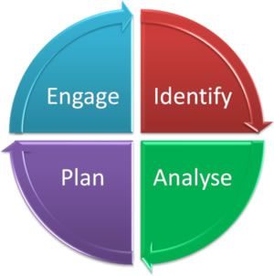
Stakeholder engagement frameworks help organisations manage relationships with individuals and groups who influence project outcomes. In complex projects such as the introduction of the StaySmart+ service at Hilton Hotels & Resorts, structured stakeholder management tools are necessary to ensure effective communication, coordination, and decision-making. Using recognised frameworks enables project managers to identify stakeholder influence, allocate responsibilities, and maintain collaboration throughout the project lifecycle (Bourne, 2020).
Figure 1: Stakeholder Engagement Cycle (Identify–Analyse–Plan–Engage) (adapted from Bourne, 2020).

Stakeholder Matrix (Power–Interest Grid)
The stakeholder matrix, also known as the power–interest grid, is a widely used tool for analysing stakeholder influence and involvement in a project. The framework categorises stakeholders based on their level of power (their ability to influence the project) and their level of interest (their concern about project outcomes) (Freeman et al., 2018)
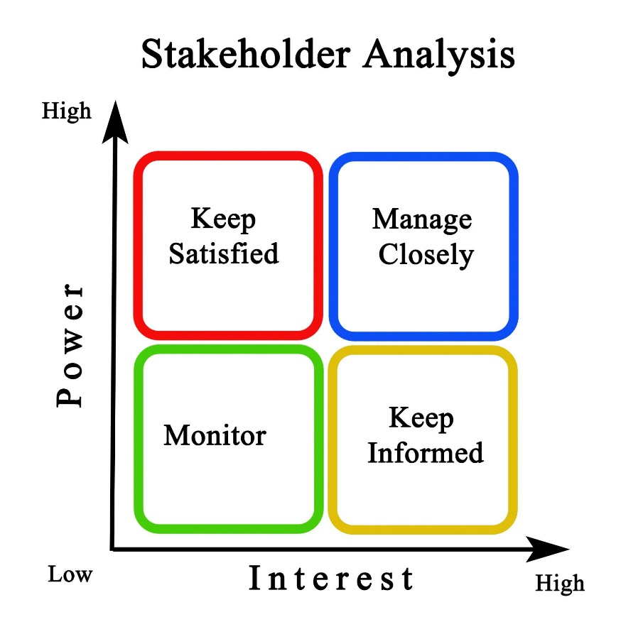
Stakeholders with high power and high interest, such as senior management and project leaders, should be closely managed because they have strong influence over project decisions. Stakeholders with high power but lower interest, such as regulators, should be kept satisfied through regular updates. Those with high interest but lower power, such as employees and customers, should be kept informed and involved in discussions. Stakeholders with low power and low interest, such as some external community members, require minimal monitoring. Using this matrix allows the project manager to prioritise engagement activities and allocate resources effectively (Mendelow, 1991).
Figure 1: Stakeholder Power–Interest Matrix (Mendelow, 1991)

RACI Matrix
The RACI matrix is a project management framework used to define stakeholder responsibilities for specific tasks. It helps clarify roles and reduce confusion during project implementation (Kerzner, 2022).
- Responsible refers to the individuals who perform the work required to complete a task. For example, the IT department may be responsible for implementing the AI technology for StaySmart+.
- Accountable refers to the person who has final authority and responsibility for the task. In this project, the project manager or senior management may be accountable for major project outcomes.
- Consulted stakeholders provide advice and expertise during decision-making. Technology suppliers and marketing specialists may be consulted during the development of the service.
- Informed stakeholders receive updates on project progress but are not directly involved in decision-making, such as travel agencies or some organisational departments.
Using a RACI matrix ensures that responsibilities are clearly defined and improves coordination between stakeholders.

Stakeholder Engagement Plan
A stakeholder engagement plan outlines how stakeholders will be involved throughout the project. The plan identifies key stakeholders, their expectations, and the strategies used to maintain their support. Engagement activities may include stakeholder meetings, workshops, training sessions, and collaborative decision-making processes. These activities help build trust and encourage cooperation among stakeholders, which improves project performance (Bourne, 2020).

Communication Plan
A communication plan ensures that information is shared effectively among stakeholders. Clear communication helps prevent misunderstandings and supports transparency. Common communication channels include regular meetings, digital communication platforms such as email and project management systems, progress reports, and feedback systems that collect stakeholder opinions. These communication tools help maintain engagement, improve collaboration, and ensure that stakeholders remain informed about project developments.

Stakeholder Engagement Process Using the 4C Model
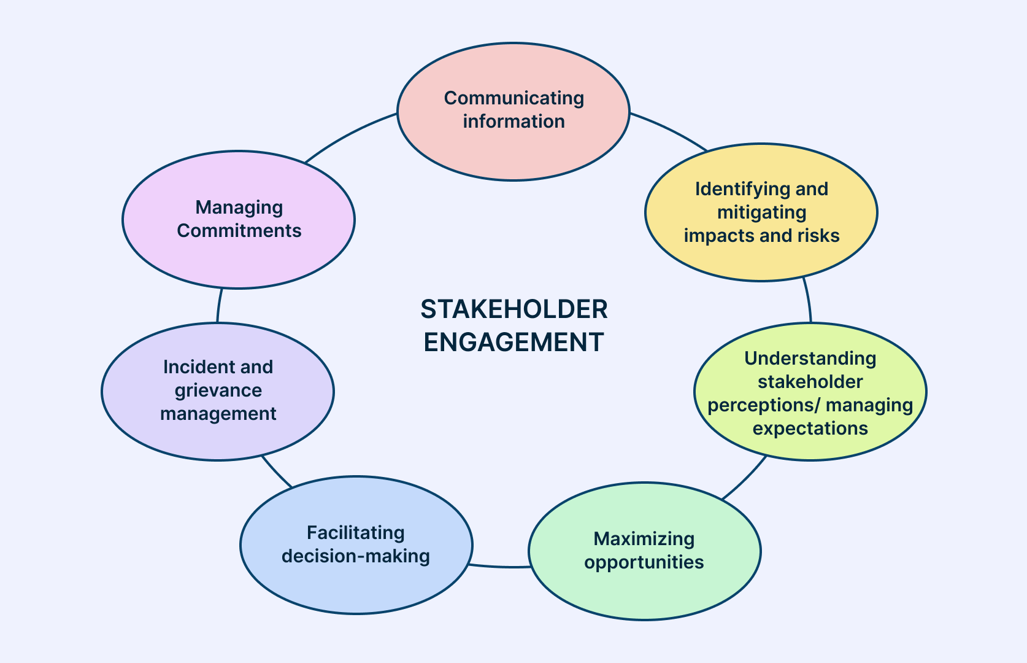
Effective stakeholder engagement is essential for the successful implementation of complex organisational projects. In the hospitality industry, projects such as the introduction of the StaySmart+ service at Hilton Hotels & Resorts require the involvement of multiple internal and external stakeholders. These stakeholders include employees, managers, customers, suppliers, and regulators. The project manager plays a crucial role in coordinating these stakeholders and ensuring their active participation throughout the project lifecycle. One useful framework for managing stakeholder engagement is the 4C model, which includes communication, collaboration, consultation, and commitment. This model helps organisations maintain strong relationships and improve project outcomes (Bourne, 2020).
Stakeholder Engagement Process Framework (Source: Freeman, 2020).

Communication
Communication is one of the most important elements of stakeholder engagement. Effective communication ensures that all stakeholders clearly understand the goals, progress, and challenges of the project. The project manager must ensure that information about the StaySmart+ service is shared regularly and transparently with all stakeholders. This may include project updates, timelines, responsibilities, and expected outcomes.
Various communication methods can be used to ensure information sharing, such as team meetings, digital communication platforms, project reports, and internal newsletters. Regular communication reduces uncertainty and helps stakeholders remain informed about project developments. According to Bourne (2020), clear communication strengthens trust between organisations and stakeholders, which is essential for successful project management. In the context of Hilton, effective communication also ensures that employees understand how to use the new digital systems and how they contribute to improved guest services.

Collaboration
Collaboration refers to the process of stakeholders working together to achieve common project goals. For the StaySmart+ service, collaboration between different departments such as IT, marketing, operations, and management is essential. Each department contributes different expertise and resources to the project. For example, the IT department develops the artificial intelligence systems, while the marketing team promotes the service to customers.
The project manager must encourage teamwork and create opportunities for stakeholders to work together. Collaborative workshops, cross-departmental meetings, and shared project platforms can help improve coordination among stakeholders. Collaboration also allows organisations to combine different ideas and expertise, which can lead to more innovative solutions. Research shows that strong collaboration between stakeholders improves organisational performance and project success (Freeman et al., 2018)

Consultation
Consultation involves seeking the opinions and feedback of stakeholders before making important project decisions. This process ensures that stakeholders feel valued and that their knowledge and experience contribute to project development. For example, hotel employees can provide practical insights about customer needs and operational challenges. Similarly, customers can offer feedback about digital services and personalised experiences.
Consultation can be conducted through surveys, feedback systems, focus groups, or stakeholder meetings. By involving stakeholders in decision-making processes, organisations can reduce resistance to change and improve the acceptance of new initiatives. According to Greenwood and Freeman (2018), organisations that actively consult stakeholders are more likely to build long-term relationships and achieve sustainable success.

Commitment
Commitment refers to the willingness of stakeholders to support the project and contribute to its success (Project Management Institute, 2021; Kerzner, 2022). The project manager must ensure that stakeholders remain motivated and committed throughout the implementation of the StaySmart+ service (Bourne, 2020). This can be achieved by clearly communicating the benefits of the project and recognising the contributions of stakeholders (Project Management Institute, 2021).
Employee training programmes, recognition systems, and performance incentives can also help strengthen stakeholder commitment (Kerzner, 2022). When stakeholders understand the value of the project and see how it benefits them, they are more likely to actively support its implementation (Bourne, 2020). Building commitment is important for maintaining long-term collaboration and achieving organisational goals (Project Management Institute, 2021).

Conflict Management Strategies
During large projects, conflicts between stakeholders may arise due to differences in expectations, priorities, or resources. The project manager must apply effective conflict management strategies to address these issues. Open communication, negotiation, and problem-solving discussions can help resolve disagreements before they escalate. Encouraging transparency and fairness also helps maintain positive relationships between stakeholders (Kerzner, 2022).

Leadership Role of the Project Manager
The project manager plays a key leadership role in stakeholder engagement. Effective leaders guide stakeholders, coordinate activities, and ensure that project objectives are achieved. Leadership involves motivating stakeholders, facilitating communication, and making strategic decisions that support project success. Strong leadership helps maintain stakeholder confidence and ensures that the project remains aligned with organisational goals.
Stakeholder Relationship Building
Building strong relationships with stakeholders is essential for long-term organisational success. Trust, transparency, and continuous communication help strengthen these relationships. When stakeholders feel respected and involved, they are more likely to support organisational initiatives and contribute to project success. In the case of Hilton, maintaining positive relationships with employees, customers, and partners helps ensure that the StaySmart+ service is successfully implemented and continuously improved.

Impact of Stakeholder Engagement on Business Performance
Stakeholder engagement has a direct and long-term effect on business performance because organisations do not operate alone. They depend on employees, customers, suppliers, investors, regulators, and communities to achieve their goals. In the case of Hilton’s StaySmart+ project, stakeholder engagement is not only a communication activity but also a strategic process that can shape project results, service quality, and competitive advantage. Stakeholder theory argues that organisations create more value when they understand stakeholder interests and build balanced relationships with them rather than focusing only on short-term financial outcomes (Freeman et al., 2018) For this reason, effective stakeholder engagement can improve project success, customer satisfaction, innovation, organisational reputation, financial performance, and sustainability outcomes.
First, stakeholder engagement strongly influences project success. A project is more likely to succeed when key stakeholders understand the project purpose, support its objectives, and cooperate during implementation. In the StaySmart+ project, senior managers provide resources, the IT team develops the technology, employees deliver the service, and customers respond to the final experience. If these stakeholders are not engaged properly, delays, resistance, and confusion may occur. Kerzner (2022) explains that successful projects depend on clear roles, shared information, and active stakeholder involvement throughout the project lifecycle. This means that engagement is not optional; it is a practical requirement for completing complex projects on time, within budget, and at the required quality standard.
Second, stakeholder engagement has a major effect on customer satisfaction. In hospitality, customer experience is central to business success because satisfied guests are more likely to return, recommend the hotel, and leave positive reviews. Engaging customers before, during, and after service delivery helps organisations understand expectations and improve service design. For example, feedback from guests can help Hilton improve AI-based communication tools, personalised travel support, and sustainable room features within StaySmart+. Sigala (2020) notes that customer engagement in hospitality improves service quality because organisations can respond more accurately to customer needs and preferences. However, customer satisfaction will only improve if the organisation acts on feedback rather than simply collecting it. Therefore, stakeholder engagement must be genuine and responsive, not symbolic.
Third, stakeholder engagement supports innovation. Innovation often develops when organisations cooperate with different stakeholders who bring new ideas, technical knowledge, and market insights. Technology suppliers may offer advanced digital systems, employees may identify practical service problems, and customers may suggest features that improve convenience. Greenwood and Freeman (2021) argue that stakeholder engagement supports learning and adaptation because it allows organisations to combine different viewpoints when solving problems. For Hilton, this means the StaySmart+ project can become more innovative if the company listens carefully to both internal and external stakeholders. At the same time, too many competing stakeholder views can slow down decision-making. This shows that engagement must be managed carefully so that it encourages innovation without creating unnecessary complexity.
Fourth, strong stakeholder engagement can improve organisational reputation. Reputation is especially important in the hospitality industry because customers often make booking decisions based on trust, brand image, and service quality. When an organisation is seen as transparent, responsible, and responsive to stakeholder concerns, it is more likely to build a positive public image. Good relationships with employees, customers, regulators, and local communities can strengthen Hilton’s reputation as an innovative and responsible hotel group. According to Fonseca and Carnicelli (2021), responsible stakeholder management improves trust and legitimacy, which are both important for long-term brand value. In contrast, weak engagement can damage reputation if stakeholders feel ignored, mistreated, or excluded from important decisions.
Fifth, stakeholder engagement affects financial performance. Better engagement can improve business performance by increasing customer loyalty, reducing employee turnover, limiting project failure, and improving operational efficiency. Engaged employees often perform better because they feel valued and included in organisational change. Satisfied customers are also more likely to spend more and return in the future. In addition, positive relationships with suppliers and partners can reduce operational disruption and improve service delivery. Although stakeholder engagement requires time and investment, the long-term financial benefits can outweigh the initial cost. Johnson, Whittington and Scholes (2020) suggest that strategic relationships with stakeholders can support competitive advantage and stronger organisational performance.
Finally, stakeholder engagement contributes to sustainability goals. In modern hospitality, sustainability is not only an environmental issue but also a business issue. Customers increasingly expect eco-friendly services, while regulators and communities expect responsible business practices. By engaging stakeholders, Hilton can better understand expectations around energy use, waste reduction, ethical sourcing, and responsible tourism. This helps the company align the StaySmart+ project with broader sustainability objectives. However, sustainability goals are more likely to succeed when stakeholders are involved in both planning and implementation. Overall, effective stakeholder engagement improves not only business results but also the long-term social and environmental value of the organisation.

Recommendations
Effective stakeholder engagement is essential for ensuring the successful implementation of the StaySmart+ service at Hilton Hotels & Resorts. Based on the previous analysis, several practical recommendations can be proposed to improve stakeholder involvement and strengthen project outcomes.
First, Hilton should develop digital communication systems to improve information sharing among stakeholders. Using digital platforms such as internal project management tools, mobile communication apps, and cloud-based collaboration systems can help employees, managers, and partners access project updates in real time. Clear digital communication channels reduce misunderstandings and improve coordination between departments (Bourne, 2020).
Second, the organisation should introduce stakeholder training programmes, particularly for hotel employees and operational staff. Since the StaySmart+ service involves artificial intelligence tools and digital customer interaction systems, employees need proper training to understand how the technology works and how to support guests using the new services. Training programmes can reduce resistance to change and increase employee confidence.
Third, Hilton should organise regular stakeholder meetings during the project lifecycle. These meetings allow managers, employees, and external partners to discuss project progress, identify challenges, and develop solutions collaboratively. Regular interaction also strengthens trust and transparency between stakeholders.
Fourth, the company should implement customer feedback platforms such as mobile surveys, online review monitoring, and guest experience applications. These systems allow customers to share their experiences and suggestions regarding the StaySmart+ service. Analysing this feedback can help Hilton continuously improve service quality (Sigala, 2019).
Finally, Hilton should strengthen sustainability engagement strategies by involving employees, customers, and local communities in environmentally responsible practices. For example, the company could promote energy-saving initiatives, waste reduction programmes, and eco-friendly travel options within the StaySmart+ service. Engaging stakeholders in sustainability initiatives helps improve organisational reputation and supports long-term responsible business practices.

Conclusion
This report examined the importance of stakeholder engagement in the successful implementation of the StaySmart+ service at Hilton Hotels & Resorts. The analysis highlighted that effective stakeholder engagement is a critical factor in managing complex projects within the hospitality industry. The situational analysis using SWOT and PESTLE frameworks showed that Hilton has strong capabilities such as global brand reputation, technological innovation, and market presence, which support the introduction of the new digital service. However, challenges such as technological complexity, competition, and changing customer expectations also require careful stakeholder management.
The report identified key internal and external stakeholders, including senior management, employees, technology partners, customers, and regulators. Each stakeholder contributes valuable resources, expertise, and insights that support project implementation. The use of engagement frameworks such as the stakeholder matrix, RACI matrix, communication plan, and the 4C model demonstrated how project managers can effectively manage stakeholder relationships.
Overall, the findings indicate that strong stakeholder engagement improves collaboration, enhances customer experience, supports innovation, and strengthens organisational performance. Therefore, effective stakeholder management is essential for ensuring the successful delivery and long-term sustainability of the StaySmart+ project.

Refrence:

Baum, T. (2020) Human Resource Management for Tourism, Hospitality and Leisure: An International Perspective. 3rd edn. London: Routledge. Available at: https://books.google.com/books/about/Human_Resource_Management_for_Tourism_Ho.html?id=igcGpilWpy8C (Accessed: 10 March 2026).
Bourne, L. (2020) Stakeholder Relationship Management: A Maturity Model for Organisational Implementation. London: Routledge. Available at: Stakeholder Relationship Management: A Maturity Model for Organisational Implementation (Accessed: 9 March 2026)
Buhalis, D. and Leung, R. (2018) ‘Smart hospitality—Interconnectivity and interoperability towards an ecosystem’, International Journal of Hospitality Management, 71, pp. 41–50. Available at: https://doi.org/10.1016/j.ijhm.2017.11.011 (Accessed: 10 March 2026).
Bulchand-Gidumal, J. (2024) Artificial intelligence’s impact on hospitality and tourism marketing: exploring key themes and challenges. Tourism Recreation Research.
Available at: https://www.tandfonline.com/doi/full/10.1080/13683500.2023.2229480
Chaffey, D. and Ellis-Chadwick, F. (2022) Digital Marketing: Strategy, Implementation and Practice. 8th edn. Harlow: Pearson. Available at: https://www.pearson.com/en-gb/subject-catalog/p/digital-marketing/P200000003912/9781292401003 (Accessed: 10 March 2026).
Cozzio, C., et al. (2025) Artificial intelligence adoption in hospitality: challenges and opportunities. International Journal of Hospitality Management.
Available at: https://www.sciencedirect.com/science/article/pii/S1660537325000505
Demir, M. and Demir, Ş.Ş. (2025) The relationship between technology investments, innovation strategies, and competitive performance in the hospitality industry. International Journal of Hospitality Management. Available at: https://www.sciencedirect.com/science/article/abs/pii/S027843192500074X
Doran, G.T. (1981) ‘There’s a S.M.A.R.T. way to write management’s goals and objectives’, Management Review, 70(11), pp. 35–36. Available at: https://www.eval.fr/wp-content/uploads/2020/01/S.M.A.R.T-Way-Management-Review-eval.fr_.pdf (Accessed: 9 March 2026).
El-Said, O. (2024) Crisis-driven innovation in hospitality: How do international hotel chains respond to global crises? Tourism Management. Available at: https://www.sciencedirect.com/science/article/pii/S0278431924000707
Fonseca, A.P. and Carnicelli, S. (2021) ‘Corporate social responsibility and sustainability in a hospitality family business’, Sustainability, 13(13), p. 7091. Available at: https://www.mdpi.com/2071-1050/13/13/7091 (Accessed: 9 March 2026).
Freeman, R.E., Harrison, J.S. and Zyglidopoulos, S. (2018) Stakeholder theory: Concepts and strategies. Cambridge: Cambridge University Press. Available at: https://www.researchgate.net/publication/327102922_Stakeholder_Theory_Concepts_and_Strategies (Accessed: 18 March 2026).
Greenwood, M. and Freeman, R.E. (2022) ‘Stakeholder engagement: Past, present, and future’, Business & Society, 61(5), pp. 1136–1196. Available at: https://doi.org/10.1177/00076503221083052 (Accessed: 9 March 2026).
https://link.springer.com/article/10.1007/s10551-020-04595-0
Hilton (2024) Travel with Purpose Report 2024: Annual Report and Sustainability Overview. Available at: https://travelwithpurpose.hilton.com/wp-content/uploads/sites/4/2025/06/2024Report.pdf (Accessed: 9 March 2026).
Ivanov, S. and Webster, C. (2019) Robots, Artificial Intelligence and Service Automation in Travel, Tourism and Hospitality. Bingley: Emerald Publishing Limited. Available at: https://www.researchgate.net/publication/348729012_Robots_Artificial_Intelligence_and_Service_Automation_in_Travel_Tourism_and_Hospitality (Accessed: 11 March 2026).
Johnson, G., Whittington, R. and Scholes, K. (2020) Exploring strategy. 12th edn. Harlow: Pearson. Available at: https://www.pearson.com/en-gb/subject-catalog/p/exploring-strategy/P200000003473 (Accessed: 9 March 2026).
Kandampully, J., Zhang, T. and Bilgihan, A. (2021) ‘Customer loyalty: a review and future directions with a special focus on the hospitality industry’, International Journal of Contemporary Hospitality Management, 33(10), pp. 3495–3535. Available at: https://www.researchgate.net/publication/275333939_Customer_loyalty_A_review_and_future_directions_with_a_special_focus_on_the_hospitality_industry (Accessed: 10 March 2026).
Kotler, P., Keller, K.L. and Chernev, A. (2022) Marketing Management. 16th edn. Harlow: Pearson. Available at: https://www.pearson.com/en-gb/subject-catalog/p/marketing-management-global-edition/P200000004662/9781292472775 (Accessed: 10 March 2026).
Kerzner, H. (2022) Project management: A systems approach to planning, scheduling, and controlling. 13th edn. Hoboken: Wiley. Available at: https://www.wiley.com/en-us/Project+Management:+A+Systems+Approach+to+Planning,+Scheduling,+and+Controlling-p-9781119805373 (Accessed: 9 March 2026).
Laudon, K.C. and Laudon, J.P. (2022) Management Information Systems: Managing the Digital Firm. 17th edn. Harlow: Pearson. Available at: https://www.pearson.com/en-gb/subject-catalog/p/management-information-systems-managing-the-digital-firm-global-edition/P200000004708/9781292740584 (Accessed: 10 March 2026).
Malone, C. (2024) Artificial Intelligence in the Hotel Industry. University of Arkansas Hospitality Research Paper.
Available at: https://scholarworks.uark.edu/cgi/viewcontent.cgi?article=1033&context=hnhiuht
Mariani, M. and Baggio, R. (2022) ‘Big data and analytics in hospitality and tourism: a systematic literature review’, International Journal of Contemporary Hospitality Management, 34(1), pp. 231–278. Available at: https://centaur.reading.ac.uk/101148/1/Manuscript_R3_EL.pdf (Accessed: 10 March 2026).
Mendelow, A.L. (1981) Environmental scanning – the impact of the stakeholder concept. In: Proceedings of the International Conference on Information Systems (ICIS), Cambridge, MA. Available at: https://aisel.aisnet.org/icis1981/20 (Accessed: 18 March 2026).
OECD (2020) OECD Tourism Trends and Policies 2020. Paris: OECD Publishing. Available at: https://www.oecd.org/en/publications/2020/03/oecd-tourism-trends-and-policies-2020_7cfc4549.html (Accessed: 10 March 2026).
Project Management Institute (2021) A Guide to the Project Management Body of Knowledge (PMBOK® Guide). 7th edn. Newtown Square, PA: Project Management Institute. Available at: https://www.pmi.org/standards/pmbok (Accessed: 10 March 2026).
Sigala, M. (2019) ‘Social media and customer engagement’. Available at: https://www.researchgate.net/publication/335684664_Social_Media_and_Customer_Engagement (Accessed: 9 March 2026).

