Parallel exhibition
Emmi Joy

This is an interpretation of my ideas being moulded into an essay focused on exploring and creating an independent exhibition based on a topic of my choice, therefore I have planned it to base it around alternate universes and the ways people perceive reality in their mind and how they expand and explore their ideas to create a whole new world. I think it’s important to show people these things in the current era as it can implement more creativity and imagination into the average person. life is a cruel and unforgiving existence however sharing these different worlds brings more eye opening and interesting ideas to the table of being human, I aim to show people the alternate ways of immersing yourself into another world and breathing new life into the concept of parallel universes and what they entail in the modern world we reside in.
Touching upon my chosen theme exploring the ideology of parallel universes and how many might exists among us I would like to direct your attention to the more simplistic scientific area of this topic and explore the idea of abnormal oddities in areas of the world we reside in, robots, hover crafts and time bending are some of the many fascinating things my chosen artist channels in his pieces of work, I would like to introduce you to Simon Stålenhag who has created a wide range of pieces over the years and has a show on amazon prime depicting one of his books being brought to life and a tabletop RPG that is also based on the same concept. I plan to base my exhibition on a parallel universe more specifically his, with sentient machines and a place that’s stuck in time with a lurking mysterious presence that looms over them there is no shortness of immense awe of what his work depicts, while also being classed as quite gory and horror like with an excellent link to how to this universe it is considered normal for enormous beings to wade the earth with hundreds of half dead people wearing helmets that take your conscience to a virtual hub following suit wires all tangled into one horrific mess of fear and looming danger, I want to bring that feeling and immerse the visitors in this universe and enlighten them to a very underappreciated artist and all his work. During this piece I would like to explore and outline my findings and opinions on Stålenhag and the emotions his work expels over every aspect of his library of work. Bringing this into consideration you feel almost more grateful of this boring world as at least our conscious isn’t trapped in virtual reality while our bodies disintegrate into a shrivelled shell of former life. Stålenhag currently has four books released all in similar timelines and ideas of each other and the odd world around them, I’ve read nearly all of them seeing each page as a beautiful work of art, I own nearly every piece of media he has brought out as his collection is small on paper the art doesn’t fail to be displayed on his social media pages and websites. Giving context and linkage between my artist and theorists it’s a clear link of what our brains can create. Although the world multiverse was created by William James an American philosopher in 1895 the word has been more elaborated on in later years with the help of David Lewis who broadened the term to fit nearly every ideology,” considered philosophical implications of a multiverse from his modal realism perspective. In fact, the concept of a cosmological multiverse and its philosophical and religious implications were considered more than a millennium prior throughout various societies and religions” (ref 1). Furthermore, looking into some of the aspects of this concept brings me to such things as the possibilities of multiple versions of yourself,” Dr. Michio Kaku has suggested that if these ideas become reality, depending on which one of the four types of parallel universes that truly exist, there are virtual copies of you in another region of space. One interesting aspect of this to consider, which catches the attention of scientists and philosophers alike, is the issue of morality.” (ref 2) linking this to Stålenhag’s work I link with this quote in mind to episode 6 of the show, it goes into the idea that while trying to fix a magnetrine farm machine (the earth’s magnetic field works with its liquid core to hover) while doing so he finds out he has travelled into an unknown world and meets another version of himself, sounds pretty simple until his search for love becomes entangled with his other self and gives an odd perspective into this sort of scenario, this links to the morality of the topic at hand and gives a sense of questioning ones ideology on how you would perceive the situation at hand.
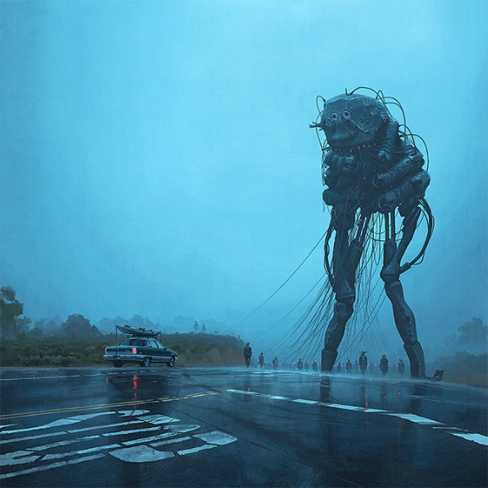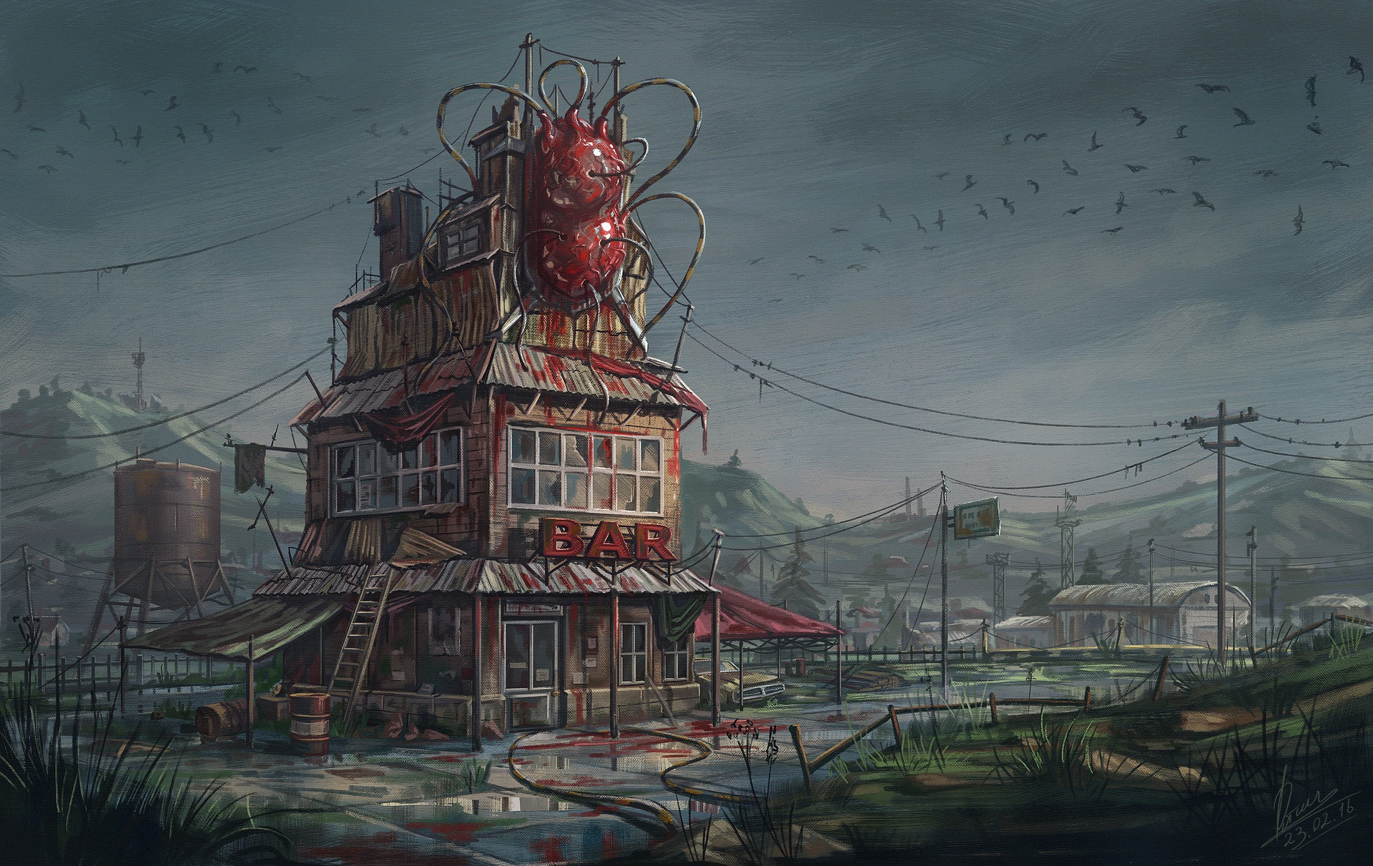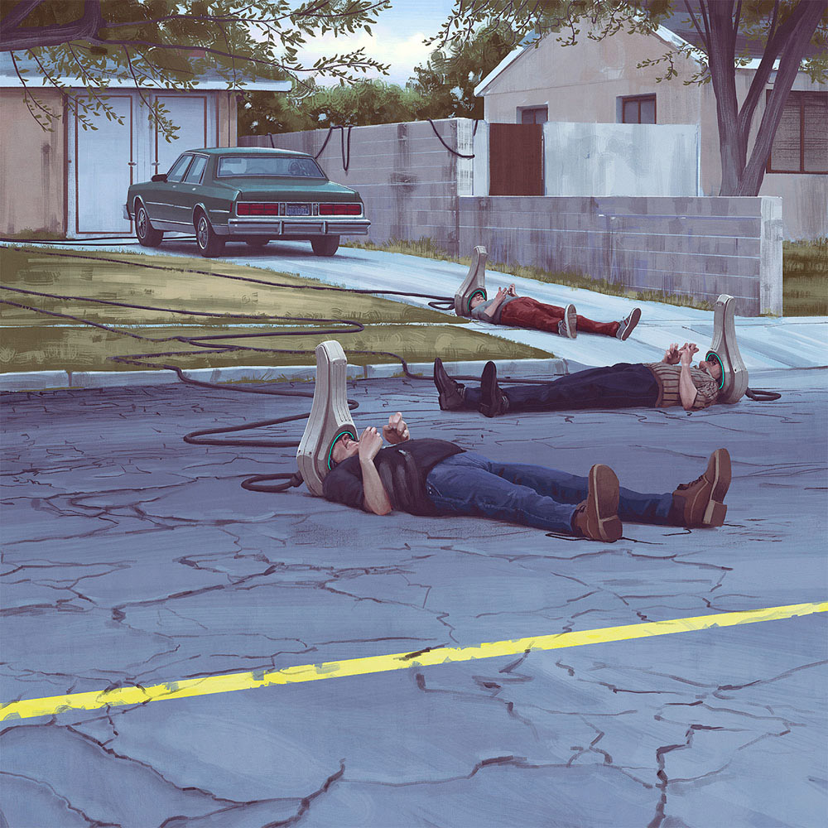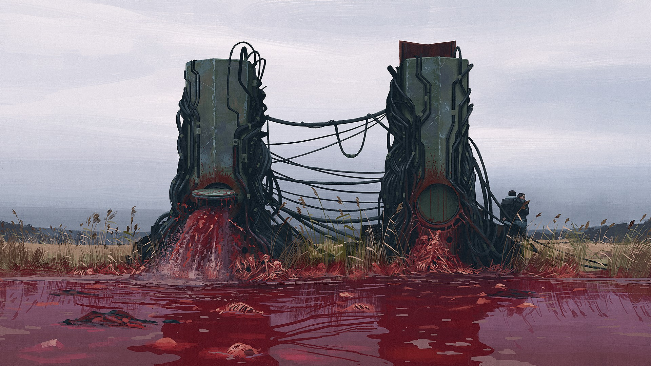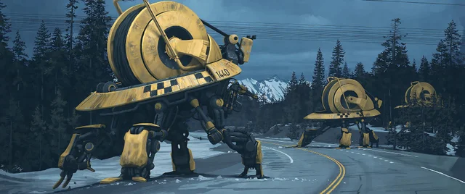

Above I have chosen my favourite pieces by Stålenhag, they are primarily created digitally but still have lots of shapes and brush textures present to give it more lifelike qualities. I will give a brief analysis of each one going horizontally left to right, as each piece has its own unique charm it won’t be too hard to distinguish each piece, I intend on talking about. The first chosen image depicts the looming figure I referenced to earlier with the true intentions being profoundly displayed for all to see and experience first-hand, the things I love most about his work is the atmosphere created by the choice of lighting, the harsh tone of blues and deep greys give it so much charm and personality this piece was made for his book ‘electric state’ being one of the encounters of the protagonist on her travels across the united states to find her brother, all of Stålenhag’s pieces are quite recent this particular piece is from around 2017. The top right image depicts another harrowing scene from electric state, the way that machinery and robotics cram together to create this abhorrent beings it bring the ideas of ethics into play trying to understand if this thing is humane or not, this was also created 2017, it addresses a simple bar that appears to almost be a living being itself. The middle left image is again an electric state piece with the way the helmets work by transporting peoples consciousness into the virtual world, this shows the torn line between virtual and reality the scary truth we also must face however while we can put our phones down these helmets become almost fused to the users head with them losing sight with what’s real and what’s not, they begin to decay and shrivel up like a freshly drained corpse. This is from 2016-2017 again electric state piece. The middle right piece is a very graphic depiction of power points spewing out blood and guts from the ‘loop’ this facility in the centre of it all, this piece was made for ‘things from the flood’ a 2016 piece of work for a particular part where it progressively gets more blood and guts. I think it’s meant to address the changes in life and how quickly it can all bleed away with the ever change times. The last piece I have to talk about is a beautiful piece that further explores the environment of the USA once more with electric state its depicting just a simple scene of this robots wandering the unforgiving terrain the simplicity of this piece is what gets me the most the way the yellow tones scream at you in all the best ways with it being a perfect depiction of colours used in a strong way.
Linking these pieces of work to the ideas of parallel universes to a theorisers context its clear that we would probably be considered the lucky ones as our problems in hind sight aren’t as bad as sentient blood filled robots roaming the land, looking at theorists I found that one stated ‘our universe is an especially friendly place for making electronic computers. In other realms, the laws of nature seem designed to thwart us.’ (ref 3) this was quoted from Brian Hayes who I found while looking at the recourses available on the UWTSD website links, it ties well with my exhibition and the aspect that we have it good compared to most people fictional or otherwise. Another Theorist I found an interesting article about was Robert Lea who says, ‘how these universes within a multiverse would differ is also currently the topic of speculation, but Adams suggests there’s no reason to believe that the laws of physics would be the same in these separate regions.’ (ref 4) This gives even more to work with by bringing in the idea of diverse ways gravity works and shapes that parallel universe, it’s fascinating how it all works and how people come to these results.
In conclusion I think that the best way to gain a viewer’s attention world could be they are scary in some sense but the way that it all grips onto the viewers and hangs on while they go off and live their lives and that’s why I chose parallel universes.

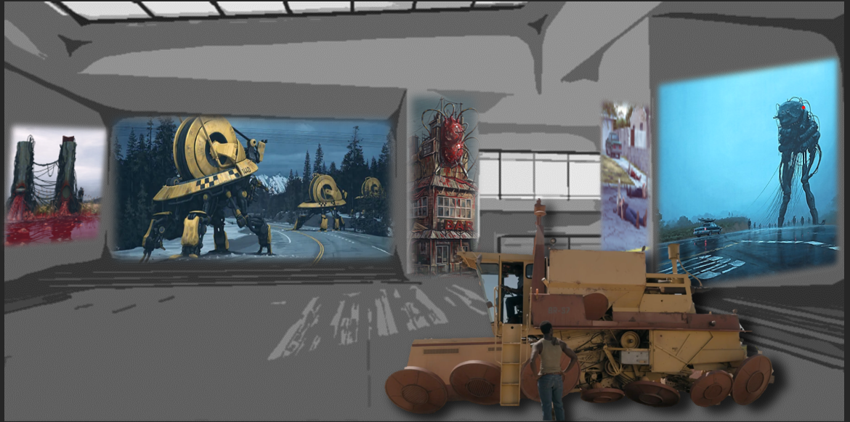
This is my lay out of how I might have the exhibition will look like it’s very tall and grand with the vehicle from the show being present as it’s an iconic piece to display, I love the large scale prints as there is a lot to look at and each piece can be individually studied and appreciated.

Reference | Link | author | Quote
Ref 1 | https://oxfordre.com/religion/display/10.1093/acrefore/9780199340378.001.0001/acrefore-9780199340378-e-157;jsessionid=8F39AE23D9AE039249014C5F00521488 | Gerald Cleaver | ‘considered philosophical implications of a multiverse from his modal realism perspective. In fact, the concept of a cosmological multiverse and its philosophical and religious implications were considered more than a millennium prior throughout various societies and religions.’
Ref 2 | https://futurism.com/parallel-universes | Futurism | ‘Dr. Michio Kaku has suggested that if these ideas become reality, depending on which one of the four types of parallel universes that truly exist, there are virtual copies of you in another region of space. One interesting aspect of this to consider, which catches the attention of scientists and philosophers alike, is the issue of morality.’
images | https://www.simonstalenhag.se/ | Simon Stålenhag | Majority of my images are sourced from this core website
Ref 3 | https://www.americanscientist.org/article/computing-in-a-parallel-universe | Brian Hayes | ‘our universe is an especially friendly place for making electronic computers. In other realms, the laws of nature seem designed to thwart us.’
Ref 4 | https://www.sciencefocus.com/space/the-multiverse/ | Robert lea | ‘how these universes within a multiverse would differ is also currently the topic of speculation, but Adams suggests there’s no reason to believe that the laws of physics would be the same in these separate regions.’

