Kenfig Dune Rejuvenation Project 2013

During December January and February a Welsh Government funded project took place to rejuvenate sand dune habitats on the Kenfig SAC. In December 2012 work took place at Merthyr Mawr. CCW site warden, Duncan Ludlow described the work in an internal document, ‘Merthy Mawr Warren Dune Rejuvenation Work Report December 2012’.

Professor Ken Pye provided advice for the Kenfig works in ‘Kenfig Dune Rejuvenation Trials, Proposals for Phase 2, KPAL Job No: 031012 12 October 2012’. The plan recommended:

- Creation of four deep trough excavations cut into tall coastal dunes.
- Strategic placement of excavated turves and sand.
- Turf stripping and development of steep side arms.

Proposed Location and Nature of Work (reproduced from KPAL 031012)

Area F was included as an extra area to work on if work on the other areas progressed faster than anticipated. CCW initiated a tendering process based on the KPAL report and Jones Brothers (Henllan) Ltd from Cross Hands, Carmarthenshire won the contract to work on both sites. Machinery arrived at Kenfig after the Christmas break on 7 January. Work continued until 6 February when five days were spent carrying out some slack rejuvenation work at Kenfig for Plantlife. Some extra funds from CCW allowed for five days further work to be carried out on the rejuvenation project from 15 to 21 February. The machines left the site on 22 February.

Machinery Used

Four machines each with a driver were used during the contract. A 20 tonne and a 14 tonne excavator using digger buckets and grading buckets dug sand, stripped turf, loaded dumper trucks and profiled spoil heaps. Both excavators stayed at the worksite throughout the contract. Two 14 tonne articulated dumper trucks were used to move material to spoil heaps. They were brought back to the reserve centre each day and parked overnight on grass next to the road under a street light so as to be clearly visible at night to deter damage and diesel theft. These two dumper trucks were used to transport drivers to and from the worksite. A tractor with diesel bowser was stored in the reserve centre’s courtyard and used to transport fuel out to the machines. A mobile toilet block was parked outside the reserve centre throughout the contract for use by the workers. The contract included the cost of a supervisor who drove one of the vehicles but was in charge of the other workers and liaised with the nature reserve manager over the work.

One of two dumper trucks used throughout the contract to move sand and spoil.

Foredune Trough Excavations

Cutting trough excavations was a new management technique for Kenfig. It involved cutting down through tall foredunes to make four steep sided U-shaped valleys orientated approximately east-west. Wind coming off the beach should funnel through the trough excavations increasing in velocity and increasing in capacity to move sand. It is hoped that the trough excavations will become wider as erosion takes place moving the large volume of sand locked beneath thick vegetation inland. If the process continues, the trough excavations may eventually join up.

Positions for the four trough excavations were marked by driving in posts at each end. Red and white plastic ribbon was tied to the tops to blow about helping drivers see the posts. An excavator and dumper truck worked from the top of the foredune with filled loads being tipped down the eastern inland side of the foredune ridge. Existing vegetation was buried under about a metre of sand. As the trough excavations deepened, the excavator and dumper trucks worked from the base of the trough excavations. Sand was transported to bury turves stripped during clearance work in the deflation corridor. It was not clear from the plans how deep the trough excavations should be cut other than ‘deep’. It was decided to keep digging as deep as reasonably possible without endangering the safety of the drivers working in the troughs. Creating long-term sand mobility was the primary objective of the winter’s work so it was felt that it was important to prioritise work on the trough excavations.

The two trough excavations cut at the northern end of the work area both linked onto existing foredune blowout hollows. This allowed the trough excavations to be completed quicker than the first two as less sand needed to be moved.

Trough excavation A4 cut into tall foredunes. Flooding in foreground is in area E. Taken about a fortnight after completion on 2 February 2013
Tracked excavator with digger bucket and dumper truck during trough digging work on 11 January 2013

Trough excavations A3 and A4 on 2 February 2013. Tipped sand extracted from trough excavations can be seen on the near (east) side of foredunes. Flooding in areas E and C.
Trough A3. Picture taken on 10 March 2013

Turf that has sloughed from the top of the dune and slid down side of trough A4. Picture taken on 10 March 2013.
Slip face on trough A3 on 10 March 2013 after several days of north-easterly wind. A sand nose building out onto the upper beach.

Turf Striping in Deflation Plains

Turf was stripped to the east (inland) side of the trough excavations in areas C, D and E. These were low-lying areas between the sand deposition zones (B1 and B2) from the trough excavations and the old haulage road. In the past these would have been sandy deflation corridors left behind by mobile dunes but they have long since vegetated over. The intension of this clearance was to allow saltation clouds of bouncing sand grains to continue moving inland from the trough excavations without being impeded by vegetation. Flooding prevented about half of this area being cleared and prevented the sand ridge in Area E being excavated and shifted to the north. Instead the ridge had all vegetation removed.

Turf-striped deflation plain, Area E. Winter flooding prevented much of this area being cleared. A central sand ridge had turf removed. Spoil can be seen piled on far left enlarging the existing side arm. Picture taken on 3 March 2013.
Turf-striped deflation plain in centre rear with spoil piled to left and far right. Picture taken on 2 February 2013.

Turf Stripping from Dune Side Arm

Turf was stripped from a side arm between points 7 and 8. A tracked excavator pulled vegetation down and used the material to make a temporary platform above a flooded area for the dumper trucks to be able to gain access. Once the dune had been cleared, the excavator dug out the platform loading spoil onto the dumper trucks which transported material to the south on a turf and sand side arm created artificially in March 2012 (SS783822). The clearance of the north side of this side arm married up with clearance that had taken place the previous winter on the south side so that the side arm constituted bare sand on both sides for about 100 metres.

Dune side arm on the south side of area on the coast side of old haulage area. This was the last work carried out during the contract.
Cleared northern dune side arm behind excavator with temporary platform at its base.

Publicity

BBC Countryfile filmed the excavation work on 11 January and the programme was televised on BBC1 three weeks later. The TV programme and the work itself generated a lot of enquiries at the reserve centre and wardens were able to explain why the work was needed and the importance of bare sand to the reserve. Photographs of the work were incorporated into Kenfig’s PowerPoint presentation which is used during introductory talks to student groups.

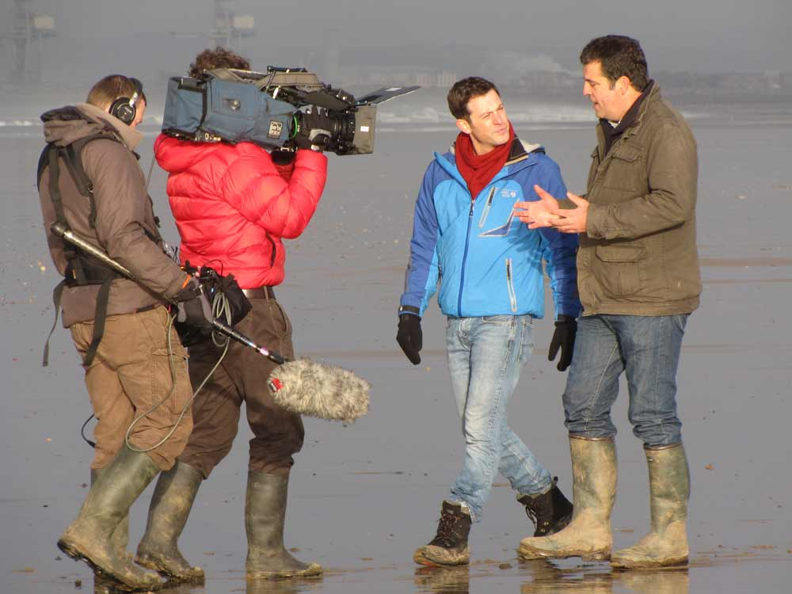
Andy Byfield from Plantlife explains to Matt why many special plants at Kenfig need bare sand and a degree of disturbance.
Matt Baker excavating sand supervised by driver Lee for BBC Countryfile on 11 January 2013.

Problems and Lessons Learned

The project ran extremely well with very few problems. However, the site experienced the deepest flooding since records began and according to some locals the deepest in living memory. This was due to a wet summer followed by wet autumn and very wet weather around Christmas. Access to the work area appeared to be blocked by flooding. On the first day of work, a tracked excavator made two cuts at low points in foredunes to let more water flow out onto the beach. This worked to a certain degree and the large machines were able to drive along the flooded haulage road but the reserve’s Landrover had to drive up onto the shingle beach to get round the flooding throughout the contract period. Several low-lying areas on the main tracks from the reserve centre to the haulage road became deeply rutted and several truck loads of sand had to be transported from the work area to keep the track usable for the machines and the general public. This took a day or so out of the contract but the improved surfacing on the track will last for many years and was a good investment for future projects.

Excess water flowing out onto beach on 29 December 2012 before a cuts were made in foredunes.
Old haulage road blocked by flooding. The wettest the reserve had been in living memory.

There was some debate before and during the contract as to whether a D6 bulldozer should have been used instead of one of the excavators. Experience gained from Merthyr Mawr suggested that a bulldozer would not have been suitable because root material slipped under the bulldozer blade then got mixed with the sand by the tracks.

As sand shifted after steep sided troughs had been excavated, turves from the top started sliding down. These mats of vegetation are likely to root into the sand and hamper the blowing of sand. To encourage the long-term success of the work done, such turves probably need to be removed on a regular basis. Some experimental work with the reserve’s tractor and silage grab will be tried to see how feasible it will be to control this problem.

The general difficulties associated with staff shortages at Kenfig were compounded in January when a member of staff had an accident slipping on ice in Cardiff breaking her wrist and needing six weeks off. The manager worked alone and to keep the project moving smoothly, had to put in some extra time, calling in during his weekends. The inclusion of a supervisor as part of the contract helped in this respect. BCBC sent down the Countryside Officer, Ecologist and volunteer co-ordinator to provide presence at the reserve centre during the manager’s weekends. A student placement from Cardiff University also helped with reserve work as far as studies permitted. Scott Hand, Senior Conservation officer for CCW visited the work site on several occasions and Mike Howe from CCW in Bangor provided support and secured the extra finance for the additional five days. Andy Byfield from Plantlife and Clive Hurford from CCW secured funding and provided support for the five days spent on turf stripping in two dune slacks.

David Carrington, Kenfig NNR Manager

