Smart and Connected Devices

Student Number: 1701603
Student Name: Daniel Davies
Lecturer: Gaynor Thomas
Date: 13/05/2019
Contents
Introduction 3
Requirements 4
Introduction 4
Web Interface 4
Requirements 4
Conclusion 4
Implementation 4
Introduction 4
Web Interface 5
Searches Implemented 7
Conclusion 7
Evaluation 8
Introduction 8
Web Interface Evaluation 8
Future Improvements 8
Conclusion 8

Introduction
Within this report a web interface is going to be created, the web interface is going to be used to allow the user to view/interact with data which has been sent from various sensors in different geographical locations. There are going to be three sections these are:
- Requirements - Within this section of the report the requirements for the web interface will be looked at, this will include what the web interface is actually going to contain. Along with this a requirements for the web interface itself.
- Implementation - Within this section of the report the web interface which has been implemented will be looked this will include screenshots of the final interface. As well, as this any searches which have been implemented will be looked at with reasoning why.
- Evaluation - Within this section of the report the evaluation of the web interface will be looked at as well as any future improvements which can be made to improve the future builds of the interface.

Requirements

Introduction
Within this section of the report the requirements for the web interface will be looked at, this will include what the web interface is actually going to contain. Along with this a requirements for the web interface itself.

Web Interface
The web interface is going to be used to allow the user to view/interact with data which has been sent from various sensors in different geographical locations. This data is going to be located in data files and will be transferred into a database. After the data has been transferred into the database the web interface will allow the user to interact with the data which is located on the database. This will including lists and graphs and will allow the user to filter the data.
The web interface will also contain various security measures, these measures will not allow any users who are not logged in to gain access to the main pages and gain access to the database data. There will be a log in page which the users can log in to their accounts and gain access to the main page and data

Requirements
The web application is going to have a few requirements which need to be meet, this requirements include:
- The application must contain a log in feature to allow the users to log in
- The application must allow the user to log out
- The application must not be accessible unless the user is logged in.
- The application must be able to transfer the files over from the text files into the database
- The application must delete all the data in the text files after it has been transfered
- The application must allow the user to filter the data
- The application must have an interface which the user is able to interact with
- The application must be able to be displayed visually using a graph

Conclusion
To conclude within this section of the report the web interface was looked at and what it is going to contain. Along with this a few requirements have been set which the final web application must achieve.

Implementation

Introduction
Within this section of the report the web interface which has been implemented will be looked this will include screenshots of the final interface. As well, as this any searches which have been implemented will be looked at with reasoning why.

Web Interface
This is the main page of the web interface, there are options to transfer the data from the files to the database as well as the option to sign out.
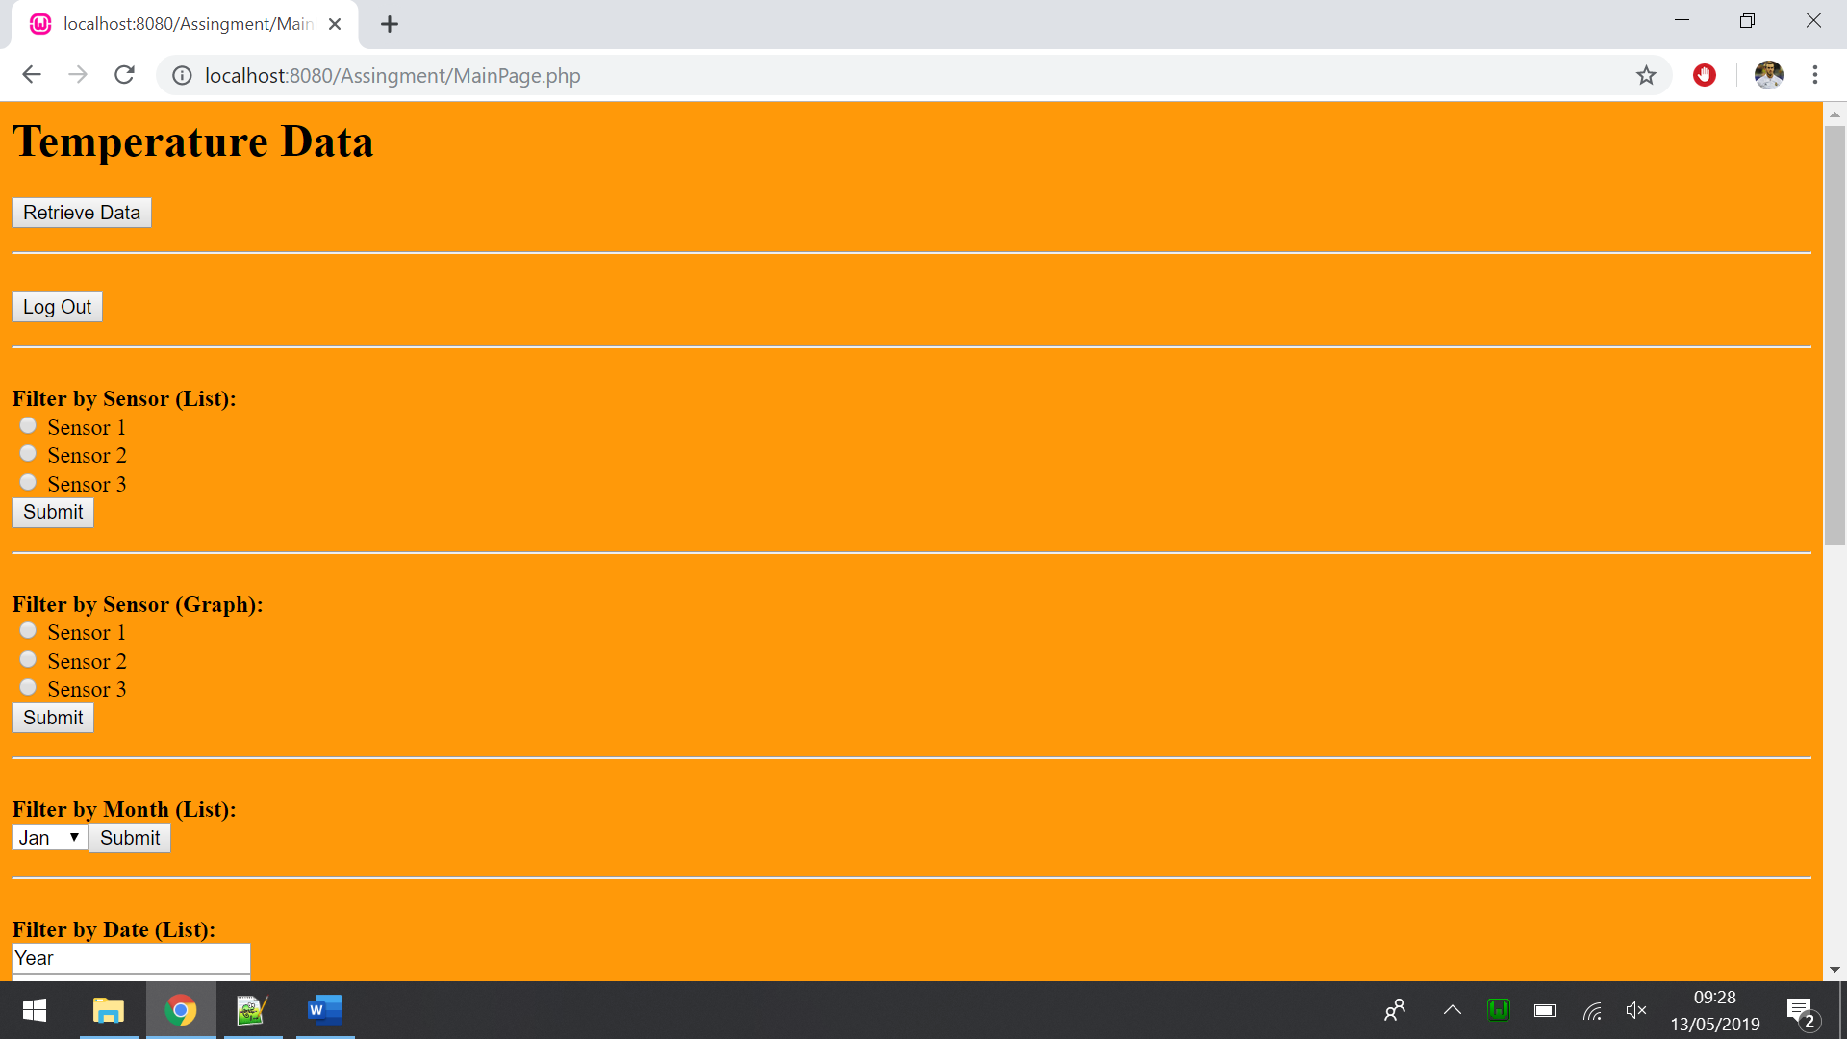

This is going to be the login page, this is going to allow the user to log in to their accounts.
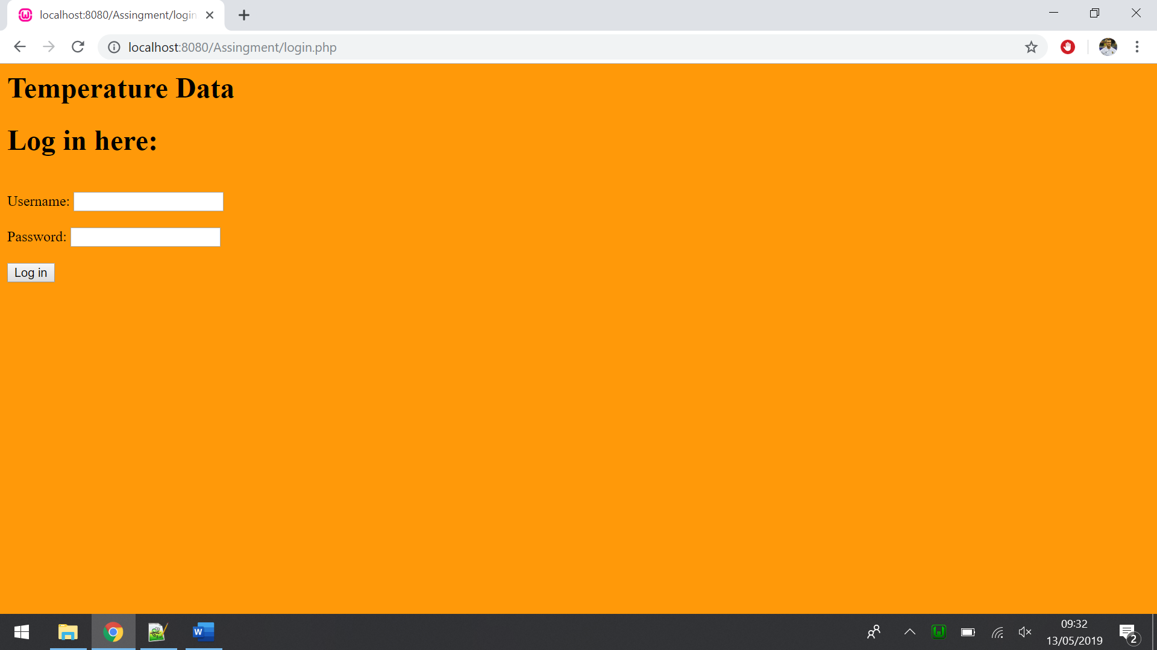

This is going to be how the interface displays the results of the various searches in a list, it also has the option to go back to the main page.
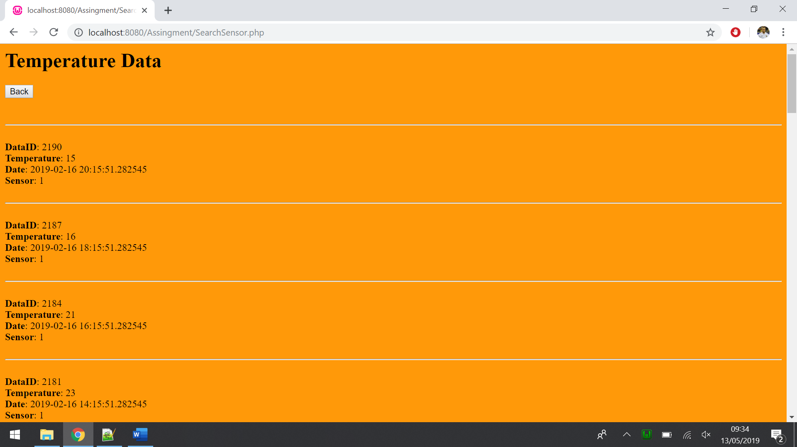

This is going to be how the interface displays the results of the various searches in a graph, it also has the option to go back to the main page.
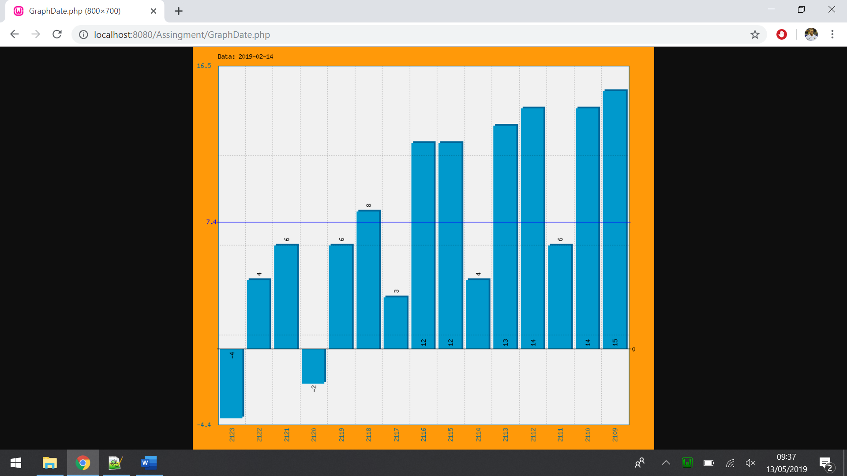

Searches Implemented
Within the web interface there are 5 different searches which were used to allow the user to filter the data. These searches include:
- Filter by Sensor (List) – The first search which has been selected is the filter by sensor. This will allow the user to pick between the 3 sensors and will display the results within a list. This has been selected to allow the user too few a specific sensor which can be useful instead of viewing all the sensors.
- Filter by Sensor (Graph) – The next search which has been selected is exactly the same as the first search accept instead of displaying the results in a list it displays the results within a graph. This has been selected to allow the user too few a specific sensor which can be useful instead of viewing all the sensors. The reason why a graph has been selected as it might be easier to see the results within a graph. Also, some users might find it easier to few the results within a graph.
- Filter by Month (List) – The next filter which has been decided on is to allow the user to filter by month, this will display all the results within that month and will display everything within a list. This has been selected to allow the user too few a specific month which is a useful filter.
- Filter by Data (List) – The next filter is the most complicated search in the web application, this search allows the user to search for a specific data this includes year, month and day. Along with this the user also has the option to search for a specific sensor, lastly this user also has the option to search for a specific hour in the day. Although the hour and sensor information do not need to be entered for the search to work. The results are going to be displayed in list for the user to few.
This allows the user to search for a very specific data instead of the more non-specific searches which have been selected so far. The reason why this search has been set up is so allow the user to find very specific information.
- Filter by Data (Graph) – This last search which has been selected is exactly the same as the last filter accept that the results will be displayed within a graph. The reason why a graph has been selected as it might be easier to see the results within a graph. Also, some users might find it easier to few the results within a graph.

Conclusion
To conclude within this section of the report the web interface has been looked at, with the final interface being looked at. As well, as this any searches which have been implemented has been looked at with reasoning why.

Evaluation

Introduction
Within this section of the report the evaluation of the web interface will be looked at as well as any future improvements which can be made to improve the future builds of the interface.

Web Interface Evaluation
Overall the final web interface is a very professional looking interface, with all the requirements being meet which means that the implementation was very successful. Some features which went very well include:
- The searches all are fully functional, with some of them display the results within a graph.
- If a user who is not logged in tries to gain access to the web interface they are unable to do so.
- The log in page is fully functional and is able to log users in to gain access to the web interface.
However, there are a few features of the interface which might not be the best, some of these include:
- The interface is not the most user friendly and some users might find it difficult to navigate through the interface.
- There is no register, so the users are only able to log in to accounts which have already been created.

Future Improvements
There are a few improvements which can be made to make the future builds of the web interface better. Some of these improvements include:
- A register page to allow users to register an account.
- Include some sort filters so that the user is able to sort the results (for example view the results within temp ascending order)
- Make the interface more user friendly

Conclusion
To conclude within this section of the report the evaluation of the web interface has been looked at as well as any future improvements have been looked at.

