
MA Criminology and Criminal Justice
University of Wales Trinity Saint David’s
2022

By Sophia Ava Ivens
1801465

An Investigation into the Number of Female Individuals in South Wales Police

Acknowledgments
I would initially wish to convey my appreciation to my dissertation supervisor Rhiannon Lloyd for the endless advice and reassurance during the progress of this research. I would also like to acknowledge each and every individual who took part in the primary data of this investigation for their time and involvement, who without, this inquiry would not exist. Lastly, I would like to express thanks to my parents for constantly encouraging me in all that I do and my friends for their unrelenting motivation.
Abstract
The purpose of this research paper is to investigate the number of female individuals within South Wales Police. It will recognize the people's perspective on this subject matter and their thoughts following their continued belief. It will also discover if the media impacts society’s point of view in today’s contemporary world. This investigation will predominately concentrate on England and Wales, especially South Wales Police force although utilizing additional forces in England and Wales in contrast. This issue is mostly unexplored and under explored in Wales, suggesting that not enough is understood regarding why prejudice concerning women in the police force still occurs in modern-day culture. This dissertation takes on both a quantitative and qualitative methodology in order to achieve a better grasp of people's ideas. An electronic survey was produced and distributed on several social media platforms in which 107 individuals took part.
The conclusions were investigated in which various topics were found. It discovered what was anticipated to be learned from this inquiry which is that discrimination against women still happens at present regardless of the history of female individuals in the police force. The online questionnaire employed as the primary data for this research paper was issued through a number of social media platforms in order to connect to as many and as broad a variety of individuals as feasible. Different in age, race, nationality, and gender for instance. As well as this, it was equally dispersed to professional online platforms such as LinkedIn to reach a larger audience with expert academics. The results of this, very much support the arguments and writing reviewed within chapter two of this document. Primarily, the scale of this problem as well as what appears to have been done so far to confront it is growing to be futile. The second idea conceded is that there is even now, unnecessary measures of stigma, even in local areas, involving women within the police force. Ultimately, the results right the way throughout, underline the need for more support which can be more easily available for women working within the police force or choosing to go into this area of work.

Table of Contents
Chapter One: Introduction…………………………………………………………………1
Outline of Investigation……………………………………………………………1
Background…………………………………………………………………………1
Study Focus………………………………………………………………………….2
Aims and Objectives………………………………………………………………3
Research Foundation………………………………………………………………4
Approach……………………………………………………………………………5
Chapter Two: Literature Review…………………………………………………………6
History of Women Within the Police Force in England and Wales……………6
The Predominance of Women in the Police Force in England and Wales……8
The Prevalence of Women in South Wales Police Force in Comparison to Others in England and Wales……………………………………………………11
Stigma Surrounding Women in the Police Force in Comparison to Men…….14
Chapter Three: Methodology……………………………………………………………17
Summary of Methods of Investigation…………………………………………17
Ethical Concerns of the Analysis…………………………………………………18
Research Methodologies Utilized Throughout…………………………………19
Research Plans…………………………………………………………………….20
Research Ideas…………………………………………………………………….22
Possible Research Constraints…………………………………………………23
Chapter Four: Findings of Primary Data…………………………………………………25
An Overview of the Data Findings………………………………………………..25
Participant Demographic of the Primary Research…………………………….26
Participant Views in the Online Questionnaire………………………………….28
Chapter Five: Overall Conclusion of Information……………………………….37
Suggestions for Future…………………………………………………….38
Reference List………………………………………………………………………40
Bibliography………………………………………………………………………48

Chapter One: Introduction
Outline of Investigation
Women in South Wales Police force and every police force around the United Kingdom is an enormous area of conversation and has been in recent years right the way throughout the country. There has not been a significant volume of exploration in this area which is one of the main motives behind the completion of this study. Due to the fact that this matter has not been greatly explored over the past few years allows the investigation to develop considerably and thus expanding the understanding on this subject matter as a social interest. Research done on this area may also help in today’s modern community particularly among the public. This study will explore the perspectives of the society surrounding female individuals in the police force, especially concentrating on South Wales Police force which is thought to be extremely vital. It is essential that this investigation is carried out in order to hopefully increase understanding of the destructive stigma surrounding women in the police force. There are a handful of consequences to carrying out this investigation with the notion of there perhaps being some sexism as an end result of the online questionnaire. It may well be a difficult subject of conversation but this being said, all appropriate measures will be taken throughout the duration of this study. This is to make sure that all those contributing are as relaxed and informed of what is required from them throughout their involvement as possible. On top of this, all individuals participating to the research will additionally be made exclusively conscious of their right to confidentiality all the way through the process as well as when analysing the data found during the course of this research paper. The overall purpose of this development is basically to increase an awareness of women within the police force and attempt to break down some of that stigma surrounding the problem.
Background
This research paper will look at the number of women in South Wales Police force in contrast to men and moreover in parallel to additional police forces in England and Wales. It will likewise assess the possible reasons discovered from this analysis as well as people's viewpoint on this subject matter. This information will be collected through a questionnaire circulated electronically through a number of social media platforms. To begin with corresponding to the Wiltshire police (2021), they documented an approximately twenty percent increase in the total number of female police officers in the earlier two years. The Wiltshire police force, for the second year in a row, employed more female police officers and staff than male. In total there were over 1,200 female individuals hired, in comparison to the 1,151 men. In contrast to this, according to the Essex police (2021), from a collective personnel of roughly six thousand people, just over forty percent of these being police staff and over half at 58.7% being police officers. The majority of police staff are female individuals at nearly sixty five percent but with the mass of police officers being around the equivalent number, being men. In conclusion, according to the South Wales Police (2021), as of March 2020, inclusive of Police Community Support Officers (PCSO’s), they employed three thousand additional representatives of police staff. Over 1,500 of these individuals were female with just roughly one thousand being men. This equates to over sixty percent of all South Wales Police workers being women which is a 0.20% rise from the year prior to this. After all, a workforce which is symbolic of the society in which it serves is a vital part of improving the people's trust and commitment in keeping the community protected. This is a portion of what this research will discover and find out whether or not South Wales Police is comprehensive and characteristic of the people it provides for.
Study Focus
One of the crucial areas of attention, in respects to this research is, to evaluate the handful of consequences which this investigation may well bring. The concept of men versus women can be seen as a more difficult subject of debate in spite of this inquiry not being a competition of the genders which several individuals may perhaps view it as being exactly that. This being said all appropriate procedures will be carried out during the duration of this inquiry to make sure that all those contributing are as informed and comfortable with what is anticipated from them as feasible. On top of this, all individuals participating will additionally be made fully conscious of their right to confidentiality all the way through the process and when assessing the numbers discovered during the course of this research paper. The whole purpose of this research paper is profoundly to increase understanding of women in stereotypically male-controlled careers and make an attempt to break down some of that stigma surrounding the topic itself. This study may well establish how serious the stigma is surrounding women in the police force in modern times. As well as this, the people's opinions on women in the police force especially South Wales Police will be examined and come from primary data findings subsequent to an electronic questionnaire. This will be circulated through a number of social media platforms as it has been assumed that by uploading this survey through social media apps will be the greatest, simplest, and most suitable way to reach as many responses from a broad variety of individuals as feasible. This is what is likely to be achieved by the accomplishment of this research and what is expected to be learned from it. It is largely the entire objective of this inquiry being carried out in the first place.
Aims and Objectives
The primary purpose of this research paper is what is likely to be achieved from the analysis itself together with the total intention of the investigation into the selected subject matter. It emphasises what is anticipated to be accomplished by the end of the inquiry and basically what is expected to be learned from it. According to Farrell (2011), the general goal of the investigation is usually bold and comprehensive although not outside of achievement or likelihood. The key aim of this study is to examine the sum of female individuals in South Wales Police.
On top of this, in accordance with Thomas and Hodges (2010), the objectives of a report are the more particular acts in which the researcher will take in order to help them achieve their complete aim of the plan. These objectives are what will help make the research more significant by stating accurately what it is the study intends to do in order to attain the goal of the research itself. The objectives for this research paper are as follows:
- The key objective of this research will be to conduct a detailed literature review into the number of female members of staff in the South Wales Police in contrast to male as well as a selection of other polices forces throughout England and Wales to determine any resemblances or variances between them.
- The next goal will be to develop primary research through an online questionnaire delivered through a number of social media platforms in order to gain community attitude of female individuals within the police force.
- The third and final objective is to discover the history of female personnel in the police force and throughout the United Kingdom. Especially centred on South Wales Police as well as the possible reasons subsequent to the results revealed.
In accordance with Scharff (2019), the notion of bigotry even now being present in today’s contemporary culture in its entirety has been an immense subject of discussion in recent years and right the way across the world. It is a subject area in which may well be contended has not been explored enough particularly in current times.
Research Foundation
The basis of this research paper is going to be built upon the reality that there is a shortage of exploration accessible out there on this subject matter, especially in the United Kingdom and more particularly in South Wales Police. According to O’Neill, Marks, and Singh (2007), there has been a small quantity of investigation carried out in current years although no literature has studied the motives behind why the community view the police and in particular women in the police in the manner that they do. There has similarly not been much discovery into this region of inquiry which is why this analysis is so important. As explained by Diaz and Nuno (2021), this seemingly underlines a gap in the research available out there on this issue that with anticipation this study may perhaps fulfil. In supplement to this, it is hoped that by discovering the why aspect of the peoples attitude surrounding women within the police force this will equally impact the interpretation of the goals of this inquiry.
This is a small-scale research paper, but it is crucial it is carried out in order to pursue a clearer perception of how females police officer encounters have changed over time. With one of the three objectives being to look into the history of women within the police force, especially concentrating on South Wales Police and any potential analyses for this. This investigation into existing literature can then be linked to primary inquiry uncovered through this paper. It can then be analysed in how these events have shifted in recent years explicitly in interests to society, bigotry, deployment, missed opportunities as well as uncovering the opinions of their colleagues and the community and their relations with them. As such, this investigation is essential and varies from a number of additional findings as it looks into the history of women and the police force which allows differences in this subject matter to be studied throughout the decades and up until the present day.
Approach
Ultimately, according to Cunningham and Ramshaw (2019), the most suitable approach when carrying out a piece of inquiry is possibly one of the most crucial facets of an effective investigation. This is because it allows the reader to evaluate the condition and consistency of the conclusions, in addition to supplying the reader with sufficient data to replicate the analysis. As supported by Springer (2021), even though every attempt will be made to provide an impartial and fair inquiry, this cannot always be accomplished. The explanation behind this is to lessen the likelihood of any academic prejudice by selecting the proper examination process for the research together with the application of reflexivity. With this, it can assist in lowering the risk of any predisposition falling into the investigation by the researcher when understanding the findings of the paper. According to Kepes, Banks and Oh (2012), it should similarly be emphasized that this will be a singular individual research paper which will not be peer evaluated. Due to this point, it would not be feasible to assuredly affirm that any and every possibility of academic prejudice would be removed throughout the evaluation.
In addition to this, it may perhaps similarly be contended that due to the potential offensiveness of this subject matter, it is simply too problematic of a topic to just use one research technique for. Due to this, the investigation will implement a varied methods style, this will be achieved through both quantitative and qualitative practices through the form of an online survey on social media. According to Leech, Dellinger, Brannagan, et al (2009), the advantage of this methodology may well allow the academic to develop upon one type of information gathering with that of an alternative. This would offer an enhanced and in depth understanding of the subject matter and in turn, improve reader trust in the conclusions of the inquiry.

Chapter Two: Literature Review
History of Women Within the Police Force in England and Wales
To begin with, this study is going to investigate the record of female individuals in the police force in the United Kingdom and more explicitly England and Wales. As clarified by Alexander and Gaston (1997), the first women employed by the police were more frequently referred to as ‘police matrons’. They were female citizens assigned to oversee, guide, and examine female inmates held in custody at courts or police bases. They were similarly employed to prepare female corpses brought into the police station morgues for assessment by a police specialist subsequent to a death. According to Astley (2011), the Metropolitan police force formally hired their first two female matrons in 1883 and by the late 1800’s there is confirmation of them within Manchester Police force as well. Very regularly police matrons were the spouses of currently serving police officers.
Rendering to Prenzler and Sinclair (2013), in August 1914 throughout the beginning of the first world war, Miss Nina Boyle, and Miss Damer Dawson (radical suffragettes), established a group which soon after became more generally recognized as the Women Police Volunteers, later the Women Police Service or WPS. The group of over forty upper class vehicle owning women, working with Home Office authorisation prepared to join Belgian migrant families who came by rail into London. Miss Damer Dawson’s brother-in-law, Captain Kensington was placed in Grantham in Lincolnshire and was crucial in organising these women in carrying out duties there. Corresponding to Jackson (2017), they even wore a uniform created by Miss Damer Dawson in spite of the reality that they remained unsworn with no powers of detention throughout this period. Regardless of this nevertheless, they were the earliest recording of women police officers in the United Kingdom carrying out real policing responsibilities. Several of these tasks consisted of calling on the families of girls they thought were in ‘moral danger’, imposing (controversially) a curfew on the women of Grantham and moving on drunks.
According to Jackson (2000), amongst the years of the first and second world wars was throughout the time of the first declared female police colleagues. A development arose in 1921 when Miss Clara Walkden of Oldham Borough Police force became the earliest, established female police officer in the Greater Manchester region. This was together with two female individuals in the Lancashire constabulary who seem to have been the primary sworn in female sergeants in the vicinity up until the late 1930’s. According to Kestner (2016) numerous authorities still dragged their feet in concerns to awarding women the equal police rights of males. Various individuals even indicated that it was unlawful for a female person to take the Oath of Constable. This was warranted as it was considered a woman was substantially incapable of carrying out the detention of a male individual. This legal contest was in future overcome by the Sex Disqualification (Removal) Act of 1919.
In accordance with Cordova and Kras (2019), less than two months after the beginning of World War Two, Chief Constable John Maxwell reported to the City Council Watch Committee that six female individuals were to carry out plain clothes police tasks within the Greater Manchester Police force. Their duties primarily consisted of guiding female detainees to court, particular investigations of a sensitive nature this may well consist of rape, sexual assault crimes or prostitution for instance and taking statements from women and children. On top of this, according to Dick and Jankowicz (2001), he additionally suggested that the current six policewomen be given complete police controls as equal to men, provided a uniform and allowed the full rank of police officer. In addition to this, he similarly thought that the recently established army camps in the region were drawing troubles with prostitution and unlawful conduct which could best be dealt with by female police officers. In fact, Chief Constable John Maxwell was a crucial part of the growth of female individuals within the police force in this country according to a number of individuals. To conclude, as reiterated by Silvestri, Tong and Brown (2013), from this, Chief Constable John Maxwell suggested that twenty female individuals be registered in the police force for the city. This statement was then acted upon in the early 1940’s with the original six official policewomen officers for Greater Manchester Police force being Janet Ida Marshall, Emma Jane Ball, Edith Lucy Whalley, Jean Stewart, Mary Laurie, and Alice Vera Vernon.
Going ahead now to the beginning of the 1960’s and according to Dick and Metcalfe (2007), was when women were found to be carrying out more patrol tasks and working within a broader variety of areas involving the fingerprint agency or offender data for example. As supported by Seklecki and Paynich (2007) the 1970’s in the Greater Manchester Police was when matters actually improved for women in the police force. The next key shift that certainly impacted the position of female individuals in the police was the 1975 Sex Discrimination Act. This law eliminated split divisions for policewomen in the force, opened up all facets of police work to women and standardised pay scales which was a massive progress for women within the police force in England and Wales.
According to Silvestri (2017), ultimately, in the mid 1990’s, it finally became possible to say that female individuals were present in all levels of the police force across England and Wales. Pauline Clare became the United Kingdom’s first female Chief Constable at Lancashire Constabulary in 1995. In concerns to South Wales Police and the advancement of female police representatives, in accordance with South Wales Police (2013), Barbara Wilding was appointed as the first female Chief Constable in South Wales Police in 2004. Currently South Wales Police employs over a thousand female police force colleagues and approximately a thousand female police officials.
The Predominance of Women in the Police Force in England and Wales
The prevalence of female individuals in the police force in England and Wales is now going to be investigated before comparing this material discovered to other police forces throughout England and Wales. Corresponding to the College of Policing (2021), over ten thousand new police officers have been employed throughout England and Wales as part of the Police Uplift Programme. In supplement to this, of all new workers between July and September of 2021, female police officers accounted for roughly fifty percent of them. Furthermore, eight police forces over the past year which consists of, Lancashire, Greater Manchester, Suffolk, Derbyshire, Sussex, Kent, and Thames Valley, have hired more women than men. Following on from this, according to the Home Office (2015), at that moment in time there were over thirty-five thousand female police officials in England and Wales. This denotes nearly thirty percent of all police constables which is a rise from just over twenty five percent in the year 2010. The percentage of female individuals in high-ranking positions of Chief Inspector and over for instance has equally increased over the previous five years. There are currently more female officers at Chief Official ranking. Finally, according to the Home Office (2016) nearly thirty percent of all police constables were female which was the greatest amount for the previous ten years. In supplement to this, just over thirty percent of all new joiners in the force were female in contrast to just over twenty percent of leavers. Of the forty-three police forces in England and Wales, Cumbria had the peak total of female police officials at just over thirty five percent followed by Wiltshire and Surrey at ratios between thirty and thirty five percent each. The Metropolitan Police, Cleveland, and the City of London each had the least records of women employed within the force at ratios between twenty-six and twenty three percent separately.
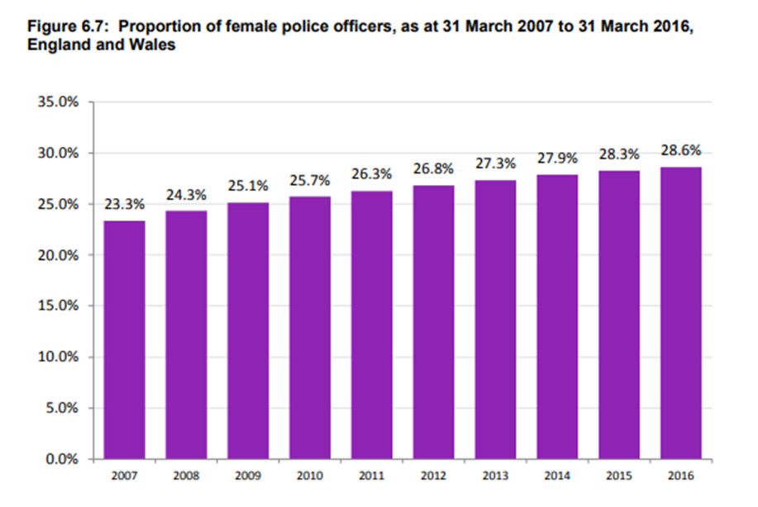
Figure one: Home Office (2016).
The chart in which can be found directly above reveals how the quantity of female police constables in all forty-three police forces in England and Wales has shifted every year since 2006/2007. Over the same period of time the percentage of female police officers has grown from just over thirty-three thousand in the years 2006/2007 to over thirty-five thousand by the years 2015/2016 which proposes that the issues female individuals face in male controlled occupations explicitly the police force in this case, are improving as time moves on.
For years there have been suggestions of prejudice and marginalization towards female individuals within the police force in this country in accordance with Westmarland (2001). Heidensohn (1995) argued;
Being a distinguishable minority creates the potential for conflict or constraint in any situation; being a part of a small minority in such a cohesive group as the police is a further problem, but to be a woman in such an insistently masculinist culture triples the problems (p. 129).
As said by Gianettoni and Guilley (2016), in spite of this quotation being over twenty years old, it ought to still be deemed how powerful it remains. Even in today’s contemporary culture and within the United Kingdom’s police forces all over the nation a number of people would still say it remains meaningful. Corresponding to Kriton and Greene (2010), policing has continually been seen as a ‘man’s world’ which guaranteed that men were offered the more potent places within the police force and monitored the stream of ability through the hierarchy. Even as the world has evolved more male individuals can usually be found within the more active, physical and firearm positions within the police forces in England and Wales. According to Richards (2001), women in the police force are more generally centred in office, childcare, and domestic kind of jobs. In the previous few years, the objective of the police position in this country has expanded further than the streets and moreso into the personal lives of civilians. This basically indicates that the police are dealing with more intimate, household and community problems. This in turn has generated a change in the composition of the structure of the police force in regards to the arrangement of the positions offered to more victim support type of responsibilities. In principle, this ought to have launched more work prospects within the police force for female individuals and as a consequence produced a more gender reflective and more evenly balanced workforce. Lastly, as stated by Allen and Dempsey (2016), figures show that an equate personnel within the police force in England and Wales has still not yet been recognized with just twenty three percent of women being in leading ranks.
According to Martin (1996), on top of this, a number of scholarly authors have also contended that women within the police force may well disguise their femininity or act in masculine ways. This has been said to be done to accomplish success, prevent any unwelcome interest and to merge into the organization easier. In other words, according to Maddock (1999) policewomen wanted to come to be ‘one of the boys’. Nevertheless, more recently there has become a different kind of female within the police force. One who is more self-confident, more independent, more ambitious, publicly womanlike, reluctant to hold themselves back, unwilling to blend in and those who may well be even more efficient than their male equivalents.
In conclusion, as indicated by Kleinlogal and Dietz (2016), in spite of the apparent barriers for women within a police situation such as establishment level prejudice and stereotype risk, there are gradually becoming more female individuals within management ranks in this country. This indicates, as asserted by Hoyt (2010) that it is feasible for women to effectively navigate their way through the police force to higher level positions. Silvestri (2003) even proposed that;
the fight for a place in policing must continue to come from women themselves (p.183).
In brief, according to Derks and Ellemers (2016), women fighting for other women could well be the greatest route to accomplish success in concerns to women within the police force in England and Wales.
The Prevalence of Women in South Wales Police Force in Comparison to Others in England and Wales
According to the South Wales Police (2022), in today’s present society there is no job within South Wales police that a woman cannot fulfil or is incompetent of. The vital influences created by female associates, both in today’s world and right the way throughout history have been an enormous role in the ongoing establishment they have come to be.
On top of this, according to South Wales Police (2020), as of March 2020, South Wales police hired over two and a half thousand police staff not involving police community support officers in total. More of these individuals were female at over one and a half thousand in parallel to not even a thousand men being part of this group of new police team colleagues. This equates to over sixty percent of all South Wales police staff being female which is a 0.20% rise from the prior year. Following on from this, as of March 2020 South Wales Police also employed over three thousand new police officers. However, less than a thousand of these individuals were female with over two thousand being male. Overall, only just over thirty percent of all South Wales Police officers are women but is a 0.50% increase from 2019. Ultimately, the South Wales Police claim to have made substantial improvement over the previous decade. There were over a hundred new police hires in 1998, only thirty-two of which were women which equates to just under thirty percent. The South Wales Police have a target of a fifty to fifty percent ratio of male and female personnel. In spite of this though, at the close of March 2020, forty percent of all new employees to South Wales Police were female. This is, nevertheless, a small reduction of forty three percent from the earlier year. Due to a few of these statistics the development involving women in the police force may well be doubted regarding South Wales Police. According to South Wales Police (2017), a report revealed that men and women within South Wales police are not being salaried inversely for equivalent labour, however there is a higher figure of women employed within the lesser grades of police staff and there is a minor amount of female police officers as a whole. In addition to this, South Wales Police do have a delivery proposal set up for female development, staffing, and maintenance in the police force. This underlines the effort that has been carried out to promote female individuals to join the police force and continue upwards throughout it. This is in order to encourage women’s health and welfare whilst working within the police and promote a compassionate, equal functioning environment for men and women similarly. From this knowledge several individuals contend for and contrary to the work and support South Wales Police have and are currently putting into women working within their police force. As explained by Shelley, Morabito and Tobin-Gurley (2011), women within the police are underrepresented countless may well claim particularly in South Wales Police although across the police service nationwide too. This research will go on to evaluate the information relating to women within South Wales police force and link it to further police forces in England and Wales to assess this assertion.
To evaluate these numbers from South Wales Police to a different police force in Wales, according to Gwent Police (2021) statistics show that only one third of all police officers employed recently within Gwent were female. On top of this, records discovered that out of the over three hundred new police officers appointed by Gwent Police between April 2020 and March 2021, just thirty five percent of them were women. These numbers were amongst the lowest of all police forces in England and Wales but are in fact comparable to those of South Wales Police. These numbers were similarly smaller than across England and Wales as a whole, in which over forty percent of all new police recruits were women. According to The Guardian (2021), Gwent Police were under scrutiny towards the end of 2021 in concerns to female police officials operating within the force. They were made to make an apology to two female individuals who reported acts of domestic violence at the hands of a fellow colleague acting together with them. They were disregarded and Gwent Police failed to correctly examine the accusations of mistreatment made by both women. Both women were serving constables when they were exploited by the now previous police officer Clarke Joslyn. It leads to the doubt as to whether or not when women do essentially join the police force, are they being considered with the equal and just amount of regard as their male counterparts? And is there even now a stigma around female individuals within the police force? These issues may well be raised as there has still been claims of the police force retaining that ‘boys club culture’ it did hundreds of years ago.
Once again, to relate this to a police force in England, according to Essex Police (2021), from a shared personnel of roughly six thousand individuals, over half being police officials (58.7%) and just over forty percent being police staff. The majority of police staff are female at almost sixty five percent with the bulk of police sergeants equally being around sixty five percent male. These numbers however have subsequently been updated since the beginning of this year (2022). As stated by the Essex Police (2022), the force currently has hired 64.82% of female staff together with 65.69% of police officers being male. This study will dig into why women appear to lean more towards the police staff positions over police constable jobs according to these statistics. Lastly, of the nearly three and a half thousand police officials within Essex Police, only just over a thousand of them are female with the remainder being male. This equates to 65.69% of all police officers in Essex Police force being men combined with 34.31% being female individuals. Essex Police force is of a comparable range to South Wales Police with similar figures of men versus women personnel. It leads to the inquiry as to whether the small sum of women working as police officers in England and Wales is a common, nationwide problem this country is still confronting.
Stigma Surrounding Women in the Police Force in Comparison to Men
There has constantly been a stigma encompassing women within the police force in contrast to men. According to Brown and Heidensohn (2000), it is anticipated with the police force being a male led line of work for there to be gender divergence within the workplace. Women’s presence in policing has not been an easy-going journey and with several findings and document specific problems in which female police officers have had to struggle with. It is well-known over the decades that women within the police have been exposed to harassment, prejudice, and sexist mindsets. The stigma surrounding women in the police force will additionally be examined during this study through primary investigation. This will give the reader an understanding of the attitude of the public in the present day concerning this subject matter. As stated by Renzetti (2013), these problems and ideas have persisted into the contemporary culture seen today. In a policing perspective, it has been recognised that increasing amounts of female police officials may well decrease seclusion and help more female individuals into this career. Nevertheless, it has equally been asked as to whether or not figures alone would have any impact on the wider social attitudes of the community and personal patterns of conduct. According to Martin (1980), it has also been indicated that a development in the number of women in the police force will not weaken the male qualities that form the managerial society. Even though gender impartiality procedures have enhanced the status of women in the police force, the rising figures alone will not enable structural change short of the additional underlying and cultural difference that the world needs to see. In accordance with Kanter (1977), this can offer an insight to the clear relationship between the position of female individuals in policing and their encounters of provocation, isolation, and bias. According to Rawlings (2002) the situation in England and Wales fittingly notes the decline of female individuals within the police force taking on greater level positions. There has likewise been observed a fall in women pursuing policing as an industrial option. In doing so, it has been doubted as to the degree of encouraging change and improvement within the police force and today’s modern culture involving this issue.
As stated by Farrow (2022), one example of prejudice in the police involves the Metropolitan Police force who towards the start of this year (2022) were under an authoritative inquiry by the Independent Office for Police Conduct or more frequently recognized as the IOPC. This report unveiled details of currently serving police constables exchanging misogynistic and inequitable communications relating to their female associates. These messages implicated conversations of raping and attacking female individuals which they then set aside as ‘banter’. This information also came at a time of strong emphasis on how women are considered within the police force and within their positions. A number of individuals have criticised the informal working ethos to occur within the police in England and Wales conversationally identified as ‘cop culture’ according to Hunt (2008). This idea arose from policing exploration dating all the way back to the 1960’s and is usually seen as a contributing element to bad police conduct as well as the stigma and bigotry involving women in the police and how they are regarded. Scholarly investigators define ‘cop culture’ as action orientated, male led and assessing intense allegiance between specific classes of police officers. According to Caveney, Scott, Williams, et al (2019), the base of ‘cop culture’ is ingrained in the pressures that being in the police force carries which is then suppressed by police officers as they navigate their responsibilities. In an atmosphere where group loyalty, physicality and hostility is vital, a number of female co-workers can incredibly swiftly find themselves on the outside. This philosophy has an inclination to maintain and entice individuals that are drawn to this specific sense of being which is how the cycle remains. Several policing academics similarly view police culture as almost having a menacing undercurrent, arguing it encourages sexist, vulgar, and macho behaviour leading to severe cases of chauvinism. As specified by Bradford and Myhill (2013) manipulating behaviour, aggression and additional adverse traits linked to a hypermasculine working environment are positively rewarded by the group. Academic scholars have discovered that the police are unwilling to confront or change these current standards as well as a lack of diversity within the police forces in England and Wales. Various findings have also come across comparable cultures within other male-controlled professions such as the armed forces, where the working society has been connected to the forceful treatment of female counterparts.
In conclusion, according to Angehrn, Vig, Mason, et al (2021) it has been and continues to be revealed a further in-depth knowledge of the immense variations in the experience of male and female colleagues of the police force. As well as this how their encounters within their work may well correlate to or affect their psychological health. Those who work within the police force, whether male or female seem to be at a greater possibility of numerous separate mental wellbeing conditions than the general population, perhaps because of the nature of their job. As indicated by Velazquez and Hernandez (2019) female police colleagues cope with a number of mental, societal, and individual difficulties for a number of reasons, several due to the stigma surrounding them being within the police force. Female members of police staff are fewer in quantity than male and unfair conduct by both low- and high-profile male police can similarly be seen among them. This obviously does not help the communities stigma surrounding women within the police force. Such prejudices are noticeable in power over transport, inadequate control in self-governance and services. These circumstances then largely all play a role in women’s limitations in relation to better performances at work in similarity to their male equivalents. The stigma surrounding these women in the police force might likewise be that they are supposed to be unqualified to take on the challenges of the profession in contrast to men. Ultimately, as well as this, several individuals say that female police colleagues are incompetent of making the individual choices in time that their male seniors can.

Chapter Three: Methodology
Summary of Methods of Investigation
This segment will offer an outline of the investigation techniques used throughout this piece of work. It will start with summarizing the ethical matters of the research followed by a comprehensive clarification of the processes, strategies, and concepts of the inquiry as well as the limitations it could well involve.
Knowing what the word research really means is usually a perfect position to begin when conducting a brand-new piece of independent analysis. According to Cambridge Dictionary (2022), the phrase ‘research’ can be identified as ‘a detailed study of a subject, especially in order to discover (new) information or reach a (new) understanding’. On top of this, as expressed by Goddard and Melville (2001), in its most general meaning, the expression ‘research methodology’ is the learning of research procedures. On the other hand, the term can additionally relate to the practices themselves or to the scholarly debate of linked background theories. Essentially, a method is a structured procedure for achieving a certain goal, which in this case would be the aims and objectives of the research already stated in the first chapter of this document. According to Paradis, O’Brien and Nimmon (2016), there is at present, not enough investigation on the number of female individuals in South Wales Police as well as the community opinion on it too. To understand new data and build upon the existing body of research surrounding this subject, it has been concluded that the greatest system of information collection is primary data. It is expected that by accumulating research in this way it will allow the inquiry techniques to be designed to meet the research goals already set out at the commencement of this analysis. In supplement to this though, it similarly guarantees that the records collected are more dependable and in turn benefit the body of research on this issue as well as people's perspective on it.
According to Meloy (2008), a longitudinal analysis of this research would involve examining certain groups of individuals over a sustained period of time, which in several instances could even consist of decades of exploration being collected for only one piece of work. As stated by Payne and Payne (2004) for this specific piece of research, granted the time outline available to the investigator for this project a cross sectional procedure will be practical to the study and conducted right the way throughout as it has been measured as the most suitable process for this investigation. In accordance with Hammersley (2013), in addition to this, the research will use both qualitative and quantitative methods of inquiry which will assist the project when evaluating the number of female individuals currently working within South Wales Police. Qualitative study will be performed through the surveys dispersed throughout a number of social media platforms which can similarly be seen as a qualitative research procedure. This will allow the investigator to explore the public’s awareness of women within the police force as well as their means of thinking in regards to this subject matter. Nonetheless, as implied by O’Dwyer and Bernauer (2013) this research process can equally fall into quantitative exploration subsequent to the collection of questionnaire responses from the public. These responses can then be analysed to create, verify, and determine suggestions and assumptions that can then be applied during the course of this research paper.
Ethical Concerns of the Analysis
According to Vanclay, Baines and Taylor (2013), it is a necessary obligation when conducting any investigation that all the research carried out is achieved in a way in which adapts to existing moral requirements. To carry out proper examination, it is essential that the scholar adheres closely to the ethical guidelines at which are in place with utterly no deviation from them under any conditions. This is done to make sure that any and all inquiry accomplished is done so with ultimate honesty, equality for all and complete reliability. In concerns to the ethical issues of this individual research project, a variation of circumstances ought to be taken into consideration. First of all, an ethics document will be done by the researcher preceding any investigation taking place in relation to the study. This is in order to ensure that any ethical problems are tackled effectively and with an applicable attitude. On top of this, according to Gelling (2016), prior to the beginning of any study, ethical consent is needed to confirm that any investigation in which entails human applicants that takes place, fulfils the stringent standards and regulations which are in place.
This ethics form contains an outline of the aims and objectives of the investigation itself as well as a summary of the planned data compilation techniques for instance such as the questionnaire. Most significantly nevertheless, elements in this ethics document will notify the ethics commission that the academic themselves has deemed the possible threats of detriment that may perhaps be enforced on those contributing to this research project. It will additionally focus on how these dangers to individuals could be reduced as and where appropriate. According to the Imperial College London (2022), conforming with ethical standards guarantees that the respectability, safety, human rights, welfare, and protection of all those who are engaged in the study are totally safeguarded where feasible and at all times.
To begin with, preceding to taking part in this research project, participants are to be made completely informed and have full awareness of what will be involved during their involvement within this experiment. From this, they ought to then be capable of making an educated decision on whether or not they would still wish to contribute to the research after knowing what it involves from them. As stated by the University of Reading (2022), the ethical agreement document will likewise incorporate within it how the primary research will be carried out for example, in this case being a questionnaire distributed through various social media platforms. It will equally state the overall location of the investigation, how and where this information will be collected and how the participants will be obtained to contribute to the study such as social media in this instance. In addition to this, it will assert how the confidentially of contributors will be kept and how the investigator will appreciate the privacy of participants in order to reduce the likely threat of harm.
Research Methodologies Utilized Throughout
To embark upon this exploration, a mixed methods style will be implemented which will comprise of both quantitative and qualitative statistics being gathered. Undertaking quantitative research will allow for the responses from the questionnaire to be examined and then interpreted into unambiguous data which is less exposed to subjective fault or understanding. On the other hand, a quantitative methodology is utilized and similarly as valuable as quantitative data as it allows the researcher to gather information quickly together with its simplicity in obtaining contributors thoughts and responses. Corresponding to Elyisi (2016), a further advantage is that the application of both kinds of data gathering allows others to evaluate the value and authenticity of the investigations results as well as its replicability. This will additionally offer sufficient evidence so that the research project may well be replicated if required to do so. Nevertheless, even though a quantitative approach may perhaps produce adaptable mathematical statistics swiftly and clearly, it is crucial to emphasise that it does have its limits and drawbacks particularly when studying sensitive issues.
Quantitative data gathering techniques do not take into account the reason or significance behind the knowledge that is collected. Consequently, this does not present the investigator with a depth of knowledge good enough on the conclusions which may well be perceived as restricted in determining contributors perspectives. This in turn, may perhaps create an aspect of scepticism over the general conclusion of the investigation. In order to conquer this, it is essential that the scholar investigates the feelings, judgments, thoughts, and encounters of those contributing to the analysis to achieve a wider grasp on the subject matter. It equally allows the researcher to recognize the community’s point of view on this topic by maintaining an open mind to any and all thoughts. To integrate this into the primary data, specific questions will not be supplied with any fixed answers to choose from. Participants will be asked a question and then presented with space to answer in their own words which will allow for those contributing to help in the gathering of qualitative information. By doing this, the survey will give those responding to it a huge level of liberty instead of pushing contributors to just be able to choose a response from a predetermined sum of answers which have been assumed by the investigator. The supposed responses authored by the investigator may not precisely define the contributors actual opinions on the problem, which in essence may well suggest that an aspect of the academics prejudice would have infiltrated the study. According to Wheeldon (2010) it can additionally offer a whole depiction of the issue itself which allows for a greater, all-round interpretation of the participants responses as well as possibly improving the trust and precision of the information gathered. Lastly, as said by Balnaves and Caputi (2001), by implementing a mixed method attitude, this can equally imply that the general research paper is less conventional and unyielding in contrast to those that simply employ a quantitative controlled research paper.
Research Plans
Questionnaires circulated through a number of social media platforms will be the main region of primary examination completed throughout this analysis. It will benefit the inquiry as due to the fact this survey is being distributed on social media, it allows it to get to the highest number of individuals in order to hopefully achieve the best number of responses. This will clearly present the strongest statistics in which can then be analysed throughout the paper. In addition to this, according to King and Wincup (2008), since the intention is to reach as many people of all genders and ages as possible, it is anticipated that the best way to do this will be through social media being a quick and easy area to reach and obtain responses from. On top of this, as conveyed by Bloomberg and Volpe (2015) through the answers to this survey it will provide the researcher with an understanding into the publics individual attitudes relating to women within South Wales Police and from this knowledge, conclusions can be put together.
To acquire the study data through primary examination, an electronic multiple choice feedback form will be used. According to Lavrakas (2008), it may well have been ideal to similarly perform face to face conversations with female police staff in South Wales Police. This would have increased the value of information, however taken considerably longer to achieve in parallel to a virtual survey which can reach hundreds of people in a matter of minutes to obtain their point of view on this subject matter. As indicated by Evans and Mathur (2005), on the other hand there are a number of advantages related to organizing online exploration utilizing questionnaires. Models of this consist of their flexibility, ease, and accessibility for both the contributors and the investigator of the research paper. In addition to this, when studying issues in which may possibly be ethically inaccurate or poignant such as the distinction between male and female individuals, it may well be contended that several participants might be anxious to convey their sincere opinions or thoughts on the question. Thus, as acknowledged by Wright (2005), engaging techniques such as an online feedback form may perhaps work well in determining contributors genuine beliefs on a subject. This is because they can present participants with a degree of ambiguity which in certain circumstances may well be claimed as less intrusive or insinuating in contrast to a face-to-face meeting with an individual. This, subsequently in turn could offer the researcher with a more representative analysis due to the more truthful responses from the community. Finally, according to Clark, Foster, and Bryman (2019), electronic questionnaires additionally have the capacity in attaining a broader audience and from this generate larger amounts of information in a fairly short time. This likewise comes with an additional advantage of the academic being able to see the answers to their survey in actual time. To conclude, most virtual questionnaire generators are similarly free of charge to gain access to and disseminate, hence aiding running expenses of the research to remain comparatively low which is mainly useful when and if funding or time is a concern.
Research Ideas
According to Crossan (2013), there are two vital investigation ideas in which have been deemed proper to manage this research project; positivism and realism. This document will opt for a more realistic approach right the way throughout the task in responding to the problem of the research itself which is fairly similar to the positivism method. As expressed by Mill (2008), quantitative practices which have previously been spoken about including the evaluation of legitimate primary and secondary numbers will come from the results of the online study. This virtual questionnaire would have been arranged to collect the scientific data needed to be rationally proven throughout the report by the investigator. According to Collins and Hussey (2014), the positivism and realism methodologies allow for the employment of a number of various types of investigation procedures. These will, in addition enable the researcher to come up with a consistent conclusion which has been considered as the most appropriate tactic for this research paper. Corresponding to Ryan (2018), the realism style of this exploration varies greatly upon the notion of liberty from the human sense of thinking. This concept is established upon the idea of a logical approach to the progress of knowledge. In comparison to this nonetheless, the subsequent research idea that this analysis aims to take on is positivism. This can be characterized by a single approach to an inquiry that seeks out the situations or motives of any social crisis in a methodical way. On top of this, as stated by Howell (2013) there are additional advantages of employing the two shared ideas simultaneously during the course of this paper. An example of this is that the two techniques used collectively will generate reliable, efficient, and illustrative data as a conclusion to this research.
Following on from this, as explained by Gallaire, Minker, and Nicholas (2014), the two major processes linked to study methods are inductive and deductive. A deductive procedure necessitates the investigator to build an assumption centred upon pre-existing conclusions which will help in supervising primary inquiry to prove or deny such consequences. In contrast to this, as defined by Wilson (2020) a more inductive approach comprises of emerging concepts or assumptions established upon findings from primary data collected throughout the course of this investigation. Hence, right the way through this exploration a more inductive type of development will be used in order to achieve individual contributions through analysing outcomes from primary numbers gathered through the online questionnaire. To conclude, as indicated by Glaser (2014), the logic behind why an inductive practice is ideal for this particular research is that the data collected through the online questionnaire will be accumulated through primary means. This will be accomplished in an endeavour to reveal why these matters occur and any possible predispositions in the figures can then be assessed throughout the research paper.
Possible Research Constraints
There are a number of distinct research limitations that ought to be taken into consideration during the course of this investigation. In terms of the electronic questionnaire which will be spread through a number of social media platforms, it will be to a certain level, challenging to reach a representative sample of individuals. This is due to the involvement of people being voluntary and hence the success of a broad selection of demographics such as age, race, nationality, and gender is not in fact guaranteed. Due to this, it may well make the results of this survey fairly harder to carefully think about and thus build assumptions and recommendations on. In addition to this, a second constraint on this investigation is the timeframe in which has been assigned for this study to be finished. It is vital that this study sticks to a rigorous program of work in order to make certain it is complete within the timeframe. In regards the virtual survey which will be circulated through a variety of social media platforms, it will be to some extent challenging to attain a representative sample due to the contribution from the individuals being voluntary. Consequently, in order to accomplish involvement which compares demographics such as sex, race, nationality, and age is not necessarily assured and may possibly make the outcomes a little tougher to thoroughly consider and generate conclusions and suggestions from. In accordance with Attia and Edge (2017), a substantial amount of performing fair research involves guaranteeing that the opinions of all participants are exemplified precisely and as proposed by said contributors. In order to accomplish this, every attempt has been made to preserve an impartial attitude to the study to sustain fairness by using a reasonable level of reflexivity throughout the study. As stated by Galdas (2017) as with all exploration, it is crucial to note that erasing any chance of prejudice comes with its limits. Even though every endeavour will be done to produce an unbiased investigation, it is essential to emphasise that as an individual research study, it will not be peer examined. Taking this into regard it would be impossible to boldly state that all prospects of academic prejudice will be totally eradicated. Lastly, as expressed by Schutt (2009), the questionnaire will consist of a disclaimer at the beginning in order to notify participants that only those over the age of eighteen are allowed to take part in the completion of the survey. This provision will additionally inform contributors of the intent of the investigation and in ongoing with the questionnaire they are also giving their permission to take part in the body of this research and verify they are over the age requirement of this inquiry.

Chapter Four: Findings of Primary Data
An Overview of the Data Findings
The subsequent section of this paper will offer equally a conversation and evaluation of the outcomes discovered from this study while delivering a methodical demonstration of the conclusions which can then be examined in this chapter. A sum of 107 individuals contributed to this investigation by completing the electronic survey dispersed through a number of social media platforms. The purpose of this research is to explore the public perception of women within the police force and essentially discover the history of women in the police force particularly focusing on South Wales Police. The findings from South Wales Police can then be matched to additional police forces in England and Wales. The purpose of fulfilling this primary inquiry is to discover first-hand the perspectives of the neighbouring society concerning women in the police force, mainly South Wales Police. The concept of women and the police force in this country is what predominately incorporates in this research. The important regions of this document may well contain the potential prejudice that a number of individuals may perhaps still feel in relation to this subject matter. This exploration has likewise been crucial in tackling the prevalence of this problem that women even now confront in today’s contemporary society in comparison to male individuals. It is likewise essential to look into the rise or decline in the number of women in the police force as well as if there is a pay gap between men and women in the police, even in today’s community. Within these key segments it furthermore combines similarities to primary data found through virtual questionnaires distributed by means of a range of social media platforms.
The investigator led a wide assessment of the earlier scholarly writing on the subject matter. This was initially to gain a stronger understanding of the importance of this matter and this data was subsequently utilized to connect to the findings of this primary statistics discovered. From this knowledge, ideas were able to be founded which is what was employed to produce and moreover reinforce the questions of the online survey, as well as this ideas were similarly discovered and used throughout this research paper.
The virtual questionnaire applied as the primary data for this inquiry was made and circulated electronically through a number of different social media platforms. This was done in order to connect to as many and as broad of a range of individuals feasible. On top of this though, as explained by Harrison and Whalley (2008), it was similarly delivered online to professional platforms such as LinkedIn in order to reach a larger range of people which would obviously include more professional academics with higher education.
These conclusions from the online questionnaire will be examined throughout this chapter and related to the numerous topics already revealed from the analysis of past literature on the subject matter. It will also be evaluated as to whether or not the community still exhibit indications of bigotry in relation to their point of view of male versus female members of staff with the police force in this country. It may perhaps similarly be examined as to whether or not the mass media in the United Kingdom could additionally be a part of societies perception of this concern.
Participant Demographic of the Primary Research
The initial question raised in this feedback form was ‘how would you best describe your gender?’. The choices offered to the contributors were; male, female, nonbinary and prefer not to say. In sum 74.8% of all contributors identified themselves as female, with just 25.2% being male individuals and no participants identified themselves as nonbinary or would have preferred not to say.
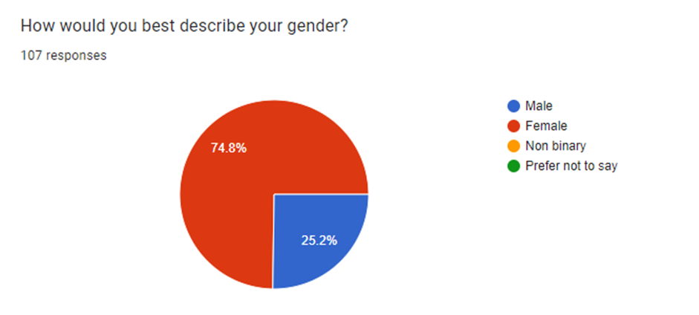
It may well be said that more female individuals in contrary to male decided to take part in this questionnaire as a consequence of the study being aimed at women. It could also be as an end result of current incidents reported in the media, such as the murder of Sarah Everard as well as the sudden increase in community support for women’s protection. This in conclusion may perhaps have made women feel more obliged towards participating to this survey and research in general. This information is centred on College of Policing (2022) who argue that even more ought to be done that is not already going on to safeguard girls and women in the world and make sure they feel dependable on the police.
Moreover, to this, question two queried participants of their age range asking, ‘what age are you?’ with the subsequent selections being; 18-24, 25-29, 30-39, 40-49, 50-59 and 60+. Those adding to the survey were asked this question as it was anticipated that the findings could be analysed to discover whether or not various age groups had conflicting perceptions on this subject matter. This is especially because it was anticipated that perhaps the older the contributors the more likelihood of there being indications of prejudice in respects to their perspective on women within the police force. This is due to the reality that according to Hargreaves, Cooper, Woods, et al (2016) up until the 1970’s, police forces in the United Kingdom separated its female members of staff from the male workers. This included split responsibilities, rankings and in a few instances even accommodations as well. The situation surrounding this switched in the 1970’s which saw the opening of the Sex Discrimination Act 1975 and the Equal Pay Act 1970. This was around the time that this discrimination stopped.
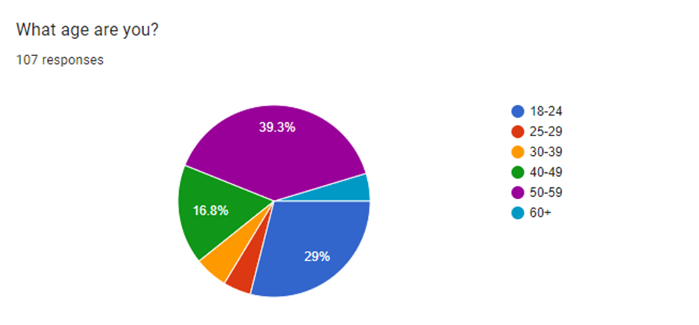
As explained by Andrade (2020), this study asserts that research conclusions can only be simplified if the example of individuals employed during the study are typical of the population. Even though it is not the main purpose of the research paper to concentrate on those taking parts gender classification or age, if recognised genders and age brackets of contributors were similarly signified in this review, it may perhaps have been likely to examine the responses more generally as illustrative of the entire community. Overall, though, the age categories of the contributors of this analysis are wide which allows for a better general demographic and hence a larger knowledge of the subject matter. This will allow the study to be as precise as feasible due to this. Nonetheless, as previously said, there were considerably more individuals who took part in this assessment in which recognized themselves as female rather than men. Due to this point, it is uncertain of how successful the outcomes ought to be concerning this as it may well lead to prejudice due to gender and the subject of this research paper. This relates to the second goal of this research paper as through the primary investigation obtained through an online questionnaire this has permitted the researcher to gain an interpretation of the community’s mindset concerning female individuals within the police force. Due to the discrepancy in figures of male versus female contributors of this analysis, it may well lead to the question as to whether or not men are not as enthusiastic or involved in this subject matter as it is not something they have ever had to challenge within this career or the world as a whole.
Participant Views in the Online Questionnaire
In terms of those contributing’s perspectives on women in South Wales Police. Question five stated ‘how many women do you imagine currently work as police officers in South Wales Police year ending 2021?’. The choices presented to the individuals participating were; 98, 148, 1076 and 2076. The results from this question were as follows;
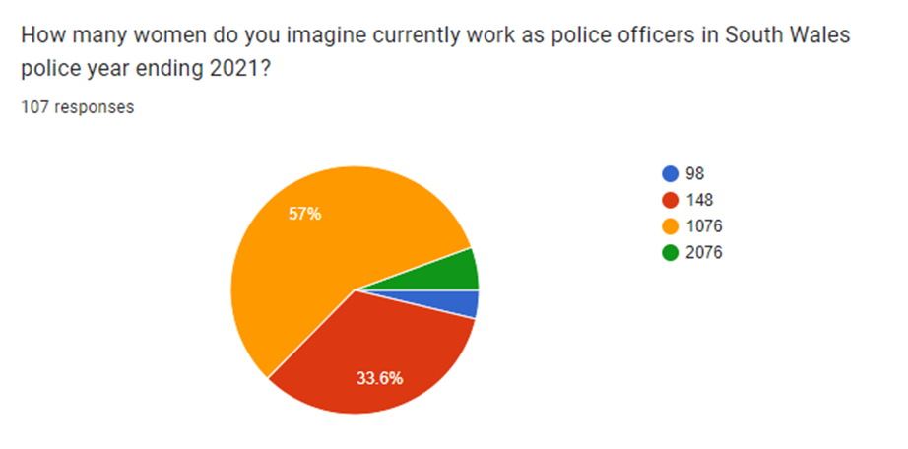
As seen in the above picture, over fifty percent of participants thought the exact figure to be 1076. This was in fact the correct amount of presently serving female police officers year ending 2021. This is interesting as just 5.6% of individuals chose the greater figure of 2076 in contrast to 3.7% of participants thinking it was the lesser alternative of 98. This can lead to the doubt as to whether a quantity of contributors merely picked one of the middle two choices presented as those were both chosen a collective total of 90.6% of all those taking part. As said by Ritter and Sue (2007), this can occasionally be a restriction to using online questionnaires. Several participants who may well be in a hurry to complete the survey will subconsciously opt for middle preferences in multiple choice questions. This clearly affects the aims of this inquiry as it may perhaps suggest that this primary investigation is not as precise as it could possibly be. Thus, as a consequence of this, it implies that a few of the objectives of this exploration may well be tougher to achieve because of this.
The next question was concerning who those contributing to this investigation thought made for a better police officer. The question posed was merely ‘who do you believe makes for a better police officer?’ The choices offered were male, female or unsure. It was no surprise that 77.6% of all those contributing selected ‘unsure’. It was previously anticipated for this option to be the most generally chosen and with the greatest percentage. It is likely that this is because it is virtually seen as the straightforward, unconfrontational and unoffensive choice. Male and female selections equally got an 11.6% of the total votes which was notable. This is because in accordance with Fritsvold (2022), it has been claimed that the world requires more women in the police force and working as police officers. It is alleged that women are more proficient at utilizing their communication abilities to assist them in resolving possibly unsafe and dangerous circumstances. This is a way in which is being progressively highlighted right the way around the world and in several police units together with England and Wales.
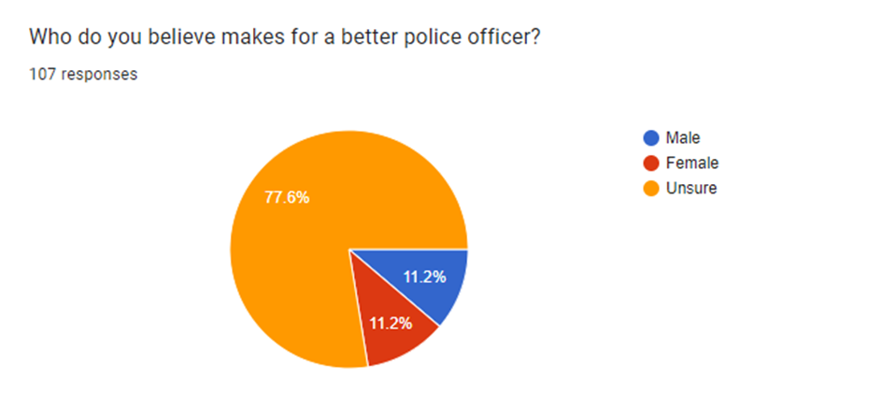
The question in which followed this in the online survey was one in which participants were able to form their personal response. The question posed was ‘what is your general opinion of South Wales Police?’. One individual wrote that they ‘treat football fans very differently to rugby fans’. This is especially fascinating as corresponding to the Home Office (2017), Cardiff City were found to have an overall reduction in the number of arrests and prohibition charges associated with football in the 2016 to 2017 football period. This similarly fell in line with the remainder of England and Wales. Cardiff City football supporters only received one new banning order which is a decline of nine less than the prior season. In spite of this, over a three-year parallel to other football associations in Wales, Cardiff City go on to have the largest figure of banning orders in the whole of Wales. In dissimilarity to this, as told by the BBC (2022) the Welsh Rugby Union and South Wales Police force have criticised the conduct of Welsh rugby supporters which led to an elderly man of eighty years old sustaining a severe injury. This restates that there are still instances which involve police authority and attention in both sport events consequently discounting this assertion.
On top of this, a further respondent stated that ‘there’s a lack of trust between police offers and the community that they work for’. This is underlined by Grierson (2022) asserting that police officers ought to work under an authorization of some kind which must be reinstated at least every five years. This would be accomplished in order to increase the peoples trust in the police force. This demonstrates that this is obviously a topic which passes through the whole of England and Wales. This information clearly reveals that this is a recurrent problem that has previously been underlined in England and Wales. In addition to this, this relates to the general purpose of this research paper as it emphasises that there are concerns that not simply South Wales Police face however several police forces challenge in England and Wales which makes for a contrast between them. This was crucial to the investigator going into this study as it was important to draw attention to parallels and distinctions between South Wales Police and additional police forces in England and Wales.
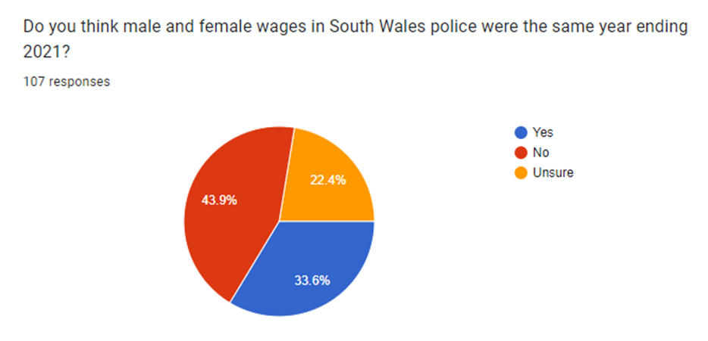
The above picture asks the question ‘do you think male and female wages in South Wales police were the same year ending 2021?. The options presented to participants were yes, no, and unsure. The findings displayed from this specific question are some of the most unexpected discovered throughout this study. According to South Wales Police (2021), as a police force they work for a society in which is fifty percent female. They would like to make sure that their personnel exemplifies the people they serve. Notwithstanding this, only over thirty percent of their police officers were women as of March 2021. In evaluating the average hourly wage of all South Wales Police officers with the median hourly salary of all their police staff, the combined gender pay gap of their collective workforce was over twenty percent. This was a surprising breakthrough, notably at the back of the outcomes of this question of the online survey with nearly half of all participants responding no. It was even more astonishing to find that this was a growth in the equivalent period in the prior year. It likewise suggests that there still ought to be a lot done in respects to women’s equality in similarity to men not only in the police force but in the whole of society. This was an equally significant outcome for the investigation as one of the goals of this research paper was to focus on the potential wage difference between male and female individuals operating within South Wales Police. On top of this, it has been vital to obtain a broader knowledge of the peoples opinion on this specific subject matter which facilitates the researcher to accomplish the aims and objectives of the analysis.
In a research paper carried out by Veldman, Meeussen, Van Laar, et al (2017), over six hundred workers employed in eighty-five separate police forces were examined in concerns to the impact of being different from other team colleagues in respects to gender. It similarly looked into additional employees awareness of their team members as well as their gender identity as contradictory with their individuality at work. The findings demonstrated that gender variation in the police force as a male dictated field was linked to apparent gender versus employment identity for women and not men. In turn, it was additionally discovered that women were noticed to be in positions within the police force that were lower than the male individuals. This was similar to the conclusions of the next question in this study which read ‘how many chief officers in England and Wales do you think were female year ending 2021?’.
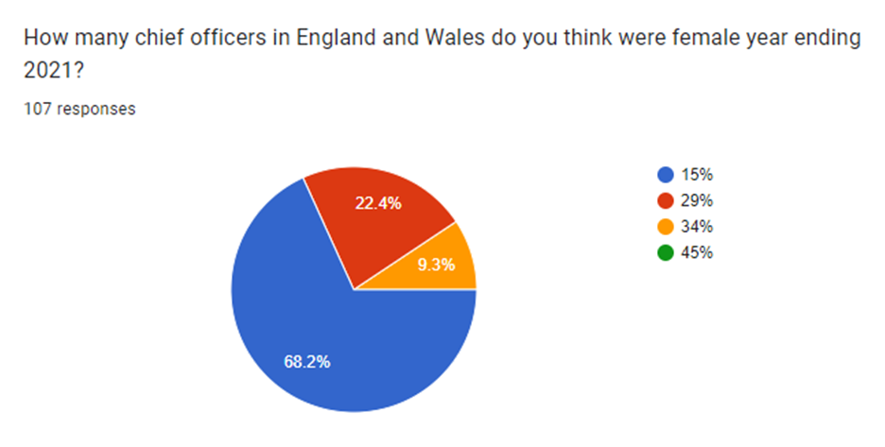
As found in the above chart, well over fifty percent of all participants thought that 15% was the exact answer. Just 22.4% of all contributors did in fact presume the answer precisely which was 29% of all chief officers in England and Wales year ending 2021 were female. Initially, it was startling that the mass of participants assumed it was the lowest possible answer of the four offered. Moreover, it is a surprising figure in itself that no more than 29% of all chief officers in England and Wales were female at the end of last year. It was necessary that this question was raised in the online feedback form as this granted the researcher of this investigation to gain an understanding into how many women the community thought worked in high-level employment positions within South Wales Police. The reality that well over half of all participants assumed it was the smallest of the four numbers presented to them may well indicate that the majority of people subconsciously do not suppose women are competent of being in high-ranking positions within a male ruled profession. This may perhaps be for two explanations. Due to their gender, thus emphasizing fundamental prejudice in today’s contemporary society. Secondly, according to Hunt (2008) several individuals may possibly suppose that due to the disproportionate opportunities between male and female individuals within the police force, that women are not given an equivalent chance to get to those positions in their vocation, irrespective of their ability and merely due to their gender.
Following on from this, the online questionnaire then goes on to ask if those participating believe that women are encouraged enough in society to join the police force in their opinion. The results are as follows;
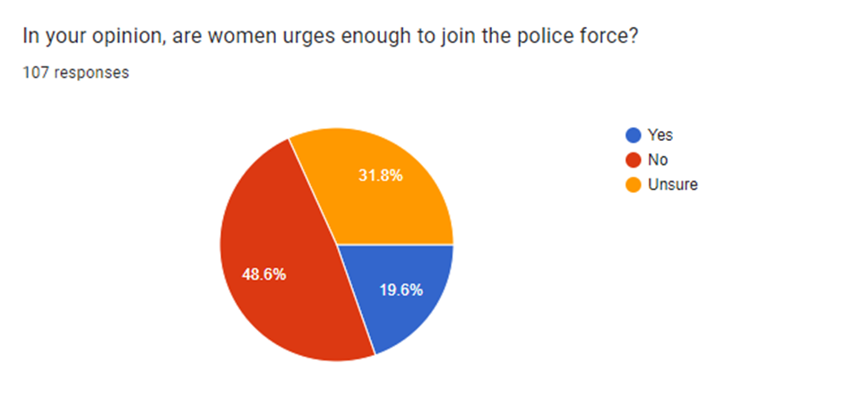
This was a very surprising outcome with almost half all participants choosing ‘no’. It was unexpected since it was earlier expected that the majority of responses would be ‘unsure’ as that is the middle ground answer. This is for the reason that this decision is found to be the most simple, instant reaction to the online survey which does not inevitably involve any contemplating. According to the College of Policing (2021), in full over eleven thousand brand new police officers have been employed throughout England and Wales as part of their Police Uplift Programme. Female police officers accounted for nearly half of all new joiners between July and September of 2021 which undermines the conclusions of this specific question of the analysis. The outcomes from this investigation showed that the people do not think that women are encouraged enough to join the police force however this data demonstrates otherwise from just last year. In supplement to this, over the past year Lancashire, Kent, Derbyshire, Suffolk, Sussex, Thames Valley, and Staffordshire have appointed more female individuals than male. This completely relates to the main purpose of this investigation which was to look into the number of female individuals employed within South Wales Police as well as other police forces throughout England and Wales.
According to Bishu and Headley (2020) the police force in England and Wales is still a male-controlled career which echoes and supports the findings of the subsequent question of the online feedback form which reads ‘do you view the police as being a male dominated profession?’. A vast total of 71% of all those taking part consider it is. Bishu and Headley (2020) likewise suppose that gender inequalities are apparent in all types of public sector agencies especially in the police force. In spite of outwardly equal prospects to access and engagement in these administrative job roles, they contemplate that women still confront gendered limits and obstacles that directly influence their encounters not just within their work but as well as their work associated results and accomplishments. Furthermore, it is contended that governmental and judicial remedies are not acceptable enough to reduce gendered incidents of female individuals operating within male dictated occupations. Instead, a social shift from within the workplace as well as the adjoining society needs to happen and is essential in allowing women in the police force to be as seen as the same as men.
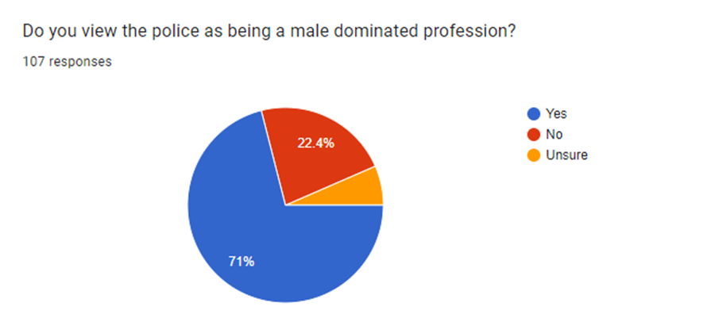
To follow on from this question, it was inquired why they think what they do in concerns to the earlier question. One individual answered with ‘because males are often believed to be more masculine, stronger than women’. This idea has been backed by study carried out by Franklin (2008), who states that investigation has been recognised that depicts the historic underrepresentation of women in general in policing. This also strengthens the third aim of this research paper which seeks to look into the history of female individuals within the police force in England and Wales. In addition to this, women within the police have repeatedly been seen as lower than men in accordance with Chen (2015) who restates the oppression these women have confronted in respects to community encounters with male police colleagues as well as professional expectations. Concepts in which try to clarify this dynamic among men and women in the police force fail to suggest an immediate relationship between the opposing practices of female police officers and a hypermasculine public structure.
Secondly to this, an additional individual wrote as their response to this question that; ‘some women may be afraid, or hesitant to join the police force due to the gender stigma’. A research paper carried out by Todak (2017) endorses yet rejects this argument. This research analysed how individuals make the choice to become police officers in the perspective of a police authority crisis. It similarly looked into the distinction between men and women’s decision-making procedure in this situation. It was revealed that female individuals expected to encounter more problems within the job role than male police officers due to their gender and underrepresentation within police employment. This clearly encourages this argument made by a contributor of the online questionnaire. Nevertheless, in opposition to this, female individuals seemed to be exceptionally determined to go into police work in order to prevail over gender specific disputes. The women who took part in this experiment felt as though they presented specific abilities in which men did not and discards the contention from the conclusions of this primary investigation.

Chapter Five: Overall Conclusion of Information
In conclusion, the main objective of this inquiry was to discover the number of female individuals within South Wales Police. On top of this nevertheless was similarly to look into the history of women in the police force in England and Wales as well as looking into the peoples point of view on women in the police force. This was in order to emphasize any bigotry which was initially expected to have been discovered in the population.
The leading conclusions of this study indicate that the mass of individuals who took part in the electronic questionnaire were essentially quite open and sincere in concerns to their thoughts on women in the police force and male-controlled professions in general. In spite of this though, it may well be contended that this was because the study was anonymous, hence taking away any of that awaited judgement surrounding the subject for the individuals. This may well have been something that those contributing were hesitant about facing prior to partaking in the feedback form. It was nonetheless surprising for individuals to be so vulnerable in respects to what they really thought of this subject matter. It suggests a potential change in current years encompassing this problem.
It is evident nevertheless, that there still remains disproportionate volumes of prejudice surrounding women in the police force which does not eliminate South Wales Police. This was something in which was revealed in the findings of the primary data survey. From the outcomes of this research paper, it has been discovered that a lot of this stigma comes from the public and not simply the police force in spite of the responsibility they play in it. It also seems as though a great deal of the trouble comes from the male individuals already working within the police force. The notion that the police force is a male led vocation comes from the labels made by the public that have been distorted by community perceptions that a women is not strong enough to be in such a career. This is something which may well prevent a variety of female individuals from entering this position regardless of their personal aspirations. This is an enormous matter for the whole of society and England and Wales which demands to be immediately developed. Hopefully this can be accomplished through the increasing of understanding and the downfall of these stereotypes of male versus women in the police force. In supplement to this, adverse encounters in which women have confronted being employed within the police force that have been reported, appear to have a massive negative effect on potential women from intending to enter into this career. From this data nevertheless, it appears to then have an extremely damaging effect on the perception of the police force as a whole in eyes of the public. This equally impacts the number of women joining the police force as it is expected that they will face adverse encounters at the back of it. In addition to this, it is apparent from these results that the claims that there is not adequate help and inspiration presented to women in contrast to men in respects to this career is real. On top of this, for those who say that sexism no longer occurs in today’s contemporary culture are apparently mistaken centred on the assumptions of the primary data of this research paper. Yet again, the blame at whom this rests with can be retained with both the police force together with South Wales Police and the neighbouring area. As a consequence of this, less female individuals are choosing to go into this career path due to the absence of equal opportunity that they consider will be given to them. From the conclusions of this research paper, it is expected that they will encounter discrimination from both inside the police force involving their male equivalents for example. As well as the sense in which they are seen by the public.
Suggestions for Future
- To start with, it is evident especially from the primary information of this study that there is a shortage of knowledge of the scope of this problem concerning women and men in the police force. It is vital that acknowledgement of these difficulties and how they can be faced and handled is looked into. In future, it is advised that more investigation is completed into this subject area in order to hopefully increase understanding of the matter and challenge the issue head on. This may well help differentiate women already employed within the police force and encourage a prospect of women choosing to go into this selected job.
- Moreover, the public ought to endlessly work in the direction of improving and shifting their attitudes on the police force as being a male dictated profession. This will also help in the decreasing of opinion that women do not fit in a career of such and consequently lead to the reduction of men and women being considered otherwise within their positions by the community. Through this, faith can be re-formed among the women in the police force and the society which will present them with ease to realize that they are being noticed and understood as equivalent to their male counterparts. This can equally be the beginning of the breaking down of that stigma in the world that encompasses female individuals within the police force.
- Moving on from this, it is currently believed that maybe the police force themselves ought to make resources accessible and more thorough for not only women but for men too to become more knowledgeable on the subject matter. If the shifts in disparity begin from within the police force and within the problem this may well lead to a difference in people's opinions in the wake of this. This suggestion comes from the literature review results which explained the need for recognition from the police themselves on what is being accomplished to confront this problem. As well as this, it is proposed that there ought to be open and honest discussions about how female individuals within the police are managing on a person level rather than work. This will also help in the beginning of breaking down that stigma between men and women in the police force and make it somewhat easier to openly discuss.

Reference List:
Alexander, J.A and Gaston, K.C. (1997), ‘Women In The Police: Factors Influencing Managerial Advancement’, University of Manchester, Manchester.
Andrade, C. (2020), ‘The Limitations of Online Surveys’, Sage, United Kingdom.
Angehrn, A, Vig, K, Mason, J, Stelnicki, A, Shields, R, Asmundson, G and Carleton, N. (2021), ‘Sex Differences In Mental Disorder Symptoms Among Canadian Police Officers: The Mediating Role Of Social Support, Stress, And Sleep Quality’, Taylor and Francis, Canada.
Astley, J. (2011), ‘Women In The Police Service: Why Do So Few Achieve The ACPO Ranks?’, University of Liverpool, Liverpool.
Attia, M and Edge, J. (2017), ‘Becoming A Reflexive Researcher: A Developmental Approach To Research Methodology’, Taylor and Francis, United Kingdom.
Balnaves, M and Caputi, P. (2001), ‘Introduction to Quantitative Research Methods An Investigative Approach’, SAGE Publications, United Kingdom.
BBC. (2022), ‘Wales V New Zealand: Bystander, 80, Hurt In Stadium Fight’, available at: https://www.bbc.co.uk/news/uk-wales-63533409, accessed on (24th of November 2022).
Bishu, S.G and Headley, A.M. (2020), ‘Equal Employment Opportunity: Women Bureaucrats in Male-Dominated Professions’, Wiley, United Kingdom.
Bloomberg, L.D and Volpe, M. (2015), ‘Completing Your Qualitative Dissertation A Road Map From Beginning to End’, SAGE Publications, United Kingdom.
Bradford, B and Myhill, A. (2013), ‘Overcoming Cop Culture? Organizational Justice And Police Officers’ Attitudes Toward The Public’, Emerald, United Kingdom.
Brown, J and Heidensohn, F. (2000), ‘Gender and Policing Comparative Perspectives’, Palgrave Macmillan, United Kingdom.
Cambridge Dictionary. (2022), ‘Research’, Cambridge University Press, Cambridge.
Caveney, N, Scott, P, Williams, S and Howe-Walsh, L. (2019), ‘Police Reform, Austerity And ‘Cop Culture’: Time To Change The Record?’, Taylor and Francis, United Kingdom.
Chen, R.H. (2015), ‘Women in Policing: In Relation to Female Police Officers’ Level of Motivation Toward the Career, Level of Stress, and Attitude of Misconduct’, University of Western Ontario, Ontario.
Clark, T, Foster, L and Bryman, A. (2019), ‘How to Do Your Social Research Project Or Dissertation’, Oxford University Press, Oxford.
College of Policing. (2021), ‘Police Hire More Women Than Ever Before’, College of Policing, United Kingdom.
College of Policing. (2021), ‘Police Hire More Women Than Ever Before’, available at: https://www.college.police.uk/article/police-hire-more-women-ever, accessed on (21st November 2022).
College of Policing. (2022), ‘Progress On Policing Commitment To Protect Women And Girls’, College of Policing, United Kingdom.
Collins, J. and Hussey, R. (2014), ‘Business Research: A Practical Guide for Undergraduate & Postgraduate Students’, fourth edition, Palgrave Macmillan, Hampshire.
Cordova, A and Kras, H. (2019), ‘Addressing Violence Against Women: The Effect of Women’s Police Stations on Police Legitimacy’, Taylor and Francis, United Kingdom.
Crossan, F. (2013), ‘Research Philosophy: Towards An Understanding’, volume eleven, RCN Publishing Company Limited, United Kingdom.
Cunningham, E and Ramshaw, P. (2019), ‘Twenty-Three Women Officers’ Experiences Of Policing In England: The Same Old Story Or A Different Story?, Sage, United Kingdom.
Derks, B and Ellemers, N. (2016), ‘Gender And Social Hierarchies: Introduction And Overview’, Routledge, London.
Diaz, V.M and Nuno, L.E. (2021), ‘Women and Policing: An Assessment of Factors Related to the Likelihood of Pursuing a Career as a Police Officer’, Sage, United Kingdom.
Dick, G and Metcalfe, B. (2007), ‘The Progress Of Female Police Officers? An Empirical Analysis Of Organisational Commitment And Tenure Explanations In Two UK Police Forces’, Emerald, England.
Dick, P and Jankowicz, D. (2001), ‘A Social Constructionist Account Of Police Culture And Its Influence On The Representation And Progression Of Female Officers: A Repertory Grid Analysis In A UK Police Force’, Emerald, United Kingdom.
Elyisi, D. (2016), ‘The Usefulness of Qualitative and Quantitative Approaches and Methods in Researching Problem-Solving Ability in Science Education Curriculum’, Queen’s University, Belfast.
Essex Police. (2021), ‘Gender Pay Gap Report’, Essex Police, Essex.
Essex police. (2022), ‘Gender Pay Gap Report’, Essex police, Essex.
Evans, J and Marthur, A. (2005), ‘The Value of Online Surveys’, Hofstra University, New York.
Farrell, J. (2011), ‘Writing a Built Environment Dissertation: Practical Guidance and Examples’, Blackwell, United Kingdom.
Farrow, K. (2022), ‘Misogyny In Police Forces: Understanding And Fixing ‘Cop Culture’’, University of Oxford, Oxford.
Franklin, C.A. (2008), ‘Male Peer Support and the Police Culture’, Taylor and Francis, United Kingdom.
Fritsvold, E. (2022), ‘Why We Need More Women Working in Law Enforcement’, University of San Diego, San Diego.
Galdas, P. (2017), ‘Revisiting Bias in Qualitative Research: Reflections on Its Relationship With Funding and Impact’, SAGE, United Kingdom.
Gallaire, H, Minker, J and Nicolas, JM. (2014), ‘Logic and Databases: A Deductive Approach’, Morgan Kaufmann Publishers, United Kingdom.
Gelling, L. (2016), ‘Applying For Ethical Approval For Research: The Main Issues. Nursing Standard’, Anglia Ruskin University, Cambridge.
Gianettoni, L and Guilley, E. (2016), ‘Sexism And The Gendering Of Professional Aspirations’, Routledge, London.
Glaser, K. (2014), ‘Inductive Or Deductive? The Impact of Method of Instruction on the Acquisition of Pragmatic Competence in EFL’, Cambridge Scholars Publisher, Cambridge.
Goddard, W and Melville, S. (2001), ‘Research Methodology: An Introduction’, second edition, Juta, United States of America.
Grierson, J. (2022), ‘Police Officers Should Work Under ‘Licence’ To Restore Trust – Report For England And Wales’, The Guardian, United Kingdom.
Gwent Police. (2021), ‘Gender Pay Gap’, Gwent Police, Wales.
Hammersley, M. (2013), ‘What is Qualitative Research?’, Bloomsbury, United Kingdom.
Hargreaves, J, Cooper, J, Woods, E and McKee, C. (2016), ‘Police Workforce, England and Wales’, Home Office, United Kingdom.
Harrison, M.E and Whalley, W.B. (2008), ‘Undertaking a Dissertation from Start to Finish: The Process and Product’, Taylor and Francis, United Kingdom.
Heidensohn, F. (1995), ‘Women in Control? The Role of Women in Law Enforcement’, Clarendon Press, Oxford.
Home Office. (2015), ‘Women In Policing’, available at: https://www.gov.uk/government/speeches/women-in-policing, accessed on (1st August 2022).
Home Office. (2016), ‘Police Workforce, England and Wales, 31 March 2016’, Home Office, United Kingdom.
Home Office. (2017), ‘Football-Related Arrests And Banning Orders, England And Wales: Season 2016 To 2017’, United Kingdom government, United Kingdom.
Howell, K. (2013), ‘An Introduction to the Philosophy of Methodology’, SAGE Publications, United Kingdom.
Hoyt, C.L. (2010), ‘Women And Leadership’, Sage, United Kingdom.
Hunt, J.C. (2008), ‘The Logic of Sexism Among Police’, Taylor and Francis, United Kingdom.
Hunt, J.C. (2008), ‘The Logic of Sexism Among Police’, Taylor and Francis, United Kingdom.
Imperial College London, (2022), ‘Ethics Approval Overview’, Imperial College London, London.
Jackson, L.A. (2000), ‘Everyday Violence in Britain, 1850-1950’, Routledge, United Kingdom.
Jackson, L.A. (2013), ‘Women Police Gender, Welfare And Surveillance In The Twentieth Century’, Manchester University Press, Manchester.
Kanter, R.M. (1977), ‘Men and Women of the Organisation’, Basic Books, New York.
Kepes, S, Banks, G.C and Oh, I.S. (2012), ‘Avoiding Bias in Publication Bias Research: The Value of “Null” Findings’, Springer, United States of America.
Kester, J.A. (2003), ‘Sherlock’s Sisters’, Routledge, London.
King, R.D. & Wincup, E. (2008), ‘Doing Research on Crime and Justice’, second edition, Oxford University Press, Oxford.
Kirton, G and Greene, A.M. (2010), ‘The Dynamics Of Managing Diversity—A Critical Approach’, Butterworth-Heinemann, Oxford.
Kleinlogel, E.P and Dietz, J. (2016), ‘A Model Of Gender Prejudice, Power, And Discrimination: How Hierarchy-Enhancing Factors Predominate Over Hierarchy-Attenuating Factors’, Routledge, London.
Lavrakas, P. (2008), ‘Encyclopaedia Of Survey Research Methods’, Sage Publications, United Kingdom.
Leech, N.L, Dellinger, A.B, Brannagan, K.B and Tanaka, H. (2009), ‘Evaluating Mixed Research Studies: A Mixed Methods Approach’, Sage, United States of America.
Maddock, S. (1999), ‘Challenging Women—Gender, Culture and Organization’, Sage, London.
Martin, P.Y. (1996), ‘Gendering And Evaluating Dynamics—Men, Masculinities, And Managements’, Sage, London.
Martin, S.E. (1980), ‘Breaking and Entering. Policewomen on Patrol’, University of California Press, London.
Meloy, J. (2008), ‘Writing the Qualitative Dissertation: Understanding by Doing’, Second Edition, Taylor and Francis, United Kingdom.
Mill, J.S. (2008), ‘Auguste Comte and Positivism’, Cosmio, New York.
O’Dwyer, L and Bernauer, J. (2013), ‘Quantitative Research for the Qualitative Researcher’, SAGE Publications, United Kingdom.
O'Neill, M.E, Marks, M and Singh, A. (2007), ‘Police Occupational Culture: New Debates And Directions’, University of Salford, Manchester.
Paradis, E, O’Brien, B, Nimmon, L, Bandiera, G and Martimianakis, T. (2016), ‘Design: Selection of Data Collection Methods’, available at: https://www.ncbi.nlm.nih.gov/pmc/articles/PMC4857496/, accessed on (20th September 2022).
Payne, G and Payne, J. (2004), ‘Key Concepts in Social Research’, SAGE Publications, United Kingdom.
Prenzler, T and Sinclair, G. (2013), ‘The Status Of Women Police Officers: An International Review’, Elsevier, United Kingdom.
Rawlings, P. (2002), ‘Policing: A Short History’, Willan, United Kingdom.
Renzetti, C.M. (2013), ‘Feminist Criminology’, Routledge, London.
Richards, W. (2001), ‘Evaluating Equal Opportunities Initiatives—The Case For A ‘Transformative’’, Palgrave Macmillan, Hampshire.
Ritter, L.A, Sue, V.M. (2007), ‘Introduction To Using Online Surveys’, Wiley, United Kingdom.
Ryan, G. (2018), ‘Introduction To Positivism, Interpretivism And Critical Theory’, Open University, United Kingdom.
Scharff, C. (2019), ‘Prepare Her For Sexism’, Sage, United Kingdom.
Schutt, RK. (2019), ‘Investigating the Social World: The Process and Practice of Research’, nineth edition, SAGE Publications, United Kingdom.
Seklecki, R and Paynich, R. (2007), ‘A National Survey of Female Police Officers: An Overview of Findings’, Taylor and Francis, United Kingdom.
Shelley, T, Morabito, M and Tobin-Gurley, J. (2011), ‘Gendered Institutions And Gender Roles: Understanding The Experiences Of Women In Policing’, Taylor and Francis, United Kingdom.
Silvestri, M, Tong, S and Brown, J. (2013), ‘Gender and Police Leadership: Time for a Paradigm Shift?’, Sage, United Kingdom.
Silvestri, M. (2003), ‘Women in Charge: Policing, Gender and Leadership’, Willan Publishers, United Kingdom.
Silvestri, M. (2017), ‘A Tale Of Conflict And Cooperation’, Routledge, United Kingdom.
South Wales police. (2017), ‘South Wales Police Gender Pay Gap Report 2017’, South Wales police, Wales.
South Wales police. (2020), ‘South Wales Police Gender Pay Gap Report 2020’, South Wales police, Wales.
South Wales Police. (2021), ‘Gender Pay Gap Report’, South Wales Police, South Wales.
South Wales Police. (2021), ‘South Wales Police Gender Pay Gap Report 2020’, South Wales Police, Wales.
South Wales police. (2022), ‘Seventy-Five Years Of Women In Policing In Cardiff’, available at: https://www.south-wales.police.uk/news/south-wales/news/2022/ion-jan/seventy-five-years-of-women-in-policing-in-cardiff/, accessed on (3rd August 2022).
Springer. (2022), ‘Materials and Methods’, available at: https://www.springer.com/gp/authors-editors/authorandreviewertutorials/howtopeerreview/materials-and-methods/10286404, accessed on (17th November 2022).
The Guardian. (2021), ‘Gwent Police Sorry For Failures Over Female Officers’ Abuse Claims’, available at: https://www.theguardian.com/uk-news/2021/nov/24/gwent-police-apologises-for-failing-to-investigate-officers-reports-of-abuse, accessed on (8th August 2022).
Thomas, D and Hodges, I. (2010), ‘Designing and Managing Your Research Project: Core Skills for Social and Health Research’, Sage, United Kingdom.
Todak, N. (2017), ‘The Decision to Become a Police Officer in a Legitimacy Crisis’, Taylor and Francis, United States of America.
University of Reading. (2022), ‘Research Ethics And Data Protection’, University of Reading, Reading.
Vanclay, F, Baines, J and Taylor, N. (2013) ‘Principles For Ethical Research Involving Humans: Ethical Professional Practice In Impact Assessment’, Taylor and Francis, United Kingdom.
Velazquez, E and Hernandez, M. (2019), ‘Effects Of Police Officer Exposure To Traumatic Experiences And Recognizing The Stigma Associated With Police Officer Mental Health: A State-Of-The-Art Review’, Emerald, United Kingdom.
Veldman, J, Meeussen, L, Van Laar, C and Phalet, K. (2017), ‘Women (Do Not) Belong Here: Gender-Work Identity Conflict among Female Police Officers’, Center for Social and Cultural Psychology, Belgium.
Westmarland, L. (2001), ‘Gender and Policing—Sex, Power and Police Culture’, Willan Publishing, Devon.
Wheeldon, J. (2010), ‘Mapping Mixed Methods Research: Methods, Measures, and Meaning’, Acadia University, Canada.
Wilson, J. (2010), ‘Essentials of Business Research: A Guide to Doing Your Research Project’, SAGE Publications, London.
Wiltshire Police. (2021), ‘2020 Gender Pay Gap Report’, Wiltshire Police, Wiltshire.
Wright, K. (2005), ‘Researching Internet‐Based Populations’, Oxford Academic, Oxford.

Bibliography:
Home Office. (2021), ‘Over 11,000 Police Hired With More Women Than Ever Before’, available at: https://www.gov.uk/government/news/over-11000-police-hired-with-more-women-than-ever-before, accessed on (1st August 2022).
Home Office. (2022), ‘Police Workforce, England And Wales: 31 March 2021 Second Edition’, available at: https://www.gov.uk/government/statistics/police-workforce-england-and-wales-31-march-2021/police-workforce-england-and-wales-31-march-2021, accessed on (1st August 2022).
Jones, J. (2017), ‘How Can Mentoring Support Women In A Male-Dominated Workplace? A Case Study Of The UK Police Force’, Palgrave, United Kingdom.

