Article
Climate, desertification and the Green Wall – how trees can advance women’s rights in the Sahel drylands
[REDACTED]
ªUniversity of Wales Trinity St David, Waterfront Campus, Swansea
A R T I C L E I N F O |  | A B S T R A C T
Article History:  Submitted 27 January 25 |  | Desertification in the Sahel is caused by anthropogenic pressures and climate change, and worsens poverty rates. This particularly impacts women, who comprise the bulk of the agricultural workforce and therefore suffer a loss of social standing. The Great Green Wall is an international project planting a band of trees 9 miles deep across the continent to halt desertification and rejuvenate agriculture. This has been aided in Burkina Faso by foreign aid organisations such as Ecosia, where project work has been carried out in conjunction with – rather than against – traditional gender roles, by paying local women to gather and plant seeds. This has resulted in increased women’s status in the region, and better agricultural activity and outputs. This paper makes recommendations for future work.  © 2025. Hosting by UWTSD. All rights reserved.
Keywords:
Climate change
Social impacts
Desertification
Great Green Wall
Poverty
Sahel
Gender roles
Female empowerment

Introduction
The Sahara Desert in northern Africa is an equatorial desert, and the largest and driest on Earth (Armon et al., 2024; NASA, 2024). Nonetheless, its past extent was far smaller than now, having spread relatively rapidly since Roman times (figure 1); since 1920 alone this spread is estimated to be 11% - 18% (Thomas and Nigam, 2018). The reasons for this increase are widely considered to be anthropogenic, largely originating with land-use changes in Roman times with widespread deforestation (McCarty, 2022) and continuing with poor agricultural practices under colonial rules (Davis, 2007).
In recent decades, however, this has been exacerbated by climate change bringing more droughts and extreme weather events (Armon et al., 2024; Rieder et al., 2024). This spread has led the Sahara to now encroach south into the Sahel drylands (Gonzalez, 2001; Yang et al., 2022).

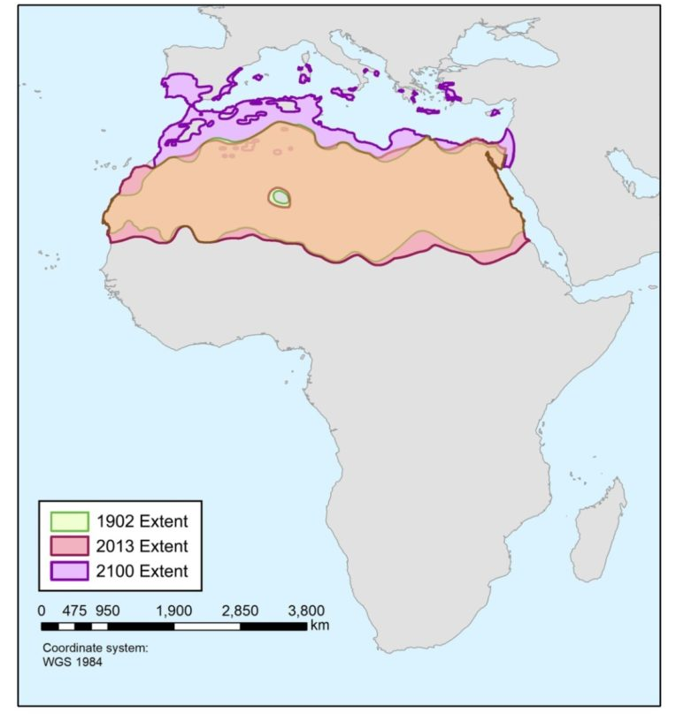
Figure 1. Saharan spread since 1902, and predicted by 2100 (Thomas and Nigam, 2018)

The socioeconomic impacts of this have been severe. This has hugely diminished farming outputs in the region, leading to food scarcity and associated social issues from Senegal in the west to Ethiopia in the east (Sacande and Muir, 2023). The poorer nations along this route have been particularly hard hit by this threat multiplication, such as Burkina Faso (Sacande, Parfondry and Martucci, 2018).
To counter the growing desertification, in 2007 work began on an $8 billion reclamation project across 27 countries named the Great Green Wall of Africa (Baker, 2019). By now progress has been more pronounced in the richer nations like Senegal, but even Burkina Faso has broken ground, aided by international partners such as the FAO and the search engine Ecosia (Sacande, Parfondry and Martucci, 2018; Ecosia, 2025a). This paper will explore the social impacts of both the threat and the solution, and examine the case study of Burkina Faso to extract recommendations for the future.

Literature Review

Desertification and the Sahara Desert
Desertification is a process in which a dryland slowly loses its vegetation, having profound impacts on hydrology and soil structure (Gonzalez, 2001; Sacande, Parfondry and Martucci, 2018). Vegetation will hold moisture in soil for longer; additionally, roots help to hold soil particles in situ, and the vegetation bodies protect soils from weather impacts. Without the vegetation, moisture evaporates from the soil far more quickly, leaving it dry and friable under hot sun. This turns it to dust that is then easily eroded by high winds, or by subsequent rain events (Yang et al., 2022; Sacande and Muir, 2023).
Anthropogenic climate change exacerbates this issue by triggering an increase in extreme weather events; droughts last longer in arid regions, and when rains do come they are markedly more severe (Armon et al., 2024). Heavy precipitation events (HPEs) in the Sahara are strongly associated with surface cyclones, have risen in frequency over the past several decades, and occur in the southern Sahara (into the Sahel) most commonly over summer when the sun is at its hottest (Armon et al., 2024). The intensity and frequency of HPEs has been such that there has been a rise in the number of lake-filling episodes in the otherwise dry desert (figure 2) (Rieder et al., 2024).
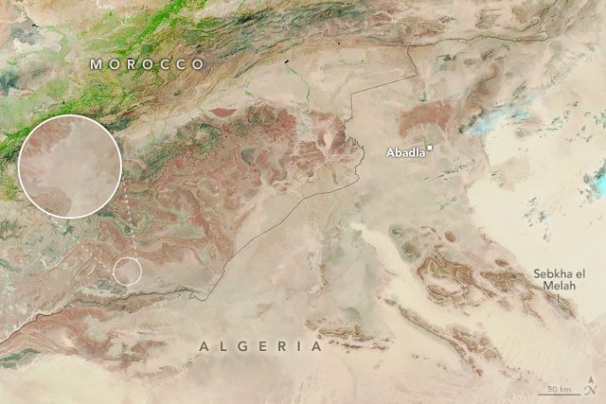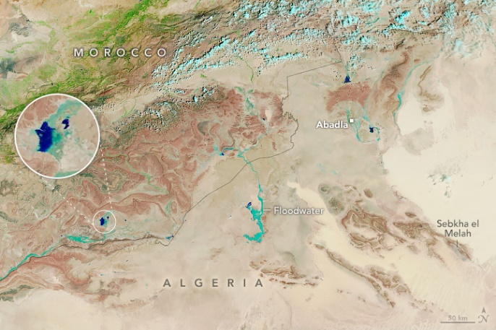
Figure 2. Floodwaters and lakes filled in Morocco and Algeria between 14 August 2024 (left) and 10 September 2024 (right) (NASA, 2024)

This effect is spreading rapidly into the Sahel drylands, traditionally a transitional region between fertile savannah and desert. Lake Chad saw a dramatic reduction between 1972-2007 (figure 3), while Mali desertifies at a rate of approximately 48km every year, leading to enormous losses in green cover since 1984 (figure 4) (Thomas and Nigam, 2018; Mulhern, 2021). 43% of Nigeria is now threatened with desertification (Gadzama, 2017).
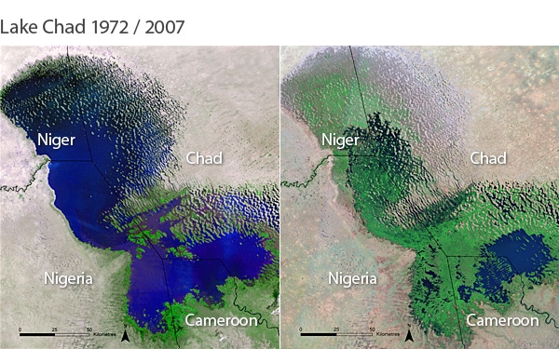
Figure 3. Reduction in Lake Chad's areal extent 1972-2007 (Mulhern, 2021)

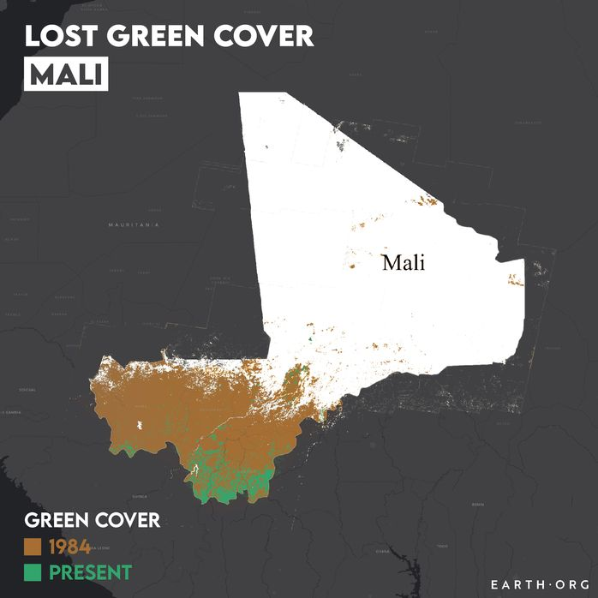
Figure 4. Loss of green cover in Mali since 1984 (Mulhern, 2021)

Agriculture in the Sahel Drylands
Agriculture in the Sahel is the majority industry, involving some 80%-90% of the population (Doso Jnr, 2014). Wind erosion and dust flux are the largest material threats, followed by drought, diminishing rainfall, overgrazing and agricultural intensification (Mulitza et al., 2010; Doso Jnr, 2014).
Traditional systems of farming in the region have employed sustainable variants of agroforestry, such as acacia tree systems. Here, acacias – a valuable source of gum Arabic, timber and fuel – are grown in groves, with crops sewn among them. The trees provide vital services in binding soil and conserving moisture, as well as increasing rainfall via evapotranspiration processes; they also protect crops and soils from wind erosion, the scorching summer sun and the HPE impacts, before providing an organic mulch with leaf fall, all of which also counters desertification (Heuze et al., 2016; UNCTAD, 2018). Pastoralism, too, benefits – the trees are an important source of browse for grazing animals during the dry season (Wickens et al., 1995; Doso Jnr, 2014).
However, there has been a loss of these agroforestry systems in the last century owing to agricultural intensification, climate change, and social pressures. Colonialism saw unsustainable changes in farming practices (Gadzama, 2017; Turner et al., 2023), while in the 1980s and 1990s, many acacia groves were over-harvested by camel-herding peoples migrating in from the increasingly drought-stricken lands they used to forage (Wickens et al., 1995).

Social Background
The Sahel has experienced a great deal of violent conflict thanks to a history of colonial rule and increasing environmental pressures from both land-use issues and climate change; a recent climate-induced example is the conflict in Darfur that led to the succession of South Sudan in 2011 (Kalilou, 2021). Lake Chad’s water loss has seen increasing conflicts between fishers, farmers and herders over diminishing resources (Barlow, 2013; Sachs, 2015), while resource-driven inter-ethnic clashes are on the rise, causing many states to attempt to control the problem with militarisation (Kalilou, 2022).
Gum Arabic production helps to alleviate much of this risk, as it increases resource availability and reduces economic pressures (Heuze et al., 2016; UNCTAD, 2018; Kalilou, 2021, 2022). Additionally, around 60% of women in the Sahel are employed in agriculture in some form, making this a vital industry for women’s empowerment (Bai et al., 2023). Violent conflicts and social upheaval frequently see the worst impacts borne by the most vulnerable in society, and in the Sahel this often translates to reductions in women’s rights and a drop in school attendance among children generally and girls in particular (Wickens et al., 1995; UNCTAD, 2018; Bai et al., 2023).

Discussion

The Great Green Wall of Africa
The original idea for a “green wall” to hold back the desert was posited in the 1950s by Richard St Barbe Baker (Mantle and Fisher, 2014), but re-suggested in 2002, approved by the Community of Sub-Saharan States in 2005, and then by the African Union in 2007 (African Development Bank, 2025). The plan is to plant in a 9 mile deep belt of trees through the countries of Senegal, Mauritania, Mali, Burkina Faso, Niger, Nigeria, Chad, Sudan, Ethiopia, Eritrea and Djibouti (figure 5), with the aim of restoring 100 million hectares, creating 10 million jobs, and sequestering 250 million tonnes of carbon by 2030 (UNCCD et al., 2020; African Development Bank, 2025).
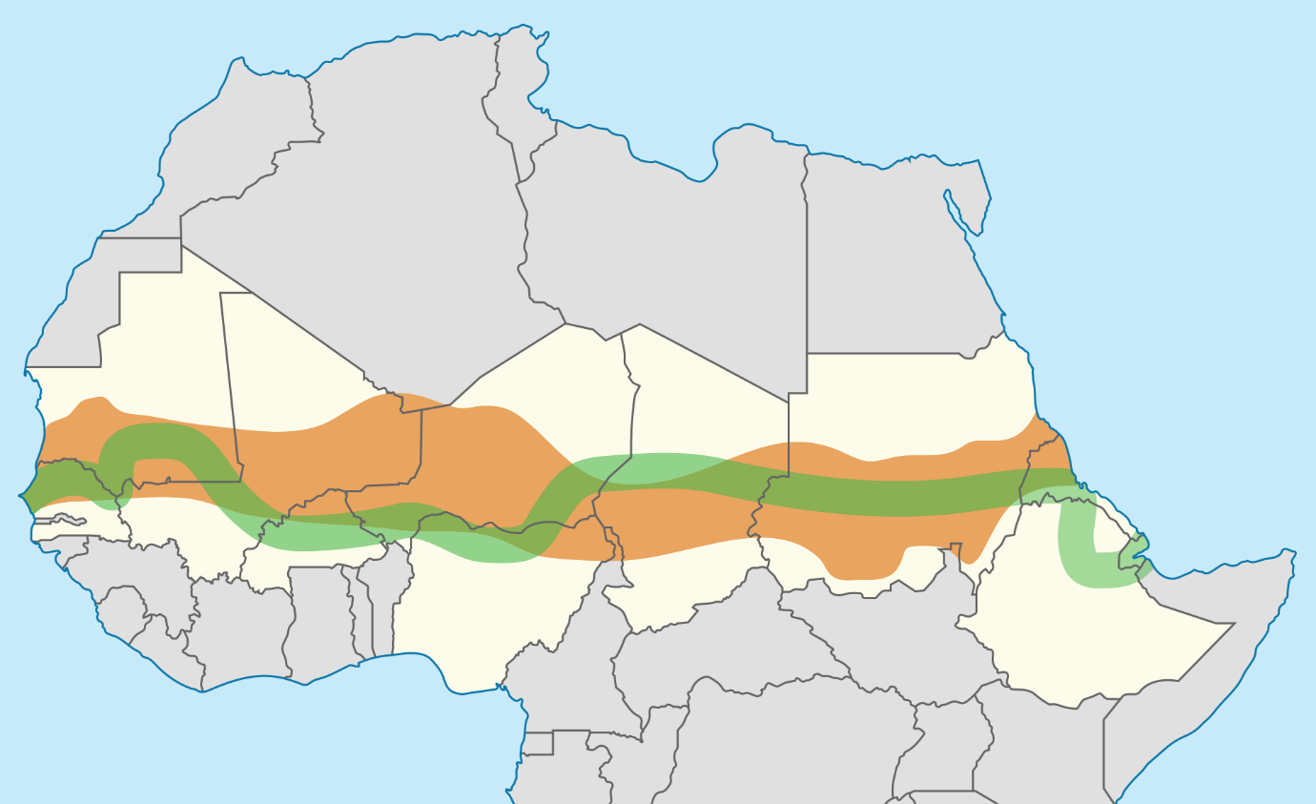
Figure 5. The Sahel region (brown), proposed Great Green Wall (green), and participating countries (white) (Sevgart, 2021)

By 2019, an estimated 15% of the wall was complete, with most gains made in Senegal (30 million acres), Ethiopia (37 million acres) and Nigeria (12 million acres) (Corbley, 2019). In addition to keeping moisture in the landscape and thus buffering the spread of the desert, other benefits have included groundwater wells re-filling, higher food security in rural areas, and additional incomes (Corbley, 2019). As of 2023, however, this figure had risen to just 18% (Raman, 2023).
The reasons for the slow progress are varied, but centre around economic and political issues. Sahel nations are mostly reliant on external and foreign funding such as from the EU, the African Union, or organisations such as Ecosia (Nature, 2023; Raman, 2023; Turner et al., 2023). Many projects associated with the Green Wall provide significant environmental or social benefits, but little in the way of economic returns, making investment politically risky; additionally, international donors preferentially invest in more politically stable countries, meaning less stable nations have been under-invested (UNCCD, 2022).
One such nation is Burkina Faso, one of the poorest countries participating in the Green Wall. In 2014, the search engine Ecosia began a tree-planting project in the country, which has now restored over 14,000 hectares; its success was such that it has now commenced further projects in Ethiopia, Mali and Senegal (Ecosia, 2025b). In addition to its environmental benefits, this has led to rises in women’s rights and other social factors. The causes of success of the Burkinabé project is examined below.

Case Study: Burkina Faso

Political and Economic Background
Between 1896 and 1960, Burkina Faso – then the Republic of Upper Volta – was a colonised protectorate of France, and suffered under oppressive colonial laws and multiple anti-colonial wars such as the Volta-Bani War of 1915-1917 (Gray, Saul and Royer, 2002; Rupley, Bangali and Diamitani, 2013; Engels, 2018). After independence was won, what followed was a tumultuous decades-long period of multiple coups in which repeated military leaders seized power, eroding Burkinabé democracy. One such leader in the 1980s was Thomas Sankara, who dedicated his rule among other things to improving women’s rights, mass vaccinating to improve public health, encouraging domestic agricultural consumption, and even creating a plan to plant over 10,000,000 trees to halt desertification (Engels, 2018; Louw, 2019); he also renamed the country to Burkina Faso. However, in 1987, Sankara was assassinated in a French-backed coup by Blaise Compaoré, who subsequently ruled for 27 years (Engels, 2018; Louw, 2019).
By the end of Compaoré’s reign, Burkina Faso remained one of the world’s least-developed countries (UN, 2016), a status it still held as of 2022, meaning it has a gross national income of less than USD$1,088, a human assets index (education and health) ranking of 60 or below, and an economic and environmental vulnerability index of 36 and above (UN, 2022). Multiple coups occurred since 2015 and a Jihadist insurgency commits regular terrorist attacks; many massacres have been committed by both government and terrorist forces, and in 2022 the government controlled just 60% of the country (Al Jazeera, 2022; Reuters, 2022; Human Rights Watch, 2023; Christensen, 2024).
The armed conflicts, combined with the droughts and floods, have dramatically interrupted markets, trade and agricultural security. Burkina Faso’s Global Hunger Index is 24.6 (serious), making it 98th out of 127 qualifying countries. 15.4% of the population is under-nourished, and 21.9% of children are stunted (GHI, 2024).

Social Structure
Burkina Faso contains around 60 different ethnic groups, all of whom have different social customs; however, there are many broad similarities in metrics such as gender roles. Burkinabé social structure generally holds that men are organisers and leaders, while women source and maintain supplies, roles that are particularly pronounced in rural areas (JICA, 2013; Ecosia, 2017). While the government has tried to improve women’s rights by enshrining their right to own land in law, there are many social, cultural and traditional factors that still enforce these roles (JICA, 2013). Early pregnancies and marriages make it difficult for girls to obtain education, an issue compounded by the need for additional workers in agriculture, a field in which women play a leading role (JICA, 2013; Bai et al., 2023). Women are 60% of Burkina Faso’s agricultural labour force and produce 70% of its food, yet own about 8% of its land (UNCCD, 2024).
However, women’s traditional roles have been affected by food scarcity; dwindling supplies to obtain mean they cannot carry out their normal socio-cultural duties, leading to a loss of social status (Ecosia, 2017). This then compounds other human rights issues faced by women in the region, particularly such as forced marriages and female genital mutilation (JICA, 2013).

Ecosia and the Great Green Wall
The principle of the planting is to dig a network of ‘half-moon’ pits, which will hold moisture and soil for longer after the rains (figure 6); into these, native and locally-important seeds are sown (Ecosia, 2025b). However, rather than foreign aid workers choosing and enacting the works, the project was implemented with and by the Burkinabé villagers who would be farming the area.
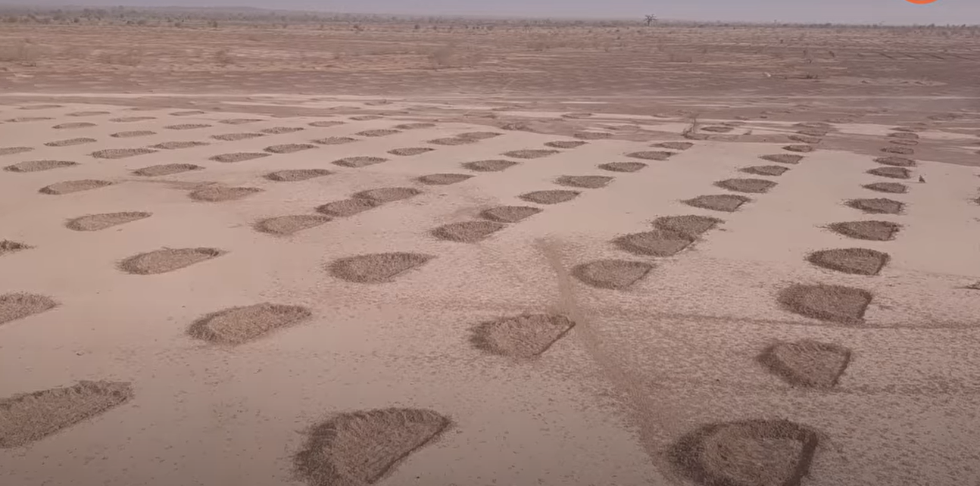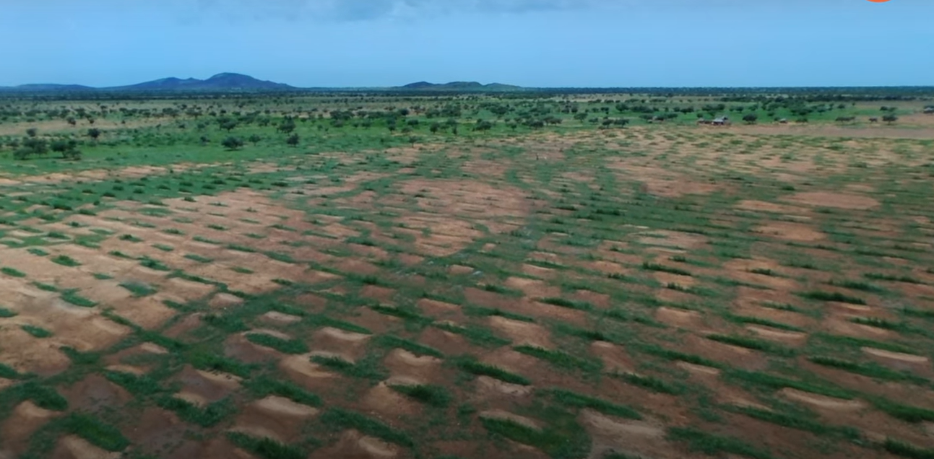
Figure 6. Burkina Faso's half-moon pits before (left) and after (right) the rainy season (Ecosia, 2017)

This involved working with Burkinabé gender roles. Trying to ‘cut across’ social roles can often cause programmes to stutter even when trying to counter those roles, as dominant actors may feel threatened and push back against the whole project (Alozie, 2024). Instead, project workers in Burkina Faso simply advised the men which trees and herbs to plant into each area, leaving them to decide. They then paid the women a fair wage to travel to areas with those plants and collect the seeds to bring back and grow in the pits. As this involved the women earning money and fulfilling their traditional duties, it increased their social standing in the participating villages (Ecosia, 2017). The wages also allowed women to justify their participation and provide for their families (Ecosia, 2017; Corbley, 2019; UNCCD, 2024).
This also allowed children – particularly girls – to return to school (Bai et al., 2023). As the plants grew and bore fruits, women would harvest these, and can now even establish co-operatives where they make additional wares for sale such as soap and handcrafts, something supported by the government to promote women’s rights (JICA, 2013).

Conclusion and Recommendations
Desertification is an urgent and profound issue in the Sahel, driven by both anthropogenic action and climate change and worsening both poverty and human rights in the region. The Great Green Wall, in areas where it has been enacted, has already borne positive results in halting desertification, improving agricultural outputs, and increasing women’s social standing. It is therefore recommended that the project should continue.
To this end, based on the literature and the case study of Burkina Faso, this paper makes the following recommendations:
- Foreign investors must invest more into even the more unstable nations of the Sahel. This could involve paying an apolitical third party already on the ground, such as Ecosia, to avoid political issues.
- Work should be carried out by locals, with foreign aid workers in a purely advisory role.
- Actions should be conducted in keeping with traditional socio-cultural roles, rather than ‘cutting across’ them.
- Locals – particularly women, as the main agricultural workers and the more socially vulnerable demographic – should be paid a fair wage for performing the work.

References
African Development Bank (2025) Great Green Wall Initiative. Available at: https://www.afdb.org/en/topics-and-sectors/initiatives-and-partnerships/great-green-wall-initiative (Accessed: 24 February 2025).
Alozie, M. (2024) “He didn’t allow me”: Gender and the Great Green Wall, African Arguments. Available at: https://africanarguments.org/2024/07/he-didnt-allow-me-gender-and-the-great-green-wall/ (Accessed: 24 February 2025).
Armon, M. et al. (2024) ‘Saharan rainfall climatology and its relationship with surface cyclones’, Weather and Climate Extremes, 43. Available at: https://doi.org/10.1016/j.wace.2023.100638.
Bai, L. et al. (2023) ‘Climate change and women employment in agriculture in the Sahel region: An empirical insight’, African journal of reproductive health, 27(10). Available at: https://doi.org/10.29063/ajrh2023/v27i10.11.
Baker, A. (2019) ‘The Great Green Wall of Africa.’, TIME Magazine, 194(11/12).
Barlow, M. (2013) Blue Future: Protecting Water and the Planet Forever. Toronto: House of Anansi Press.
Christensen, S. (2024) Suspected jihadists kill hundreds in Burkina Faso attack, Reuters. Available at: https://www.reuters.com/world/africa/suspected-jihadists-kill-hundreds-burkina-faso-attack-2024-08-27/ (Accessed: 24 February 2025).
Corbley, M. (2019) Dozens of Countries Are Working Together to Plant ‘Great Green Wall’ Across Africa – and It is Holding Back Poverty, Good News Network. Available at: https://www.goodnewsnetwork.org/dozens-of-countries-have-been-working-to-plant-great-green-wall-and-its-producing-results/ (Accessed: 24 February 2025).
Davis, D.K. (2007) Resurrecting the Granary of Rome: Environmental history and French colonial expansion in North Africa, Resurrecting the Granary of Rome: Environmental History and French Colonial Expansion in North Africa. Available at: https://doi.org/10.1215/00021482-83.3.421.
Doso Jnr, S. (2014) ‘Land degradation and agriculture in the Sahel of Africa: causes, impacts and recommendations’, Journal of Agricultural Science and Applications, 3(3), pp. 67–73.
Ecosia (2017) How tree planting empowers women. Available at: https://blog.ecosia.org/how-tree-planting-empowers-women/ (Accessed: 24 February 2025).
Ecosia (2025a) Burkina Faso, Ecosia. Available at: https://blog.ecosia.org/tag/burkina-faso/ (Accessed: 22 February 2025).
Ecosia (2025b) Re-greening the desert. Available at: https://blog.ecosia.org/burkina-faso/ (Accessed: 24 February 2025).
Engels, B. (2018) ‘Ernest Harsch: Burkina Faso. A History of Power, Protest, and Revolution’, PERIPHERIE – Politik • Ökonomie • Kultur, 38(1). Available at: https://doi.org/10.3224/peripherie.v38i1.11.
Gadzama, N.M. (2017) ‘Attenuation of the effects of desertification through sustainable development of Great Green Wall in the Sahel of Africa’, World Journal of Science, Technology and Sustainable Development, 14(4). Available at: https://doi.org/10.1108/wjstsd-02-2016-0021.
GHI (2024) Burkina Faso, Global Hunger Index. Available at: https://www.globalhungerindex.org/burkina-faso.html (Accessed: 24 February 2025).
Gonzalez, P. (2001) ‘Desertification and a shift of forest species in the West African Sahel’, Climate Research, 17(2 SPECIAL 8). Available at: https://doi.org/10.3354/cr017217.
Gray, L.C., Saul, M. and Royer, P. (2002) ‘West African Challenge to Empire: Culture and History in the Volta-Bani Anticolonial War’, The International Journal of African Historical Studies, 35(2/3). Available at: https://doi.org/10.2307/3097697.
Heuze, V. et al. (2016) Gum Arabic tree (Acacia Senegal). Available at: https://www.feedipedia.org/node/342 (Accessed: 22 February 2025).
Human Rights Watch (2023) Burkina Faso: Army Linked to Massacre of 156 Civilians. Available at: https://www.hrw.org/news/2023/05/04/burkina-faso-army-linked-massacre-156-civilians (Accessed: 24 February 2025).
Nature (2023) ‘Is Africa’s Great Green Wall project withering?’, Nature. Available at: https://doi.org/10.1038/d41586-023-01293-6.
Al Jazeera (2022) State controls just 60 percent of Burkina Faso: ECOWAS mediator, Al Jazeera. Available at: https://www.aljazeera.com/news/2022/6/18/state-controls-only-60-percent-of-burkina-faso-mediator (Accessed: 24 February 2025).
JICA (2013) Country Gender Profile: Burkina Faso . Ouagadougou. Available at: https://www.jica.go.jp/Resource/english/our_work/thematic_issues/gender/background/c8h0vm0000anjqj6-att/burkinafaso_2013.pdf (Accessed: 24 February 2025).
Kalilou, O. (2021) ‘Climate change and conflict in the Sahel: The acacia gum tree as a tool for environmental peacebuilding’, International Affairs, 97(1). Available at: https://doi.org/10.1093/ia/iiaa178.
Kalilou, O. (2022) Afforestation With the Acacia Gum Tree and Violent Conflict Mitigation in the Sahel Region. Seoul. Available at: https://openknowledge.fao.org/server/api/core/bitstreams/dda187ab-a971-4186-833f-171613a36109/content (Accessed: 22 February 2025).
Louw, S. (2019) ‘A Certain Amount of Madness. The Life, Politics and Legacies of Thomas Sankara’, Politikon, 46(3). Available at: https://doi.org/10.1080/02589346.2019.1642985.
Mantle, P. and Fisher, B.J. (2014) The Man of the Trees and the Great Green Wall: A Baha’i’s Environmental Legacy for the Ages, Wilmette Institute. Available at: https://web.archive.org/web/20151123051233/http://wilmetteinstitute.org/the-man-of-the-trees-and-the-great-green-wall-a-bahais-environmental-legacy-for-the-ages/ (Accessed: 24 February 2025).
McCarty, M.M. (2022) ‘Reforesting Roman Africa: Woodland Resources, Worship, and Colonial Erasures’, Journal of Roman Studies, 112. Available at: https://doi.org/10.1017/S0075435822000338.
Mulhern, O. (2021) Is the Sahara Desert Growing?, Earth.org. Available at: https://earth.org/data_visualization/the-past-present-and-future-of-the-sahara-desert/ (Accessed: 22 February 2025).
Mulitza, S. et al. (2010) ‘Increase in African dust flux at the onset of commercial agriculture in the Sahel region’, Nature, 466(7303). Available at: https://doi.org/10.1038/nature09213.
NASA (2024) A Deluge for the Sahara, NASA Earth Observatory. Available at: https://earthobservatory.nasa.gov/images/153320/a-deluge-for-the-sahara (Accessed: 22 February 2025).
Raman, S. (2023) Progress is slow on Africa’s Great Green Wall, but some bright spots bloom, Mongabay. Available at: https://news.mongabay.com/2023/08/progress-is-slow-on-africas-great-green-wall-but-some-bright-spots-bloom/ (Accessed: 24 February 2025).
Reuters (2022) Burkina Faso gives civilians 14 days to evacuate ahead of military operations. Available at: https://www.reuters.com/world/africa/burkina-faso-gives-civilians-14-days-evacuate-ahead-military-operations-2022-06-24/ (Accessed: 24 February 2025).
Rieder, J.C. et al. (2024) ‘Meteorological ingredients of heavy precipitation and subsequent lake filling episodes in the northwestern Sahara’, EGUsphere [preprint] [Preprint]. Available at: https://doi.org/10.5194/egusphere-2024-539, 2024. (Accessed: 22 February 2025).
Rupley, L., Bangali, L. and Diamitani, B. (2013) Historical Dictionary of Burkina Faso. The Scarecrow Press.
Sacande, M. and Muir, G. (2023) ‘Restoring Food Systems with Nutritious Native Plants: Experiences from the African Drylands’, Food and Nutrition Bulletin, 44(2_suppl). Available at: https://doi.org/10.1177/03795721231190779.
Sacande, M., Parfondry, M. and Martucci, A. (2018) Biophysical and socio-economic baselines - The starting point for Action Against Desertification. Rome. Available at: https://openknowledge.fao.org/handle/20.500.14283/ca0390en (Accessed: 22 February 2025).
Sachs, J.D. (2015) The Age of the Sustainable Development. New York: Colombia Press.
Sevgart, U. (2021) ‘Map of route of Great Green Wall, participating countries and Sahel’.
Thomas, N. and Nigam, S. (2018) ‘Twentieth-century climate change over Africa: Seasonal hydroclimate trends and sahara desert expansion’, Journal of Climate, 31(9). Available at: https://doi.org/10.1175/JCLI-D-17-0187.1.
Turner, M.D. et al. (2023) ‘Great Green Walls: Hype, Myth, and Science’, Annual Review of Environment and Resources. Available at: https://doi.org/10.1146/annurev-environ-112321-111102.
UN (2016) List of Least Developed Countries (as of May 2016), UN Committe for Developmet Dolicy.
UN (2022) List of Least Developed Countries (as of October 2022), UN Committe for Developmet Policy.
UNCCD et al. (2020) The Great Green Wall Implementation Status and the Way Ahead to 2030, The African Wall.
UNCCD (2022) Global Land Outlook 2nd edition. Available at: https://www.unccd.int/resources/global-land-outlook/global-land-outlook-2nd-edition (Accessed: 24 February 2025).
UNCCD (2024) Green jobs for women in Burkina Faso and Senegal, United Nations Convention to Combat Desertification. Available at: https://www.unccd.int/news-stories/stories/green-jobs-women-burkina-faso-and-senegal (Accessed: 24 February 2025).
UNCTAD (2018) Gum Arabic: Growing demand means new opportunities for African producers. Available at: https://unctad.org/en/pages/newsdetails.aspx?OriginalVersionID=1736 (Accessed: 22 February 2025).
Wickens, G.E. et al. (1995) Role of Acacia species in the rural economy of dry Africa and the Near East, FAO Conservation Guide.
Yang, Z. et al. (2022) ‘Analysis of spatiotemporal changes and driving factors of desertification in the Africa Sahel’, Catena, 213. Available at: https://doi.org/10.1016/j.catena.2022.106213.

