Health & Saftey
Student Name:  Student ID: | Reeve Thomas  2419449

Contents

- Introduction
- What is the Building Safety Act
  - Effects on the Construction Project
- Types of Health & Safety to be Implemented
- CDM Regulations
- Risk Assessment

Introduction

In this assignment report, I will be talking about the health and safety impacts towards the Kings Rd development. The development consists of the construction of a block of affordable flats located in the southwest region of Swansea.

What is Building Safety Act?

This act was introduced to the world of construction on the 5th of July 2021. It outlines all the safety standards when constructing a building. For example, it had a big impact on the Grenfell Tower fire tragedy. The act will focus on ensuring the safety of high-rise residential buildings like Grenfell and even low rise. Because of the Grenfell incident the Building Safety Act introduces stricter regulations and oversight. The Act also has created a new job role in the construction industry such as a regulator. This role will be part of the HSE. Furthermore, the Act will also set out responsibilities and accountabilities to personnel to carry out the building safety checks. This then leads to the regulator providing safety information and addressing concerns to the new owner of the recently bought house or building. The regulators can also investigate health and safety accidents that are involved in the building. They can also create enforcement for your construction company, so for example give out fines, penalties and more enforcement actions.

Effects on the Construction Project
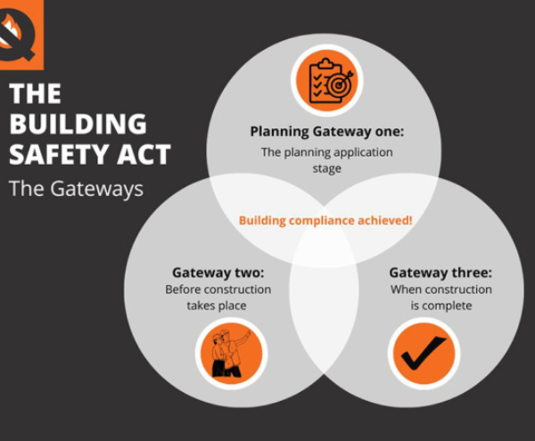

Produced by QuelFire for Quelfire, Produced on (21st October 2022) The Building Safety Act: The Gateways [Online] Available at: https://quelfire.co.uk/the-building-safety-act-the-gateways/ [Accessed 10th May 2025]

This piece of legislation can impact a high-rise block of flats in many ways. Such as the site will have to include enhanced safety measures that include regular safety assessments and the implementation of measures to mitigate identified risks. As stated above the Act will introduce an accountable person who is responsible for the safety of the building. This personal must ensure that all safety protocols are put into place such as fire exits on all floors, to make the floors spacious for the buyers to get out when there is an emergency, with plenty of fire extinguishers and many more different items so that it is compliant with the modern-day regulations. All residences when purchasing property must be given safety information as stated above. The Act also requires a gateway process this consists of gaining approval at 3 key stages. These key stages consist of planning, design and construction and even before occupation. This will ensure that safety is considered at every stage of the projects process. There also needs to be a golden thread, this means that all documents are included with the construction project such as different construction decisions, changes and safety information throughout the building’s lifecycle. These documents will be inserted into one big record ensuring transparency and accountability.

Types of Health & Safety to be Implemented

Furthermore, when it comes to what health and safety should be implemented when constructing a block of flats, several different laws and regulations are particularly relevant. This can include the Health and Safety at Work Act 1974. This piece of legislation makes sure that it places duty on employers, clients even landlords to ensure that they’re the health and safety of a site is up to the best standard it can be for the employees and tenants. The health and safety measures for this particular site can include fire safety, electrical safety, gas safety, the correct PPE worn onsite and what PPE does roles require, for example when employees are around saw dust and chemicals, they will either need a respirator or dust mask these will come under the Control of Substances Hazardous to Health Regulations 2002 in other words COSHH. As dust can be harmful not just now but maybe in the future. Also, under this act welfare facilities need to be provided such as a drying room, a canteen where employees can have a hot drink or a bite to eat, and toilets. There also needs to be barriers located around the site, barriers are one of the most important pieces of health and safety to the site. As it can prevent you from getting run over by different plants located around the site. Barriers are also needed when working at height, as there can be loose wood from the scaffolding. They can also help to prevent access to hazardous areas of the site. If there are no barriers located around the site you can receive penalties or possibly fines, as putting barriers around the site is a legal requirement and needs to follow the modern-day health and safety regulations.

Moreover, on what regulations need to be implemented on the construction site, the Regulatory Reform (fire Safety) Order 2005. This order requires that fire safety risk assessments are to be conducted out in communal areas of the site, and to make sure that all fire measures are always implemented around the site even when the employer has handed the properties over to the buyers. There are other regulations that would need to be put in place such as Housing Health and Safety Rating System (HHSRS). This piece of legislation is part of the Housing Act 2004 and is used a lot to assess potential hazards in residential properties including the block of flats. As a block of flats can be a high-rise structure, the Work at Height Regulations 2005 will also have to be implemented on the construction site. These regulations require are to ensure that work at height is professionally planned and supervised by the competent people involved in the site such as a health and safety inspector or part of the construction management team, this will then prevent falls from happening. These regulations also highlight why barriers are so important on a construction site.

Additionally, another law called Personal Protective Equipment at Work Regulations 1992, these systems put into place in the construction site require employers to provide personnel protection equipment if employees do not have any. The employers also must make sure that the equipment is maintained properly, fits correctly and puts employees on training courses on the PPE’s use in their working environment. Employers also must assess the risks in that work environment to determine the appropriate PPE needed for the various tasks. Leading from this is another similar regulation called Provision and Use of Work Equipment 1998 in layman’s terms PUWER. This regulation consists of the working area to be properly maintained, clean, and safe at all times of the day. PUWER does not just come under the working area to be maintained but also the equipment provided by the employer. The equipment will have to be tested to see if it safe some of these tests can include PAT testing. Employers must check the training and education of the employees just because they are not competent to use certain equipment or perhaps machinery. The PUWER regulation covers a wide range of equipment, including different tools, appliances and plants.
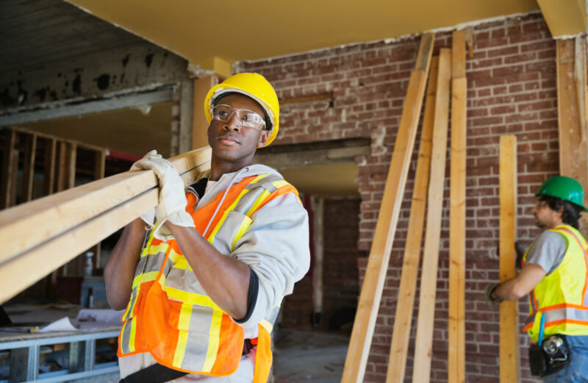
Produced by N. Warrick for Safeopedia, Produced on (20th May 2024) Choosing the Right PPE in Construction Industry [Online] Available at: https://www.safeopedia.com/choosing-the-right-ppe-in-the-construction-industry/2/9676 [Accessed 10th May 2025]

Besides the equipment side of regulations there are also regulations that involve how to lift objects safely. This regulation is called Manual Handling Operations Regulations 1992. The regulations for this, require employers avoiding various hazardous manual handling operations where possible, assess and reduce the number of risks of injury from those that cannot be avoided. If some of the employees haven’t had the training onsite, we must place them on a manual handling training course, as it is day-to-day practice. We will also have to make sure that other regulations, such as the Control of Noise at Work 2005, are in place to make sure that equipment acquired for the exposure to noise in the workplace, there are other regulations such as Control of Vibration at Work 2005, this covers all the vulnerability from the vibration tools such as hammer drills. All, these regulations will help massively with creating a safe sustainable working environment for the different employees that will enter the site for the foreseeable.

CDM Regulations

When looking at CDM (Design and Management) regulations 2015, they are designed to improve health and safety in very different ways. They will place different responsibilities on all parties involved in the construction project, including clients, designers, contractors and employees. This is to ensure that health and safety risks are managed effectively from the planning stage all the way through till project completion. The Key elements to the CDM regulations consist of planning and managing projects from the start, appointing duty holders and ensuring that all construction companies, and parties involved in the project have very good communication and cooperation throughout the construction process. As it can have a massive impact on the various construction roles on the project, some of these roles include the clients, they must be responsible for ensuring that suitable arrangements are made for the project, they also have to provide pre-construction information to the designers and contractors at the start of the project and when requested. They will also have to ensure that the construction phase plan is in place before any work has begun on the project.

The client will also have to ensure that the principal designer and contractor are appointed where it is required. This then leads to the principal designer, as they are also involved in CDM regulations. They provide several responsibilities, for example:

- Plan and manage health and safety during the pre-construction phase
- Locate and excute any risks
- Ensure designers are doing their jobs
- Prepare and provide relevant information

There is also responsibility put on to the designers allocated to the project. These responsibilities can include looking out for any risks during the process of the design work. They will also have to provide various amounts of information about the remaining risks to the principal designer and the contractors assigned to this construction project. The head designer for this project will have to look through the drawing to make sure all designs are safe and can be built used and maintained safely when the project being handed over to the buyers.

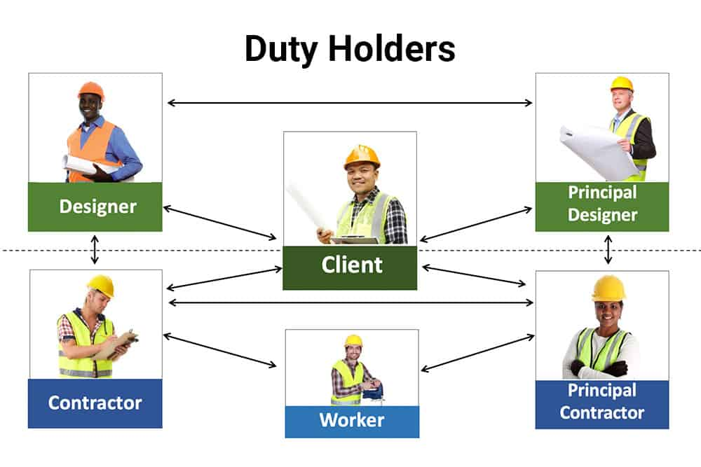
Produced by Humas Focas for Human Focas, Produced on (11th August 2022) The Role of Duty Holders Under the CDM Regulations 2015 [Online] Available at: https://humanfocus.co.uk/blog/role-of-duty-holders-under-the-cdm-regulations-2015/ [Accessed 10th May 2025]
The CDM regulations also have a big impact on the contractor as they are assigned to manage, plan and monitor their own work and that of their subcontractors, or staff that are onsite. They also must comply with the directions of the client. The contractor is also assigned a duty to provide their employees with information on training and health and safety.

They also must provide any employees with PPE or any equipment they require to carry out the job as stated above. The contractors will also have to organize the construction phase plan and make sure that it is implemented. They also have to organize different duties for the employees onsite as well as their own work. This normally relies on the project management team. Ensure that all employees have been inducted on the site before any work has been started from them. Make sure all welfare facilities are suitable for the employees, as well as hiring a reliable security company.

Risk Assessment

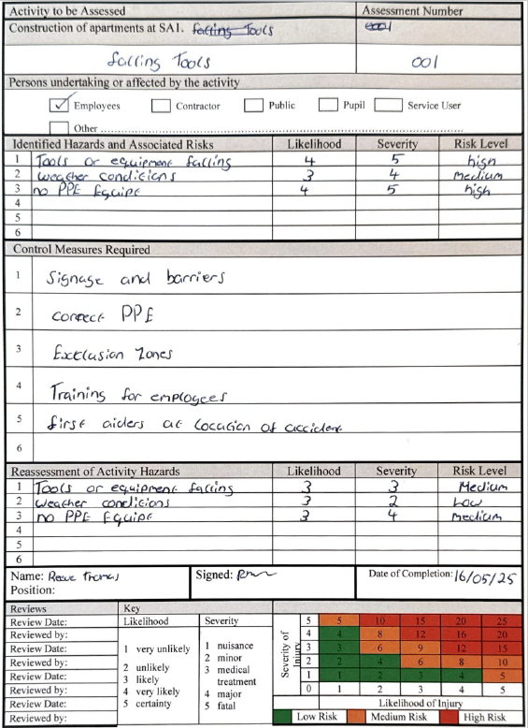

Referance Table

Title ​ | URL ​ | Type | Author ​  ​ | Dates​  ​
The Building Safety Act: The Gateways | https://quelfire.co.uk/the-building-safety-act-the-gateways/ | Image | QuelFire | Produced on (21st October 2022) [Accessed 22nd January 2025]​
Choosing the Right PPE in Construction Industry ​ | https://www.safeopedia.com/choosing-the-right-ppe-in-the-construction-industry/2/9676 | Image | N. Warrick | Produced on (20th May 2024) [Accesed 10th May 2025]​
The Role of Duty Holders Under the CDM Regulations 2015 | https://humanfocus.co.uk/blog/role-of-duty-holders-under-the-cdm-regulations-2015/ | Image | Human Focas | Produced (11th August 2022) [Accessed 10th May 2025]​

