
Software development
Assignment 1
© 2021 University of Wales Trinity Saint David
Submitted by:
Daniela Mihalkova
BSc Cloud Computing
Module code: ACCB4017
Student ID: 2021925

Contents
A1. Different types of control structures in programming 2
A2. Different types of loops in Python 8
For Loop 8
While Loop 8
A3. List in Python 10
Exercise 1: 12
Exercise 2: 14
Exercise 3: 16
Exercise 4: 19
References 23

A1. Different types of control structures in programming

The three main forms of control systems are sequential, selection, and repetition. They may be mixed and matched in any way to solve an issue. By default, the control structure carry out sequential executing the statements line by line in which they appear. A condition is tested using the selection structure.
- Sequence structure
In a sequence structure, an action or event leads to the next ordered action in a specified order. The sequence can include any number of actions, but none of them can be skipped. When the program is run, it must complete each action in the order provided, with no opportunity to skip or branch to a different action. Selection structure
A selection structure, also known as a conditional structure, is a programming component that conducts several operations depending on whether a Boolean condition is true or false. If you need to test several conditions, use an elseif structure within an if end or if-else structure.
- Repetition
The practice of looping or repeating elements of a computer program is known as repetition in computer programming. There are different types of loop. The simplest is when a set of introductions is repeated a certain number of times. A different sort of loop keeps repeating until a specific condition is fulfilled.
A condition is a state that tests instructions if they are repeated. If the condition is 'False', the instructions are repeated again. There will be no further repetitions if the condition is 'True' [1].

Let’s have a look at some Selection Control Statements:
- Simple if
- If-else
- If-elif-else

- Single-alternative Selection Structure:
Flow Diagram:
Python supports a few logical conditions which are used in if statements. Following all the statements that we have.
equals to: x == y
not equals to: x != y
less than: x < y
less than or equal to: x <= y
more than: x > y
more than or equal to: x >= y
When we are using if statements it is actually a decision-making statement we have like a condition if is true then we are going to execute certain commands or certain statements and if is false, we are going to skip the execution [3].

Condition
If Condition is False
If Condition is True

Conditional Code

Example of If statement:

# Collect string / test length
string = input('Please enter a test string: ')
if len(string) < 6:
print('Your string is too short.')
print('Please enter a string with at least 6 characters.')

Please enter a test string:

ok
Your string is too short.
Please enter a string with at least 6 characters.

Process finished with exit code 0

- Dual-alternative ifs
- Contain two alternatives
- Then if – then – else structure
If someCondition is true then
do oneProcess
Else
Do theOtherProcess
Endif

Flow Diagram:

FALSE
Condition
A flowchart that describes a selection structure must begin with this decision. The selection structure must ask a question that can be answered only with yes or no. Ask a question and take one of two actions.
TRUE
Body of IF

Body of Else

Example of If – else statement:

name = input('Enter your name: ')
age = int(input('Enter your age: '))
marks = int(input('Enter your marks: '))
if (age>17 and age<=21 and marks>=80):
print(name+' is eligible!')
else:
print(name+' is not eligible!')

Enter your name: Daniela
Enter your age: 33
Enter your marks: 75
Daniela is not eligible!

Process finished with exit code 0

Enter your name: Daniela
Enter your age: 20
Enter your marks: 90
Daniela is eligible!

Process finished with exit code 0

- IF – ELIF – ELSE
Flow Diagram:

FALSE
If Condition

TRUE
Condition
Of elif
FALSE
If Body

Else
Body
Elif
Condition

Using an elif statement we can check several conditions for TRUE and when of them does it then run a block of code. The elif statement, like the else statement, is optional.

Example of If – elif statement:

temp = int(input('Please enter a current temperature: '))
if temp > 30:
print('It is very hot!')
print('You have to drink more water today!')
elif temp > 20:
print('It is nice weather outside!')
else:
print('It is cold today!')
print('You can take umbrella with you!')

Please enter a current temperature: 36
It is very hot!
You have to drink more water today!
Process finished with exit code 0

Please enter a current temperature: 18
It is cold today!
You can take umbrella with you!
Process finished with exit code 0

Please enter a current temperature: 22
It is nice weather outside!
Process finished with exit code 0

A2. Different types of loops in Python

Loops can repeat a section of code until it meets a certain. Their use in programming is quite frequent. A function's first statement is performed first, then the second, and so on. You may find yourself in a scenario where you need to run a block of code several times. Different control structures are available in programming languages, allowing for more complex execution pathways. A loop statement allows us to repeat the execution of a statement or a set of statements.

For Loop
To iterate through members in a series, the for loop is used. It is frequently used when you have a piece of code that has to be repeated "n" times.

While Loop
While Loop is a programming construct that is used to repeat a block of code. It executes the code block numerous times until a specific condition is fulfilled, rather than just once.
Python, like other programming languages, utilizes a loop, however instead of a variety of loops, it is limited to only two: "While loop" and "For loop"

- While loops are run dependent on whether the conditional statement is true or false.
- For loops are also called iterators because they iterate the element based on the condition provided.
- For loops in Python may also be used for a variety of different purposes (indicating the set of components that we wish to loop over)
- In the For Loop, a breakpoint is used to break or stop the process at any point.
- The Continue statement keeps printing the statement and produces the outcome according to the condition provided.
- In a "For loop", the enumerate function returns the index number of the number of the collection we are looking at [2].

Example of while loop:

num = 1
sum = 0
print('Enter a number! Please enter zero(0) to exit!')

while num != 0: # preform operation
num = float(input('Please enter your number: ')) #ask the user to provide a number
sum = sum + num; #get the sum of all numbers
print('sum =', sum)
else:
print('Finished sum')

Output:

Enter a number! Please enter zero(0) to exit
Please enter your number: 50
sum = 50.0
Please enter your number: 100
sum = 150.0
Please enter your number: 40
sum = 190.0
Please enter your number: 0
sum = 190.0
Finished sum
Process finished with exit code 0

For loop:
# How to calculate the numbers in a list
Numbers = [7, 10, 5, 4, 9, 7, 6, 2,8] # list of numbers
Sum = # variable which storing the sum
For i in numbers: # iterate over the list
Sum = Sum + i
Print(“The sum of the numbers is: ”, Sum)

Output:
The sum of the numbers is: 58

Process finished with exit code 0

A3. List in Python

A Python list is collection of date items that may be sorted and changed. Unlike an array, which can only hold objects of the same kind, a list can hold a variety of things. A list can include any data type of object, including another list. To make a list, place all of the elements inside square brackets [] and separate them with commas. It may contain an infinite number of objects from various stores, such as integer, float, string, and so on. Lists allow you to store several items in a single variable. Lists are one of four built-in data structures in Python for storing collections of data: ​the other three are tuple, set, and dictionary, and each has its own set of features and uses.

#Different types of list

letters = ['a', 'b', 'c']
matrix = [[0,1], [2,3]]
zeros = ['0'] * 5
combined = zeros + letters
numbers = list(range(20))
chars = list('Hello Python')

print(letters)
print(matrix)
print(zeros)
print(combined)
print(numbers)
print(chars)

Output:

['a', 'b', 'c']
[[0, 1], [2, 3]]
['0', '0', '0', '0', '0']
['0', '0', '0', '0', '0', 'a', 'b', 'c']
[0, 1, 2, 3, 4, 5, 6, 7, 8, 9, 10, 11, 12, 13, 14, 15, 16, 17, 18, 19]
['H', 'e', 'l', 'l', 'o', ' ', 'P', 'y', 't', 'h', 'o', 'n']

Process finished with exit code 0

Exercise 1:
Write a program which allows the customer to enter a name and to choose a product on particular price.
- Logical stages:
- Prompt the user to enter a name
- Give the user option to choose a product
- Prompt the user to enter a quantity
- Ask the user if it wants to add next product
- Print total on the screen

- Code of the program with annotation
cust_Name = input("Please, enter your name: ") # give the user enter the name
cust_Choice = input("Please, choose from our products: juice-£2, cake-£15.50 or bananas-£2.80: \n") # enter the choice
product = ["juice", "cake", "banana"] # list of items (data type-string)
prod_Quantity = int(input("Please, enter a quantity of product: ")) # enter the quantity of product (data type integer)
price = float # the price is data type float

if cust_Choice == "juice": # price of items
price = 2
if cust_Choice == "cake":
price = 15.50
if cust_Choice == "bananas":
price = 2.80
sumOrder = price * prod_Quantity # calculation of total order with one product
print("Do you need something else? ") # give a chance to choice next product
print("Please select 'yes' or 'no': ") # prompt the user to choice one of provided option
next_Choice = input() # get the user choice

if next_Choice == "no": # if user's choice is 'no', calculate the total
print(cust_Name, ", your order total is: £", sumOrder)

while next_Choice == 'yes': # if the user has more then one choice
cust_Choice = input("Please, choose from our products: juice-£2, cake-£15.50 or bananas-£2.80: \n")
prod_Quantity1 = int(input("Please, enter a quantity of product: "))

if cust_Choice == "juice":
price = 2
if cust_Choice == "cake":
price = 15.50
if cust_Choice == "bananas":
price = 2.80
print("Do you need something else? ")
next_Choice = input("Please select yes/no: ")
if next_Choice == 'no': # if the customer won't other product
totalOrder = price * prod_Quantity1
total = sumOrder + totalOrder # add new product price to the previous total
print(cust_Name, ",your order total is: £", total) # print the total

- Testing:
- Normal path with one product
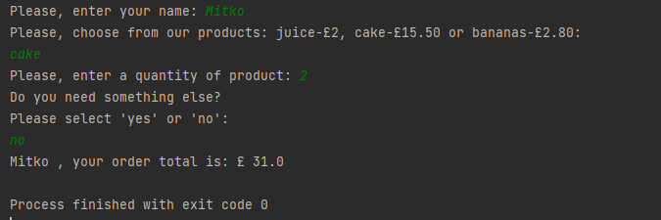
The program works as expected. It calculates the correct answer!
- Normal path with two products
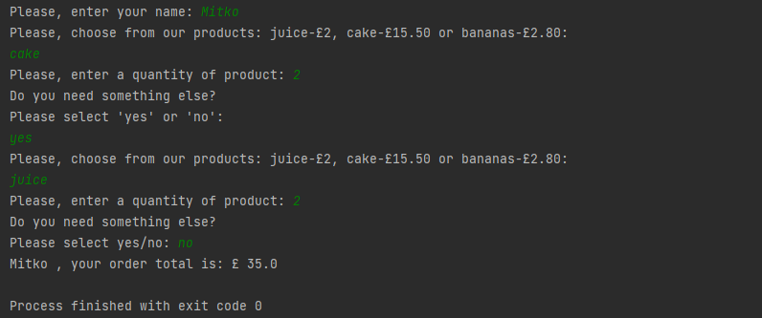
The program works as expected. It calculates the correct answer!

Exercise 2:
Write a program which allows user to enter a radius of inner and outer area and to calculate the difference between them.
- Logical stages:
- Prompt the user to enter a radius
- Check the entered number if it is bigger then 0
- Calculate area using a formula: p * (radius ** 2)
- Prompt the user to enter a second radius
- Calculate the difference between both areas
- Print the result on the screen

- Code of program with annotation
radius = float(input("Please enter the radius of inner area: \n")) # user enter the radius
p = 3.142 # define P

while radius <= 0: # check the radius is a positive number
print("The radius must be above 0!")
radius = float(input()) # try again

inner_Area = p * (radius ** 2) # calculate the inner area
print("The area of the inner circle is: \n", "{:.2f}".format(float(inner_Area))) # print the area

radius2 = float(input("Please enter the radius 2 of outer area: \n")) # user enter the second radius
while radius2 <= 0: # check the radius is a positive number
print("The radius2 must be above 0!")
radius2 = float(input()) # try again
outer_Area = p * (radius2 ** 2) # calculate the outer area
print("The area of the outer circle is: \n", "{:.2f}".format(float(outer_Area))) # print the outer area

difference = outer_Area - inner_Area # calculate difference between two areas
print("The difference between the radius is: \n", "{:.2f}".format(float(difference))) # print the difference

- Testing:
- Normal path
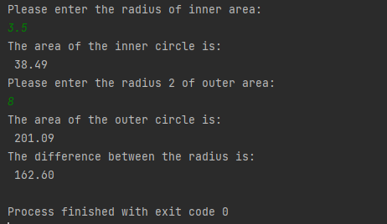
The program works as expected. It calculates the correct answer!

- Test radius for valid input
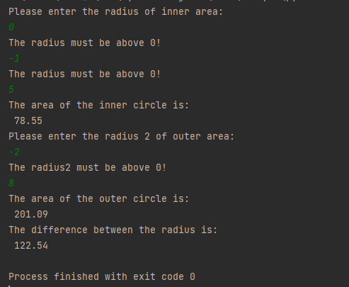
The program did not allow the user to enter 0 or negative number. Program preformed correctly.

Exercise 3:
Write a program which allows user to enter five names of staff and their salaries, and to calculate how much a company will pay for a month, and how much the company will spend if increase the salary with 10%.

Logical stages:
- Prompt the user to enter a names
- Prompt the user to enter a salary
- Print the list of names and salaries
- Calculate the increased salary with 10%
- Calculate the difference between
- Print the result on the screen

B) Code of program with annotation

staff_Name = [] # define a list of names
staff_Salary = [] # define a list of salaries
total = float()

for i in range(5): # using of loop
name = input("Please enter the staff name: ") # user enter name of staff
staff_Name.append(name) # add a single name to existing list
salary = float(input("Please enter the staff salary: ")) # enter a salary
staff_Salary.append(salary) # add a salary to existing list
total = total + salary # calculate the total of salaries
print('Staff details: ')
for i in range(5):
print(staff_Name[i], staff_Salary[i]) # print all names and salaries
print("The total salary amount of all staff is: ", "{:.2f}".format(float(total))) # print the total of salaries
increase = total * 1.1 # calculate increasing of salary with 10%
print('Increased amount with 10% is: ', "{:.2f}".format(float(increase))) # print the increased total
difference = increase - total # calculate the difference between totals
print('The company has to spent ' , "{:.2f}".format(float(difference)), "more per month!") # print the difference

- Testing:
- Normal path
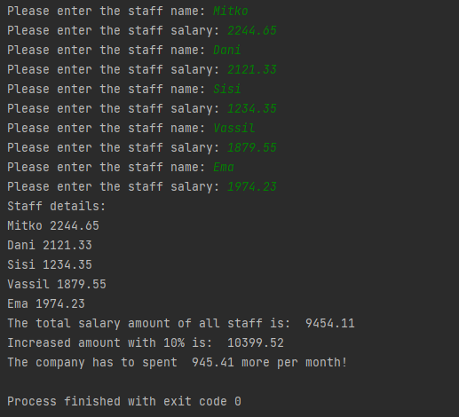

Exercise 4:
Spinning game:
Each time the player requests another try, the program have to print three random numbers ranging from 0 to 9. If the program prints on the screen 999 it is a Jackpot - 2000 points. If there is a combination of any two numbers except 9 the user will get 5 points. If it is a combination of two numbers 9 the user will get 200 points. By combination is of three matched numbers the user will get 15 points.
- Logical stages:
- Prompt the user to enter a choice
- Check for combination of three nines
- After each spinning, ask user if it wants to spin again
- Check for two nines
- Check for any combination of three matched numbers except with 9
- Check for any combination of two numbers
- Print the total score on the screen
B) Code of program with annotation

import random
spin = input('Do you want to play? Please enter "yes" or "no": ') # enter the user choice
score = 0
while spin == 'yes': # if customer choice is yes
a = random.randint(0, 9)
b = random.randint(0, 9)
c = random.randint(0, 9)
print(a, b, c) # print the random numbers
if a == b == c == 9: # combination of three 9
score = score + 2000 # add 2000 points to the previous score
print("Jackpot!")
print("Congratulations! Your score is: ", score) # print the total score
spin = input('Do you want to spin again? Please enter yes/no: ') # ask the user for new spinning

elif (a == b == 9) or (a == c == 9) or (b == c == 9): # check for two nines
score = score + 200 # add 200 points to the previous score
print('Congratulations! You win! Your score is: ', score) # print the total score
spin = input('Do you want to spin again? Please enter yes/no: ') # ask the user for new spinning

elif a == b == c != 9: # check for any combination of three matched numbers except with 9
score = score + 15 # add 15 points to the previous score
print('Congratulations! You win! Your score is: ', score) # print the total score
spin = input('Do you want to spin again? Please enter yes/no: ') # ask the user for new spinning

elif a == b != c or b == c != a or a == c != b: # check for any combination of two numbers
score = score + 5 # add 5 points to the previous score
print('Congratulations! You win! Your score is: ', score) # print the total score
spin = input('Do you want to spin again? Please enter yes/no: ') # ask the user for new spinning

else:
print('You loss! do you want to try again? Please enter yes/no: ') # when it’s a combination of three different numbers
spin = input()

- Testing:
- Normal path with combination of any two numbers
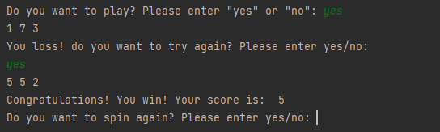
The program works as expected

- Normal path – add the score to previous one
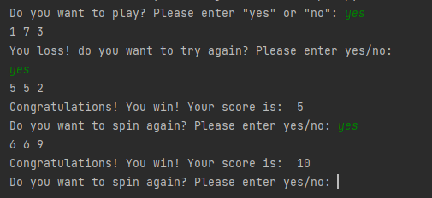
The program works as expected. Calculate correctly.

- Normal path with calculation of two nines
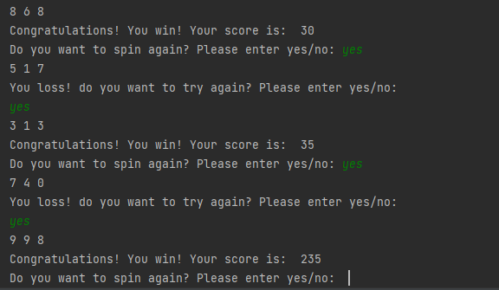
The program works as expected. Calculate correctly.

- Normal path - combination of three matched numbers
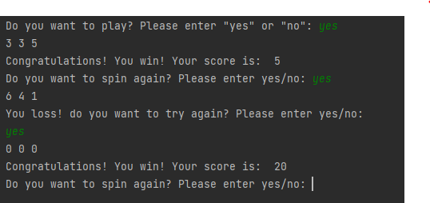
The program works as expected! Calculate correctly.

References

[1] | D. L. Yse, "Essential Programming | Control Structures," 22 Jan 2020. [Online]. Available: https://towardsdatascience.com/essential-programming-control-structures-2e5e73285df4. [Accessed 16 08 2021].
[2] | T. Point, "Python - Loops," 2021. [Online]. Available: https://www.tutorialspoint.com/python/python_loops.htm. [Accessed 18 08 2021].
[3] | B. University, "Single alternative selection structure a selection," 04 2020. [Online]. Available: https://www.coursehero.com/file/p7g6gog/Single-alternative-selection-structure-a-selection-structure-that-requires-a/. [Accessed 18 08 2021].

