STUDENT NAME: ANTHONIA AKPAN
STUDENT ID: 2026998
MODULE: INTRODUCTION TO PHYSIOLOGY
MODULE CODE: BMHP5003_ BIRM
ASSIGNMENT TITTLE: ACADEMIC POSTER PERSENTATION
LECTURER’S NAME: RACHEAL RIVERS

CONTENT PAGE

The Cardiovascular System………………………………. Page 1
The Heart chambers………………………………………… Page 2
Electrical Conduction System………………………………Page 2
Diseases and Recommendations…………………………. Page 3
References..........................................................................Page 4

Pulmonary artery:
btrcecrvtb
Uig6rd5xw4wxercvtvrvrcrvc c0078cccc
The Cardiovascular system
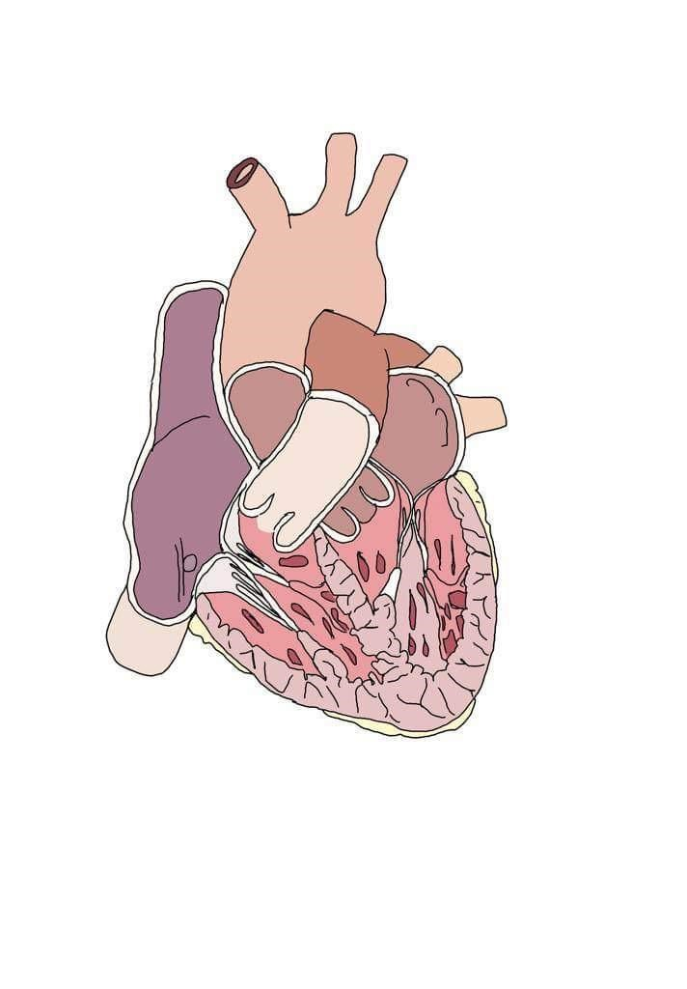

- The heart is an important and intricate organ in human body (Baillargeon, et al 2014; Weinhaus, A. and Roberts, K. 2005).
- It is a powerful pump that completes two main functions which includes collection of blood from tissues and pump it to the lungs, and collection of blood from the lungs and pump it to all the body tissues.
- The is located in the shielding thorax, behind the sternum, and resting on the exceptional sheath of the diaphragm (Weinhaus, A .and Robert, K. 2005).

Coronary arteries: supply blood to the heart muscle (Tucker, et al;2017; Mitchell, R. and Schoen, F. 2010)

Mitral Valve: keep blood flowing in the right direction.

Pulmonary vein: brings the oxygenated blood back in from the lungs (Bianco, C.(2004)

septum: separates the ventricles and allows for proper blood flow through the heart.

Apex of heart :helps pump out blood from the ventricles to the rest of the body or the lungs

Aorta: Circulate the oxygenated blood to the whole body (Buijtendijk, et al;2020; Bianco, C.2004)
Tricuspid valve: allows blood to flow easily to the heart from the body.

Inferior vena cava: Carries blood from the lower part of the body (Bianco, C. 2004)

Right ventricle: pumps oxygen-poor blood to the lungs via the pulmonary artery (Bianco, C. 2017).

Left atrium: receives oxygen rich blood and pass it to the left ventricle.

Pulmonary artery: pushes blood out of the lungs (Buijtendijk, et al;2020; Bianco, C .2004)

Right atrium: transfer deoxygenated blood towards the right ventricle.

Superior vena cava: Blood from the upper part of the body is carried out by superior vena cava (Buijtendijk, et al; 2020; Bianco, C.2004)

The Heart chambers

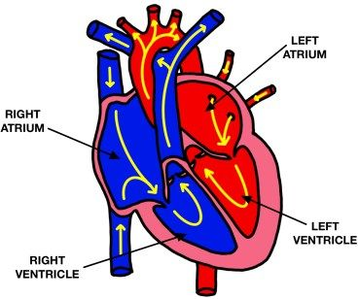
The heart consists of four chambers link to major veins or arteries that carry blood in and out of it. Right atria, Left atria, Right ventricle and Left ventricle. (Moorman et al; 2003; Sylva, et al; 2014).

Right Ventricle-Pumps blood out of the heart through Aorta. (Bianco, C.2017).
Right Atrium- Receiving part of incoming of de-oxygenated blood from the body.
Left Ventricle-pumps oxygen rich blood to the body. (Bianco, C.2017).
Left Atrium- Receiving part of incoming of oxygenated blood.

Oxygen-poor blood

Oxygen-rich blood

ELECTRICAL CONDUCTION SYSTEM

- The electrical conduction system which involves the Sinoatrial node, and the Atrioventricular node controls the movement of the heart.
- The Sinoatrial node controls the signal that makes the heartbeat.
- The Atrioventricular node takes electrical signals from the upper part of the body down to the lower parts.
- Also, there are a combination of fibres and an electrical bundle branch, the bundle of his and the purkinje fibres.
- The pumping and contraction of the heart ventricles is contr0lled by the purkinje fibres (Hulsmans,et al; 2017).
Diseases /Recommendations

- Heart diseases otherwise known as cardiovascular diseases poses a great burden to United Kingdom, UK.
- In 2012, cardiovascular disease was one of the commonest causes of death in women in UK (Bhatnagar, et al; 2015; Lui, et al; 2002).

- Alcohol consumption should be moderate.
- Avoidance of the use of tobacco is necessary.
- Regular exercise is needed.
- Limit intake of sodium.
- Management of stress is required.
- Consult your health provider.
- Seek advice on how to improve the health of the health.

OTHER DISOERDERS ARE:
- Atrial fibrillation
- Arrhythmia
- Cardiomyopathy
- Congestive heart failure
Atrial fibrillation- is the abnormal electrical signal in the atrium.
Arrhythmia- The result of slow or too fast heartbeat without a space.
Cardiomyopathy- Occurs when the heart muscle becomes bigger or stiffer.
Congestive heart failure- Cause by improper pumping of blood within the body due to weakness or stiffness of the heat.

MAIN CAUSES OF HEART DISEASES
- Alcohol intake
- Smoking
- Lack of exercise
- Lack of healthy diets
- Negative emotion
(Wells, A. 1994; Kubzansky, L. and Kawachi, I. 2000).

REFERENCES

Baillargeon, B., Rebelo, N., Fox, D., Taylor, R, and Kuhl, E. (2014). The living heart project: A Robust and Integrative Simulator for Human Heart Function. European Journal of Mechanics-A/Solids, 48, pp.38-47. Assessed at sciencedirect.com.
Bianco, C. (2004). How your heart works. HowStuffWorks. Archived from the original on 29.
July 2016. Retrieved 14 August 2016.
Bhatnagar, P., Wickramasinghe, K., Williams, J., Rayner, M; and Townsend, N. (2015). The
Epidemiology of cardiovascular disease in the UK 2014. Heart, 101(15), pp.1182-1189.
Buijtendijk, M; Barnett, P; and van den Hoff, M. (2020) Development of the Human Heart. In American Journal of Medical Genetics Part C: Seminars in Medical Genetics (Vol. 184, No. 1, pp. 7-22). Hoboken, USA: John Wiley & Sons, Inc.
Hulsmans, M., Clauss. S., Xiao. L., Aguirre, A; King, K., Hanley, A., Hucker, W; Wülfers, E. Seemann, G., Courties, G. and Iwamoto, Y. (2017) Macrophages Facilitate Electrical Conduction in the Heart. Cell, 169(3), pp.510-522.
Kubzansky, L. and Kawachi, I. (2000) Going to the Heart of the Matter: Do Negative
Emotions Cause Coronary Heart Disease? Journal of psychosomatic research, 48(4 -5), pp.323-337.
Liu, J; Maniadakis, N., Gray, A; and Rayner, M. (2002). The Economic Burden of Coronary
Heart Disease in the UK. Heart, 88(6), pp.597-603.
Mitchell, R. and Schoen, F. (2010) Blood vessels. Robbins and Cotran: Pathologic Basis of Disease. (Eighth edition) Saunders Elsevier, Philadelphia, US, pp.516-17.
Moorman, A., Webb, S., Brown, N; Lamers, W; and Anderson, R. (2003) Development of the Heart:(1) Formation of the Cardiac Chambers and Arterial Trunks. Heart, 89(7), pp.806-814.Assessed at heart.bmj.com.
Sylva, M., van den Hoff, M; and Moorman, A. (2014). Development of the Human Heart.
American Journal of Medical Genetics Part A, 164(6), pp.1347-1371. Assessed at Academia.
Tucker, W; Arora, Y., and Mahajan, K. (2017) Anatomy, Blood Vessels, Treasure Island: FL: StatPearls Publishing.
Weinhaus, A. and Roberts, K. (2005). Anatomy of the Human Heart. Handbook of Cardiac
Anatomy, Physiology, and Devices, pp.51-79. Assessed at link, springer.com
Wells, A. (1994). Passive Smoking as a Cause of Heart Disease. Journal of the American
College of Cardiology, 24(2), pp.546-554.

