University of Wales TSD
Student Name: Collins Festus Anieke
I707647
Lecturer: Tushara Balendran
20/06/2021
MBA Marketing Management
Assignment 1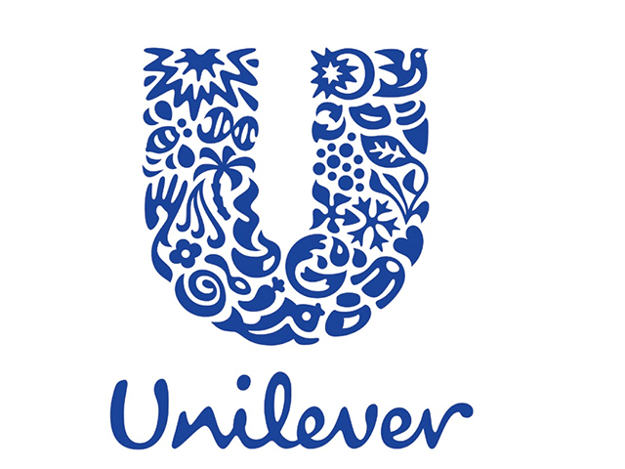

Table of contents

Introduction…………….. Page 1
Company Overview………..Page 2
Communication…………………Page 3
Communication Model…………Page 4
Integrated Marketing Communication……Page5
Promotional Strategies…………………….Page6
Definition of Branding and Brand Equity Page 7
Keller’s Brand Equity Model………………Page8
Customer Journey and Touchpoint…….Page9
Customer Journey Mapping………………..Page10
Customer Touchpoint……………………………Page11
Total Engagement Model……………………….Page12
Conclusion………………………………………..Page13
Reference Lists………………………………..Page14

This is a report in form of business format and focusing on marketing management as it relates to the United Kingdom based Unilever company of which the logo is shown above according to (Hobbs, 2020) At this stage, it is imperative to define marketing management before laying out structure of the report. Marketing management can be defined as the organisation and management system of production and sale’s activities of the enterprise, market research for the purpose of formation and satisfaction of demand for production in order to make profit (Vasilily, 2016)The report will contain the brief overview of the United Kingdom Unilever as the chosen company and definition of communication as it relates to marketing management. There will be diagram from reliable source that explains communication model in relation to marketing and integrated marketing communication will be defined in this report to ease the given task. There is certainly going to be evaluation of current and new promotional strategies and the recommendation that can help the company raise awareness of its brand. Branding and brand equity will be distinguished and defined in different concepts while Keller’s Brand equity Model advantages and disadvantages will be related to the task. The customer journey and touchpoints of the chosen company will be discussed together with the explanation of the customer journey mapping.
Brief overview of Unilever Company:
Unilever is a multi-national consumer goods giant company and the products are available in 190 countries in the world. Its leading brand includes Marmite, PG Tips, Pot Noodle, Lipton, and Knorr and so on (Hossain, 2020) In 1927 Unilever was founded and headquartered in Rotterdam, the Netherlands and this progressed to operational merger and acquisition between Dutch margarine Unie and British soap maker, Lever Brothers in 1929. The name Unilever is as a result of portmanteau of the two companies based in Netherland and Britain and in 1930, the business grew and started expanding to Africa and Latin America as the merger and acquisition paid off. The net worth of United Kingdom Unilever in 2020 was £6.073 billion, the total asset was £67,659 billion in 2020 while the total equity was £17,655 billion (Hobbs, 2020) In 2004 the weather was very cloudy for the company as it received first ever profit warning and this led to the company decision to initiate new business strategy that can bring positive changes to the company (Siddique, 2018)
Communication:
The definition of communication is subject to empirical diversity but in relation to marketing, it can be defined as the use of multifaceted channels which can help business make access to potential customers (Dawle, 2020) analytically, the use of these multifaceted channels also involves the improvement of current business strategy in order to influence customer’s engagement and purchase decision for example; Unilever which is a consumer goods giant company uses social media outfit such as internet network, Facebook and other online services to communicate and influence customer purchase decision. The overall objective of marketing strategy is geared towards raising awareness of the company’s brand or its product and services for the purpose of sales so the customer target is where the main function of marketing communication begins (Dawle, 2020) and the effective framework of marketing communication in most cases focus on vision, value, organisational goals and strategy.
Communication Model:
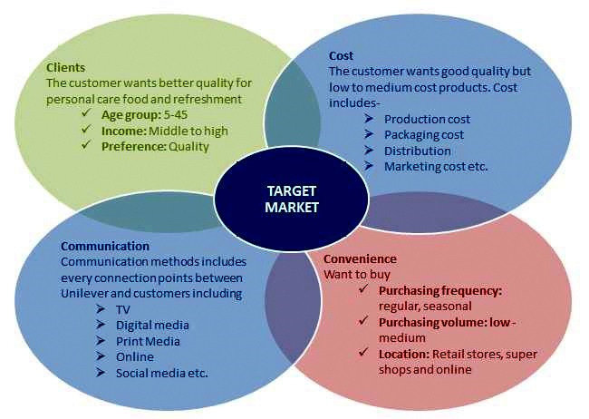The above diagram is the interactive and transactional communication model of the United Kingdom based Unilever company according to (Hossain, 2020) the communication model of the company consist of Clients, Cost, Communication and Convenience. The clients are segmented into age group and income level for example; the middle to high class incone earners prefare quality products and services irrespective of the price while the age group 5-45 concentrate on quality for personal care food and refreshment. In terms of cost, the customers of Unilever average price but quality product, so the

Works Cited
al., E. A. e., 2016. Mapping the customer journey: Lessond Lerned from graph-based online attribution modeling. International Journal Of Research in Marketing, Volume 33, pp. 457-474.
Anderl, E., 2016. Mapping the customer journey: Lessons learned from graph-based online attribution modeling. International Journal of Research in Marketing, Volume 33, pp. 457-474.
Anon., 2020. Swot Analysis of Unilever 2020, s.l.: SWOT ANALYSIS.
Bruce, T., 2010. Mapping The customer mapping. Making Leaders successful Every Day, 5 February.
Camilleri, M. A., 2017. Integrated Marketing Communications. Researchgate.
Dawle, A., 2020. AN OVERVIEW OF MARKETING COMMUNICATION STRATEGY: A DESCRIPTIVE STUDY. International journal of current Research, 12(10).
Harmeling, C., 2016. Toward a theory of customers engagement marketing. Journal of the Academy of marketing science.
Heinberg, M., 2020. HOW NOSTALGIC BRAND POSITIONING SHAPES BRAND EQUITY: DIFFERENCES BETWEEN EMERGING AND DEVELOPED MARKET. Journal of the academy of marketing Science, 48(5), pp. 869-890.
Hobbs, A., 2020. Analyzing Unilever's Pledge to Cut Back on Plastic, London: SAGE.
Hossain, M., 2020. Marketing Strategy and Sustainable Plan of Unilever. International Journal of Scientific Research and Engineering Development, 3(4), pp. 680-692.
Kirveev, V., 2061. Marketing management as the Realization process of Research, Production and sale activity of the Enterprise. International review of management and marketing, 6(6), pp. 228-234.
Lee, S. L., 2018. A customer Point Management System For Effective Service Communication. BCRP, 1(1), pp. 46-49.
Muneeb, A., 2020. HOW BRAND IMAGE AND PERCEIVED SERVICE QUALITY AFFECT CUSTOMER LOYALTY THROUGH CUSTOMER SATISFACTION. ACADEMY OF MARKETING STUDIES JOURNAL, 24(1), pp. 1528-2678.
Ozbal, O., 2020. A trust-based peer to peer digital brand equity (P2P-DBE) Model. Jpournal Of Marketing Theory and Practice, 26 8, 28(4), pp. 497-520.
Pahwa, A., 2020. Customer Touchpoint. What Are Customer Touchpoint? Importance & Example, 11 June.
Payne, E. M., 2017. Omni-Channel Marketing, Integrated Marketing Communications and consumer engagement. ProQuest, 11(2), pp. 185-197.
Readingroom, n.d. User Journey mapping, s.l.: Digital Consultants.
Samson, S., 2017. Journey Mapping the User Experience. Researchgate, 78(4), p. 459.
Shilling, A., 2016. Strategic Relationships and Branding Your Firm. Money Management Executive;. ProQuest, 24(6), pp. 1-na.
Siddique, F. B., 2018. Unilever Sustainable Living Plan: A critical Analysis. 2 May.
Sokunbi, I. A., 2018. PRESENTATION ON UNILEVER UK AND UNILIVER NIGERIA.
Sudbury, L.-R., 2020. The Trajectory Touchpoint Technique: A Deep Dive Methodology for service innovation. Journal Service Of Research, 23(2), pp. 229-251.
Ukaj, F., 2016. The role and Importance of Brand in the Marketing of Small and Medium Sized Enterprises in Kosovo. International Journal of Marketing Studies, Nov, 8(6), pp. 1918-7203.
Vasilily, K., 2016. Marketing Management as the Realization Process of Research, Production and Sales Activity of the Enterprise. International review of Management and Marketing, 6(6), pp. 228-234.
Yousaf, A., 2017. CONCEPTUALISING TOURIST BASED BRAND-EQUITY PYRAMID: AN APPLICATION OF KELLER'S -BRAND PYRAMID MODEL TO DESTINATION. Journal Of Tourism and Hospitality Management, 23(1), pp. 119-137.

(Readingroom, n.d.)company is careful about production, distribution, packaging and marketing cost of their goods and services. The company uses social media touchpoint to reach out to customers for example; Tv, Digital media, Print Media and Online services (Hossain, 2020) and Unilever is aware that it is more convenient for their customers to purchase regular, seasonal and average cost products mainly through online internet network.

Integrated Marketing communication:
Integrated marketing can be defined as an audience motivation of business method of tactically managing investors, contents, networks and outcomes of brand communication programmes (Payne, 2017) the example of integrated marketing communications are the following:
Public relation/Publicity | Personal Selling | Digital Advertising
Broadcast Advertising | Print/Advertising | Outdoor Advertising
Sales Promotion | Interactive Marketing | Digital Marketing

The diagram is the example of integrated marketing communication mix according to (Camilleri, 2017) integrated marketing communication (IMC) is a strategic customer touchpoint that can impact customer engagement which can push up the profit of the company. Since every company needs to evaluate customers to know if there is any chance of purchase decision, there is need for the customers to be aware of the product and services and this will enable the company know how much the customers value the benefits of their goods and services and what are the customers perception of the business (Camilleri, 2017)
Promotional Strategies
Since the effectiveness of advertising can be measured by a number of methods such as Digital Ad rating, Consumer Neuroscience, Radio Airplay and online streamlining, the marketing and promotion of United Kingdom based Unilever are done through various mediums, intermediaries or platform for example; TV, Online Ad, Billboard, Campaign and Prints (Hossain, 2020) however, there are new promotional strategies that can be used to raise awareness of the Unilever brands for example; Retailer Promotion. The main elements of the retailer promotion are discount in prices, communication of sales promotion and the objectives of the promotion. There are different forms of price discount as an element of promotion strategy ranging from straight price discount for example; Buy-one-get one free (BOGO’S) frequent shopper card discount and bundle promotion. In furthering this hypothesis, “Retailer Promotion” which can be used an alternative by Unilever to raise awareness of its brand are in the following form:
Types of Retailer Promotion
Regarding new promotional strategy to raise awareness of brand
Price Reduction | Temporal decrease of price by the retailers
Retailer Coupon | Issuing of coupons by the retailers during advertisement or on the shelf
Free Goods | Giving free items to the consumer as a discount. It can be in form of buy one and get one free or buy X and get Y free
Sweepstakes | Entering consumers into contest where they are likely to win prices or cash
Free Trial | Giving consumers free samples of the product in order to encourage purchase decision
Discount card | Sign up consumers on the cards that track their purchasing record. It gives the retailer the opportunity to provide the items on discount to the consumers.
Rebates | Giving the consumers notices of rebate on the shelf on one item or the order. Ironically, it can encourage impulse buying or arouses interest on purchase decision
Bundle Promotion | Giving the consumers discount for complementary products
The above diagram is the new promotional strategy which the United Kingdom based Unilever company can use to raise the awareness of its brand according to (Hossain, 2020) though the use of these promotional strategies encourage customer centric in marketing environment but there is something unto word. It may not influence purchase decision because there are customers who are compulsive and would not be willing to acknowledge services made available by any company for example; there could still be argument about an existing price discount by a customer without minding the interest of the company.

Definition of branding and brand equity
Branding: Branding is an instrument of competition especially in marketing environment since managers constantly face the critical challenge of developing their brand therefore; branding can be defined as the marketing practice of developing the size and scope of a brand (Shilling, 2016) branding is an eye catcher since it is a possible way to consolidate existing customers and attract new ones’. Tackling the issue of branding, managers need to constantly evaluate their personal value proposition, the uniqueness of their marketing strategy, core competence and philosophy that can drive marketing experience as this makes it easy to discover areas that need to change for competitive purpose.
Brand: It is imperative for an enterprise to have a good impact in their business and this can only be achieved through the creation of a brand that belongs to its business purpose so; brand can be defined in marketing as a tool for the identification of products and services (Ukaj, 2016) brand represents the features and present time characteristics of a product and services as well as differentiating a business set up from the other for example;
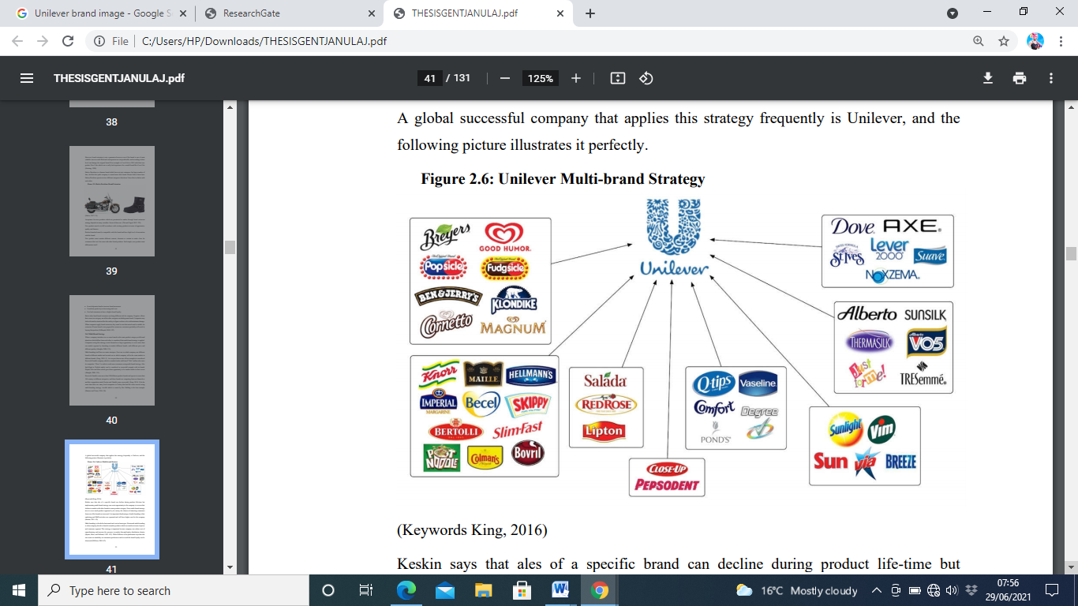
The above diagram represents the unique and dynamic product brand belonging to the United Kingdom based Unilever consumer giant company according to (Sokunbi, 2018)

Modern products cannot be accessed without a brand so it leads to consumer perception and sentiment as an image of the enterprise (Ukaj, 2016) there is meddling of concepts between brand and trademark, with brand, a product is identified and its specific image is transferred to the consumers which is a possible way to influence purchase decision while trademark represents only the products sold under it (Ukaj, 2016) furthermore, the basic difference between branding and brand hinges on developing the size and scope of the product as branding while brand is the uniqueness of the tangible product and services according to (Ukaj, 2016)
Keller’s Brand Equity Model
Brand equity as it relates to consumer market is a bundle of various economics and psychological benefits for the end user (Ozbal, 2020) A brand in critical assessment differentiates a product from the other and capable of influencing consumers’ purchase decision because it serves as the spotlight and benefit of the product on offer. As the consumers base their purchase decision on comparison, they go a long way to ask questions about a particular brand or base their decision on heuristic. Making choice of a brand depicts the value of the customer, saves the cost of product brand search and creates a long positive perception in the mind of the consumers (Ozbal, 2020)
Keller’s Brand Equity Model and Relationship to UK Unilever Company:
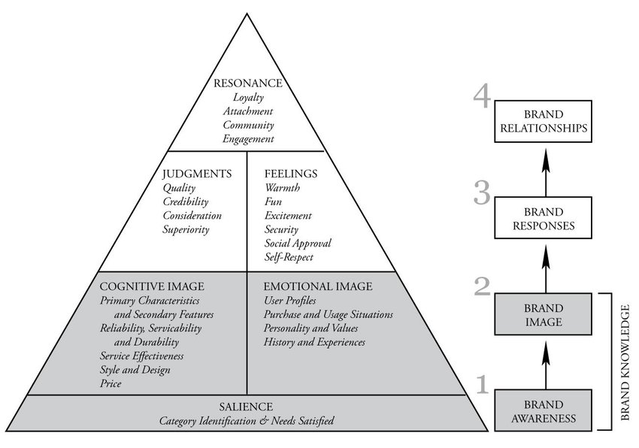The above is the Keller’s Brand Equity Model according to (Ozbal, 2020) the purpose of the image is to show how it is related to the marketing activities of United Kingdom based Unilever used in this assignment as a case study. Understanding the Keller’s Brand Equity Model, on a personal ground it is empirical at a point since it cannot be a generic marketing Model. However, every marketing activity is customer centric but this particular brand equity is the model chosen by the United Kingdom Unilever consumer giant company and different marketing companies have peculiar Brand Equity Model. Relating the identities of Keller’s Brand Equity Model to the chosen case study, it consists of Brand awareness, Brand Image, Brand Responses, and Brand Relationship (Ozbal, 2020) Brand Awareness: The brand awareness tactics is based on salience whereby the Unilever consumer company categorises the stakeholders and other partners for proper identification. It uses this unique tactics for raising awareness of its product brand. This is achieved by engaging the stakeholders, partners in supply chain and the government agencies thereby raising the awareness of brand through Sales and Marketing, Sales: Working closely with retailers, Unilever makes sure that their products are available all the time and displayed on different marketing outlet for example; from supermarket to e-commerce: Marketing: It uses media marketing platform to engage with customers and raise awareness of the brand for example; digital marketing or advertisement on bill board (Hossain, 2020)
Brand Image: Unilever has shifted attention on traditional media as means of brand awareness to the use of cognitive social media and this offers the public the physical experience of the brand. It is no longer talking but offering customer experience for example; through the durability of its product and services (Hossain, 2020) brand image
Brand Responses: Brand based on customers’ feedback helps to engage in communication that enables the company know the feelings of end users. Knowing the position of end users is the strategy the company uses to improve the quality and raise awareness of the brand according to (Hossain, 2020) however, it is not all about the customers in principle and practice but customer profiling and product segmentation can as well help to raise brand awareness for example; category identification.
Brand Relationship: The essence of brand relationship is to arouse or retain customer loyalty and engagement just as using relationship marketing for customer retention and patronage (Hossain, 2020) Offering two different items of the same quality is a good strategy for substitution but it may be a flaw strategy if the competitor can improve on the same substitute however, brand relationship helps Unilever close the gap that competitors can flank.
Advantages of Keller’s Brand Equity Model:

- It is subject to differential effect through brand relationship that enables Customers have substitutes.
- It creates brand awareness which influences brand equity that depends on customers brand knowledge.
- It enables Customers identify a certain brand at any point in time because of its nature of product category.
- It lays emphasis on the importance of branding in the development of marketing strategy
- It influences Customers loyalty because of its capability of identifying the categories of Customers’ needs (Yousaf, 2017)

Disadvantages of Keller’s Brand Equity Model
- The application of Keller’s brand equity model is weak in emerging market because of various competing brands but better in a developed market due to long established barrier to entry.
- The weakness of the model in emerging market makes consumers’ domestic brands replaced by imports and global brands.
- Multiple competing brands in the market might impede the brand positioning since there is guarantee of the model competitive advantage (Heinberg, 2020)
- The brand awareness of the model compromises the consumers to stick it instead of leaving them open to other choices

- It leaves the consumers vulnerable to exploitation in the emerging market since the chances are high for fake products because of weak barrier to entry (Muneeb, 2020)

Customer journey and touchpoints
Customer journey and touchpoint are both hypothetical in method depending on the organisations however; its generic objective points towards achieving market share and increase sales however; hinging on customer journey therefore it can be defined as a trajectory touchpoint technique to enhance customer experience for understanding of value and purchase of an item through various service components to ultimately increase innovativeness (Sudbury, 2020) however, the significance of service innovation is changing. Many years back, service innovation classified as “Radical versus Incremental” had something in common and hinged only on goods and services. Radical and incremental changes that time towards new product or improvement were understood as innovation however; new perceptive of understanding of innovation has shifted focus to customer centric (Sudbury, 2020)

Customer Touchpoint:
A customer touchpoint is any communication by the potential or any customer with the organisation’s brand before, during or after purchasing something from the brand (Pahwa, 2020) for instance; Mr A is driving on the high street and notices a product brand displayed on the window. After noticing the item displayed, he got interested that turned into desire and decided to visit the shop to buy the specific item displayed on the window. The potential customer buys the product due to the interactive impression occasioned by the item’s advertisement however; unfortunately, the item could not satisfy the customer’s quest because it has stopped working. Literally, the customer experience with the brand that has stopped working opened a new page of Customer service to deal with issue to protect the image of the organisation and help to build a new business strategy to remedy the weakness of the previous product
Touch points are initiated by the company or Customers, So; there are four main types of Touch points: Company Created Touchpoint; this is the planned marketing massages by the company using promotional strategy mix to raise the awareness of the company’s brand so that potential customers can trop in and buy the product (Pahwa, 2020) for example; the use of website and other online measures fall into the category of customer touch point of the United Kingdom Unilever. A good number of Unilever customers who start the customer journey to the company have the pain point on brand advertisement initiated by the company (Sokunbi, 2018) Intrinsic Touch point: This second type of customer touch point is basic because it is experienced only when the customer buys and consumes the product brand (Pahwa, 2020) however; there could be bad testimony of the brand that does not actually represent the brand quality since some customers are compulsive liars. Unexpected Touch point: These are unexpected references or positive information given to other potentials by the existing customers based on their customer experience and the referrals can be through word of mouth and this is the reason service innovation has shifted focus on improvement to customer centric. Company-Initiated Touch points: This is the type of touch point whereby the customers contact the company by themselves through the customer care representative (Pahwa, 2020) for example; telephone conversation. During conversation, the company uses persuasive words to represent the image and brand which can trigger customer journey. There has to be customer touch point management in place to improve the service communication with the customers which helps the company in business strategy and plan for onward period of time (Lee, 2018) Customer touch points are experienced Before, During or After Purchase: for example;
Touch points before Purchase:
- Online Advertisement
- Digital Marketing Content
- Company Events
- Peer Referral

Touch points during purchase:
- Formal or informal conversation with salespeople
- Catalogues of the company product
- Review of products
- Point of sale
Touch points after purchase:
This aspect of touch point can be intrinsic or extrinsic for example;
Letter of appreciation, upselling or cross-selling email, subscription renewal and feedback (Lee, 2018)
Customer journey mapping
The purpose of customer journey mapping is to identify gap in the market in order to implement marketing strategies as ways of reaching the customers in order to help them in buying process from beginning to end (Anderl, 2016) in order to achieve good customer experience the diagram underneath shows the stages of customer journey that can help you to make informed choices about guiding your customers in the right direction:
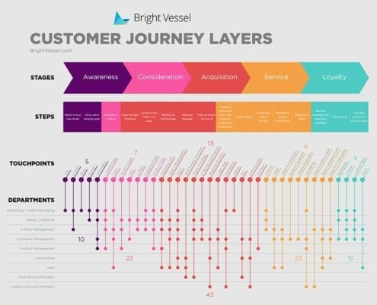
Source of the diagram :( brightvessel.com/customer-journey-2018)
Customer journey stage (1) Awareness

The first stage of customer journey is awareness which is a pain point that leads a potential customer to start researching information and seeking an answer to solve a problem. The first customer perceptive matters a lot when researching and finding an answer to a problem and the pain point is only successful if the customer’s enquiries are through especially on the company’s customer touch points (Samson, 2017)
Customer Journey Stage (2) Consideration
At this stage the customer must have done series of information finding regarding the brand intended to buy but there could be still no assurance for positive purchase decision. Furthermore, there may be an obstacle of negative online review comment that can dissuade the customer’s interest in the product for example the previous customer experience during or after touch point. However, potential customers may be mis- lead by conscious bias piece of information attached to a product through social media outlet by the competitors (Samson, 2017)
Customer Journey Stage (3) Decision/Acquisition
This stage is the progression of the consideration aspect of customer journey. At this point, the prospective customer must have researched and ready to make an opinion regarding the product. However, the decision of the prospective customer is dependent on outcome of the concluded research which is the basis of positive or negative purchase decision (Samson, 2017)
Customer Journey Stage (4) Retention/Service
This is the ability of the company to keep a customer over a long period of time. It requires sustainability plan that engages both the company and the customer for example; feedback strategy which can be positive or negative and no matter the feedback, the company will have the opportunity to know how the customer feels about a product or service. Knowing how the customer feels about a product or service means knowing what to improve or consolidate by the company, however understanding the value of the customer is very helpful in this case (Samson, 2017)

Customer Journey Stage (5) Advocacy
At this stage, the customer becomes the brand ambassador of the company and this is an evidence of customer satisfaction. Referrals are made by the customer and word of mouth positive information is disseminated that enables the company becomes a market leader (Samson, 2017) Since marketing management is about creating and planning to develop new product, advertising and promoting the product, it is imperative to understand how the company’s workplace culture can enhance customer engagement without which there can be no competitive advantage. Furthermore, the exigency of customer journey and touch point cannot be overlooked because the two identities are the paradigm of customers’ advocacy which depends on experience.
Strengths of Unilever Customer Journey Mapping:
Customer journey mapping is a resource or capacity building that enables the company predicts the models of touch points required to customer retainer ship as well as making it the basic tools of end user centric strategy. The context of customer personas during the journey mapping such as motivations or behaviours can be understood and such understanding can lead to re-modelling for further successful user research (Readingroom, n.d.) Such journey mapping as strength of Unilever has helped to make sustainability plan that engaged both the company and the customers through discovering their behaviours and what motivates them according (Samson, 2017)
Weaknesses of Unilever Customer Journey Mapping:
In as much as the journey mapping can be strength for the company in order to build capacity after finding the challenges facing Customer touch points and the need for end user centric strategy, it creates extra responsibility of monitoring the feedback and company progress over time. As journey maps even now represent in-depth understanding throughout structural silos, some firms make maps the basis of the company’s customer experience record effort. Instead of apprising their finding periodically from time to time, they continually feed fresh customer response and performance metric into their journey maps (Bruce, 2010) Logically, this can affect customer advocacy especially Unilever consumer giant that need to make their customer experience unique and provide variety of products available after updating their customer feedback in order to satisfy customer’s demand.

Total engagement Model 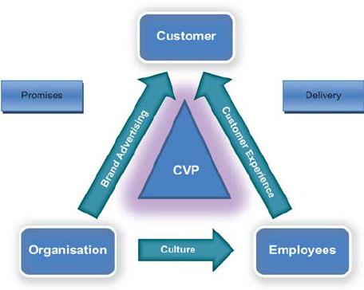
Total engagement model can be defined as a company’s purposeful effort to motivate, empower and assess the contribution of customers to marketing function that can enhance the company’s ability to make a shift in marketing research and business strategy (Harmeling, 2016) the model is essential since the company cannot do with customers who are supposed to be engaged instead just a random approach. Although, the model is customer centric since the organisation and the employees do everything to please the customers, there is need to consider the value of the customers and how they contribute to the business. The customers are also engaged by the company’s brand and this is the reason for brand differentiation, furthermore, the workplace culture and the employees play important roll to implement policies and good attitude that can give the customers good experience for instance, United Kingdom Unilever uses intrinsic and sometime extrinsic motivation as a promotional strategy to engage the customers for loyalty (Hossain, 2020)

Conclusion:
Since there is no generic technique applicable to all the companies, each company undertakes peculiar approach that suits its marketing strategies. However; the aims and objectives of marketing management are the same irrespective of the company involved. The assignment hinges on marketing management with reference to UK Unilever Company discovered as one of the leading consumer giants in the world which means that the company needs to continuously analysing their competitors in order to implementing the marketing strategies suitable to the changing marketing environment.

Reference Lists:
al., E. A. e., 2016. Mapping the customer journey: Lessond Lerned from graph-based online attribution modeling. International Journal Of Research in Marketing, Volume 33, pp. 457-474.
Anderl, E., 2016. Mapping the customer journey: Lessons learned from graph-based online attribution modeling. International Journal of Research in Marketing, Volume 33, pp. 457-474.
Camilleri, M. A., 2017. Integrated Marketing Communications. Researchgate.
Dawle, A., 2020. AN OVERVIEW OF MARKETING COMMUNICATION STRATEGY: A DESCRIPTIVE STUDY. International journal of current Research, 12(10).
Harmeling, C., 2016. Toward a theory of customers engagement marketing. Journal of the Academy of marketing science.
Heinberg, M., 2020. HOW NOSTALGIC BRAND POSITIONING SHAPES BRAND EQUITY: DIFFERENCES BETWEEN EMERGING AND DEVELOPED MARKET. Journal of the academy of marketing Science, 48(5), pp. 869-890.
Hobbs, A., 2020. Analyzing Unilever's Pledge to Cut Back on Plastic, London: SAGE.
Hossain, M., 2020. Marketing Strategy and Sustainable Plan of Unilever. International Journal of Scientific Research and Engineering Development, 3(4), pp. 680-692.
Kirveev, V., 2061. Marketing management as the Realization process of Research, Production and sale activity of the Enterprise. International review of management and marketing, 6(6), pp. 228-234.
Lee, S. L., 2018. A customer Point Management System For Effective Service Communication. BCRP, 1(1), pp. 46-49.
Muneeb, A., 2020. HOW BRAND IMAGE AND PERCEIVED SERVICE QUALITY AFFECT CUSTOMER LOYALTY THROUGH CUSTOMER SATISFACTION. ACADEMY OF MARKETING STUDIES JOURNAL, 24(1), pp. 1528-2678.
Ozbal, O., 2020. A trust-based peer to peer digital brand equity (P2P-DBE) Model. Jpournal Of Marketing Theory and Practice, 26 8, 28(4), pp. 497-520.
Pahwa, A., 2020. Customer Touchpoint. What Are Customer Touchpoint? Importance & Example, 11 June.
Payne, E. M., 2017. Omni-Channel Marketing, Integrated Marketing Communications and consumer engagement. ProQuest, 11(2), pp. 185-197.
Samson, S., 2017. Journey Mapping the User Experience. Researchgate, 78(4), p. 459.
Shilling, A., 2016. Strategic Relationships and Branding Your Firm. Money Management Executive;. ProQuest, 24(6), pp. 1-na.
Siddique, F. B., 2018. Unilever Sustainable Living Plan: A critical Analysis. 2 May.
Sokunbi, I. A., 2018. PRESENTATION ON UNILEVER UK AND UNILIVER NIGERIA.
Sudbury, L.-R., 2020. The Trajectory Touchpoint Technique: A Deep Dive Methodology for service innovation. Journal Service Of Research, 23(2), pp. 229-251.
Ukaj, F., 2016. The role and Importance of Brand in the Marketing of Small and Medium Sized Enterprises in Kosovo. International Journal of Marketing Studies, Nov, 8(6), pp. 1918-7203.
Vasilily, K., 2016. Marketing Management as the Realization Process of Research, Production and Sales Activity of the Enterprise. International review of Management and Marketing, 6(6), pp. 228-234.
Yousaf, A., 2017. CONCEPTUALISING TOURIST BASED BRAND-EQUITY PYRAMID: AN APPLICATION OF KELLER'S -BRAND PYRAMID MODEL TO DESTINATION. Journal Of Tourism and Hospitality Management, 23(1), pp. 119-137.

