Ramatoulie Baldeh 2022866

Assignment: Digital Estimating and Measurement in Construction
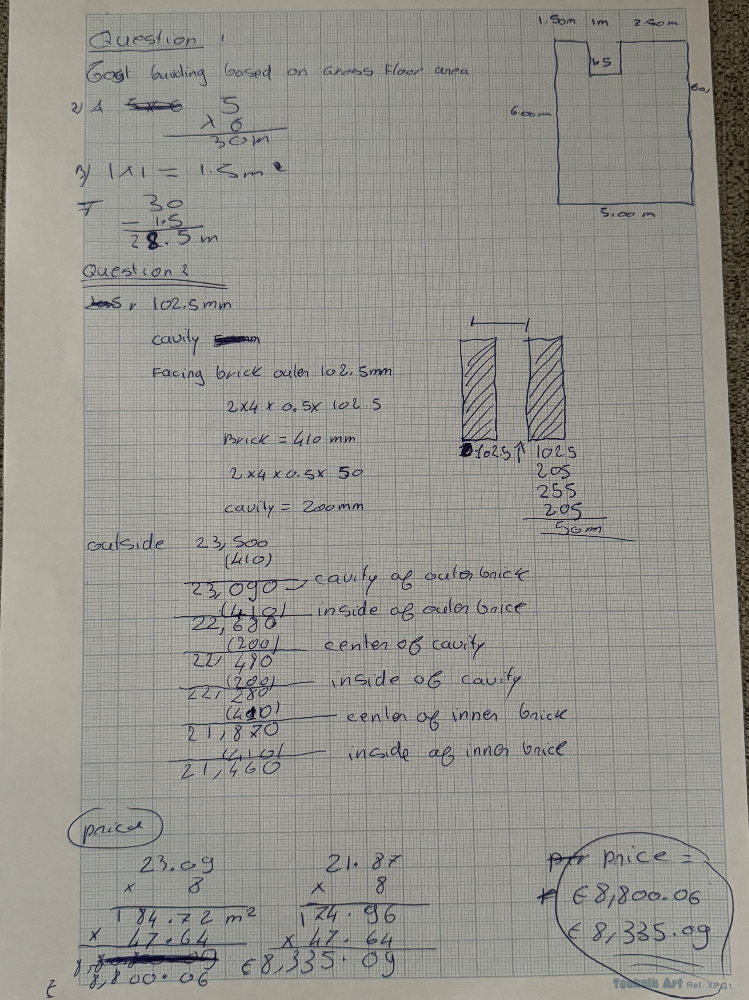

Report on Assumptions and the Role of the Quantity Surveyor

Prepared by Ramatoulie baldeh
Date: 24/01/2024

1. Assumptions
In the process of estimating and planning for our construction project, I, [Your Name], have made several assumptions based on my understanding and knowledge of the project requirements. These assumptions are critical for accurate calculations and planning. They are as follows:
- Unit Cost: The unit cost used in our calculations is derived from industry standards and reflects the prevailing market rates for construction in our specific location. This includes considerations for standard construction materials, methods, and labour costs.
- Standard Dimensions: In cases where detailed specifications were not provided, I have assumed standard dimensions for doors and windows. These can be further adjusted during the more detailed design phases as specific requirements become available.
- Foundation Type: I have assumed the utilization of a conventional foundation type suitable for our local soil conditions. Any specific foundation requirements will be incorporated into our plans as more detailed information is obtained.
- No Special Features: The estimates are based on a standard building design without incorporating unique architectural features or specialized construction needs.

2. Role of the Quantity Surveyor
A quantity surveyor is responsible for managing the contracts and costs of a construction project. His/her job description involves carrying out studies of project duration and labour costs, examining and analysing material costs, coordinating supply deliveries, paying labourers, and giving contractors advice and suggestions on legal and contractual issues.
By Team | August 15, 2023
As your Quantity Surveyor, my role is multifaceted and crucial to the success of our construction project. I would like to outline the key aspects of my role:
- Accurate Measurements: My commitment is to ensure precise measurements of materials, providing the foundation for meticulous project planning, efficient resource allocation, and a smooth construction process.
- Cost Control: Rigorous monitoring and control of costs are integral to my role. Through detailed analysis of project costs at every stage, I aim to prevent budget overruns and ensure optimal res
- ource utilization.
- Project Management: Acting as a project manager, I coordinate with contractors, suppliers, and various stakeholders. This includes overseeing timelines, identifying potential risks, and implementing strategies to keep our project on schedule.
- Risk Management: My proactive stance on risk management involves identifying and mitigating potential challenges early in the project. This approach helps minimize unexpected issues, contributing to a streamlined construction process.
- Value Engineering: Always on the lookout for opportunities in value engineering, my aim is to find cost-effective solutions without compromising quality or functionality. This approach maximizes the value of your investment.

3. Reference
Construction Industry Standards. 2024 Best Practices and Guidelines for Quantity Surveyors. Quantity Surveyor Job Description, Key Duties and Responsibilities – Job Description And Resume Examples
This report is a culmination of my research and understanding of the project requirements, reflecting my commitment to ensuring a successful construction endeavour.
End of Report

