

LEVEL 5

SEMESTER 1 & 2

MODULE CODE: SHSS5084
Expedition Skills

aSSESSMENT TYPE: Project
Assessment/Component: 2
COMPONENT WEIGHTING: 70%
WORD COUNT: 5,000 WORDS
MODULE TUTOR: DENISE LEONARD

Expedition Portfolio

Produce a detailed log of the planning for the expedition. This will include comprehensive risk assessments, route plans, emergency procedures, transport arrangements, medical forms, pre-expedition training/ preparation and any other relevant details. Further information related to this assessment can be found on Moodle under Expedition Portfolio Resources as well as on-going tutorial support.

SUBMISSION DETAILS:

Deadline:
Date: 8th February 2019
Time: 3.00pm
Portal: Turnitin

School of Sport, Health & Outdoor Education

Assessment Feedback Sheet

Student No./Name:
Module: SHSS5084
Module Code: Expedition Skills

Personal Evaluation – to support your academic progress please complete the section below BEFORE submitting your work.
What do you consider to be the best aspects of this work?
Which aspects do you consider could have been improved in this piece of work? |  |  | The quality of writing
What have you found most satisfying whilst undertaking this submission? |  |  | Getting it done before the deadline
ASSESSMENT CRITERIA | Learning  Outcomes |  | GRADE
ASSESSMENT CRITERIA |  |  | Poor  0 – 25% | Unsatisfactory  26-39% |  | Satisfactory  40 – 49% | Good  50 – 59% | Very Good  60 – 69% | Excellent  70 – 85% |  | Exceptional  86– 100% | %
Produce a well presented and comprehensive expedition planning log with logical format and clarity of purpose | 1,2,4,6 |  |  |  |  |  |  |  |  |  |  | 100%
It is expected that students will present work that is proof read, correctly referenced and adheres to the Assessment Checklist. Therefore a range of 0 – 10 marks will be deducted for non-completion of any of the points on the checklist below.
TUTOR COMMENTS:

Submission date:  via Turnitin |  | Return date:  (at least within 4 weeks) |  |  | Tutor: Denise Leonard |  |  |  |  | Mark:

Assignment Checklist

- Please complete the Personal Evaluation section of the Assessment Feedback sheet, add your name and details, and paste the whole of this assignment document into the front of your assignment

- Submission is a single word file, clearly labelled with your name and module code
- Font style - Times New Roman, size -12 for text and 14 for headings
- Ink colour – black only
- Line spacing – 1.5 line spacing and 2cm- 2.5cm page margins
- Quotations more than three lines to be indented 1 line spacing
- One line space between paragraphs, paragraphs must be left aligned
- Pagination (your assignment should have page numbers)
- All tables and figures are internally referenced and have a title
- Word count checked and written at end of text (before references and any appendix)
- Assignment is within 10% of the word limit (excluding references and any appendices)
- All references in the text are included in the reference list
- Correct referencing following the Harvard style, as described in the Palgrave study skills book ‘Cite them Right’.
- Correct spelling using UK English
- Correct use of punctuation
- Grammar and syntax correct- double check anything that has a green line under it
- I have read my assignment out loud to myself and it makes sense and is easy to read
- Somebody else has read my work and it makes sense to him or her!
- I have checked and I have not plagiarised
Failure to follow these guidelines will cost you marks!
Expedition Skills

Introduction
Throughout this document I will be discussing my plan for my expedition plan. I will be talking about how to I am going to plan and run my expedition and what I will need to run it. I will be talking about whom I will be taking with me as my assistant and who will be supporting my expedition and why I have chosen them.

Expedition Overview
My expedition will be run on the 11th to the 13th of April.
As my expedition I am partnering up with one of my class mates John Paul as my second for one day and I will be their second for the other day and then the third day we will split between us and have our participants lead a section of the expedition.
For the expedition we will be traveling roughly 40km along the Wales Coastal Path and starting from Bosheston National Trust car park and walking over the three days and finishing at Amroth at New Inn Pub.
At all times throughout the expedition I will conduct myself in a professional manor and adhere to any code of conduct that the university provides. I will also have to fill in an expedition contract stating what I am doing, where I am going and for how long I will be gone. You can find thing in Appendix

Aims and Objectives
For Day 1 I will be leading the session with John Paul as my assistant.
For Day 2 John Paul will be leading the session with me as his assistant.
For Day 3 we will give the participants more responsibility in leading the walk.

Day 1 – Aims for day one are that I will teach our participants basic map skills so that they can lead smaller sections of the walk, they should be able to rotate a map and follow the path and take a bearing by the end of day one. The main aim of the day is that they will be able to Macro Navigate sections of the path. While my partner will chip in when needed with local history information and information on local flora and fauna.

Day 2 – Aims for day two are that John Paul will lead the session while visiting historical sites with the main aim of teaching our participants about the local history. While I will add sections where they will start to learn about Micro Navigation.
Day 3 – Aims for day three are that we will be giving the participants more responsibility with map reading and leading the group. They should be able to combine the last two days of map skills and be able to lead us through the route and if they need help we are there to give them support and guidance.

For the first two days of the expedition we will be using a democratic leading style so that we can make the day a productive as we can and so that the participants can make the most out of the expedition. For the third day we are taking a more of an Abdicratic leadership style as we will be giving the participants tasks to do along the walk for that day.

How will we meet the Aims and Objectives?
To make sure that all aims and objectives are met I will make sure all my knowledge is up to date and valid for when I want to lead the session and teach the participants what I know.
To make sure all aims are met for day one I will make sure that my knowledge on basic map skills is up to date and I will then pass on my knowledge to the participants throughout the day. I will also make sure I find out what the participants already know about map reading and what they want to know about map reading.

Expedition Leader Profile and Competencies / Qualifications
Sam Sharp
07572127077
Currently I do not hold any qualifications for walking and walking in lowland terrain or to run this expedition as a professional, I do not have any qualification to run an overnight expedition. However I have done the lowland leader training and by the time we run the expedition I will have hopefully completing the lowland award which would mean I can run the walks. I would also complete an overnight competency course to show that I am able to run the expedition overnight, I have also participated in the hill and mountain skills course which gives me more experience being in the outdoors in different terrains. I have been gaining the experience I need for the certificate over that last few months and logging each walk I do with the Digital Log Book (DLOG). I have a range of experience of walking in the outdoors and wild camping in different location.
I also have relevant first qualification to take carry out any first aid in the outdoors that is needed.

Expedition Assistant Profile and Competencies / Qualifications
John Paul Brady
07775777816
As I am running this expedition as part of a team I have decided to choose John Paul as my second on the days that I will be leading. I have chosen him as he had a wide range on knowledge of the areas that we will be walking in and has also completed the lowland leader training and will hopefully go on to complete the lowland leader award, he has also participated in the same hill and mountain skills course I have which shows that he also has experiences in different terrains and competent with map skills. He also has relevant first aid qualification that is needed in the outdoors.
He has experience in lowland terrain and is keen to progress into taking groups out on walks.

Expedition Team Profile
This will be completed as and when I have gained the participants needed for the expedition.
For my expedition I would like to find participants that have little to no experience being in the outdoors but are keen to gain some and also to find people that would like to learn new basic skills within outdoor environments.

Expedition Support Person
Ross Dallimore
07846467167
I have decided to choose Ross Dallimore as my support person for my expedition, my reason for this is that he lives relatively close to the venue and has some knowledge about the area that can be useful. He has also recently completed his mountain leader training and has the relevant first aid, skills and experience within the outdoors.

First Aid Provisions
As part of the essentials I will make sure that the participants bring their own first aid kit with their own personal medication if they need it. I will also have a first aid kit with extra equipment in so that in the case of an accident I can do what I can to help while waiting for emergency services. I have also completed a 16 hour outdoor first aid course which means that I am able to carry out any first aid that is needed in the outdoors. I know that my assistant also has the relevant first aid qualifications so if necessary they are able to also carry out first aid. For the days that I am leading the session I will be the primary first aider and on the days that I am not leading the session I will not be the primary first aider. I will also make it clear to the group that they will not be required to carry out first aid unless it is absolutely necessary.

Medical Declaration Forms
SHSS5084 EXPEDITION LEADERSHIP
MEDICAL DECLARATION FORM
Please complete this form as accurately and truthfully as possible. The information you disclose will be confidential and will only be used to help the expedition leaders respond to an injury or illness.

Name: _____________________________________________ D.O.B.:______________________

Address: ________________________________________________________________________

________________________________________________________________________________

Mobile Number: __________________________________________________________________

Next of Kin/Guardian Name: ________________________________________________________

Next of Kin/Guardian Contact Number: ________________________________________________

If you answer yes to any of the following questions, please give brief details in the space provided.

1. Do you currently suffer from any physical or psychological medical conditions/ailments?
________________________________________________________________________________

2. Are you currently taking any form of medication?
________________________________________________________________________________

3. Do you have any form of allergy?
________________________________________________________________________________

4. Do you currently have any injuries or ailments?
________________________________________________________________________________

5. Do you have history of any physical or psychological medical conditions, injuries or ailments that may affect your participation in any aspect of the programme?
________________________________________________________________________________

If you have answered yes to any of the questions above, please use the space provided on the back of this sheet to give further details, and ensure you discuss this with the expedition leaders.

I declare that the information on this form is as accurate and truthful as possible.
I acknowledge it is my responsibility to keep expedition leaders informed of any information stated here in, or changes to this information that may affect my participation in the expedition.

Signature: _________________________ Date: __________________

Above is a copy of the medical declaration for I will give to my participants before they come on my expedition. Go to Appendix 3.

Assumption of Risk Form

SHSS5084 EXPEDITION LEADERSHIP
ASSUMPTION OF RISK FORM

(Please read this document carefully)

Expedition’s that are run as part of module SHSS5084 Expedition Leadership inherent in the Outdoor Adventure Education programme at the University of Wales: Trinity Saint David, can take place both at day and night and in different environments, which might be considered remote or hostile, often without easy access to advanced medical or other facilities.

I (full name) ________________________________________ ____________
Acknowledge and accept that participation in an expedition of this nature entails both known and unanticipated risks, which could result in damage to my property, physical or emotional injury, paralysis and death. I understand that such risks cannot be eliminated without jeopardising the fundamental qualities of the expedition. By participating in this expedition I accept these risks and take responsibility for my own actions and involvement.

I accept the fact that I have a personal duty and responsibility to learn and to follow safety guidelines and procedures established by the expedition leaders:
Expedition Leader: _____________________________________________________
Assistant Leader: _____________________________________________________

I undertake to inform those named above, at any point during the expedition process, should I not understand what is expected of me or should I not wish to further participate in the expedition. However, due to the venues being used, I understand that it might not always be possible to simply stop or withdraw immediately from the expedition.

I am physically and mentally fit to participate in this expedition. I have completed a medical form that is accurate and true. I agree to notify the expedition leaders of any changes to my health or fitness. If I become ill or injured I give my consent for first aid to be administered and for provision of other medical treatment or rescue services as required.

Signed: ________________________________ Date: _____________________

Above is the assumption of risk form that will be filled in. Go to Appendix 2.

Behavioural Expectations
When we run our expedition we have certain behavioural expectations of our participants. We will give our participants a behavioural form to fill in prior to the expedition and we will discuss them further when we know who will be coming with us on our expedition, we will discuss these on our preparatory day to make sure everyone knows what is expected of them, including ourselves. We will also discuss the country side code as that will be a big part of how we should behave in the outdoors. Should any participant misbehave during the course of the expedition will be reminded of the behavioural form and should they misbehave again they will then be asked to remove themselves from the expedition, there will either be arrangements to take them home or we will call the expedition off depending on how bad it is. This is because I do not want my expedition being compromised due to one person’s silly behaviour.
As we are university students running the expedition I do not want anything to reflect badly on us and on the university. To make sure that they know exactly what us expected of them I will give them a form to fill in. Go to Appendix 4.

Individual Kit List
Clothing
Walking trousers/shorts T-shirt Jumper (fleece) Base layer (thermal)
Jacket (insulated) Walking shoes/boots Hat Gloves
Waterproof jacket Waterproof trousers
Spare layers (base layer/t-shirt/socks/jumper)
Rucksack (65L +)
Camping Tent Sleeping bag Sleeping bag liner Sleeping mat
Bivouac bag (weather depending) Tarpaulin
Cooking
Cooking stove/Trangia’s Pots and pans Cleaning products
Food Utensils
Personal
Individual first aid kit/ medicines Head torch Map (map section will be provided) Compass Flask Whistle Water bottle Walking poles
Power bank Sun cream Sanitary kit Sunglasses
Snacks (sweets/energy bars)
Items marked in Green can be obtained from stores at Cynefin.
Items marked in Red are preferable but not essential.

Group Kit List
Group shelter First aid kit Gloves Hat Jacket (insulated)
Fleece Hi-vis jacket food

Equipment Request Form
For this expedition we will need to borrow certain equipment from Cynefin and to make sure we know what we have taken by the end of the expedition. To do this we will be using an Equipment Request Form.
It is so that we can make a note of what we have taken and when we have taken it. We also know that when we bring the equipment back we can make a note of whether it needs to be services or not.
In appendix 1 there is a copy of the equipment request form that we will be using.

Preparatory Training Undertaken
We will conduct preparatory training once we have finalised who will be participating in this expedition. The reason for this preparatory training is so that we can assess the participant’s fitness levels and basic walking skills to see how they would do on the expedition. I will be assessing their knowledge of basic navigation.
We will also discuss how too correctly put up and take down a tent, and go over what kind of kit is needed and how to pack a rucksack efficiently.
The route that has been chosen for preparatory training walk will be a walk along the Wales coastal path from Llansteffan beach to Carmarthen. A date for this preparatory training will be discussed with the participants at a later date to ensure that they are able to make it.

Reconnaissance of Expedition Route
I have completed a full reconnaissance of the route we will be taking over the three days. I have made sure that I know the area we will be walking in and making sure my navigation around these area and knowledge of the locals areas are up to date to make sure I know what I am doing when it comes to leading the expedition.
There are further reconnaissance’s that need doing as I still need to further my knowledge of the coast past to make sure that I know where I am going and to make sure I know where all the escape routes are. I also need to make sure that my local knowledge of the area is up to date.

Campsites
There have been campsites identified that we can use for our expedition.
Day 1: at Freshwater East, Grid Reference SS 026,981 there is a possible wild camping spot. During the reconnaissance of the area we came across a small clearing in the wood alongside the coastal path, after a discussion with my assistant we decided that this would be the best place to camp for the first night as there is enough space in the clearing to pitch up enough tents and less than 10 minutes away there is a toilet block at the Freshwater East car park.

Day 2: for day two there were a few possible camping spots that we identified. These locations were either in or around Tenby.
Kiln park caravan park, Grid Reference, SN 123,003. Kiln Park is a large caravan and camping park that can be found roughly 10 minutes off the path. This campsite is quite large and has a range of facilities that can be used.

Windmills caravan park, Grid Reference, SN 130,019. This campsite is a small site that can be located up Slippery Back in Tenby; this campsite is the furthest from the route which means that a small detour would be needed to get there. However if this becomes the best option then a small detour does not matter.

Meadow Farm caravan park, Grid Reference, SN 132,016. This campsite is a small campsite that is located just off the coastal path and is situated near Allen’s View in Tenby; this campsite would be the ideal campsite as it is the closest to the coastal path and also has facilities that can be used.

Day 3: for this day we would not need to look for a campsite as this is when we will be finishing the expedition and will be driving home at the end of the day.

Route Cards and Escape Routes
For this expedition we have created a series of route cards to follow while walking along the coastal path. Routes cards can be very useful as you can mark on them points of reference and good points to have checkpoints and escape routes. A routes card will contain grid references and descriptions of the location to help you when you find it. These route cards are based on the Duke of Edenborough style route cards as I believe them to be the easiest to use and helpful when it comes to reading them while on route. You can find a copy of each day’s route card in Appendix 6.

Contingency Planning
The Pembrokeshire Coastal Path can be a very exposed coast path in places. However the coast path is still very accessible through most weather. During the lead up to the expedition I will be monitoring the weather to make sure that when we get to the expedition time we will be doing it in the best weather possible. If we were to do the expedition and during the lead up some of the coast path had been badly exposed to the elements there can be parts of the path that are closed off which means that we would need a contingency plan so that we can carry on with the expedition.
One contingency plan that we have is that should we need to we can flip the expedition over so we start where we finish and we finish where we start. Should we need to do this due to adverse weather this would be a great option as the last section of the expedition is the most sheltered, this would mean that we would be protected more than the other side of the walk and would be able to see out the bad weather without being too exposed.
If there is adverse weather there can be the issue of landslides. However if we were to encounter landslides there are different detours that we can take which will keep us on route and allows to carry on the expedition. These detours are usefully pointed out by the Pembrokeshire National Park who monitor and maintain the coastal path in Pembrokeshire.
There are also two sections of the expedition that runs through the Ministry of Defences firing ranges where they may be conducting firing exercises. This would mean that we would need to take to path around the compound as we would not be allowed to walk through. Prior to the expedition we will find out if they will be conducting any exercises during the time of our expedition.

Weather Forecast Sources
During the lead up to the expedition I will be monitoring the weather to make sure that we carry out the expedition in the best time and to also make sure we know if we need to not run it due to adverse weather. The sources I will be using to monitor the weather during the run up will be the Met Office and Accuweather. I will be using these resources as the Met Office is where all weather companies find their information and Accuweather because they are also a reliable source of weather information.

Contact with Landowners
During sections of this walk there are areas of land we will be passing through that we may need a little more information on. For example the Ministry of Defence may be running firing exercises so I would need to contact then to find out when they will be conducting them and make sure we run our expedition around their times so we are not inconvenienced.

Risk Assessments
For this expedition we need to carry out a set of risk assessments. These are done to make sure that we know the risks we are taking while carrying out these activities and to make sure we know what to do to try and make sure we avoid these risks. The way we do this is put control measures in place. These are to make sure that when it comes to taking a risk we do everything we can to make sure nothing happens. For example, if you are walking along a path and there is an electric fence along it you would make sure that no one touches it, you would do this by making sure everyone knows it is there and they know not to touch.
For this expedition we have obtained generic risk assessments associated with walking and camping and have made our own site specific risk assessments, these are to make sure that when it comes to the walk we already know what is coming ahead. You can find these risk assessments in Appendix 5.

Road Worthiness of Vehicles
When we run this expedition we will need transport to get to the starting spot and back their when we finish. As I have a car and so dies my assistant we will both be able to leave a car at the start and at the finish of the expedition. The reason for this is so that we are able to finish and we do not have to rely on anything else to get us back to the start to pick up the other car. In Appendix 7 you can find a copy of driving licences and insurance documents.

Important Contact Details
For this expedition there is a list of important contact detail that I will need to take with me in the case of an emergency. These numbers are for my lecturers and my course administrator. I will need these numbers because if there was to be an accident as well as providing my own first aid and calling the emergency services they would also need to know what is going on so that they can go through the university protocol.
Tom Moore – 07794445535
Graham Harvey – 07896431200
Denise Leonard – 07956835785
Sian Davies – 01267225187

Accident Emergency Procedures
In the case that there was an accident there are a set of procedures that need to be followed these procedures are there so that you know exactly what you need to do. I will also sign this document to say they I will carry out these accident procedures correctly and to the best of my ability. You can find a copy in Appendix 9.

Expedition Contact Details
These expedition contact detail will be a list of our expedition teams contacts, so myself, my assistant and our two participants. These details are there in the case that we need to contact them and do not already have their details. We need these details so that we can make sure we have the ability to contact them in cases of emergencies or even just to ask about meeting for the preparatory training. You can find a copy of the form in Appendix 10.

Appendix

Appendix 1
SHSS5084 EXPEDITION LEADERSHIP
Equipment Request Form

Name:

Dates of Expedition:

Date of collection:

Date of Return:

Item/s | Serviceable check or | Date of Return

I have checked and agree that all the equipment is complete and serviceable.

Signature:

Date:

Appendix 2
SHSS5084 EXPEDITION LEADERSHIP
ASSUMPTION OF RISK FORM

(Please read this document carefully)

Expedition’s that are run as part of module SHSS5084 Expedition Leadership inherent in the Outdoor Adventure Education programme at the University of Wales: Trinity Saint David, can take place both at day and night and in different environments, which might be considered remote or hostile, often without easy access to advanced medical or other facilities.

I (full name) ________________________________________ ____________
Acknowledge and accept that participation in an expedition of this nature entails both known and unanticipated risks, which could result in damage to my property, physical or emotional injury, paralysis and death. I understand that such risks cannot be eliminated without jeopardising the fundamental qualities of the expedition. By participating in this expedition I accept these risks and take responsibility for my own actions and involvement.

I accept the fact that I have a personal duty and responsibility to learn and to follow safety guidelines and procedures established by the expedition leaders:
Expedition Leader: _____________________________________________________
Assistant Leader: _____________________________________________________

I undertake to inform those named above, at any point during the expedition process, should I not understand what is expected of me or should I not wish to further participate in the expedition. However, due to the venues being used, I understand that it might not always be possible to simply stop or withdraw immediately from the expedition.

I am physically and mentally fit to participate in this expedition. I have completed a medical form that is accurate and true. I agree to notify the expedition leaders of any changes to my health or fitness. If I become ill or injured I give my consent for first aid to be administered and for provision of other medical treatment or rescue services as required.

Signed: ________________________________ Date: _____________________

Appendix 3
SHSS5084 EXPEDITION LEADERSHIP
MEDICAL DECLARATION FORM
Please complete this form as accurately and truthfully as possible. The information you disclose will be confidential and will only be used to help the expedition leaders respond to an injury or illness.

Name: _____________________________________________ D.O.B.:______________________

Address: ________________________________________________________________________

________________________________________________________________________________

Mobile Number: __________________________________________________________________

Next of Kin/Guardian Name: ________________________________________________________

Next of Kin/Guardian Contact Number: ________________________________________________

If you answer yes to any of the following questions, please give brief details in the space provided.

1. Do you currently suffer from any physical or psychological medical conditions/ailments?
________________________________________________________________________________

2. Are you currently taking any form of medication?
________________________________________________________________________________

3. Do you have any form of allergy?
________________________________________________________________________________

4. Do you currently have any injuries or ailments?
________________________________________________________________________________

5. Do you have history of any physical or psychological medical conditions, injuries or ailments that may affect your participation in any aspect of the programme?
________________________________________________________________________________

If you have answered yes to any of the questions above, please use the space provided on the back of this sheet to give further details, and ensure you discuss this with the expedition leaders.

I declare that the information on this form is as accurate and truthful as possible.
I acknowledge it is my responsibility to keep expedition leaders informed of any information stated here in, or changes to this information that may affect my participation in the expedition.

Signature: _________________________ Date: __________________

Appendix 4

Behavioural expectation

Student

I will agree to start this contract on this date _____________. I will agree to act within these rules and regulation, I also understand that if any of these rules are broken the leader; Sam Sharp has the power to ask politely to remove myself from the group and activity.
- To follow the remits of the law, that applies to all.
- To follow university rules and regulations.
- To promise to promote good and proper behaviour as an ambassador of the university.
- To not cause any harm to public property and property of other group member.
- To not consume any alcohol or illegal substances. The consumption of alcohol is prohibited throughout the day.
- To be open-minded and join in with other activates whilst at the campsite.
- To respect everyone’s personal views and beliefs.
- To avoid using any loud/foul language in public areas especially where there any members of the public and/or children near.

Failure to comply and follow these rules participants will be politely asked to leave by the expedition Leader and either taken home or the expedition will finish, and will not be invited back on future expeditions.

Name:
Date:
Signed:

Appendix 5
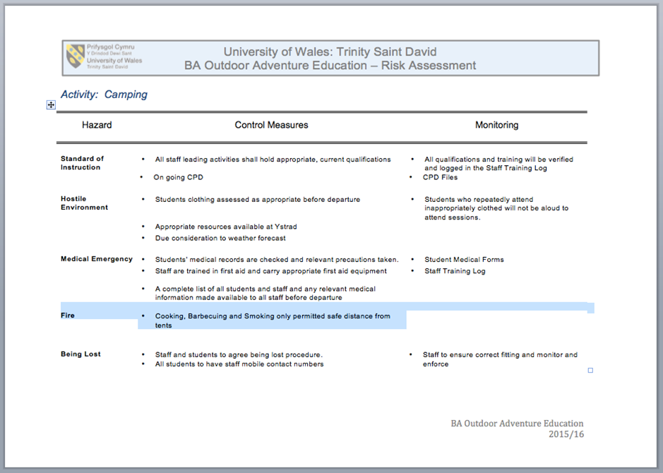

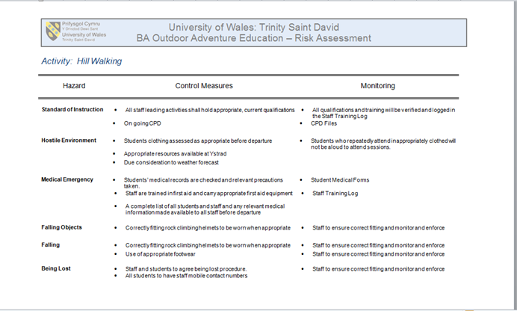



Appendix 6
Day 1 Route Card

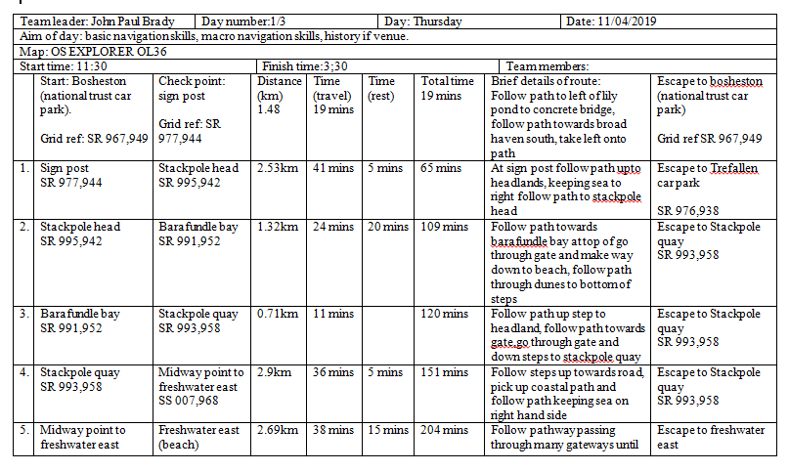
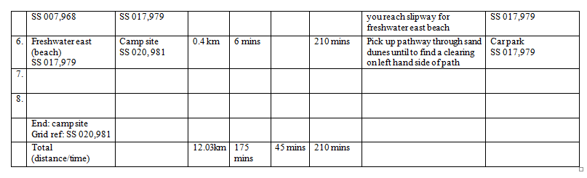

Day 2 Route Card

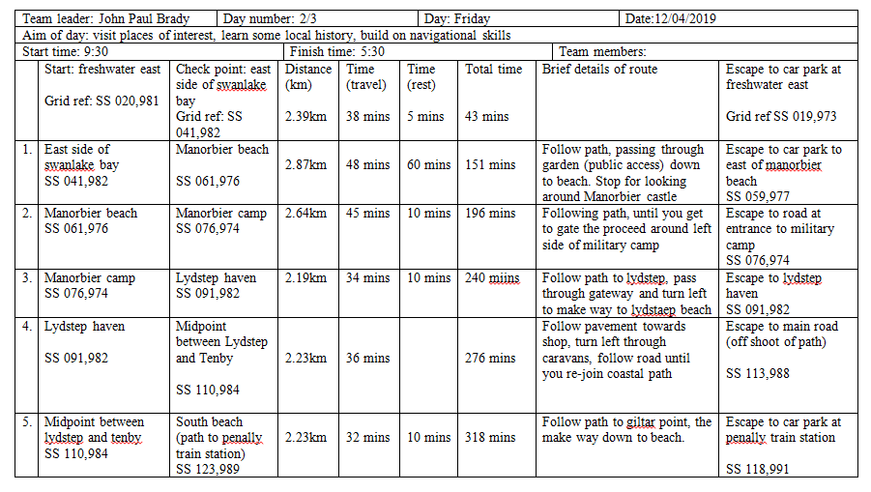

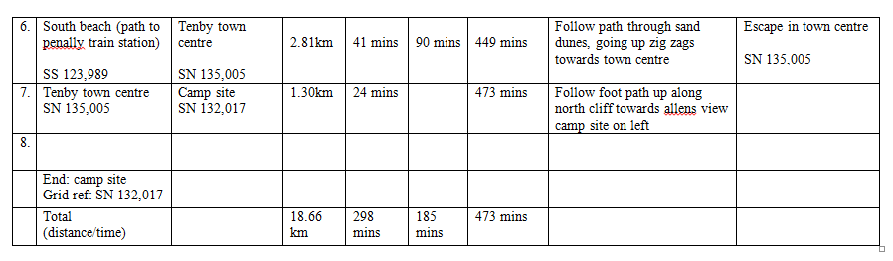

Day 3 Route Card

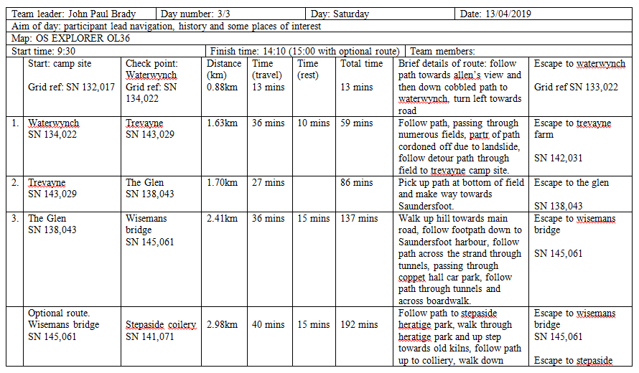

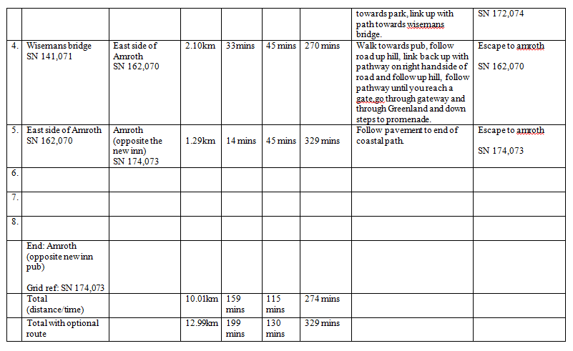
Appendix 7

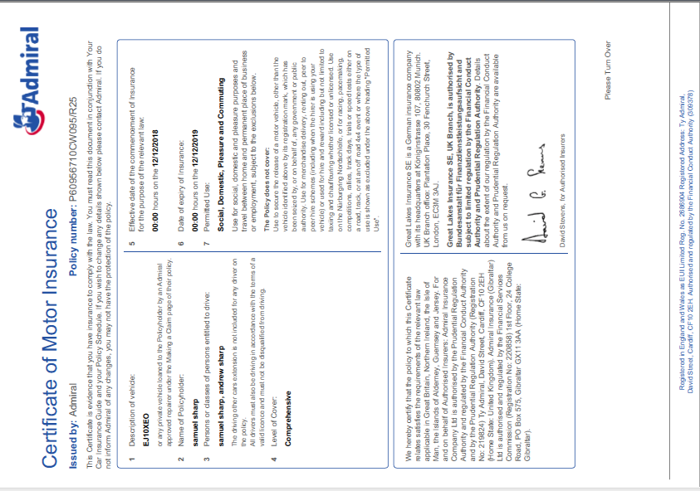



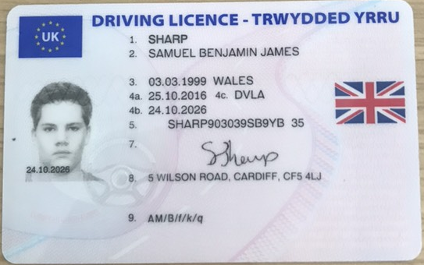

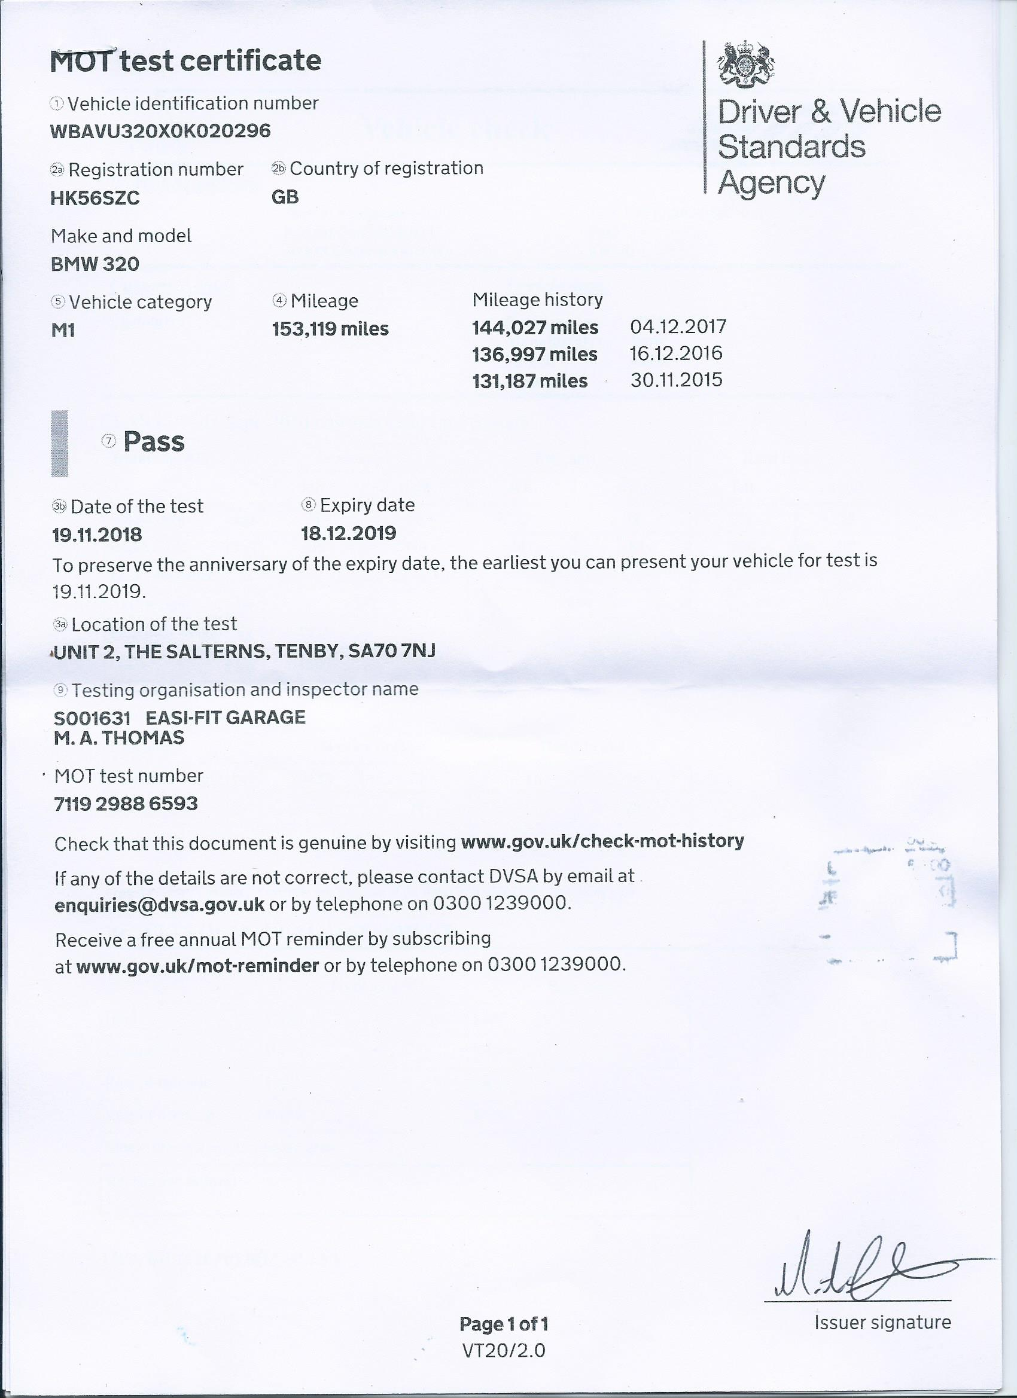

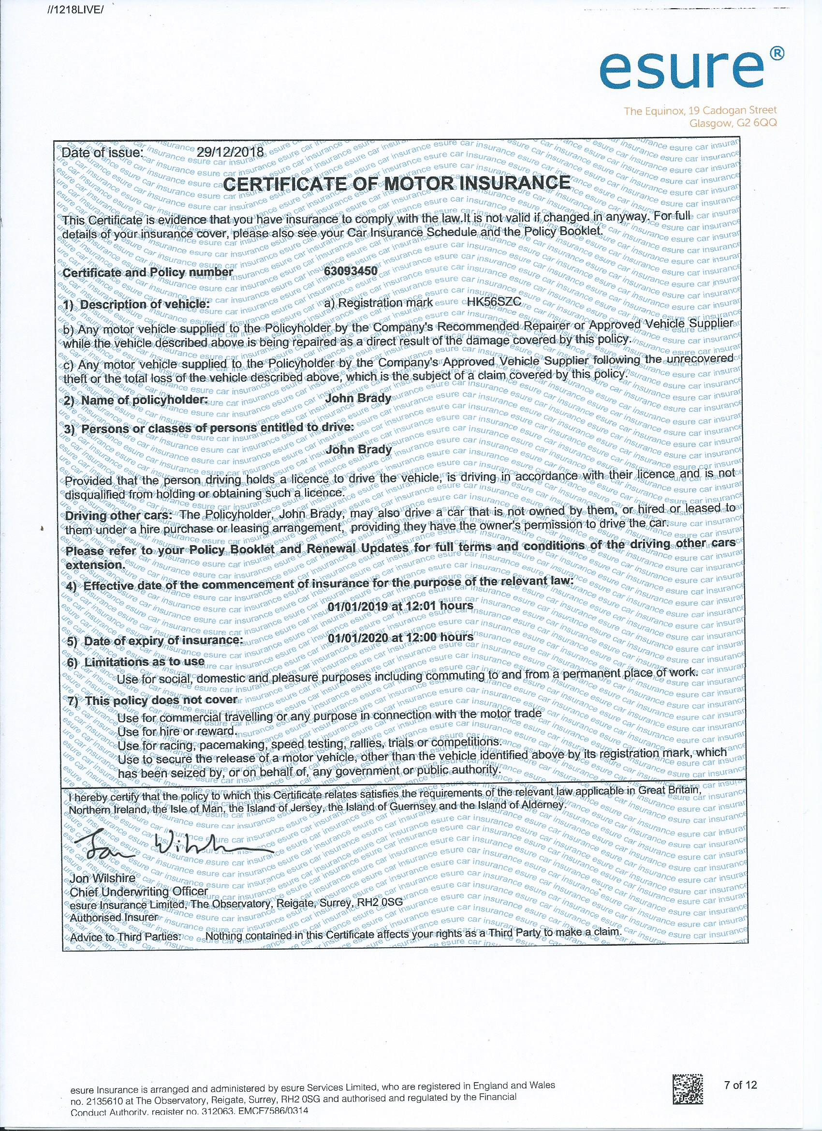



Appendix 8

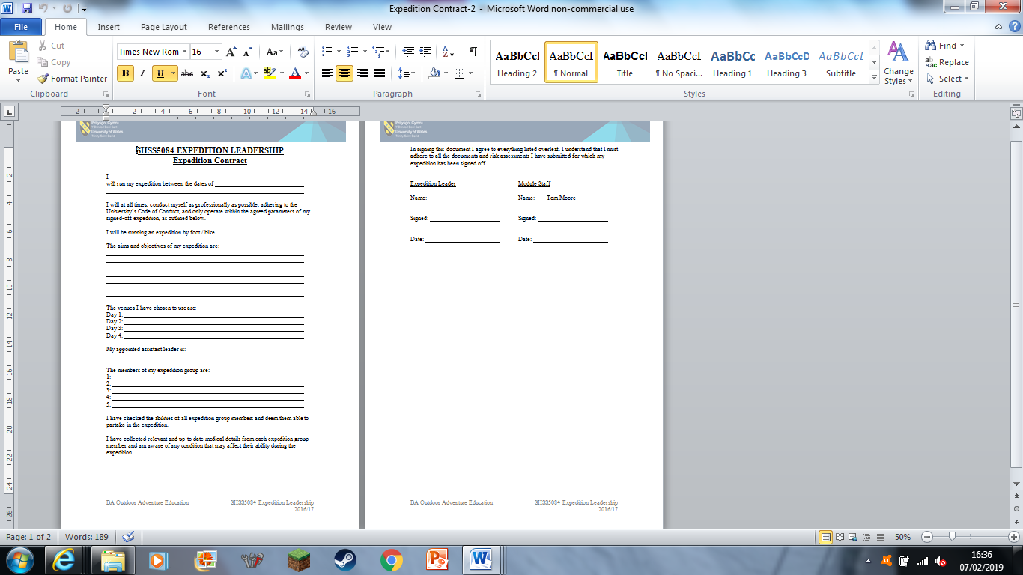

Appendix 9



Appendix 10



