Cyber security issues within the modern world
Module: Advanced cyber security
Module code: ACCA6000
Lecturer: Dr Carlene Campbell

Contents
1 Introduction 5
1.1 Why has cybersecurity become an important issue? 5
1.2 What threats exist? 5
Disruption 5
Distortion 6
Deterioration 7
2 Future trends of cyber security 7
2.1Phishing 7
2.2 Phishing targets 7
2.3 Ransomware 8
2.5 Delivering Ransomware 8
2.6 Exploit kits 8
2.7 Targets 8
3 Lab 1 Email tracker 9
3.1 Conclusion 12
4 Lab 2 CyberGhost 12
4.1 Conclusion 14
5 Lab 3 Malware 15
5.1 Conclusion 16
6 Lab 4 Cryptography 17
6.1 Conclusion 18
7 Packet tracer 19
7.1 Password encryption 19
7.2 Firewall 19
7.3 IP configuration 19
7.4 PC ping 20
7.5 Firewall setup 20
7.6 Ping after firewall 20
7.7 Conclusion 21
7.8 Access list 21
7.9 ACL conclusion 23
8 conclusion 23
9 References 24
Bibliography 24

Figure 1 Phishing targets [8] 8
Figure 2 Email tracker install 9
Figure 3 Email tracker features 9
Figure 4 My trace reports 10
Figure 5 Trace pop up 10
Figure 6 Show original 10
Figure 7 Email code 11
Figure 8 Trace fucntion 11
Figure 9 Email report 11
Figure 10 Website report 12
Figure 11 Route map 12
Figure 12 IP Address route 13
Figure 13 Device report 13
Figure 14 Email tracker Revisited 14
Figure 15 CyberGhost no connection 15
Figure 16 South korea server 15
Figure 17 Server MBPS 16
Figure 18 VPN features 16
Figure 19 IP Location 17
Figure 20 Original location 17
Figure 21 Altered location 18
Figure 22 Original location 18
Figure 23 Malware installation 19
Figure 24 Malware menu 20
Figure 25 Malware scan 20
Figure 26 Malware scan report 20
Figure 27 Advanced report 21
Figure 28 Scan scheduler 21
Figure 29 Cryptool 22
Figure 30 Encrypted message 22
Figure 31 Key length encryption 22
Figure 32 Encryption 23
Figure 33 Encryption save file 23
Figure 34 RC2 file open 24
Figure 35 Decryption settings 24
Figure 36 Decrypted message 25
Figure 37 Packet tracer design 26
Figure 38 S2 configuration 26
Figure 39 Service password-encryption 27
Figure 40 PC0 IP configuration 27
Figure 41 PC1 configuration 27
Figure 42 PC0 pinging PC1 28
Figure 43 PC1 pinging PC0 28
Figure 44 Firewall configuration 28
Figure 45 Firewall test 29
Figure 46 Access list 30
Figure 47 Default gateway 30
Figure 48 Server0 default gateway 30
Figure 49 Access list configuration 31
Figure 50 PC2 ping 31
Figure 51 PC3 ping 32
Figure 52 PC4 ping 32

1 Introduction
This assignment will be about researching different cyber security issues that are affecting business and organisations around the world. The research will be about different kind of attacks how to stop them e.c.t. once research has been conducted different hacker techniques will be exercised and will be analysed. By conducting the exercise, it will be easier to analyse what the attack is and how to prevent it.

1.1 Why has cybersecurity become an important issue?
Cyber security has become important because the devices that are used in everyday tasks contain confidential information such as sensitive data , personal identifiable information and protected health information [1]. Not only do everyday devices contain this confidential information of the user but also companies , websites and organisations etc. how companies will store this information is via devices that are connected to their network, for example personal information such as name , address , student , customer , employee number , income , outcome etc. will all be stored within a database that the organisations have created.

1.2 What threats exist?
When a user is looking to protect their devices and their personal information, they need to be aware of what dangers exist and how they should protect themselves from these dangers. Having known what dangers exist this will allow the user to be wary of any suspicious content they may come across. Not only knowing what threats exist but the user should also know how these threats are carried out.

A website was found called information security forum this is a non-profit organisation that has a membership with many of the world’s leading organisations, they are dedicated to investigating and resolving key issues in information security and risk management [2]. This website has experience with many organisations and this website has posted a threat horizon for 2019. This threat horizon involves key cyber security issues that they have identified for businesses and organisations. These threats are:

Disruption
Disruption is an issue that focuses on the reliance of a network connection. By a company, organisation relying on a network connection to operate this will mean that the network will need to be constantly operating and never in a down state.
Within disruption lies a key issue of a premeditated outage that will bring the trader to its knees [3]. A premediated outage is a difficult issue to prevent as a network will never know when an attack is incoming or planned, in order to prevent an outage the network will need to be secured successfully and if any attack does happen to any device then it will notify the network and the network management team will be able to identify the attack and resolve it. Before a device on the network or the network itself is forced in a down state.
The second issue that lies within the disruption threat is ransomware [3]. Ransomware is a software attack that will then send user a corrupt a file, email etc that contains a virus. This virus will suspend the user’s system until the user gives the attacker what the attacker wants.

The third issue that will be discussed has become a more modern solution as this issue is people of authority within an organisation coerced into revealing information [3]. This problem can be eradicated by the organisation training their employees in cyber security and making them aware of threats and issues that exist and how they should deal with these issues if they appeared. Not only will this rely on the organisations providing training, but this will also rely on organisations having a safe and secure network. As if an employee was able to leak information then there is a network security issue that the organisation should address immediately. As if key information is released then this could pose a great danger to the company as they will have failed to follow the data protection act.

Distortion
The first factor of information distortion is automated misinformation [3]. Companies and organisations in the modern world utilise different technology and computer methods to store information. For example, a method that is most common is the use of databases, within a database this is where information can be stored and altered. As well as manual alteration databases will allow automatic alteration. When creating automatic alterations within a database or a network it is important that the features are setup appropriately. As the information that is automatically updated can be confidential information that should never be misinterpreted and should always be accurate as it is confidential information of a customer, user.

The second factor is about how falsified information can affect performance [3]. Not only is it important to have accurate and up to date information, but it is also important to make sure that no information that is stored is falsified or has been forgotten to be updated. For example, if a business is unable to be accurate with its income then the business will likely have more money going out than coming in which will make the business harder to manage. So, having up to date information can be crucial when running a business that relies on electronic management. As the information will likely be stored within a database that will display the total of incomings and outgoings.

The final factor within this section is a block chain. A block chain is where cryptocurrency is stored in a public database [4]. Within this database it will be made up of digital blocks, within these digital blocks this is where purchases with cryptocurrency will be stored. With each purchase a block will come with its own unique identity that is produced, this unique ID is what will be used to gain access to that specific purchase record. The issue with this factor is that if a hacker is able to gain access to a block chain and is able to acquire these unique ID addresses then the hacker will be able to acquire information that the ID contains. The information that can be acquired will be the order number which will contain the buyer’s username and purchase details. This is where a block chain poses a threat is that if a data block has been accessed then the buyer’s information will be displayed giving the hacker access to confidential information.

Deterioration
The first factor of deterioration is regarding surveillance laws that will expose corporate secrets [3]. When setting up a company or organisation there is many surveillance devices that can be placed in a building or within a network. The surveillance devices are used to monitor an area where they are placed. Once placed the footage on surveillance devices can be recorded and stored and can be viewed at any time by authorised personnel. When managing a surveillance device, it is crucial for only authorised personnel to have access to surveillance devices as they will have key footage which can capture any event that happens within the monitored area.
The second factor of deterioration is privacy regulations [3]. When any computer network or databases are set up there are regulations that exist and need to be followed. these regulations will fall in line with the data protection act, as any company/ organisation that involves any sort of computer credentials will need to follow the data protection act. Failing to follow this act can lead to the employee suing the company for not keeping their information confidential.
The third and final factor is rushing out AI [3]. When AI is being introduced it is crucial for the organisation to implement over time rather than rushing it, as when AI is being introduced it is being used to improve the system that is already in place. As AI can be unpredictable this can lead to a major cyber security threat as it will be unstable and the actions that the AI carries out may not be what the organisation / company wanted. As well as this making sure the AI is secured and protected should be vital before implementing the AI as if there is a weakness to the AI that is being implemented then hackers will likely focus their attacks on the AI and exposing the other weaknesses within the organisations network.

2 Future trends of cyber security

As technology and computing becomes more advanced over time this means that the security measures for these devices on a network will need to be constantly updated and making advancements. Only will security measures be constantly upgraded but new hacking methods will also be produced or any hacking methods that already exist will be upgraded by the hackers to penetrate the new security measures. In order for a network to stay secured the network will need to look at what methods exist and what methods are
currently trending. By looking at what methods are trending this will allow a network security team to prepare their network to defend against the new hacking methods that are being produced.

2.1Phishing
A trend that has been identified is phishing becoming more deadly. Phishing attacks involve a digital message such as an email that is sent to a user [5]. Within this email there will a file or a link once the receiver clicks on the link or the file, the link or file will open and will plant a virus within the users system to retrieve personal information such as credit card details , location , name , username and password etc.

2.2 Phishing targets

In 2018 research was carried out to discover who were the targets for phishing. By looking at the stats below it is clear to see that the main target was financial organisations followed by email, cloud, payment services and SaaS.
The financial industry was a main target as in a finance company this is where customers bank account details will be kept which would be a target for hackers. As hackers will look for a way to acquire personal information that will benefit them.

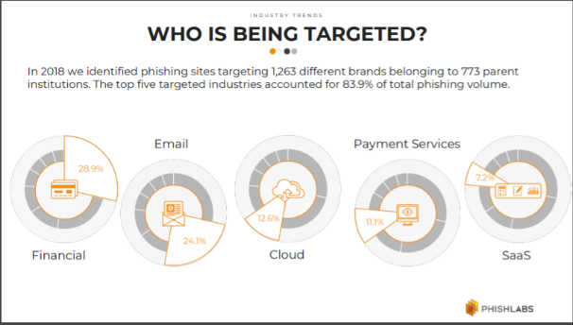
Figure 1Phishing targets
Figure 2 Phishing targets [8]

2.3 Ransomware
Ransomware is a hacking software method that can be sent to a user and will disable the user’s machine. By disabling the users machine ransomware will allow the hacker to make demands from the victim. Once the demands have been met by the victim the hacker will then remove the ransomware as the hacker has acquired what the hacker required.

2.5 Delivering Ransomware
Originally ransomware would be distributed via emails and exploit kits. Using these methods would go under the consumers / businesses radar as it would look like a normal email being received [6]. For the modern delivery of Ransomware hackers will select their target, by selecting a target this will allow the hacker to acquire the information on the target and will be able to create an attack that will be aimed for that specific target. When selecting a target the hacker will need to consider the scale of the business or target as targeting a large business will result in the Ransomware costing more to deliver as it will be targeting a large group of people.

2.6 Exploit kits
Spelevo exploit kit is a part of Ransomware. The way a splevo exploit kit works is by placing an advert or a link on a website, once the user has accessed this website they will need to click this link to remove the advert or to allow them to access the content. Once the link has been clicked by the user this will then open a new tab for a user that will redirect them to another website, this is where the exploit kit will try and install itself within the users system to acquire information on the user [7].

2.7 Targets
When a hacker is considering a target for ransomware factors will need to be considered. These factors include the targets location, income, data value, operating system and status. All of these factors will decide the hackers target and pay-out, as for example if the hacker is targeting a someone of important status who is rich then the hacker will demand a higher amount of money because the hacker has identified the targets status and location. Not only is the demand a pay-out for the hacker but this is also a way for the hacker to acquire funds to improve the ransomware that was used or the hacker will take these funds and fund to hack a bigger target.

3 Lab 1 Email tracker
In order to access email tracker, it first hard to be installed.
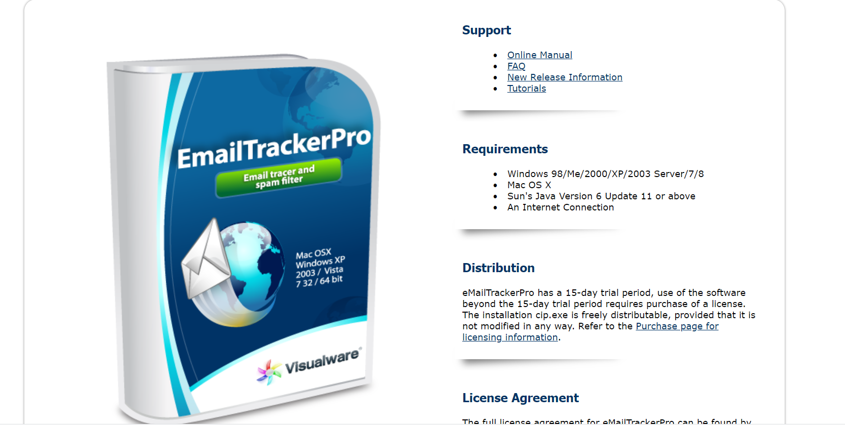
Figure 3 Email tracker install
Once email tracker was installed it could then be accessed. Once opened this was presented and the advanced edition was selected, so that the user can gain the access to the features that where required.
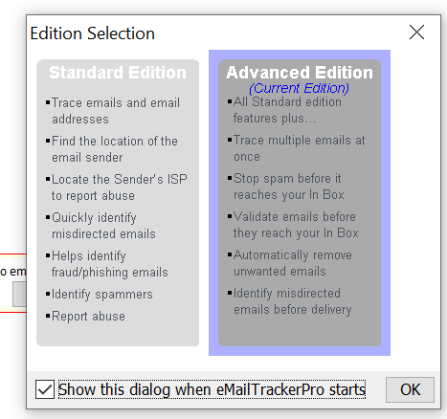
Figure 4 Email tracker features
Once the edition was selected the user then clicked on my trace reports here is where a report can be produced from an email.
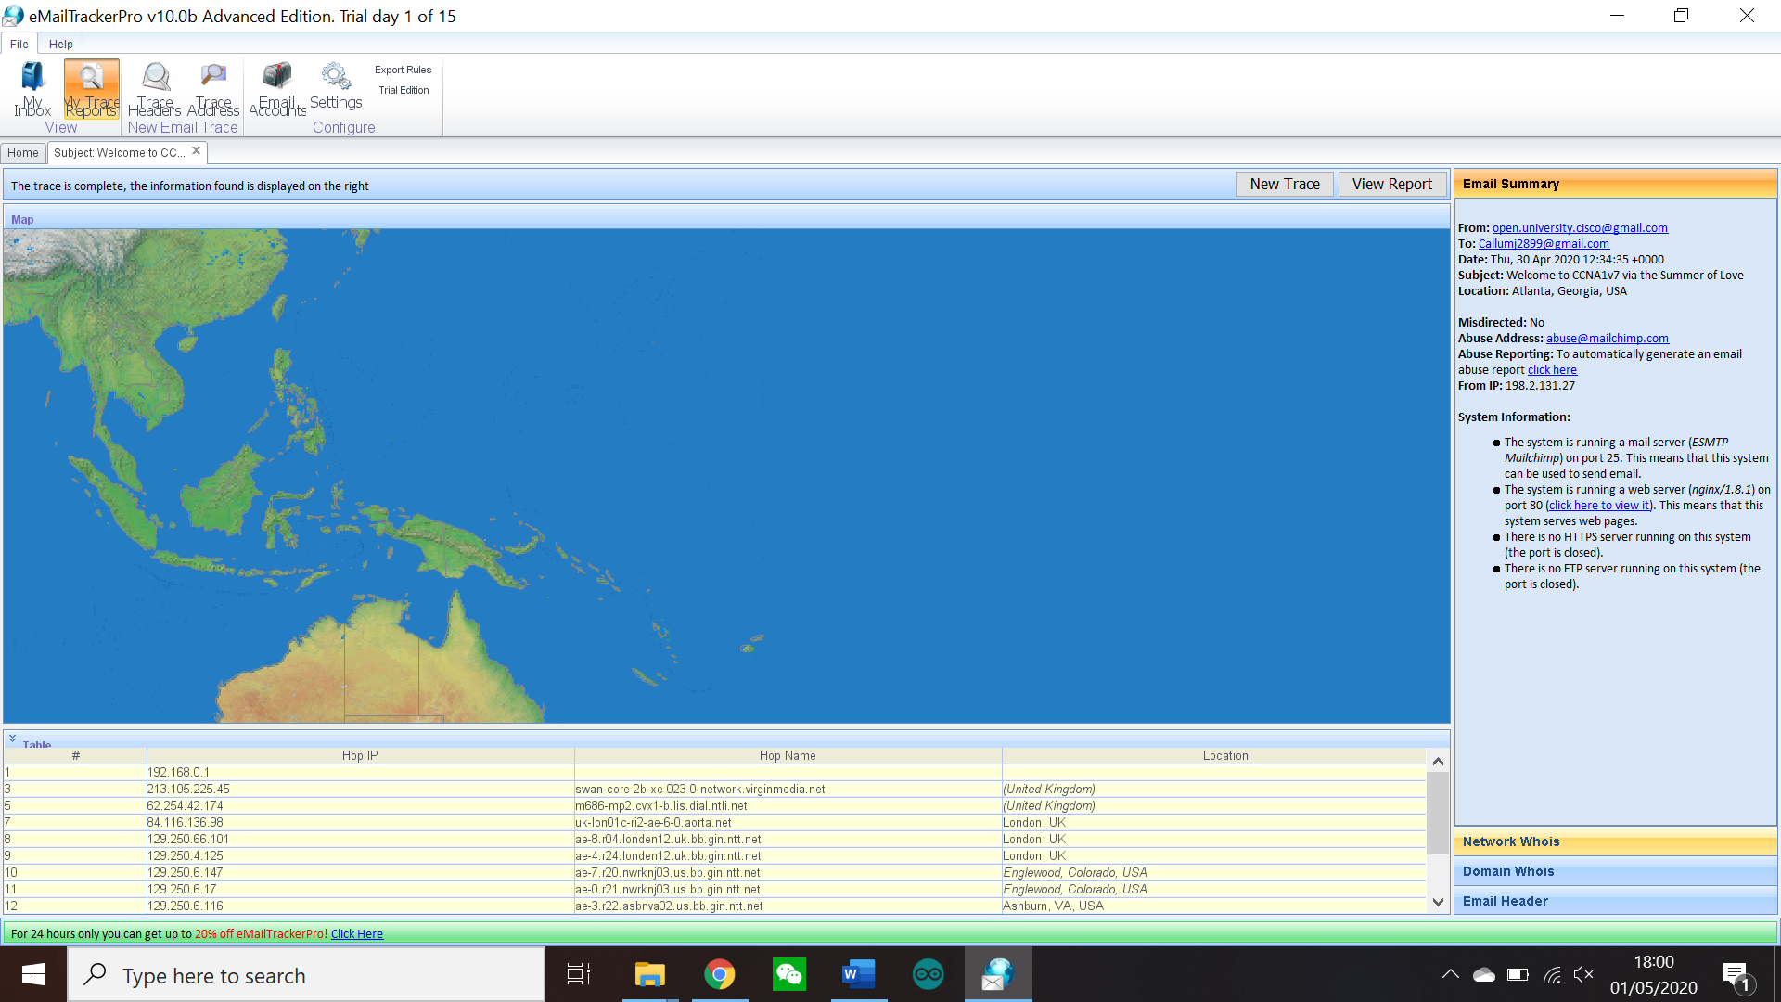
Figure 5 My trace reports
Once this tab was selected this pop up appeared. Within this pop-up this Is where the emails original code could be inputted to trace the email.
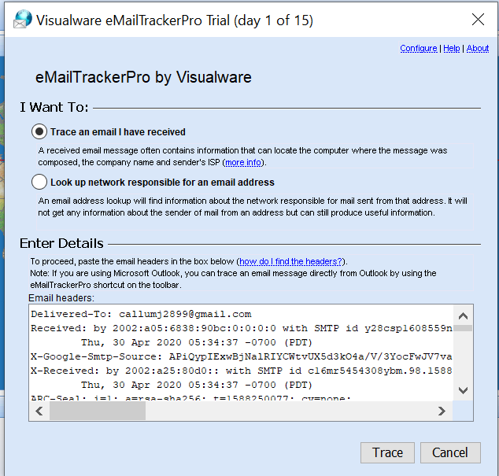
Figure 6 Trace pop up

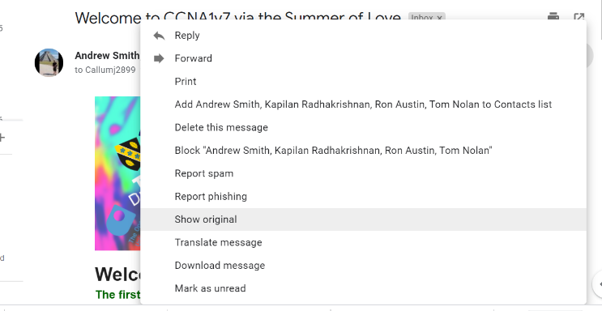
To get the email code an email was accessed within Gmail, within this email the show original function was used to acquire the email in its original state.
Figure 7 Show original

Once the show original function was used a new tab would open, within this tab this is where the emails code will be displayed and can be copy and pasted into the email tracker trace.
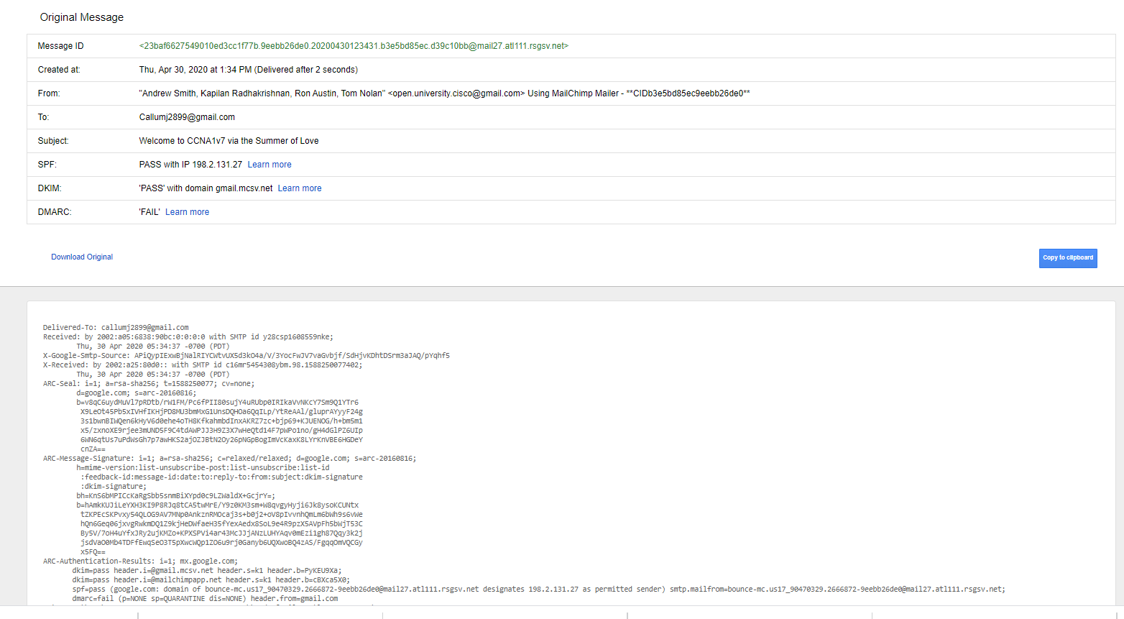
Figure 8 Email code
Once the code was acquired it would then be copy and pasted into the trace function in email tracker.

Once trace was enabled email tracker would then produce a report based on the email. The report will contain the emails route and IP addresses that were used to deliver and send the email.
Figure 9 Email report
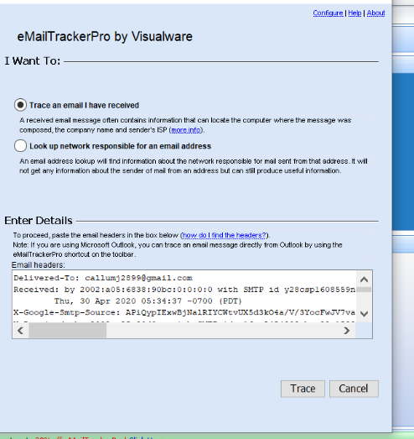
Figure 10 Email code trace

Once the report was completed within email tracker. The website was then accessed to acquire a more in-depth report on the email that was received.
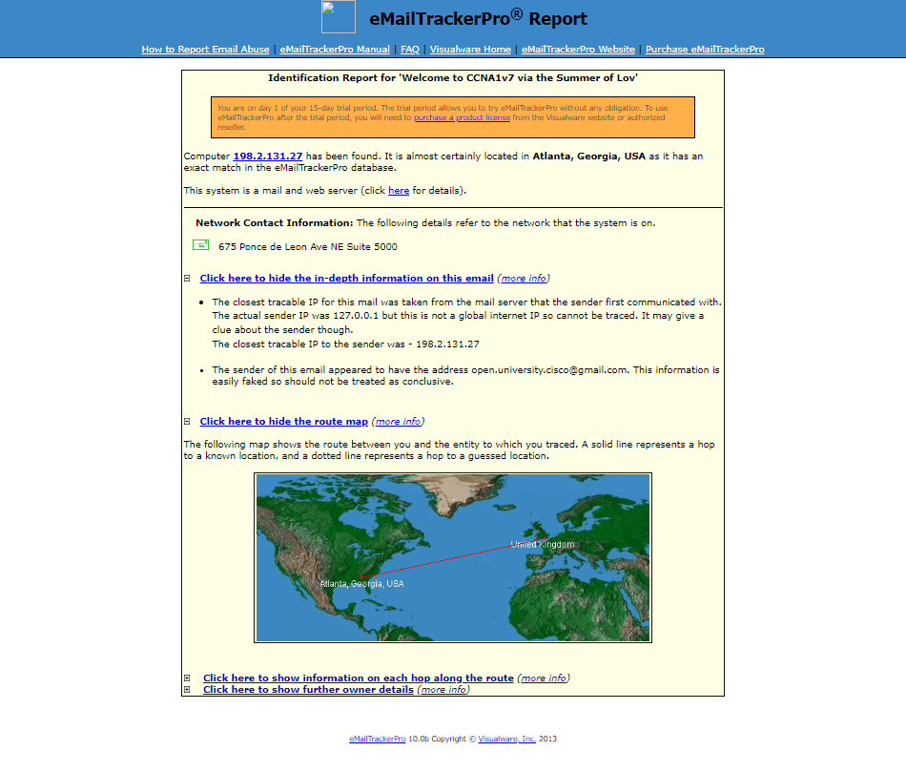
Figure 11 Website report

This report would then show the email map route. As is displayed the email was sent from Atlanta Georgia USA to United Kingdom. This can only be known because it was traced by the email tracker.
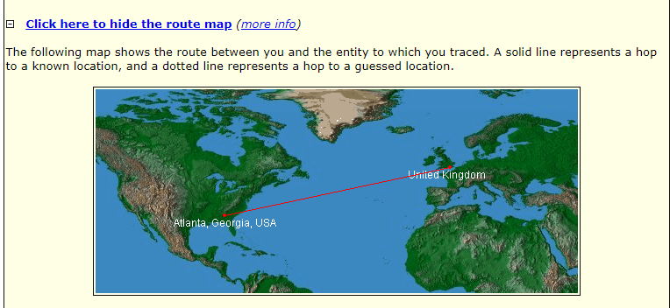
Figure 12 Route map
To follow on from the routing map the report would then show the IP address route of the email. This would contain the IP address from the sender to the receiver.

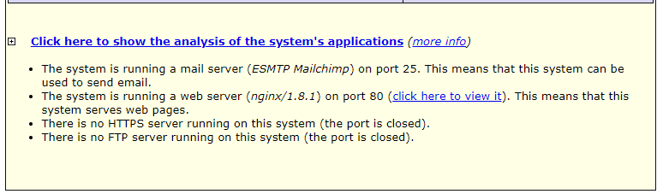
The final evidence that the report included was details on the owner’s device that is sending the email.

Figure 13 Device report
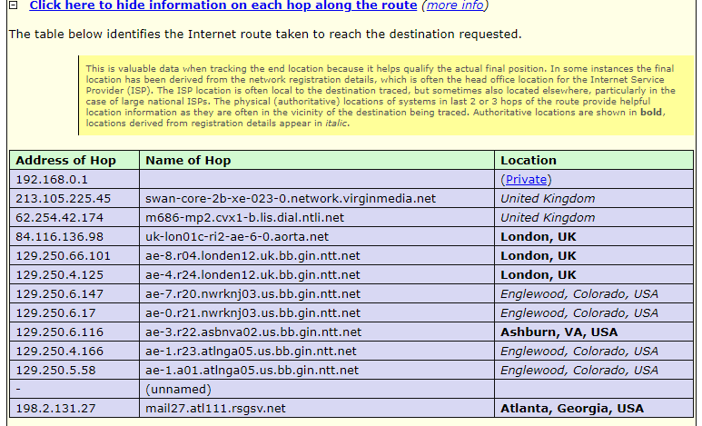
Figure 14 IP Route

Figure 15 Email map

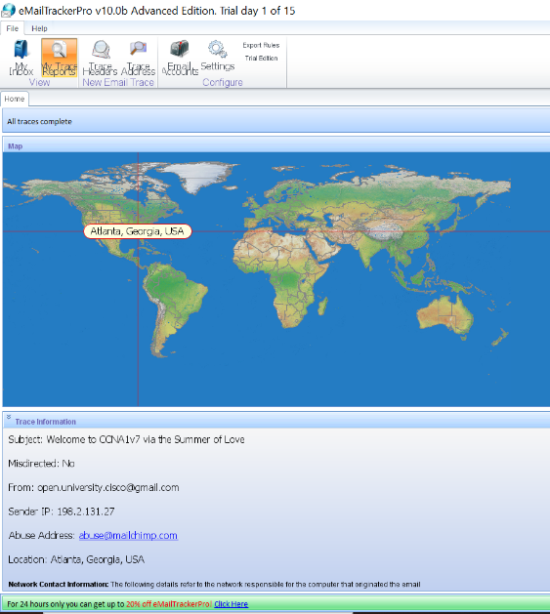
Once the user was done looking at the report and wanted to revisit email tracker. Then the original report will be saved, and the user will see the first report that was created displayed when email tracker is accessed.

3.1 Conclusion
To conclude email tracker the user thought that using email tracker was very beneficial as this software is able to trace where an email was sent from and the journey the email took. By looking at where the email came from and the senders details the user is able to use this software and the report that was gathered to make a judgement on whether the email that was received was legit.

4 Lab 2 CyberGhost

For this lab CyberGhost was utilised in order to surf the web anonymously by accessing a VPN server.

First of all, CyberGhost was installed, once installed it would ask the user to connect to a server.
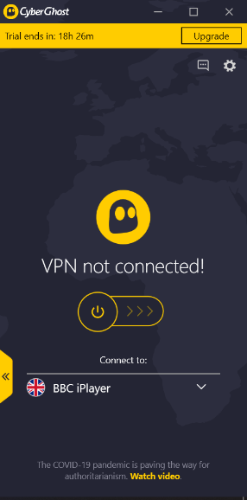
Figure 16 CyberGhost no connection

Once opened the south Korea server was chosen by the user. By choosing the south Korean server this would make the users location changed from the original location to somewhere in south Korea.
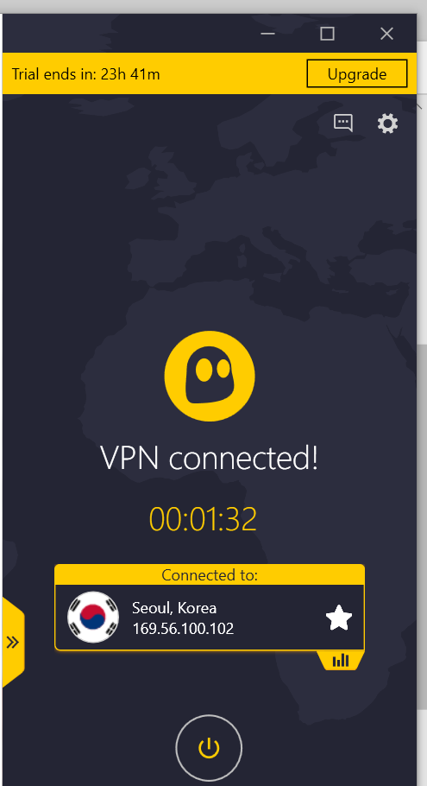
Figure 17 South Korea server

Once a connection to the server was established it, CyberGhost would then present the user with the MBPS the user was getting.
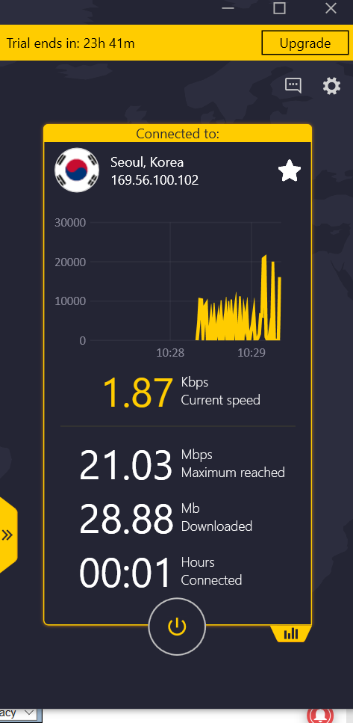
Figure 18 Server MBPS
Another feature that CyberGhost brings is for the user to allow connection features. For the purpose of this lab no features where needed to be turned on. Whereas if the user wanted to use a virtual private network then they will need to consider enabling these features for their network.
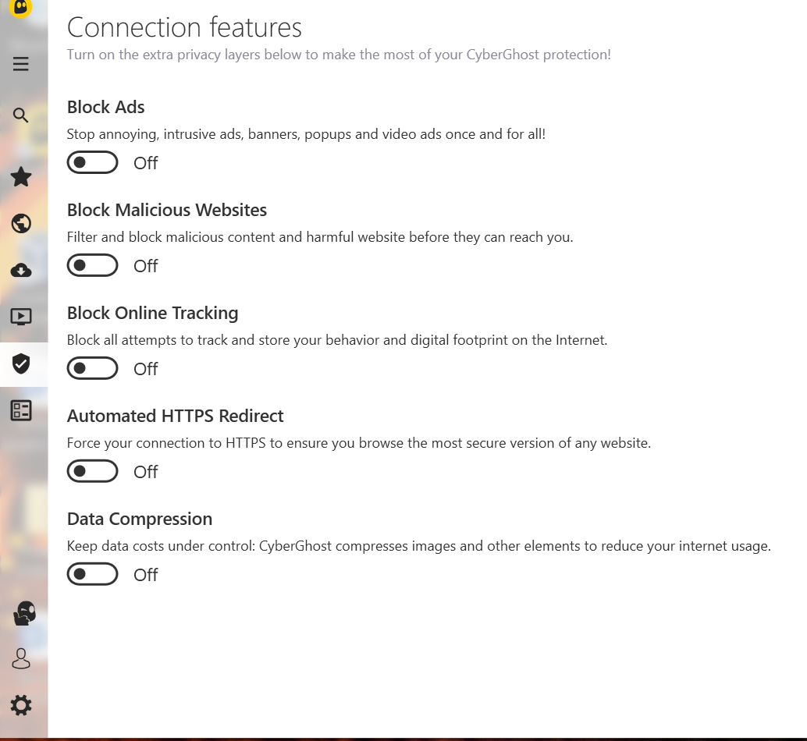
Figure 19 VPN features

Once the Virtual private network was enabled. The user then searched for what is my IP address on the Mozilla Firefox web browser. This link would allow the user to view their devices Ip address and location.
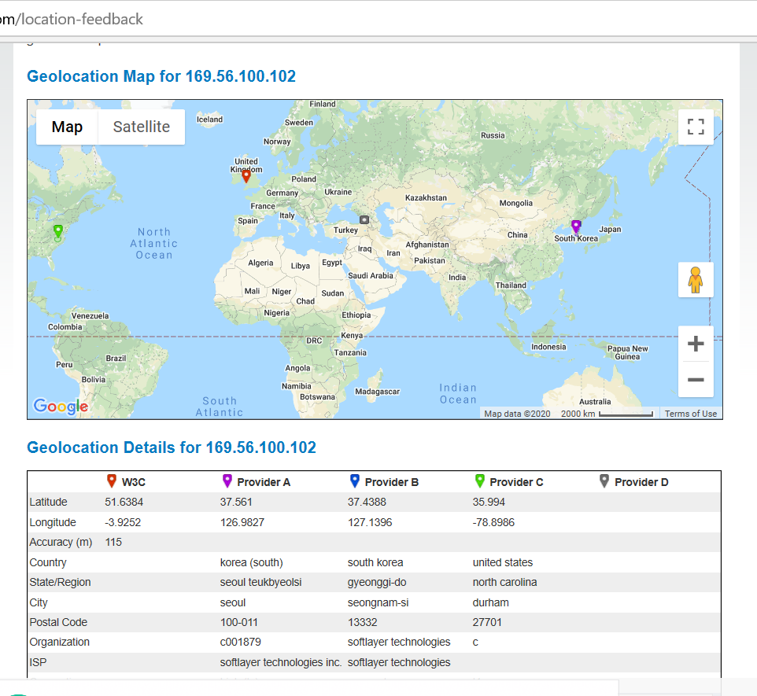
Figure 20 IP Location

When zoomed in on the map this is what the pings looked like for red (original location) and purple (altered location).
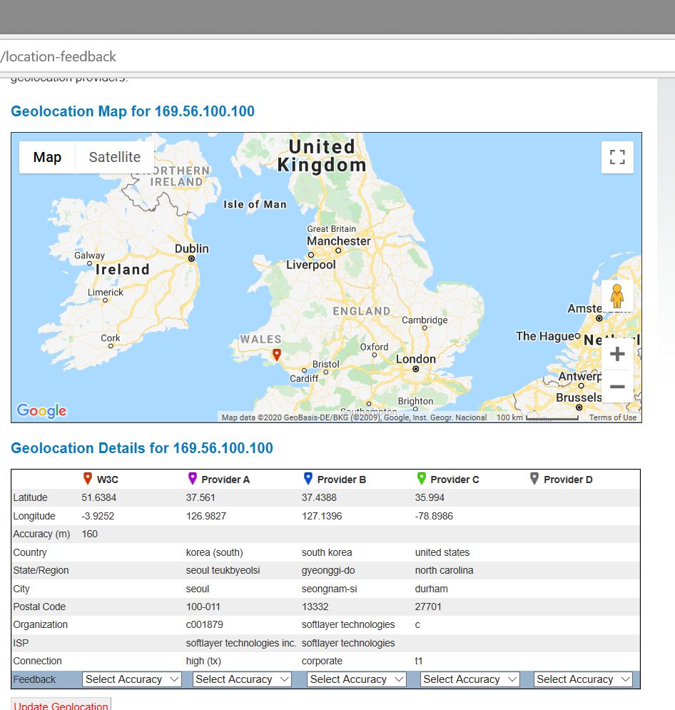
Figure 21 Original location
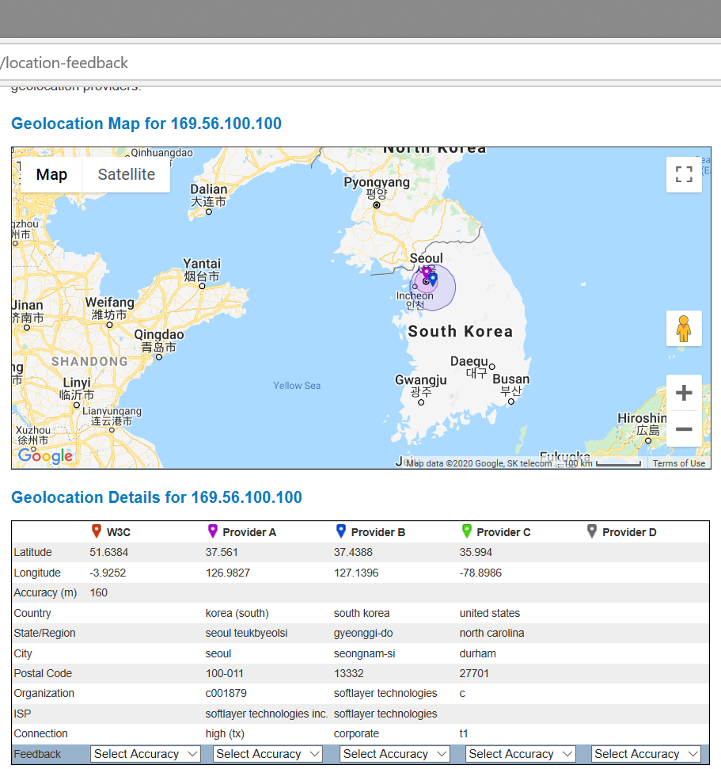
Figure 22 Altered location

When the VPN was turned off the user then checked this website again to see if there was any change. Once the map loaded the user found out that with the VPN turned off the original location and IP address will show.

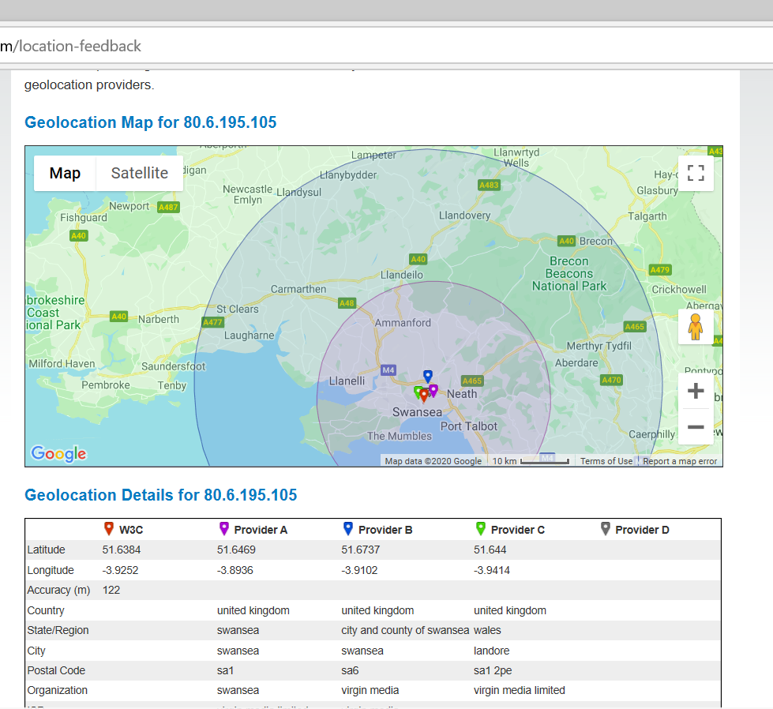
Figure 23 Original location

4.1 Conclusion

After using cyberghost the user came to the assumption that a VPN network is beneficial when trying to access content that is region locked. Not only is VPN good for a accessing a different countries server but it is also a good way to surf the web anonymously and protect the users IP address when surfing the web. As when a website is accessed the users IP address will be stored by enabling cookies but if the user is using a VPN then the VPN IP address will be stored. As well as these two factors a VPN connection is also a good way for the user to keep their IP address and location secure from any hackers. The user is able to hide their location as a VPN network will automatically change the user’s location and IP settings.

5 Lab 3 Malware

To start off this lab Malware had to be downloaded and installed. This software will be used as an antivirus software, this lab will go into how malware works and what the software does for the user’s computer.
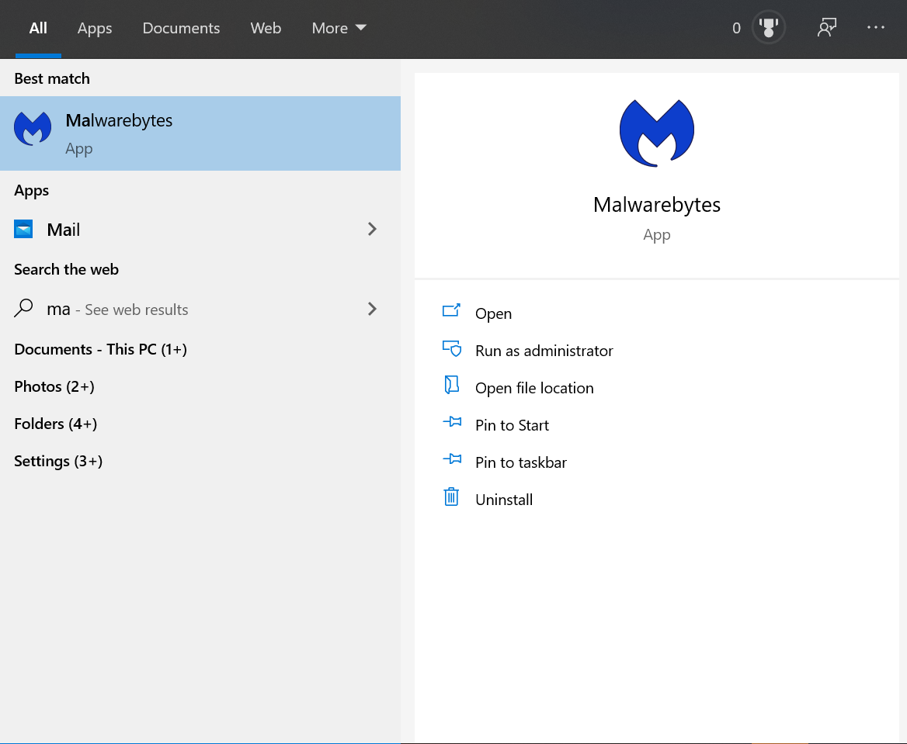
Figure 24 Malware installation

In the picture below is the options that Malwarebytes will present to the user once logged in. once logged in the user is able to use Malwarebytes to scan their system for any viruses. The user is also able to turn on real tome protection settings as seen in the bottom right box. These real time protection features can be turned on to protect the user’s system from any viruses by preventing them.

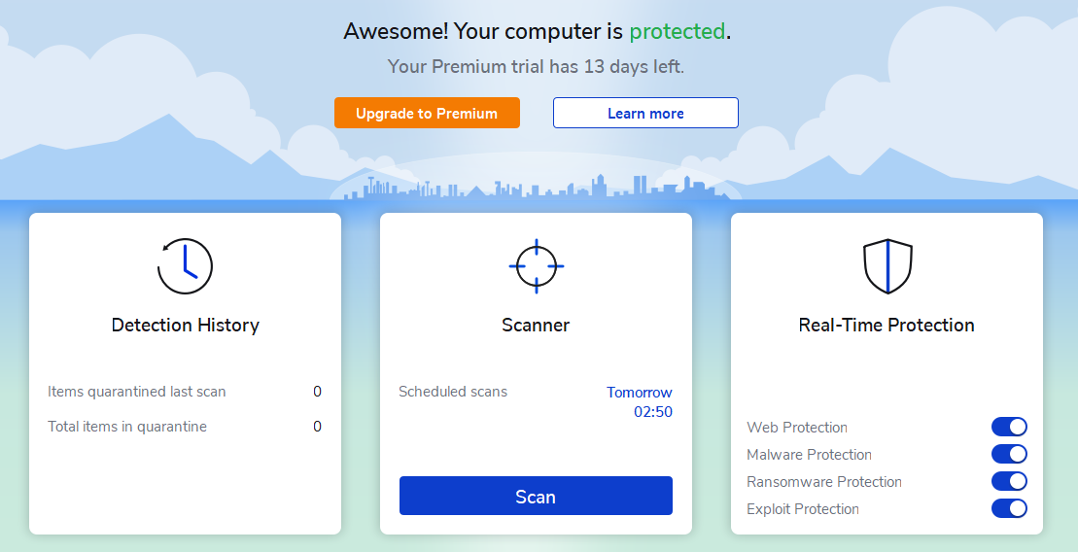
Figure 25 Malware menu

Once the user presses the scan button Malware will present the user with the screen below. The screen below is showing the scan that is currently happening on the user’s system. This scan is to detect any viruses that is on the user’s system.
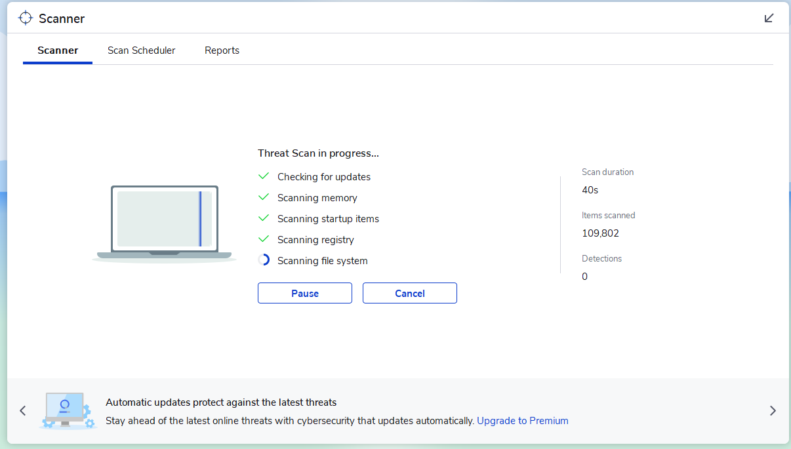
Figure 26 Malware scan
Once the scan has finished a report will then be produced of the user’s system. This report will notify the user if there are any viruses on the user’s system. In this case no viruses where reported so no further action needed to be taken as the user’s system is already clean.
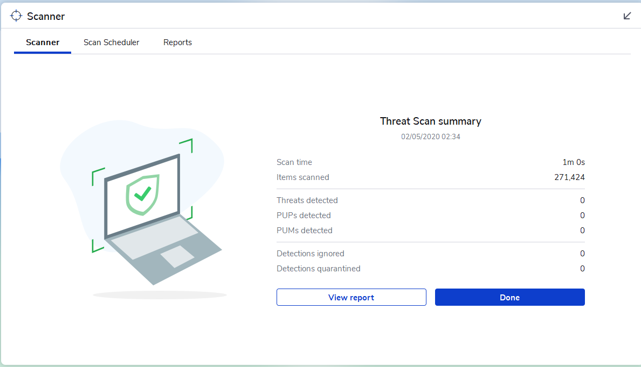
Figure 27 Malware scan report

Once the scan summary has finished and the user clicks done. There is a scan report that the user can then access, this scan report will allow the user to see an overall summary of the report that was gathered on their system. Not only is the summary presented but the user will also be able to look at an advanced version report of their system. In this advanced report this is where the user can see the specifics of their system and if a threat has been detected within their system.
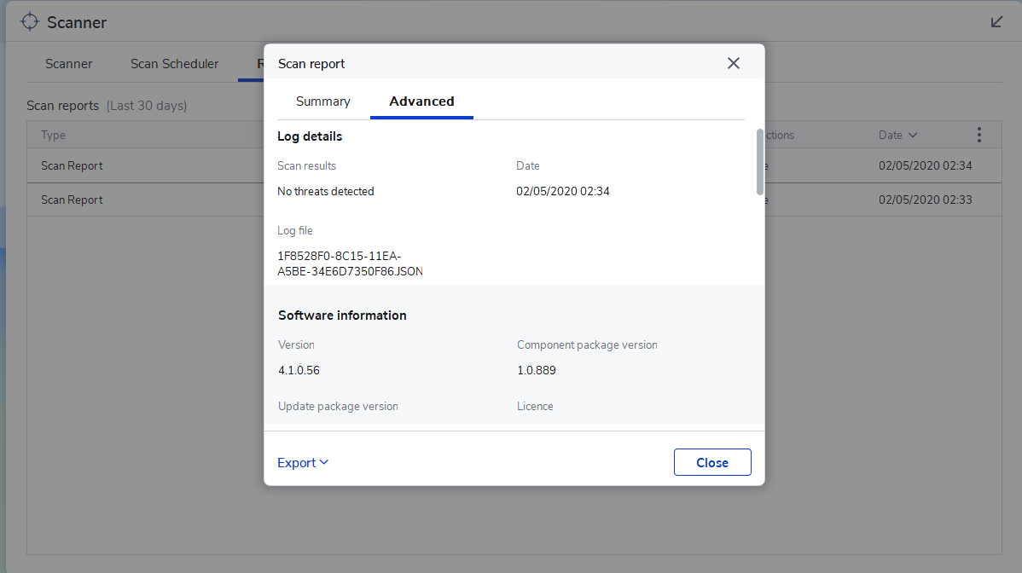
Figure 28 Advanced report

Another feature that Malware has is a scan scheduler. This scan scheduler is a manual schedule that the user can set up for the software to scan their system on a regular basis. This is a good method of protecting the system as a scan is scheduled to be complete at a certain time.
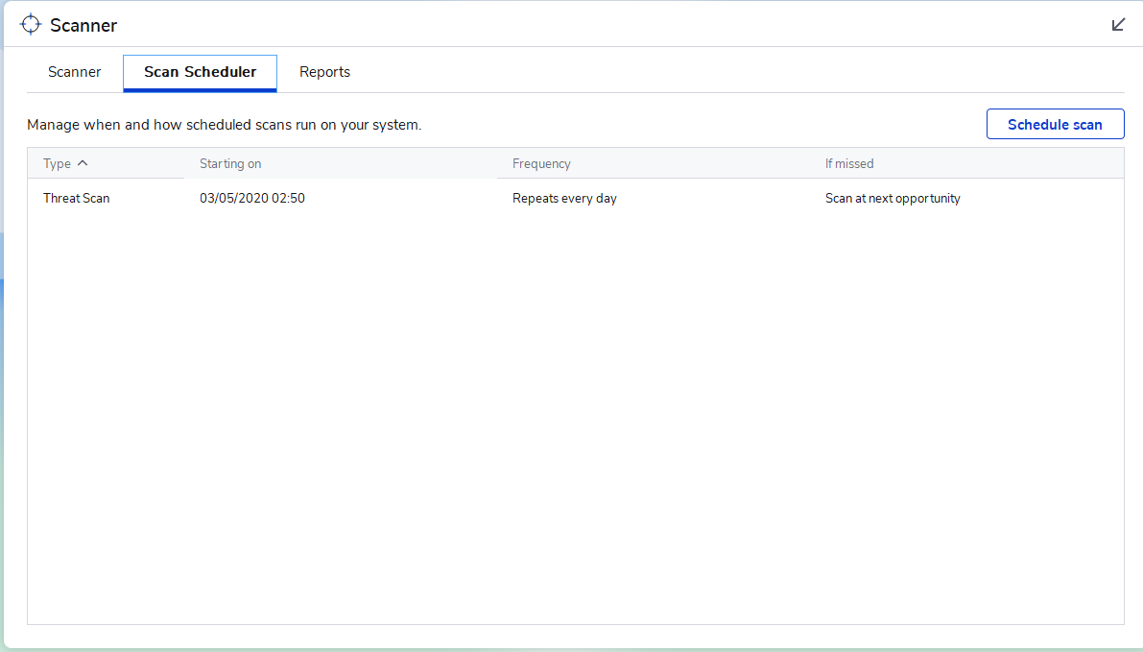
Figure 29 Scan scheduler

5.1 Conclusion
After downloading and using Malwarebytes the user thought that this service is very beneficial for their device and for company/organisation. The reason the user thought that Malwarebytes is a good service because once installed it will protect the user’s device and it will also deliver the user a scan report. As well as a scan report of the users system there is also a malware scan schedule which the user can setup, by having a scan scheduler this could make the user feel that their device was more protected as this software would always scan for viruses when scheduled. Another feature is the ability to remove the viruses not only does this software notify the user of viruses on their system, but it will also allow the user to remove any viruses that are found. Utilising this software is a safe and secure way for the user to make sure there are no viruses within their system.

6 Lab 4 Cryptography
Cryptography will be used to encrypt and decrypt message within a file.
To begin this lab cryptool was downloaded and installed
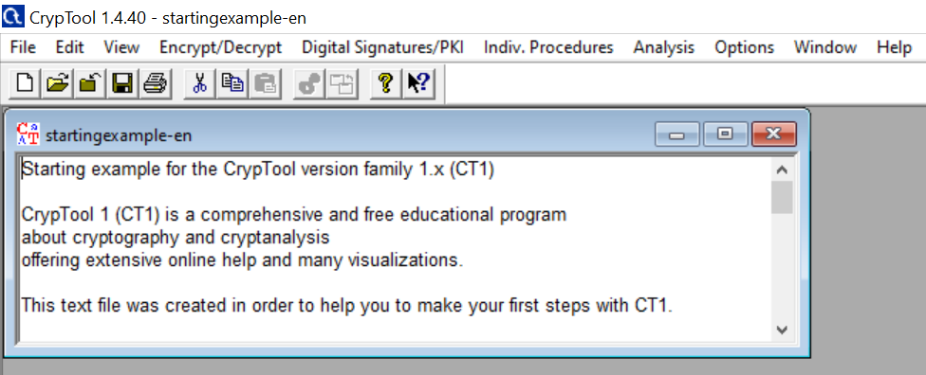
Figure 30 Cryptool
For the next stage the start-up example box will be closed, and the user will click file and open a new one. In this new file the user entered the information that they wanted to encrypt. The RC2 will be discussed in the next image as RC2 is what is required to encrypt the information.
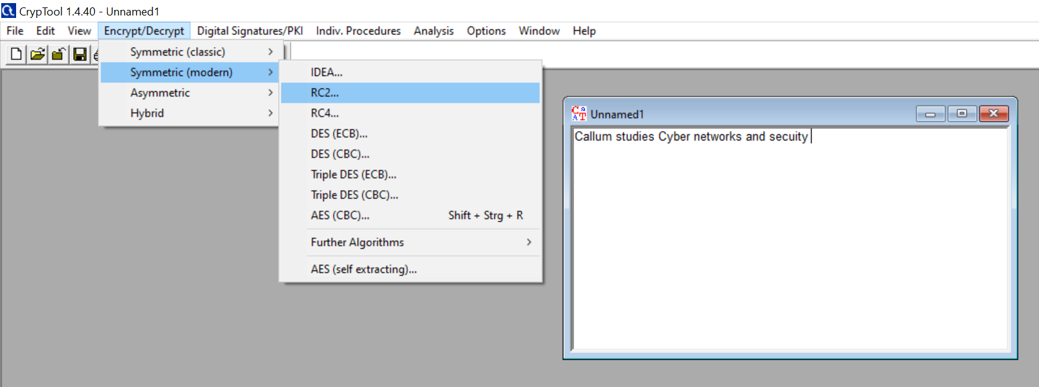
Figure 31 Encrypted message

When RC2 was clicked a new box would open. In this new box this is where the user can set the key length of the encryption. For this lab the user set the key length as 8 bits and 0.5 as the hexadecimal number.
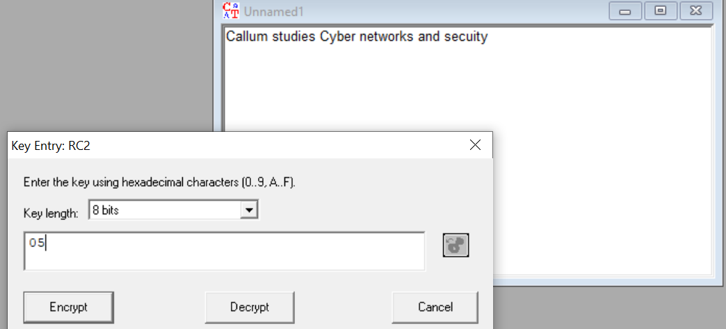
Figure 32 Key length encryption
Once the key length the user would then click encrypt which will then encrypt the message. Once the message was finished encrypting this is how the message would display.
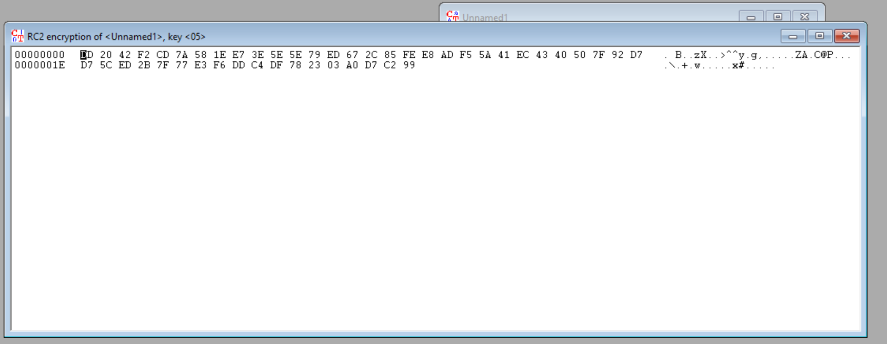
Figure 33 Encryption
Once the message was encrypted the file can then be saved and sent to a user. Once the file is sent to a user the user will need to decrypt the message as the message has been encrypted to protect the file.
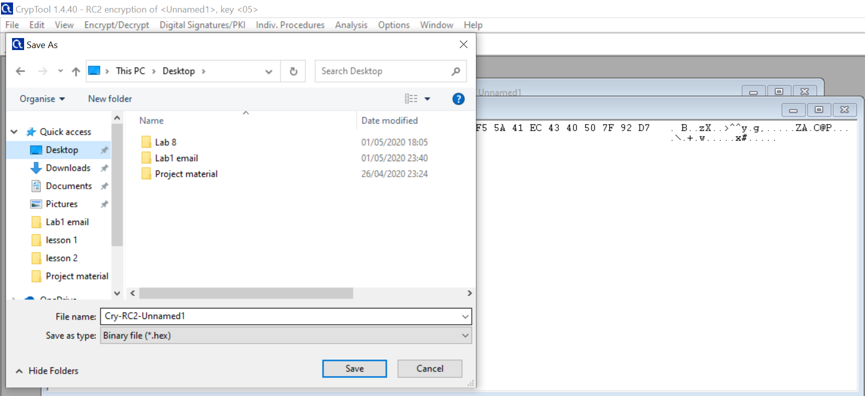
Figure 34 Encryption save file

After the file has been saved the user will now open the file.
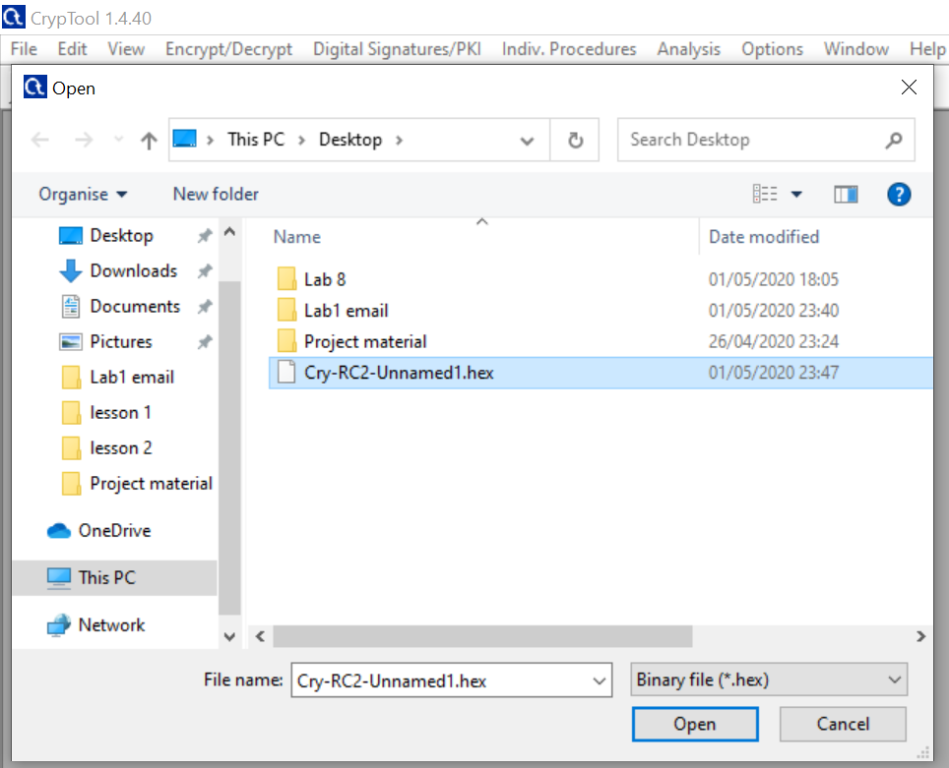
Figure 35 RC2 file open
Once the user opens the file, they will be presented with the key entry prompt. This image shows that the encryption has worked on the file. In order to decrypt the file the user will need to set the same key length of 8 bits and 0.5 hexadecimal once these settings have been set the user can then click decrypt and the unnamed1 pop up will decrypt and show the original message.
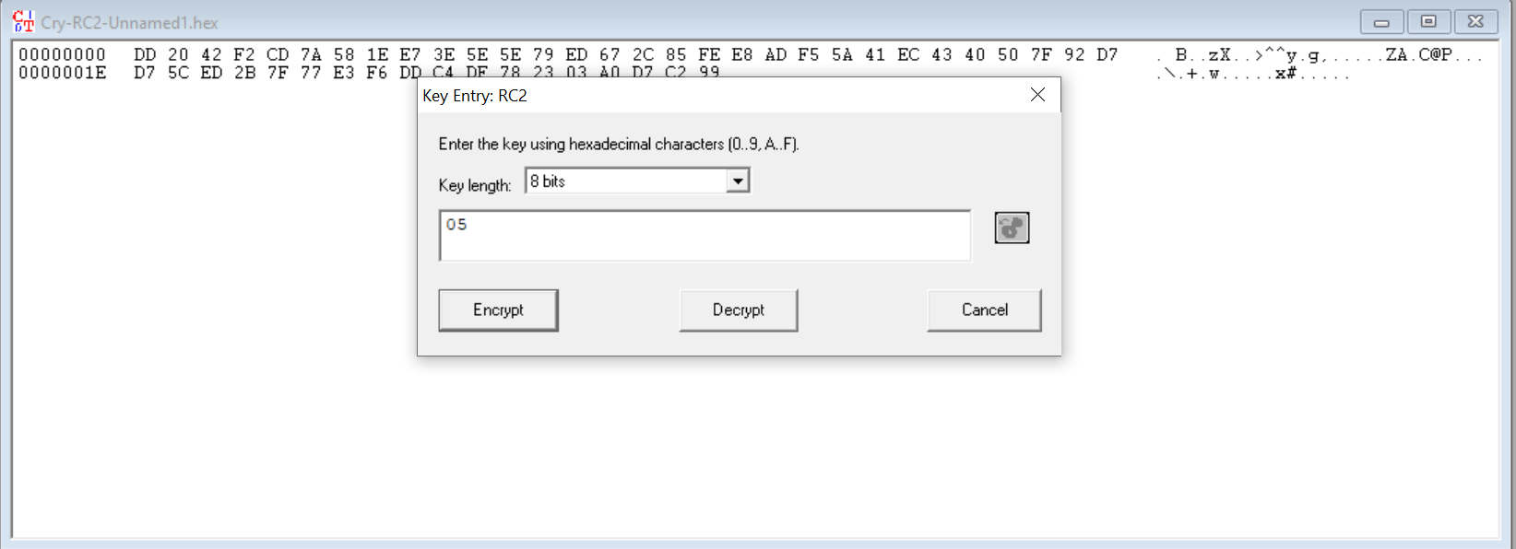
Figure 36 Decryption settings
Once the settings have been set correctly the user can then click decrypt. As the settings where correct this pop up was removed and the original message was displayed along with its encryption.
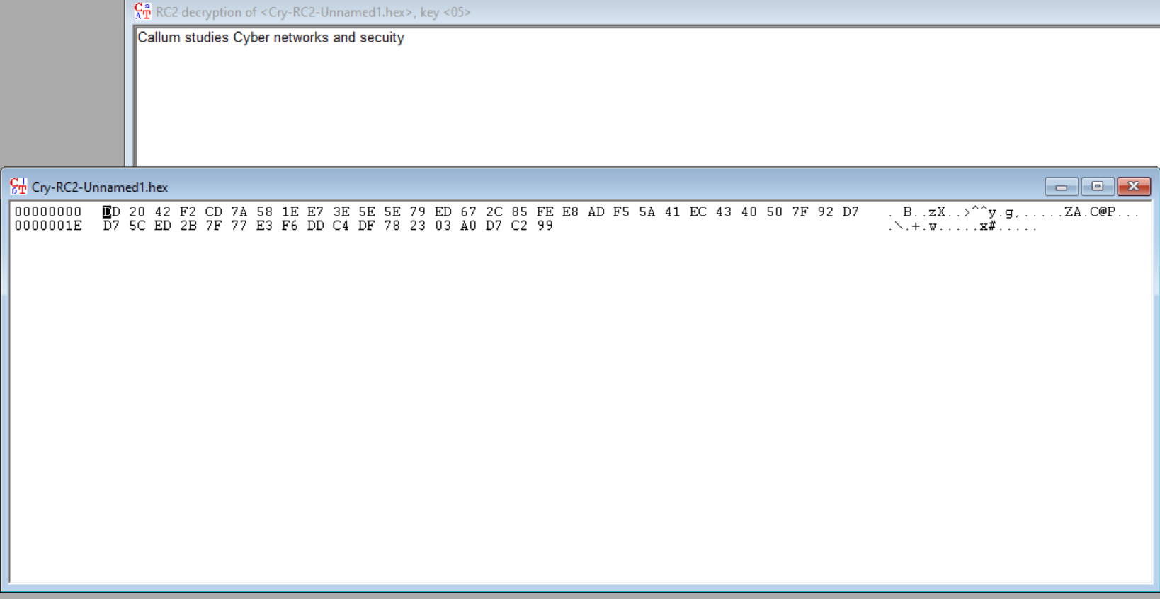
Figure 37 Decrypted message

6.1 Conclusion
This method of file encryption can be very useful but in order for this file decryption to work the user will need to be in contact with the sender. As the file decryption will require the receiver to know the specific key length and the correct hexadecimal setting, once the correct settings have been applied the file can then be decrypted. Although this requires a lot of communication this method of file encryption is very useful as seen in the lab the original message will be encrypted to numbers and letters which are hiding the original message. Once the settings have been applied the message will then become encrypted and will be sent in the encrypted form, to decrypt the file the receiver will need to know the decryption settings. By completing this lab the user was able to successfully send an encrypted file and decrypt the file, after watching how file encryption works the user believes that this method is also a good way to keep the users files secure and safe when distributing them as by encrypting a file the information will be hidden until decrypted.

7 Packet tracer
In this section of the report a packet tracer design will be shown along with configurations on the devices. Within the packet tracer design there will be a password encryption, firewall and access control lists.
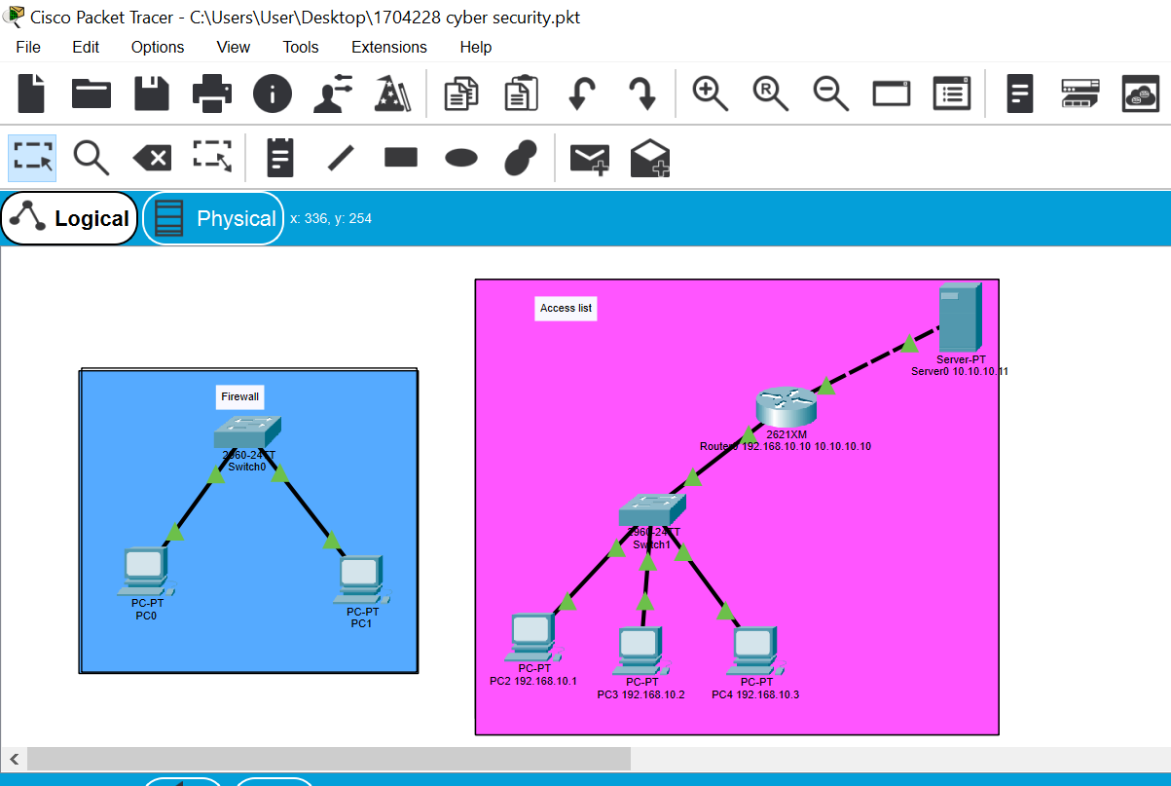
Figure 38 Packet tracer design

7.1 Password encryption
To start off with the configuration command. The first configuration was adding a host name to the routers and to the switches, by adding a hostname this would give the routers and switches a name which would be r1, s1 and s2. Once the host name was configured the user then decided to add a password and then they added an encryption onto the password, by having a password this would make the device more secure by having credentials. Having just a password wasn’t secure enough for the user so the user added an encryption onto the password, this encryption would hide the password from its original form so only the creator will know the password as they created the password unless they shared the password with others. In the below images this is displaying the cli configuration that the user applied to s1 the basic configurations displayed below will also have been set on s2 and r1.
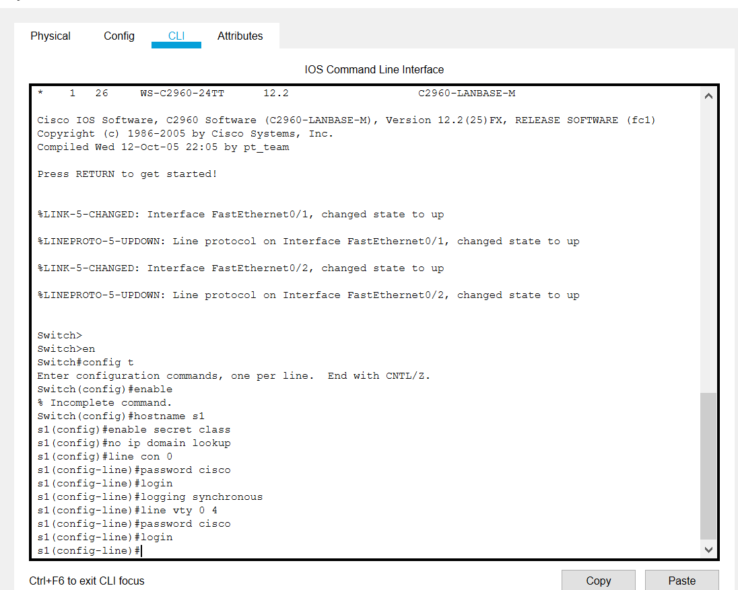
Figure 39 S2 configuration
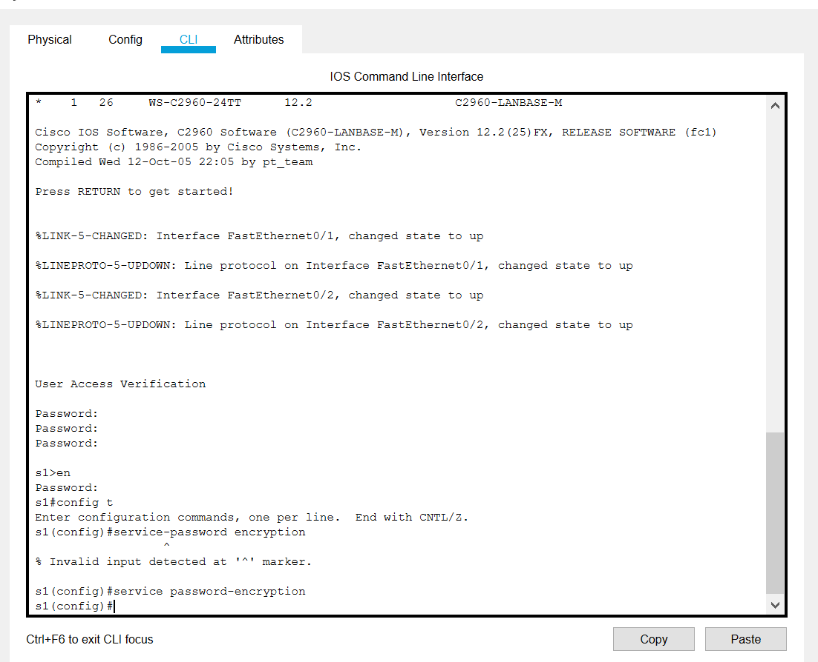
Figure 40 Service password-encryption

7.2 Firewall
Once the devices were added to the topology the IP addresses were also configured to pc0 and pc1. Both of these pcs within the network will have their own unique IP address, each of the pcs IP addresses will be needed as they will need to ping each other. The pcs will need to ping each other as this is where testing the firewall will be put in place, the firewall has been put in place to prevent the devices on this network getting any viruses or packets sent to them from outside the network.

7.3 IP configuration
These 2 Ip addresses where applied to pc0 and pc1. These IP addresses will be needed for the ping stage and to test the firewall service.
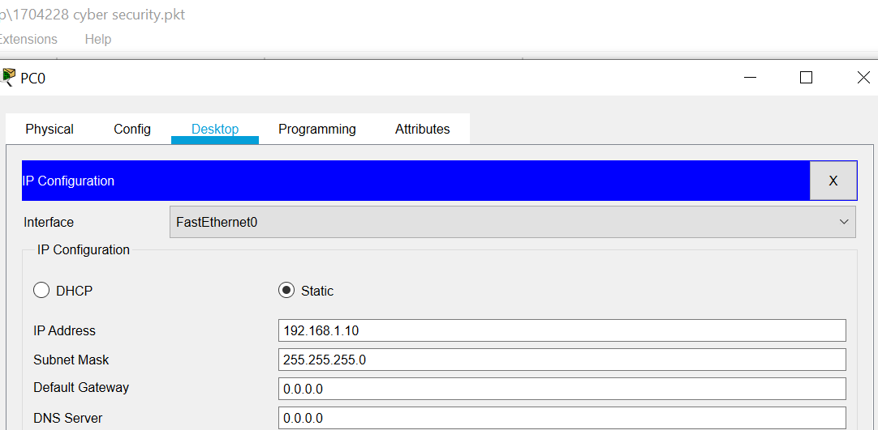
Figure 41 PC0 IP configuration
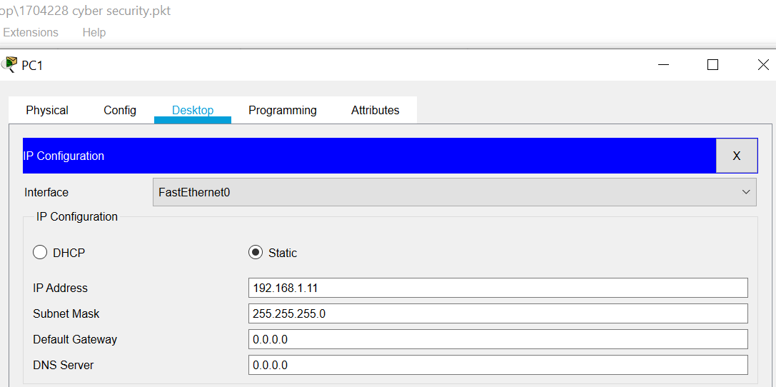
Figure 42 PC1 configuration

7.4 PC ping
Once the IP addresses were set and each of the devices where configured the user made sure that each device could ping each other. By the devices pinging each other this means that the devices are able to communicate with one another within the network. Not only was the user making sure that a connection was established but the user was also making sure that the packets being sent where being sent successfully.
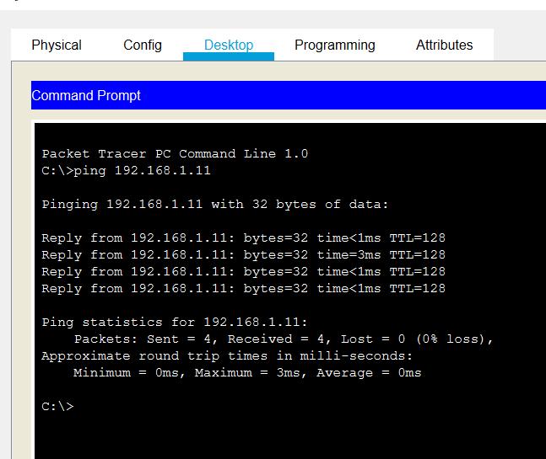
Figure 43 PC0 pinging PC1
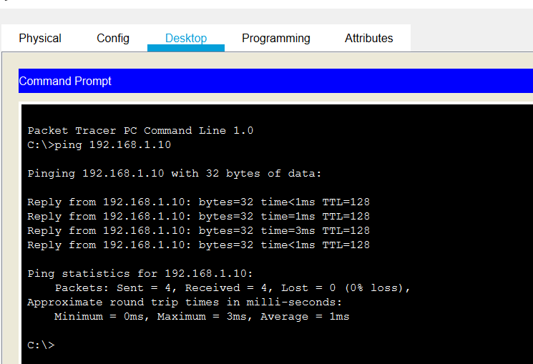
Figure 44 PC1 pinging PC0

7.5 Firewall setup
Once the pcs where setup the user then decided to configure a firewall setting to pc1. The firewall has been set to deny ICMP packets, by denying packets this will allow PC1 to no longer receive packets. By denying packets this will allow the PC to be more secure as it won’t accept any incoming packets, so this reduce the pcs chances on the network to receive any viruses that are sent to this pc.
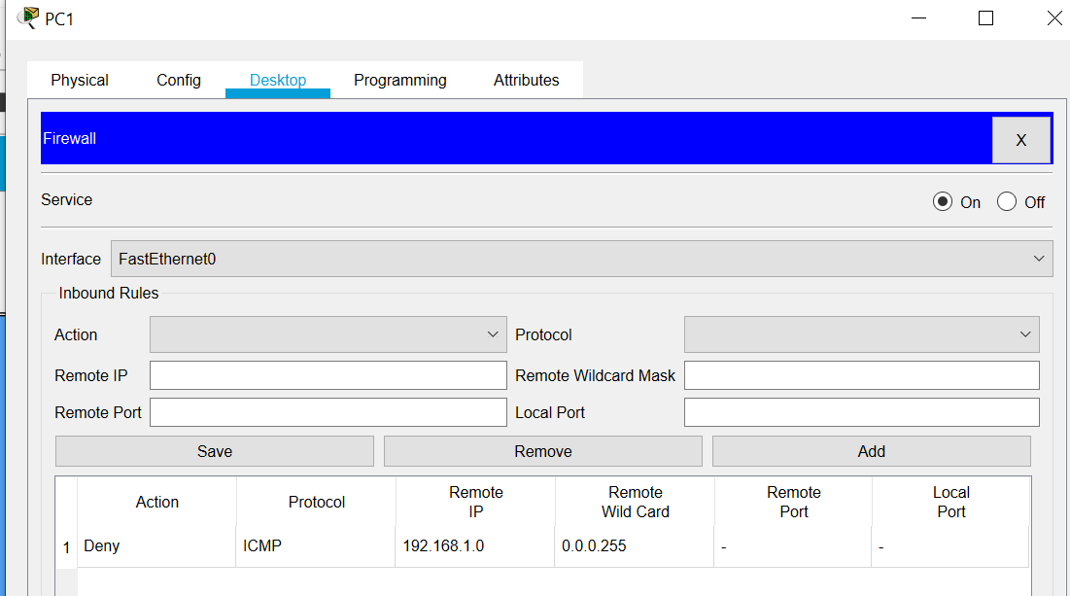
Figure 45 Firewall configuration

7.6 Ping after firewall
Once the firewall was configured the user wanted to test if packets would be denied or accepted on PC1. To test this the user had PC0 to ping PC1, represented below is the results of PC0 pinging PC1. To test this the user had PC0 to ping it’s self once this was completed it was reported that there was 0% packet loss which was expected. Once the first test was completed the user carried out the second test which involved PC0 pinging PC1, as expected the results where different. Where as in figure42 there was a 100% packet transfer success before the firewall, now there is 0% packet success. The reason it has changed from 0% to 100% is because the firewall was set up after the first ping was carried out, now having the firewall setup to deny packets it has done exactly what the user intended the firewall to do and that was to deny packets.

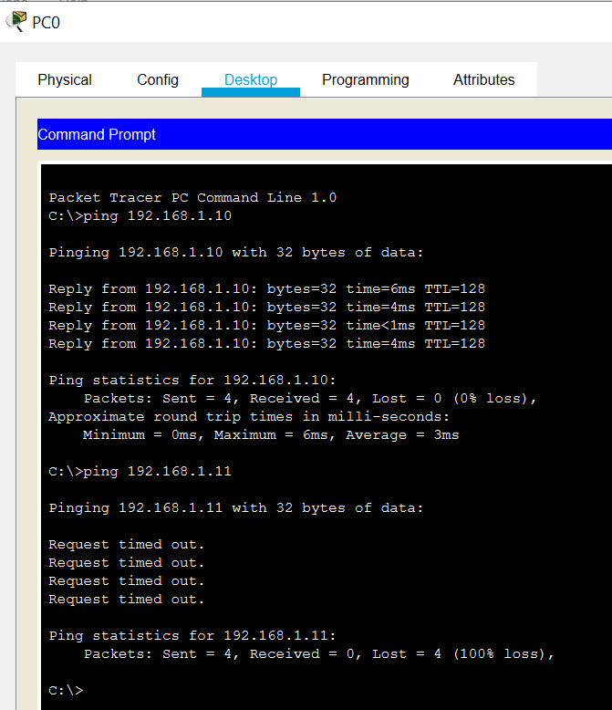
Figure 46 Firewall test

7.7 Conclusion
For the firewall setup this would be very beneficial to an organisation such as a university, organisation or business. The reason is because it is a cyber security defence that is used to counter virus such as ransom ware , fake emails and corrupted files etc. as viewed in the packet tracer implementation it was clear to see that the firewall was successful and achieved what the user intended it to do. By denying packets coming in this will reduce the risk of any viruses existing on this pc. Although this is a countermeasure it does not mean that it is not impenetrable. As these counter measures also have hacking counters to them so it is vital that when a firewall is implemented that it is kept up to date and that no vulnerabilities exist within the user’s network. Along with firewall it would be suggested to use virus detection software such as malware bytes which was used in a in one of the labs during this report. Having these 2 features will greatly increase your network defences as the user will have the firewall that will stop incoming packets and then the user can access malware bytes to scan their system for any viruses.

7.8 Access list
Once the firewall was in the place the user then decided to add a few more devices to the network. These devices where 3 extra pcs, 1 router, 1 switch and a server. Within this network this allowed the pcs to not connect to a switch but to a router and a pc. The user will configure an IP address to the router, this address will be the default gateway. By setting the default gateway this will allow the pcs to connect to the router which will then give them access to the server.
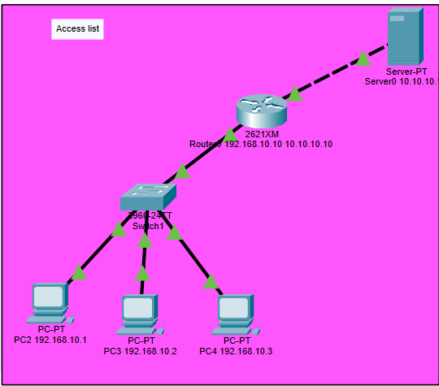
Figure 47 Access list
To start off with the configuration the PCS, switch and router had to be assigned an IP addresses. The most important IP address here is the routers address. The routers address will be the default gateway for the network, this is where the pcs will get their connection from. Once the default gateway was set on the router the default gateways address was then added on to PC2, PC3 and PC4.
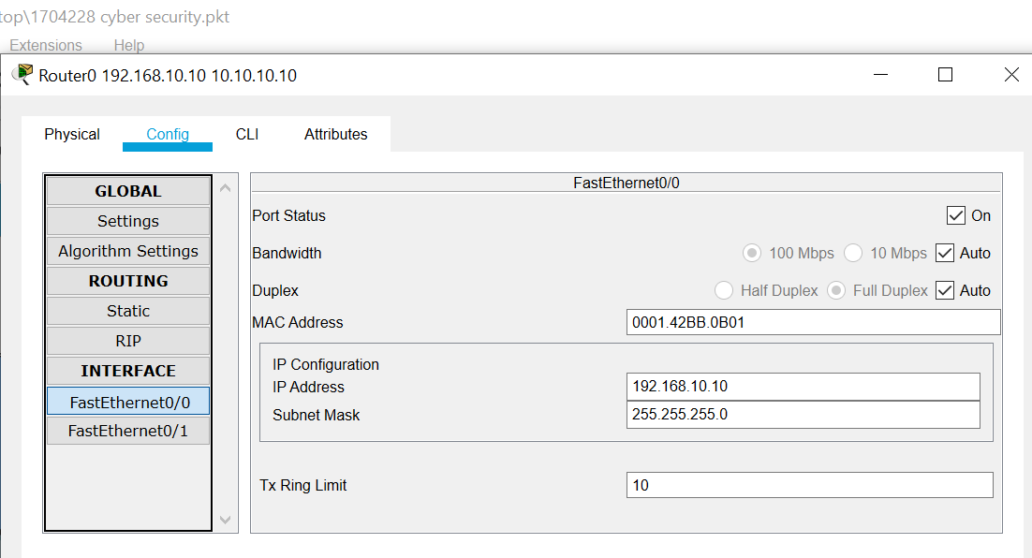
Figure 48 Default gateway

Once the routers gateway set it was then time to set up the IP address for the server. The server and the router will be essential when making the ACL list. As these will be the hosts of the access control list which will be configured in R1.
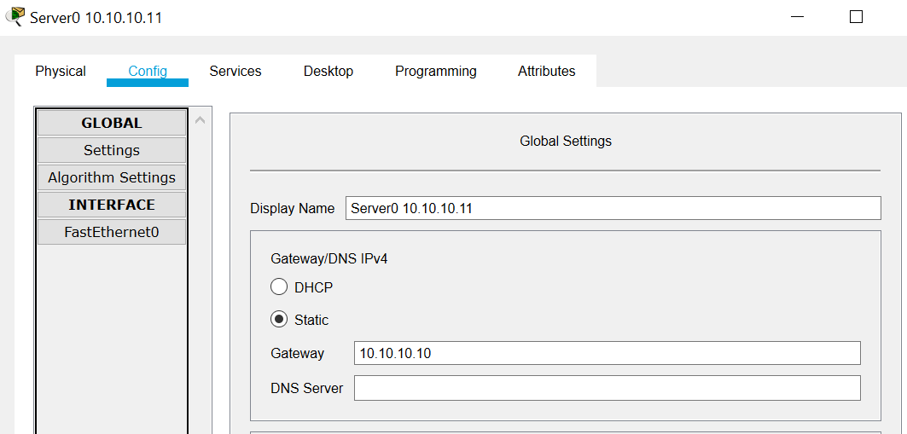
Figure 49 Server0 default gateway

For the final part of the configuration the user went into router and had to configure an access control list. This list that has been configured will tell the router what IP address can’t ping the network. As displayed in the screenshot below the access lists displays that 192.168.10.2 which is PC3 to not ping the network. Whereas the permit any section will allow other devices to ping the network.
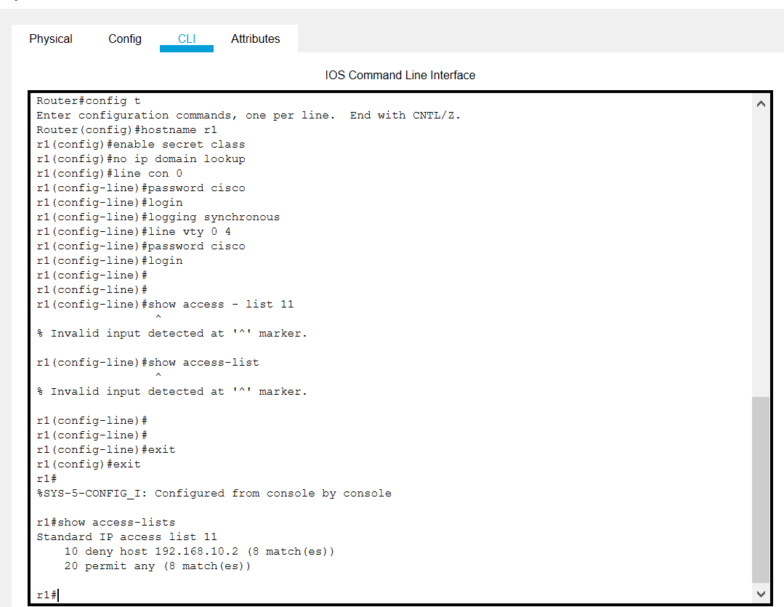
Figure 50 Access list configuration
The screenshots below will represent that the access list has worked. As PC3 is unable to ping the default gateway and the server address whereas the PC2 and PC4 are able to ping both addresses.
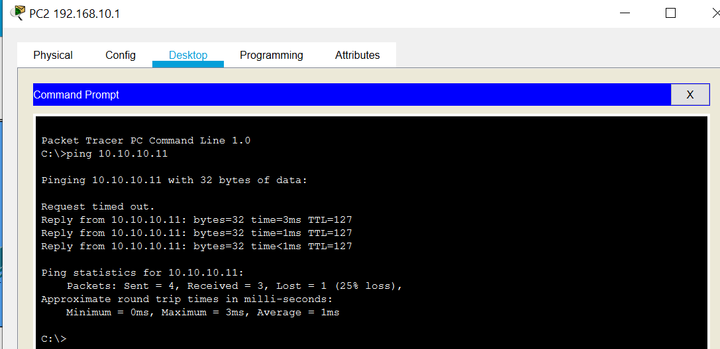
Figure 51 PC2 ping
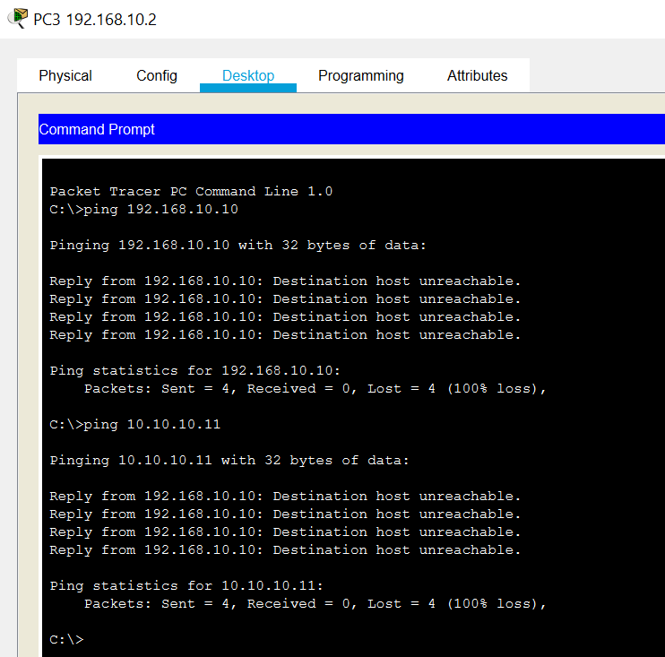
Figure 52 PC3 ping
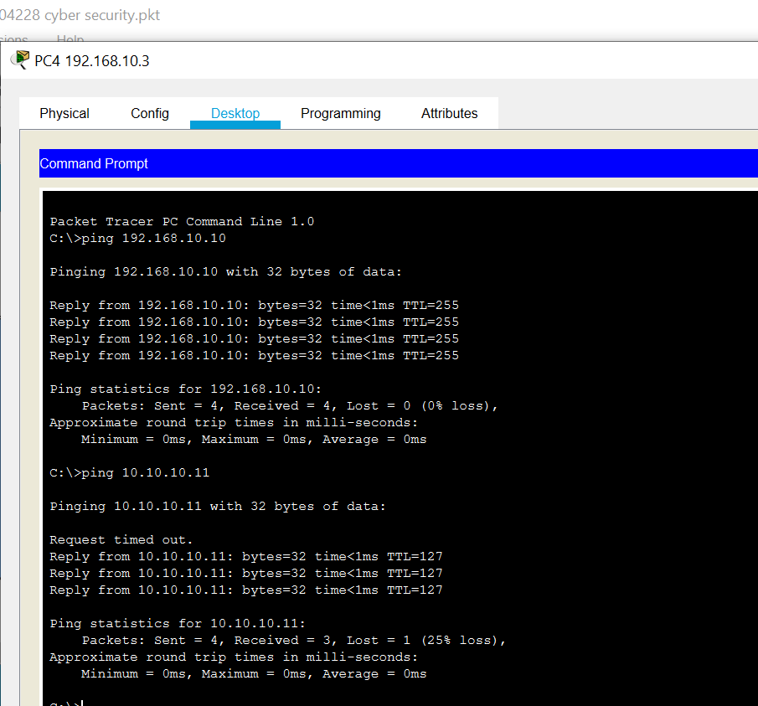
Figure 53 PC4 ping

7.9 ACL conclusion
For ACL the user also believes that this method will be good when implemented into a company network, as the devices will need to be manually applied to the ACL list. This is also where the disadvantage comes in off for an organisation like a university, they will need to employ someone who will add the devices to an access list which can be a very tedious task. Although this was a simple demonstration within packet tracer. The user thought that if applied right the ACL list can be very beneficial as it can only allow certain devices access within the network. As seen in the ACL ping screenshots it is evident that PC3 failed to ping the server and the router because the router was set to
be very beneficial as it can only allow certain devices access within the network. As seen in the ACL ping screenshots it is evident that PC3 failed to ping the server and the router because the router was set to deny access to 192.168.10.3. by failing to ping the set addresses this means that this device wasn’t able to send any packets or do any file transfers across the network. So for example if in the university there was a device that was suspect to an attack or had a virus on it the network manager could access the ACL list and deny network access to this device, the only problem that comes with this is that the network manager will need to know the devices IP address in order to block it on the ACL list. With so many devices in a university environment it can become difficult for the network manager to find the suspect IP address and block this device as there will be so many devices within the university.

8 conclusion
After researching the future trends of cyber security, it is evident that hacking methods are becoming more and more vicious in the modern day. In order to counter these attacks, it is best for the cyber security team to find out how these attacks are improving and how they can defend their network from these devices. Once task 1 was completed the user then completed cyber security experiments these experiments where email tracker, cryptography, VPN and malware bytes. Each one of these was used by the user to experience what using these different software was like. It turns out that all of these labs the user found beneficial when protecting their device for example email tracker is beneficial for finding out where an email came from and accessing an email report containing in depth details, next was cryptography which was encrypting and decrypting a file the cryptography lab was the lab that the user thought they would use less as this lab requires communication between the sender and the receiver. Thirdly for VPN this was a software that the user has come across before so the user thought that VPN was really good for protecting their devices as seen in the lab the IP address of the users device will change to their selected country. Lastly for the lab software there was malware this software is a must for any device or company as malware will scan the user’s device for any viruses.
To conclude with packet tracer the user setup a network that was going to be used in a smart campus. Within this network there where switches, routers PCS and servers. Within packet tracer the user configured the devices with their own IP address and did configuration within the cli to acquire the ACL control and to enable firewall. By setting this up in packet tracer the user is able to test the settings they setup by pinging each device. For the real implementation of a network a lot more defences will need to be set up as this would be the university network, so there should be no vulnerabilities,

9 References

Bibliography

[1] | A. T. Tunggal, “Why is cyber security important,” UpGuard, 15 January 2020. [Online]. Available: https://www.upguard.com/blog/cybersecurity-important. [Accessed 20 April 2020].
[2] | “about us,” ISF30, [Online]. Available: https://www.securityforum.org/about/. [Accessed 2020 April 2020].
[3] | “Threat horizon 2019: Disruption , Distortion , Deterioration,” ISF 30, 2019. [Online]. Available: https://www.securityforum.org/research/threat-horizon-2019/. [Accessed 2020 April 2020].
[4] | N. Reiff, “Blockchain explained,” Investopedia, 1 February 2020. [Online]. Available: https://www.investopedia.com/terms/b/blockchain.asp#what-is-blockchain. [Accessed 1 April 2019].
[5] | M. Moore, “Top cybersecurity threats in 2020,” Univeristy of San Diego, [Online]. Available: https://onlinedegrees.sandiego.edu/top-cyber-security-threats/. [Accessed 20 April 2020].
[6] | K. Murray, “Ransomeware Threat isn't over. ist evolving,” WEBROOT, 28 February 2019. [Online]. Available: https://www.webroot.com/blog/2019/02/28/the-ransomware-threat-isnt-over-its-evolving/. [Accessed 20 April 2020].
[7] | “splevo exploit kit debuts new social engineering,” MalwareBytes, 5 March 2020. [Online]. Available: https://blog.malwarebytes.com/threat-analysis/2019/12/spelevo-exploit-kit-debuts-new-social-engineering-trick/. [Accessed 20 April 2020].
[8] | PhishLabs, “2019 PHISHING TRENDS AND INTELLIGENCE REPORT,” 2019. [Online]. Available: https://info.phishlabs.com/hubfs/2019%20PTI%20Report/2019%20Phishing%20Trends%20and%20Intelligence%20Report.pdf. [Accessed 20 April 2020].

marking criteria and Student FEEDBACK

This section details the assessment criteria. The extent to which these are demonstrated by you determines your mark. The marks available for each criterion are shown. Lecturers will use the space provided to comment on the achievement of the task(s), including those areas in which you have performed well and areas that would benefit from development/improvement.

Common Assessment Criteria Applied (Assignment 1) | Marks available | Marks  awarded
1. Engagement with Literature Skills
Extent of research and/or own reading, selection of credible sources, application of appropriate referencing conventions.
You have engaged with the literature, however, you need to utilise more peer reviewed articles. Key concepts discusses. The appropriate referencing used (Grade mark: 77.78%) | 45 | 35
2. Knowledge and Understanding Skills
Extent of knowledge and understanding of concepts and underlying principles associated with the discipline.
3. Cognitive and Intellectual Skills
Analysis, evaluation and synthesis; logic, argument and judgement; analytical reflection; organisation of ideas and evidence
You have demonstrated very good research knowledge in most areas. How do these all link together? The analysis and evaluation of the literature is missing in some areas making them seems to be isolated sub-areas. You have given an excellent account of the lab exercises and how users and organisations could benefit; though you could expand more in this area. (Grade mark: 88.89%) | 45 | 40
4. Practical Application Skills
Deployment of methods, materials, tools and techniques; application of concepts; formulation of innovative and creative solutions to solve problems.
5. Transferable Skills for Life and Professional Practice
Attributes in professional practice: individual and collaborative working; deployment of appropriate media; presentation and organisation.
Your report need formatting as well as some of the figures. There are grammatical errors. (Grade mark: 60.00%) | 10 | 6

Assignment Mark (Assessment marks are subject to ratification at the Exam Board. These comments and marks are to give feedback on module work and are for guidance only until they are confirmed. ) | Late Submission Penalties (tick if appropriate) |  | 81%
 | Up to four weeks late |  | 81%
 | First Attempt? |  | 81%

marking criteria and Student FEEDBACK

This section details the assessment criteria. The extent to which these are demonstrated by you determines your mark. The marks available for each criterion are shown. Lecturers will use the space provided to comment on the achievement of the task(s), including those areas in which you have performed well and areas that would benefit from development/improvement.

Common Assessment Criteria Applied (Assignment 2) | Marks available | Marks  awarded
1. Engagement with Literature Skills
Extent of research and/or own reading, selection of credible sources, application of appropriate referencing conventions.
2. Knowledge and Understanding Skills
Extent of knowledge and understanding of concepts and underlying principles associated with the discipline.
You demonstrated relevant knowledge and understanding by explaining the theories and concept in a meaningful way. Could be improved if more peer reviewed articles were used. (Grade mark: 75.00%) | 20 | 15
3. Cognitive and Intellectual Skills
Analysis, evaluation and synthesis; logic, argument and judgement; analytical reflection; organisation of ideas and evidence
You have documented the physical packet tracer design. Your implementation discussion could inter-relate more how to combat or enhance challenges to the University. (Grade mark: 75.00%) | 20 | 15
4. Practical Application Skills
Deployment of methods, materials, tools and techniques; application of concepts; formulation of innovative and creative solutions to solve problems.
Your practical design are two isolated LANs (firewall and ACL, similar to another student,), they are not a connected converged network. The password implemented on the routers and switches are not encrypted and if compromised can easily be known. Though you have discussed a practical design, this was not implemented. You have not demonstrated understanding of implemented a Packet Tracer design in an advanced way. (Grade mark: 33.33%) | 60 | 20
5. Transferable Skills for Life and Professional Practice
Attributes in professional practice: individual and collaborative working; deployment of appropriate media; presentation and organisation.

Assignment Mark (Assessment marks are subject to ratification at the Exam Board. These comments and marks are to give feedback on module work and are for guidance only until they are confirmed. ) | Late Submission Penalties (tick if appropriate) |  | 50%
 | Up to four weeks late |  | 50%
 | First Attempt? |  | 50%

