Contents
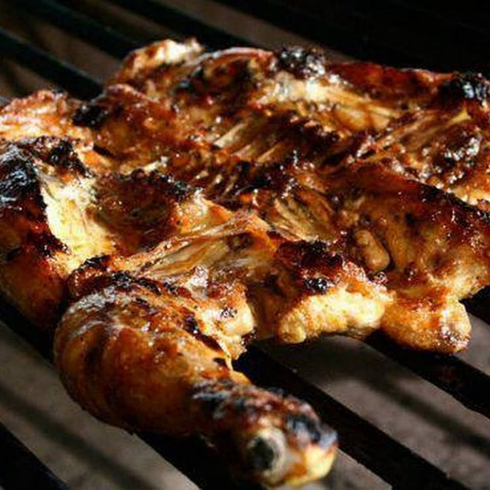

BUSINESS COMPANY OVERVIEW……………………………….2
Introduction……………………………………………………………….3
Business plan development……………………………………….4
Executive Summary……………………………………………………5
Marketing plan………………………………………………………….5
Human Resources Plan………………………………………………6
Operational plan………………………………………………………...7
Strategic plan…………………………………………………………....8
financial plan…………………………………………………………….9,10
Conclusion………………………………………………………………...11
References…………………………………………………………………12

Student name: Andrea barros dos Santos
Module: Managing Projects in the Workplace
Module code: BMSW 5104
Lecturer: Sujeewa Herath
Assignment Title: Project Management Plan

BUSINESS COMPANY OVERVIEW

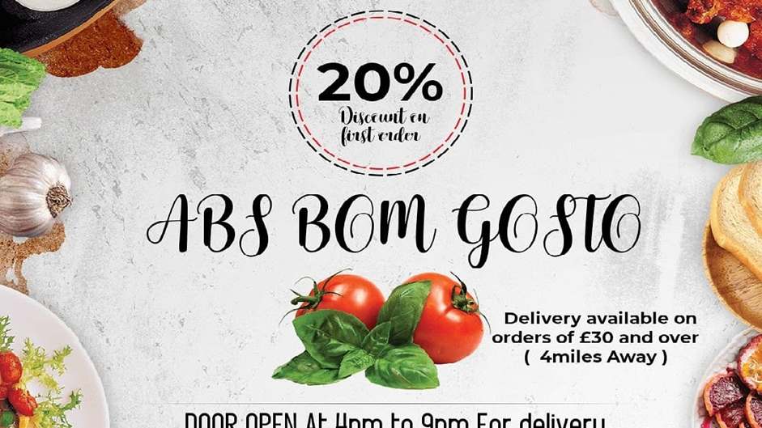
Grill restaurant.
Name: ABS BOM GOSTO LTD
Opened since July 2019 by a young woman who, due to the pandemic and the confinement of Covid19, found herself having difficulties managing her own accounts and taking into account that she would have a vast experience in everything that has to do with gastronomy because she worked in several typical food restaurants PLOP (Portuguese speaking countries) and also having as one of his favourite moments to cook for other people as well as family members, he decided to work in his own business.
Location: 19 hemsby gardens ng6 8nt, Nottingham
Time works: 7 days a week from 10 am to 8 pm.
Contact: 07783 519817/0115 874 7742
This is the link of the Business
http://www.absbomgostoltd.co.uk/
I created a simple website in which I displayed the menu with images, e-mail so that customers could have direct contact with the restaurant to clarify doubts about the dishes as well as prices and even book an order for parties and private celebrations and via email everything more formal, economical, fast, and organized.

INTRODUCTION



The company undergoes continuous changes due to the constant evolution of technological and marketing factors, to remain in the market today, investments must be made to have alternatives that are continuously innovated to have a business deference, choose varied menus.
Sometimes with some differences they meet, but it is part of everyday life. The combination ended up on PALOPs tables due to the combination and mixing of foods which became a delight because there is nothing better than combining grilled fish with palm oil and banana beans and a vinaigrette sauce. The organization's strategy, when aligned with the aims and the business mission, makes it possible to create means to circumvent threats and take advantage of the opportunities of the environment, adjusting the weaknesses to outline projects aimed at the strengths that the organization has. The search for tools and instruments that supply improvements in organizations is permanent and small companies need to be constantly improved so as not to have a low in the face of high competition. To have a superior performance in the administration of the company, it is necessary to create strategies that cover the entire organization, with the arrival of Strategic Administration to organizations in the beginning of the 20th century, it made it possible to formalize long-term business planning, defining goals and guidelines for decision making. Giving continuity to the business, a Strategic Management becomes indispensable, which will seek the best positioning in the market with the help of Strategic Planning. Through strategic planning, the organization becomes aware of the market/customers, suppliers, and partners, that is, the company has a systemic view, which streamlines and bases decision-making, uniting efforts in a single direction.

PURPOSE OF THE PLAN
This plan aims to show reflections on questions about the products that will be offered, main marketing strategies, organizational strategies, and the company's financial projections.
RESTAURANT "ABS BOM GOSTO", will use in the market offering different meals with the taste of countries (PALOP). the viability of this project and to succeed and remain fixed in the market.

OPPORTUNITY IDENTIFIED
The factor that I added as the main factor for the elaboration of this Business Plan, will be the fact that the enterprise will propose to work with a concept of production and quality.
To this end, the company RESTAURANT "ABS BOM GOSTO" will enter the market offering products with very affordable prices, quality in both preparation and cleaning, a wide environment, and a variety of products to the taste of each customer, in which market analysis will be conducted - target through the marketing of relationship.
ANDREA BARROS will own the business – who, in addition to having an experience in cooking on these same floors, has some technical courses in hilltops. Portuguese language) and will be incorporated as a limited liability company, with the corporate name of: "ABS BOM GOSTO LTD", and with the name of RESTAURANT "ABS BOM GOSTO". The first share capital will be 25,000.00 which will be obtained through a financing meeting – credit request
RESTAURANT "ABS BOM GOSTO"
Quality in the products: The differential of this company is in the quality of the product, the presentation design, the cleanliness of the space and the friendliness and speed of its employees. Since most competitors use raw materials that are often of dubious nature, the kitchen equipment, furniture, and utensils used and food maintenance to prepare the products are exposed outdoors and the environment is inadequate for making meals. Fast and efficient service for the customer to perceive a good service from the employees, speed, comfort, and friendliness ensure a good courtesy and affordable prices: The company will sell its products accessible to any staff. Payment by credit card: Through this form of payment the company hopes to win many customers.

Mission, Vision, and Values:

MISSION:
“Offering a pleasant and pleasant environment, refined, quality food, good service and speed”
VISION:
"To be the largest chain of PALOP restaurants".

VALUES:
Teamwork; Recognition of Human work; Develop partnerships and quality for self-knowledge.

MARKETING PLAN
For a period, the company's advertising was conducted through an agency specialized in marketing, but due to the excessive costs and the seasonal sales periods during the year, investments in this area became difficult, so it was decided to end the contract. with the agency.
The organization realized that the investment would have to be long-term, so it was decided not to invest in this area. Today the RESTAURANT "ABS BOM GOSTO" uses social networks such as Facebook E, Instagram, and a website to promote the Restaurant.
Customer satisfaction until now was felt through informal conversation with customers and by seeing the service, so the entrepreneur is inside the restaurant every day and can see from the attitude whether the customer was well attended or not. to the customer is conducted by a waiter, who welcomes him at the entrance, gives him the menu and goes with him to the table. Waiters are encouraged to offer products and drinks that have good margins, but without taking away the privacy of the customer, who is free to choose the different dishes and drinks of the house.
The goal at the time of sale is for customers to be tempted to choose products that will increase revenue.
HUMAN RESOURCES PLAN
For the recruitment of personnel, the company RESTAURANTE ABS BOM GOSTO chose to hire a recruitment agency, with a selection and application of tests, for the choice of kitchen assistants and attendants.
After choosing, these employees will undergo training, in which they will be explained how to work, handle food, serve the public and the proper use of their clothing, as well as proof of the menu so that they understand and feel about what they are sell.
The service must be of the same standard, regardless of the day, time and employee, so that customers are always received and served in the best possible way. The workforce will be composed like this:
Manager: will manage managing employees, perfecting costs, buying raw materials, that is, responsible for running the company.
Kitchen assistants: they will oversee preparing the food selected by the customer, preparing the grilling, and preparing the juices (2nd shift).
Attendants: their duties will be to serve the customer in the best practical way, with agility, speed, and efficiency (1 per shift).
Nutritionist (outsourced): the nutritionist will have to balance and dose the calories.

Employee compensation will be:

Salad bowl: £1,200.00

Cook: £1,800.00

Attendant: £600.00

General Services: £1,000.00

Outsourced Service - Accounting: £160.00

Dish assembler: £1,400.00

Kitchen Assistant: £1,200.00

- The company will offer food and transportation vouchers to its employees as a salary supplement, as well as punctuality and attendance bonuses.

OPERATIONAL PLAN

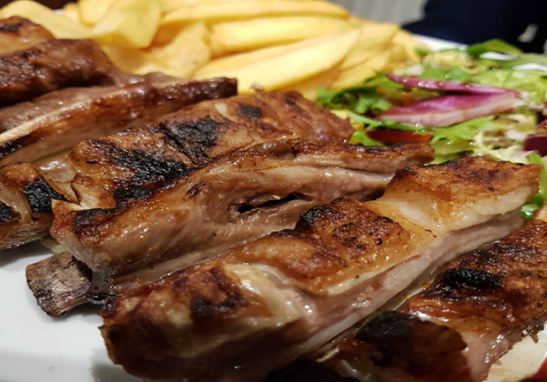

ABS BOM GOSTO LTD will have its restaurant in Nottingham in a shop found in Bulwell with, an area of 30m², found in the city centre. The opening hours will be from Monday to Sunday from 10 am to 9 pm, will be divided into two shifts, working time of 6 hours. As the restaurant will serve food made on the grill, it is important that customers know where they come from and the quality of the product they are consuming and paying for. For this, foods from the grilled part such as meat, fish and seafood will be displayed inside a glass window with ice for appreciation so that there is no doubt as to their quality. Another point to be highlighted is the hygiene of the food and the cleaning of the employees with the use of gloves and caps when managing the products.


Customer service will be:

- command
- order assembly
- Serving the ABS BOM TASTE dish
STRATEGIC PLANNING
Based on a restaurant portfolio, it can be better optimised:
“To provide a service of tasting dishes based on noble meats combined with a relaxed atmosphere and live music, will promote unique sensations and moments”. Its core business is to transform products into delicious dishes based on meat, fish and seafood, as well as typical dishes from PALOP countries, according to the requirements imposed by customers, always respecting the temperature, deadlines and handling of the products, guaranteeing the quality of the service provided. It is noticed that the business of this restaurant is in line with the propositions of Kotler and Keller (2006), who claim that the business goes beyond the product or service delivered to the market, but aims to be a process of customer dissatisfaction.

FINANCIAL PLANNING

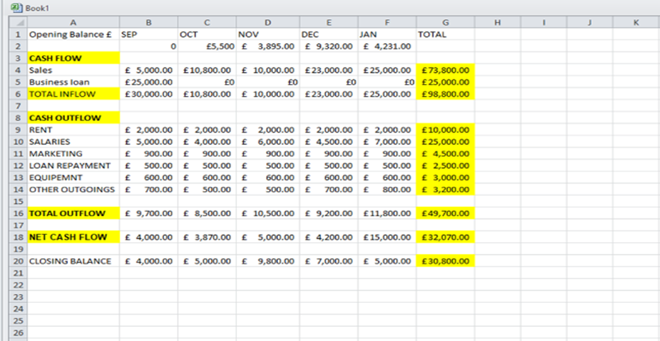

The viability of this business has proved to be very good, the company has tripled its turnover. All costs and expenses are posted and monitored closely.
For Carneiro and Matias (2011), the budget is a powerful instrument for short-term financial planning, but it must be combined with strategic planning to stop the effects of competition. The company uses a formatting system that performs calculations and keeps track of finances, which provides managers with an overview of the organization's income and expenses.
Accounting that provides a monthly income statement of the company. The entrepreneur is always attentive to meet all the requirements of the legislation so that nothing gets out of control.

In 2020, the owner went to seek resources for the renovation of the space, the company did not have its own resources available, everything was done with money borrowed from the Bank, the company is well organized, it had the social balance, profitability and good revenue, for this reason was presented to the bank which made it get the money to invest in machinery, equipment and in the renovation and also a value for the working capital.
The difficulty came because, as they are short-term loans, to be paid within one, two and three years, only 20% went beyond 2 years, this made the company work twice as hard to pay off the debts, which has made new investments impossible. All investment made was to improve the environment, visual aspect and comfort, the equipment was to meet basic needs, investment was made in air conditioning, 57 tables, chairs, the visual part was redesigned, this allowed to attract customers with a higher average ticket , the costs of the waiters and the rent are the same to serve the two types of customer, the one with the highest average ticket and the one who goes at dawn and spends less. The focus was on customers who are more willing to spend if it allows to increase the profitability of the business. There has been a big difference since this investment was made, as there is an increase in consumers with higher incomes, which provides an increase in the consumption of snacks with greater value.
After managing to pay off the debts, the priority is to invest even more in the environment to improve the cosiness, because according to the owner, everything that has been invested so far in the environment has returned, in line with the research that revealed that 90% of the surveyed customers go to the establishment to have a happy hour, listen to live music, have a GOOD VIBES moment. This is due to the fact that the place serves as a meeting point for business meetings, birthdays, family events as well as only at random times of day because it is located in the center of the city, which leads the public to attend the restaurant from 18:00 to 24:00, thus providing the enterprise with greater sales as this public spends more. Currently, the company is in good financial health, as it has revenues that enable it to fulfill its financial obligations without failing to comply with the quality of services and products purchased.

CONCLUSION

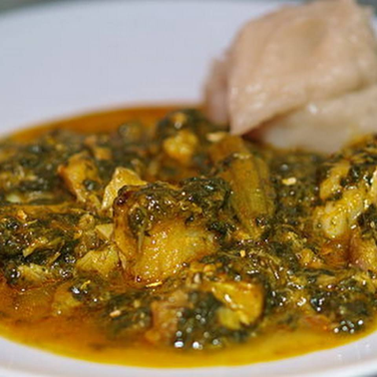

Through the knowledge I obtained in the Managing Projects in the Workplace module, I learned the importance of the planning activity in our business decisions. Developing a plan, both professionally and personally, allows me to have a greater opportunity in the choices made during my career and to have a smaller number of problems appropriate without this planning. In order to develop a business plan, the activity was very well structured and worked out, by elaborating all the details that exist in the reality of a restaurant in a theoretical way. Upon seeing the operational needs of the enterprise, I realized the difficulties and opportunities that the market provides for it. The need for data interest only showed the reality of the market in which this business is involved, they gave me the satisfaction of carrying out in-depth research about this sector, competitors, suppliers and customers, in addition to planning all areas of activities to be be carried out over the specified period.
According to the research acquired in this project, the food sector is expanding in the city of Nottingham, as well as in society in general, being a great business opportunity, since it is an essential branch for the daily maintenance of individuals, thus and doing it in a healthy way is essential to obtain a more lasting and pleasant life. To complete, I elaborated the business structure, with a strategic plan, marketing planning, operational plan, human resources and financial plan, all carried out into a reality of theoretical prediction. Through this planning, the company acted in the market of grilled food meals and traditional dishes having a forecast of great future financial results. After I visualized the competitors' data, the possible financial results were projected, considering a period of five years, going through the phases of introduction, growth and maturity of the business.

REFERENCES
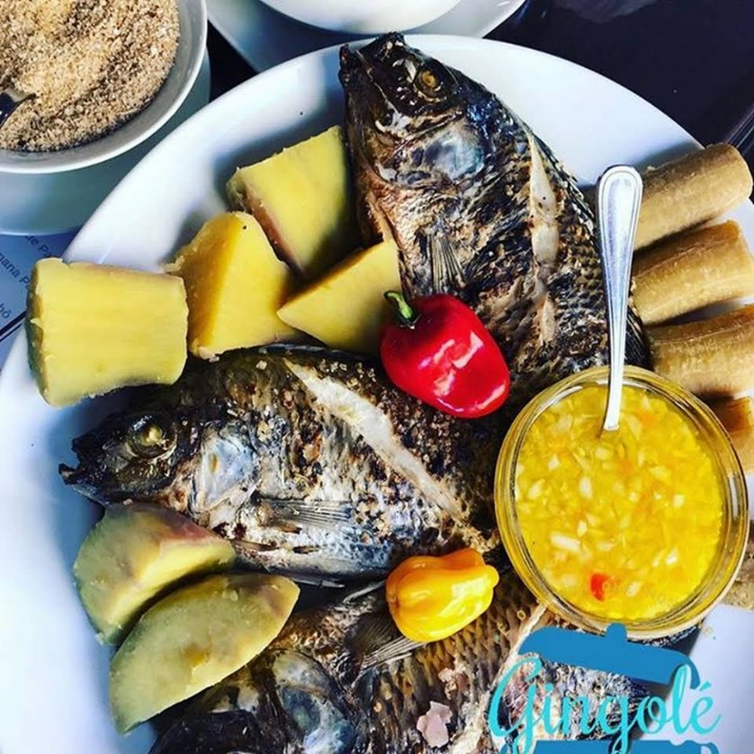

- Albaz, M.M.A., 2019. The strategic role of human resources planning to achieve sustainable competitive advantage.

- Brounen, D., Koedijk, K.G. and Pownall, R.A., 2016. Household financial planning and savings behavior. Journal of International Money and Finance, 69, pp.95-107.
- Chernev, A., 2020. The marketing plan handbook. Cerebellum Press.

- Craig, J.P., Nelson, J.D., Azar, D.T., Belmonte, C., Bron, A.J., Chauhan, S.K., de Paiva, C.S., Gomes, J.A., Hammitt, K.M., Jones, L. and Nichols, J.J., 2017. TFOS DEWS II report executive summary. The Ocular Surface, 15(4), pp.802-812.

- Duke, N.C., 2016. Oil spill impacts on mangroves: recommendations for operational planning and action based on a global review. Marine Pollution Bulletin, 109(2), pp.700-715.

- Habitat, U.N., 2019. The strategic plan 2020-2023.

- Kusumaningrum, I., Hidayat, H., Anori, S. and Dewy, M.S., 2016. Learning Outcomes in Vocational Education: A Business Plan Development by Production-Based Learning Model Approach. International Journal of Environmental and Science Education, 11(18), pp.11917-11930.

- McKeever, M.P., 2018. How to write a business plan. Nolo.



