Amy Morgan
2319574
Contemporary Management Approaches
BMSP4013
Glenn Behenna

Contemporary Management Approaches of Netflix
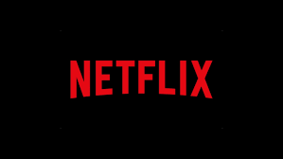

Content
Contemporary Management Approaches of Netflix 1
Content 1
Introduction 3
Main body 3
Conclusion 4
References 5

Introduction

This paper will explore the contemporary management approaches of the global giant Netflix, its organisational context, and approaches. The paper will look at the culture of Netflix and how they treat their employees, in terms of work motivation and satisfaction.

Main body

Background

Netflix is a large international streaming service operating in over 190 countries offering services in over 30 different languages. Netflix was founded by Reed Hastings and Marc Randolph in 1997, testing their business idea of a postal DVD service in 1998 (United States Securities and Exchange Commission, 2023, p.45). Hastings provided the initial investment of 2,5 million dollars after selling his company Pure Atria, in 1999 Jeff Bezos offered Hasting and Randolph an investment offer of 15 million dollars, Mark Randolph wanted to take Jeff Bezos up on the offer, but Reed Hastings turned down the offer, Walfisz (2023). The global success of Netflix is very impressive considering they started off with a simple idea of sending DVDs by mail, Netflix now employes over 12800 people internationally. (Netflix Careers and Employee Benefits US News, 2023).

Organisational context

Hastings company would send DVD’s straight to your house for a set monthly rate with a no late fee’s. He produced this Idea because like many of Blockbusters costumers he was frustrated with having to pay the 40 dollars late fee he had racked up. Late fees were a huge part of Blockbusters revenue making up 16 percent of their revenues equalling to 800 million dollars (Olito & Bitter, 2023). In 2000 Hastings and Randolph were operating at a monetary loss despite growing their subscriber base to 300,000, Reed Hastings and Mark Randolph approached Blockbuster with a 50-million-dollar potential partnership deal where they develop a blended model where they run the online business and blockbuster running the stores. Blockbusters former CEO John Antioco saw Netflix as a “very small niche business” (Bhaimiya, 2023). In the summer of 2002 Netflix hit the public trade centre with stocks starting at 15 dollars a share, (Netflix Investors, 2002). The company first became profitable in 2003, the year Netflix crossed the one million subscribers, Justin et al (2012). In 2004 Blockbuster launched their own online DVD rental service where costumers could order their movies online and have them shipped to their homes for free, this service was aimed directly at undercutting competition from rival Netflix (CNET,2004). Marc Randolph stepped down as CEO in 1999 to turn to product development and left the company in 2003, Marc Randolph was content with being the invisible face and leaving the company before Netflix became the streaming giant it is today, Cuccinello (2019). In 2010 after Netflix popularity continued to grow Blockbuster fell into one billion dollars' worth of debt, causing Blockbuster to file for bankruptcy, Blockbusters company was delisted from the NYSE, Olito & Bitter, (2023). In 2007 Netflix went on to launch its video streaming service and as of the third quarter of 2023 Netflix had around 247.2 million paid subscribers, as displayed in figure 1 (Stroll, Oct,19,2023).
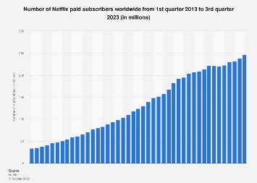
Figure 1 Netflix: number of subscribers worldwide 2023 (Stoll 2023)

Approaches to organisation and management

Netflix’s main approach to organisational structure and management follow the systems and human relations approaches (Dotan 2018). Netflix also displays elements of the contingency management approach, as they use several different strategies across the array of departments such as; Lewin’s Change Model, U-turn and Total Quality Management (Kobiruzzaman 2023; Muhammad 2019). Netflix used this strategy to overcome multiple barriers such as a change of management to cope with the digital era.

as displayed in the image below, figure 1 they use U-FORM hierarchy.
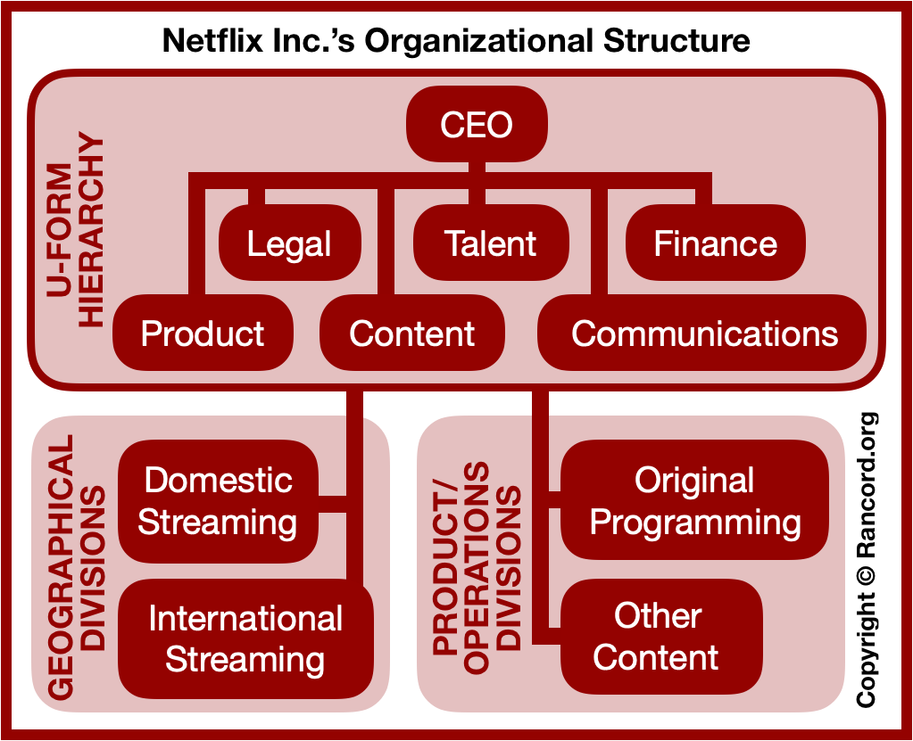
Figure 1, Netflix organisational structure. (Anderson 2019)

Work and motivation
People over process is Netflix’s core philosophy when it comes to work motivation and satisfaction (Netflix jobs 2023). It was not always like this, When Netflix first started out, they followed an honour system where staff would keep track of their own days off and let their managers know. the normal practise of set holiday days and sick days, but as they grow, they realised they had to account for the workload on the days staff would be off. Netflix’s Chief Talant Officer first considered a formal tracking system, but Reed had another idea stating, “Are companies required to give time off? If not, can't we just handle it informally and skip the accounting rigmarole.” (McCord, 2014). After some research they found out that California had no law that governed vocation time. Netflix did a complete 180 and went for the adultlike behaviour approach, they stated that salary staff could take as many vacation days they thought were appropriate as long as they worked it out with their managers and colleges beforehand, also while always acted in Netflix’s best interest. Netflix done similar strategies throughout all their departments. (McCord, 2014). Netflix has several workplace benefits such as flexible work arrangements, company holidays and work opportunities outside of the U S just to name a few. (Netflix Careers and Employee Benefits, 2023).

theories and models

The theories and models Netflix follow are similar to those of Elton Mayo the father of human relation movement and McGregor theory Y. Elton Mayo is the father of the Human Relations Movement, Elton Mayo was the first to realise that worker output and satisfaction were liked to social factors such as the way employees were treated on the job in 1937 the Hawthorne Experiment found that the attention from the study made the employees feel important which in turn resulted in a better output. Which is now commonly known as the Hawthorne effect. Human relations philosophy falls under three categories
Key work groups and teams
Excellent upward communication
Superior leadership
By adopting this theory organisations find that their employees are more motivated, productive, and more committed to their jobs.
McGregor’s theory Y believes in balance is always best. Theory Y believes that people enjoy working to fulfil ambition. That people do not need strict instructions to be motivated and to take responsibility to reach their goals.
A motivated system not one based on results works well Theory Y also believes that you just must connect the right people to the right jobs they have to be given freedom to choose and create also receive help they should ask for input from the team as the more ideas the better.

Perception and communication

Perception and communication are important in an organisation process.
Perception is how people intercept and make sense of their surroundings and how people see and understand things happening around them. Effective communication in an organisation is essential for a smooth workflow and productive relationships. Clear communication helps in sharing feedback and ideas and resolving conflicts. Effective communication ensures that everyone understands their roles, responsibilities, and the goals of the organisation.
According to (Glassdoor2021). in 2018 based on 830,000 employees 87% of Netflix employees seem to like their CEO Reed Hastings scoring him 18% above the average Glassdoor CEO approval rating of 69%. A current employee of Netflix expressed a view that Netflix has a great culture that focuses on freedom and responsibility, your treated like an adult in terms of how and when to do your work as long as it gets done well. The current Senior Software Engineer expressed a range of positive views including transparency and communication. On the other hand, employees express that the culture fear is real, and you must play work politics. In summery there are a mix of views on how Netflix treats their employees. And from that the author believes that no matter what you do you are never going to be able to please everyone.

Conclusion
In summary based on my research Netflix has come a long way from a simple idea from not wanting to pay a fine to a multibillion-dollar worldwide empire based on continually moving with and keeping up with technology. Netflix seems to have a modern approach to business and management with an open and honest approach to their employees.

References

Anderson, D. (2019). Netflix Inc.’s Organizational Structure & Its Strategic Implications. https://www.rancord.org/netflix-organizational-structure-design-organizational-chart-characteristics

Bhaimiya, S. (2023). Netflix's co-founder says Blockbuster execs tried not to laugh when they pitched a $50 million partnership — it's now worth $149 billion. https://www.businessinsider.com/netflix-blockbuster-pitch-meeting-rejected-50-million-partnership-deal-2023-4?r=US&IR=T#:~:text=Netflix's%20co-founder%20took%20to,pitched%20a%20%2450%20million%20partnership

CNET. (2004). Blockbuster enters online DVD rental business. https://www.cnet.com/culture/blockbuster-enters-online-dvd-rental-business/
Cuccinello, H, C. (2019). Netflix Cofounder Marc Randolph On Why He Left, Becoming A Mentor And His Love Of Chaos. https://www.forbes.com/sites/hayleycuccinello/2019/09/17/netflix-cofounder-marc-randolph-memoir/

Dotan, T. (2018). How Netflix’s Management Structure Is Rewriting the Hollywood Script. https://www.theinformation.com/articles/how-netflixs-management-structure-is-rewriting-the-hollywood-script

Glassdoor.(2021).What It’s Really LikeTO Work For Netflix In The Wake Of Wall Street Journal Expose. https://www.glassdoor.com/blog/netflix-wall-street-journal/

Justin, B. (2012). How long did it take subscription services (like Netflix, Hulu, Spotify, ClassPass) to reach 1 million users?. https://askwonder.com/research/long-subscription-services-like-netflix-hulu-spotify-classpass-reach-1-million-ylqibnndg#:~:text=Netflix%20started%20in%201997%20but,paid%20subscription%20service%20was%20launched.

Kobiruzzaman, M. M. (2023). Netflix Organizational Change & Organizational Structure 2023. https://newsmoor.com/netflix-organizational-change-organizational-management-change-examples/.
Mcord, P. (2014). How Netflix Renovated HR. https://hbr.org/2014/01/how-netflix-reinvented-hr

Muhammad, R. (2019). Lewin’s 3 Stage Model of Change Explained. https://www.bmc.com/blogs/lewin-three-stage-model-change/

Netflix Investors. (2002). Netflix Announces Initial Public Offering. https://ir.netflix.net/investor-news-and-events/financial-releases/press-release-details/2002/Netflix-Announces-Initial-Public-Offering/default.aspx
Netflix jobs (2023) https://jobs.netflix.com/culture

Olito, F., & Bitter, A. (2023). Blockbuster: The rise and fall of the movie rental store, and what happened to the brand 2023. https://www.businessinsider.com/rise-and-fall-of-blockbuster?r=US&IR=T

Stoll, J. (2023). Number of Netflix paid subscribers worldwide from 1st quarter 2013 to 3rd quarter 2023. https://www.statista.com/statistics/250934/quarterly-number-of-netflix-streaming-subscribers-worldwide/#:~:text=How%20many%20paid%20subscribers%20does,compared%20with%20the%20previous%20quarter
United States Securities and Exchange Commission. (2023) Annual Report Pursuant to Section 13 or 15(d) of the Securities Exchange Act of 1934.
https://s22.q4cdn.com/959853165/files/doc_financials/2022/ar/4e32b45c-a99e-4c7d-b988-4eef8377500c.pdf. (p.45)
https://www.businessinsider.com/rise-and-fall-of-blockbuster?r=US&IR=T#but-trouble-was-on-the-horizon-in-1997-as-blockbuster

Netflix Careers and Employee Benefits US News (2023) https://money.usnews.com/careers/companies/netflix-1413346#:~:text=About%20Netflix&text=Netflix%20is%20a%

Walfisz, J. (2023). Reed Hastings Steps Down: The Rise and Fall of Netflix’s CEO. https://www.euronews.com/culture/2023/01/20/reed-hastings-steps-down-the-rise-and-fall-of-netflixs-ceo#:~:text=Borrowing%20the%20impressive%20books%20model,%242.5%20million%20into%20the%20idea.

