
January 13, 2021
LCMB 7002
DUDAK BEATA STUDENT NUMBER 2010697
MODULE LEADER JIA MIAO
FINANCIAL MANAGEMENT
ASSIGNMENT

Contents

PART A) THE BERKELEY GROUP HOLDING PLC 2
PART B) A CRITICAL REVIEW OF THE BERKELEY GROUP HOLDING PLC FINANCIAL PERFORMANCE FOR THE PERIOD 2015-2019 3
PART C) INVESTMENT APPRAISAL TECHNIQUES 14
1.0 Evaluation of Capital Investment Appraisal Techniques in context of Project A and Project B 14
2.0 Advantages and Disadvantages of Investment Appraisal Techniques critically discussed …………………………………………………………………………………………………………………………………………………………….17
REFERENCES 20
APPENDICES 22
Appendix 1 Berkeley Group, Data from the audited financial statements 22
Appendix 2 Berkeley - Financial Reports for the year ended April 2020, April 2019 23
Appendix 2.1 Berkeley - Financial reports for the year ended 2020; 2019 24
Appendix 3 Berkeley Group, Financial Reports for the year ended 2018; 2017 25
Appendix 4 Berkeley Group, Financial Reports for the year ended 2018; 2017 26
Appendix 5 Berkeley Group, Financial Reports for the year ended 2017; 2016 27
Appendix 6 Berkeley Group, Financial Reports for the year ended 2017; 2016 28
Appendix 7 Berkeley Group, Financial Reports for the year ended 2015; 2014 29
Appendix 8 Berkeley Group, Financial Reports for the year ended 2015; 2014 30
Appendix 9 Berkeley Group, share price for the year ended 2015 31
Appendix 10 Berkeley Group, Dividend breakdown 2018 32
Appendix 11 Berkeley Group, Market Share price 2016-2018 33
Appendix 12 Balfour Beatty, Market Share Price 2019 34

PART A) THE BERKELEY GROUP HOLDING PLC
  Revenue (GBP) 1.89bn  Net Income (GBP) 374.10m  Incorporated 2004  Employees 2.71k | The Berkeley Group Holding plc was found in 1976. The 100% owned subsidiaries are The Berkeley, St Edwards, St George, St James, St Joseph, St Williams, Berkley First, Berkeley Commercial and Berkeley Partnership brands. The group “is engaged in residential-led property development focusing on regeneration and mixed-use property developments” (Financial Times, 2021). “The group builds homes, neighbourhoods, communities, luxury homes, and affordable housing for families, first time buyers, students, and senior people in London and South East of the UK (Financial Times, 2021).
The company was founded by Tony Pidgley and Jim Farrer in Weybridge in 1976 as Berkeley Homes. The business aimed “to focus on executive housing on single plots or small sites” and build 100 houses in less than a year. The company floated its shares on USM in 1984, thereafter expanded to new geographic areas to the West, South Midlands and East Anglia forming joint ventures. By 1988 – over 600 executive homes were built a year. At the time the company’s strategy was aggressive house sale for cash in the fear of the housing market industry “overheating”. In 1990-91 company moves its operations to urban areas due to changes in operational orientation to regenerate the deprived sites of the UK (Birmingham, Manchester). In Early 2000 the company refined its strategy again “to concentrate primarily on relatively large-scale urban redevelopments in the London area” (Free Encyclopedia, 2020). In 2015, the company won Large Developer of the Year at the RESI awards organised by Property Week” (RESI Awards, 2016). The course of the COVID-19 pandemic had cost the company £80m just in the first 6 weeks, the company had cancelled shareholders’ pay-outs and began to close the construction sites, the pre-tax profit was down 35% partly due to COVID-19 impact. The founder died in June 2020(Free Encyclopedia, 2020).
BUSINESS PURPOSE – “is to build quality homes, strengthen communities and improve people’s lives” (Berkeley Group, 2020)
STRATEGIES:
- Long-term strategy is to invest in the right-risk return opportunities to ensure the financial strength of the group, to make a return to shareholders that support the company to achieve a business purpose (Berkeley Group, 2020)
- Respond “to the cyclical nature of the housing market and focuses on transforming the most challenging and complex sites into exceptional places where communities thrive” (Berkeley Group, 2020"
- Berkeley is committed to operate incident and injury-free and aspires to have a positive health impact on all those employed and affected by what we do." (Berkeley Group, 2020)
Secondarily data from the company’s audited and published financial statements for the 6-year period (2015 – 2020) is gathered for the analysis. The profitability, efficiency, gearing, and liquidity ratios are employed to critically review the financial performance of BERKELEY GROUP PLC for the period 2015-2019. Graphs and charts are used throughout the report to support the financial analysis. The financial performance of the company for the period 2020, will be looked at separately, this is due to unprecedented global environmental challenges of COVID-19 that affected the performance of the company adversely.
Figure 1 Peer Analysis as at 11/01/2021
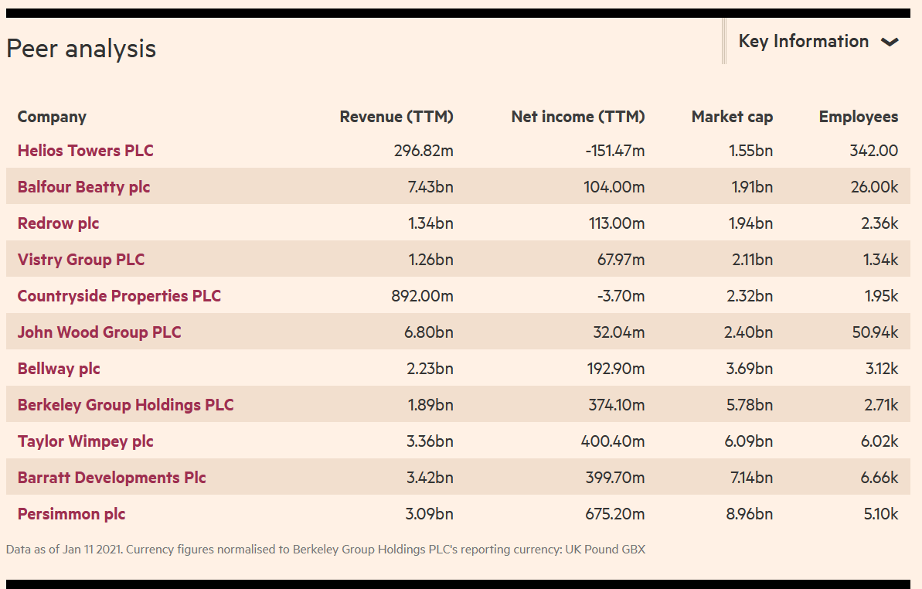
(Source: https://markets.ft.com/data/equities/tearsheet/profile?s=BKG:LSE)

PART B) A CRITICAL REVIEW OF THE BERKELEY GROUP HOLDING PLC FINANCIAL PERFORMANCE FOR THE PERIOD 2015-2019
The profitability ratio analysis provides evidence about the capability of a business to create profit relating to revenue. The company's profitability is the greatest case to worry for both its proprietors and investors. Profitability can be assessed by calculated two groups of ratios: margins and returns. The high ratios and value commonly associated with the business performing well (CFI - Corporate Finance Institute, 2015)
Findings: Table 1Calculations of Profitability ratios for The Berkeley 2016-2020 and Balfour Beatty PLC/ 2019
Findings

Table2 Comparison of Profitability ratios for The Berkeley PLC - 2016-2020 and Balfour Beatty PLC - 2019

ROCE - Return on Capital Employed - “ROCE Shows how much operating income is generated for each pound invested in the company” (CFI, 2015) | Berkeley has a steady high ROCE, with 2017 outperforming all the years. Comparing to the Benchmark ROCE for the construction industry (20%), The Berkley has a healthy ROCE over the continuous period from 2016 – 2019. Having said that, in 2019 we can see a drop of almost 3% on the return. Keeping in mind that operating profit for 2019 was as healthy as that in the previous years, and the fact that debt has been reduced too, we could observe that in 2019 company had the highest equity over a period of 5 years. The action to improve the ROCE ratio is selling off unprofitable or unnecessary assets (pieces of outdated machinery) (Maverick, 2019) | 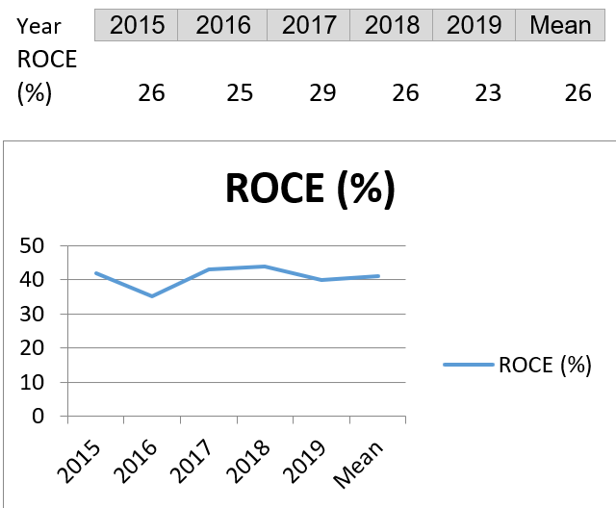
ROE-Return on Equity – “ROE expresses the rate of return on the money that equity investors have put into the business” (CFI, 2015) | The construction industry average ROE is 25%; Berkeley has significantly increased ROE from 2016 to 2017, with a very slight dip in 2018 and even further in 2019. The ratios for three consecutive years (2016-2018) were above the industry’s average. In 2019 ROE reduced by almost 8% from the return in 2018, the combination of the reduced net profit and the increase in equity attributed to a reduction of ROE. The action to take could be suggested to improve sales and reduce operational cost (CFI, 2015) | 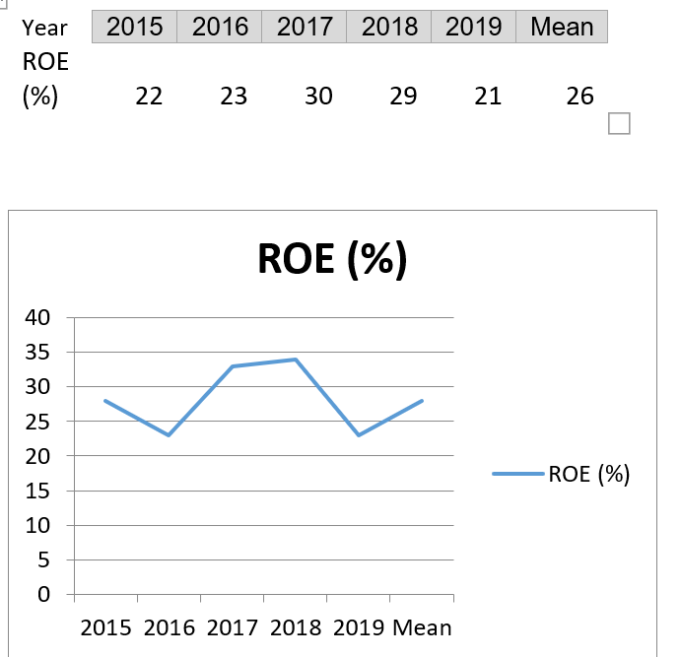
GPM - Gross Profit Margin – “Margin ratios represent ability of the company to convert sales into profits at various costs levels. The High GP Margin signifies high efficiency of the business’ main operations, with the ability to cover expenses, costs, depreciation, and dividends as well as create the profit to the business” (CFI, 2015) | iLumen Financial Benchmarking reported that construction average GPM is 19-20% and 21-25% for new build (as at 2005), The Berkeley manages sales well above the construction industry average with the steady growth of GPM from 34.21% in 2016 to 34.99% in 2018. This period corresponds with the new operational strategy adopted by The Berkeley of focusing on the large-scale redevelopments in the London area. Although 2019 had a slight drop in GMP (in contrast to 2018), the GPM of 31% is still well above the industry average. We can suggest that the reduction of GPM came mainly from the rise in the cost of sales. This is supported by the fact that although the sales and revenue went up comparing to the year 2018, the Gross Profit went down (CFI, 2015) | 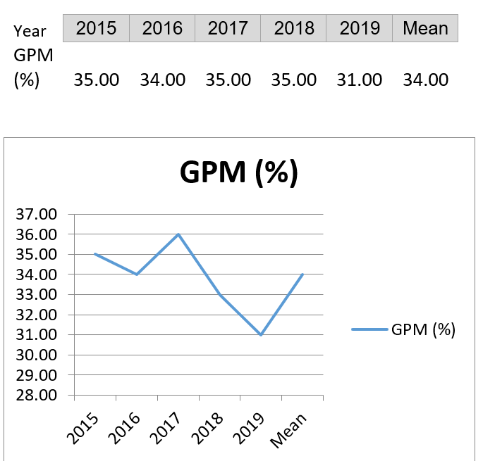
Operating Profit Margin – “Operating Profit Margin looks at the earnings in comparisons to sales in % before interest expenses and income tax are deducted” (CFI, 2015) | Berkeley shows high OPM with a steady increase over three years (2016-2018) and well above the estimated industry average of 3.83% (iLumen Financial Benchmarking report). The company is well equipped to pay its financial obligations. High OPM shows the strength of the company’s management. Similarly, to GPM, the rising unexpected cost in the external macroenvironment contributed to drop in OPM in 2019 (CFI, 2015) | 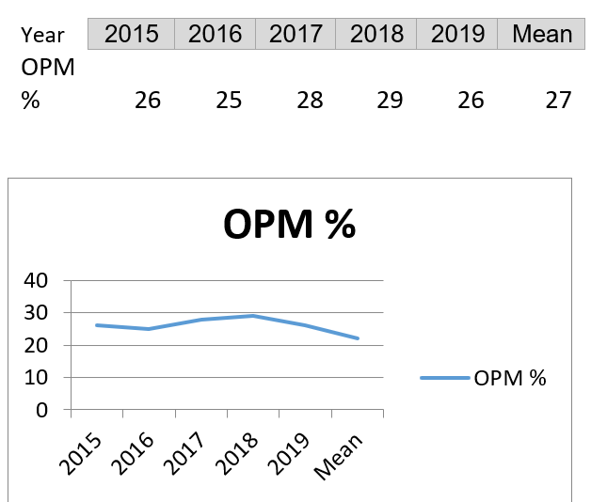
NPM-Net Profit Margin – “Net Profit Margin looks at the net profit of the company in relation to the total revenue in % and provides the bottom picture of the company profitability after all expenses, interest and tax are taken away” (CFI,2015) | NPM had steady growth over the period of 2016 – 2018, where Net Profit Margin had a smooth increase in-tune with the growing GP Margin. However, in 2019 NPM drop from 28% in 2018 to 21% where the sales revenue had grown but Net Profit, in contrast, had dropped. We can conclude that although the company seemed to succeed in bringing its operating expenses down in 2016-2018, the year 2019 looked like a challenging time for the company. Ahead of a general election, the year 2019 proved to be a critical moment for the London-focused housebuilder. Along with soaring construction commitments (10th of the capital’s projects were built just in 6 months) there were apprenticeship schemes and environmental commitments. The anticipated drop in operating profit and net profit were well-identified with the predicted decline in the house market. Even though the sales were up, the house prices were 13% cheaper compared to the year 2018. Regardless of this return, chief executive R.Perrins was positive that this is a good start to the year 2019 (Newman, 2019). | 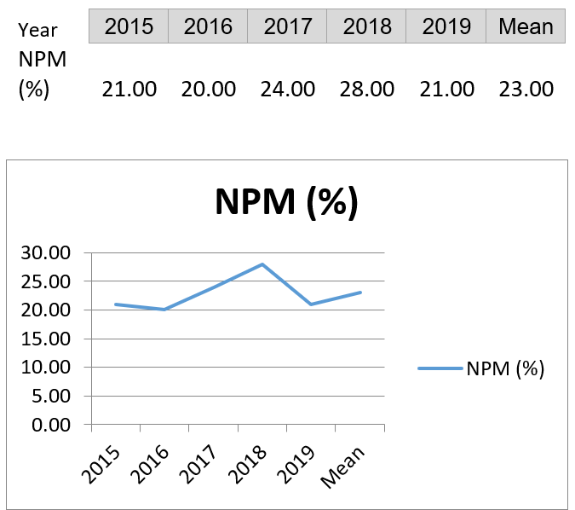
ROA - Return on Assets – Net Income / Total Assets - “This ratio represents ability of the company to generate Income from its total assets” (CFI , 2015) | The continuous rise in Return on Assets over a period of 5 years illustrates that business is profitable and efficient (Mean 13.5%). In comparison to the business competitor Balfour Beatty (ROA 1.4%), we can suggest that Berkeley succeeded in generating income from its assets. “As a general rule, a return on assets under 5% is considered an asset-intensive business while a return on assets above 20% is considered an asset-light business” (CFI , 2015), positioning The Berkeley in the middle (13.5%) | 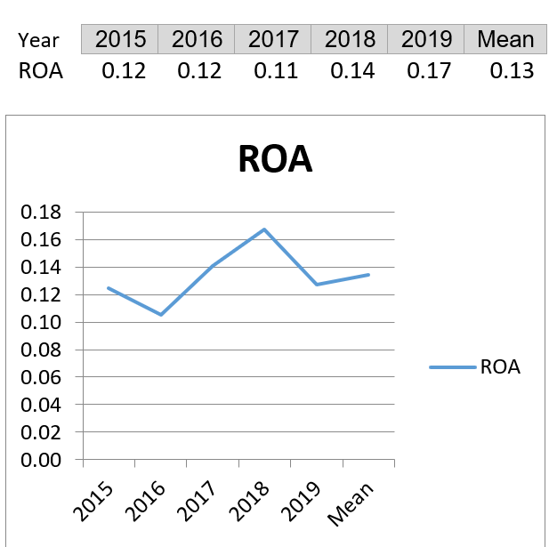

Interpretation
Upon investigation of the profitability ratios, it is observed that ROCE, ROE have steady growth over the period 2016-2018 with 2017 being the best performer over the period of analysis. The ratios are well above the construction industry average (20% & 25% respectively). The company enjoys healthy returns on invested capital. OPM is satisfactory and is well above the construction industry average of 3.83%. The company is well equipped to pay out its financial responsibilities and has fewer financial risks attached. Steady strong OPM represents the strength of the company’s management. GPMs of the company are positioned steadily between 34% – 35%. The ratios are above the range of standard norms (25%-30%), hence why it is to say that the GPM of Berkeley Group is satisfactory for the period of investigation. NPM was steadily increasing over time (2016-2018), while GPM remained unchanged which might indicate effective management of operating activities. ROA has a positive increase and well above the industry benchmark of 6.8%. However, in 2019, the investigated margins and returns suffered a minor contraction. The external environmental factors played a big part in the changes that the company was subject to. According to (Newman, 2019) Investors Chronicle’s political and economic factors affected the financial performance of the company: a housing market downturn and a general election that had prompted an additional environmental and educational expense. Having said that, comparing the mean for each margin and return with those of the competing business, we can clearly see that Berkeley is way ahead or at par with its competitors. Despite reduced profitability in 2019, the company had a very good ability to generate profit from available resources producing a steady growth in revenue from operations (from £2000M to £3000M (Appendix 1)).
2020 Analysis
The course of the pandemic hit the company very hard and this resulted in dropped figures for margins and returns. Figures according to CITYA.M. - the dramatic drop in sales April – May (3months into pandemic) push yearly revenue down more than 1/3. Profit before tax fell 35% (£503.7m), revenue was down 35% (£1.9m) in the year ended April 2020. Sales (April – May) down 50%, although the company managed to keep the prices against its expectations: 2, 723 homes sold for an average price of £677K during the year, down from 3,698 homes at £748K last year (Daniel, 2020). Nevertheless, although ROCE and ROE shrank significantly (the effect of the larger equity and reduced sales), the Margins (GPM, NPM, OPM) are managed to stay at the level of 2019 performance (Table 2).
Liquidity ratios assess a company’s capability to repay short-term commitments of one year or less (i.e., how quickly assets can be turned into cash). A high liquidity ratio suggests that a business is carrying too much cash that could be used in other fields. A low liquidity ratio means a firm may have difficulties paying short-term obligations (CFI, 2015-2021)

Table 3 Calculations of Liquidity Ratios for The Berkeley 2016-2020 and Balfour Beatty PLC/ 2019
Table 3.1 The Berkeley Liquidity position 2015-2020
Year | 2020 | 2019 | 2018 | 2017 | 2016 | 2015 | Mean | Balfour Beatty PLC/ 2019
CR- Current Ratio | 2.7:1 | 2.8:1 | 2.8:1 | 2.3:1 | 2.1:1 | 2.1:1 | 2.4:1 | 0.91:1
QR -Quick Ratio | 0.9:1 | 0.9:1 | 0.5:1 | 0.3:1 | 0.4:1 | 0.6:1 | 0.6:1 | 0.87:1
Working Capital/ (£m) | 2,944 | 2,883 | 3,051 | 2,579 | 1,971 | 1,655 | 2,621 | -156

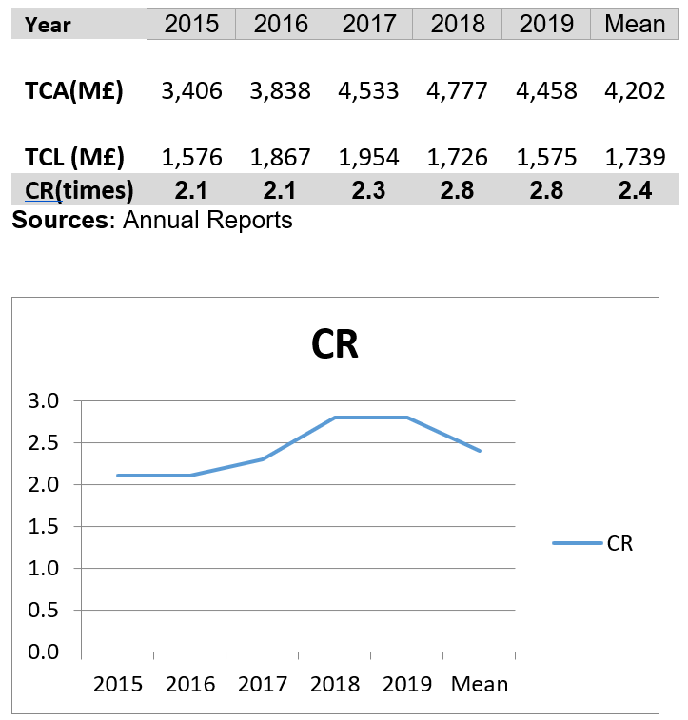  Table 3.2 | CR - Current Ratio “measures company ability to pay its current Liabilities from current Assets” (CFI, 2015-2021).  Table 3.2 explains the current assets and current liabilities of Berkeley for the period 2015-2019. It illustrates that current assets had a great increase from 2015 to 2018 from 3.4bn to 4.8bn, the larger part aggregate in inventory (Appendix1) which assumes widespread growth in operations. Although 2019 had a retraction from the graph’s growth line in assets, it is still well above the previous years (2015 -2016). The company reduced its current liability over the period 2016-2019 while increasing its current assets. In 2020 despite the COVID-19 effect (insolvencies, closures, administrations) company’s relation between assets and liability remains the same as the pre-COVID position of 2019. 2020 sees both Current Assets and Current Liabilities are increased, possibly due to slowing down in sales and company delaying payments.

Interpretation
Looking at the summary (Table 3.1) the company has improved its current liquidity from 2015 to 2020 as indicated by CR ratio analysis. Contrasting the results of the current ratio analysis with the standard norm and Balfour Beatty PLC metrics, it is evident the company has a good ability to meet payment obligations. The current ratio’s standard norm is 2:1, whereas the metrics (Table 3.1) are above the standard norm (the most recent 2019 is 2.8:1; 2020 – 2.7:1) placing the company in a good financial position to pay its debt. The company has accurately managed its working capital (CA – CL) requirements essential for daily operating activity. The table also has shown that for the period from 2018 to 2020 the company has a comparatively high CR (Balfour Beatty PLC is 0.91:1) which is signal that the company assets are highly liquid and can be used quickly to pay off current liabilities as and when needed, or it can also suggest that company is not using its assets or short-term financing efficiently, i.e. has to look at WCM more closely (Saleem, 2011)

Table 3.3  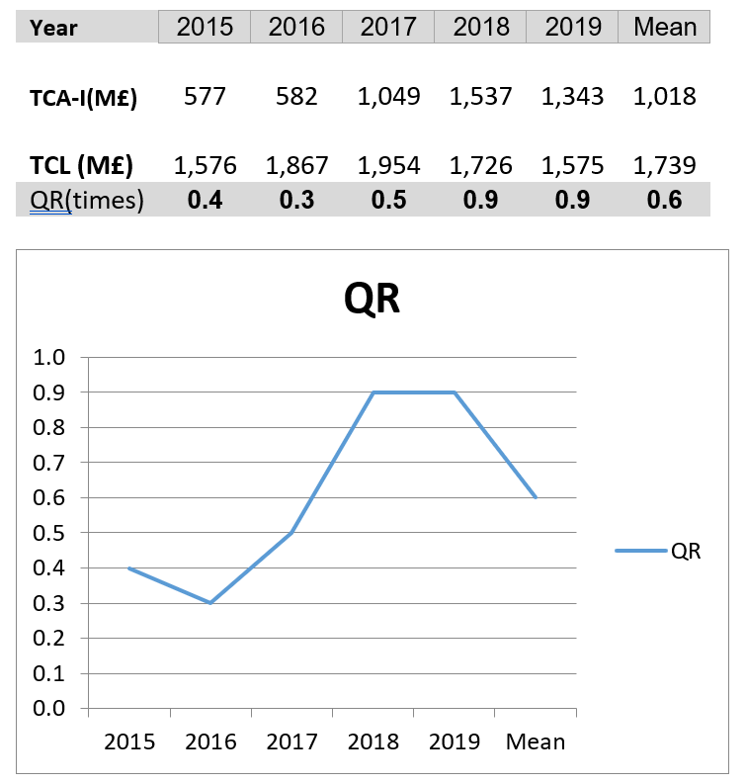 | QR – Quick Ratio “provides more severe test of liquidity, it indicates company ability to pay its current Liabilities without relying on the sale of Inventory or External Financing” (CFI, 2015-2021)  Tables 3 and 3.3 present QR assessments of company liquidity for the period 2015-2020– or the company’s capacity to pay its existing debt without selling inventory or using short-term financing. The standard norm of the quick ratio is 1:1. It is noted that Berkeley’s quick ratio although not maintained at the suggested standard norm (1:1), it had gradually recovered from 0.4 in 2015 to 0.9 in 2019-20 improving its liquidity position and almost reaching the standard norm.

Interpretation
Investors and creditors analysing the business for creditworthiness want to see a company with a quick ratio above 1. Berkeley’s QRs for 2015, 2016, 2017 indicate that the business had not enough capability to resolve its short-term debt if immediate notice is given. “QR considers more liquid assets such as cash, accounts receivables, and marketable securities” (CFI, 2015-2021), so the QR metrics represent the truer picture of the company’s capabilities to settle a short-term debt. Taking into consideration, the nature of the construction industry, Berkeley holds a high level of stock for expanded operations, hence why the QR metrics position. The industry player Balfour Beatty PLC in 2019 held a similar position (QR-0.87). Having said that, from 2018 through to 2020 Berkeley improved its QR significantly (as high as 0.9), i.e., the company has more readily available assets to offset the short-term liabilities. It is important to note, that Liquidity ratios (Current, Quick, and Cash) “vary by the numerators used in the equation, consequently, an acceptable ratio figure will differ between the three” ratios, i.e.,” “an acceptable current ratio will be higher than an acceptable quick ratio, and both will be higher than an acceptable cash ratio” (CFI, 2015-2021). Therefore, evaluating a combination of CR (2.8) and QR (0.9) suggests that the company does not have immediate liquidity problems.
Conclusion
Liquidity management is critical for Berkeley, as for every corporation, that means to pay existing operating and financial costs that are short-term but maturing long-term debt. Liquidity ratios as a liquidity management tools greatly affect the profitability of organisation, i.e., the business has enough liquid assets (Cash, Bank) to meet the scheduled expenses, by comparing “the cash and near-cash (Current assets) with the payment commitments (Current liabilities)” (Saleem, 2011). Berkeley must look at its “receivables from customers and inventories of finished goods and raw materials, and its payment obligations to suppliers, operating and financial expenditures that must be paid soon, and maturing instalments under long-term debt” (Saleem, 2011). Berkeley must ensure that the coverage of the CL by CA is adequate, it implies that otherwise, the company might face troubles in meeting its current financial responsibilities. This can affect the company's profitability and credit rating by investors (Saleem, 2011). The Liquidity versus Profitability Principle: There is a trade-off between liquidity and profitability; gaining more of one ordinarily means giving up some of the other (Saleem, 2011).
Efficiency Ratios examine the operational efficiency of the company, which are correlated with profitability ratios. Thus, if the efficiency ratios have been enhanced over time, this could signal that the business has grown to be more profitable. Efficiency ratios compare the expenses applied within a business operation to the revenue generated from the amount spent to operate a business. The ratios examine how a company turning their “inventory, sales, assets, accounts receivables or payable (Credit Guru Inc, 1999-2021)
Figure 1. Efficiency ratios
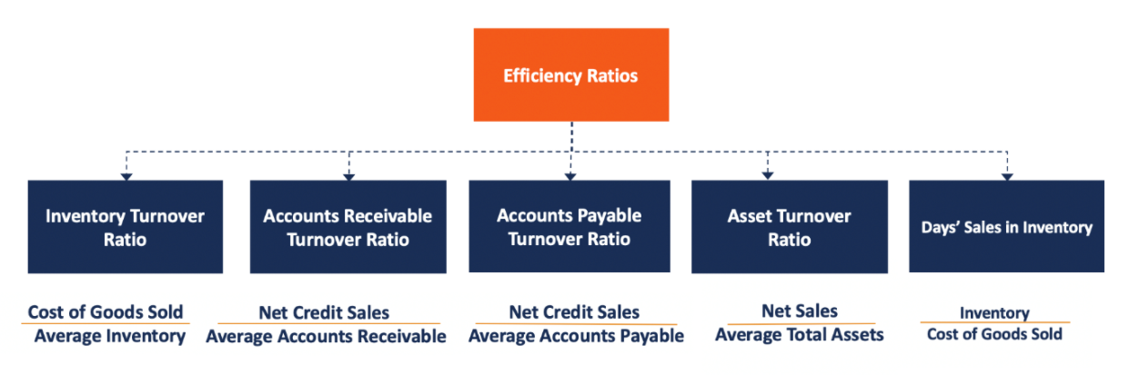
(source: Efficiency Ratios - Overview, Uses in Financial Analysis, Examples (corporatefinanceinstitute.com))
Findings:
Table 4 Calculations of Efficiency Ratios for The Berkeley 2016-2020 and Balfour Beatty PLC/ 2019

Table 4.1 Efficiency position of The Berkeley 2015-2020 and Balfour Beatty PLC-2019
Due to words limits for this report, we will analyse the Assets Turnover ratio, Payables Payment Period and Receivables Collection period
Assets turnover ratio “measures the value of a company's sales relative to the value of its assets. The ratio indicates the efficiency with which a company is using its assets to generate income” (Hayes, 2020). High Asset turnover indicates a more efficient use of the company’s assets. Berkeley’s Assets Turnover figures vary from year to year. The analysis revealed that in 2017 for every 1£ company invested in business it generated 1.27£ in sales revenue. Again in 2018 the company made less efficient use of its assets (1.03£ generated for every 1£ invested). There is no ideal ratio benchmark for the industries but evaluating Assets Turnover to a similar company from the FTSE 350 – Belfour Beatty PLC, we can see that player's Asset Turnover ratio for the period 2019 was 2.09 which is much high than Berkeley’s. The assets turnover tends to differ from industry to industry. Thus, construction companies like Berkeley owning larger asset bases have low asset turnover. The reason behind the low asset turnover could be a large asset purchased during the year. To have a bigger picture of efficiency position of the company, AT ratio, must be evaluated in conjunction with other efficiency ratios (Hays, 2020).
Payables Payment Period “represents the average number of times a company pays off its creditors during an accounting period” (CFI, 2015-2021). “A higher payable turnover ratio is favourable, as it enables the company to hold cash for a longer time”. Berkeley has a high Payables Payment Period that tends to decrease over the period of 5 years. The company reduced Payables days from 504 days in 2016 to 287 days in 2019). The high payment period in 2020 is mainly attributed to the fact that the company managed to negotiate favourable payment terms with the suppliers (purchase on credit), which allowed less frequent payments available to the Construction Company during the COVID-19 pandemic. Regardless of the favourable agreements, this could raise a concern about Berkeley’s short-term liquidity, especially, in comparison to Berkley’s competitor, Belfour Beauty (Annual Report, 2019).
Receivables Collecting Period - evaluates the efficiency of revenue collection, looking at the number of times a business obtains its “average accounts receivable over a given period” (CFI, 2015-2021). Berkeley figures (38 days in 2016, 31 days in 2017, and 18 days in 2018 and declining) are regarded as a beneficial term, suggesting that the firm is collecting their payments faster for their products, particularly in contrast to Belfour Beatty’s receivables ratio (41 days, 2019) (Annual Report, 2019).
Conclusion Efficiency Ratios show that Berkeley’s management has succeeded in managing and using its assets better in 2018-19, then in 2016-2017.

Investment Ratios - used by the investors to assess earnings and future performance of the company.
Findings:
Table 5 Calculations of Investment Ratios for The Berkeley 2016-2020 and Balfour Beatty PLC/ 2019

Table 5.1 Investment position of The Berkeley 2015-2020 and Balfour Beatty PLC-2019
Earnings Per Share, or income per share “measures how many pence of net income have been earned by each ordinary share during accounting period” (CFI, 2015-2021). As with any profitability or market prospect ratio, EPS relates to higher earnings per share is favourable than low earnings per share, since this implies “the business is more valuable and the firm has more profits to distribute to its shareholders” (AccountingCourse, 2021). Berkeley’s Annual Reports (2016-2018) show a rapid growth of the earnings per share from 295.8 pence to 562.7 pence, with a drop in 2019 to 481.1 pence, and a further reduction in 2020. Nevertheless, in comparison to Belfour Beatty’s EPS, for 2019 were 19.00p, Berkeley is a better choice to invest in. According to “FTSE350 the top 20 dividends paying stocks (construction industry) had the Dividend Yield of 8-9%” (Stocks That Have Raised Dividends for 10 Years, 2018) (http://www.morningstar.co.uk/uk/news/111721/top-20-ftse-350-dividend-paying-stocks.aspx/, accessed 09/11/2020). Looking at Berkeley’s Historical Dividend Yield Data we can see a significant drop from 7.1% in 2016 to 0.41% in 2019 in Yield ratio, this is due to the Market price of Ordinary Share variations in the last 4 years. But it does not mean that the company is a bad investment, and to rely on this ratio alone is a mistake. We must look at Yield in conjunction with other ratios (example: EPS is high). Capital Gearing Ratio aids to examine the capital structure and financial strength of the company. As a “low-geared” business, Berkeley enjoys a low Capital Gearing Ratio. Although throughout the period of 2015 – 2020 the gearing metric fluctuated between 1.16% (2015) and 16.77% (2020), nevertheless in comparison to Belfour Beatty, which had a capital gearing ratio of 44.7% (2019) it looks much favourably to the investors. Berkeley’s position allows the company to borrow a cheap form of funds from the investors easier because it has been a low-risk investment.
Recommendations
Referring to the evaluation of the four groups of ratios above, competitor’s evidence, and industry average figures we can suggest The Berkeley Group represents a good investment opportunity. Nevertheless, it also can be recommended to the company to strengthen its financial position to adopt the following
- Profitability
To improve ROCE – “the company might sell the outdated equipment, which would lower the company’s total asset base and therefore increase the business’ ROCE since getting rid of unused or unnecessary assets permits for less capital to be employed to assist the same amount of production” (Maverick, 2019).

- Liquidity
The company’s Board must work on its Quick ratio to improve it further, which would prevent the unnecessary sale of inventory if the need for the financial obligations would arise immediately.
- Efficiency
The company must take actions to improve its Assets turnover that is lacking, this could be done by increasing sales revenue further.
- Investment
Although the current P/E ratio and Dividend Yield are lower than of those industry competitors in conjunction with high EPS, business looks attractive to the investors.

PART C) INVESTMENT APPRAISAL TECHNIQUES

Evaluation of Capital Investment Appraisal Techniques in context of Project A and Project B

“The investment appraisal is concerned with organisational management decisions about which projects or assets to invest in and how to finance them to achieve corporate goals” (Harris, 2011). The information is delivered using capital investment appraisal techniques. Three methods of capital investment appraisal will be evaluated and explained, these are the payback method, the accounting rate of return and the net present value method (Weetman, 2013).
Table C1 – Payback Period calculations
Definition: PayBack Period “is the time required for positive project cash flow to recover negative project cash flow from the acquisition and/or development years. Payback can be calculated either from the start of a project or from the start of production” (Weetman, 2013). Payback period calculation is used to assess the length of time that cash invested in the project takes to come back as quickly as possible as a cash flow. The most desirable project, under PBP, is the project that takes the shortest time. The calculation from Table C1 illustrates that project B offers the Shortest Payback Period, i.e., offers a better choice of investment in relation to the PBP measure (Weetman, 2013).

ACCOUNTING RATE OF RETURN
Definition: “The Accounting Rate of Return uses accounting profit, rather than cash flows, is calculated by taking the Average Annual Profits expected from a project as a percentage of the capital investment” (Weetman, 2013). This report uses the initial investment for illustration and analysis, but the average investment variable is quite useful too as it makes arbitrary assumptions over the capital use over the project. ARR ranks the projects in relation to the highest rate of return. It decides the project suitability based on the future net earnings expected compared to the capital cost (CFI - Corporate Finance Institute, 2015). In terms of decision making, Project A has an ARR of 11.76% which is high than Project B 11.11%. “The higher the ARR, the more profitable the company will become”, therefore the project A is more acceptable than the project B (Table C2) (Weetman, 2013
Table C2 Calculation of ARR
NET PRESENT VALUE method of capital investment appraisal “considers all cash flows over the life of the project and makes allowances for the time value of money” (Weetman, 2013). “Net present value pursues to obtain the total value of a potential investment opportunity”. The concept behind it - is to project all the future cash inflows and outflows related with a venture capital, discount all those future cash flows to the present day, and then add them together” (Fernando, 2020). “The overall figure after counting all the positive and negative cashflows collectively is the investment’s NPV”. A positive NPV indicates that, after accounting for the time value of money, the investment will be profitable if the project to go ahead (Fernando, 2020). Both projects NPVs have positive figures, hence both ventures exceed the cost of capital and can be accepted for the investment. However, since project B NPV (£9.964M) is higher than project A NPV(£6.9615M) it would be appropriate to accept project B as a capital venture (Table C3).

Table C3 Calculation of Net Present Value

Evaluation of results and Project Recommendation
The cash recovery from the investment is one of the main measures of success of a capital project. The project B is recovering cash from the investment faster, thus Project B is the preferred choice to invest, Project A looks less attractive to finance, as it takes longer to recover the cash flow return. The PBP assumes certainty about the cash flows predictions, again the total predicted inflow from project B (£130M) is greater than from project A (£125M), however, the method does not consider commercial risks and the cost of finance (if borrowed). The cash flows earned from both projects are sufficient to repay the capital amount invested, but the projects must be able to provide rewards to the investors too. The Project’s A ARR is equal to 11.76%, which means that the project is expected to earn 11.76 pence for every pound invested per year, where the Project B ARR is equal to 11.11 pence reward for one pound invested in the project (which is less than A). The analysis of ARR suggests that project A will make a greater return than B over the project life. In contrast, The BPB method used to identify the payment back term ignored the cash received beyond the payback repayment term, therefore does not account for the long-term profitability. Although the Project A payback period is longer, than Project B, the amount of the return received over project A life is greater than that of Project B. In accounting terms, higher financial returns over the projected period of life appeal more favourably to the investors, than a short inburst of cash. But we cannot ignore the fact that ARR assumes “accounting income in future years has the same value as accounting income in the current year” (CFI - Corporate Finance Institute, 2015). Considering, the facts so far, we can suggest that Project A and the Project B opportunities are similar, hence why the NPV method of evaluation will be a deciding factor in project recommendation. Net Present Value is the most conventional technique of investment evaluation since it considers the “factors such as the investor’s cost of capital, opportunity cost, and risk tolerance through the discount rate” (Fernando, 2020). Additionally, it “accounts for the time value of money and can be used to compare investment alternatives that are similar” (Fernando, 2020). A positive NPV indicates the generated project earnings exceeded anticipated costs. Accordingly, Project B has a positive NPV that is much greater than Project A.
THE CONCLUSION The evaluation of the calculations of investment appraisal methods allows recommending project B to be adopted for the capital investment.

Advantages and Disadvantages of Investment Appraisal Techniques critically discussed

Advantages |  | Disadvantages
Payback Period

The method is favoured for its simplicity, it is helpful for a smaller firm relying on the short payback period, i.e., with short investment periods and limited amounts of funds to spend (Weetman, 2013). |  | Fails to consider TVM – time value of money, i.e., do not take into consideration that long-term investments have a financial cost of borrowings and the fact that today’s earnings potentials give a greater value of the cash today than in the future (Maverick, 2019)
The Formula is easy to calculate and can be used quickly for a very basic comparison calculation |  | The method overlooks any cash flows after the payback date, hence fails to compare the profitability of comparable projects beyond the payback day (Maverick, 2019)
The short payback periods keep the financial Liquidity of the company, as it helps to reduce the risk of losses, especially within a changing economic environment (Maverick, 2019) |  | Appropriate for short term investments, since long-term cash inflows are disregarded in the long-term projects, does not analyse projects in its lifetime
Can be useful when the financier has a time limit and would like to find out the fastest time to get the money back on the investment (Weetman, 2013). |  | Oversimplicity prevents method to account for the complexity of the cash flow, especially in the projects with the fluctuated cash flows (Sales, Revenue)
 |  | Do not account for the risk factors, financing costs, hence the investments are not assessed properly (Weetman, 2013).
 |  | Do not provide decision criteria to indicate if the investment increases company’s value, hence must be used in conjunction with other methods
Advantages | Disadvantages
Accounting rate of return

The method accepts the view of net earnings i.e., profits after tax and depreciation. This is a crucial factor in the evaluation of an investment proposal. With the help of the method the company can calculate its performance (Maverick, 2019) |  | Ignores TVM - time value of money, do not recognise the difference in projects of the similar profit value but with the profit accumulation over different stages of project’s life; with one of the projects building up the profit at the earlier stages of investment, while the compared one - the project’s profit came at the latest stage of life (Maverick, 2019)
Uses Accounting measures for profit, that is easily understood, the records from the statement can be used for calculations; it also provides a clear illustration of the profitability of a venture (Weetman, 2013). |  | The ARR is affected by non-cash items like depreciation, which in some companies could distort the decision, depending on the depreciation policy used across the project (CFI, 2015)
The method looks at the project expectancy over the project life (Weetman, 2013). |  | The calculation of returns differs depending on the formula used, complicating the decision process for the project appraisal ROE/ ROCE/ARR (Maverick, 2019)
 |  | Do not consider the external factors (risks). The method is not additive, you cannot add up projects (Weetman, 2013).
 |  | Do not consider cash inflows, relates to the profit only, do not differentiate the period of profits earned (20%ARR in In Year 8 and 18% ARR in Year 6 have a different value) (Weetman, 2013).
Advantages |  | Disadvantages
Net Present value

Method “considers the concept of the time value of money (TVM) i.e., a pound today is worth more than a pound tomorrow owing to its earning capacity” (CFA Institute, 2021). It is crucial for construction, given the length of time of the projects |  | Analysis “makes assumptions and estimates about the future events that may not be reliable”, often projects required additional unforeseen expenditure (CFA Institute, 2021)
NPV provides an unmistakable most clear measure. “It approximates wealth creation from the potential investment in today’s money, given the applied discount rate” (Mendell, 2020) |  | A company must select a discount rate, “the method assumes the discount rate is not changing over the life of the investment or project”. But discount rate is not the same from year-to-year, as well as “Opportunity costs change and vary across financiers” (Mendell, 2020).
“NPV accounts for investment size, it operates for comparing minor investments to multi-billion-pound projects or acquisitions” which is important for the construction industry (Mendell, 2020) |  | There is no guidance on selecting the discount rate, required for calculations (CFA Institute, 2021)
“Method accounts cash flows rather than net earnings (which includes non-cash items such as depreciation)” (Mendell, 2020) |  | Overconfidence in assuming the accuracy of the predicted future cashflows, do not take account of hidden cost (a sunk cost)
“NPVs are additive, in case of multiple projects and excess capital, the projects can be added up to get an idea of cumulative wealth-creation from all investable ventures (Mendell, 2020). |  | Could be a hard method to understand, especially for a non-financial population
Enable the decision to select a project, it also a good measure of profitability, especially when applied to mutually exclusive projects (Financial Management , 2021) |  | Since the methods are absolute in figures and not a percentage, it is hard to compare the projects of different sizes, as the larger projects inevitably will have a larger NPV than smaller one (CFA Institute, 2021)

Non-financial factors take an important part in the decision-making process for an investment appraisal. The areas of consideration are linked to technical analysis, human and social factors, organisational behaviour, legal analysis. The examples of some of the factors: adhering to the requirements of existing and future regulation, “matching industry standards and good practice”, allowing for a human factor - the moral, expertise, knowledge, developing relationships with contractors and consumers, keeping up a business reputation, relationship with the community and the impact of environmental issues, “anticipating and dealing with future threats, such as protecting intellectual property against potential competition” (NIBusiness.co.uk, 2021). In most cases a combination of financial and non-financial criteria has to be considered in the appraisal of the project, moreover, the business has to allow for the non-financial factors specific to their trading industry and to fit well with the overall business strategy (NIBusiness.co.uk, 2021)

REFERENCES
AccountingCourse, 2021. Earnings per Share (EPS). [Online]
Available at: the company is more profitable and the company has more profits to distribute to its shareholders.
[Accessed 12 01 2021].
Berkeley Group, 2020. Annual Report, London: Berkeley Group.
CFA Institute, 2021. Advantages and Disadvantages of NPV. [Online]
Available at: Advantages and Disadvantages of NPV [Accessed 10 01 2021].
CFI - Corporate Finance Institute, 2015. What are Profitability Ratios?. CFI, pp. [Online]. Available from:https://corporatefinanceinstitute.com/resources/knowledge/finance/profitability-ratios/ [Accessed 11/01/2021].
CFI , 2015. Return on Assets & ROA Formula. CFI - Corporate Finance Institute, pp. [Online]. Available from: https://corporatefinanceinstitute.com/resources/knowledge/finance/return-on-assets-roa-formula/. [Accessed 29/12/2020].
CFI, 2015-2021. What is a Liquidity Ratio?. Corporate Finance Institute, pp. [Online]. Available from:https://corporatefinanceinstitute.com/resources/knowledge/finance/liquidity-ratio/. [Accessed 20/12/2020].
Credit Guru Inc, 1999-2021. Financial Statement ratio analysis - eficiency ratios. Articles on financial statement analysis, pp. [Online]. Available from: https://www.creditguru.com/index.php/financial-analysis/financial-analysis-articles/32-financial-statement-ratio-analysis-efficiency-ratios. [Accessed 29/12/2020].
Daniel, A., 2020. Berkeley Group profits fall by a third after coronavirus lockdown. CITYA.M., pp. [Online]. Available from:https://www.cityam.com/berkeley-group-profits-fall-by-a-third-after-coronavirus-lockdown/. [Accecced 11/0/2021].
Fernando, J., 2020. Investopedia. [Online] Available at: Investopedia [Accessed 06 01 2021].
Financial Management , 2021. Advantages and Disadvantages of NPV. Financial Management Concepts In Layman Terms, pp. [Online]. Available from: https://efinancemanagement.com/investment-decisions/advantages-and-disadvantages-of-npv. [Accessed 11/01/2021].
Financial Times, 2021. Equities. Financial Times, p. [\online]. Available from: https://markets.ft.com/data/equities/tearsheet/profile?s=BKG:LSE. [Accessed 10/01/2021].
Free Encyclopedia, 2020. Berkeley Group Holdings. Wikipedia, p. [Online]. Available from: https://en.wikipedia.org/wiki/Berkeley_Group_Holdings. [Accessed 02/01/2021].
Harris, P. E.-M. M., 2011. Review of Management Accounting Research. London: Palgrave Macmillan,.
Hayes, A. J. M., 2020. Asset Turnover Ratio. Investopdia, p. [Online]. Available from:https://www.investopedia.com/terms/a/assetturnover.asp. Accessed [10/01/2021].
Maverick, J., 2019. How Can a Company Improve on Its Return on Capital Employed (ROCE)?. Investopedia, pp. [Online]. Available from: https://www.investopedia.com/ask/answers/042415/what-are-some-ways-company-can-improve-its-return-capital-employed-roce.asp. [Accessed 19/01/2021].
Maverick, J., 2019. Investopedia. [Online]
Available at: https://www.investopedia.com/ask/answers/062915/what-are-some-limitations-and-drawbacks-using-payback-period-analysis.asp[Accessed 09 01 2021].
Mendell, B., 2020. Pros and Cons of Using Net Present Value (NPV). Forest Finance & Economics, Timberlands, pp. [Online]. Avalable from:https://forisk.com/blog/2020/05/31/pros-and-cons-of-using-net-present-value-npv/. [Accessed 11/01/2021].
Newman, A., 2019. Berkeley Group back to normal. Investors' Chronicle, pp. [Online]. Available from: https://www.investorschronicle.co.uk/shares/2019/12/06/berkeley-group-back-to-normal/. [Accessed 11/01/2021].
NIBusiness.co.uk, 2021. Investment appraisal techniques. [Online]
Available at: https://www.nibusinessinfo.co.uk/content/non-financial-factors-investment-appraisal
[Accessed 11 01 2021].
RESI Awards 2016". resiawards.com. Retrieved 6 January 2021
Saleem, Q. R. R., 2011. Impacts of liquidity ratios on profitability. Interdisciplinary Journal of Research in Business, 1(7), pp. 95-98.
Stocks That Have Raised Dividends for 10 Years, 2018. Stocks That Have Raised Dividends for 10 Years. Morning star, 09 11, p. https://www.morningstar.co.uk/uk/.
Weetman, P., 2013. Financial and management accounting. 6 ed. Harlow: Pearson Eduction.

APPENDICES

Appendix 1 Berkeley Group, Data from the audited financial statements
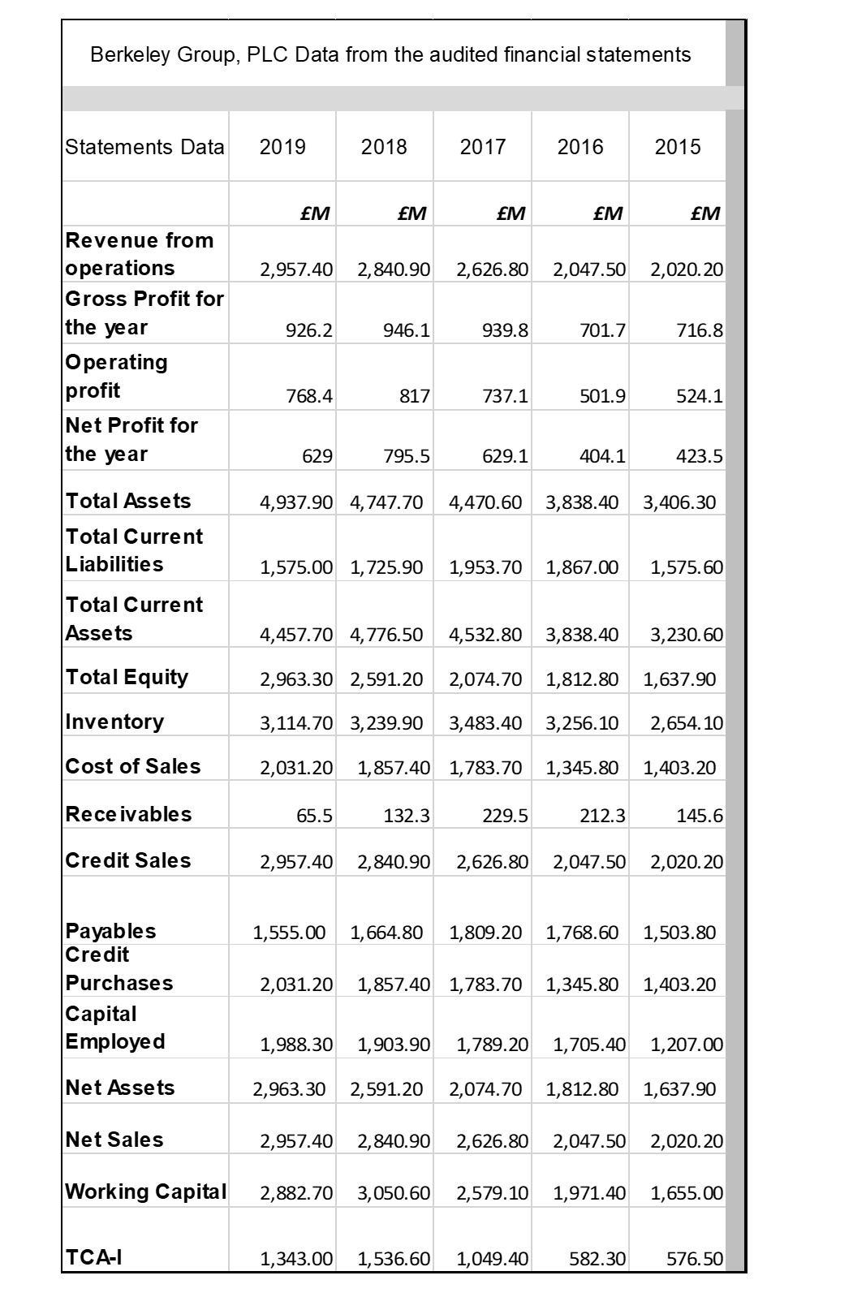

Appendix 2 Berkeley - Financial Reports for the year ended April 2020, April 2019
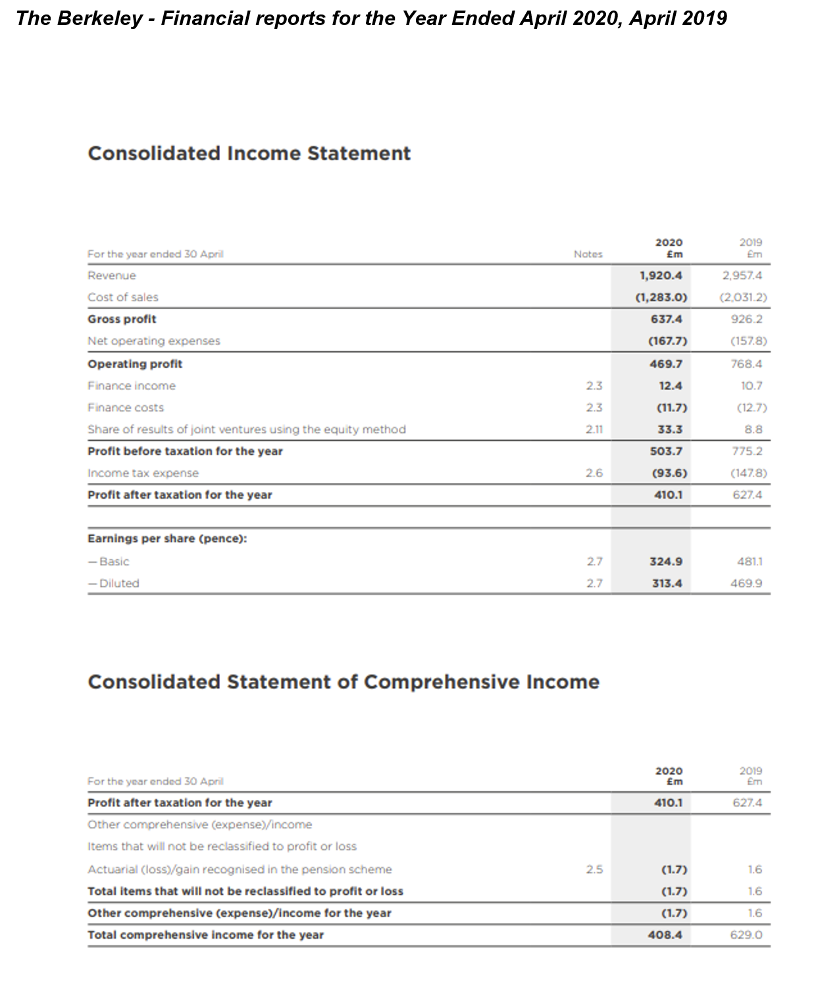

Appendix 2.1 Berkeley - Financial reports for the year ended 2020; 2019

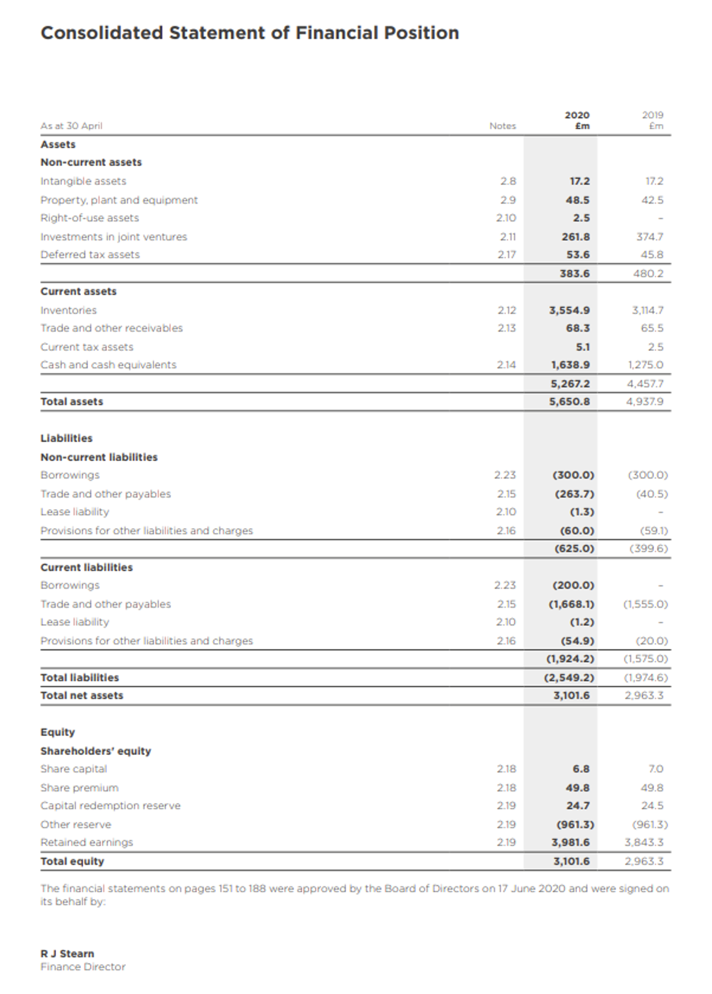

Appendix 3 Berkeley Group, Financial Reports for the year ended 2018; 2017

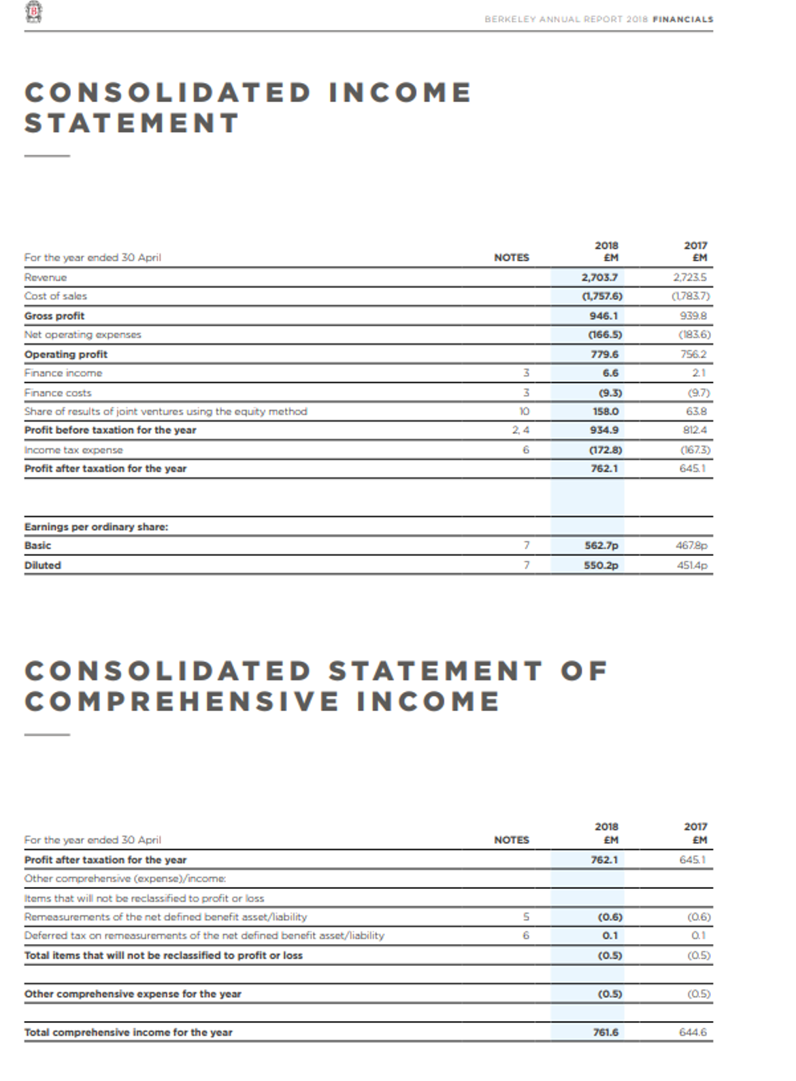

Appendix 4 Berkeley Group, Financial Reports for the year ended 2018; 2017

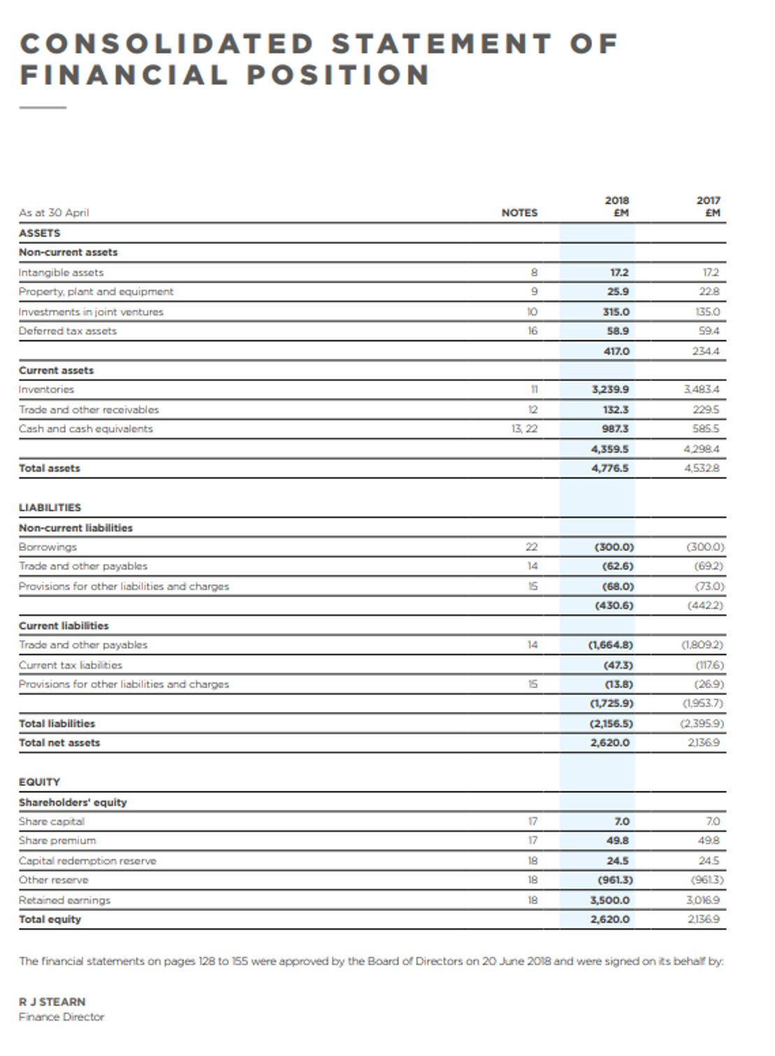

Appendix 5 Berkeley Group, Financial Reports for the year ended 2017; 2016
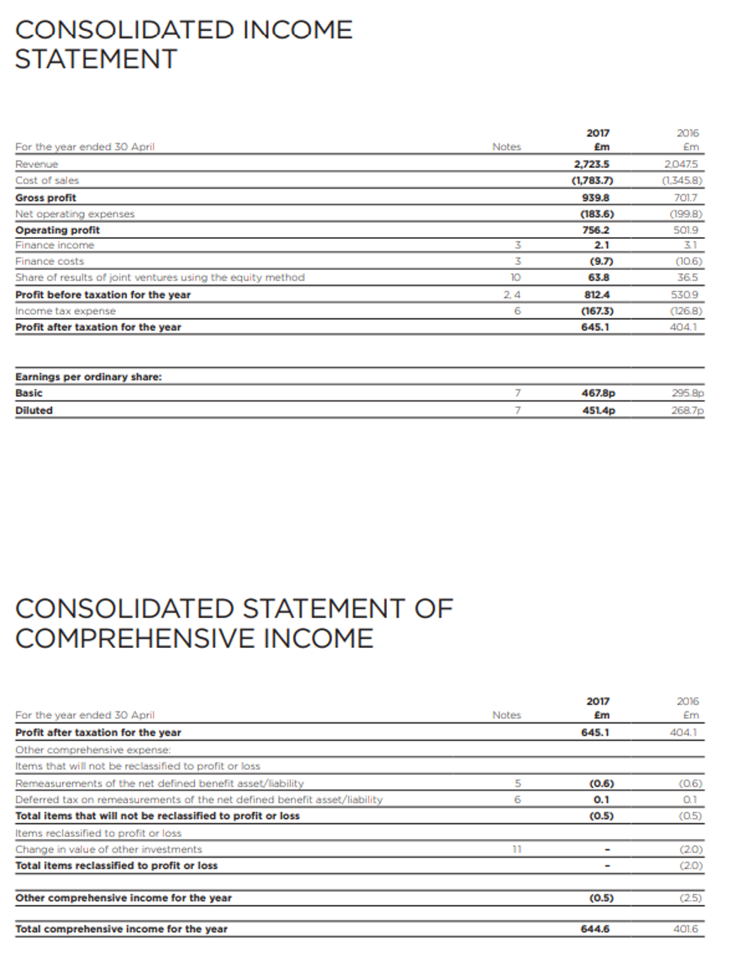

Appendix 6 Berkeley Group, Financial Reports for the year ended 2017; 2016
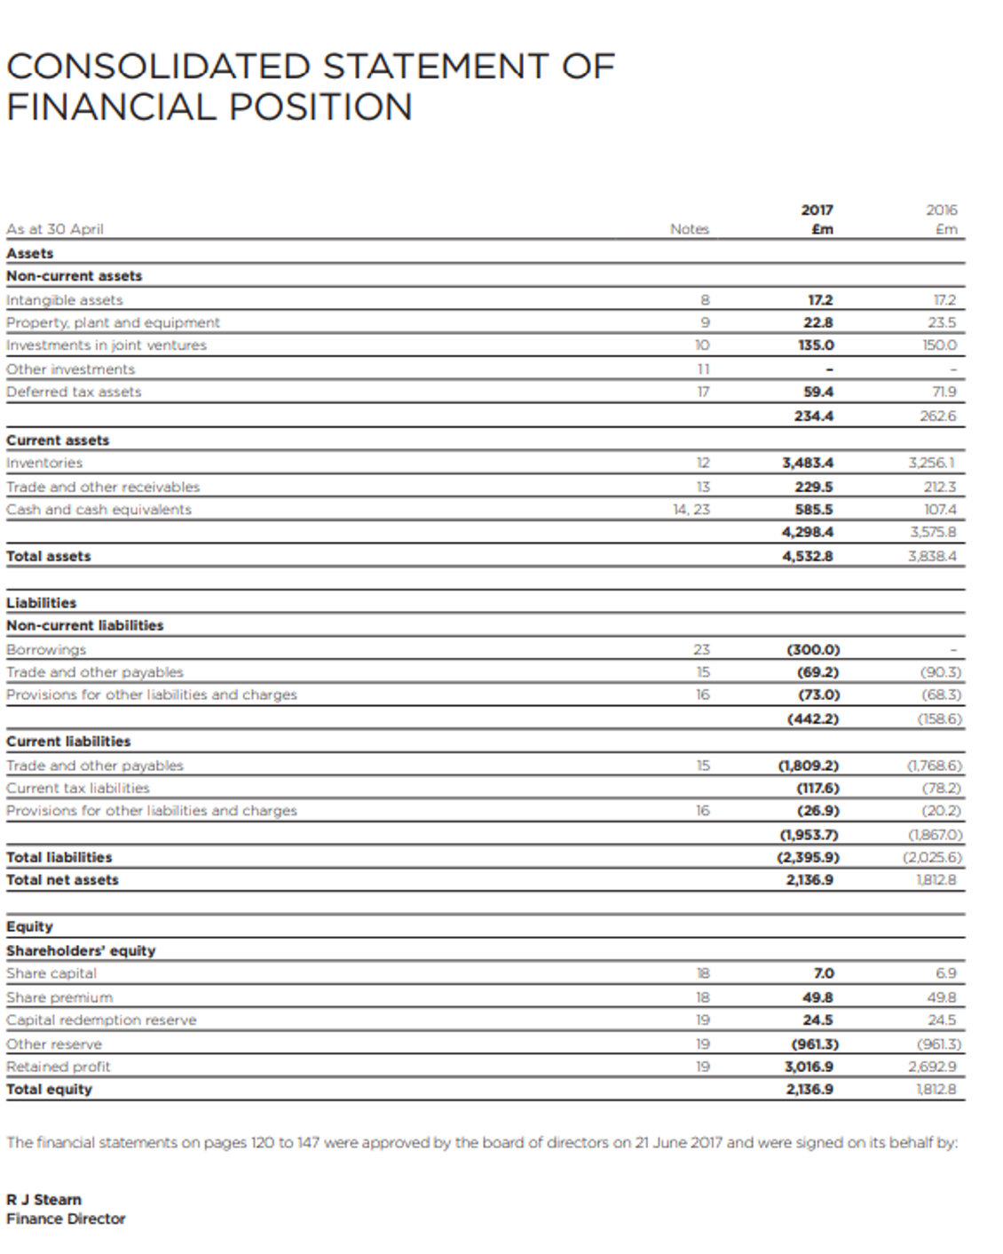

Appendix 7 Berkeley Group, Financial Reports for the year ended 2015; 2014
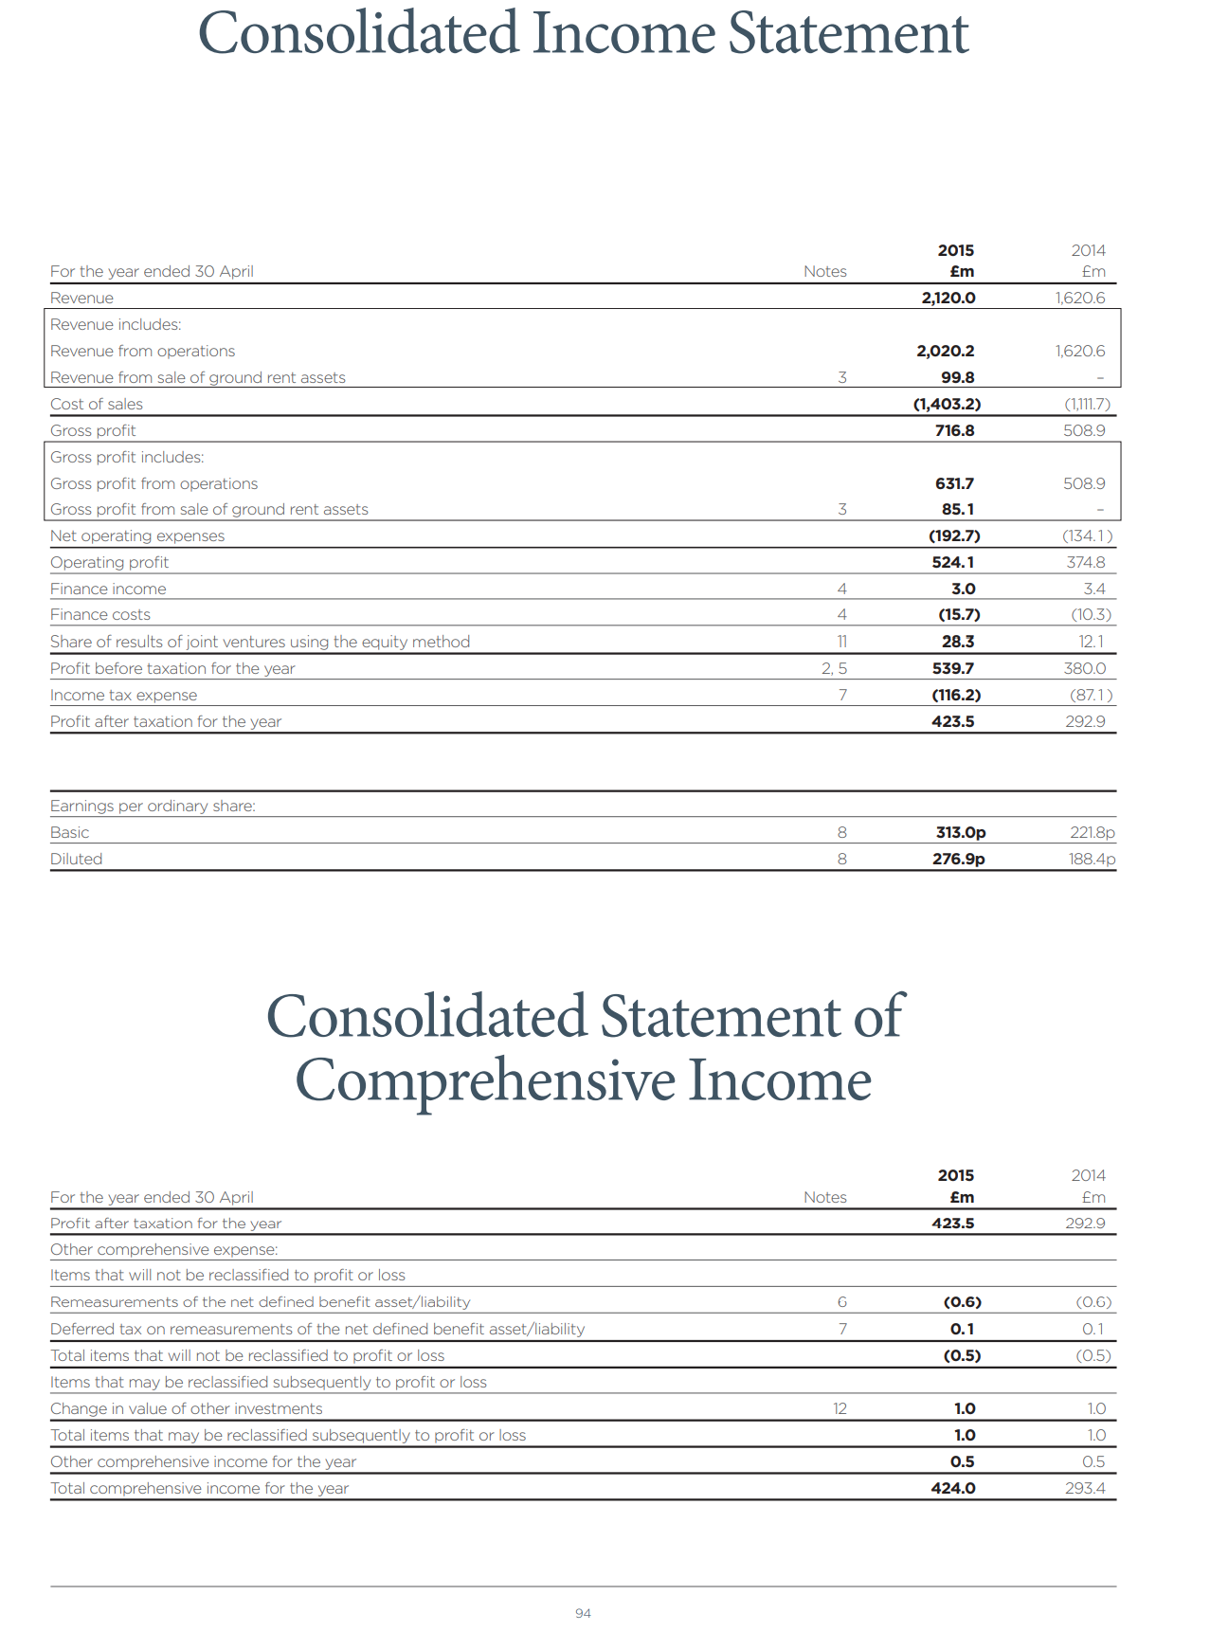

Appendix 8 Berkeley Group, Financial Reports for the year ended 2015; 2014

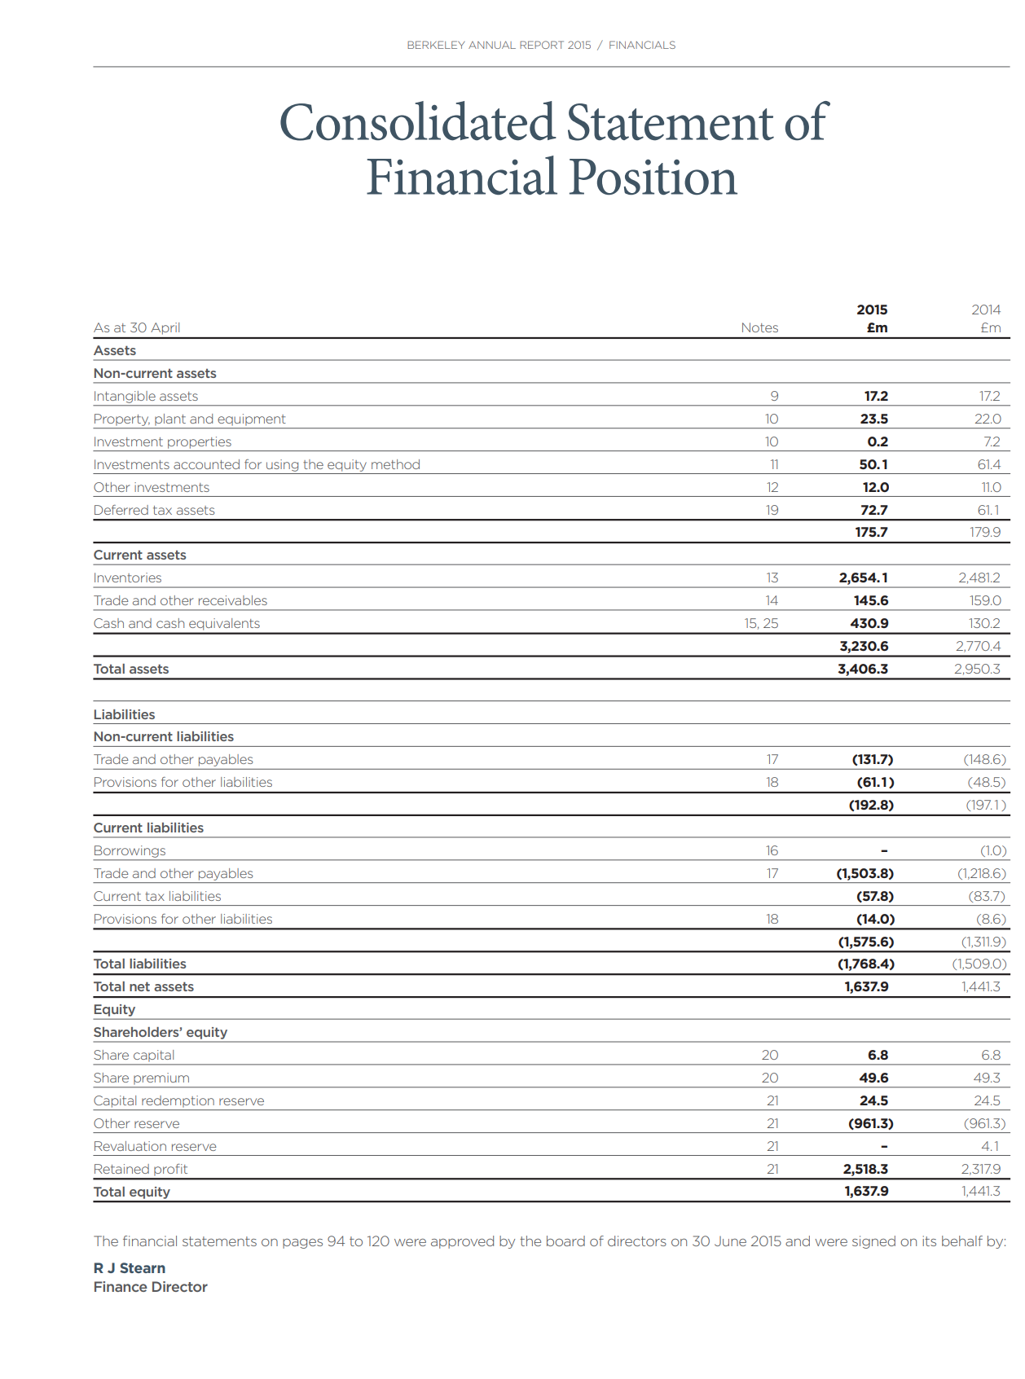

Appendix 9 Berkeley Group, share price for the year ended 2015
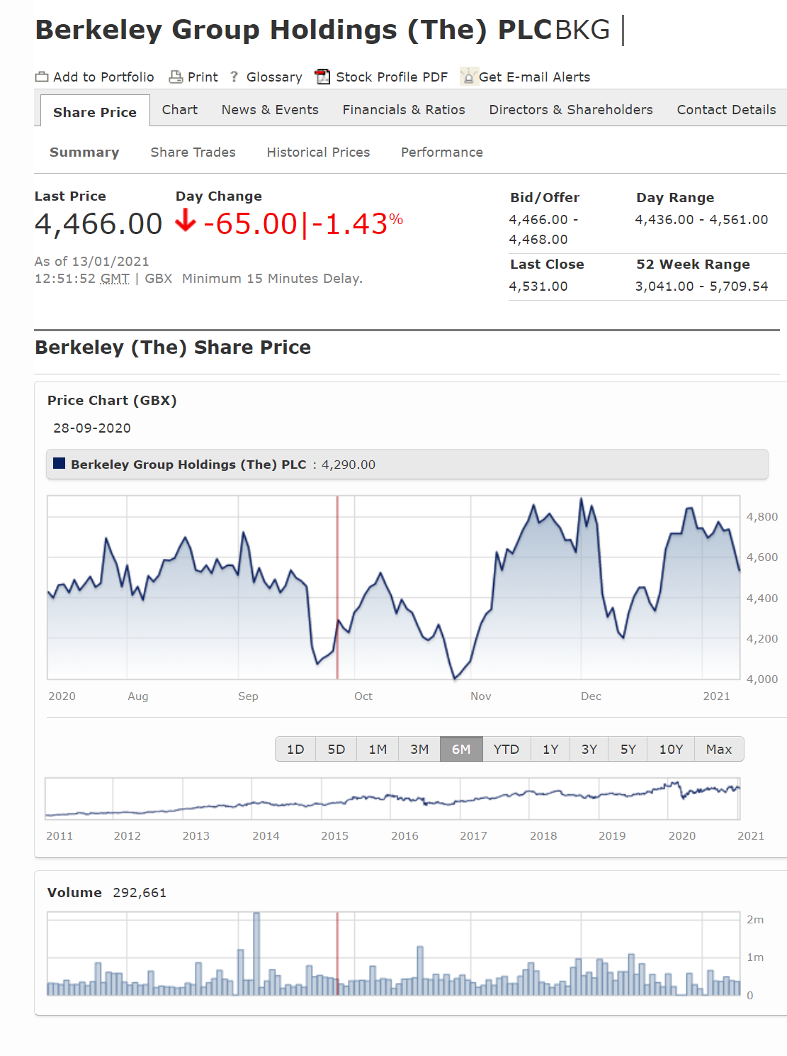

Appendix 10 Berkeley Group, Dividend breakdown 2018

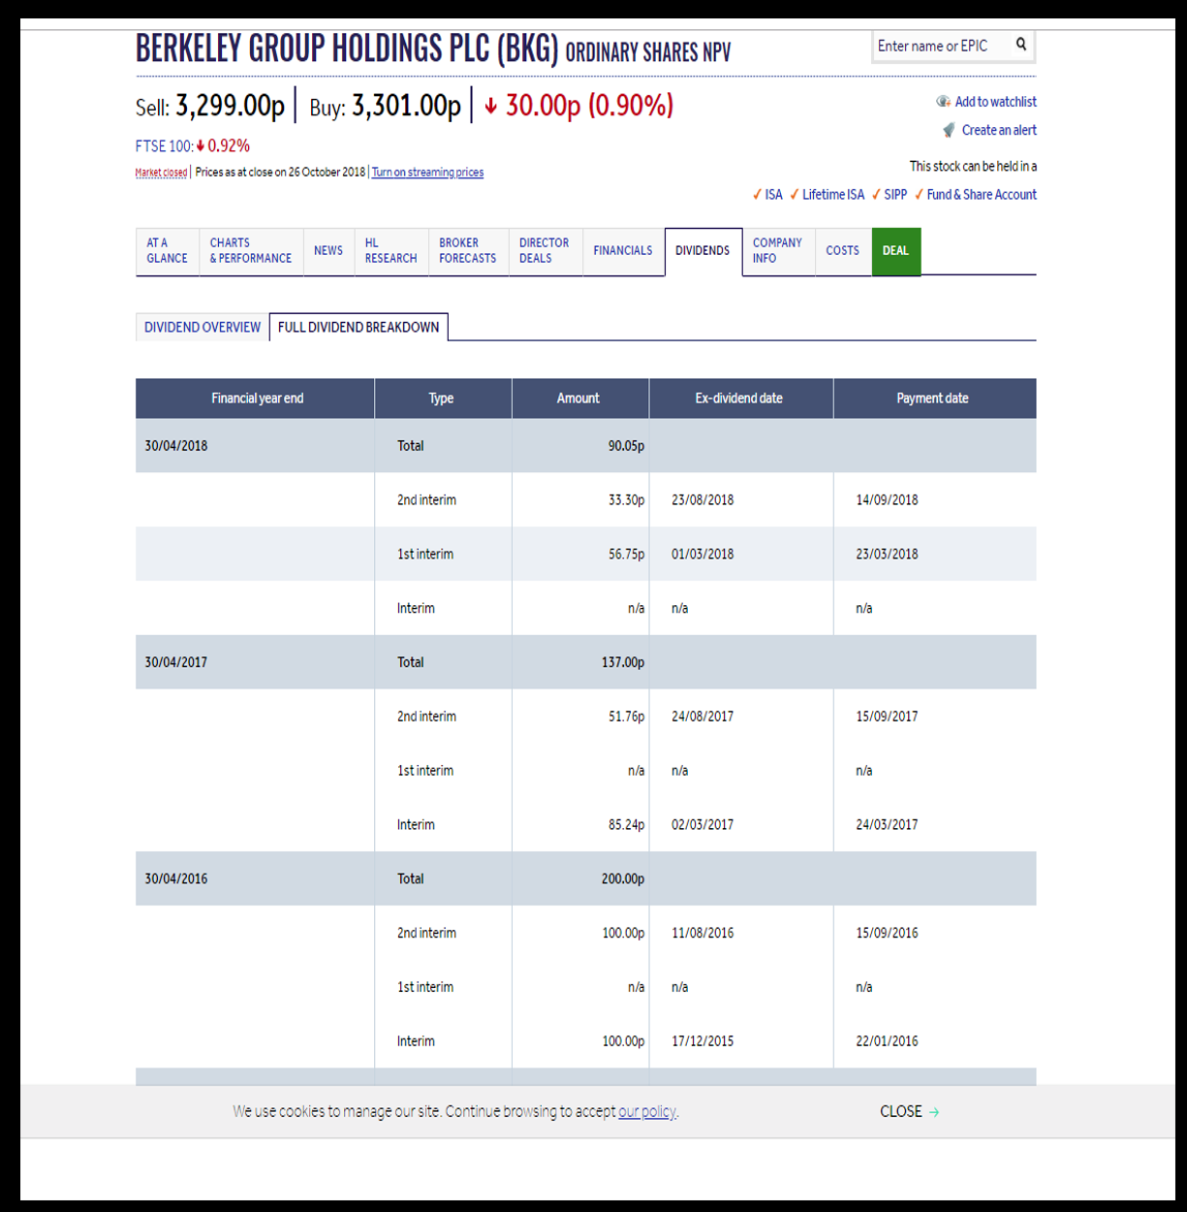

Appendix 11 Berkeley Group, Market Share price 2016-2018


Appendix 12 Balfour Beatty, Market Share Price 2019


