The huge changes to how schools will teach in Wales next term
The new curriculum gives teachers more freedom and does not set out a detailed plan for exactly what should be taught in schools
- SHARE

- Comments

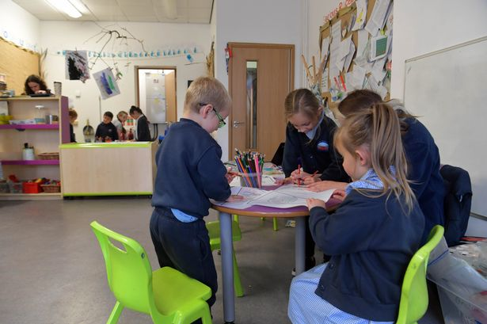
The will be a big shake up in the curriculum starting in September (Image: WalesOnline/Rob

When children go back to school in Wales in September all primaries and half of secondaries will begin teaching a new curriculum. The biggest change to education in a generation has been years in the making and the Welsh Government has provided £35m of extra cash to support it this year.
The rollout of the new curriculum is for children in year seven and below from September. Older groups in high schools will continue as before.
Teachers will have more freedom on what they teach and traditional subject boundaries will be scrapped under the reform. The Welsh Government has allowed high schools to delay until next year, which half have done - that means children in their first year of secondary will follow different curriculums depending where they go to school.

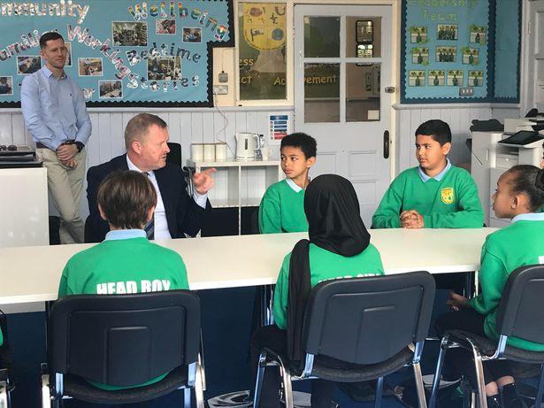
Education Minister Jeremy Miles chats to children during a visit to Lansdowne Primary in Cardiff last term (Image: WalesOnline)

So what does the new curriculum mean and will the change be obvious? Here is a rough guide to what will be happening in classrooms and why:
Traditional subjects ditched
Under the new curriculum traditional boundaries between subjects are scrapped and there will be instead six new Areas of Learning and Experience (AoLEs). Subjects will be banded together in faculties.
The six areas are:
- Maths and numeracy
- Languages literacy and communication
- Science and technology
- Humanities
- Health and wellbeing
- Expressive arts
How will that work in practice?
The Welsh Government explainer document says: “Specific subjects will still be taught, but schools can decide to combine them so learners understand the links between them. In humanities for example a topic like climate change can be looked at holistically through geography, history and impact on society. Literacy, numeracy and digital competence will be taught to all throughout their schooling.”
What will be taught then?
The new curriculum gives teachers more freedom and does not set out a detailed plan for exactly what should be taught. But it states “what matters” and sets out “progression steps” for each learning area.
What will be mandatory?

The mandatory subjects in the new curriculum are:
- Religion, values and ethics
- Relationships and sexuality education
- Welsh
- English
- Literacy, numeracy, and digital competence
- Maths and numeracy
- Languages, literacy and communication
- Science and technology
Parents will no longer be able to remove their children from sex education classes. The Welsh Government says RSE will be age appropriate. Campaigners say it is wrong to discuss issues like gender and sexuality with the youngest children. One group is taking High Court action over the plans. You can read more about that here

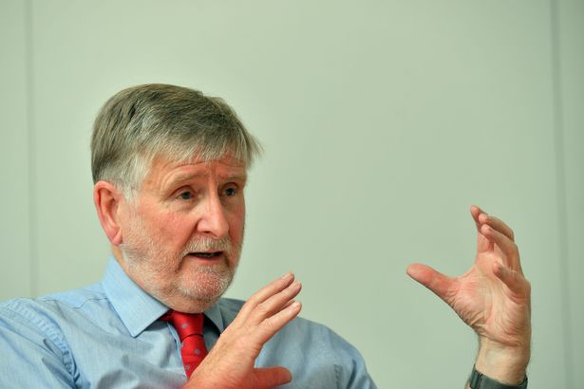
Professor Graham Donaldson, architect of Wales' new curriculum

What about exams?
These changes mean GCSEs and other qualifications will have to be adapted. New qualifications will be brought in and taught from 2025 to reflect the changes.
When will the new curriculum come in for each school year?
- September 2022 – Up to year 6 in primary and year 7 in those secondary schools not delaying
- September 2023 – Year 7 and 8
- September 2024 - year nine
The curriculum will then roll out year by year until it includes year 11 by 2026 .
What about the old “key stages”?
Key Stages 2, 3 and 4 will go. The Foundation Phase principles will remain, but will become a part of “one seamless curriculum” for children aged three to 16.

What about school assessment?
As Foundation Phase Learning, and Key Stages 1 and 2, no longer exist so assessments under those stages has ended. The Welsh Government said there will be a new approach to assessment which focuses on individual learner progression.
“Progression steps” relating to “broad expectations” of a child’s progress at age 5, 8, 11, 14 and 16 will be followed.
Year 9 learners, apart from those in special schools will continue to do the end of Key Stage 3 assessment that support the current National Curriculum until Curriculum for Wales roll out reaches year 9 in September 2024.
The Welsh Government explainer document says: "Assessment should always focus on moving learning forward by understanding the learning which has already taken place and using this to ensure that each learner is challenged and supported appropriately, according to their individual learning needs."
Will teaching be different?
The Welsh Government explainer document says: “The way children learn in primary and secondary schools will be different. Learning will include skills and experiences, as well as knowledge.
“Teachers will have more freedom to teach in ways they feel will have the best outcomes for their learners."
When did this all start?
The current curriculum has been in place more than 30 years, before the internet. Those in charge of education felt it needed updating to reflect the world children live in today and the world they will grow up in
Work on the changes goes back to March 2014 when the Welsh Government asked Professor Graham Donaldson to review the curriculum and assessment arrangements in schools in Wales.
Professor Donaldson recommended key stages and subject boundaries be ditched and replaced with “progression steps”, relating broadly to expectations at ages five, eight, 11, 14 and 16. Teachers would have more freedom to choose what's taught and exams would need to change. And that is, broadly, how schools will operate from next term.
A Welsh Government spokesman said: “This September the teaching of our transformative new curriculum for Wales will start in primary schools and almost half of secondary schools.
"This important development offers an exciting new opportunity to equip young people with the knowledge, skills and experiences they need to thrive as adults.
"It will set high standards for all with a curriculum that allows every learner to progress to their full potential. We look forward to seeing this approach to education which will help young people to become informed citizens of Wales and the world.”
What teaching unions say
Teaching unions and school leaders' representatives have been broadly supportive of the new curriculum, but they have some concerns. These include a loss of specialist teachers, under plans to ditch subject boundaries, and also lack of time to prepare thanks to the pandemic. The Association of School and College Leaders Cymru and the National Association of Headteachers Cymru have pointed out that primary schools were not allowed to delay roll out to 2023, but when secondary schools were given that choice half chose to wait.
Some schools have been pioneering the new curriculum for several years and sharing their experiences with others. Teachers in those schools said it is useful to find links between subjects and pupils are progressing well.

