BMHP5023 Introduction to Physiology
Student name: Tsion Abiyo
Student number: 2328768
Component 1: Written Assignment (Case Study Report)

Table of Contents

1.Introduction 1
2. Regulation of glucose 1
3. Cellular Metabolism and Insulin Action 3
4. Diagnosis and Monitoring 4
5. Lifestyle and Medical Management 5
6. Complications and Prevention 8
7. Conclusion 8

8. References ................................................................................ 9

1. Introduction
Diabetes mellitus is a metabolic disorder in which there is deficiency of insulin production or resistance (In insulin resistance, the body's cells especially muscle, fat, and liver cells become less responsive to insulin. As a result, the body requires more insulin to achieve the same glucose-lowering effect) of organs to the effect of insulin. It is a metabolic disorder characterized by hyperglycemia (raised blood sugar level) and results from the defective insulin production, secretion, or utilization. Major cause of morbidity and mortality, though these outcomes are not due to the immediate effects of the disorder. The pancreas continues to generate insulin in people with Type 2 Diabetes Mellitus (T2DM), but the cells in the body do not react to it well, which leads to persistently elevated blood sugar. About 90% of diabetes cases in the UK are type 2 diabetes (T2DM), which is strongly linked to obesity and genetic predispositions (Diabetes UK, 2023). In order to provide an effective care we must have an adequate knowledge of the physiology and management techniques of type 2 diabetes, which they regularly face in care settings.

2. Regulation of Blood Glucose
In healthy individuals, blood glucose levels are maintained between 4 - 7 mmol/L by a hormonal feedback system that includes the pancreas, liver, skeletal muscle, and adipose tissue (Hall and Hall, 2020). The islets of Langerhans are groups of endocrine cells found in the pancreas. Beta cells release insulin when glucose rises after a meal. Alpha cells secrete glucagon when glucose falls during fasting. Insulin promotes glucose uptake into muscle and fat through GLUT4 transporters, while glucagon triggers glycogen breakdown and glucose release from the liver
(Sherwood, 2016). Together they maintain a steady supply of fuel for cellular metabolism. In Type 2 diabetes, target cells mainly in muscle and adipose tissue become insulin-resistant. The pancreas compensates by secreting more insulin, but over time β-cells become exhausted and insulin output declines (Powers and Davis, 2022). The result is chronic hyperglycemia .Excess glucose is converted into triglycerides, contributing to dyslipidemia, and the liver continues to release glucose despite high blood levels. The liver acts as a central glucose buffer. After meals it stores excess glucose as glycogen, and during fasting it breaks glycogen down again under glucagon’s influence. This keeps blood glucose levels from falling too low during the night or in between meals (Hall and Hall, 2020).
The adrenal glands also release cortisol and adrenaline when blood glucose levels drop, which increases the synthesis of glucose by the liver. People with diabetes frequently see higher readings during illness because these hormones can boost glucose even further during periods of infection, stress, or injury (Guyton and Hall, 2021).Comprehending this correlation enables nurses to counsel patients regarding dietary or medication modifications during sick days. Furthermore, thyroxin and growth hormone have longer-term, slower actions that raise the need for glucose in tissues. These counter-regulatory hormones work together to maintain the energy supply, but if stress or illness are not adequately handled, they may make diabetes more difficult to control.

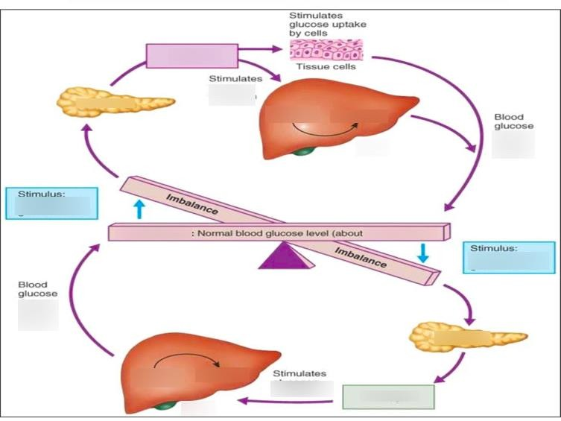
Figure 1: normal blood-glucose regulation by insulin and glucagon (adapted from Sherwood, 2016).

Diabetic complications like nephropathy and retinopathy are caused by endothelial damage brought on by poorly managed hyperglycemia, which glycosylates blood vessel proteins.

3. Cellular Metabolism and Insulin Action
Insulin functions at the cellular level as a key to open the cell membrane and let glucose pass through GLUT-4 transporters. Glycolysis converts glucose inside the cell into pyruvate, which is subsequently converted into ATP via the citric-acid cycle, supplying energy for essential functions (Guyton and Hall, 2021). Insulin also promotes the production of glycogen and prevents the breakdown of proteins and lipids.
In Type 2 diabetes, this process is impaired because insulin receptors or post-receptor pathways are disrupted. As a result, glucose remains in the bloodstream while cells rely more on fat metabolism, leading to inflammation and oxidative stress (Saltiel and Kahn, 2022).Thus, although glucose remains in the bloodstream, cells switch to fat metabolism, producing more free-fatty acids and ketone bodies. This metabolic alteration increases inflammation and oxidative stress, which worsens insulin resistance.
The differences between Type 1 and Type 2 diabetes is when β-cells in Type 1 are destroyed by an autoimmune reaction, the pancreas cannot produce any insulin at all, which leads to a total shortage of insulin. Insulin is still present in Type 2, sometimes at high concentrations, but the tissues do not react well to it. This means that many people with Type 2 can initially control glucose by weight loss and tablets that improve sensitivity, whereas those with Type 1 are completely dependent on insulin injections to survive (Powers and Davis, 2022). However, if glucose levels stay elevated, both disorders carry a risk of long-term vascular problems. Lipotoxicity is the term for the microscopic disruption of insulin-signaling proteins caused by prolonged exposure to high levels of free fatty acids in obesity (Saltiel and Kahn, 2022).

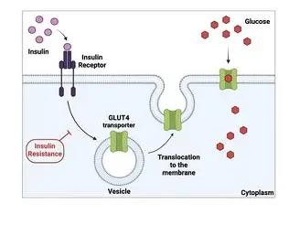
Figure 2: Insulin binding to receptor and GLUT-4 transporter activation (adapted from Saltiel and Kahn, 2022).

4. Diagnosis and Monitoring
A key component of successful self-management for those with Type 2 diabetes is selfmonitoring of blood glucose (SMBG). Monitoring levels on a regular basis offers quick, tailored feedback. It helps patients understand how their blood sugar levels are affected by specific foods, portion sizes, activity, and stress (American Diabetes Association, 2023). For example, a patient may choose whole meal alternatives if they detect a discernible increase after eating white bread.
Table 1 below summarizes the diagnostic criteria for Type 2 diabetes, adapted from NICE (2023).
Test Normal Diabetes diagnosis
Fasting plasma glucose < 6.1 mmol/L ≥ 7.0 mmol/L on two occasions
Random plasma glucose < 7.8 mmol/L ≥ 11.1 mmol/L with symptoms
HbA1c < 42 mmol/mol (6 %) ≥ 48 mmol/mol (6.5 %)
Table 1: Diagnostic criteria for T2DM (adapted from NICE, 2023).
HbA1c remains the preferred method for long-term monitoring because it reflects the average glucose level over 8–12 weeks.Continuous glucose monitors (CGMs) or capillary finger-prick testing give daily readings that direct treatment modifications. Aim for 4–7 mmol/L prior to meals and less than 8.5 mmol/L two hours following a meal (NHS England, 2022).
While HbA1c gives a reliable long-term picture, it can be misleading in conditions that affect redblood-cell lifespan, such as anemia or recent blood loss. In these cases, fructosamine tests or direct glucose measurements provide more accurate information (NICE, 2023). Continuous glucose-monitoring (CGM) systems, which measure interstitial glucose every few minutes through a small sensor on the skin, are becoming more common. They alert patients to trends and prevent unrecognized nocturnal hypoglycemia. For nurses, interpreting CGM data supports patient education by linking lifestyle choices with glucose patterns in real time. Although these devices can be expensive, growing NHS adoption shows their value in preventing hospital admissions and improving engagement (NHS England, 2022).
Nurses teach patients how to perform these tests safely, interpret results, and recognize signs of hypo- or hyper-glycaemia. Consistent record-keeping supports multidisciplinary reviews and early detection of trends requiring medication changes.

5. Lifestyle and Medical Management
The objectives of T2DM management are to normalize glucose levels, prevent complications, and improve wellness. Changing one's lifestyle is the cornerstone:
- Diet: Moderate consumption of complex carbohydrates, lean protein, healthy fats, and less processed sugar is advised. The Mediterranean diet has improved cardiovascular outcomes and glucose control (Esposito et al., 2019).

- Exercise: Participating in at least 150 minutes of physical activity per week improves insulin sensitivity and weight control (Colberg et al., 2016).

- Losing weight: even a 5–10% reduction can greatly improve glycaemic markers (NICE, 2023).
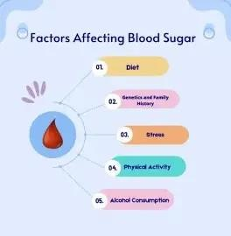
Figure 3: Lifestyle factors influencing blood-glucose control
Pharmacological therapy is gradually introduced when lifestyle modifications are inadequate:
Medication options:
- Metformin – improves insulin sensitivity.
- Sulfonylureas – increase insulin secretion.
- GLP-1 agonists and DPP-4 inhibitors – enhance incretion effects and reduce appetite.
- SGLT2 inhibitors – promote glucose excretion via urine (Davies et al., 2022).
- Insulin therapy – added when oral therapy fails.
Education, incentive, and routine review are the main goals of nursing care. Teaching proper glucose testing and injection techniques is one of the key duties.• Monitoring blood pressure, weight, and foot health.
- Promoting moderation in alcohol intake and quitting smoking.
- Organizing recommendations to podiatrists and dietitians.
Every year, screening should be done for retinal, nephropathy, neuropathy, and cardiovascular disease—all consequences of inadequate control (NHS England, 2022). Early detection stops irreversible damage and allows for prompt intervention. There is much more to managing Type 2 diabetes than just blood sugar readings.
We must consider the individual as a whole, including their social life, emotional world, and cultural background, in order to provide true, effective care.
Psychological obstacles are frequently more significant than physical ones. Diabetes stigma affects many people, which can lead to feelings of shame or condemnation. They may have trouble staying motivated or feel overpowered by messages about food and medicine from society. This is when the assistance of a nurse is essential. A competent nurse employs conversational strategies like motivational interviewing in place of giving orders. They assist patients in discovering their own motivations for wanting to improve their health as well as their own conflicting emotions. The goal is to assist someone in discovering their own "why."

This method shows a great deal of regard for the culture of the patient. Instead of outlawing beloved traditional foods, a nurse might talk about healthier serving portions or recommend substitutes for traditional recipes. A person is far more likely to adhere to their health plan when they have this collaborative spirit.
Effective diabetes therapy, crucially, takes into account not only the physical symptoms but also the significant psychological and social aspects of having a chronic condition. Nurses are taught to recognize the signs of "diabetes distress," a particular kind of emotional exhaustion brought on by the daily stress of self-care; this is more than just an occasional irritation; it's a heavy load that may be difficult for someone to handle. By offering compassionate emotional support and practical, empowering information, nurses help individuals transition from feeling defined by their diagnosis to feeling empowered and in control of their health journey.
In addition, nurses are crucial to health promotion because they assist patients in forming enduring, sustainable habits that lower future risks. Giving patients practical, life-saving information about the importance of annual eye exams for the early detection of retinopathy, teaching them daily foot care techniques to prevent complications, and outlining "sick-day rules" so they know when to check in more frequently and seek help are all part of this. Nurses assist people in moving from feeling defined by their diagnosis to feeling empowered and in charge of their health journey by providing them with compassionate emotional support along with useful, empowering knowledge.

6. Complications and Prevention
Retinopathy, nephropathy, and neuropathy are micro vascular symptoms of macro vascular illness, whereas the heart and peripheral circulation are impacted (NICE, 2023). Nurses should emphasize that reducing blood pressure, cholesterol, and glucose significantly lowers these risks. Early issue detection can be aided by routine screening, which includes yearly retinal imaging, urine albumin testing, and foot examinations. Preventive education should include wearing appropriate footwear, giving up smoking, and drinking enough of water. Staying hydrated, quitting smoking, and wearing suitable footwear should all be part of preventive education. Teaching regular examination and timely reporting of ulcers helps avoid amputations in those who already have neuropathy. Nurses may make theoretical prevention a daily practice by combining careful observation with compassionate instruction (NHS England, 2022).

7. Conclusion
Insulin resistance and poor glucose utilization are the main causes of type 2 diabetes mellitus, a preventable but progressing metabolic disease. Knowing how blood sugar is physiologically regulated enables nurses to predict problems and customize therapies. Evidence-based medicine, organized monitoring, and early lifestyle modifications preserve glycemic control and enhance quality of life. Long-term success still depends heavily on ongoing patient education and collaboration among medical experts. In summary, type 2 diabetes is a challenging but manageable condition. Understanding its physiological functions—such as how insulin regulates blood sugar and how glucose is utilized for energy production is crucial for patients. When paired with this practical tool of routine blood glucose monitoring, people may learn a great deal about their own health. By adopting evidence-based dietary and smoking lifestyle modifications, people may take charge, improve their glycemic control, and enhance their quality of life.

8. Reference
- Barnett, A.H. (2021) Diabetes in practice. 6th editionn. Oxford: Blackwell.
Colberg, S.R. et al. (2016) ‘Exercise and type 2 diabetes: joint position statement’, Diabetes Care, 39(11), pp. 2065–2079.
- Davies, M.J., D’Alessio, D.A., Fradkin, J. et al. (2022) ‘Management of hyperglycaemia in type 2 diabetes, 2022 update’, Diabetologia, 65(12), pp. 1925–1956.
Diabetes UK (2023) Facts and statistics about diabetes. Available at: https://www.diabetes.org.uk.
- Esposito, K. et al. (2019) ‘Mediterranean diet and glycaemic control’, Nutrients, 11(6), pp. 1–13.
- Guyton, A.C. and Hall, J.E. (2021) Textbook of medical physiology. 15th edn.
Philadelphia: Elsevier.
- Hall, J.E. and Hall, M.E. (2020) Guyton and Hall: Pocket Companion to Medical Physiology. 14th edn. Philadelphia: Elsevier.
NHS England (2022) National diabetes audit and care guidelines. Available at:
https://www.england.nhs.uk.
- NICE (2023) Type 2 diabetes in adults: management (NG28). Available at: https://www.nice.org.uk/guidance/ng28.
- Powers, A.C. and Davis, S.N. (2022) ‘Mechanisms of insulin secretion and action’, The New England Journal of Medicine, 386(2), pp. 123–132.
- Saltiel, A.R. and Kahn, C.R. (2022) ‘Insulin signalling and the regulation of glucose and lipid metabolism’, Nature Reviews Molecular Cell Biology, 23(6), pp. 365–382.
- Sherwood, L. (2016) Human physiology: from cells to systems. 9th edn. Boston:
Cengage Learning.

