Event Risk Assessment

2306691

- INTRODUCTION

The National Health Service (NHS) has recently announced that they are facing significant pressure due to a combination of factors such as increased demand, a growing elderly population, and complex healthcare needs. As a result, they require adequate risk protection to provide high-quality service and care to their patients. In the last year, the NHS has made remarkable progress in practicing better consideration of patients, one of these areas is through improved risk assessments and putting patient safety and needs first (NHS England, 2024a).

The purpose of this risk assessment is to use the knowledge acquired over the years to identify, evaluate, and manage the risks, vulnerabilities, and threats involved in transporting patients from neighbouring hospitals to a new high-dependency unit that caters to patients with dementia,furthermore, ensuring that the patient's care is given top priority. NHS England (2021a) set out a new structure for non-emergency patient transport services (NEPTS) in August 2021, the new structure focuses on establishing care that is steadily receptive, fair and maintainable.

It is imperative to ensure the transport has as little negative emotional impact on the patients as possible, it will be an unnerving situation for the patients and the move would need to be as comfortable as possible (NHS England, 2021a). Smith (2017) discusses dementia patients feel anxiety and stress to a greater level and rely on their sensory processing to gauge what is going on around them, therefore, becoming more sensitive to the surrounding environment. The primary objective is to minimize risks by conducting comprehensive research and complying with industry-specific standards and regulations to remove or reduce any hazards. The care setting thrives on being person-centered, hence, both qualitative and quantitative research outcomes are useful for such studies (NHS England, 2024b).

RISK: The likelihood of a situation or object causing harm (The Free Dictionary, 2024)

QUALITATIVE: A type of research that involves discussions, findings are described using words not numbers. The aim is to understand feelings and thoughts (Think Local Act Personal, 2024) (TLAP).

QUANTATITIVE: This is something that can be measured through numbers, examples of this would be surveys and questionnaires (TLAP, 2024).

HAZARD: An object, situation, or behaviour that can cause injury, damage or harm (Safeopedia, 2019).

STANDARDS AND LEGISLATION: Legal acts, regulations or codes to follow (Standards Council of Canada, 2024).

METHOD

Vulnerability-based methodology will play an important role throughout this risk assessment. Vulnerability assessments in the care sector, especially healthcare facilities, involve evaluating potential risks and impacts of individual hazards (World Health Organisation, 2021) (WHO). The Office for Health Improvement and Disparities (2022) suggests to understand the vulnerabilities the risk assessment would first need to identify any hazards, when the hazards have been identified the next step would be to assess the vulnerabilities of each hazard, furthermore, this will give a better understanding to how the patients and staff could be affected by potential hazards.

Areas that will need to be risk assessed are:

• Increase safety for patients and staff/ Violence and challenging behaviour.
• Bed rail entrapment.
• Transporting patients and equipment/Moving and handling.

  - Increase safety for patients and staff/Violence and challenging behaviour - Patients will need an assigned medical worker, their mobility concerns will need to be addressed, patients will need to be treated with dignity, involving them in conversations regarding the upcoming change, they will still need their medication on time (Caring for Care, 2023). Areas for concern are:
- An irate family member who considers their relative is not been properly treated verbally abuses a healthcare worker.
- A nurse verbally abused and threatened by a patient who is confused and scared.
- A driver is hit by a confused elderly patient.
- A patient wandering off.
- Having enough staff.
- Ensuring all medication is given and transported.

Who is at risk:
- Staff members
- Driver
- Patients
- Passersby (in hospital)

To prevent these risks there will be enough healthcare workers to support their peers and patients, if a risk becomes an issue there will be enough staff to step in to support the healthcare workers and patients (NHS Employers, 2021). Involve family members and patients in discussion regarding the move (Prior and Campbell, 2018). Healthcare workers will also be part of the discussion as to how they will feel more safe, ensuring good moral amongst staff (NHS, Employers, 2021).

ISSUE: The current situation that has arisen after the risks have been taken into consideration.

2.2. Bed Rail entrapment – Bed rails are primarily used for safety measures to reduce the risk of a fall but, there are instances where bed rails can be the cause of concern, moving patients in a bed from one facility to another can be a cause of concern (HSE, 2012). Some of these concerns are:
- rolling over the top of the rail
- climbing over the rail
- climbing over the footboard
- violently shaking and dislodging rails
- violent contact with bedrail part

Who is at risk:
- Patients
- Passersby (in hospitals)
- Staff
- Driver

To prevent these risks there will be enough healthcare workers to support their peers and patients, if a risk becomes an issue there will be enough staff to step in to support the healthcare worker and patients (NHS Employers, 2021). Bed rails will be checked in advance and patients will be treated with dignity with their concerns and views being taken into consideration (HSE, 2012). Healthcare workers will also be part of the discussion as to how they will feel more safe, ensuring good morale among staff (NHS, Employers, 2021).

2.3.Transporting patients and equipment/Moving and handling – Miller (2021) suggests that moving and handling is of the utmost importance to do correctly, when done incorrectly the concerns are:
- Emotional stress to patients and healthcare workers
- Discomfort and loss of dignity are common experiences for individuals who are being moved.
- Injury to both the patient and health care worker.

NEPTS is the mode of transport being used during this move.
The following table puts the patients and their needs into categories, it is essential to make the journey as comfortable as possible for the patient, therefore in contrast to the NEPTS, an extra member of staff will be added to the journey, this is to ensure the person centered approach is the primary goal for at least one member of staff, while other members of staff concentrate on the technical and physical aspects of the move (NHS England, 2021b). The driver is included in the number of crew.

Mobility Catergory | Number of crew | Mobility definitions
Walker | 2 | - Can manage own mobility  - Requires no lifting or moving
Walker with assistance | 2 | - May require assistance  - Requires no lifting
Wheelchair 1 | 2 | - May require assistance  - Will need suitable access equipment  - Has to travel in their own wheelchair
Wheelchair 2 | 3 | - Will require assistance  - Will need suitanle access equipment  - Has to travel in their own wheelchair
Bed | 3 | - Requires transport while on stretcher  - May require assistance during the journey
Bariatric wheelchair | 3 | - Will need suitable access  - May require assistance throughout the journey
Bariatric Bed | 3 | - Will need suitable access to transport  - May require assistance throughout the journey

Who is at risk?:
- Patients
- Healthcare workers
- Driver

To prevent these risks there will be enough healthcare workers to support their peers and patients, if a risk becomes an issue there will be enough staff to step in to support the healthcare worker and patients (NHS Employers, 2021). All equipment will be checked in advance and patients will be treated with dignity with their concerns and views being taken into consideration, healthcare workers will also be part of the discussion as to how they will feel more safe, ensuring a good moral amongst staff (BMJ, 2021).

COMPLIANCE

3.1 Violence and challenging behaviour

To ensure correct protocol and to follow proper legislation guidance the ‘Health and Safety at Work Act 1974’ (HSWA) has been put in place (Health and Safety Executive, 2024) (HSE) (Legislation.gov.uk, 2024). As discussed in HSE (2024), HSWA is the main legislation covering occupational health and safety. HSE (2024b) confirms the ‘Health and Safety at Work Act 1974’ is up to date with all changes known to be in force on or before 08 May 2024.

HSE (2024b) informs that HSWA set out a wide variety of duties which include:

Employees have a responsibility to themselves and to their colleagues to uphold a safe and supportive work environment.

In addition to HSWA, Legislation.gov.uk (2024) introduced ‘The Management of Health and Safety at Work Regulations 1999’ which also has credible legislation to follow, these include:

Employers must arrange necessary contacts for first aid, emergency medical care and rescue work (HSE,2024a).

Every employer must conduct a thorough assessment of the risks that their employees are presented with while they are at work (HSE, 2024a).

Employers need to make suitable arrangements based on the nature of their event for effective planning (HSE, 2024a).

3.2 Bed Rail Entrapment

‘Sector Information Minute, 2006 (SIM), Bed rail management’ legislation discusses the usage of bed rails (HSE, 2012). These include:

Are bed rails required? – is alternative equipment more suitable? (HSE, 2012).

Is the bed rail installed correctly and securely? Different types of beds may require specific rail fittings (HSE, 2012).

Are there gaps in the bed rail bars that could entrap the patient's head or body? Has the supplier provided adequate advice and instruction? (HSE, 2012).

Below is an example of table of a risk assessment for SIM (HSE, 2012):

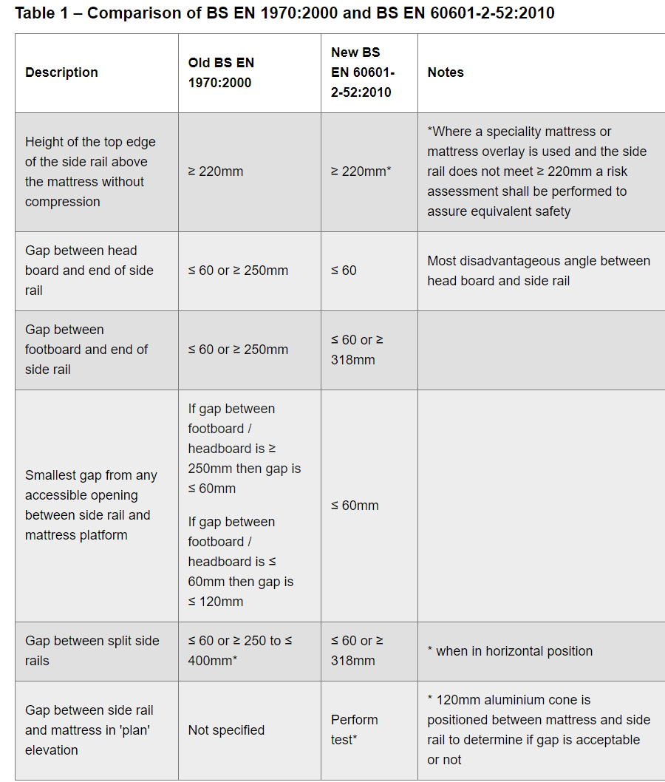

3.3 Moving and Handling

HSE (2014a) Manual handling - Manual Handling Operations Regulations 1992 - Guidance on Regulations,

Employers must adhere with the Manual Handling Operations Regulations 1992, as amended by the Health and Safety Regulations 2002 (HSE, 2014a).

The guidance provides instructions on how to avoid, assess, and minimise the risk of injury resulting from manual handling.(HSE, 2014a).

HSE (2014b) ‘Lifting Operations and Lifting Equipment Regulations 1998’ guide and set of regulations is intended for individuals who work with equipment provided at their workplace or those that are meant to be used by employees. It also applies to those who employ these individuals, represent them, or work as competent persons responsible for examining lifting equipment.These regulations outline the requirements for compliance with Lifting Operations and Lifting Equipment Regulations 1998.(LOLER) (HSE, 2014b).

NEPTS Legislation

This is a strategic framework to enable local improvement (NHS England, 2021b). From April 2022, subject to legislation, NHS Integrated Care System (ICS) bodies would assume responsibility for overseeing NEPTS and transport support more widely.

NHS England (2021b) and ICS bodies to determine how best to deliver this

responsibility, additionally, expects implementation of components outlined in the national framework:

Every ICS body must appoint a designated healthcare professional to supervise non-emergency patient transport (NHS, 2021b).

Involving healthcare providers in planning, commissioning, and managing transport services ensures integration with the wider pathway, aligning with the goals of ICS (NHS, 2021b).

4. RISK ASSESSMENT REGISTER

Ref | Risk Description | Likelihood of occurrence (Score 1-5) | Impact of Risk occurrence (Score 1-5) | Risk Score (Likelihood x Occurrence) | Risk Severity (High, Medium, or Low)
1 | Violence and challenging behaviour towards staff | 4 | 3 | 12 | Medium - High
2 | Violence and challenging behaviour towards others | 4 | 3 | 12 | Medium - High
3 | Bed Rail Entrapment | 2 | 5 | 10 | Medium - High
4 | Moving Equipment injury | 2 | 5 | 10 | Medium - High
5 | Causing injury to patients | 2 | 5 | 10 | Medium - High
6 | Low staff morale | 1 | 3 | 3 | Low
7 | Staff not trained correctly | 1 | 5 | 5 | Low
8 | Patients feeling scared | 5 | 5 | 25 | High
9 | Transport not being reliable | 1 | 5 | 5 | Low

5. CONCLUSION AND RECOMMENDATIONS

To conclude, effective and efficient patient transportation can be achieved through staying up to date with standards and legislation (HSE, 2014a). NHS (2021b) report found that the Non-Emergency Patient Transport Service (NEPTS) is a suitable mode of transportation in the healthcare sector, however, further research is needed to determine cost-effectiveness, overall, NEPTS provides the necessary equipment and expertise to transport non-emergency care patients safely. HSE (2012) found healthcare workers have sufficient information to move patients who rely on beds safely by following bed rail legislation, therefore, results in managing the risk of injury involving bed rails is a priority for patient safety. Smith (2017) explains patients with dementia may display violent and challenging behaviour due to bouts of confusion and frustration caused by their illness, he risk report suggests several ways to reduce the risk of aggressive outbursts for both patients and healthcare workers. By following the correct legislation and codes of conduct, healthcare workers can provide excellent person-centered care while minimizing risks (NHS England, 2021b). Overall, sufficient standards and codes of conduct are in place to manage these risks effectively.

There are several recommendations and several areas that can be improved. Firstly, more research can be done to ensure patients are transported safely to the hospital ward, such as having sufficient staff on hand to reduce risks (Miller, 2021). Additionally, patient rooms should be personalized and suitable for each individual (NHS England, 2021a). It's also important to determine whether medication was given before, during, or after the journey. Finally, communication between healthcare workers must be prioritised to ensure the best possible care for patients (NHS Employers, 2021).

Reference list

British Medical Journal (2021) How can I boost team morale? Available at: doi:https://doi.org/10.1136/bmj.n183 (Accessed 15 April 2024).

Caring for Care (2023) The importance of Moving and Handling training. Available at: https://caringforcare.co.uk/importance-moving-handling-training/ (Accessed 30 March 2024).

Health and Safety Executive (2012) Sector Information Minute (SIM 07/2012/06) Bed rail risk management. Available at: https://www.hse.gov.uk/foi/internalops/sims/pub_serv/07-12-06/index.htm#risk-assessment (Accessed 09 April 2024).

Health and Safety Executive (2014a) Manual handling - Manual Handling Operations Regulations 1992 - Guidance on Regulations. Available at: https://www.hse.gov.uk/pubns/books/l23.htm (Accessed 09 April 2024).

Health and Safety Executive (2014b) Executive Lifting Operations and Lifting Equipment Regulations 1998. Approved Code of Practice and guidance Safe use of lifting equipment Available at: https://www.hse.gov.uk/pubns/books/l113.htm (Accessed April 18 2024).

Legislation.gov.uk (2024a) The Management of Health and Safety at Work Regulations 1999. Available at: https://www.legislation.gov.uk/uksi/1999/3242/contents/made (Accessed 15 April 2024).

Legislation.gov.uk (2024b) Health and Safety at Work etc. Act 1974 Available at: https://www.legislation.gov.uk/ukpga/1974/37/contents (Accessed 18 April 2024).

Miller, V. (2021) Manual Handling in Care Homes. Available at: https://cpdonline.co.uk/knowledge-base/health-and-safety/manual-handling-care-homes/ (Accessed on 30 March 2024).

NHS Employers (2020) Improving performance by improving staff wellbeing: North Bristol NHS Trust. Available at: https://www.nhsemployers.org/case-studies/improving-performance-improving-staff-wellbeing (Accessed 20 March 2024).

NHS ENGLAND (2021a) Non-emergency patient transport mobility categories guidance. Available at: https://www.england.nhs.uk/long-read/non-emergency-patient-transport-mobility-categories-guidance/ (Accessed 10 April 2024)
NHS England (2021b) Improving non-emergency patient transport services, Report of the nonemergency patient transport review. Available at: https://www.england.nhs.uk/wp-content/uploads/2021/08/B0682-fnal-report-of-the-non-emergency-patient-transport-review.pdf (Accessed 12 April 2024)

NHS England (2024a) England Workforce, training and education. Available at: https://www.hee.nhs.uk/our-work/person-centred-care (Accessed 10 April 2024).

NHS England(2024b) Priorities and Operational Planning Guidance. Available at: https://www.england.nhs.uk/long-read/2024-25-priorities-and-operational-planning-guidance/ (Accessed 10 April 2024).

Office for Health Improvement & Disparities (2022) Vulnerabilities: applying All Our Health. Available at: https://www.gov.uk/government/publications/vulnerabilities-applying-all-our-health/vulnerabilities-applying-all-our-health (Accessed 06 April 2024).

Prior, S.J. and Campbell, S. (2018) ‘Patient and Family Involvement’: A Discussion of Co-Led Redesign of Healthcare Services. 10(1) Available at: http://doi:10.2196/jopm.8957

Safeopedia (2019) Hazard. Available at: https://www.safeopedia.com/definition/152/hazard 2019 (Accessed 01 April 2024).

SCC (2024) What are Standards. Available at: https://www.scc.ca/en/standards/what-are-standards (Accessed 05 April 2024)

Smith, Z. (2017) The Emotional Impact of Dementia. Available at: https://www.elder.org/the-elder/the-emotional-impact-of-dementia/ (Accessed 10 April 2024).

The Free Dictionary (2024) Medical Dictionary. Available at: https://medical-dictionary.thefreedictionary.com/medical+risk (Accessed 10 April 2024).

Think Local Act Personal (2024) TLAP Care and Support Jargon Buster. Available at: https://www.thinklocalactpersonal.org.uk/Browse/Informationandadvice/CareandSupportJargonBuster/#/ (Accessed 01 April 2024).

World Health Organisation (2021) Checklists to Assess Vulnerabilities in Health Care Facilities in the Context of Climate Change. Available at: https://www.who.int/publications/i/item/9789240022904 (Accessed on 09 April 2024).

