

Student’s Name: Md Mehedi Hasan
Student ID: 2506709
Module Name: International Marketing: Principles and Practices
Module Code: LCMB7026
Lecturer's Name: Tushara Balendran
Assessment component 1: Individual report
Term 2
Word Count: 5443

Table of Contents
1. Introduction 4
1.1 Background 4
2. Comparative market analysis 5
2.1 Political and legal environment. 5
2.2 Economic context 6
2.3 Social and cultural factors (with Hofstede model) 7
2.4 Technological, environmental and competitive factors 10
2.5 PESTEL similarities and differences summary 10
3. Comparative STP analysis 11
3.1 Segmentation 11
3.2 Targeting 11
3.3 Positioning 12
3.4 STP similarities and differences summary 13
4. Comparative 7Ps analysis (UK vs India) 14
4.1 Marketing mix definition and decision logic 14
4.2 Product 14
4.3 Price 14
4.4 Place 15
4.5 Promotion 15
4.6 People 16
4.7 Process 16
4.8 Physical evidence 17
4.9 7Ps similarities and differences summary 18
5. Directional development strategy in India 19
5.1 Strategic choice 19
5.2 Why focused differentiation fits 19
5.3 Risks and control conditions 19
6. Ethical issues in Zara's marketing mix 21
6.1 Environmental intensity 21
6.2 Labour and due diligence 21
6.3 Communication ethics 22
6.4 Ethical implications summary 22
7. Recommendations 23
7.1 Global core, local edge 23
7.2 KPI-led governance 23
7.3 India growth sequencing 23
7.4 Ethics and omnichannel activation 23
8. Conclusion 24
Section 2: Gibbs Reflective Account 25
Description 25
Feelings 25
Evaluation 25
Analysis 26
Conclusion 27
Action plan 27
References 28

1. Introduction
In this report, a case is examined on Zara international marketing strategy in the United Kingdom and India to determine what aspects of the brand needs to be standardised and what needs to be modified to meet the local market. The usefulness of the country pair is analytically due to the fact that UK is a mature, high-income and highly transparent fashion market, but India is more strongly endowed with a long-run growth potential with more severe affordability constraints, higher regional dispersion and more aspirational consumption rationale. The main thesis is that Zara must maintain a global strategic core in brand identity, design rhythm and supply-chain discipline and customize customer-facing decisions in pricing, channel emphasis, promotional framing and assortment depth by market context (Theodosiou and Leonidou, 2003; Ryans et al., 2003).

1.1 Background
Zara is the main retail division of Inditex and is commonly known to translate trend indicators into store collections quicker than the majority of apparel rivals. The two markets have been entering the UK in 1998 and India in 2010, thus the two markets should be given a significant period of operating history in the context of a meaningful comparison of the performance of one fast-fashion brand in very different demand conditions (FashionUnited, 2012; Indian Retailer, 2010). The comparison is supported by recent performance statistics, too: ITX UK Limited reported a big and mature base of turnover in the UK, whereas Zara business in India still demonstrates a significant scale but a more limited scale-and-affordability ratio (ITX UK Limited, 2025; Business Standard, 2025).
The report thus employs PESTEL, STP and the 7ps as decision tools as opposed to description headings. Every part goes evidence-implication-judgement. It is then analyzed where a directional development strategy towards India can be achieved and the ethical concerns in the marketing mix of the company and wraps up with practical recommendations before a separate Gibbs reflection on the learning process.

2. Comparative market analysis
Here, PESTEL is applied to provide the answer to the question whether Zara can implement one operating formula in both countries or whether market-level conditions should be adjusted selectively. The framework will be most practical in cases where all factors are directly related to a marketing impact instead of being described in the background.
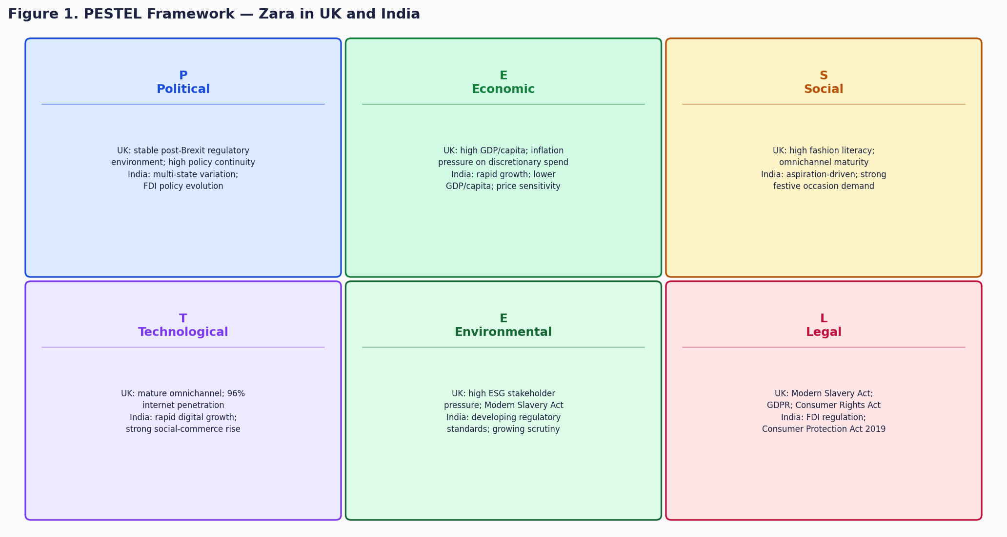

2.1 Political and legal environment.
Zara finds the UK politically and legally favourable in terms of policy continuity, expectations of consumer-rights and disclosure are relatively transparent. Such clarity reduces institutional uncertainty around store planning and omnichannel implementation, but also makes commercial failures in governance more expensive. Modern Slavery Act implies that marketing strategy in the UK cannot ignore ethical due diligence; it impacts brand trust, media presence and reputational resilience directly (UK Government, 2015; OECD, 2018).
India is favourable as well, but due to other reasons. The increased demand, the pace of reform and digital-public infrastructure provides greater expansion headroom, particularly within major urban centres. The less desirable side is the implementation unequal among the states, levels of cities and local operation environments. In the case of Zara, this implies that India ought to be operated more closely with sequencing and more localized coordination as opposed to a national rollout paradigm (Morgan et al., 2011; Theodosiou and Leonidou, 2003).

2.2 Economic context
The economic difference between the two markets is strategically decisive. Zara has very different affordability limits, basket-size expectations, and reasonable premiums in each market because World Bank GNI per capita data positions the UK at an approximate of US$49,470 and India at an approximate of US2,650 in the respective series in 2024 (World Bank, 2026a; World Bank, 2026b). It does not imply that India does not have an opportunity, but it is only that price architecture cannot be moved without changing.
Recent evidence of the company is in the same direction. UK business enjoys the revenue density and more established omnichannel base whereas India has better long-run runway with smaller readily available customer base at the present price image of Zara (ITX UK Limited, 2025; Business Standard, 2025). The UK is economically favourable in terms of stable monetisation and India is favourable in terms of the growth potential; the opportunity cost is that an opportunity in India is more conditional on local fit.
This contrast is enhanced by inflation, currency context and competitors structure. The UK customers can make quick comparisons of Zara with a broad range of apparel and are able to internalize a middle price premium in situations when trends are evident. In India, the same premium is appraised against a more elastic spending climate, therefore, the cost of imports, the exchange-rate pressure and local price ladders are more evident at the point-of-sale. Zara thus requires better price architecture discipline in India, not necessarily reduced prices.

2.3 Social and cultural factors (with Hofstede model)
The social comparison is key since Zara competes in the symbols that move fast as much as it competes in product. Both markets are very sensitive to the global fashion cues yet this does not imply that the same consumption logic can be used in both markets. Personal expression, convenience and routine omnichannel behaviour is a stronger factor in fashion choice in the UK. Fashion in India is also aspirational, social and more occasion sensitive. According to De Mooij and Hofstede, convergence in media exposure does not eliminate divergence in consumer meaning systems, precisely the reason why Zara could retain one brand language and still have to use various proof points by market (de Mooij and Hofstede, 2002; de Mooij and Hofstede, 2010).
A stricter method would be to introduce the real Hofstede scores and then elaborate on its meaning to marketing decisions. UK has a score of 35 on power distance, 89 on individualism and 69 on indulgence and India has a score of 77, 48 and 26 respectively. That numerical difference is why UK messaging can be biased more towards self-expression and lightness, whereas India requires more of an aspirational, trust, and visible value signal.
The cultural point is supported by digital maturity and urban structure. DataReportal indicates profound connected use in both nations, although the social role of digital does not resemble. In the UK, there are digital touchpoints that facilitate daily browsing, comparison and fulfilment. Digital touchpoints also influence trend discovery itself in India in terms of creator content, social proof and mobile-first browsing habits (DataReportal, 2025a; DataReportal, 2025b). The similarity lies in the high fashion visibility, the difference is that India requires more active conversion support by that visibility.

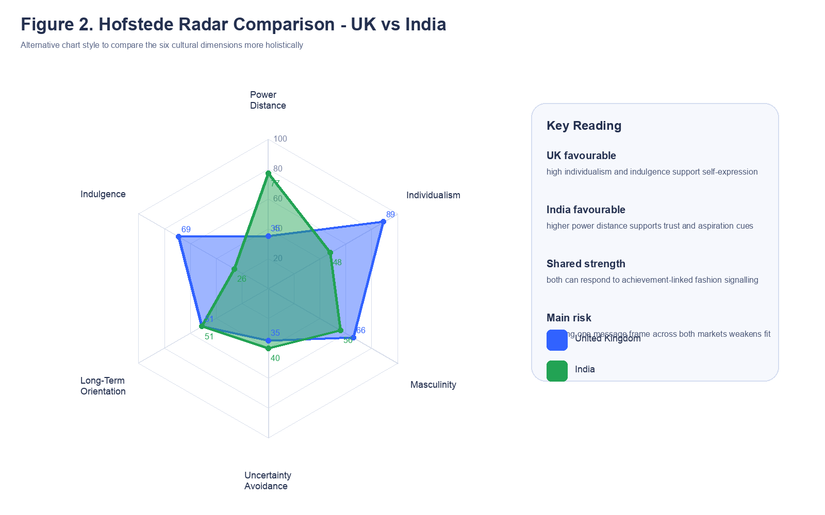
Figure 2. Hofstede radar comparison - UK vs India
Source (Figure 2): score pattern interpreted through de Mooij and Hofstede (2010) and country-level Hofstede comparison data used in this report.
Table 1. Hofstede score comparison and marketing implication
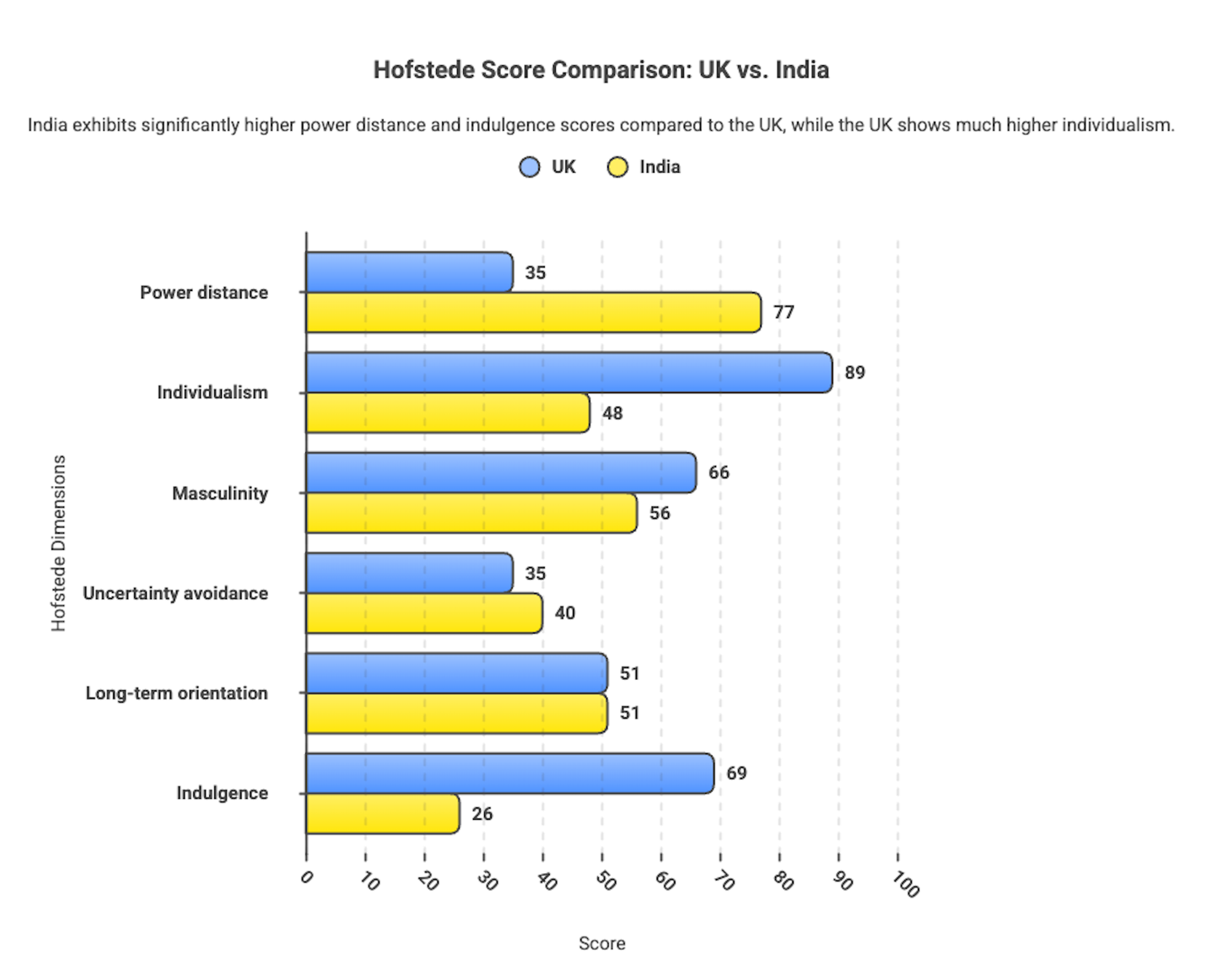

Figure 3. Hofstede Score Comparison: UK vs India
Source: Author’s own graph based on Hofstede data (de Mooij & Hofstede, 2010)

2.4 Technological, environmental and competitive factors
Technology is important to Zara as a means of promotion and also as an operating model. The speed with which the demand signals are converted into replenishment and assortment decisions is what makes fast-fashion advantage (Caro and Gallien, 2010; Barnes and Lea-Greenwood, 2010). This facilitates a thick store-digital system in the UK. Technology is also critical in India, though in a much more growth-enabling sense that needs to transform social discovery into trusted commerce in an unequal market environment.
The forces of environment and competition are also varied in their manifestations. Both nations put pressure on waste, traceability and fast-fashion intensity on Zara, but the pressure in the UK is more stakeholder-facing and disclosure-driven, whereas in India, the pressure on sustainability is increasing with more intense affordability trade-offs (Niinimaki et al., 2020; Bick et al., 2018). The UK is a more transparent comparison-shopping environment, whereas India is a better combination of premium aspiration and higher price elasticity in terms of competition. These are not small context details and they transform how Zara ought to position value, speed and brand accessibility.

2.5 PESTEL similarities and differences summary
The primary similarity is that both nations are significantly business-wise, digitally interconnected and open to scrutiny of the environment and ethical standards. The primary distinction is that the UK incentivises operational optimisation in a developed system, and India incentivises gradual growth with more strict price, channel and governance adjustments. This is the reason why Zara is not to decide on the opposition of standardisation and adaptation but standardise its core and adapt its market implementation.

3. Comparative STP analysis

3.1 Segmentation
The useful segments that Zara has had in both markets are not merely the demographic segments but the psychographic and behavioural segments: trend involvement, digital fluency, purchase frequency and willingness to pay to be in style. In the UK, such a profile has a wider proportion of urban consumers due to higher income and fashion confidence levels. The same rationale remains in place in India, but here the shift to more rapid convergence due to city tier, income distribution and occasion-driven purchasing is more narrow. A VALS-type reading is thus more helpful in India since it renders the aspirational and achievement-based aspect of demand explicit and not presupposed (Della et al., 2009).
Segmentation is not fixed as well. In the UK, it is economic pressure that can drive even fashion conscious consumers to more discriminating basket behaviour, whilst in India it is the occasion and the context of the city, as well as the social presence of the consumer, that can shift behaviour between aspiration and restraint. Zara ought to read segments therefore as moving demand states as opposed to permanent boxes. This is important since the application of the identical market logic to the other would be exaggerated by the approach of static segmentation.

3.2 Targeting
In both countries, the targeting needs to be selective and differentiated, although its scope needs to be different. A mature omnichannel system in the UK can enable Zara to reach a broader audience of fashion-engaged premium-mass. In India, the targeting needs to be smaller and more gradual, whereby more emphasis should be placed on metro consumers who are high digital usage and high aspirational demand. It is not to make India a little UK but to focus on the market based on the reality of conversion economic and then grow on the basis of supporting evidence (Theodosiou and Leonidou, 2003; Morgan et al., 2011).
Targeting should also be influenced by mission type. Routine wardrobe refresh, convenience and seasonal relevance can be used to reach out to the UK shoppers. In India, targeting must acknowledge the presence of a greater influence of occasion-based buying, visible style signalling and greater sensitivity to perceived value. In both countries, the same behavioural trigger can be used to target urban trend adopters by Zara but the behavioural trigger differs.

3.3 Positioning
In both nations, Zara has maintained its main positioning as a fashion-driven, design-oriented, and faster-moving fashion brand as compared to its competitors in the basic apparel sector. The resemblance is thus high: in both markets Zara is competing with trend credibility as opposed to the lowest price. The difference is how accessibility is perceived. In the UK, the name Zara is more readily interpreted to mean high-quality at a price. In India, the offer is more aspirational since the average purchasing power is lower and thus increases the psychological price barrier. Zara ought to retain one glamorous label and switch the evidence points by market: convenience and trend responsiveness in the UK; visible style worth, occasion relevance and discriminatory availability in India.
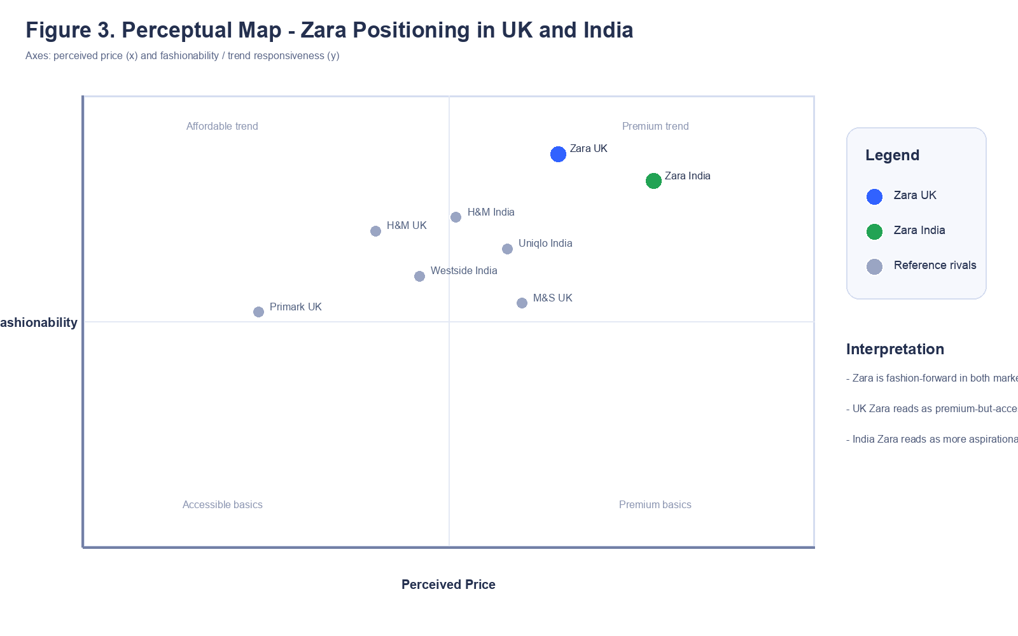
Figure 4. Perceptual map of Zara's positioning in the UK and India
Source (Figure 3): author-generated perceptual map based on comparative brand-position interpretation across selected rivals in each market.

3.4 STP similarities and differences summary
The similarities in strategy across STP are that Zara must continue to target trend-oriented urban consumers in both markets. The strategic distinction lies in the UK being able to sustain wider premium-mass targeting whereas India needs more evidence-based and focused targeting and a more aspirational positioning. Explicit spelling out of these similarities and differences enhances the strategic judgement.

4. Comparative 7Ps analysis (UK vs India)

4.1 Marketing mix definition and decision logic
The marketing mix in this report is considered to be the balanced combination of product, price, place, promotion, people, process and physical-evidence decisions by which Zara transforms strategy into market experience. Each of the elements is directly compared in the UK and India in such a way that the analysis is evaluative and not descriptive.

4.2 Product
Zara must retain its global product engine standardised in that the key competitive strength of the brand lies in fast design-to-shelf cycles (Tokatli, 2007; Caro and Gallien, 2010). Adapt what should be product depth and width. Deeper outerwear and trans-seasonal layering is a way to make business sense in the UK. In India, attire, breadth and choice of time to celebrate are more about the lightness. The common factor is a common world style DNA, the distinction is how depth of category should be weighed by climate, occasion and expense.
The depth of products is about the extent to which Zara goes in a category in a market, whereas the width is about how expansive the overall offering is. Beyond the UK, layering further and broader use of trans-seasonally is a business rationality. In India, the issue of lighter categories and more specific fit between daily wear and occasional dressing are more important. This means that Zara needs to retain a single design philosophy but change the extent to which each category is marketed in each country.

4.3 Price
The most obvious adaptation lever is price. The UK will have an easier time maintaining a premium-mass position of Zara since the price image of the brand falls in a wider accessible range. India needs more attentive ladder with more value explanation since the same headline prices are realized to be more exclusive. The similarity is that Zara should defend brand equity in both markets; the difference is that India requires more finer entry-point management and transparent price to value communication.
That difference is explained by a number of factors: income disparity, currency context, competitor intensity and consumer reading fair value. Practically, Zara needs to be more vigilant about opening price-points, markdown frequency and transparent price rationalization in India than in the UK. It is not merely whether a garment is priced higher or lower but whether the customer perceives that the premium is justifiable in that market.

4.4 Place
Decisions on place must be channel-based. Zara is mostly direct in both of these markets as it is the one that has control over its own stores and websites, but still some malls selectively influence the quality of traffic. Mature omnichannel integration: store, app and fulfilment as a single system is the focus in the UK. In India, the focus must be on metro-first sequencing, greater dependence on malls that perform well and increased conversion of mobile discovery to store or site purchase. The similarity is direct brand control; the difference is network maturity.
It is the place not just of location but also of channel role. A store may be used in the UK as display space, collection point and service node at the same time. The store commonly takes on a more credibility-building aspect in India, particularly in upscale malls where physical reassurance continues to assist in conversion. The former resembles direct brand control; the latter what the store must do on a commercial basis.

4.5 Promotion
The visual aspect of the promotion should be the same as the minimalist identity of Zara, but the communication focus should be different. Immediacy, editorial fashion authority and convenience can be more relied on in integrated marketing communications in the UK. Social discovery logic and visible value support are more significant in India. Any assertions regarding benefits, sustainability benefits or competitive advantages should be explicitly supported in-text and not impressionistically (Duan et al., 2021; Joy et al., 2012).
The examples used in promotions ought to be different even in the situations when the visual identity is the same. Faster drops, convenience and clean editorial cues are more important elements that UK promotion can depend on. India requires better integration of social discovery, local shopping peaks and visible value explanation. In both nations, however, the promotional assertions must be backed up by true facts to ensure that the message does not surpass the operation behind it.

4.6 People
The amount of country-level staff totaled in public is not always reported in the source pack, and thus the most valid comparison is functional, not numerical. The omnichannel speed, visibility of stock and low-friction service should be optimised in UK teams. India requires additional consultative selling, better fit direction and articulation of fabric, sizing and product value in the developing cities where high-end-mass fashion sales have higher perceived risk. The similarity here is that the quality of the staff impacts conversion in both markets, the difference here is the reassurance and explanation level needed.
Training and motivation must thus be of varying focus. The UK employees require a better coordination between online and offline service moments. India requires increased confidence-building service behaviour, better product clarification and better management of initial reluctance in the premium-mass purchase. The similarity is that individuals transform strategy into experience, the difference is the degree of consultative support required to achieve the sale.

4.7 Process
Speed is actually realized in process where Zara has an advantage. In UK, the focus is on efficiency of the mature systems: stock accuracy, fulfilment discipline and quickness in responding to customer complaints online and store. In India, speed is prioritized with more robust forecast buffering, city-level stock balancing and more strict government as scale increases. The point of similarity is that there is process quality on which brand trust is based in both markets, and the point of difference is that India requires more growth-stage control, whereas the UK requires more mature-system optimisation.
The process indicator that is of great usefulness is customer complaints as they indicate where the brand promise and implementation are different. Reliability and speed should be supported in complaint handling in the UK. The process must also be trust building by making returns, delivery timing and service recovery transparent, in India. Quality of processes is thus a marketing issue and an operating issue.

4.8 Physical evidence
One of the recognisable Zara signatures in stores, packaging and websites should be physical evidence. In the UK, it equates to non-digital-store disparity and flawless click-and-gather execution. In India, it translates to the same worldly aesthetic and some better payment, delivery and returns indicators so as to create confidence at the point of decision. The similarity is a single consistent visual identity; difference is the degree of comfort that the interface has to offer.
This difference is reflected in the websites. The UK location can also take the lead on the expectations of online fulfilment, and the India interface will have the advantage of more prominent reassurance on payment, delivery and returns. The identical minimalist design language can then remain stationary, albeit the information cues under it must evolve to meet the assurance requirements of the market.
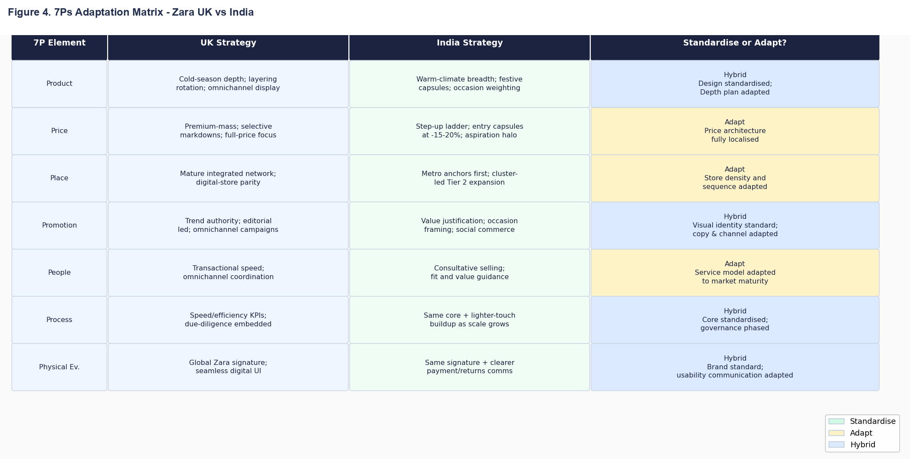

Table 2. 7Ps standardisation and adaptation summary

4.9 7Ps similarities and differences summary
The commonality is that Zara must continue to be a single brand with a single global operating spine. The distinction is that India requires a greater amount of adaptation in terms of price, channel stress, promotional framing and reassurance cues whereas the UK requires more mature-system optimisation. That is the practical definition of local fit standardisation.

5. Directional development strategy in India

5.1 Strategic choice
The more appropriate directional development choice would be India since its headroom in demand in the long run is higher than in the UK, yet the proper strategy is not the proliferation of stores in a short period of time. It is a rigorous, staged development that is centered around a focused-differentiation logic. Competing in India, Zara needs to focus on speed-to-trend, design credibility and controlled accessibility instead of trying to engage in price competition in the broad market (Porter, 1980; Business Standard, 2025).

5.2 Why focused differentiation fits
Focused differentiation is appropriate since Zara has both an operational and symbolic edge in India. Its quicker trend cycle and superior retail experience is targeted at urban aspirational customers who appreciate the need to be seen as fashionably relevant but do not wish to climb the price ladder into the luxury category. A wide cost-based approach would water down brand equity and an undisciplined premium approach would reduce the size of the addressable market excessively. The superior way is to protect a clean section, and extend only when it has proven.
The advantage of this route is strategic clarity. It informs Zara what not to do more than what to do. Zara must not attempt to replicate the low-cost volume players, and it must not believe that higher-end aspirational necessarily ensures access. Rather, it must safeguard the segment of the market where speed, design credibility and controlled store experience is truly appreciated.

5.3 Risks and control conditions
The biggest danger is that of being caught in the middle of the premium and affordability reality. This is why India expansion must be fenced by controlled measures: contribution margin by city, repeat purchase rate, sell-through and discipline of full-price, stock-out. In case those indicators become weak, we need to refine fit and then scale further. To put it briefly India must be cultivated as a strictly controlled strategic reserve, not as a volume pursuit.

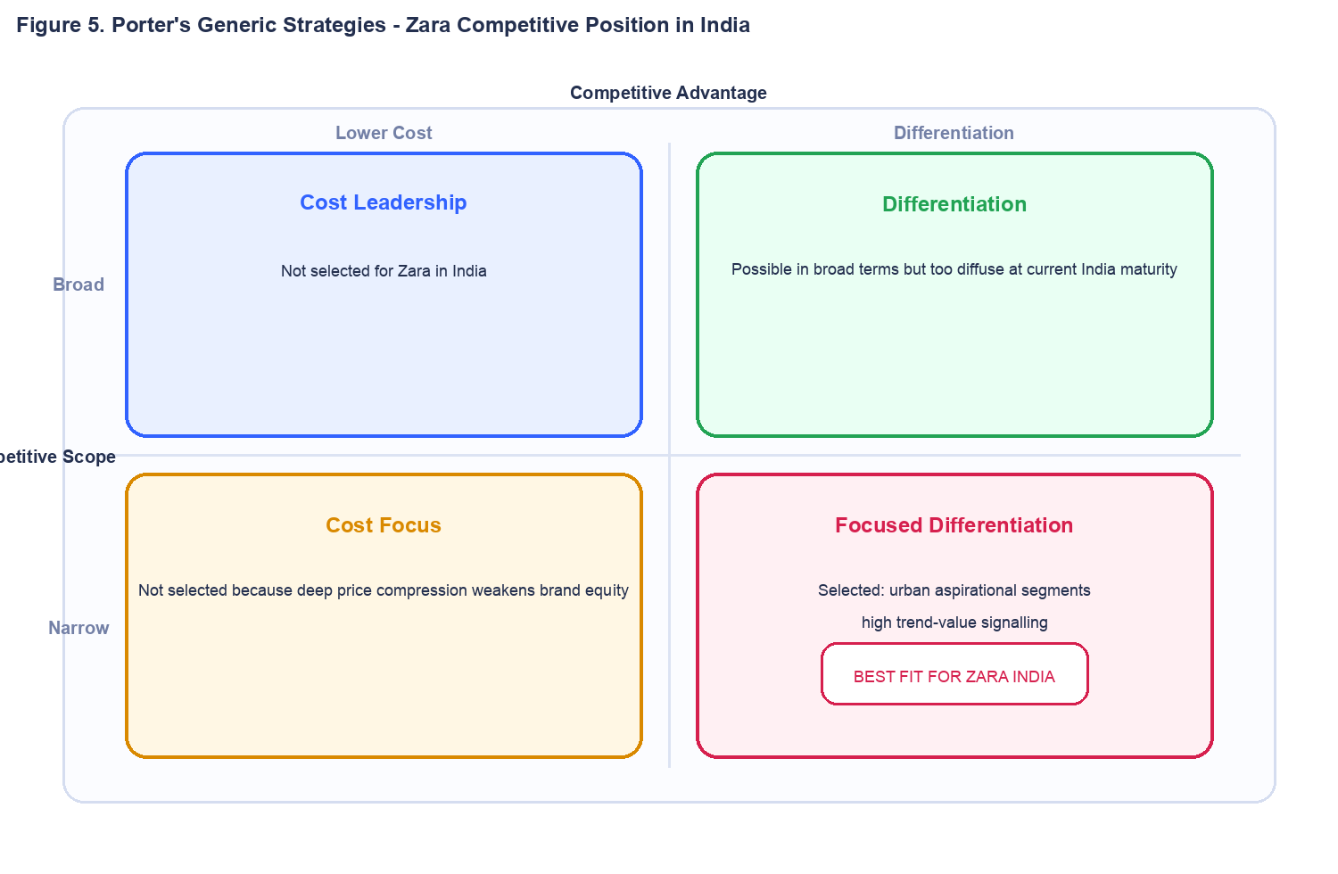
Figure 6. Porter's generic strategies - Zara competitive position in India
Table 3. Phased India development plan

6. Ethical issues in Zara's marketing mix

6.1 Environmental intensity
The initial significant ethical concern is the environmental weight that is constructed in high-volume fast fashion. Studies continually indicate that production and consumption patterns today pose severe expenses in materials, energy and waste and pollution routes (Niinimaki et al., 2020; Bick et al., 2018). In the case of Zara this is not just CSR. In case the brand does not, in addition to speed and newness, enhance waste and traceability controls, environmental risk will turn into strategic risk.
This problem relates to product and place decision as well. Assuming that Zara can speed up the assortment turnover without wasting, it increases the marketing mix indicating the ethical issue. Ethical enhancement thus needs more than a sustainability message, operational change of sourcing, product life cycle, and after usage of goods.

6.2 Labour and due diligence
The second problem is the labour governance in a multifaceted supply chain. The speed of the fashion system and its high demands on time and cost have heightened the significance of due diligence, monitoring and remediation of suppliers. OECD guidance clarifies that ethical responsibility cannot be fulfilled on general statements; it must include risk controls that can be found within commercial processes (OECD, 2018). The expectations of disclosure are particularly harmful to trust in the context of weak labour governance in the UK.
People and process within marketing mix are also impacted by this labour issue. When the lead times are pushed shrilly, the dice does not remain in procurement; it influences the manner in which the brand delivers fashion speed as a visible promise. Ethical discipline is not then an optional add on to commercial decisions but a state of credible marketing.

6.3 Communication ethics
The third one is communication ethics. When the sustainability or responsibility claims outpacing the operational evidence, the brands generate a credibility gap. The study of transparency indicates that the effectiveness of claims is determined by specificity and trust rather than the volume of messages (Duan et al., 2021). Zara must therefore have discipline in its claims: fewer generalized claims, more quantifiable disclosures and a better connection between the words used in marketing and confirmed operational behavior.

6.4 Ethical implications summary
The commonality of these ethical issues is that they are all located within the 7ps as opposed to being external to them. The impact of choice of product is intensity of material, the impact of choice of process is due diligence, the truthfulness impact is promotion and the place impact is how the responsibility is experienced by customers. The contrast is that the UK market renders governance failure more transparent, whereas India renders the tradeoff between ethical advancement and affordability administration more business sensitive. The ethical dilemma facing Zara is thus to make responsibility a part of its operating system instead of creating a messaging layer.

7. Recommendations

7.1 Global core, local edge
Zara ought to institutionalise a global core, local edge doctrine. The identity of the brand, design cycle and supply-chain management must be global. Market evidence should dictate price ladders, channel focus, message framing and assortment depth chosen. This safeguards efficiency without compromising on local relevance (Theodosiou and Leonidou, 2003; Zou and Cavusgil, 2002).

7.2 KPI-led governance
The two markets should be operated by the management with varying KPI focuses. Omnichannel conversion, full-price sell-through and repeat frequency should be the priority in the dashboard in the UK. Dashboard additions in India should include affordability conversion, city-tier productivity and digital-to-store conversion. This helps to avoid strategic drift and makes market-fit decisions evidence-based (Morgan et al., 2011; Caro and Gallien, 2010).

7.3 India growth sequencing
Expansion to India should be gradual. Metro depth must be acquired followed by a choice city-cluster growth only in the event of a good economics and retention indicator. This is more rational than the fast expansion of the footprints since it safeguards brand equity as well as capital discipline.

7.4 Ethics and omnichannel activation
Lastly, Zara needs to combine ethical reporting and activation of omnichannels closer together. Measurable disclosures should be linked to sustainability and labour claims, whereas the targeting and promotion should be based on the previously identified psychographic and cultural differences identified in the STP analysis. This would render the brand more believable and also more business-specific.

8. Conclusion
The UK vs India comparison reveals that standardisation and Adaptation are not two options that necessitate the replacement of one option. Standardising strategic spine of the brand and making customer facing implementation more responsive to the economic, cultural, and channel realities of the market is the stronger position. UK needs to be run like a mature business of optimisation; India needs to be run like a business of gradual growth. That is the conclusion that is common to PESTEL, STP, the 7ps and the directional strategy analysis.

Section 2: Gibbs Reflective Account

Description
I did this assignment as a personal MBA student in the United Kingdom with personal connections to Bangladesh, and that status had a role in my topic selection, and my analytical attention. I chose Zara since it is international to accommodate theory-based research and particular enough to enable opinions on a single actual brand. I decided on the UK and India then due to the fact that the two countries provide a good contrast of a mature high-income market and a high-growth South Asia market that seems to be culturally closer to my experience. My primary challenge was to transform that opposing into a comparative argument as opposed to two independent descriptions.
I had a working process which had a number of stages. I initially turned the brief into hard constraints, then projected the evidence I needed to get per significant section, and then wrote the analysis based on one common question: what does this factor demand Zara do differently in the UK and India? It was not until then that I checked how the structure itself was contributing to or undermining the argument.

Feelings
I was confident in the topic at the beginning but not as confident in how to maintain the analysis critical. Zara is simple to describe but difficult to pass over description to judgement which is defensible. My personal tension with ethics was also because Bangladesh relates closely to the production of apparel globally, and labour and sustainability issues were closer to me than in a purely abstract situation. At the stage of drafting, I felt much more confident when I started basing each paragraph on a single claim, a single base of source and a single implication.

Evaluation
The best thing about it was the choice of structuring the report based on the single strategic question: what should Zara standardise and what should it adapt to across the UK and India. It was that question that made the report coherent throughout, in the introduction to the recommendations. The second strength consisted in source triangulation. I combined marketing theory, macro data, company data and policy direction as opposed to depending on a single type of data, which enhanced quality of judgement.
structure was the weaker aspect of my first draft. There were areas that were over-saturated and the reflective area was applying the incorrect model. The process of revision made me work on the hierarchy, make similarities and differences more specific, and use concrete Hofstede scores instead of the ambiguous cultural language. At that, the revision did not only enhance the wording but also the scholarly quality of the work.

Analysis
The distinction between working with a framework and a framework is my most valuable learning. Previously, in my studies, I occasionally viewed models as information containers. One of the lessons that I have acquired in this assignment is that a framework must only be valuable when it transforms the decision at hand. PESTEL was important since it indicated why the Zara UK strategy needs to leverage a mature system and why the India strategy needs to be a gradual process. STP was important in that it helped in explaining why the identical brand might still require more focused targeting and a more aspirational positioning in India. The 7Ps were important since they put that reasoning into implementation decisions.
I also came to know something about reflective discipline itself. Gibbs is effective as it obliges the transition between the event and the feeling, followed by the judgement and action. That construction assisted me in perceiving how my personal background both supported and hindered the analysis. This helped me become more sensitive to labour, value and ethical risk since this is something that I was particularly sensitive to given my Bangladeshi background. Meanwhile, I needed to cross-verify that opinion with published evidence to ensure that personal familiarity would not turn into assumption. This served as a helpful reminder that postgraduate work needs to be postured and also controlled (Gibbs, 1988; Williams, 2012).
Another lesson is about uncertainty. My first concern was that restrained company information, which is market-specific, would be considered as a weakness that would lower the quality of the report. At the close, I learned that it is customary to have incomplete information in international marketing, and that the optimal reaction is not to feign certainty but to formulate more conditional advice. That is how the ultimate plan about India became staged, evidence based and operationally focused as opposed to the generalized statement about growth.

Conclusion
On the whole, the assignment helped me enhance my skills to make evidence-based international marketing decisions in the face of missing information. I shifted to the descriptive comparison to the structured evaluation and I also learned to be more conscious of the presentation quality, section hierarchy and citation discipline on the validity of an argument. The task also taught me that reflection is most effective when it is associated with real decisions made in the course of writing and not a separate narrative added at the end.

Action plan
To complete the tasks in the future, I will use a five-part action plan. First, I will start with a more stringent evidence map in order that every section has a specific source base prior to drafting. Second, I will decide earlier section hierarchy, particularly in the case of a marker that is most likely to encourage comparison and explicit summary. Third, I will take notes of short weekly reflection in the drafting process to ensure that the final reflective account is not based on mere memory. Fourth, I will incorporate at least one contradictory or qualifying source in each of the major analytical sections in such a way that the argument will be truly critical. Fifth, I will look more critically at visual presentation since poor diagrams and incompatible numbering can detract even strong analysis (Burton, 2011; Gibbs, 1988).
I will also develop a basic pre-submission review procedure: the structure of the checks, the quality of the check figures, the support of all evaluative statements in the text and then go over the number of words assessed dis-aggregated to the tables and references.

References
Barnes, L. and Lea-Greenwood, G. (2010) 'Fast fashion in the retail store environment', International Journal of Retail & Distribution Management, 38(10), pp. 760-772. doi: 10.1108/09590551011076533.
Bick, R., Halsey, E. and Ekenga, C.C. (2018) 'The global environmental injustice of fast fashion', Environmental Health, 17(1), 92. doi: 10.1186/s12940-018-0433-7.
Burton, J. (2011) 'Facilitating reflective learning in higher education', Higher Education Research & Development, 30(4), pp. 415-427. doi: 10.1080/07294360.2010.512631.
Business Standard (2025) 'Zara's India FY25 sales flat at Rs2,782.06 cr, profit up 23% to Rs299.47 cr'. Available at: https://www.business-standard.com/companies/news/zara-s-india-fy25-sales-flat-at-2-782-06-cr-profit-up-23-to-299-47-cr-125061200024_1.html (Accessed: 31 March 2026).
Caro, F. and Gallien, J. (2010) 'Inventory Management of a Fast-Fashion Retail Network', Operations Research, 58(2), pp. 257-273. doi: 10.1287/opre.1090.0698.
DataReportal (2025a) Digital 2025: United Kingdom. Available at: https://datareportal.com/reports/digital-2025-united-kingdom (Accessed: 27 February 2026).
DataReportal (2025b) Digital 2025: India. Available at: https://datareportal.com/reports/digital-2025-india (Accessed: 27 February 2026).
de Mooij, M. and Hofstede, G. (2002) 'Convergence and divergence in consumer behaviour: implications for international retailing', Journal of Retailing, 78(1), pp. 61-69. doi: 10.1016/S0022-4359(01)00067-7.
de Mooij, M. and Hofstede, G. (2010) 'The Hofstede model: Applications to global branding and advertising strategy and research', International Journal of Advertising, 29(1), pp. 85-110. doi: 10.2501/S026504870920104X.
Della, L.J., DeJoy, D.M. and Lance, C.E. (2009) 'Explaining fruit and vegetable intake using a consumer marketing tool', Health Education & Behavior, 36(5), pp. 895-914. doi: 10.1177/1090198108322820.
Duan, Y., Aloysius, J.A. and Wu, D. (2021) 'Communicating supply chain sustainability: transparency and framing effects', International Journal of Physical Distribution & Logistics Management, 51(8), pp. 819-845. doi: 10.1108/IJPDLM-04-2020-0107.
FashionUnited (2012) Zara opens its 80th store in UK. Available at: https://fashionunited.uk/news/fashion/zara-opens-its-80th-store-in-uk/201205256091 (Accessed: 1 March 2026).
Gibbs, G. (1988) Learning by Doing: A Guide to Teaching and Learning Methods. Oxford: Oxford Polytechnic.
Indian Retailer (2010) India opens its first Zara store. Available at: https://www.indianretailer.com/news/apparel-fashion/india-opens-its-first-zara-store.n4408 (Accessed: 1 March 2026).
ITX UK Limited (2025) Annual Report and Financial Statements for the year ended 31 January 2025. Available at: https://find-and-update.company-information.service.gov.uk/company/02245999/filing-history/MzQ4MjkxMDU0MmFkaXF6a2N4/document?download=1 (Accessed: 31 March 2026).
Joy, A., Sherry, J.F., Venkatesh, A., Wang, J. and Chan, R. (2012) 'Fast Fashion, Sustainability, and the Ethical Appeal of Luxury Brands', Fashion Theory, 16(3), pp. 273-295. doi: 10.2752/175174112X13340749707123.
Morgan, N.A., Katsikeas, C.S. and Vorhies, D.W. (2011) 'Export marketing strategy implementation, export marketing capabilities, and export venture performance', Journal of the Academy of Marketing Science, 40, pp. 271-289. doi: 10.1007/s11747-011-0275-0.
Niinimaki, K., Peters, G., Dahlbo, H., Perry, P., Rissanen, T. and Gwilt, A. (2020) 'The environmental price of fast fashion', Nature Reviews Earth & Environment, 1, pp. 189-200. doi: 10.1038/s43017-020-0039-9.
OECD (2018) OECD Due Diligence Guidance for Responsible Supply Chains in the Garment and Footwear Sector. Paris: OECD Publishing. doi: 10.1787/9789264290587-en.
Porter, M.E. (1980) Competitive Strategy: Techniques for Analyzing Industries and Competitors. New York: Free Press.
Ryans, J.K., Griffith, D.A. and White, D.S. (2003) 'Standardization/adaptation of international marketing strategy', International Marketing Review, 20(6), pp. 588-603. doi: 10.1108/02651330310505204.
Theodosiou, M. and Leonidou, L.C. (2003) 'Standardization versus adaptation of international marketing strategy: an integrative assessment of the empirical research', International Business Review, 12(2), pp. 141-171. doi: 10.1016/S0969-5931(02)00094-X.
Tokatli, N. (2007) 'Global sourcing: insights from the global clothing industry-the case of Zara, a fast fashion retailer', Journal of Economic Geography, 8(1), pp. 21-38. doi: 10.1093/jeg/lbm035.
UK Government (2015) Modern Slavery Act 2015. Available at: https://www.legislation.gov.uk/ukpga/2015/30/contents (Accessed: 27 February 2026).
Williams, K. (2012) 'Using a framework for reflection: Gibbs' reflective cycle', in Bulman, C. and Schutz, S. (eds.) Reflective Practice in Nursing. 5th edn. Basingstoke: Palgrave Macmillan, pp. 214-224. doi: 10.1007/978-0-230-37724-0_16.
World Bank (2026a) GNI per capita, Atlas method (current US$) - United Kingdom. Available at: https://api.worldbank.org/v2/country/GB/indicator/NY.GNP.PCAP.CD?format=json (Accessed: 31 March 2026).
World Bank (2026b) GNI per capita, Atlas method (current US$) - India. Available at: https://api.worldbank.org/v2/country/IN/indicator/NY.GNP.PCAP.CD?format=json (Accessed: 31 March 2026).
Zou, S. and Cavusgil, S.T. (2002) 'The GMS: A Broad Conceptualization of Global Marketing Strategy and Its Effect on Firm Performance', Journal of Marketing, 66(4), pp. 40-56. doi: 10.1509/jmkg.66.4.40.18519.

