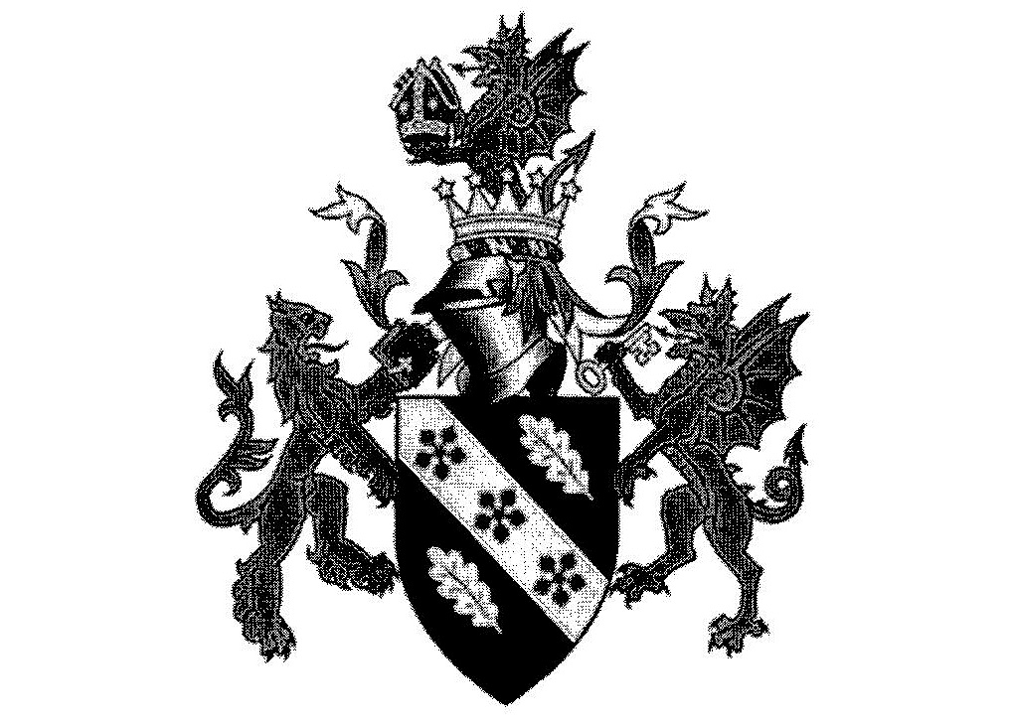

Romania
International Business Communications
JIAZHU WANG
1703858

Executive Summary 3
1.0 Introduce 3
2.0The political environmen 3
2.1Political structure 3
2.2 Laws and regulations 4
2.3 Power distanc 4
2.4 Universalis 4
2.5 Uncertainty avoidance 4
3.0 Cultural Environment 5
3.1 Diverse culture 5
3.2 Custom 5
3.3 Etiquette 5
3.4 Gift 5
3.5 Language 6
3.6 Masculinity versus Femininity 6
3.7 Individualism 6
4.0 Natural environment 7
4.1 Natural 7
4.2 The relationship between man and nature 7
5.0 Economic environment 7
5.1 Economic 7
5.2 Long-term versus Short-term 7
6.0 Summary 7
7.0 Reference 8

Executive Summary
Romania is a developed capitalist country. Romania joined NATO on March 29, 2004 and Romania joined the EU on January 1, 2007.
This report will:
- Romania background presentation
- The Impact of Romanian Political Environment on Culture
- The Cultural Impact of Romania on Society
- The impact of Romania's economic environment on culture
- The impact of Romania's natural environment on culture
The report found that Romania's culture is divided into several categories. These include:
- Political structure
- Laws and regulations
- Diverse culture
- Custom
- Etiquette
- Gift
- Language
- Economic development
- Nature
The theory needed to analyze this report is as follows:
- PowerDistance
- Universalism
- Uncertainty Avoidance
- Masculinity versus Femininity
- Long-term versus Short-term
- Individualism
- The relationship between man and nature
This article comes from textbooks of various information and news.

1.0 Introduce
Romania is the largest country in South-Eastern Europe, at the southern tip of central Europe. Its capital, Bucharest, is the region's largest financial center, which it calls "Paris of Eastern Europe." Romania has both mountains and sea, the Carpathian Mountains, the Blue Danube, and the Black Sea to the east. Romania also intact a lot of churches, castles and palaces, as well as the medieval town. ( Christopher & Richard,2013) Romania has a long history, their ancestors were Dacians, and afterwards they formed a Romanian integration with the Romans, meaning "Roman nation" in Latin. The Romanian flag, also known as the Tricolor, is also the same in the world as the national flags of other countries. ( Kurt,1996)
After joining the European Union on January 1, 2007, Romania applies the eu's unified external tariff and common trade policy. The eu's external anti-dumping measures, quotas and technical standards are also applicable in Romania. Romania's economy is growing at a very fast rate, growing at the top of the European Union. It is known as the "tiger", and its overall situation is among the best in the European Union.( Nigel,2014)

2.0The political environment
2.1Political structure
Romania practices a democratic republic. The president is the head of state and government. The program advocates the establishment of a multi-party system, free elections, the formulation of a new constitution, Separate legislative, executive and judicial powers, and to cancel the central economic system.The Romanian Parliament approved the establishment of a new constitution in 1991.( Nicolae,2002)

2.2 Laws and regulations
The law clearly provides for the protection and the protection of private property; allows minorities to use their language in local administrative and judicial proceedings; provides grants to children and orphans in poor families; guarantees equal rights for men and women; repeal of compulsory military service; and addition of accession to EU and NATO The articles stipulate that Luo citizens and their counterparts in the EU enjoy the same powers and obligations as lawfully and allow EU citizens to buy land and own the land in Romania.( Monica,2011)

2.3 Power distance
Power distance refers to the expectations and unequal distribution of power acceptance vulnerable members of institutions and organizations in the country. Do employees superiors courage to express their dissent? Subordinate superiors believe the decision-making style is authoritarian, paternalistic or democratic? Subordinates like better decision-making style superiors? Answer these questions is to let investigators calculated by the power distance index, whereby it can be seen dependencies between people in a country. Low power distance index mostly in developed countries. ( Geert Hofstede,1996)
According to the above conditions, Romania is a country with a low power. Romania's political system for the political situation in the country is more stable to obtain and maintain political power is a complete rule-based system. In countries with low power distance, and community members emphasize different division, decentralization and self-determination, does not focus on the status within the organization. In the lower organizations and the subordinate dependent and the easier to discuss issues with superiors,it often refute superiors, pragmatic relationship with a negotiated settlement. High power distance tend to poorer countries and regions, the concentration of power,strict supervision, there is a better grading system. This political power is monopolized by a few countries, usually the social elite, acquire and maintain power is often a way of using the power or violence. In the organization, the higher the degree of dependence, When the emotional distance between the upper and lower levels is higher, they can not directly discuss the issue,but it is unlikely to directly refute superiors. (Geert Hofstede,1994)

2.4 Universalism
According to the above conditions, Romania is a universal country. Universalist stress the importance of laws and regulations that govern action, and these guidelines should not vary. ( Fons Trompenaars,2004)In addition, generally it argues that should take an objective attitude towards all things, and there is a truth only in the world, there is only one right method to solve the problem.( Fons Trompenaars,2000)

2.5 Uncertainty avoidance
Uncertainty avoidance Hofstede defined is a culture, in the face of uncertain or unknown members feel when the threat level. This feeling is usually expressed through a sense of tension and the need for predictability. By "at work you feel nervous or anxious frequency of how high?" Asked employees working in different countries, "I should not violate the company's rules and regulations, even if for the benefit of the company?" "Do you think you will continue to work for the company how long?" Hofstede calculate the national culture of uncertainty avoidance index. (Geert Hofstede,2003)
The Romanian society advocates democratic self-government. The response of the government to public opinions is relatively timely. Members of the society with higher quality and greater autonomy. Therefore, for the uncertainty and variability,members of the community to take mostly conform to the natural and tolerant attitude, the overall low level of social anxiety. Therefore, in this country of Romania, the uncertainty does not exclude managers with more time to focus on organizational and strategic national decisions they, and individual initiative in the organization can be fully exploited in this environment . In high uncertainty avoidance index countries, advocating social order, Laws and regulations become more complicated, because the government is in a strong position in society. Members of society by the government or organizational control to avoid the situation unpredictable. The members of the society more than that uncertainties in life is a threat and thus produce anxiety, maybe even irrational aggressive behavior under certain circumstances. At work, the organization's managers advocate precise and strict management system, attention from scholars point of view in the decision-making process.As a result of tight control of uncertainty, innovation is almost no space in the organization. (Geert Hofstede,1996)

3.0 Cultural Environment
3.1 Diverse culture
Romania is a very diversified country, with its southern part being a Balkan culture, its central and western part being Central European and its eastern part being Russian.( Kurt,1996)

3.2 Custom
Romanian cheerful, fond of music, often improvise in various restaurants, and sometimes enjoy dancing and dancing, surrounded by silence, can not hear someone talking. Except for a period of summer, concerts, operas, ballet performances are held almost every night, and tickets are cheap. Business activities in Romania make it a good idea to wear conservative suits on all occasions.( Tim & Darren,2001)

3.3 Etiquette
There are many traditional etiquette in this country of Romania. For example, when men and women meet, they always say hello to the woman by the male side and then greet the man by the female side. When a group of men and women go out by men always let the woman go first, and men to take care of women has become a social fashion.( Lucian,2001) Romanian families attach great importance to the holidays and usually celebrate gifts to each other. As a result, Romania is selling very well on holidays.

3.4 Gift
Romanians like singular numbers, which should be singular, not double, at gifts. However, when attending funerals or expressing condolences, they used to send flowers in double numbers. In addition, Romania, like other Christian countries, is the most taboo figure.Friends and relatives usually meet hugging and veneer, boys need to give flowers to women, the total number of flowers should be singular, but not 13. ( Derby,2008) In rural or mountainous greet guests, people are always the first to send a large piece of fresh bread; then also ask guests to drink cask wine, these are the guest of honor local traditional rituals.( Nicolae,1997)

3.5 Language
The official language of Romania is Romanian, the main national language of Romania is Hungarian, but the popular languages are English and French. ( Derby,2008) Therefore, Romania is a country where high-context languages and low-context languages coexist.

3.6 Masculinity versus Femininity
People's minds is a social program, but also the emotional nature. People in society, the role of feelings from within society. Hofstede gender roles will be divided based on the "masculine" trend dimensions, namely masculine male or representatives oppose legislation "feminization" tendency is that the cultural dimension of female or feminine. When gender roles emotional significantly different when the man is considered to be decisive, tough, focused on material success, a woman is considered to be humble, gentle, focus on quality of life, such a society is called social quality males. (Geert Hofstede,1984)
So feminine qualities in a higher index of Romania, this organization is committed to maintain a harmonious atmosphere, allow more employees to actively participate in policy management. Staff focus on cooperation, they maintain a good working relationship and security work.. (Geert Hofstede,1998)

3.7 Individualism
Individualism is a loose social structure, organizational structure, everyone is concerned about their own values and needs, advocates individual effort for the benefit of their own. Collectivism refers to a strong social organization, in this organization, all of the interests above personal interests, people expect "social house" to take care of members, but also to maintain absolute loyalty in return group. Hofstede employee survey, said: "For you, the ideal job, the most important component of what is?" You do not have to consider whether their current work related to these factors. The answer is mainly focused on two aspects, some people think that personal time, freedom and challenge is the most important, the country is considered to be individualistic society; another part of the people believe that training opportunities, good working conditions, give full play to their skills most importantly, a country is considered to be a collective society. (Geert Hofstede,1996)
In high individualism index Romania, the benefits outweigh the individual interest groups, so only when personal interests are effectively maintained they will take into account the interest groups. Romanian emphasis on individual freedom and personal achievement, they often use personal means of incentives to stimulate competition. However, staff turnover is relatively high, mainly based organizations are hiring and promotion skills. (Geert Hofstede,2003)
So in a country like Romania, a person alone means he can handle everything, but will get more respect. In countries with high individualism, policy makers rapidly decisions, but may encounter opposition run-time.( Fons Trompenaars,2003)
However, in collectivist countries interests are more important than individual interests, on the integration of people and groups from birth. Employees of the organization have emotional dependence, so the relationship between the administrators and managers harmony. So the turnover rate of employees is very low, they give priority to people who can promote moral relations, but the most important thing is skill. (Geert Hofstede,1984)

4.0 Natural environment
4.1 Natural
The Danube leads directly to the Black Sea, thus forming Europe's largest delta. Danube Delta located in the eastern part of Romania, is a famous tourist attraction of Lo, which is caused by the siltation of the upper stream of the Danube day and night. Rich in resources here, known as Europe's largest geological and biological laboratories. The delta is also a "paradise" for birds and animals, with an abundance of over 300 species of birds and 45 endemic species of fish in countless lakes and swamps.( James,2015)

4.2 The relationship between man and nature
Another cultural factor is the relationship between man and the environment. This problem has two different values. One is the value orientation control environment (internal control), and the other is to adapt the value orientation of the environment. (export-oriented control). ( Fons Trompenaars,2004)Different values direct impact on people behave in daily life and social management. Values greater emphasis on the organization's control environment and realize their own functions, when the ambient outside the scope of their control will show uncomfortable. However, the above conditions can be seen in Romania belong to adapt to the environment, to promote the value orientation in harmony with the environment, recognize environmental impact of future development based on. ( Fons Trompenaars,1993)

5.0 Economic environment
5.1 Economic
The outbreak of the international financial crisis in 2008 caused a great impact on the Romanian economy. With the aid of international agencies, Romania pursued a policy of increasing and reducing its deficit and the economy rebounded. Before the outbreak of the international financial crisis, the Romanian economy maintained its rapid growth for eight consecutive years and at one time became one of the fastest growing countries in the EU. However, after the outbreak of the crisis, although Romania was relatively cautious and prudent in its local operations, the direct impact of the crisis on the banking sector was less directly affected by the crisis. However, the crisis has an indirect impact on the Romanian economy. ( Monica,2011)

5.2 Long-term versus Short-term
It refers to members of a particular culture of the extent of social needs, emotional and physical satisfaction. The cultural dimension shows the degree of moral life worth pursuing, it does not need any religious faith to prove with the degree of satisfaction. Because long-term positioning indicators of national economic growth has a strong correlation. (Geert Hofstede,2003) First of all, Romania's economic growth is stable. Secondly, Romania is a religious country, with almost 99% believing in religion. ( Lucian,2001)Therefore, Romania is a long-term country.

6.0 Summary
According to the conditions of the political environment, Romania is a country with a low power distance. At the same time, Romania is still a country with a low uncertainty index. Therefore, Romania's social members emphasize the different division of labor in the organizations and they do not pay attention to the status but they pay attention to the actual results. The Romanian society advocates democracy, and the quality of the members of society is high, so the overall social anxiety level is low. According to the conditions of cultural governance environment, Romania is a country with a high index of low femininity and temperament, and Romania's society advocates individualism. They emphasize individual achievement and quality of life, so the organization has a good communication environment, but staff turnover is also high. From the long-term positioning found in the economic environment, Romania's economy can continue to grow. In the natural environment, Romania believes that the environment has an impact on the future, so Romania's cultural values promote harmonious coexistence with the environment

7.0 Reference
Christopher dreyso & Richard Watkins., Lonely Planet Romania & Bulgaria, 2013,p13

Geert Hofstede ,Culture′s Consequences: International Differences in Work-Related Values (Cross Cultural Research and Methodology),1984,p71

Kurt Treptow, A History of Romania, 1996,p20

Fons Trompenaars, Peter Prud'Homme,Managing Change Across Corporate Cultures,2004,p45

Nigel Shakespeare, Times New Romanian: Voices and Narrative from Romania, 2014,p18

Geert Hofstede ,Culture′s Consequences: Comparing Values, Behaviors, Institutions and Organizations Across Nations,2003,p67

Nicolae Klepper, Romania Of History, 2002,p21

Fons Trompenaars, riding the waves of culture,1993,p43

Monica Pocora,Special Seizure Stipulated in Romanian Criminal Law and Special Law,2011,p3

Geert Hofstede ,Cultures and Organizations, Software of the Mind: Intercultural Cooperation and its Importance for Survival,1996,p18

Tim Burford and Darren Langley, The Rough Guide to Romania, 2001,p31

Fons Trompenaars, Business across cultures,2003,p32

Lucian Boia, Romania, 2001,p16

Geert Hofstede ,Masculinity and Femininity: The Taboo Dimension of National Cultures (Cross Cultural Psychology),1998,p52

Derby Stowe, Romania - Culture Smart! The Essential Guide to Customs & Culture, 2008,p32

Fons Trompenaars, Managing People Across Cultures,2004,p16

Nicolae Klepper, Taste of Romania: Its History, Folklore, Art, Literature, and Poetry, 1997,p9

Fons Trompenaars & Charles Hampden-Turner,Building Cross‑Cultural Competence: How to Create Wealth from Conflicting,2000,p60

James Roberts, The Mountains Of Romania, 2015,p31

Geert Hofstede ,Uncommon Sense About Organizations: Cases, Studies, and Field Observations,1994,p54

