



Amanda Glanville
Student Number 1810229
BMHR7010 - Resourcing & Talent Management
Wordcount: 4877 (excluding executive summary, bibliography, contents & glossary)
(allowance 4500 +/- 10%)

Broadening the Talent Pool within Hywel Dda University Health Board
Recognising the significant challenges faced by Hywel Dda University Health Board (HDdUHB, in terms of Resourcing and Talent Management (R&TM), this report identifies the significant internal and external factors that affect recruitment, attraction, selection, talent management and succession planning.

Executive Summary

External factors identified included the challenging labour market position and the impact of skills shortages, Brexit, Covid-19, technological advancements and the political pressures as a result of being a public sector organisation. Internal factors identified include workforce demographics, the challenges bought on by the location of the health board, increased levels of employee turnover and retention challenges that the health board face. The report also considers leadership challenges and how current development processes support resource and talent planning.

Considering skills needs of the future, this report identified that although Organisational Development opportunities to improve the wellbeing provided contemporary approached to support staff health and well-being, there was a reactive approach to talent planning. It recommends the need to create the foundations using a Training Needs Analysis, understanding the skills needed as the health board moves to her social model of health.

This report identifies why HDdUHB need to implement flexible working patterns in as many areas as possible to create greater workforce flexibility. It recommends the implementation of a self-rostering system where possible to reduce turnover and improve attraction.

The responsibility of managers in Resourcing and Talent management identifies the need to significantly invest in their development and support, recognising the impact this has on employer brand, well-being, retention and promoting that HDdUHB is an employer who invests in their workforce.

Finally the health board recognises the three main recommendations require significant resource to implement and therefore also identifies additional opportunities to widen the talent pool through positive action and use of funded training programmes, employablity skills and pre-employment support programmes.

Glossary ………………………………………………………………………………………………...4
1.0 Introduction ……………………………………………………………………………………….5
2.0 External and internal factors…………………………………………………………..…………6
2.1.1 Skills levels in the economy 7
2.1.2 Brexit 8
2.1.3 Covid 9
2.1.4 Technological Impact 9
2.1.5 Political Impact 10
2.2 Internal Factors …………………………………………………………………………………..10
2.2.1 Location 10
2.2.2 Workforce Demographics 11
2.2.3 Turnover and retention 11
2.2.4 Development 12
2.2.5 Leadership 13
3.0 How HR Systems, processes and practices in HDdUHB impact the talent pool…………15
3.1 Attraction and identification 15
3.4 Engagement and retention 17
3.3 Development 20
3.4 Policies and how they impact R&TP 23
4.0 Conclusion & Recommendations………………………………………………………………24
4.1 Talent planning, identifying future potential talent and driving a learning culture 24
4.2 Implement systems to provide the workforce with the flexibility 25
4.3 Leadership/management skills at all levels 27
4.4 Widening Access through positive action 28
4.5 Data and Return on Investment (ROI) 29
Bibliography …………………………………………………………………………………………..30

BMJ – British Medical Journal

Glossary
EU – European Union
FE – Further Education
HBR – Harvard Business Review
HDdUHB – Hywel Dda University Health Board
HE – Higher Education
HEIW – Health Education Improvement Wales
HR – Human Resources
HRM – Human Resource Management
LNA – Learning Needs Analysis
NHS – National Health Service
N&M – Nursing & Midwifery
NMC – Nursing & Midwifery Council
ONS – Office of National Statistics
R&TP – Resourcing and Talent Planning
TNA – Training Needs Analysis
UK – United Kingdom
WTE – Whole Time Equivalent

Hywel Dda University Health Board (HDdUHB) is one of the largest NHS Health Boards in Wales, meeting the healthcare needs of Pembrokeshire, Carmarthenshire and Ceredigion, equating to 384,000 people. Employing over 10,000 staff (HDdUHB, 2022c), HDdUHB is one of the largest employers in the region.

Introduction
Understanding the skills and supply of the workforce is essential in responding to the challenges faced as an organisation and the wider health and social care system, and in the context of the economic landscape and ongoing global pandemic (HDdUHB, 2021f). As with most NHS organisations, HDdUHB are at crisis point with staff shortages within nursing, doctors and consultants, with other professions following closely (HDdUHB, 2022c) (Nursing Times, 2021). With the increased pressure for job satisfaction, NHS workers are leaving. Recruitment and retention is a growing concern (NHS Federation, 2021).

This report will define, explore and develop interventions to increase workforce supply routes, focusing on external and internal challenges, HR systems and processes of the organisation and how these can support the recruitment of a more diverse range of candidates, broadening the talent pool.

2.0 External and internal factors

Recognising talent management is seen as critical within HRM, it is defined as the ability to “seek, attract, identify, develop, engage, retain and deploy individuals who are considered particularly valuable to an organisation” (CIPD, 2021a). The effectiveness needs to be strategically led, which will improve organisational brand, learning culture, performance and workforce diversity (CIPD, 2021a).

Success within an organisation is dependent on the ability to ensure that teams have the skills, experience and attitude, linked to organisational objectives (Taylor, 2018). Critical factors facing HDdUHB relate to skills shortages, high turnover, fatigued workforce and the ongoing pressure of the NHS to deliver quality healthcare (HDdUHB, 2021e).

2.1 External Factors
The employment rate in Wales as of November 2021 was 74.1%, an increase of 1.8% on the year. Unemployment rates were at 3.4%, down 1.4% on the year and the economically inactive attributed to 23.3%, down 0.8% on the year (Welsh Government, 2022). This had led to a tight labour market (ONS, 2021), significantly impacting the talent pool at HDdUHB, with limited specific skills and fierce competition for talent. With demand outstripping supply, employees have greater bargaining power (Taylor, 2018).

The ability to recruit into vacancies is worsening, with 46% of employers reporting recruitment difficulties (CIPD, 2021c). Even the lower skilled jobs have less applications, exacerbated by private sector organisations increasing wages to overcome recruitment challenges (HR News, 2022).
The BMJ outline how the current workforce challenges has resulted in unrealistic workloads, burnout and significant impact on staff well-being.
“Without enough clinical staff the health service won’t recover, let alone thrive” (Oliver, 2022).

2.1.1 Skills levels in the economy

Internal skills shortages impact recruitment and talent management significantly within HDdUHB. The current vacancy gap is 728 Whole Time Equivalent (WTE), in additional to a deficit of 222 WTE based on additional budgeted funded establishment. The Workforce shortages result in a reliance of Agency usage to the value of £33.1M per annum, impacting the overall financial commitment of the organisation (HDdUHB, 2022a). Nursing & Midwifery (N&M) contribute to 57% of the vacancies and reliance of temporary workforce (overtime, bank and agency). N&M contributes to 89% of the vacancy gap (HDdUHB, 2022b). Occupations linked to critical skills shortages is growing, with these being recognised as medical practitioners, psychologists, pharmacists, radiographers, physiotherapists, social workers, paramedics and nursing auxiliaries (GOV.UK, 2021).

As of the last Census (2011), the percentage of the population in Wales who had no qualifications were 25.9%, those attained level 1 was 13.3% and achieved level 2 15.7% (ONS, 2011). Figure 1 demonstrates that despite the HDdUHB population footprint showing an improvement on the Welsh average, this still outlines that 36.1% of the local available workforce do not have the level 2 qualification.

Figure 1 - Census 2011 Qualifications (ONS, 2011)

This information gives insight, however the 2021 data, which will be published in March 2022 will provide up to date intelligence.

2.1.2 Brexit

Many EU healthcare workers are leaving the UK because of the uncertainty of Brexit (Dayan, et al., 2020). The number of N&M EU workers in the UK was increasing from 2.4% in 2013, to 5% in 2019. Since Brexit, not only has the number of EU nurses and midwives joining the UK fallen by 90%, but those also leaving has increased from 4,000 during 2014/2015, to 13,000 in 2015/2016. Research carried out by the Nursing and Midwifery Council (NMC) identified that 51% of EU nurses are concerned about Brexit and their future. (Nursing Times, 2020). The government has tried to support the impact of this by offering an Immigration Health Surcharge refund (GOV.UK, 2020), however data suggests this does not show significant impact on EU citizens residing in the UK (Nursing Times, 2020).

2.1.3 Covid

Covid-19 has severely impacted NHS organisations (Nursing Times, 2021), especially with the need for mass testing units and vaccination centre’s diminishing workforce supply routes.
Recognising the need to delay patient treatment as a result of Covid-19 has meant waiting lists in Wales have significantly increased from 460,000 in January 2020 to 680,000 in November 2021 (Digital Health and Care Wales, 2022). This has significantly impacted the health and well-being of HDdUHB workforce as a result of clinical pressures and staff shortages bought on by the increased workload of Covid-19 (HDdUHB, 2021e).

At the start of the pandemic Covid-19 there was an increase in younger workers wanting a career in the NHS (HR Review, 2021), this validated by a 3.5% increase in UCAS applications for medical careers (UCAS, 2021).

2.1.4 Technological Impact

Technological advancement was on the horizon prior to Covid-19, but this has catapulted the digital transformation within HDdUHB by over five years (HDdUHB, 2021d). Notable pressures now exist to provide a different healthcare provision, providing remote appointments and telehealth, which will not only require sufficient financial resources, but the need for the infrastructure and workforce development to embed this change fully (Hutchings, 2020). Digital intensification can also lead to the inability to disconnect from work. contributing to burnout (Deloitte, 2020).

2.1.5 Political Impact

As an NHS public sector organisation, HDdUHB are significantly impacted by political actions, with the more recent English proposal for Covid-19 vaccines being made mandatory (BBC, 2022). At the start of the pandemic, people were concerned about financial commitments and flocked to the NHS. Once government introduced furlough, and other self-employed grants/schemes, this reduced supply of the labour market, with many applicants who had offers withdrawing as their security had been restored (HDdUHB, 2022c).

2.2 Internal Factors

2.2.1 Location

The location impacts the talent pool and due to the organisational nature, there is no ability to relocate as with other sectors. The rurality and poor transport infrastructures create barriers, not only for existing workforce who on average travel a greater distance than the National average (ONS, 2011), and the lack of local higher education provision results in school leavers accessing provision further afield and not returning, compacting the ageing population demographics issue, recognising that net out-migration from rural areas is highest among those aged 20-29, leaving for education or work, returning to retire (Ungar, 2019).

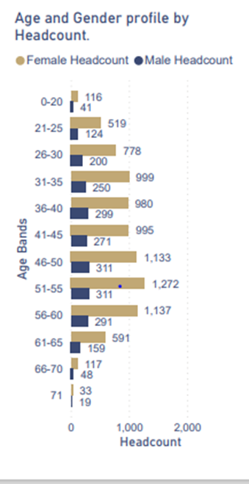
2.2.2 Workforce Demographics

A significant challenge facing HDdUHB is workforce ageing demographics. Figure 2 shows that 34.38% are over 51, 60% of our total workforce are over 40 and 19.1% of our workforce are over 55 years of age and over (HDdUHB, 2022b). This is set against the strategy to deliver “A Healthier Mid and West Wales” which will require workforce transformation as between 60-80% of our workforce today will be our workforce tomorrow (Welsh Government, 2019).
Figure 2 - Workforce Demographics

2.2.3 Turnover and retention

Turnover costs UK organisations £8.6bn per year (Deloitte, 2020). As at May 2021, HDdUHB’s 9.8% turnover rate is higher than the NHS Wales rate of 8%. As at October 2021, the turnover rate shows improvement to 9.17% (HDdUHB, 2022b). Figure 3 provides further analysis of the turnover within HDdUHB.
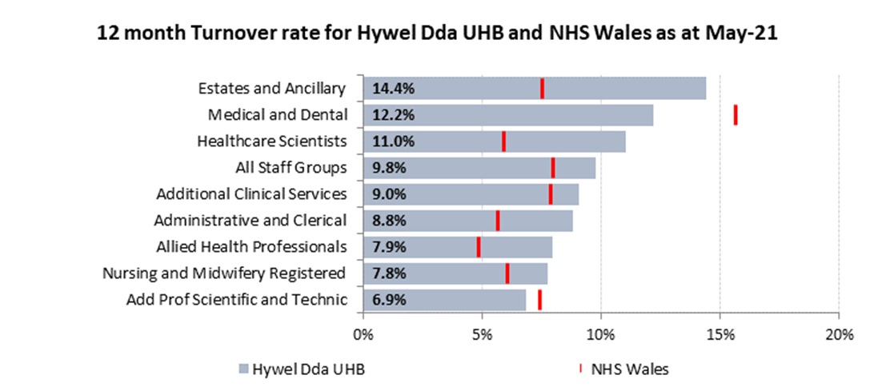
Figure 3 Turnover rate Vs NHS Wales (HDdUHB, 2022b)
The top identified reasons for leaving are categorised as retirement, work/life balance and lack of development opportunities.

2.2.4 Development

In times of crisis, learning and development activities are often hard hit, precisely when the ability to adapt, learn and improve is particularly imperative (Taylor, 2018). From an employee brand perspective, career development is ranked within the top three important elements to attracting talent (CIPD, 2020b). The 2021 survey places greater emphasis on the need to upskill existing staff as a way of combating hard-to-fill vacancies and overcoming recruitment difficulties (CIPD, 2021c).

The Equitable Access to Training Survey completed within HDdUHB outlines that 40% of the workforce feel that there is no development opportunities within HDdUHB (HDdUHB, 2021c). Figure 4 highlights the parity given to development as the most popular retention strategy in 2019 within the UK (CIPD, 2020c) and due to the Wales/NHS rigidity around pay, benefits and reward schemes, development is the only one of the top four strategies that HDdUHB have the autonomy to make significant changes. Other strategies include improved onboarding, improved people management skills and creating clearer career pathways, which can all be attributed to the development of the workforce. Despite the evidence that suggests development is critical to employee retention (CIPD, 2021b; CIPD, 2020c; CIPD, 2020a; Deloitte, 2021; Forbes, 2018; HDdUHB, 2018; HDdUHB, 2021; HDdUHB, 2021a; Harvard Business Review, 2021; LinkedIn, 2021 and NHS Federation, 2021), the HDdUHB Annual Report 2019/2020 highlights the lack of commitment given to development of the workforce (HDdUHB, 2021d).
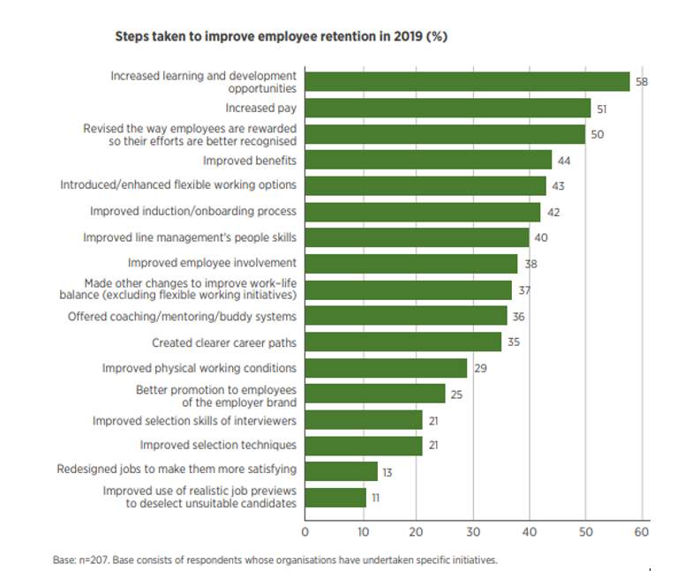
Figure 4 - Steps to improve employee retention (CIPD, 2020e)

2.2.5 Leadership

The Discovery Report provided a voice for staff which highlighted the need for a change in leadership approaches adopted by HDdUHB. The hierarchical structure during covid-19 softened, with employees having a taste of flatter structures, which promoted trust, autonomy and improved communication. Whilst most staff who began hybrid working thrived on the ability to manage their workload, whilst managing the challenges of their personal life, leaders/managers struggled with control and lacked the skills to deal with the changing workforce needs, including managing mental health, presenteeism, managing remote teams and identifying performance metrics to measure new working cultures (HDdUHB, 2021e).

Knowing how to deal with mental issues has never been more critical for leaders/managers as managers feel ill-equipped and therefore is not dealt with (HDdUHB, 2021e), contributing to the increase organisational costs (Deloitte, 2020). Deloitte (2020) suggests that 16.7% of the workforce suffer with poor mental health at any one time, costing organisations £45bn per year. This includes £26.6bn due to presenteeism, which in the main, is caused by stress, poor mental health, sleep deprivation or financial worry (CIPD, 2020d). Public Health England have made recommendations that training for managers to support staff with mental health issues to be made mandatory (Powell, 2021), signifying the importance of providing leaders/managers with the skills to manage effectively.

Redeployment has uncovered the variation of micro cultures operating within HDdUHB, with a significant proportion of work-based stress centred around toxic cultures, causing fear, anxiety, feeling of lack of management support or appreciation and a ‘them and us’ culture (HDdUHB, 2021e), which backs up findings of the HDdUHB findings of the staff survey, outlining the extremes of culture across the Health Board (Quality Health, 2020).

3.0 How HR Systems, processes and practices in HDdUHB impact the talent pool

3.1 Attraction and identification

HDdUHB have a strategic objective to transform the end-to-end recruitment pathway, focussing on candidate’s experience (HDdUHB, 2020e). Being an NHS organisation significantly reduces the local decisions HDdUHB can take to reduce the labour shortages and broaden the talent pool. An example relates to salaries using Agenda for Change pay scales, annual leave and other terms and conditions of employment (NHS Staff Council, 2021). Despite salary being the main positive action employers are taking to overcome the recruitment challenges (CIPD, 2021c), HDdUHB’s must identify other mechanisms to attract and retain their workforce.

Investing significantly in marketing to promote work/life balance in rural coastal scenes using the Train-Work-Live campaign (shown below) has been successful, alongside the incentive of relocation costs to current or new employees for hard to fill vacancies of up to £8,000 to cover costs of temporary accommodation and travel expenses. with a payback if individuals leave within two years of service (HDdUHB, 2021a).

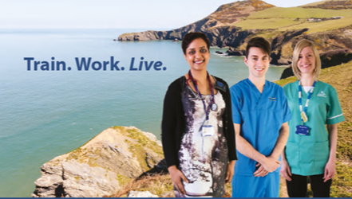

Seen as an outdated method (Taylor, 2018), HDdUHB recruitment practices focus predominantly on individual attraction using a job analysis, detailed job descriptions and person specifications, which focusses far more of qualifications, rather than the person and that a greater shift to a competency based approach should be considered (Cook, 2016).
This approach for recruitment, selection and appointment also misses’ opportunities to engage with unsuccessful candidates in relation to wider vacancies (Florence, 2021). Recognising the number of the population that hold a level 2 qualification above discussed earlier, this also reduced the talent pool.

The competency approach is also significantly criticised as it reduces diversity in the workforce, limiting the approaches to problem solving (Whiddett & Kandola, 2000) and as this does not lend itself well to rapidly changing environments (CIPD, 2021e), this approach does not reflect the needs of HDdUHB, working in a VUCA context.

Current Selection with both the shortlisting and interview process relies on scoring, with an audit process to assess managers adherence to the process, focussing on the person specification and qualifications outlined in the person specification (HDdUHB, 2019b). Where an individual do not have all the criteria, limited autonomy is given to managers who identify personal attributes or talent, thus reducing the talent pool.

In order to broaden the talent pool, many organisations are switching to a strengths-based approach to recruitment and progression, which when trialled by North Yorkshire Police resulted in increased external and internal candidate experience, an increase of 60% satisfaction in fairness and led to a reduction in appeals (CIPD, 2021d).

3.4 Engagement and retention

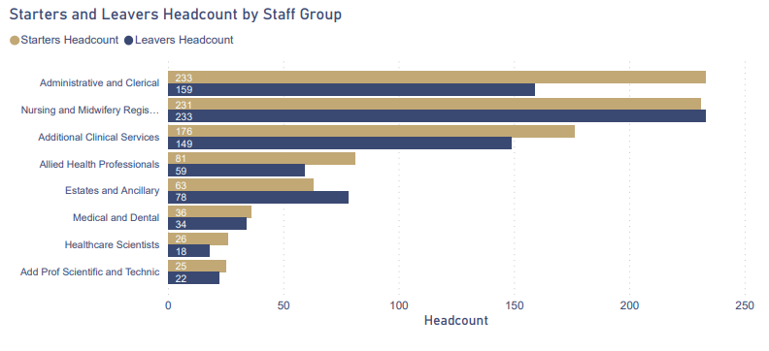
HDdUHB has the highest turnovers across NHS Wales, at 9.8%, with an NHS Wales average of 8% (HDdUHB, 2022b). Retirement is the largest “reason for leaving”, which reflects the workforce demographics and the proposed changes to the 1995 pension scheme (Legal and Medical, 2021). Figure 5 highlights that despite significant effort to recruit, this only closes the vacancy gap by 13% due to a high volume of leavers (HDdUHB, 2022b)
Figure 5 - Starters and leavers 2021

The retention strategy (HDdUHB, 2029) identifies strategy, but lacks focus on the importance of data, creating the opportunity to make inaccurate assumptions limited data.

When considering the leaver trend for 2021, figure 6 highlights how HDdUHB leavers match the trend described as the ‘Great Resignation’, coined by Professor Anthony Klotz (Chugh, 2021), Resignations within the mid-career individuals between 30 and 45 years old match the trends globally, however, the number of 60-70 year olds fell globally (Cook, 2021), but this was not evident within HDdUHB, as the number increased during the same period (HDdUHB, 2022c). This could be attributed to the pension changes as a result of panic (Legal and Medical, 2021) or/and that despite being fatigued, during the height of the pandemic those staff who were nearing retirement kept going due to a sense of pride and loyalty to the NHS, with the NHS Clapping providing a sense of togetherness, of belonging (Sandhu, 2020).

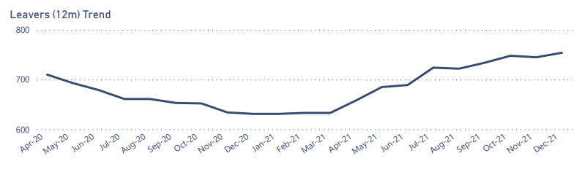

Figure 6 - Leavers 2021 (HDdUHB, 2022b)

The Harvard Business Review suggests organisations need to understand data and reasons and develop tailor made retention programmes linked to findings and not be tempted to follow mass retention programmes being introduced in other organisations (Cook, 2021).

HDdUHB Retention Programmes

Contemporary approaches are being taken by to drive change culture across HDdUHB, providing greater opportunities to listen to staff. Initiatives are in the initial stages, but include:
- A staff experience and engagement improvement programme, using data and intelligence, to drive organisational learning and enhanced leadership awareness of behaviours leading to cultural improvement.
- Staff awards, events and motivational recognition programme, building loyalty and commitment (Taylor, 2018),
- Staff benefits optimisation programme - Creating greater awareness of the employee benefit package, not only improving attraction and retention, but support the local economy sustainability agenda.
- Formation of a Culture & Staff Experience Team focussing on employee voice through a central resignation post-box, a speaking up safely platform including a campaign “if you are thinking of leaving, come and chat?” linked to “stay interview”, analysing exit interviews
- Introduced OD Relationship Managers to work with Trade Unions and services to co-create a People Culture Plans
- HDdUHB have invested significantly in the well-being interventions including a well-being hub, a lifelong learning fund to allow staff to learn a hobby (HDdUHB, 2022d), ecotherapy retreats for staff who are at risk of burnout or experiencing stress, calm rooms and green spaces (HDdUHB, 2022c). Growth of the Staff Psychological Wellbeing Service has also provided support for managers and teams, linked to the Rest, Recovery and Wellbeing Programme and listening spaces are also created, providing opportunities to share experiences.

3.3 Development

HDdUHB has seen a significant decrease in training budgets within recent years, despite research identifying that development and career progression is a significant contributory factor to retention (Forbes, 2018) (Harvard Business Review, 2021) (CIPD, 2020c). Therefore there is a reliance to work closely with FE and HE institutions to access training through various funding options.

The 2011 Census outlined the population in Wales who had no qualifications was 25.9%, those attained level 1 was 13.3% and achieved level 2 15.7% (ONS, 2011). Despite the HDdUHB population footprint showing an improvement on the Welsh average (fig 7), this still outlines that 36.1% of the local available workforce do not have the level 2 qualification. Recognising that the All-Wales Career Framework monitored by HEIW and Welsh Government suggest that all Health care workers at band 2 need to hold a level 2 qualification, this demonstrates the need to have the capacity to upskill the workforce at all levels (NHS Wales, 2018). The 2021 Census, which will start to be published in March 2022, will provide an up-to-date picture.

Figure 7 - Qualifications of local population V's Wales average (ONS, 2011)

Strategic direction identifies that the Education and Development Service are listening to staff and creating opportunities to suit their individual learning needs and preferences through an Equitable Access Survey. Where development opportunities are provided, the workforce have a higher commitment to the organisation, positively impacting retention (Deloitte, 2021) (CIPD, 2021b). Supporting this, initiatives underway include:
- Moving from an induction process to enhance retention, to a six-month onboarding programme, recognising that on average, 9% of staff left within the first year between 2018-2020 (HDdUHB, 2022b). A phased approach will allow new starters to access a diverse range of learning opportunities, including information relating to wellbeing, staff benefits, how to speak up safely and development opportunities, whilst providing an opportunity to gather staff experience data.
- Development of various programmes that focusses on making a difference to our customers, colleagues and individuals, embedding values, providing reflection and building healthy working relationships.
- Succession planning and talent management focuses on senior roles Band 7 and above, which includes access to reverse mentoring programmes and coaching. The current talent management strategy suggests that although there is a significant investment in leadership development, this is not reflected in the development of the whole workforce.

Grow Your Own Brand
The reputation and employer brand of offering development opportunities within HDdUHB has seen significant social media interest with the launch of the Apprenticeship Academy in 2019, having since onboarded 127 apprentices (HDdUHB, 2021f). The nursing pathway equates to 83% of the overall apprenticeship provision, with the aim of providing a long-term pipeline to support the nursing crisis. Increasing the use of foundation, advanced, higher and graduate apprentices are in the strategic plan as well as to design a joint apprenticeship programmes, working collaboratively with local authority colleagues.

HDdUHB have an ambitious Workforce Development Plan to support the long-term nursing crisis, however recognising the immediate need, HDdUHB are planning overseas recruitment, providing a short/medium term solution. Intelligence suggests that overseas recruitment does not provide a long-term solution (HR Review, 2021), but will plug the gap until the Grow Your Own Programmes flourish.

3.4 Policies and how they impact R&TP

HDdUHB have included revising the approach to policy formation into the strategic Priorities for 2022/2023 objectives. The emphasis being on a summarised and flexible approach, encouraging discretion and trust of our workforce (HDUHB, 2019a). One of the key changes in approach will be a sense check in relation to whether it helps or hinders retention of staff.
In this respect it is proposed that all related policies will be incorporated into one umbrella policy with one common overarching policy statement which sets outs the Health Board’s intention to support flexibility as widely as possible and encouraging managers to consider all options.

Each of the following groups of policies will fall under one umbrella policy and will be supplemented with numerous appendices which are likely to include:

- This All Wales Management of Attendance Policy and has been the subject of some tensions, lacking a person centred approach to using managers discretion This is currently under review, as does not reflect the post-pandemic practices.
- Work Life balance/Flexible Working, Term time working policy, Work/life Balance/flexible working policy, Homeworking policy and the Flexitime policy and procedure has currently been suspended due to not reflecting the new organisational culture to home/hybrid working. Consideration need to be given as to how these new policies will relate to clinical staff, recognising the need for equity, whilst meeting the needs of a diverse workforce.

4.0 Conclusion & Recommendations

HDdUHB have invested significant resource into R&TP with many of the interventions have not been not being fully embedded at present. This report outlines that there are significant challenges facing HDdUHB, and many of these factors are intwined and difficult to consider in isolation. Ways to broaden the talent pool therefore needs to be considered holistically. These recommendations complement the findings of the R&TP Survey 2020, which identify a need to use workforce planning techniques using data and evidence, develop internal skills and mobility, focus on flexibility and work/life balance of the workforce and support diversity through training. (CIPD, 2020e).

4.1 Talent planning, identifying future potential talent and driving a learning culture

Obtaining data in relation to development is vital to overcoming talent shortages, understanding the future skills needs and the current skill mix within an organisation (Manpower Group, 2018). HDdUHB is already working towards a transformational healthcare system, moving to a social model of health (Welsh Government, 2019) and success depends on being able to identify the future vision, roles and skills needed (CIPD, 2021f). Although there are several specific Training Needs Analysis (TNA), absence of a Learning Needs Analysis (LNA) to identify HDdUHB’s current and future capability needs means that it is not possible to compare with existing skills, attitudes and knowledge of the workforce (CIPD, 2021g). Due to lack of leaning needs, foundations need to be created to complete the full Workforce Planning Cycle (CIPD, 2021a). In addition, lack of a LNA, means that HDdUHB will be unable to demonstrate the need for financial investment, benchmark against other similar organisations and provide HE or FE institutions with skills needed and in turn, missing significant opportunities for developing the workforce (CIPD, 2021h). This in turn will prevent a proactive approach to talent management.
This will have significant impact on broadening the talent pool as it will provide employees with an insight into the skills needed to reach their future potential, result in greater opportunities for development across the whole workforce and provides individuals the skills to be confident within their role and therefore supports retention (CIPD, 2020c).

4.2 Implement systems to provide the workforce with the flexibility

Research identifies that flexibility is key to employee attraction and retention (Deloitte, 2021) and the pandemic has changed the landscape of working practices significantly in many vocational areas (CIPD, 2021b).

Following the ‘Great Resign global study, evidence suggests that 46% of people will leave their jobs if they cannot work remotely (Microsoft, 2021), confirming the need to create flexibility within roles. As a result of the struggle of childcare arrangement, nearly 15% of working parents have had to change working patterns as a result, which has now become the norm across many organisations and demonstrated that flexibility can be managed without significant detrimental impact to organisation (Working Families, 2021). There is now an expectation that employers will see an increase of 50% demand for flexible/agile/hybrid working (ACAS, 2021) and where these are refused, employees have greater power as a result of the tight labour market, impacting the turnover within organisations (Timewise, 2021).

The level of flexibility that can be offered to staff within HDdUHB has predominantly been based on the specific role of individuals, although the introduction of E-Rostering has seen significant improvement in the ability to approve flexible working requests (Drake, 2014).

If HDdUHB want to truly improve their employer brand, retain their workforce and widen their talent pool, they need to implement a self-rostering system, which has been achieved within other NHS organisations. This will provide greater flexibility, improving work-life balance for clinical staff, providing the ability to choose shift patterns around personal circumstances (Barrett & Holme, 2018).
The Royal London NHS Foundation Trust implemented self-rostering as a way of combatting turnover, with the project being known as ‘the joy at work programme’. It started on one ward, quickly being rolled out to 32 inpatient areas as a result in the working conditions. Vacancy rates improved by 6.5% in a six-month period (NHS England, 2019).
Learning in other NHS organisations identified that it was easier within larger teams, although smaller teams were happy to work cross wards, demonstrating a collaborative approach. This resulted in less team conflict, improved patient care, allowed for extended clinics, improved retention and reduction in bank and agency staff (NHS Fife, 2019).

In order to implement Self-rostering, HDdUHB should consider the following (Department for Health, 2016)
- Involve the team and over communicate if needed
- Allow Opportunity for questioning
- Be clear about parameters
- Create a trial plan and go through any challenges
- Provide training on agreed system
- Implement
- Monitor
With the implementation of self-rostering, job share and being fully supportive of hybrid and agile working, this would significantly increase the talent pool and support, carers, parents, those with disabilities (Timewise, 2021). This needs to be prominent on advertisements and on all media campaigns as those who need flexibility will not apply for vacancies, unless stated on the advertisement (Whiting, 2020). Research suggests that flexible/hybrid working increases productivity (Whiting, 2020), It also reduces accommodation space requirements, which is significant challenge for HDdUHB due to a reduction in estate (HDdUHB, 2021d).

4.3 Leadership/management skills at all levels

Having effective management within an organisation can have the greatest positive impact on retention and therefore retaining talent within an organisation (CIPD, 2021b). Embracing a new era of people management, HDdUHB recognise the HR Disrupted concept of people management, recognising employees as adults, consumers and humans. This moves away from parental relationships, less reliance of policies and greater shift to managing relationships, which increases the need for managers/leaders to have the effective people management skills (Adams, 2017). Managers are having to deal with more complex and diverse teams, because of multi-generational factors and individual needs (Waldman, 2021), exacerbated by Covid-19, a fatigued workforce and staffing shortages (Deloitte, 2020).

Managers are expected to provide support to employees suffering with mental health, which contributes significantly to their loyalty to an organisation, reduces turnover, sickness and attrition (Mental Health Foundation, 2019). Protection for employees with ongoing mental health concerns from discrimination and harassment is covered by the Equality Act 2010 and Disability Discrimination Act 1995, providing the right to reasonable adjustments being made (Lewis & Sargeant, 2020), with an expectation that managers understand how their involvement can make a difference.

Management need the confidence, skills and tools to manage their teams and how to embrace diversity, promote autonomy and manage team dynamics. In terms of leadership development, offered by HDdUHB, this is only available to 6% of the workforce, despite 27% being responsible for managing people (HDdUHB, 2022c).

4.4 Widening Access through positive action

Championing a culture of inclusion and widening access, Longhurst Group use a disability job board to promote vacancies, broadening their talent pool (CIPD, 2021d), recognising that the main barrier faced by 82% of candidates with a disability is identifying disabled friendly employers (Evenbreak, 2021). Signing up to this platform cannot be done in isolation; this will require working with managers to raise awareness and consider policies and opportunities relating to role design, providing crucial support to employees with individual needs (Rutnam, 2017).
It is imperative that as all these recommendations progress, there is a need to use case studies to promote best practice through social media and other platforms to promote HDdUHB as an employer of choice, continuing building an employer brand.

4.5 Data and Return on Investment (ROI)

All HRM systems and processes leave unanswered questions in relation to data, this related to reasons for managing recruitment processes, attrition, positive action in relation to turnover and talent planning. Gathering, analysing and report all data on R&TP.
In addition, very little evidence exists to date on the how HDDUHB will measure ROI, making it difficult to analyse the effectiveness of the R&TP interventions.

Bibliography
ACAS, 2021. New study reveals half of employers expect more flexible working requests from staff after the pandemic is over. [Online] Available at: https://www.acas.org.uk/new-study-reveals-half-of-employers-expect-more-flexible-working-after-pandemic [Accessed 28 January 2022].

Adams, L., 2017. HR Disrupted. Great Britain: Practical Inspiration Publishing.

Barrett, R. & HOLME, A., 2018. Self-rostering can improve work–life balance and staff retention in the NHS. Briotish Journal of Nursing, 27(5), pp. 264-265.

BBC, 2022. Covid: Ministers plan to scrap NHS jab requirement for England. [Online]
Available at: https://www.bbc.co.uk/news/uk-60207436 [Accessed 05 February 2022].

Charlesworth, A., 2021. The Health Foundation: What action is required to make NHS workforce shortages a thing of the past?. [Online] Available at: https://www.health.org.uk/news-and-comment/blogs/what-action-is-required-to-make-nhs-workforce-shortages-a-thing-of-the-past [Accessed 01 February 2022].

Chugh, A., 2021. What is 'The Great Resignation'? An expert explains. [Online]
Available at: https://www.weforum.org/agenda/2021/11/what-is-the-great-resignation-and-what-can-we-learn-from-it/ [Accessed 05 February 2022].

CIPD, 2020a. Succession Planning. [Online] Available at: https://www.cipd.co.uk/knowledg e/strategy/resourcing/succession-planning-factsheet#7316 [Accessed 01 February 2022].

CIPD, 2020b. Resourcing and Talent Planning Survey 2020, London: Chartered Institute of Personel and Development. [Accessed 27 January 2022].

CIPD, 2020d. Managing the challenge of workforce presenteeism in the COVID-19 crisis, London: Chartered Institute of Personnel and Development.

CIPD, 2020e. Resourcing aand Talent Planning Survey 2020, London: Chartered Institute of Personnel and Development.

CIPD, 2021a. Talent management. [Online] Available at: https://www.cipd.co.uk/knowle dge/str ategy/resourcing/talent-factsheet [Accessed 06 January 2022].

CIPD, 2021b. Employee Turnover and Retention. [Online] Available at: https://www.cipd.co.uk/knowledge/strategy/resourcing/turnover-retention-factsheet#7173
[Accessed 01 February 2021].

CIPD, 2021c. Labour Market Outlook, London: Chartered Institute of Personnel and Development.

CIPD, 2021d. Resourcing and Talent Management 2021: Casestudies, London: Chartered Institute of Personnel and Development.

CIPD, 2021e. Competence and competency frameworks. [Online] Available at: https://www.cipd.co.uk/knowledge/fundamentals/people/performance/competency-factsheet
[Accessed 03 February 2022].

CIPD, 2021f. Workforce Planning. [Online] Available at: https://www.cipd.co.uk/knowledge/strategy/organisational-development/workforce-planning-factsheet [Accessed 01 February 2022].

CIPD, 2021g. Identifying learning and development needs. [Online] Available at: https://www.cipd.co.uk/knowledge/fundamentals/people/development/learning-needs-factsheet [Accessed 18 February 2022].

CIPD, 2021h. Learning and Skills at Work Survey 2021. [Online] Available at: https://www.cipd.co.uk/Images/learning-skills-work-report-2021-1_tcm18-95433.pdf
[Accessed 01 February 2022].

Conlow, R., 2018. The Top 10 Things Employees Want From Their Job. [Online]
Available at: https://www.linkedin.com/pulse/20180327053227-64275548-the-top-10-things-employees-want-from-their-job/ [Accessed 02 February 2022].

Cook, I., 2021. Harvard Business Review: Who Is Driving the Great Resignation?. [Online]
Available at: https://hbr.org/2021/09/who-is-driving-the-great-resignation [Accessed 29 January 2022].

Cook, M., 2016. Personnel Selection: Adding Value Through People - A Changing Picture. 6 ed. Chichester: Wiley Blackwelll.

Dayan, M. et al., 2020. Understanding the impact of Brexit on health in the UK, London: Nuffield Trust.

Deloitte, 2020. Mental health and employers: Refreshing the case for investment. [Online]
Available at: https://www2.deloitte.com/content/dam/Deloitte/uk/Documents /consultancy/deloitte-uk-mental-health-and-employers.pdf [Accessed 01 February 2022].

Deloitte, 2021. The Deloitte Global 2021 Millennial and Gen Z Survey. [Online] Available at: https://www2.deloitte.com/global/en/pages/about-deloitte/articles/millennialsurvey.html
[Accessed 28 January 2022].

Department for Health, 2016. Operational productivity and performance in English NHS acute hospitals. [Online] Available at: https://assets.publishing.service.gov.uk/government/uplo ads/system/uploads/attachment_data/file/499229/Operational_productivity_A.pdf
[Accessed 05 February 2022].

Digital Health and Care Wales, 2022. NHS Waiting Times. [Online] Available at: http://www.wales.nhs.uk/nhswalesaboutus/nhswaitingtimes[Accessed 02 February 2022].

Drake, R., 2014. Five dilemmas associated with e-rostering. Nursiong Times, 14(6), p. 110.

Evenbreak, 2021. Evenbreak exists to solve a couple of big problems. [Online] Available at: https://www.evenbreak.co.uk/en [Accessed 04 February 2022].

Florence, 2021. Nurse Recruitment: Be obsessed with talent!. [Online] Available at: https://www.florence.co.uk/posts/nurse-recruitment-be-obsessed-with-talent
[Accessed 02 February 2022].

Forbes, 2018. Developing Your Employees Is The Key To Retention. [Online]
Available at: https://www.forbes.com/sites/meghanbiro/2018/07/23/developing-your-employees-is-the-key-to-retention-here-are-4-smart-ways-to-start/?sh=57d422a37344
[Accessed 03 February 2022].

GOV.UK, 2020. Get an immigration health surcharge refund if you work in health and care. [Online] Available at: https://www.gov.uk/apply-immigration-health-surcharge-refund/tier-2-visa-medical-professional[Accessed 18 January 2022].

GOV.UK, 2021. shortage occupations for healthcare and education. [Online]
Available at: https://www.gov.uk/government/publications/skilled-worker-visa-shortage-occupations-for-health-and-education/skilled-worker-visa-shortage-occupations-for-healthcare-and-education [Accessed 01 February 2022].

Harvard Business Review, 2021. Harvard Business Review. [Online]
Available at: https://hbr.org/2021/11/6-strategies-to-boost-retention-through-the-great-resignation [Accessed 29 January 2022].

HDdUHB, 2018a. A Healthier Mid and West Wales: Our Future Generations Living Well, Staffing technical document to support the strategy. [Online] Available at: https://hduhb.nhs.wales/about-us/healthier-mid-and-west-wales/healthier-mid-and-west-wales-folder/documents/a-healthier-mid-and-west-wales-strategy/[Accessed 04 January 2022].

HDdUHB, 2019b. All Wales Recruitment and Selection Policy. [Online]
Available at: https://hduhb.nhs.wales/about-us/governance-arrangements/policies-and-written-control-documents/ [Accessed 05 February 2022].

HDdUHB, 2020e. Strategic Objectives, Planning Objectives and Specific Requirments, Carmarthen: Hywel Dda University Health Board. HDdUHB, 2021a. Relocation Expenses Policy. [Online] Available at: https://hduhb.nhs.wales/about-us/governance-arrangements/policies-and-written-control-documents/policies/relocation-expenses-policy/
[Accessed 03 February 2022].

HDdUHB, 2021c. Equitable Access to Training Survey, Carmarthen: Hywel Dda University Health Board.

HDdUHB, 2021d. Hywel Dda University Health Board Annual Report and Accounts 2020/2021. [Online] Available at: https://hduhb.nhs.wales/about-us/your-health-board/board-meetings-2021/annual-general-meeting-agenda-and-papers-29-july-2021/agm-papers-29-july-2021/item-4-hdduhb-annual-report-and-accounts-2021-21-bilingual/#page=81
[Accessed 29 January 2022].

HDdUHB, 2021e. Understanding the Staff Experience in Hywel Dda University Health Board during the 2020-2021 Covid-19 Pandemic, West Wales: Rest, Recovery and Recuperation Reference Group.

HDdUHB, 2021f. Workforce Annual Plan (Including Workforce Technical Document), Carmarthen: HDdUHB.
HDdUHB, 2022a. Senedd Committee Report, Carmarthen: Hywel Dda University Health Board.

HDdUHB, 2022b. Workforce Dashboard, Carmarthen: Hywel Dda University Health Board.

HDdUHB, 2022c. Workforce Profile PODCC Update, Carmarthenshire: Hywel Dda Universerty Health Board.

HDdUHB, 2022d. Lifelong Learning Recovery and Restoration Fund, Carmarthen: Hywel Dda University Health Board.

HDUHB, 2019a. Workforce, Organisational Development & Education Strategy, Carmarthenshire: Hywel Dda University Health Board.

HR News, 2022. Wages set to rise as-cost-of living crisis looms. [Online] Available at: https://hrnews.co.uk/wages-set-to-rise-as-cost-of-living-crisis-looms/[Accessed 02 February 2022].

HR Review, 2021. NHS Seen Increase in NHS Job Applications, s.l.: HR Review.
HRM, 2015. The Flexible Firm Model. [Online] Available at: http://humanresourcemanagementpj.blogspot.com/2015/09/the-flexible-firm-model.html?m=1
[Accessed 02 February 2022].

Hutchings, R., 2020. The impact of Covid-19 on the use of digital technology in the NHS. [Online] Available at: https://www.nuffieldtrust.org.uk/files/2020-08/the-impact-of-covid-19-on-the-use-of-digital-technology-in-the-nhs-web-2.pdf [Accessed 02 February 2022].

Legal and Medical, 2021. 3 big NHS pension scheme changes you need to know. [Online]
Available at: https://www.legalandmedical.co.uk/3-big-nhs-pension-scheme-changes-doctors-and-dentists-need-to-know/[Accessed 05 February 2022].

Lewis, D. & Sargeant, M., 2020. Employment Law: The Essentials. 15 ed. London: Kogan Page.

LinkedIn, 2021. Workplace Learning Report 2021: Skill Building in the New World of Work 5. [Online] Available at: https://learning.linkedin.com/resources/workplace-learning-report
[Accessed 18 June 2021].

Manpower Group, 2018. Solving the Talent Shortage. [Online] Available at: https://www.manpowergroup.com/workforce-insights/world-of-work/solving-the-talent-shortage#:~:text=To%20overcome%20today%E2%80%99s%20growing%20global%20talent%20shortage%20and,and%20critical%20for%20companies%20to%20develop%20needed%20talent. [Accessed 29 January 2022].

Mental Health Foundation, 2019. How to support mental health at work. [Online] Available at: https://www.mentalhealth.org.uk/sites/default/files/how-to-support-mental-health-at-work.pdf [Accessed 02 February 2022].

Microsoft, 2021. The Next Great Disruption Is Hybrid Work—Are We Ready?. [Online]
Available at: https://www.microsoft.com/en-us/worklab/work-trend-index/hybrid-work
[Accessed 29 January 2022].
NHS England, 2019. Improving joy at work – electronic self-rostering (The Royal Free London NHS Foundation Trust). [Online] Available at: https://www.england.nhs.uk/looking-after-our-people/the-programme-and-resources/we-work-flexibly/improving-joy-at-work-electronic-self-rostering-the-royal-free-london-nhs-foundation-trust/ [Accessed 29 January 2022].

NHS Federation, 2021. Staff Shotages. [Online] Available at: https://nhsfunding.info/symptom s/10-effects- of-underfunding/staff-shortages/#:~:text=The%20King%E2%80%99s%20Fund%20updated %20report%20into%20NHS%20workforce,to%20be%20recruited%20from%20overseas.%20More%20items...%20
[Accessed 30 January 2022].

NHS Fife, 2019. Guidance on Self- rostering as part of the Flexible Working Policy. [Online]
Available at: https://www.nhsfife.org/media/33691/hr40-64-guidance-on-self-rostering.pdf
[Accessed 02 February 2022].

NHS Staff Council, 2021. NHS Terms and Conditions of. [Online] Available at: https://www.nhsemployers.org/sites/default/files/2021-09/NHS-Terms-and-Conditions-of-Service-Handbook-v45_0.pdf [Accessed 13 February 2022].

NHS Wales, 2018. Developing Excellence in Healthcare: An NHS Wales Skills and Career Framework for Healthcare Support Workers supporting Nursing and the Allied Health Professions. [Online] Available at: http://www.nwssp.wales.nhs.uk/sitesplus/document s/1178/HCSW%20Career%20Framework%20Nursing%20and%20Allied%20Health%20Professions.pdf [Accessed 18 January 2022].

Nursing Times, 2020. BREXIT: Royal College of Nursing priorities update – overview, London: Royal College of Nursing.

Nursing Times, 2021. The UK nursing crisis – 2021 and beyond. [Online] Available at: https://www.nursingtimes.net/clinical-archive/healthcare-it/the-uk-nursing-crisis-2021-and-beyond-28-04-2021/ [Accessed 03 February 2022].

Oliver, D., 2022. Act on workforce gaps, or the NHS will never recover. British Medical Journal, January, 10(1136), p. 376.

ONS, 2011. Census: Local Area Report for. [Online] Available at: https://www.nomisweb. co.uk/ [Accessed 01 February 2022].

ONS, 2021. Labour market overview UK May 21. [Online] Available at: https://www.ons.gov.uk/employmentandlabourmarket/peopleinwork/employmentandemployeetypes/bulletins/uklabourmarket/may2021 [Accessed 22 January 2022].

Powell, C., 2021. Employers should provide all managers with mental health training, health watchdog says. [Online] Available at: https://www.peoplemanagement.co.uk/new s/articles/employers-should-provide-managers-with-mental-health-training-health-watchdog-says?+health+watchdog+says [Accessed 30 January 2022].

Quality Health, 2020. NHS Wales Staff Survey 2020, Cardiff: Quality Health.
Rutnam, P., 2017. Job Carving and More. [Online] Available at: https://civilservice.blog.gov.uk/2017/11/27/job-carving-and-more/ [Accessed 06 February 2022].

Sandhu, S., 2020. Clap for Our Carers: behavioural scientists explain why we applaud – and why some people don’t take part. [Online] Available at: https://inews.co.uk/news/clap-for-our-carers-nhs-key-workers-applause-thursday-why-explained-423079?ico=read_more
[Accessed 04 February 2022].

Schofield, C., 2018. Generation Y Characteristics. [Online] Available at: https://www.hrzone.com/engage/employees/what-do-generation-y-really-want
[Accessed 05 February 2022].

Taylor, S., 2018. Resourcing an Talent Management. 7 ed. London: Chartered Institiute of Personnal & Development.

Timewise, 2021. Timewise Flexible Jobs Index 2021. [Online] Available at: https://timewise.co.uk/article/flexible-jobs-index/ [Accessed 27 January 2022].

UCAS, 2021. More People Thank Ever Before Want to be a Doctor, https://www.ucas.co m/corporate/news-and-key-documents/news/more-people-ever-want-be-doctor: UCAS.

Ungar, M., 2019. The End of Rural Communities: Why Young People Leave. Many youth prefer their rural homes but are forced to leave for work and school.. [Online]
Available at: https://www.psychologytoday.com/us/blog/nurturing-resilience/201811/the-end-rural-communities-why-young-people-leave [Accessed 01 February 2022].

Waldman, E., 2021. How to Manage a Multi-Generational Team. [Online] Available at: https://hbr.org/2021/08/how-to-manage-a-multi-generational-team [Accessed 05 February 2022].

Welsh Government, 2019. A Healthier Wales: A Plan for Health and Social Care. [Online]
Available at: https://gov.wales/sites/default/files/publications/2021-09/a-healthier-wales-our-plan-for-health-and-social-care.pdf [Accessed 23 January 2022].

Welsh Government, 2022. Labour market overview: January 2022. [Online] Available at: https://gov.wales/labour-market-overview-january-2022 [Accessed 01 February 2022].

Whiddett, S. & Kandola, B., 2000. Fit for the job?. People Management, 25 May.
Whiting, K., 2020. World Economic Forum: The Future of Flexible Working, According to 6 Companies. [Online] Available at: https://www.weforum.org/agenda/2020/08/flexible-remote-working-post-covid19-company-predictions/ [Accessed 26 January 2022].

Working Families, 2021. COVID-19 and flexible working: the perspective from working parents and carers. [Online] Available at: https://workingfamilies.org.uk/publications/covid-19-and-flexible-working/ [Accessed 29 January 2022].

