

Student Name | Nihla Kauser Salim
Student ID | 2326132
Module | Component 1 portfolio
Module Code | BMHP5015
Lecturer | Raheela Shaikh

Task 1 – Personal Brand

Introduction
Personal branding is the manner in which you convey your distinctive attributes, principles, and competencies to others. Through improving your self-esteem, making you stand out in competitive settings, and bringing in opportunities that complement your job goals, it is important for your professional development (Gorbatov, Khapova and Lysova, 2018).
Developing My Personal Brand
My personal brand has been developed through more than 20 years in retail, during which I gained exceptional communication, customer service, and problem-solving abilities. Managers and colleagues often recognise my reliability, kindness, and dedication. My training in first aid, counselling, and classroom assistance reflects my passion to help others. My confidence and advocacy skills have also improved as a result of serving as a university forum representative.
As I go into health and social care, I aspire to become a nursing associate, a position that integrates clinical care with empathy (NHS, 2019). I am developing my digital literacy, getting practical experience in care environments, and strengthening my leadership and teamwork abilities in order to further build my brand. To continue to reflect my changing identity and goals, I additionally aim to interact with professional networks and update my LinkedIn page.
Future Direction of My Brand
Establishing a strong personal brand will help my achievement of a rewarding position as a nursing associate. It enables me to explore important opportunities in health and social care, interact with people, and demonstrate my values.

Task 2 - Network Map
I am creating a network map to highlight support, social, community, and career connections, as mapping personal networks is recognised as a valuable tool for understanding support systems (Vicary et al., 2025).

Network Mapping
Community
Social
Career
Support
Job Brand
Linkedln
University Lecturer
Careers Advisors
Online Tajweed
Husband
Friends
Community Centre
Local Library
NHS
Indeed
Mom & Dad
Social Media
Brothers & Sisters
Religious Groups
Cultural Groups
Friends
Facebook
Whatsapp
Neighbours

Rationale
My network is a mix of open, selective, and closed connections, giving me access to different kinds of support. At the centre are close family members, including my spouse, parents, and siblings, along with trusted friends. These relationships provide strong emotional and practical help, offering security and stability in my life (Mask, 2025). This core group represents bonding social capital, which is important for trust and resilience. Beyond these close ties, my network also includes wider contacts that allow me to share ideas and explore opportunities, creating a balance between personal support and professional growth (Rözer, Mollenhorst and Poortman, 2015).
To be able to further my academic and personal growth, I also interact with a limited number of people, such as my university lecturer, LinkedIn connections, and members of religious groups. I also have access to open networks through community places like the local library and online Tajweed courses, which expose me to a variety of perspectives and educational opportunities.
However, there are areas of weakness in my network. Although my bonding connections are strong, I still need to build my bridging capital by interacting with people from other backgrounds and occupations in the health and social care sectors. My lack of connections with influential individuals, such as managers, legislators, or professional associations, enhances my linking capital.
To improve, I want to interact with volunteer coordinators more, go to career events, and network with professionals in the sector. My journey into health and social care will be improved by expanding these areas, which will also improve my career development and personal brand.

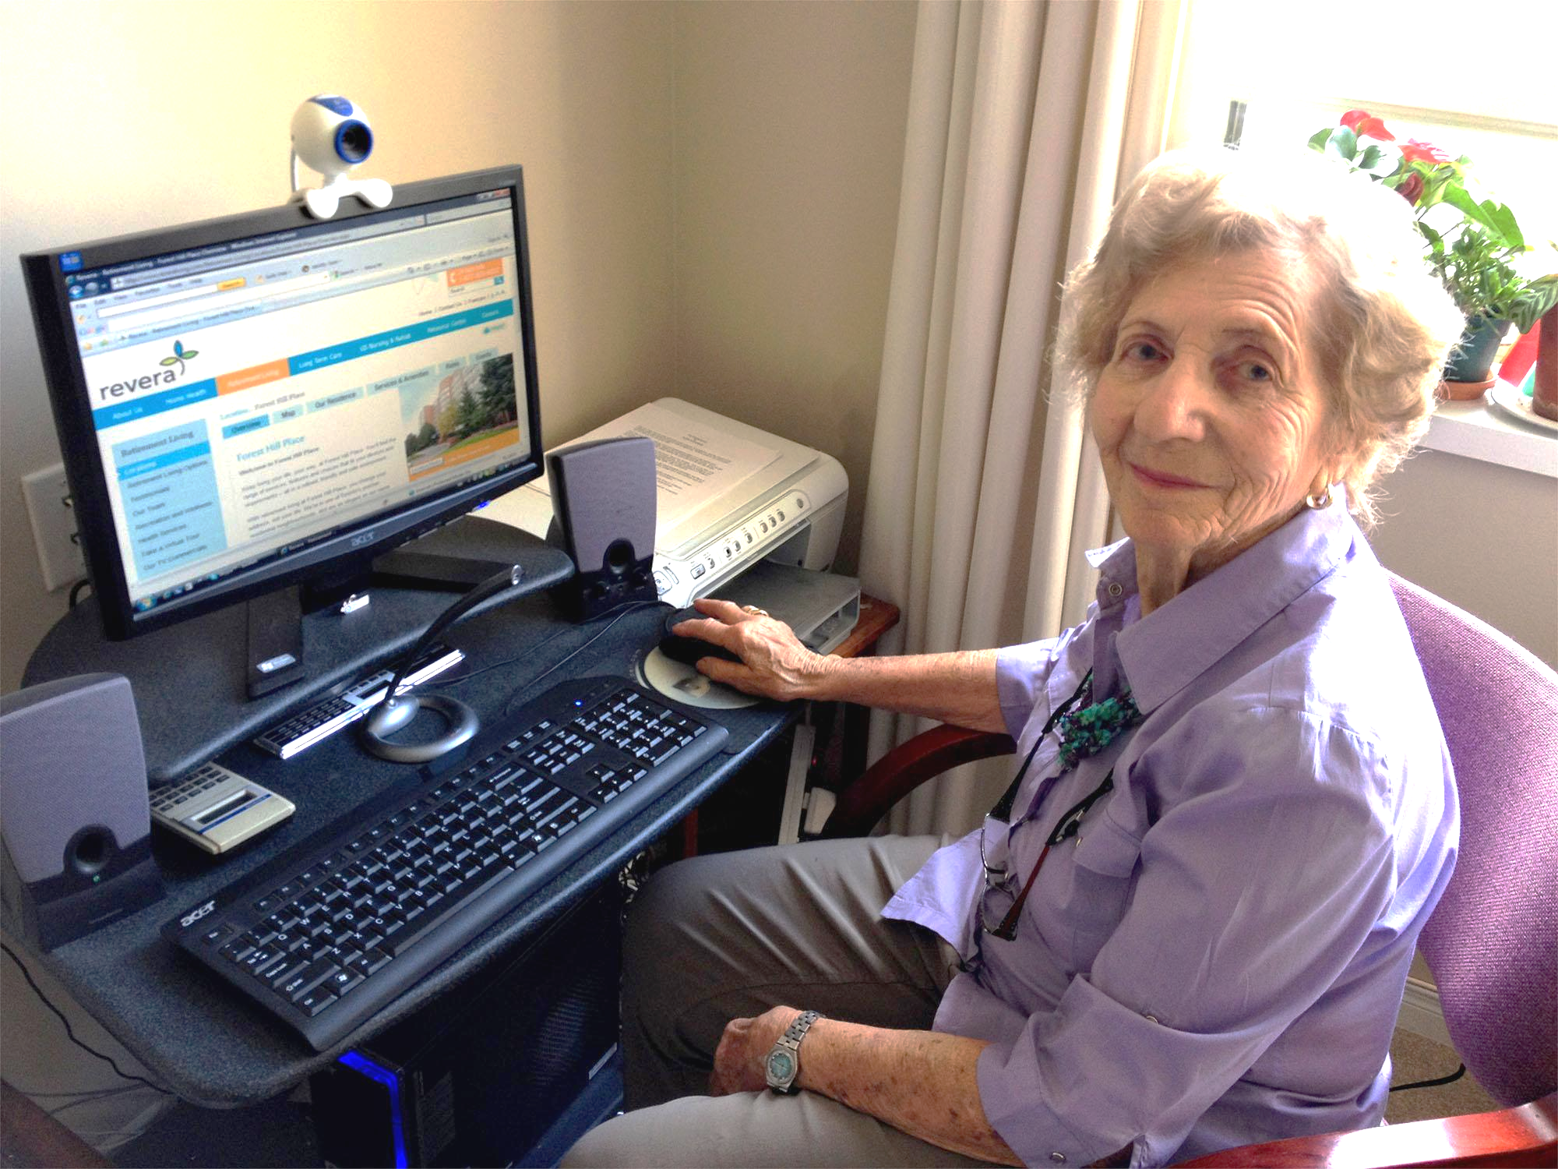 Older adult using technology during the COVID-19 pandemic (Graham, 2021).

Task 3 – Blog:
Easy Access online : Helping Older Adults Use NHS Services

Introduction
The NHS now uses apps to schedule doctor's appointments, check prescriptions, and keep track of health. Unfortunately, for many older adults, the move to digital healthcare can seem confusing or perhaps challenging (Health, 2025). In the UK, over 7% of homes are without internet access, and 10 million adults do not have basic digital skills. This is important because those who need healthcare the most may find it difficult to access it (NHS England, 2023).
The Challenge of Digital Healthcare for Older Adults
With over 30 million users, the NHS App provides access to prescription medications and medical records, but managing such a large digital platform can present significant challenges (Gov.UK, 2022). However, many older adults struggle to use the NHS App due to limited digital skills, low confidence with technology, or lack of access to devices. This digital exclusion can lead to missed appointments, delayed care, and poorer health outcomes (Kunonga et al., 2021).
Support and Inclusion Initiatives
Support is available to help older adults engage with digital healthcare. The NHS has developed a Digital Inclusion Framework, which promotes written alternatives, improves digital training programmes, and enhances app accessibility (Knight, 2024). With the goal to help older people feel more confident online, organisations like Age UK also host workshops and offer assistance. The goal of these initiatives is to bring older people into digital healthcare and not exclude them (Age UK, 2023).
The Role of Carers and Families
Carers and family members play an important role in supporting older adults with digital healthcare. They can encourage participation in local digital skills workshops, explain the benefits of using the internet, and assist them in trying out basic health apps (Doraiswamy et al., 2021). These simple, everyday actions can make a significant difference in boosting confidence, reducing isolation, and improving access to essential services.
Conclusion
Digital healthcare possesses the capacity to enhance the quality of life for all individuals, particularly elderly people. It's important to offer accessible training, reasonably priced gadgets, and paper-based solutions for individuals who want them in order to make sure they don't fall behind. If you are a family member or carer, think about discussing local digital support programmes with your doctor. Supporting your loved ones to use safe internet health resources can have a major effect. Together, we can make NHS services more user-friendly and accessible for everyone.

Task 4 – NHS Equality, Diversity and Inclusion Quiz
1. What is the primary goal of the NHS Equality, Diversity, and Inclusion Improvement Plan?
To establish an equitable and diverse NHS where disparities in health are reduced and all staff feel appreciated. To make it possible for everyone to thrive and provide better patient care, it aims to establish an atmosphere of connection.
2. How does the NHS EDI Improvement Plan propose to tackle the gender pay gap?
By increasing openness in pay data and promoting fair career advancement and flexible employment for all genders. To help to bridge gaps among departments and responsibilities, it also encourages frequent reviews and action plans.
3. What is meant by the term ‘intersectionality’ as used in the NHS EDI Improvement Plan?
It implies acknowledging how different aspects of identity, such as race, gender, and disability, converge to influence individuals' lives. This makes it easier for the NHS to understand and deal with overlapping inequalities.
4. Why is it important for the NHS to create a psychologically safe work environment?
It creates an environment where staff feel empowered to express themselves, contribute ideas, and raise concerns without fear. Improved teamwork, wellbeing, and more secure patient care result from this.
5. How does the NHS EDI Improvement Plan suggest improving the experience of internationally recruited staff?
By providing equitable treatment, enhanced assistance, and culturally sensitive induction and development opportunities. Additionally, it encourages mentoring and inclusive leadership to make employees feel appreciated and welcomed.
6. What role does leadership play in advancing EDI objectives according to the NHS Improvement Plan?
Leaders are anticipated to demonstrate inclusive conduct, assume responsibility, and advance progress on EDI objectives. Embedding EDI into daily decision-making and hearing staff input are also important.
7. Identify one way the NHS EDI Improvement Plan aims to reduce health inequalities within the workforce.
In order to increase access and results, it focuses on developing and supporting marginalised populations. This covers equal recruitment processes and specialised wellbeing assistance.
8. Why does the NHS EDI Improvement Plan emphasise the importance of collecting and analysing data on protected characteristics?
To find gaps, monitor development, and create strategies that successfully combat inequality. The NHS utilises excellent data to monitor impact over time and make well-informed decisions.
9. Explain how flexible working policies can contribute to equality and inclusion in the NHS workforce.
They make roles more accessible to individuals with varying situations by assisting employees in balancing their personal and professional obligations. In addition to promoting retention, flexible choices lower barriers for disabled employees and carers.
10. What is one strategy mentioned in the NHS EDI Improvement Plan to combat bullying and harassment in the workplace?
Establishing training and transparent reporting procedures to encourage accountability and courteous conduct. Further, the plan promotes early intervention and help for impacted workers (NHS England, 2023b).

Task 5 – A Letter to Yourself
Dear Me,
I recognise the significant burden you are presently bearing. You have to balance the responsibilities of a part-time job, managing a busy household, taking care of your two-year-old daughter, and dealing with the psychological and physical difficulties of pregnancy that are made worse by low iron levels. The anxiousness, the overpowering sense of tiredness, and the frequent tears are human reactions to exceptional situations, not signs of weakness. It is sufficient that you are trying your hardest.
Upon reflection, I regret not having introduced you sooner to the concepts of resilience and emotional intelligence, which I now understand more deeply. Despite simply controlling emotions, emotional intelligence goes further than recognising them, understanding their causes, and reacting to them in positive ways. Perhaps you would have felt more empathy for yourself and less guilt if you had known this. Recognising your feelings without passing judgement is a powerful wellness practice.
Despite not even realising it, you were developing resilience. Every time you got out of bed regardless of your exhaustion, every time you comforted your daughter while holding back your own tears, those were moments of great courage. True resilience is understanding when to ask for help, when to take a break, and when to be kind to oneself. It is not about enduring in silence.
I would remind you to breathe if I could go back in time to those difficult moments and sit next to you. I would assure you that you are not alone, that your emotions are real, and that your physical and mental well-being are important. I would advise you to write in a diary, talk to a friend, or perhaps see a therapist. It's a release, not a burden, to express your feelings.
Above all, I want you to understand that taking care of yourself is important and not selfish. You have much more strength than you realise, and you are learning and developing every day. Keep going, but give yourself permission to ease down when needed. You are doing an outstanding job, even when it seems like you are falling short.
With love and understanding,
Me
Task 6: Gantt Chart
I will be using a Gantt chart and timeline to strengthen my management skills through effective planning, organisation and tracking tasks (Project Manager, 2022).
To achieve my goal of becoming a nursing associate, I have created a structured timeline that reflects clear dependencies and realistic sequencing. By following this timeline, I can systematically build qualifications, experience, and a strong professional identity, ensuring readiness for employment in the health and social care sector.
Gantt chart colour key

Tasks Nov Dec Jan Feb Mar Apr May June July Aug Sept Oct Nov Dec
1- Complete level 5 H&SC
2- Update LinkedIn Profile
3-Develop CV
4- Cover Letter
5- Gain Work Experience
6- Complete Level 6 H&S
7-Apply For Jobs
8- Register with NMC

Colour | Statues
Green | Completed
Yellow | In progress
Blue | Not started



Task 7 – Making Changes – Report

Improving Healthcare through Digital Care Planning

Digital care planning in healthcare (Department of Health and Social Care, 2025).

Introduction
In my role as a care home manager, I propose substituting paper-based records with digital care planning. The purpose of this adjustment is to improve person-centred care delivery and record keeping in terms of accuracy, accessibility, and efficiency (Chen, Lehmann and Malin, 2024).
Managing the Change
Kotter's 8-Step Model will be used for the change, beginning with identifying existing inefficiencies to create urgency. To manage the transition, a group of senior carers and IT support will be formed. Before the new system is fully implemented, evaluations will be carried out and staff will receive training on its use. To enhance the process, input will be gathered on a regular basis (Kotter, 1995).
Skills Required
Effective interaction to convey the advantages, leadership to motivate employees, time management to plan training, and problem-solving to handle technical issues are all required abilities (Sikka et al., 2021).
Barriers | Solutions
Employee resistance: Some people could be uncertain of technology | To boost confidence, give staff practical training while engaging them in making decisions
Restricted resources: Buying gadgets may be limited by financial constraints | Phase the implementation or seek NHS funding for the digital transformation
Duration limits: Training time may be limited by daily care responsibilities | Plan short, adjustable training sessions for shorter periods

Conclusion
Digital care planning will improve staff productivity, lower mistakes, and improve the quality of care. Both patients and employees will gain from this change if it is carefully planned and supported.

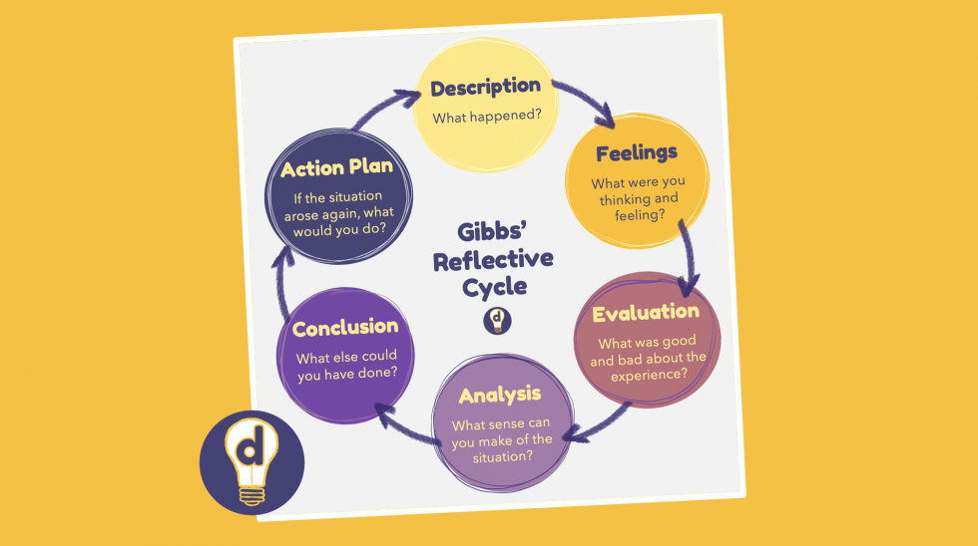
Task 8 – Self-Reflection
I used Gibbs' Reflective Cycle (1988) to reflect back on what I had learnt in this module, which allowed me to look at experiences, emotions, and professional growth in more detail while completing important tasks.
(Graham, 2021)
Description: Writing a letter to myself during the resilience and wellbeing session was one key experience. I had to identify my challenges and connect them to resilience and emotional intelligence in order to complete this work.
Feelings: In the beginning, the exercise made me feel vulnerable and emotional since it brought up memories of how difficult it was to manage work and family. But when I realised how far I had come, I was also relieved.
Evaluation: I was able to identify my strengths, like determination, and also my areas for growth, like asking for support sooner. Because it developed self-awareness, it was a positive experience.
Analysis: This was important since resilience and emotional intelligence are essential parts of social and health care. Understanding my feelings and ways to cope will enable me to effectively manage stress and assist others. My understanding of wellbeing and professional behaviour has been strengthened by connecting knowledge to practice.
Conclusion: I should have given more thought to achievable strategies for strengthening resilience, such as networking, which was covered earlier in this course, and time management, which we discussed later.
Action Plan: I will use emotional intelligence strategies going forward, ask for support when I need it, and continually engage in reflective practice. My ability to handle change and maintain wellbeing in work environments will become stronger as an outcome.

References

Age UK (2023) Helping Older People Improve Their Digital Skills, Age UK. Available at: https://www.ageuk.org.uk/our-impact/programmes/digital-skills/ (Accessed: 12 November 2025).
Chen, Y., Lehmann, C.U. and Malin, B. (2024) ‘Digital Information Ecosystems in Modern Care Coordination and Patient Care Pathways and the Challenges and Opportunities for AI Solutions’, Journal of Medical Internet Research, 26(2), p. e60258. Available at: https://doi.org/10.2196/60258.
Ding (2023) Graham Gibbs and the Value of Learning by Doing, Ding. Available at: https://ding.global/graham-gibbs-and-the-value-of-learning-by-doing/ (Accessed: 17 November 2025).
Doraiswamy, S., Jithesh, A., Mamtani, R., Abraham, A. and Cheema, S. (2021) ‘Telehealth Use in Geriatrics Care during the COVID-19 Pandemic—A Scoping Review and Evidence Synthesis’, International Journal of Environmental Research and Public Health, 18(4), p. 1755. Available at: https://doi.org/10.3390/ijerph18041755.
Gibbs, G. (1988) Learning by Doing, A Guide to Teaching and Learning Methods. Available at: https://dsdweb.co.uk/wp-content/uploads/2021/10/learning-by-doing-graham-gibbs.pdf (Accessed: 15 November 2025).
Gorbatov, S., Khapova, S.N. and Lysova, E.I. (2018) ‘Personal Branding: Interdisciplinary Systematic Review and Research Agenda’, Frontiers in Psychology, 9(9), pp. 1–17. Available at: https://doi.org/10.3389/fpsyg.2018.02238.
Gov.UK (2022) NHS App Hits over 30 Million sign-ups, GOV.UK. Available at: https://www.gov.uk/government/news/nhs-app-hits-over-30-million-sign-ups (Accessed: 2 October 2025).
Graham, J. (2021) Why Technology Matters so Much for Older People during a Pandemic, Silver Century Foundation. Available at: https://www.silvercentury.org/2021/05/why-technology-matters-so-much-for-older-people-during-a-pandemic/ (Accessed: 13 November 2025).

Health (2025a) Managing Healthcare Easy as Online Banking with Revamped NHS App, GOV.UK. Available at: https://www.gov.uk/government/news/managing-healthcare-easy-as-online-banking-with-revamped-nhs-app (Accessed: 2 October 2025).
Health (2025b) Patients to Benefit from cutting-edge NHS Care from Their Homes, GOV.UK. Available at: https://www.gov.uk/government/news/patients-to-benefit-from-cutting-edge-nhs-care-from-their-homes (Accessed: 14 November 2025).
Knight, L. (2024) Inclusive digital healthcare: what you need to know | NHS Confederation, www.nhsconfed.org. Available at: https://www.nhsconfed.org/publications/inclusive-digital-healthcare-what-you-need-know (Accessed: 12 November 2025).
Kotter, J. (1995) Leading change: Why Transformation Efforts Fail, Harvard Business Review. Available at: https://hbr.org/1995/05/leading-change-why-transformation-efforts-fail-2 (Accessed: 15 November 2025).
Kunonga, T.P., Spiers, G.F., Beyer, F.R., Hanratty, B., Boulton, E., Hall, A., Bower, P., Todd, C. and Craig, D. (2021) ‘Effects of Digital Technologies on Older People’s Access to Health and Social Care: Umbrella Review’, Journal of Medical Internet Research, 23(11), p. e25887. Available at: https://doi.org/10.2196/25887.
Mask, R. (2025) What Is Social Capital and Why Is It so Important?, Snhu.edu. Available at: https://www.snhu.edu/about-us/newsroom/career/what-is-social-capital (Accessed: 31 September 2025).
NHS (2019) Nursing Associate, Health Careers. Available at: https://www.healthcareers.nhs.uk/explore-roles/nursing/roles-nursing/nursing-associate (Accessed: 2 October 2025).
NHS England (2023a) Inclusive digital healthcare: a framework for NHS action on digital inclusion, NHS England. Available at: https://www.england.nhs.uk/long-read/inclusive-digital-healthcare-a-framework-for-nhs-action-on-digital-inclusion/ (Accessed: 2 October 2025).
NHS England (2023b) NHS England» NHS equality, Diversity and Inclusion (EDI) Improvement Plan, www.england.nhs.uk. Available at: https://www.england.nhs.uk/publication/nhs-edi-improvement-plan/ (Accessed: 15 November 2025).
Project Manager (2022) Ultimate Guide to Gantt Charts, Project Manager. Available at: https://www.projectmanager.com/guides/gantt-chart (Accessed: 13 November 2025).
Rözer, J., Mollenhorst, G. and Poortman, A.-R. (2015) ‘Family and Friends: Which Types of Personal Relationships Go Together in a Network?’, Social Indicators Research, 127(2), pp. 809–826. Available at: https://doi.org/10.1007/s11205-015-0987-5.
Sikka, V., Salvatore Di Somma, Galwankar, S.C., Sinha, S., Garg, N., Neilesh Talwalkar, Garg, S., Mahajan, P., Chauhan, V., Moreno-Walton, L., Siddharth Dubhashi, Dutta, V., Venkataramanaiah Saddikuti, Nanayakkara, P.W.B., Grover, J., Ketan Paranjape, Singh, S., Sharma, P., Sanjeev Bhoi and Sinha, T. (2021) ‘The World Health Organization Collaborating Center for Emergency and Trauma (WHO-CCET) in South East Asia, the World Academic Council of Emergency Medicine (WACEM), and the American College of Academic International Medicine (ACAIM) 2021 Framework for Using Telemedicine Technology at Healthcare Institutions.’, DOAJ (DOAJ: Directory of Open Access Journals), 14(3), pp. 173–179. Available at: https://doi.org/10.4103/jets.jets_105_21.
Vicary, E., Kapadia, D., Bee, P. and Brooks, H. (2025) ‘Mapping Support systems: a cross-sectional Examination of Personal Support networks, Perceived support, Mental Health outcomes, and help-seeking Behaviours among UK Undergraduate Students’, BMC Public Health, 25(1). Available at: https://doi.org/10.1186/s12889-025-24360-1.

