WORKSHEET 1 – TESTING (Using Variables)
[Copy and paste your original code from Moodle into this box. Do not change it.]
internal class Program
{
private static void Main(string[] args)
{
String Surname; //Declaring a string variable named Surname
int Age; //Declaring an int Variable called Age
String NationalInsuranceNumber; //Declaring a string variable named NationalInsuranceNumber
String UserDetails; //Declaring a string Variable named User Details

Console.WriteLine("Please Enter Your Surname");

Surname = Console.ReadLine();

Console.WriteLine("Please Enter your Age");
Age = int.Parse(Console.ReadLine());
while (Age > 100)
{

if (Age < 100)
{
Console.WriteLine("This Age is Valid");

}
else
{
Console.WriteLine("Please Enter a Valid age ");
break;
}
Console.ReadLine();
}

Console.WriteLine("Please Enter Your National Insurance Number");
NationalInsuranceNumber = Console.ReadLine();
if
(NationalInsuranceNumber == null)
{
Console.WriteLine("Please Enter a Valid National Insurance Number");
}
else
{
Console.Write("This is a Valid National insurance Number");
}

Console.WriteLine("These Are Your details " + Surname + ", " + Age + ", " + NationalInsuranceNumber);
UserDetails = Console.ReadLine();

Console.WriteLine("Please press Enter to exit the program");
Console.ReadKey();

}
}

- Original code:

Code Testing

For each test below, run your code and enter the values provided. Provide a screenshot of the programme running. Did the programme behave correctly or did it do something unexpected? Fill in a box for each test below.

Surname:
- Enter JONES
- Leave blank
- Enter 123

National Insurance Number:
- Enter PE 25 34 12 B
- Leave blank
- Enter AB 11 22 33 44 55 66 77 (ie too long for National Insurance number format)

Age
- Enter 34
- Enter 150
- Enter -4
- Enter a letter

Test:
Surname i. Enter JONES

Screenshot(s) of output:
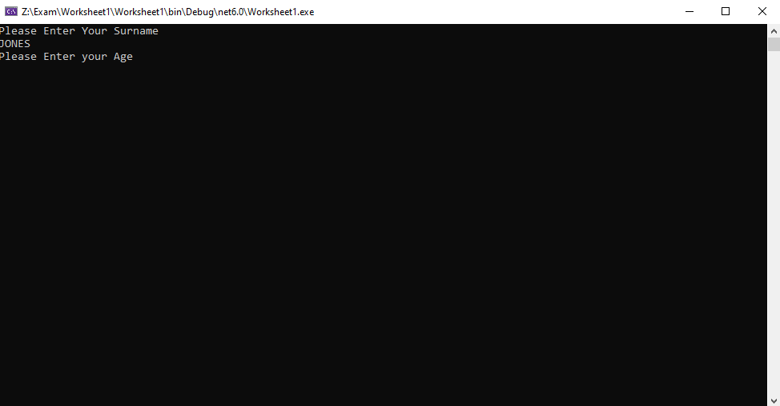
Result: Did the programme behave as expected ie syntactically and logically correct?

YES

Test:
Surname ii Leave blank

Screenshot(s) of output:
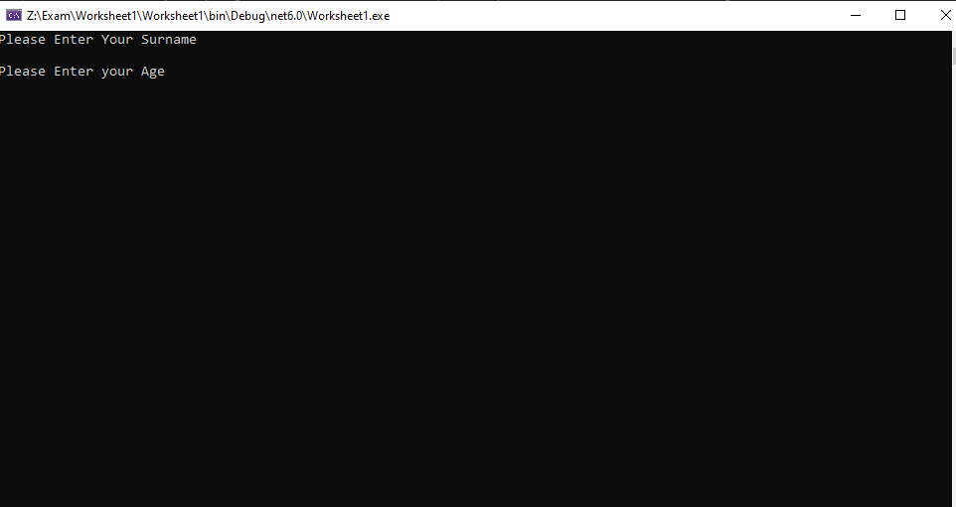
Result: Did the programme behave as expected ie syntactically and logically correct?
No , I should’ve included a presence check

Continue the rest of the tests below. (Copy and paste a box for each one)

Test:
Enter 123 into the surname
Screenshot(s) of output:
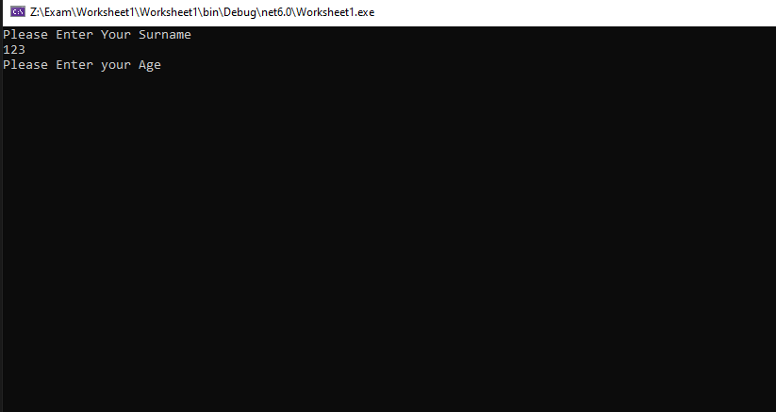
Result: Did the programme behave as expected ie syntactically and logically correct?
No, I should’ve added a validation check which checked for a valid surname

Test:
Enter PE 25 34 12 B

Screenshot(s) of output:
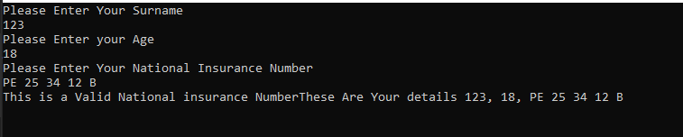
Result: Did the programme behave as expected ie syntactically and logically correct?
Yes

Test:
- Leave blank

Screenshot(s) of output:
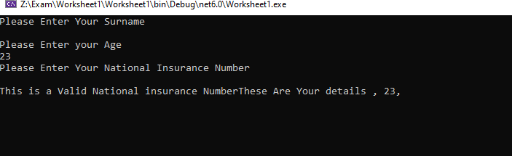
Result: Did the programme behave as expected ie syntactically and logically correct?
No, I needed to add a presence check that works, I put one in but the loop doesn’t function properly to make it work

Test:
- Enter AB 11 22 33 44 55 66 77 (ie too long for National Insurance number format)

Screenshot(s) of output:
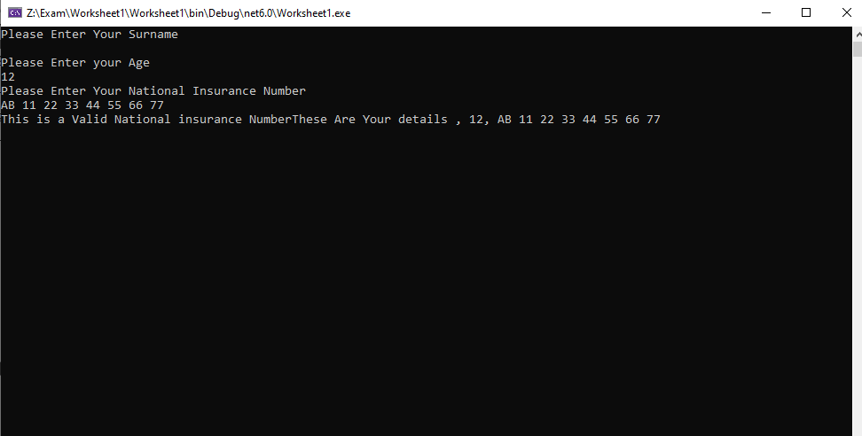
Result: Did the programme behave as expected ie syntactically and logically correct?
I should’ve added a range check to check for how long the input was

Test:
- Enter 34

Screenshot(s) of output:
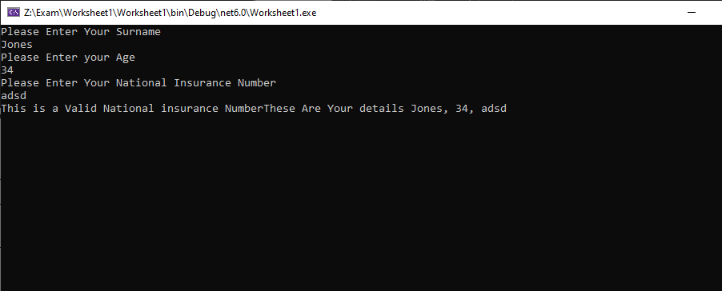
Result: Did the programme behave as expected ie syntactically and logically correct?
Yes

Test:
Enter 150

Screenshot(s) of output:
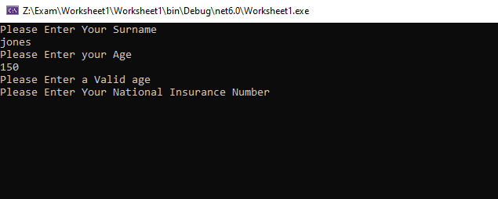
Result: Did the programme behave as expected ie syntactically and logically correct?
The Validation check works but it doesn’t loop back to the question to be able to fill it out again

Test:
Enter -4

Screenshot(s) of output:
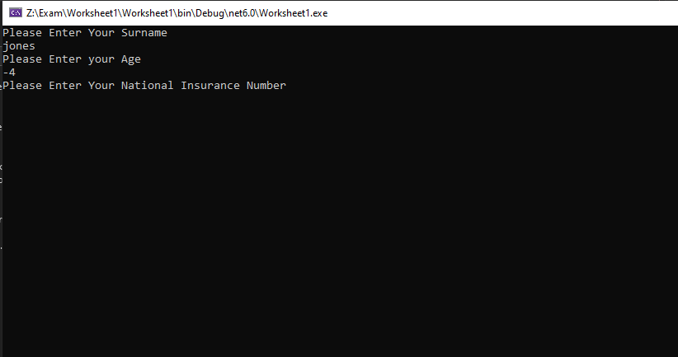
Result: Did the programme behave as expected ie syntactically and logically correct?
No, I didn’t take into account that people could put in minus numbers

Test:
- Enter a letter

Screenshot(s) of output:
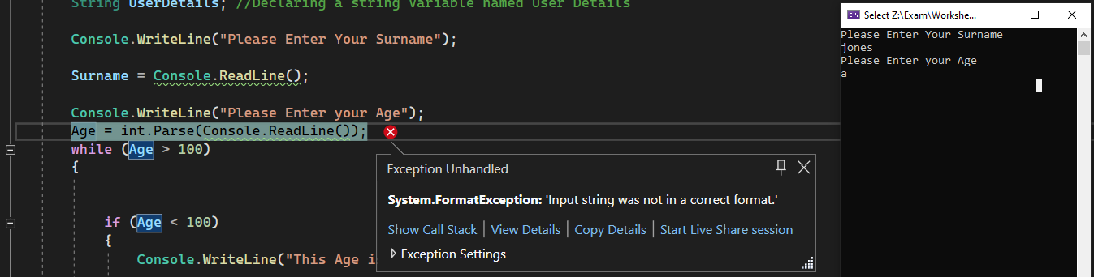
Result: Did the programme behave as expected ie syntactically and logically correct?
No, I think this is happening when I leave it blank because the age has to be in the int format for it to work which means that it breaks if an int isn’t put in

- Consider the results of the above tests and revisit your code in order to solve the problems. (Note: you may not be able to solve all of them, but solve as many as you can.)

Paste your revised code here:

using System.Runtime.CompilerServices;

internal class Program
{
private static void Main(string[] args)
{
String Surname; //Declaring a string variable named Surname
int Age; //Declaring an int Variable called Age
String NationalInsuranceNumber; //Declaring a string variable named NationalInsuranceNumber
String UserDetails; //Declaring a string Variable named User Details

Console.WriteLine("Please Enter Your Surname");
Surname = Console.ReadLine();

if
{
Surname == null || Surname.Length == 0) ;
Console.WriteLine("This is an invalid Surname Try Again");
}
else
{
Console.WriteLine("This is a Valid Surname");
}

Surname = Console.ReadLine();

Console.WriteLine("Please Enter your Age");
Age = int.Parse(Console.ReadLine());

if (Age < 100)
{
Console.WriteLine("This Age is Valid");

}
else
{
Console.WriteLine("Please Enter a Valid age ");

}
Console.ReadLine();

Console.WriteLine("Please Enter Your National Insurance Number ");
NationalInsuranceNumber = Console.ReadLine();
if
(NationalInsuranceNumber == null)
{
Console.WriteLine("Please Enter a Valid National Insurance Number ");
}
else
{
Console.Write("This is a Valid National insurance Number ");
}
Console.ReadLine();

Console.WriteLine("These Are Your details " + Surname + ", " + Age + ", " + NationalInsuranceNumber);
UserDetails = Console.ReadLine();

Console.WriteLine("Please press Enter to exit the program");
Console.ReadKey();

}
}

