LEARNING IN THE DIGITAL ERA (COMPUTING & ELECTRONICS)

ACCA4025

RORY EVANS (2218702)

BA COMPUTER GAMES DESIGN

Contents Page
Page 1: E-Portfolio
Page 2: Task 1- IEEE Referencing & written summary on essential academic and employment skills & Task 2 - Collaborative Teamwork
Page 3: Task 2 - Professional Academic poster & Task 3 - Professional Academic poster
Page 4: Task 4 - E-Portfolio creation and review
E-portfolio
Link to E-Portfolio ACCA4025
Homepage of E-Portfolio
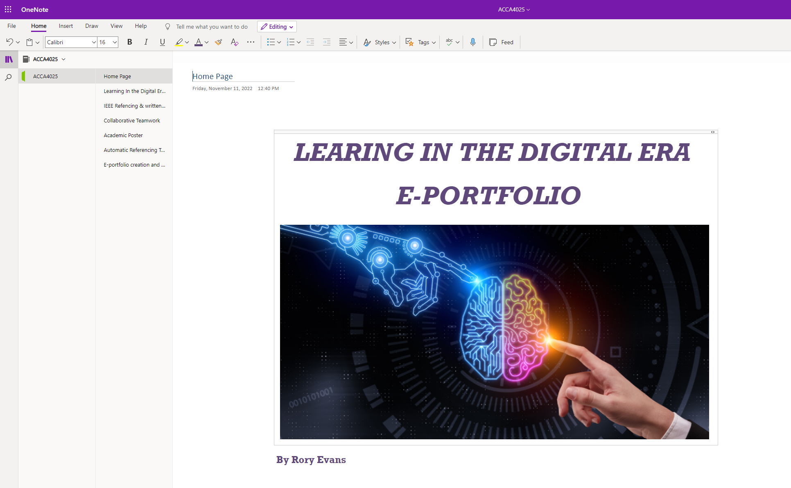

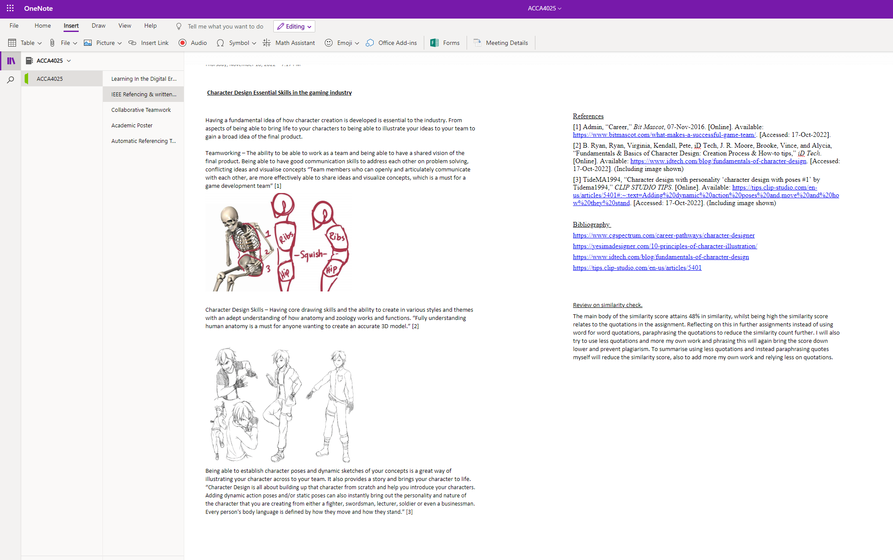
Task 1: IEEE Referencing & written summary on essential academic and employment skills

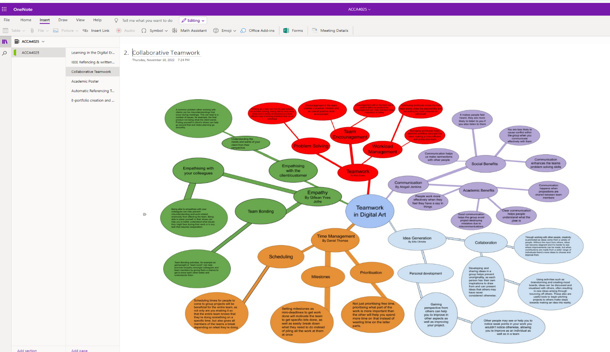
Task 2: Collaborative Teamwork

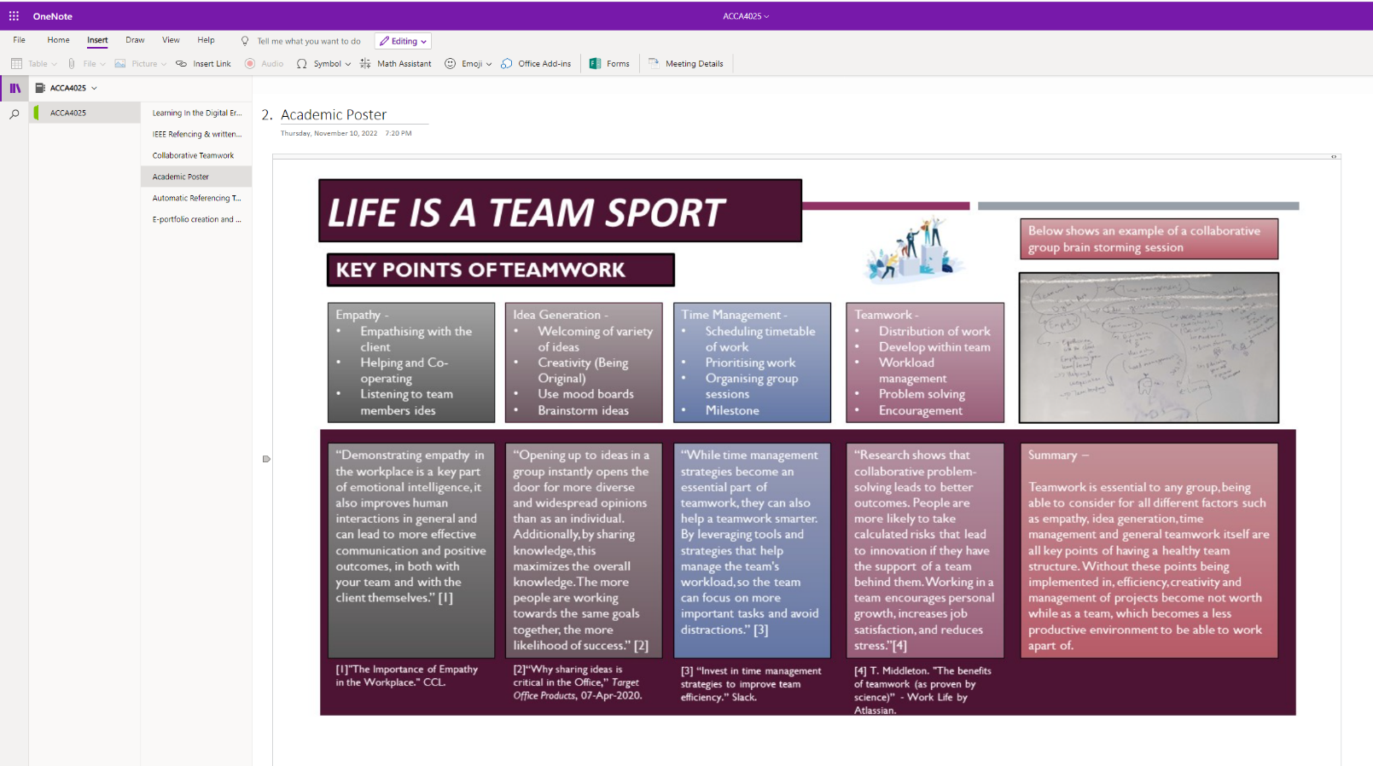
Task 2: Professional Academic poster - Academic poster final (1).pptx

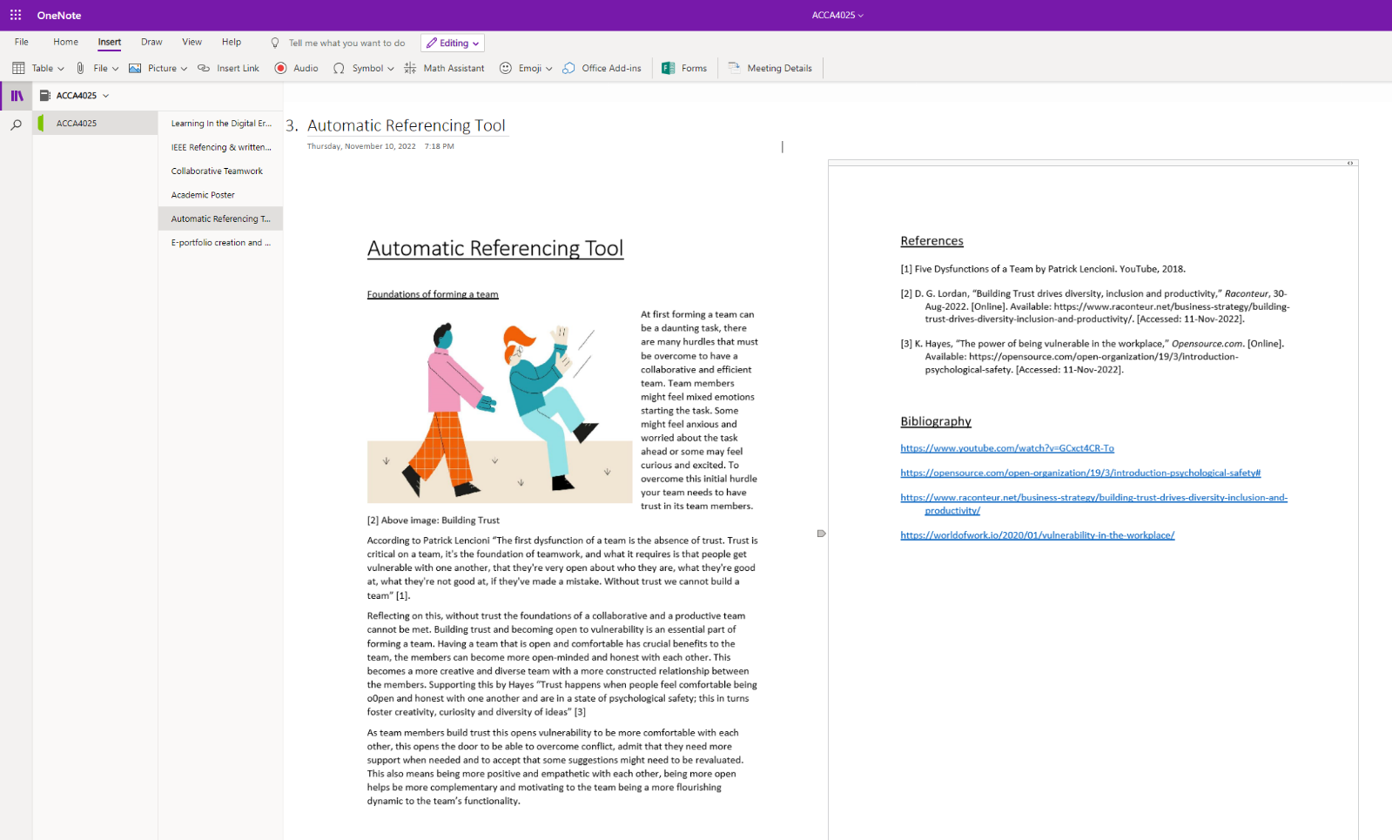
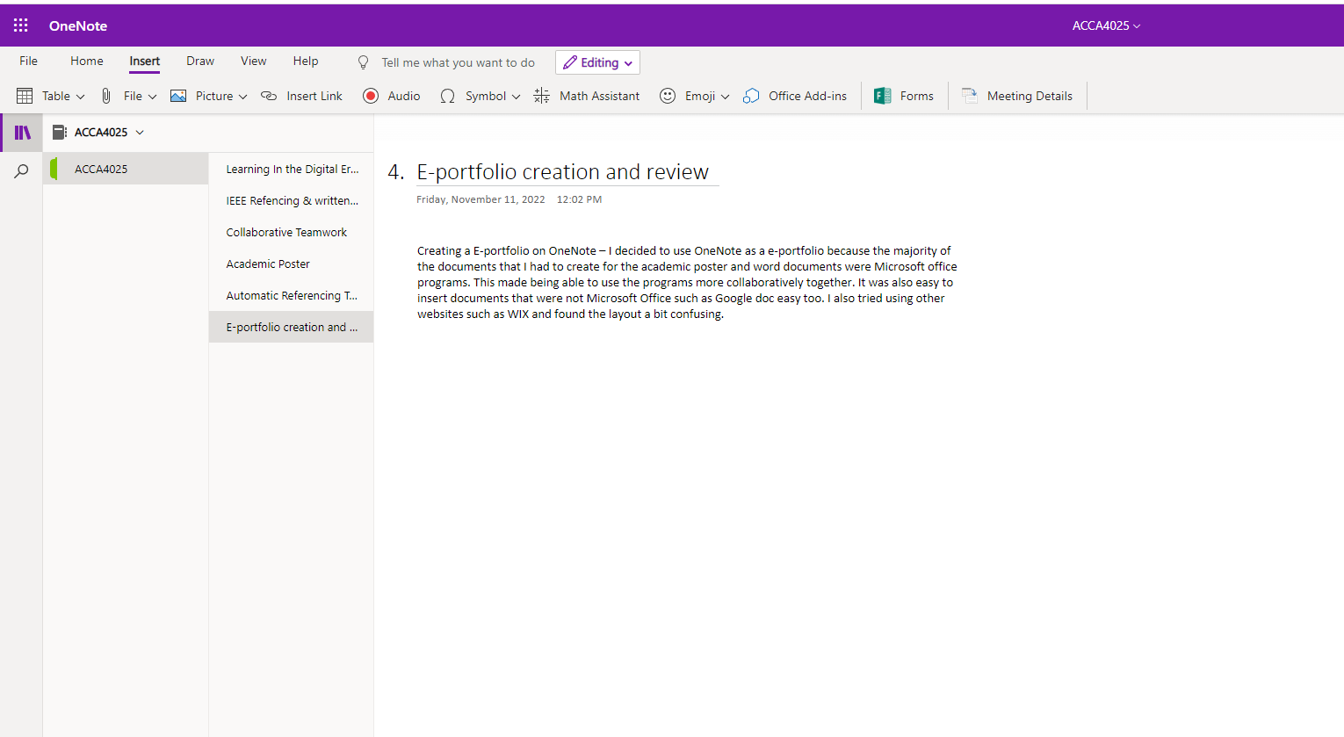
Task 3: Automatic Referencing tool
Task 4: E-portfolio creation and review

