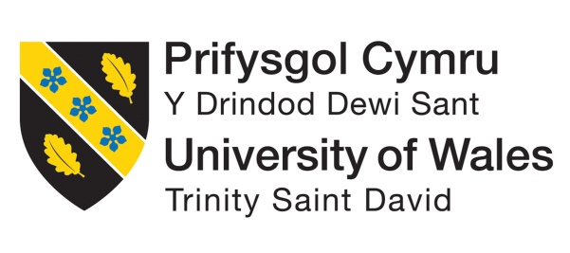

BMIH5004
Management and Organisational Behaviour
LEVEL 5
Student ID: 2130481
Lecturer: Giulia Chifari

Student Name
ID

Contents
Introduction 3
Organizational Structure 3
Culture 5
Goals 6
Change Initiatives 7
Strategic Direction and Current Business Performance 8
Conclusion 10
References 11

Introduction
Hyatt Hotels Corporation is a prominent global hospitality entity that manages franchises, owns ownership stakes, and controls the chain of hotels, resorts, and development of residential properties. The company manages over 875 properties across 60 countries spanning six continents. The aim of this report is to evaluate the organizational structure and culture of the company to determine its goals. Also, the study discusses recent change initiatives and their impact on business performance. Finally, the report analyzes the strategic direction and position of the company to determine its management approach that affects its functioning in the highly competitive hospitality sector.

Organizational Structure
An organizational structure serves as a framework that depicts how specific objectives and tasks are managed within an organization and governs the flow of information across different organizational levels. Likewise, it acts as a blueprint for resource allocation, task distribution, and coordination of organizational operations (Ahmady et al, 2016). The design of the organizational structure is influenced by several factors, such as the organization's size, business nature, strategic objectives, and other relevant considerations. These factors collectively mold the structure to ensure it effectively aligns with operational efficiency and strategic goals.
In centralized setups, decisions originate from higher authorities and flow downwards and there is a clear chain of command. While decentralized structures assign decision-making power to different levels within the organization and provide employees with significant independence and decision-making authority (Kenton, 2023).
There are various types of organizational structures such as hierarchical, functional, divisional, flat, and matrix layouts. It is imperative for senior management to consider multiple aspects like business goals, industry, and company culture before determining the most suitable organizational type (ANG, 2023).
- Hierarchical Structure is commonly found in larger organizations, characterized by multiple levels of authority interconnected through a chain of command.
- Functional Structure forms a company based on the specialization of its workforce and this structure is commonly adopted by SMEs.
- Divisional Structure, commonly embraced by large corporations with diverse business units, organizes the leadership team around the products, projects, or subsidiaries.
- Flat Strcuture has few or no middle management levels between leadership and employees. It is common in small businesses and startups due to their size and lack of hierarchy.
- Matrix Structure assigns employees to multiple supervisors, divisions, or departments simultaneously.
Hyatt Hotels Group combines aspects of both divisional and divisional structures and operates as a hybrid organizational structure. This type of structure blends elements from two or more organizational structures, commonly combining functional and divisional structures (Cornforth, 2020). This approach enables the company to manage its diverse portfolio of hospitality and hotels in an effective manner while ensuring clear lines of communication and accountability.
At the corporate level, Hyatt Group deploys an operative or functional structure in order to streamline diverse organizational functions such as sales and marketing, legal, finance, human resource, and accounts operations into departments. While, on the divisional side, Hyatt resorts and hotels are often grouped by geographic region or brand name. For instance, the company maintains separate business units for its various brands like Alila, Grand Hyatt, and Hyatt Regency. Additionally, Hyatt is geographically divided into three regions: Americas, Asia Pacific, and Europe, Middle East, and Africa (EMEA). This division allows employees to concentrate efforts on addressing the unique preferences and needs of customers in these respective regions (Organimi, 2020). By employing a hybrid structure, Hyatt enhances organizational flexibility and agility, enabling better resource allocation and navigation of change. This facilitates the implementation of new initiatives or projects across different areas of the group.
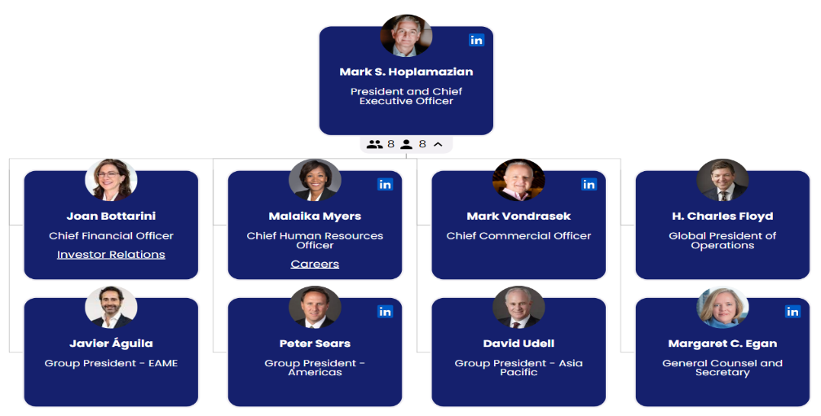

Hyatt Hotels Group Organizational Chart (Organimi, 2020)
Hyatt's Management Team, under the leadership of the President and CEO, take responsibility for the company's daily operations. They are supported by a team of C-level executives overseeing key functional domains including Finance, HR, and Operations, as well as geographic regions such as the Americas and Asia Pacific. Additionally, the Group maintains a Board of Directors tasked with upholding corporate governance standards, ensuring legal and regulatory compliance, and adhering to ethical guidelines and best practices.

Culture
Organizational culture encompasses the underlying values, beliefs, and principles that form the basis for an organization's management system, along with the set of behaviors and management practices that demonstrate and reinforce those principles. The culture of an organization can significantly impacts its success or failure as it influences decision-making processes and shapes employee attitudes and behaviors (Mohsen et al, 2020). It directly impacts the organization's responsiveness to change, highlighting the vital importance of effective change management for achieving success. According to the CIPD (2023), managing change effectively is vital due to the low success rate of change initiatives, which can greatly impact on employee retention and organization and organization's market position.
Handy's theory outlines four distinct management styles, each contributing to the formation of organizational culture over time (Cacciattolo, 2014).
- Person Culture prioritizes individual needs and interests over organizational goals. Employees in such cultures may feel more important than the organization itself and may lack loyalty to organizational objectives.
- Role Culture is characterized by the distribution of roles and responsibilities based on knowledge, training, and individual interests (Handy, 1986).
- Power Culture can be exemplified as a 'web,' in which control spreads like a network from the core to the rest of the organization, minimizing rules and bureaucracies. Consequently, authority and decision-making are controlled by a limited number of individuals who possess substantial power and receive special privileges.
- Task Culture prioritizes task completion, assembling appropriate resources and personnel within the organization to accomplish objectives efficiently.
Hyatt Hotels Group upholds a more structured culture characterized by defined roles and standardized procedures. The organizational culture of the company supports the Role Culture as everyone understands their place within the organizational hierarchy. The company has made significant progress in strengthening its diversity by providing inclusive leadership training to its managers, and in its talent management strategies (Hyatt Hotels Corporation, 2023). As a large company with numerous subsidiaries and units, Hyatt effectively adopts the Role Culture model to ensure a unified culture across all hotels and foster a predictable and flat system. The company prioritizes the recruitment, improvement, and retention of diverse talent to ensure fairness in its internal processes and strive for equity.
Although Role Cultures are typically slow to change, Hyatt manages change effectively through streamlined communication, training, and research and development processes. At Hyatt, employees operate with a sense of assurance and predictability, focusing on meeting standards rather than seeking power or control over their work.

Goals
The primary goal of the Hyatt Hotels Corporation extends far beyond the conventional hotel experience for its guests. As articulated on the Hyatt company website, their mission is to deliver genuine hospitality that positively impacts the lives of individuals they interact with daily. Additionally, the company aims to cultivate a workplace culture centered on respect and inclusivity for all guests and employees. Derived from this mission is Hyatt Corporation's objective for each of its brands to be the preferred choice of not only guests but also employees and owners.

Change Initiatives
In today's ever-changing and unpredictable business landscape, organizations must embrace strategies for managing change effectively. Organizational change embraces the initiatives undertaken by a company or business to modify significant aspects of its structure, including its culture, technologies, infrastructure, or internal processes (Errida and Lotfi, 2021).
The hospitality sector has continuously adapted to address emerging challenges and maintain a competitive edge. The uncertainties and fears associated with travel during the global COVID-19 pandemic have prompted hotels to rethink conventional business practices (Hanelt et al, 2021).
The pandemic significantly impacted Hyatt Group, leading to a substantial decline in bookings, reaching as low as 90% by April 2020 (Goldman, 2021). In response, Hyatt Group has prioritized technological advancements and adapted initiatives in line with guest preferences.
Nadler and Tushman (1989) distinguish four types of organizational change: tuning, adaptation, reorientation, and recreation. Tuning and adaptation focus on efficiency to make incremental adjustments in response to external factors. while adaptation modifies the firm's response to its environment through structured processes. In contrast, reorientation and recreation represent strategic changes. Reorientation anticipates external events, focusing on continuity while adjusting organizational values and structures. Recreation, on the other hand, emerges from external threats leading to drastic changes, to facilitate strategic shift and exploration.
Hyatt Hotel Group embarked on an initiative to elevate its digital hospitality experience by revamping its customer engagement approach. This endeavor involved the integration and enhancement of existing systems to offer a comprehensive range of capabilities across its hotels and resorts. To refine technology changes, Hyatt has strengthened capabilities within its existing team in order to streamline application development and management processes. The Group acknowledged the challenges associated with decentralized data, particularly in maintaining reliable systems and embraced technological change to improve its organizational processes.
This change falls under the quadrant of reorientation and fulfills strategic objectives due to the anticipated growth of digital transformation in hospitality industry. Meanwhile, Hyatt partnered with a leading smartphone provider to integrate digital keys into their wallet app (Escobar, 2023).
Hyatt sought assistance from Hapi; a user-friendly platform and application, to yield an off-the-shelf integration service and act as a quick collaborator in their digital transition. Hapi offers extensive event streams and transactional APIs, enabling hotel companies like Hyatt to accelerate innovation by facilitating integration, development, and deployment opportunities. The platform provides a comprehensive integration suite, efficiently leveraging and presenting data in a seamless manner, satisfying both guests and employees. This helps Hyatt to assess real-time data and make rapid decision-making to continuously refining and enhancing the key delivery process and its capabilities (Freed, 2022). Additionally, Hyatt Group is implementing intelligent messaging technology across its global portfolio, enabling personalized communication between guests and hotel staff. This integration caters to guests' inquiries both before their arrival and during their stay, in their preferred language and communication method.

Strategic Direction and Current Business Performance
Strategic direction entails the plans necessary for an organization to proceed towards its vision and accomplish its objectives. It plays a vital role in driving companies forward and effecting substantial changes. Furthermore, strategic direction provides clarity of purpose and objectives for the organization, ensuring that all stakeholders understand their role in achieving them (Fuertes et al, 2020). It involves determining the fundamental processes and values that position the organization for success, including its mission, culture, vision and core values.
Hyatt Group Strategic Direction
Mission: To provide unique and outstanding experience to its guests.
This distinctive guest-centric approach has positioned Hyatt as one of the leading hospitality brands globally.
Vision: To encourage environment of care and understanding
Coe Values: Respect, integrity, and humility
Hyatt’s core values guide its conduct, rooted in the conviction that empathy and kindness are powerful forces for promoting equality, fairness, and community cohesion (Hyatt Hotels Corporation, 2023).
Culture: Hyatt’s culture is committed to ensuring that equity, diversity, and inclusion are ingrained in its policies, protocols, and people (Hyatt Hotels Corporation, 2023).
This strategic direction enables the organization to guide its decisions and actions, with innovation, respect, authenticity, empathy, and humility shaping the culture of Hyatt Group and influencing its strategic path.
SWOT Analysis
Strengths
- Exceptional guest experience
- Strong global presence
- Diverse brand portfolio
- Strong financial performance with significant growth (Arif and Hossin, 2016)
- strategic partnerships
- Sustainability and innovation initiatives
Weaknesses
- High competition
- Risk of geographic dilution
- Compliance issues in new markets
- Significant financial and operational risks due to new acquisition and expansion
Opportunities
- Expansion in emerging markets
- Investment in digital transformation
- Sustainability initiatives
- Emphasis on wellness and immersive travel experiences
- Strategic partnerships with local governments and tourism authorities
Threats
- Regulatory challenges
- Highly competitive hospitality industry
- Changing customer preferences
- Economic downturns
- Geopolitical and cybersecurity risks
- Labor issues

Conclusion
The report has provided insights into the progress made by Hyatt Hotels Group in advancing its organizational culture to foster diversity, equity and inclusivity both within and beyond the organization with increased accountability and communication. Hyatt is placing a significant emphasis on fostering strategic direction across all levels and firmly believes that all stakeholders should reflect the diverse range of perspectives and experiences to cultivate progressive organizational culture. The company’s aim for a more equitable and inclusive Hyatt community is evident in its broad range of initiatives, commitments, and objectives which mainly emphasize developmental opportunities, employment practices, partnerships and support network.

References
Ahmady, G.A., Mehrpour, M. and Nikooravesh, A., (2016). Organizational structure. Procedia-Social and Behavioral Sciences, 230, pp.455-462.
ANG, J., (2023). What Is An Organizational Structure? Available at: https://venngage.com/blog/what-is-organizational-structure/ (Accessed: 23 February 2024).
Arif, T.M.H. and Hossin, M.Z., (2016). A comparative analysis of internal and external environments between Hotel Hyatt, UK and Hotel The Cox Today, Cox’s Bazar, Bangladesh. IOSR Journal of Humanities and Social Science, 21(6), pp.13-22.
Cacciattolo, K., 2014. Understanding organisational cultures. European scientific journal.
CIPD., (2023). Organisational Culture. Availab;e at: https://www.cipd.org/en/views-and-insights/cipd-viewpoint/organisational-culture/ (Accessed: 23 February 2024).
Cornforth, C., (2020). The governance of hybrid organisations. In Handbook on hybrid organisations (pp. 220-236). Edward Elgar Publishing.
Errida, A. and Lotfi, B., (2021). The determinants of organizational change management success: Literature review and case study. International Journal of Engineering Business Management, 13, p.18479790211016273.
Escobar, M. C. (2023). 2022 Hotel Visionary Winner: Hyatt Hotels. Available at: https://hospitalitytech.com/2022-hotel-visionary-winner-hyatt-hotels (Accessed: 23 February 2024).
Freed, J., (2022). How Hyatt Powers an Innovative Digital Guest Experience with Real-Time Data. Available at: https://www.hospitalitynet.org/news/4111647.html (Accessed: 23 February 2024).
Fuertes, G., Alfaro, M., Vargas, M., Gutierrez, S., Ternero, R. and Sabattin, J., (2020). Conceptual framework for the strategic management: a literature review—descriptive. Journal of Engineering, 2020, pp.1-21.
Goldman, S., (2021). The technology innovation behind Hyatt's pandemic pivot indicates a long-lasting change in the hotel industry. Available at: https://www.businessinsider.com/hyatt-cco-on-how-technology-changed-hotel-business-marketing-model-2021-9 (Accessed: 23 February 2024).
Handy, C., (1986). Understanding organizations. Penguin Uk.
Hanelt, A., Bohnsack, R., Marz, D. and Antunes Marante, C., (2021). A systematic review of the literature on digital transformation: Insights and implications for strategy and organizational change. Journal of Management Studies, 58(5), pp.1159-1197.
Hyatt Hotels Corporation., (2023). Culture – Caring for People. Available at: https://about.hyatt.com/en/world-of-care/caring-for-people.html (Accessed: 23 February 2024).
Hyatt Hotels Corporation., (2023). DIVERSITY, EQUITY & INCLUSION. Available at: https://about.hyatt.com/en/world-of-care/caring-for-people/Diversity-equity-inclusion.html (Accessed: 23 February 2024).
Hyatt Hotels Corporation., (2023). POLICIES, STATEMENTS & REPORTING. Available at: https://about.hyatt.com/en/world-of-care/policies-statements-reporting.html (Accessed: 23 February 2024).
Kenton, W., (2023). Organizational Structure for Companies With Examples and Benefits. Available at: https://www.investopedia.com/terms/o/organizational-structure.asp (Accessed: 23 February 2024).
Mohsen, A., Neyazi, N. and Ebtekar, S., (2020). The impact of organizational culture on employees performance: an overview. International Journal of Management (IJM), 11(8), pp.879-888.
Nadler, D.A. and Tushman, M.L., (1989). Organizational frame bending: Principles for managing reorientation. Academy of Management Perspectives, 3(3), pp.194-204.
Organimi., (2020). Hyatt Hotels’ Organizational Structure. Available at: https://www.organimi.com/organizational-structures/hyatt-hotels/ (Accessed: 23 February 2024).

