TITILE PAGE
Student Name: Kingsley Adu Brefo
Student ID :2424521
Module code: BMHP5014
Assignment Title: component 1
Lecturer Name: Zarah Ahmed

Task 1: concept Map
Figure 1.1: Concept Map Content
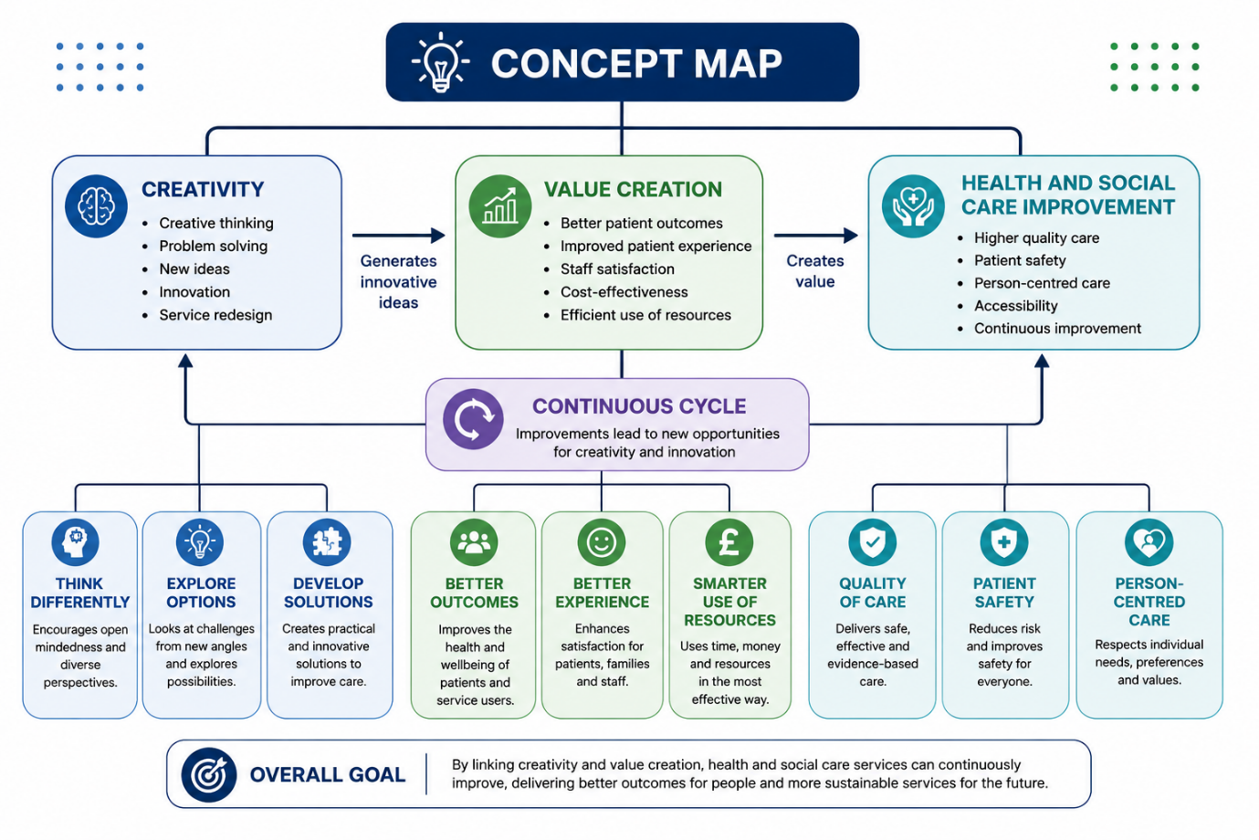
The concept map demonstrates the relationship between creativity, value creation, and health and social care improvement. These concepts are closely linked because creativity often acts as the starting point for innovation and service development within health and social care organisations.
Creativity involves generating new ideas, thinking differently, and finding solutions to existing challenges. In health and social care settings, professionals use creativity to redesign services, improve care processes, and develop innovative ways of meeting the needs of patients and service users. For example, digital healthcare technologies and new approaches to patient care have emerged through creative thinking.
When creative ideas are implemented successfully, they create value. Value creation occurs when healthcare services achieve better outcomes for patients while making effective use of available resources (Gray, 2020). This value can be seen through improved patient experiences, increased staff satisfaction, greater efficiency, and better health outcomes. In addition, value creation helps organisations respond to increasing demands while maintaining high standards of care.
The value created through innovation contributes directly to health and social care improvement. Improvements may include safer services, higher quality care, increased accessibility, and more person-centred approaches. These improvements benefit both patients and healthcare organisations. As services improve, new opportunities for innovation emerge, encouraging further creativity and continuous development. This creates an ongoing cycle of improvement where creativity generates value, value drives service improvement, and improved services encourage new creative solutions (Nolte, 2018).
Task 2 – Self-Reflection of Group Activity
I have used Gibbs' Reflective Cycle (1988) to reflect on the Convergent and Divergent Paperclip Thinking activity. Convergent thinking involves analysing information to identify the most appropriate solution to a problem, whereas divergent thinking involves generating a variety of creative ideas and exploring multiple possible solutions (Cropley, 2023). During the activity, my group was asked to think of as many different uses for a paperclip as possible. Although the exercise focused mainly on divergent thinking, I realised that I initially approached it using convergent thinking.
At the beginning of the activity, I only thought about the paperclip's intended purpose, which was holding sheets of paper together. My ideas were limited because I concentrated on the object's designed function instead of considering alternative possibilities. This showed that I was focusing on finding one correct answer rather than exploring a range of ideas.
As the discussion progressed, other members suggested using a paperclip as a phone stand, a SIM card removal tool, a keyring and a small craft tool. Listening to these ideas encouraged me to think more creatively and helped me move from convergent to divergent thinking. As more suggestions were shared, I became more confident in contributing my own ideas. I noticed that one person's suggestion often inspired another idea, demonstrating how creativity can develop through collaboration.
Initially, I felt uncertain because I struggled to think beyond the paperclip's normal purpose. However, I became more engaged as the activity continued and realised there were no right or wrong answers. This made me feel more comfortable sharing ideas without worrying about making mistakes.
Looking back, I believe the activity was effective because it encouraged teamwork and allowed everyone to contribute. The group primarily used divergent thinking, as our aim was to generate as many ideas as possible rather than select the best one. Working together helped produce more creative ideas than I would have developed on my own. One limitation was that I restricted my own thinking at the beginning by focusing too much on the paperclip's intended use.
This experience helped me understand the importance of being open-minded when solving problems. In health and social care, practitioners frequently encounter situations where there is no single correct solution. Using divergent thinking enables professionals to consider a range of possible approaches to meet the individual needs of service users before applying convergent thinking to select the most appropriate course of action. This supports person-centred care by encouraging flexible and creative problem-solving.
Task 3 – Case Study of a UK Innovation
One of the most successful innovations introduced by the NHS is the NHS App. The app was launched to provide patients with easier access to healthcare services through a digital platform. Users can book appointments, order repeat prescriptions, view their health records, and access NHS services from their smartphones or computers. The development of the NHS App demonstrates how creativity can be used to solve healthcare challenges and create value for both patients and healthcare organisations (NHS England, 2024).
Before the introduction of the app, many patients relied on telephone calls or face-to-face visits to manage routine healthcare needs. This often resulted in long waiting times and increased administrative pressure on healthcare staff. The creative idea behind the NHS App was to use digital technology to simplify these processes and make healthcare services more accessible. Rather than continuing with traditional methods, the NHS adopted a more innovative approach that reflected the increasing use of technology in everyday life.
The NHS App has created significant value for patients. One important benefit is improved accessibility. Patients can access healthcare information and services at a time that suits them, without needing to contact a GP practice directly. This is particularly valuable for individuals with busy schedules, mobility difficulties, or long-term health conditions. By providing access to personal health information, the app also encourages patients to become more involved in managing their own health and wellbeing.
The innovation has also created value for healthcare organisations. By reducing the number of routine phone calls and administrative tasks, healthcare staff have more time to focus on direct patient care. NHS England (2024) reports that millions of users now access services through the app, demonstrating its widespread adoption across the country. This has helped improve efficiency while supporting the NHS's wider digital transformation agenda.
Creativity played a key role in the success of the NHS App because it challenged traditional approaches to healthcare delivery. Instead of simply improving existing systems, the NHS developed a new way of connecting patients with services. Murray et al. (2023) argue that digital health innovations can improve patient engagement, communication, and access to care when designed around user needs.
Overall, the NHS App is an excellent example of how creativity can drive innovation within health and social care. The app has created value by improving accessibility, increasing efficiency, supporting patient involvement, and helping healthcare organisations deliver more responsive services. Its success demonstrates how innovative thinking can contribute to meaningful and sustainable improvements in healthcare.
Task 4 – Research Task
Mental health stigma continues to be a major issue within health and social care in the UK. Although awareness of mental health has increased, many people still experience discrimination, negative attitudes, and fear of being judged because of their mental health condition. This can affect whether individuals seek help and access the support they need.
One study by Hanlon and Swords (2022) explored the reasons why mental health stigma continues to exist. The researchers found that many people still have misconceptions about mental illness, often linking mental health conditions with weakness, danger, or unpredictability. These stereotypes can lead to prejudice and discrimination. The study also found that social attitudes and media portrayals can influence how mental health conditions are perceived. As a result, some individuals avoid discussing their mental health concerns because they fear being treated differently by others.
A second study by Knaak et al. (2023) examined stigma within healthcare environments. The researchers found that although healthcare professionals are trained to provide care, negative attitudes towards mental illness can still exist within healthcare settings. Some patients reported feeling dismissed or misunderstood when discussing their mental health concerns. The study suggested that a lack of knowledge, limited training, and unconscious bias can contribute to these experiences. The authors argued that improving mental health education and awareness among healthcare workers could help reduce stigma and improve patient care.
While both studies focus on mental health stigma, they identify different causes of the problem. Hanlon and Swords (2022) highlight the influence of public attitudes and stereotypes, whereas Knaak et al. (2023) focus on barriers that exist within healthcare services. Together, these studies demonstrate that stigma is influenced by both societal and professional factors.
Thus, mental health stigma remains a significant challenge because it discourages help-seeking behaviour and can negatively affect the quality-of-care people receive. Addressing misconceptions, increasing education, and promoting greater awareness are important steps towards creating a more supportive and inclusive health and social care system.
Task 5 – Podcast Script
Task 6 – NHS Leadership Framework Analysis
The NHS Healthcare Leadership Model was developed to support leadership at all levels of the NHS. Rather than viewing leadership as the responsibility of managers alone, the framework recognises that everyone can contribute to improving services and influencing positive change. The model consists of nine dimensions: inspiring shared purpose, leading with care, evaluating information, connecting services, sharing the vision, engaging the team, holding to account, developing capability, and influencing for results (NHS Leadership Academy, 2013). These dimensions provide a guide for how effective leaders should behave when working with patients, colleagues, and organisations.
The leadership approach reflected in the NHS Healthcare Leadership Model is closely aligned with transformational leadership. Transformational leaders motivate and inspire employees by creating a shared vision, encouraging innovation, supporting professional development, and empowering staff to improve practice (Northouse, 2022). This leadership style is particularly appropriate in healthcare settings that are undergoing change, introducing new ways of working, or seeking to improve the quality of patient care. During periods of organisational change, transformational leadership helps staff remain motivated, engaged and committed to achieving shared goals.
The framework is important because healthcare environments are complex and constantly changing. Leaders are expected to support high-quality care while responding to challenges such as workforce pressures, increasing demand, and limited resources. According to Storey and Holti (2013), effective leadership encourages collaboration, innovation, and continuous improvement across healthcare services. The framework also promotes values such as compassion, accountability, and teamwork, which are essential for creating positive workplace cultures and improving patient outcomes.
One component of the framework that is particularly important for encouraging creativity is engaging the team. This dimension focuses on involving staff in decision-making, listening to different perspectives, and creating an environment where people feel valued and respected. When employees feel that their opinions matter, they are more likely to contribute ideas and suggest improvements. This is especially important in health and social care because frontline staff often have direct experience of the challenges faced by patients and service users.
To apply this leadership style effectively, leaders require several key skills. These include effective communication, emotional intelligence, active listening, problem-solving, teamwork, decision-making, conflict resolution, and the ability to motivate and inspire others (Northouse, 2022). These skills enable leaders to build trust, encourage collaboration, and create a positive working environment where staff feel confident sharing ideas and participating in service improvement.
West et al. (2022) argue that compassionate and inclusive leadership helps create psychological safety, allowing staff to speak openly, share ideas, and take part in innovation. For example, a team member may identify a more efficient way of delivering services or improving patient experiences. By encouraging open communication and collaboration, leaders can help transform these ideas into practical improvements. As a result, engaging the team not only supports creativity but also contributes to better quality care, improved staff wellbeing, and more positive outcomes for patients.
Task 7 – Self-Reflection Journal Entry
Throughout this module, my understanding of creativity in health and social care has changed significantly. Before starting the module, I viewed creativity mainly as the ability to produce new ideas or artistic work. However, I now understand that creativity is also about finding practical solutions to real problems and improving the experiences of service users.
One of the most valuable lessons I learned was that creativity and value creation are closely connected. An idea only becomes valuable when it has a positive impact on people, organisations, or communities. Through activities such as the paperclip thinking exercise and the development of my CareConnect UK project, I realised that innovation often begins with identifying a problem and then exploring different ways to address it. This helped me appreciate the importance of thinking beyond traditional approaches when designing services.
The module also showed me that value in health and social care is not only measured by financial outcomes. Value can be created by improving wellbeing, increasing access to support, promoting independence, and enhancing the quality of life of service users. This understanding influenced the development of my CareConnect UK proposal, which focused on reducing loneliness among older adults through technology and community support.
As I progress in my professional career, I will apply this learning by remaining open to new ideas and looking for opportunities to improve services. I now recognise that creativity is an important skill for anyone working in health and social care because it can lead to meaningful improvements that benefit both individuals and communities.

Reference
Cropley, A.J. (2023) Creativity: A Very Short Introduction. Oxford: Oxford University Press.
Gibbs, G. (1988) Learning by Doing: A Guide to Teaching and Learning Methods. Oxford: Oxford Polytechnic.
Gray, M. (2020) Value Based Healthcare. 2nd edn. Newcastle upon Tyne: Cambridge Scholars Publishing.
Hanlon, H.R. and Swords, L. (2022) ‘Why mental health stigma persists: Understanding public attitudes towards mental illness’, Journal of Mental Health, 31(6), pp. 787–794.
Knaak, S., Modgill, G. and Patten, S. (2023) ‘Mental illness stigma in healthcare: Improving attitudes and reducing barriers to care’, Healthcare Management Forum, 36(2), pp. 89–95.
Murray, E., Hekler, E.B., Andersson, G. and Collins, L.M. (2023) ‘Evaluating digital health interventions: Key considerations for healthcare improvement’, Journal of Medical Internet Research, 25, e46329.
NHS England (2024) NHS App. Available at: https://www.nhs.uk/nhs-app/ (Accessed: 28 June 2026).
NHS Leadership Academy (2013) Healthcare Leadership Model. Leeds: NHS Leadership Academy.
Nolte, E. (2018) ‘How do we ensure that innovation in health service delivery and organisation is implemented, sustained and spread?’, World Health Organization Health Evidence Network, 57, pp. 1–44.
Storey, J. and Holti, R. (2013) Towards a New Model of Leadership for the NHS. Birmingham: NHS Leadership Academy.
West, M., Eckert, R., Collins, B. and Chowla, R. (2022) Compassionate Leadership and Innovation in Health and Social Care. London: The King's Fund.

