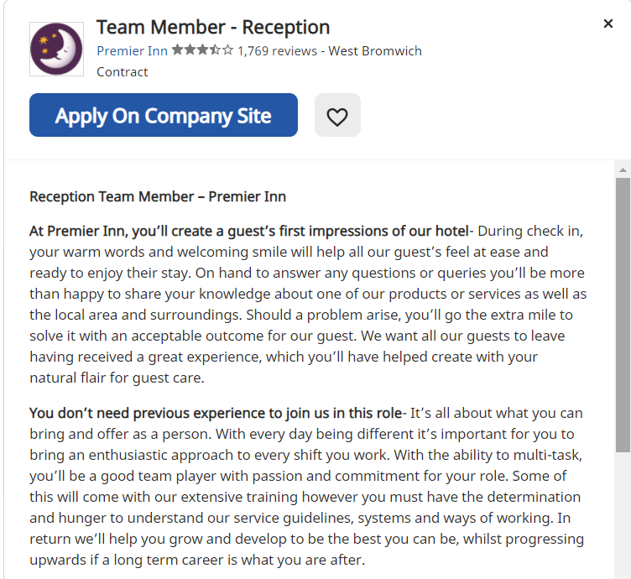
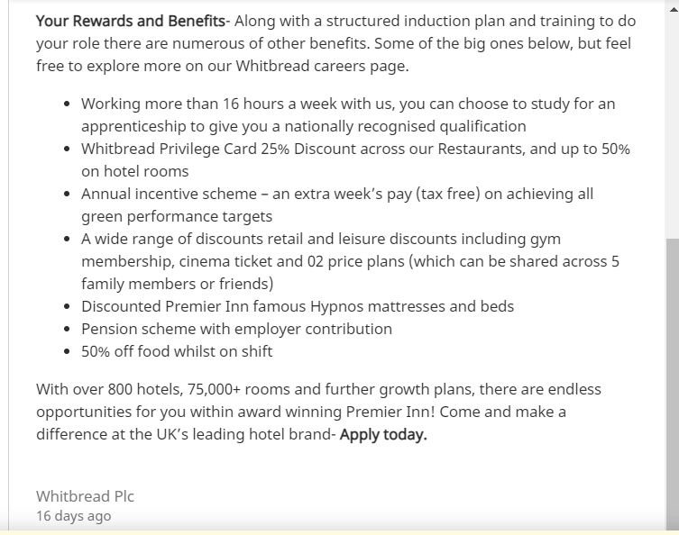#
ALEXANDRU COPACIU
Phone 07464748409
E-mail: alexandru.copaciu59@gmail.com
PROFILE
Self-motivated, responsible, and highly devoted in the workplace with experience in hospitality industry and knowledge to handle a vast selection of administration duties. In the past I have used successfully own initiative and I am a good team worker looking for the exciting role as Hotel Receptionist that it will give me the opportunity to incorporate my professional skills set with my passion.
EXPERIENCE
PICK PACKER/ HTA Group Limited, Coventry, UK (2015 - present)
DRIVER - Compiling deliveries according to customer invoice and instructions as
part of a multi-disciplinary team within the warehouse
- Inspected and inventoried stock to ensure minimal waste and product
damage, protecting the organisations investments and assets
- Deliver the merchandise whenever it is needed

HOTEL San Luca Hotel, Spoleto, Italy (2012 - 2015)
RECEPTIONIST - Interacted with potential customers over the phone, acting as a first point
contact and generating income for the hotel by taking and confirming
bookings.
- Pro-actively assisted management with ad hoc tasks and took a flexible
approach to assisting teammates with responsibilities to provide a high
quality service to guests and visitors

STOREMAN Pensa Silvana, Spoleto, Italy (2011 - 2012)
- Received merchandised and inspected them for damage
- Stocking shelves
- Packing and sending orders to costumers
SKILLS
- Safety conscious – Good knowledge of health and safety legislation e.g., Fire evacuation
- Written and verbal communication skills - Developed them in
the 9 years’ experience in logistics and customer services roles
- Great team worker – Accustomed to working in group during the projects from the academic year at University of Wales
- Microsoft Office – Good capability of using the office programs for the creation of professional documents
EDUCATION
CERTIFICATE IN HIGHER EDUCATION/ TECHNICIAN IN TOURISM LEVEL 3
SKILLS FOR THE WORKPLACE Roznov High School, Romania
University of Wales Trinity Saint Davis (2020- present) (2006-2010)

LANGUAGES English C1 Italian C2 Romanian C2
References on request

ALEXANDRU COPACIU

46 Bewick Croft, Coventry, CV2 4QR
alexandru.copaciu59@gmail.com
07464748409
February 19, 2021
Premier Inn
West Bromwich
Re: Reception Team Member

Dear Sir/Madam,
I would like to express my interest in the vacancy role of Reception Team Member position as seen on Indeed website. I have attached a copy of my CV outlining my skills and experience for your attention.
I am a self-motivated person with a positive attitude with prior experience in the hospitality industry. As mentioned in my CV, I have worked for three years for the San Luca Hotel, in Italy, where I gained skills such as verbal communication and guest interaction, problem solving, and attention to detail. I prioritise guest experiences and customer service in all my job roles. I am ambitious and enthusiast which I think it will bring value to the Premier Inn Hotel brand.
I believe that my experience and my skills would make me a good candidate for the job role and hope that you will consider my application. The passion that I have for the workplace inspires me to do better and it motivates me to grow and develop myself.

I would appreciate the opportunity to speak to you regarding my candidacy . I am looking forward hearing from you. Please feel free to call me at 07464748409 or to email me at Alexandru.copaciu59@gmail.com.

Yours faithfully,
Alexandru Copaciu

