

LOCATION: Swansea | LLEOLIAD: abertawe
LEVEL 7 | LEFEL 7
EXAMINATION PERIOD | CYFNOD ARHOLIADAU
MAY 2021 | MAI 2021

MODULE CODE: ACCA7029
COD Y MODWL: ACCA7029
ENTERPRISE CORE NETWORKING
TIME: 3 HOURS

Name : Peng Xu

Student ID : 2006614

Date & Time : 4/5/2021

This is an individual practical test, held under examination conditions. You will be assigned three Switches and three Routers; you should configure these devices based on the given specifications.

This paper is marked out of 100.

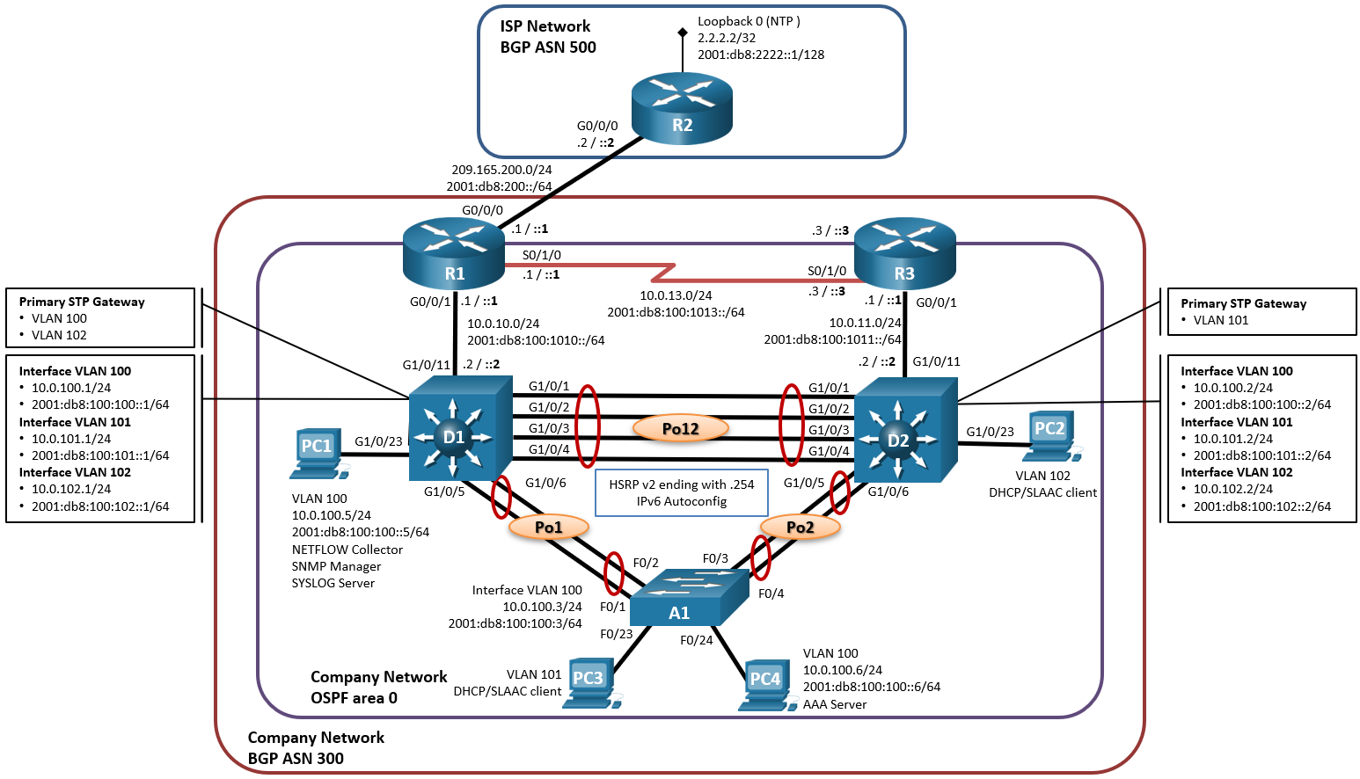
Topology

255.255.255.248
Addressing Table
Device | Interface | IPv4 Address | IPv6 Address | IPv6 Link-Local
R1 | G0/0/0 | 209.165.200.225/27 | 2001:db8:200::1/64 | fe80::1:1
R1 | G0/0/1 | 10.0.10.1/24 | 2001:db8:100:1010::1/64 | fe80::1:2
R1 | S0/1/0 | 10.0.13.1/24 | 2001:db8:100:1013::1/64 | fe80::1:3
R2 | G0/0/0 | 209.165.200.226/27 | 2001:db8:200::2/64 | fe80::2:1
R2 | Loopback0 | 2.2.2.2/32 | 2001:db8:2222::1/128 | fe80::2:3
R3 | G0/0/1 | 10.0.11.1/24 | 2001:db8:100:1011::1/64 | fe80::3:2
R3 | S0/1/0 | 10.0.13.3/24 | 2001:db8:100:1013::3/64 | fe80::3:3
D1 | G1/0/11 | 10.0.10.2/24 | 2001:db8:100:1010::2/64 | fe80::d1:1
D1 | VLAN 100 | 10.0.100.1/24 | 2001:db8:100:100::1/64 | fe80::d1:2
D1 | VLAN 101 | 10.0.101.1/24 | 2001:db8:100:101::1/64 | fe80::d1:3
D1 | VLAN 102 | 10.0.102.1/24 | 2001:db8:100:102::1/64 | fe80::d1:4
D2 | G1/0/11 | 10.0.11.2/24 | 2001:db8:100:1011::2/64 | fe80::d2:1
D2 | VLAN 100 | 10.0.100.2/24 | 2001:db8:100:100::2/64 | fe80::d2:2
D2 | VLAN 101 | 10.0.101.2/24 | 2001:db8:100:101::2/64 | fe80::d2:3
D2 | VLAN 102 | 10.0.102.2/24 | 2001:db8:100:102::2/64 | fe80::d2:4
A1 | VLAN 100 | 10.0.100.3/23 | 2001:db8:100:100::3/64 | fe80::a1:1
PC1 | NIC | 10.0.100.5/24 | 2001:db8:100:100::5/64 | EUI-64
PC2 | NIC | DHCP | SLAAC | EUI-64
PC3 | NIC | DHCP | SLAAC | EUI-64
PC4 | NIC | 10.0.100.6/24 | 2001:db8:100:100::6/64 | EUI-64

Task 1: - Topology Creation and Basic Configuration (10 marks)
Using Packet Tracer software create the topology shown above and complete all tasks below.
- Configure hostnames on each device.
- Disable DNS lookup on all routers
- Enable ipv6 unicast routing
- Configure all devices with IP address shown in the above tables and network topology.

Task 2: - Device Configuration (80 marks)
- On the “Company Network” (i.e., R1, R3, D1, and D2), configure single-area OSPFv2 in area 0. Use OSPF Process ID 4.

  - Assign the following router-IDs. R1: 0.0.4.1, R3: 0.0.4.3, D1: 0.0.4.131, D2: 0.0.4.132
  - On R1, R3, D1, and D2, advertise all directly connected networks / VLANs in Area 0. On R1, do not advertise the R1 – R2 network.
  - On R1, propagate a default route. Note that the default route will be provided by BGP.
  - Disable OSPFv2 advertisements on: D1: All interfaces except G1/0/11. D2: All interfaces except G1/0/11.

- On the “Company Network” (i.e., R1, R3, D1, and D2), configure classic single-area OSPFv3 in area 0. Use OSPF Process ID 6

  - Assign the following router-IDs. R1: 0.0.6.1, R3: 0.0.6.3, D1: 0.0.6.131, D2: 0.0.6.132.
  - On R1, R3, D1, and D2, advertise all directly connected networks / VLANs in Area 0. On R1, do not advertise the R1 – R2 network.
  - On R1, propagate a default route. Note that the default route will be provided by BGP.
  - Disable OSPFv3 advertisements on: D1: All interfaces except G1/0/11. D2: All interfaces except G1/0/11.

- On R1 in the “ISP Network”, configure MP-BGP.
  - Configure R1 in BGP ASN 300 and use the router-id 1.1.1.1.
  - Configure an IPv4 and IPv6 neighbor relationship with R2 in ASN 500.
  - In IPv4 address family:
    - Disable the IPv6 neighbor relationship.
    - Enable the IPv4 neighbor relationship.
    - Advertise the 10.0.0.0/8 network.
  - In IPv6 address family
    - Disable the IPv4 neighbor relationship.
    - Enable the IPv6 neighbor relationship.
    - Advertise the 2001:db8:100::/48 network.
  - Configure two static summary routes to interface Null 0:
    - A summary IPv4 route for 10.0.0.0/8.
    - A summary IPv6 route for 2001:db8:100::/48.

- R2 in the “ISP Network”, configure MP-BGP.
  - Configure R2 in BGP ASN 500 and use the router-id 2.2.2.2.
  - Configure and enable an IPv4 and IPv6 neighbor relationship with R1 in ASN 300
  - In IPv4 address family:
    - The Loopback 0 IPv4 network (/32).
    - The default route 0.0.0.0/0.
  - In IPv6 address family
    - The Loopback 0 IPv0 network (/128).
    - The default route (::/0).
  - Configure two static summary routes to interface Loopback 0:
    - An IPv4 default static route.
    - An IPv6 default static route.

- On all switches configure VLANs as shown in the table:

VLAN number | Name | Network
100 | Management | 10.0.100.0/24
101 | UserGroupA | 10.0.101.0/24
102 | UserGroupB | 10.0.102.0/24
999 | NATIVE

- Set D1 and D2 as DHCP server for VLANs 101 and 102. Exclude 10.0.x.1 to 109 and 141 to 254 on both LANs.

ip dhcp excluded-address 10.0.11.2
ip dhcp excluded-address 10.0.100.2
ip dhcp excluded-address 10.0.101.2
ip dhcp excluded-address 10.0.102.2

ip dhcp pool VLAN 101

ip dhcp excluded-address 10.0.10.2
ip dhcp excluded-address 10.0.100.1
ip dhcp excluded-address 10.0.101.1
ip dhcp excluded-address 10.0.102.1

ip dhcp pool VLAN 102

- On all switches, configure IEEE 802.1Q trunk interfaces on interconnecting switch links.

- On all switches, change the Native VLAN on trunk links.

- On all switches, enable the Rapid Spanning-Tree Protocol.

spanning-tree mode mst
spanning-tree mst configuration Switch(config-mst)# sh current
revision 1
instance 1 vlan 3, 5, 7
instance 2 vlan 2, 4, 6
spanning-tree mst 2 root primary

- On D1 and D2, configure the appropriate RSTP root bridges based on the information in the topology diagram. D1 and D2 must provide backup in case of root bridge failure.
D1(config)# spanning-tree mode rapid-pvst

- On all switches, configure an LACP EtherChannel as shown in the topology.

SW1(config)#interface range G1/0/1-2
SW1(config-if-range)#channel-group 1 mode active
SW1(config-if-range)#exit
SW1(config)#

SW1(config)#interface range G1/0/3-4
SW1(config-if-range)#channel-group 2 mode desirable
SW1(config-if-range)#exit
SW1(config)#

SW2(config)#interface range G1/0/1-2
SW2(config-if-range)#channel-group 1 mode passive
SW2(config-if-range)#exit
SW2(config)#

SW2(config)#interface range G1/0/3-4
SW2(config-if-range)#channel-group 3 mode on
SW2(config-if-range)#exit
SW2(config)#

SW3(config)#interface range G1/0/1-2
SW3(config-if-range)#channel-group 2 mode auto
SW3(config-if-range)#exit
SW3(config)#

SW3(config)#interface range G1/0/3-4
SW3(config-if-range)#channel-group 3 mode on
SW3(config-if-range)#exit
SW3(config)#

- On D1, configure HSRP version 2.
- D1 is the primary router for VLANs 100 and 102; therefore, their priority will also be changed to 150.
  - Configure IPv4 HSRP group 104 for VLAN 100, assign virtual IP address 10.0.100.254, group priority 150 and enable preemption
  - Configure IPv4 HSRP group 114 for VLAN 101, assign virtual IP address 10.0.101.254 and enable preemption
  - Configure IPv4 HSRP group 124 for VLAN 102, assign virtual IP address 10.0.102.254, group priority 150 and enable preemption
  - Configure IPv6 HSRP group 106 for VLAN 100, assign virtual IP address ipv6 autoconfig, group priority 150 and enable preemption
  - Configure IPv6 HSRP group 116 for VLAN 101, assign virtual IP address ipv6 autoconfig and enable preemption
  - Configure IPv6 HSRP group 126 for VLAN 102, assign virtual IP address ipv6 autoconfig, group priority 150 and enable preemption

enable
config t
interface g0/1
standby version 2
standby 1 ip 192.168.1.254
standby 1 priority 150
standby 1 preempt
end

enable
config t
interface g0/0
standby version 2
standby 1 ip 192.168.1.254
end

enable
config t
ip default-gateway 192.168.1.254
end

enable
config t
ip default-gateway 192.168.1.254
end

- On D2, configure HSRP version 2.
- D2 is the primary router for VLANs 101; therefore, their priority will also be changed to 150.
  - Configure IPv4 HSRP group 104 for VLAN 100, assign virtual IP address 10.0.100.254 and enable preemption
  - Configure IPv4 HSRP group 114 for VLAN 101, assign virtual IP address 10.0.101.254, group priority 150 and enable preemption
  - Configure IPv4 HSRP group 124 for VLAN 102, assign virtual IP address 10.0.102.254 and enable preemption
  - Configure IPv6 HSRP group 106 for VLAN 100, assign virtual IP address ipv6 autoconfig and enable preemption
  - Configure IPv6 HSRP group 116 for VLAN 101, assign virtual IP address ipv6 autoconfig, group priority 150 and enable preemption
  - Configure IPv6 HSRP group 126 for VLAN 102, assign virtual IP address ipv6 autoconfig and enable preemption
D1(config)# interface vlan 11
D1(config-if)# standby version 100
D1(config-if)# standby 11 ip 10.11.0.254
D1(config-if)# standby 11 priority 150
D1(config-if)# standby 11 preempt
D1(config-if)# standby 116 ipv6 autoconfig
D1(config-if)# standby 116 priority 150
D1(config-if)# standby 116 preempt
D1(config)# interface vlan 101
D1(config-if)# standby version 2
D1(config-if)# standby 21 ip 10.21.0.254
D1(config-if)# standby 21 preempt
D1(config-if)# standby 216 ipv6 autoconfig
D1(config-if)# standby 216 preempt
D2(config)# interface vlan 102
D2(config-if)# standby version 2
D2(config-if)# standby 11 ip 10.11.0.254
D2(config-if)# standby 11 preempt
D2(config-if)# standby 116 ipv6 autoconfig
D2(config-if)# standby 116 preempt
D2(config)# interface vlan 100
D2(config-if)# standby version 2
D2(config-if)# standby 21 ip 10.21.0.254
D2(config-if)# standby 21 priority 150
D2(config-if)# standby 21 preempt
D2(config-if)# standby 216 ipv6 autoconfig
D2(config-if)# standby 216 priority 150
D2(config-if)# standby 216 preempt

- On all devices, set the local clock to the current UTC time.
clock set 19:25:00 4 may 2021
- Configure R2 as NTP master at stratum level 3.
R3# show clock
R3# clock set 19:25:00 20 MAY 2021
R3# show clock
R3# show clock detail
R3(config)# ntp master 10
R3# show ntp status
R2# show clock
R2(config)# ntp server 172.16.1.2
R2(config)# clock timezone EST -5
R2# show clock detail
R2# show ntp associations
R2# show ntp status

- Configure NTP as follows: R1 must synchronise with R2. R3, D1, and A1 to synchronize time with R1. D2 to synchronize time with R3.

- On all switches, configure host access ports connecting to PC1, PC2, PC3, and PC4.

- Configure PortFast and BPDU Guard on the interfaces connected to PCs. Shutdown all unused ports.
- Enable port security on ports connected to end devices. Set the maximum so that only one device can access the Fast Ethernet ports.
- Secure the ports so that the MAC address of a device is dynamically learned and added to the running configuration. Set the violation mode so that the Fast Ethernet ports are not disabled when a violation occurs, but a notification of the security violation is generated and packets from the unknown source are dropped.
S1# show mac address-table dynamic
S1# show mac address-table address <PC-A MAC here>
S1# clear mac address-table dynamic
S1# show mac address-table
S1(config)# mac address-table static 0050.56BE.6C89 vlan 99 interface fastethernet 0/6
S1(config)# no mac address-table static 0050.56BE.6C89 vlan 99 interface fastethernet 0/6

Task3: Network connectivity
Using ping command, verify end-to-end connectivity:
From PC-A, ping PC-B & PC-C. Is it successful? ___no____
From PC-A, ping default gateway. Is it successful? ___no____
From PC-B, ping 172.27.0.1. Is it successful? ___no___
From PC-A, ping 209.165.200.225. Is it successful? __no___

Verify HSRP is working as expected
Issue the shutdown command on R1 G0/1, and then re-issue the following commands to verify that HSRP is working as expected:
From PC-B, ping 172.27.0.1. Ping should not be successful ___no___
From PC-B, ping default gateway. Is it successful? ___no_____
From PC-B, ping 209.165.200.225. Is it successful? ___no_____

Submission Requirement
The packet tracer file should be saved as “studentname_id” and uploaded onto Moodle. In addition to packet tracer file, you must also submit

- This document with Task 3 completed

All documentation for your solution should be submitted electronically on Moodle.
It is your responsibility that you submit all the outputs and files correctly.

Packet Tracer does not support internal BGP in this version.Only external neighbors are supported.

