BUSINESS PLAN

STUDENT NAME: NICOLETA TEPES GHIBOSU
STUDENT ID: 1921330
MODULE: BMSW4006
LECTURER: AFZAL MUNNA

BUSINESS PLAN

Table of Contents
Introduction 3
Company’s overview 3
Product and services 3
Market audit 4
Target Market 5
Marketing plan 5
SWOT analysis 6
PESTEL analysis 6
Management team 7
Financial plan 8
Conclusion 8
Reference list 10
Appendix 14

Introduction
Nowadays, the hotel business is continuously blooming. Starting and maintenance of the hotel business is quite complex. This business plan will show a roadmap to develop a business plan and continue without ant retardation or obstacles. Development of a hotel business is dependent on the few important factors. These factors have been discussed in the entire project; these are company’s analysis, product and service analysis, market audit, identifying the target market, development of marketing plan. This project will develop a management team to distribute the work among the stakeholders. This project will develop a financial plan to give luxurious facilities to the customer.

Company’s overview
The Ritz London luxurious hotels will give high quality luxurious fasciitis to the consumer. There are many hotel businesses, as a new hotel business, it requires some strategies to compete with other businesses. This company will give higher quality of hospitality, entertainment facilities, and different kinds of foods to satisfy customers. Without innovation and higher quality of facilities, it seems impossible to gather huge success in the newly started business plan. This luxurious hotel is situated in London in England.
The management authority will give higher quality of services to the customers. Customer’s satisfaction is the primary motto of this hotel. This is a five star hotel and launched in 1906.The owner of this hotel is Abdulhadi Mana Al-Hajri. Involvement of the management team will take the responsibility to give security to the people. There are nearly 111 rooms, an elegant and large dining hall and one large parking area. A swimming pool, library and gym helped to entertain customers in this hotel. London is known as a great tourist spot. A huge number of travelers come to London; the hotel's location will help to attract tourists to this luxury hotel. It will be a tall building and it will give a beautiful view, with rooftop patio. Organisational website will give all kinds of information along with hotel ratings. These facilities are helpful to know the authenticity of choosing this hotel (theritzlondon, 2021).

Product and services
The Ritz London luxury hotel will give higher quality of service facilities to the customer. It will provide an extensively furnished room; it has provided a smoke free environment and air conditioned facilities. Free and wireless internet connection has been provided to attract more customers to this hotel. Stakeholders of this hotel will give attention to the cleanliness, during this COVID 19 period, enough sanitizer has provided to the customer. As per the opinion of Yam Mamuang (2017), higher quality of Italian, Chinese, American, Indian and other international foods will be given to the customers (theritzlondon, 2021).
The Management department of this hotel will give attention to the hospitality. Organisational staff will show polite and professional behaviour to the customers. During this pandemic situation, the higher authority will provide self service facilities to the customers for giving security to the customers. Moreover, this luxurious hotel will give medical facilities to the consumers and stakeholder in any kind of emergency. Providing transport facilities to the tourist is also a part of hotel services. This hotel will give all kinds of entertainment facilities to the customers for maintenance of the customer satisfaction level. This company will give vent facilities to their customers. Some customers want to celebrate their marriage anniversary ceremony, birthday celebration, Christmas day celebration and so on. As per the opinion of Popovic et al. (2019), this company offers 18 kinds of tea leaves; its traditional afternoon tea is quite popular. Giving these fasciitis will help to attract more customers. Exceptional service facilities and personal care facilities would be given to the customers. Arrival drinks, chocolates, macarons and welcome flowers would be given to the customers for increasing their satisfaction level. This company will provide many amenities to the customers, like spacious desks, expensive toiletries, slippers, robes, and a large TV with many channels.

Market audit
Marketing audit is a comprehensive and systematic macro and micro environment analysis process. This process will help to improve organisational strategy, objective, goals and many other important factors. As per the opinion of Potjanajaruwit (2020), this process is highly effective to improve the hotel’s marketing performances. This entire process needs to be systematic, independent, periodical and comprehensive. Some important factors are used to complete this market auditing system, these are productivity audit, function audit, environment audit, strategic audit, system audit and many other.
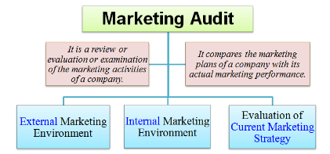
Figure 1: Market Audit
(Source: Suksutdhi 2020)
- Property analysis
Property analysis represents this hotel’s internal analysis. Company’s revenue value and marketing practices are interrelated. Marketing auditor of this company will gather necessary data from SEO metrics, PPC, social media and company’s website. Collecting data from websites and social media will give the opportunity for modification of its services.
- Competition Analysis
The competitor analysis process is effective to increase the organisational performances. As per the opinion of Suksutdhi (2020), this company has some tough competitors like, Hyatt hotel, Belmond, Hilton worldwide. Getting all information about these competitor’s products and service quality will help to implement more innovative strategies. These innovations would affect the customer’s satisfaction level.
- Marketplace analysis
Marketplace analysis would help to know the market position of this luxury hotel. Using digital tools like the company's website, social media and review rating helped to understand the company’s market position. In the opening of Prodanova et al. (2019), this company has involved IDeaS Revenue Management System (RMS) to get numerous successes from this hotel. Annual revenue value has increased nearly 2% (Jones and Comfort, 2021). Total revenue value has become $40 billion; it clearly shows the growth of market value.

Target Market
Target market or market segmentation process is pendent on a few important factors; these are psychographic factor, behavioural segmentation, geographic location, socio economic actor and demographic segmentation. Customer’s choice is dependent on the three key factors; these are service quality, amenities and location.
- Demographic segmentation
Higher authority of the hotel gives facilities to the customers, according to their age, gender, income, education, lifestyle and ethnicity. This hotel company mainly attract the young age group of people. People come to this hotel for different purposes like birthday celebrations, travelling, business meetings and so on. The hotel industry gives spa facilities to the customers, mainly female customers get attracted by this facility. Mostly the young generation of people come here for travelling.
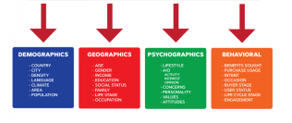
Figure 2: Target market
(Source: Saruno et al. 2021)
- Psychographic segmentation
Psychographic segmentation is dependent on the lifestyle, interest, attitude and values. Organizational staff shows their polite nature to the customers with efficiency and professionalism. It helps to attract customers.
- Behavioural segmentation
Behavioural segmentation process is based upon brand interaction, user status and purchasing habits. The hotel industry gives spa facilities to the customers. Opening bars for business meetings and travellers, Giving wireless network facilities to the young generation is quite common in this hotel.
- Geographic segmentation
Geographic segmentation plays a crucial role to attract customers for determination of the business performances. Many international tourists come here to see London. In the opening of Saruno et al. (2021), during this COVID 19 period, international transport facilities have been affected. Marketing managers will give attention to the national customers to maintain the consistency level.

Marketing plan
Knowing the company’s mission and vision will help to develop a successful marketing plan to make a synchronisation among all organisational activity levels. In the opening of Mjongwana and Kamala (2018), this company is intended to give higher quality of services and high quality of leisure facilities to satisfy the customers. Internal and external analysis processes will help to know the company's position in the national and international market.

SWOT analysis
Strength  - Increasing brand name  - Employee’s service quality  - Periodic innovation | Opportunity  - Location facility  - Growing demand  - Increasing interest in tourism
Weakness  - Restriction in international transport system  - Increasing product’s cost  - Social distance or lockdown | Threat  - Increasing competition  - Self service facilities decrease the customer’s satisfaction.
Table 1: SWOT analysis

PESTEL analysis

Political | - Brexit decreases the economic profits  - Terrorism threat is present
Economical | - Macro economic situation  - Increasing the cost of raw materials
Social | - Demographic changes is present  - Role of social media is useful  - Nuclear family patterns
Technological | - Online hotel booking facility  - Online payment facility  - Company’s website
Environmental | - Frequent climate changes  - Natural disaster  - Flood, storm
Legal | - Consumer protection rules  - Visa restriction due to COVID 19
Table 2: PESTEL analysis
This analysis process will help to gather information about the limitations. Using technological advantages and gathering information about the market competition would help to develop a marketing plan. Some important strategies would be discussed in the following section.
In the opening of Rakhmetulinam et al. (2021), developing effective relations with the organisation influencer would help to continue business. Getting transport facilities, mical facilities and spa facilities would help to attract more customers.
Nowadays, most of the travellers and tourists are highly active on social media, promoting business on social media and taking help from the online tourist app could be appropriate to develop a successful business plan.
Increasing a company's value by using more economic advantages helped to attract most of the luxury costumes. Moreover, it helps to attract international costumes, after a pandemic situation.
Modification of the booking experiences would be highly effective to give accessible facilities to the customers. Work on the customer’s review is highly effective for improvement of the business performances.

Management team
Team management is another vital factor to distribute work among the responsible prison. Team management processes will be useful for the execution of work in a systematic process.

Post | Activities
CEO | The CEO or founder of this luxury hotel will establish this hotel.
Project manager (PM) | Project manager will analyse the internal and external factors. In the opening of Karabašević et al. (2019), the PM will make a time schedule; a cost budget will be allocated to develop a business plan.
Investor | Investors would provide enough economic resources to complete all activities.
HR authority | HR executives are responsible for hiring efficient employees and staff for managing all activity.
Team leader | Team leader will monitor the growth of activities. TL is responsible to give training to the employees to give high quality of services to the customers.
Subordinate stakeholders | Stakeholders are engaged to give all types of facilities to the customers with professionalism.
Table 3: Team management

Financial plan
Project manager has distributed nearly $73000 cost into different sectors. Investing money is helpful to give higher quality of services to all these activities for increasing the growth rate of this company. Project manager has distributed this cost to fulfil long term and short term activities. Revenue management system is effective to develop the last time cancellation policies, authority gets a certain amount of concession price from the customers. Economic manager takes the responsibility to distribute cost among all activities. It is essential to develop a five years plan before initiating this project.

Finance plan | Amount
Revenues | $19000
Sales cost | $7000
Staff cost | $ 5000
Discount cost | $9000
Operating cost | $7000
Taxation cost | $6000
Profit before taxation | $11000
Investment cost | $9000
Total | $73000
Table 4: Cost budget

Conclusion
This project has developed an appropriate business plan for managing all activities. The Ritz London is a luxury hotel that gives all kinds of fasciitis to the customers. It is essential to follow some strategies for execution of business plans. Introduction has a portrait and outline of this project. The overview of this luxury hotel helped to gather information about this hotel. The entire description of the product and service quality has successfully been mentioned. This is a five star hotel and it gives luxurious facilities to the customers. Free and wireless internet connection, medical facilities, transport facilities, spa facilities, gym facilities are present to satisfy customers in this hotel. Market audit has discussed a few important factors; these are property analysis, competitor analysis and market place analysis. Target market has been discussed, which is based upon demographic segmentation, behavioural segmentation, psychographic segmentation and geographic segmentation has been successfully covered in this project. A proper marketing plan, team management plan and financial plan have been developed to complete this project.

Reference list
Jones, P. and Comfort, D., 2019. Sustainable development goals and the world’s leading hotel groups. Athens Journal of Tourism, 6(1), pp.1-14.
Karabašević, D., Popović, G., Stanujkić, D., Maksimović, M. and Sava, C., 2019. An approach for hotel type selection based on the single-valued intuitionistic fuzzy numbers. International Review, (1-2), pp.7-14.
Mjongwana, A. and Kamala, P.N., 2018. Non-financial performance measurement by small and medium sized enterprises operating in the hotel industry in the city of Cape Town. African Journal of Hospitality, Tourism and Leisure, 7(1), pp.1-26.
Popovic, G., Stanujkic, D. and Karabasevic, D., 2019. A framework for the evaluation of hotel property development projects. International Journal of Strategic Property Management, 23(2), pp.96-107.
Potjanajaruwit, P., 2020. Agrarian business development in accordance with the national economic and social development plan of SMEs in Thailand. In E3S Web of Conferences (Vol. 175, p. 13036). EDP Sciences.
Povorozniuk, I.M., 2020. Problems of small hotel business development in Ukraine. Economies' Horizons, (1 (12)), pp.43-49.
Prodanova, N.A., Savina, N.V., Kevorkova, Z., Korshunova, L.N. and Bochkareva, N., 2019. Organizational and methodological support of corporate self-assessment procedure as a basis for sustainable business development. Entrepreneurship and Sustainability Issues, 7(2), p.1136.
Rakhmetulinam, Z.B., Rakhmetulina, A. and Omurzakov, A., 2021. INFLUENCE OF MEGA EVENTS ON THE DEVELOPMENT OF HOTEL BUSINESS IN KAZAKHSTAN. Central Asian Economic Review, (3), pp.102-112.
Saruno, Y., 2021. The development of the relationship model of causal factors affecting the financial report quality and financial success of small and medium sized hotel business in Thailand. Turkish Journal of Computer and Mathematics Education (TURCOMAT), 12(8), pp.2924-2929.
Suksutdhi, T., 2020. HUMAN CAPITAL DEVELOPMENT GUIDELINES FOR SMALL HOTEL BUSINESS. Journal of Critical Reviews, 7(19), pp.3608-3612.
theritzlondon, (2021), Available at: https://www.theritzlondon.com/ [Accessed on: 1.05.2021]
Wibowo, L.A., Dirgantari, P.D., Hurriyati, R., Widjajanta, B. and Hijrianti, R.A., 2020. E-WOM in creating purchasing decisions on online hotel reservation. Journal of Tourism, Hospitality and Culinary Arts, 12(1), pp.248-259.
Yaemjamuang, B., 2017. Investigating motivation of the hotel employees at the operational level: A case study of the hotel business in Samut Songkram Province, Thailand. International Journal of Business and Economic Affairs, 2(1), pp.8-11.

Appendix:
Slide 1:



Slide 2:
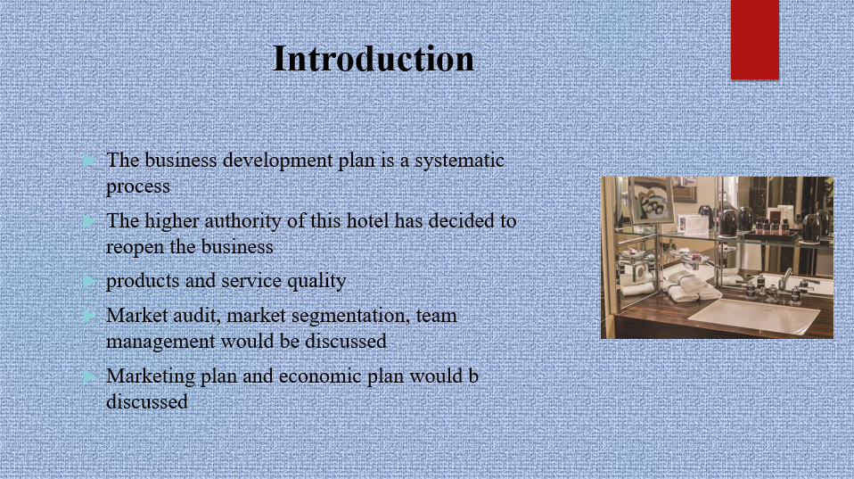
The business development plan is a systematic process for the maintenance of consistency in the business. The demand for the hotel industry is continuously increasing. The higher authority of this hotel has decided to reopen the business. Some important factors like the company's analysis, products and service quality are included in the business development plan. This project will focus on the market audit, market segmentation, team management, marketing plan and economic plan in the following section.

Slide 3:
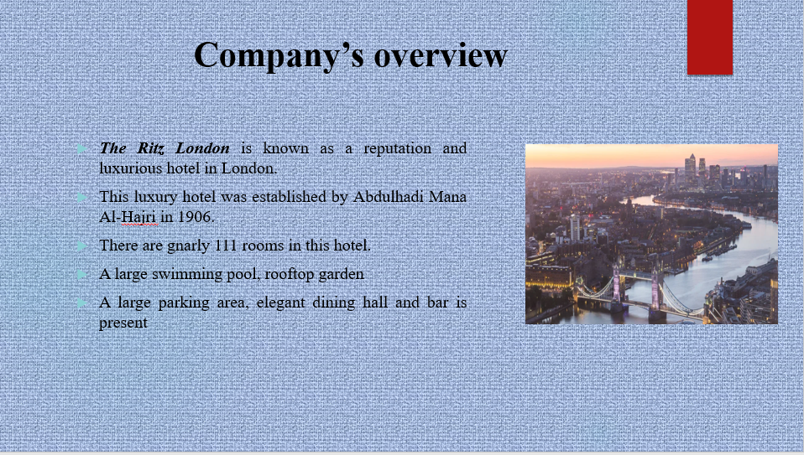
The Ritz London is known as a reputation and luxurious hotel in London. This luxury hotel was established by Abdulhadi Mana Al-Hajri in 1906. The higher authority has decided to reopen this hotel to give a higher quality of facilities to the customers (Povorozniuk, 2020). There are gnarly 111 rooms in this hotel. A large parking area, elegant dining hall and bar is present to provide a higher quality of leisurely treatment. This hotel is known to all due to its famous traditional afternoon tea. A large swimming pool, rooftop garden and rooftop patio give the customers a pleasant nature. This company is serving for marriage cremony, birthday celebration, office meeting and for the travellers. London is a popular place, due to its pleasant view, it gives extra facilities to this hotel.

Slide 4:
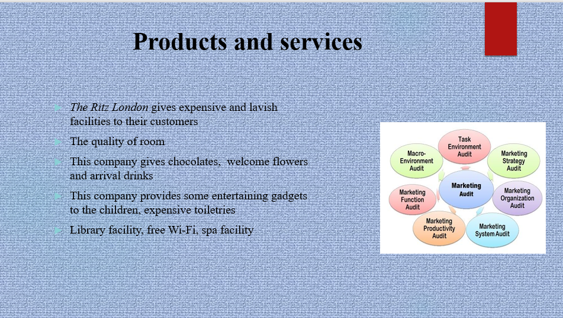
Products and services
The Ritz London gives expensive and lavish facilities to their customers. The quality of room, a large dining hall, transport facilities, medical facilities is there to satisfy customers. Many customers and tourists want some personal touches rather than professionalism. This company gives chocolates, welcome flowers and arrival drinks (Potjanajaruwit, 2020). Along with these, this company provides some entertaining gadgets to the children, expensive toiletries, best quality of national and international foods, spacious desks and so on.
Customer satisfaction is the primary motto of this company. It gives some leisure treatment to the customers like gym facility, library facility, free Wi-Fi, spa facility and children park to satisfy customers. This company gives a higher quality of security to the customers (Prodanova et al. 2019). Along with these professional and polite natures impress all customers. Maintenance of hospitality is another best part of this hotel.

Slide 5:
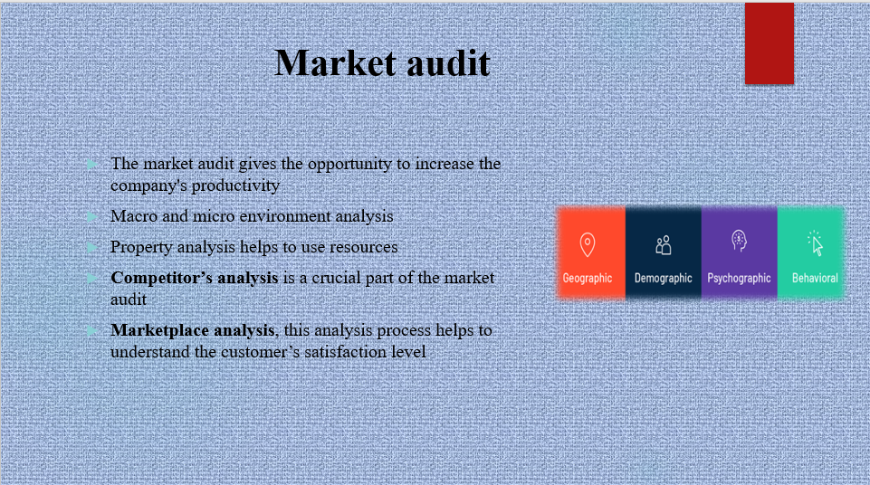
The market audit gives the opportunity to increase the company's productivity. Macro and micro environment analysis help to understand the external environment, internal environment and evaluate marketing strategies. This company has developed a property analysis strategy to develop innovative strategies. Property analysis helps to use resources for the determination of organisational growth.
This luxury hotel has tough competitors, like Hilton Worldwide and Hyatt hotel. Competitor’s analysis is a crucial part of the market audit. This analysis process is appropriate for knowing the competitor's strength and weakness in the market (Popovic et al. 2019). Another important strategy is marketplace analysis, this analysis process helps to understand the customer’s satisfaction level. Review reports, social media and online feedback processes give the opportunity to understand the marketplace.

Slide 6:
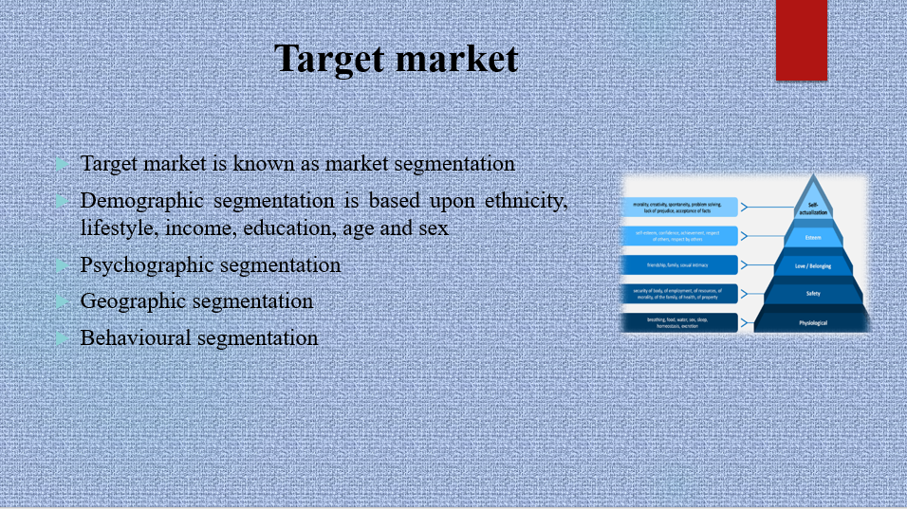
Target market is known as market segmentation. This company generally targets tourist groups, officers and young generations of people. This market segmentation process is dependent on four important factors, these are demographic segmentation, psychographic segmentation
Behavioural segmentation and geographic segmentation. A huge number of tourists come to London to visit this place (Mjongwana and Kamala, 2018). Demographic segmentation is based upon ethnicity, lifestyle, income, education, age and sex.
This hotel gives attention to psychographic segmentation. Providing the best hospitality care, pleasant view and leisure treatment are used to attract customers. Gives spa facilities and high quality of foods helps to attract foreign tourists.

Slide 7:
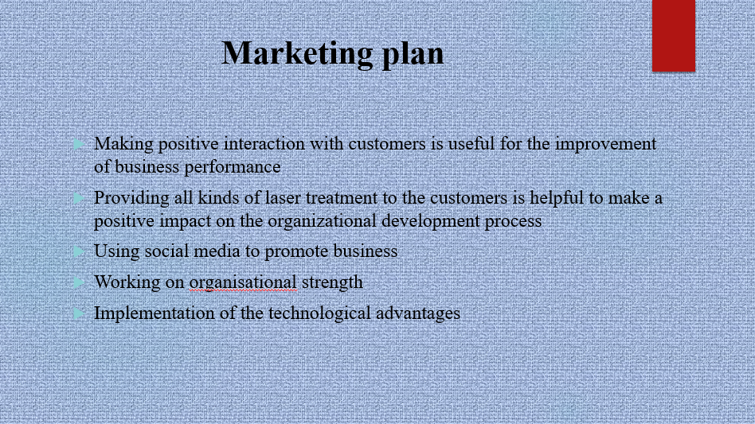
Making positive interaction with customers is useful for the improvement of business performance.
Providing all kinds of laser treatment to the customers is helpful to make a positive impact on the organisational development process.
Using social media to promote business could be effective for the maintenance of the company's sustainability (Karabašević et al. 2019).
Working on organisational strength is also appropriate for managing business performance level.
Implementation of the technological advantages could be appropriate for giving a higher quality of the facilities to the customers for determination of business performances.
Along with technological advantages, some traditional approaches are required to satisfy customers.

Slide 8:
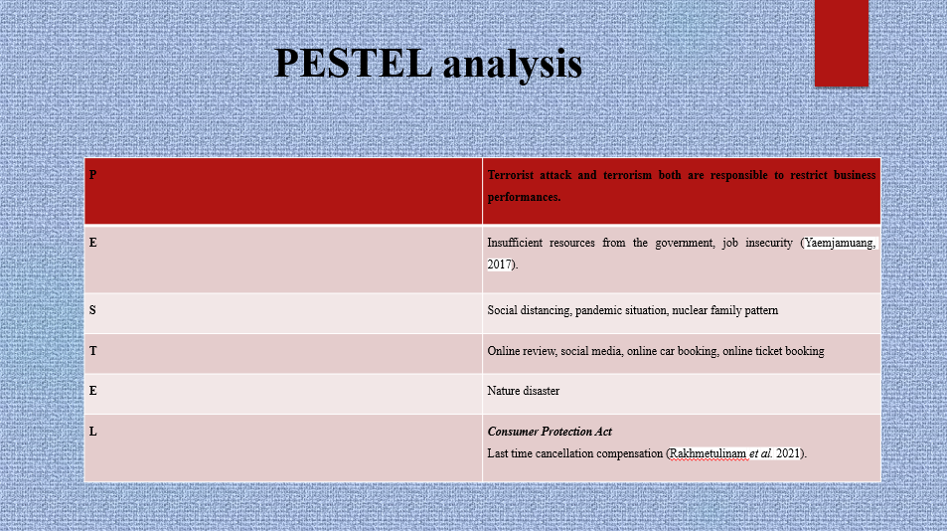

Slide 9:

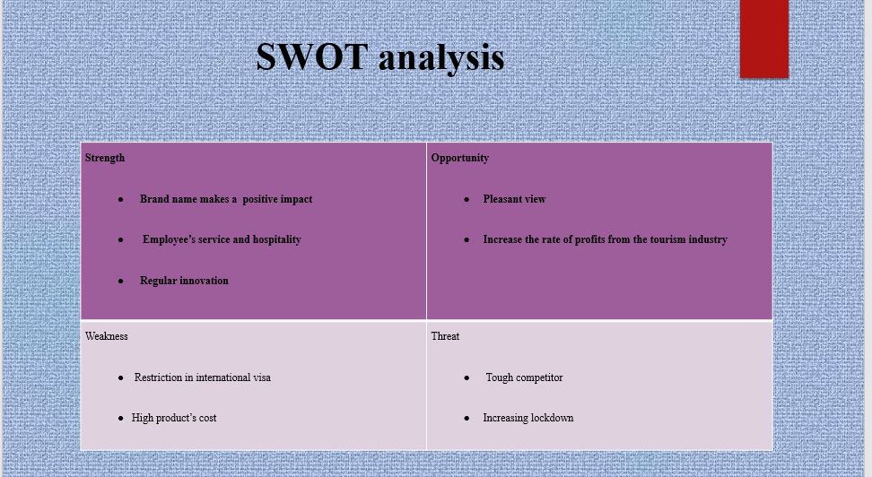
Slide 10:
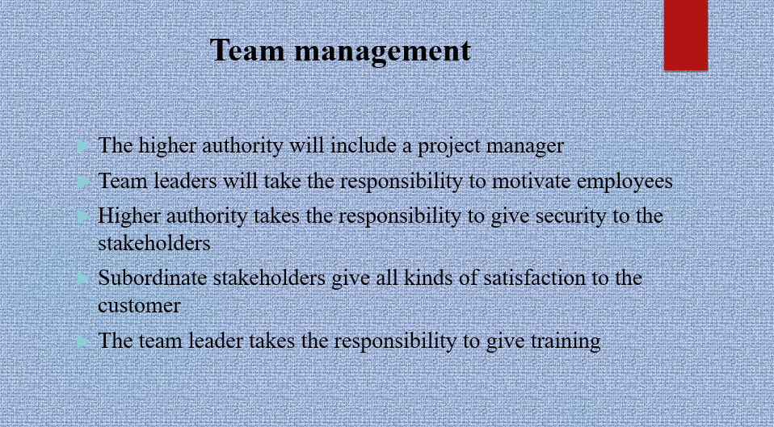
Business development plans focus on team management. Every person has different responsibilities. Distribution of work among the stakeholders helps in better execution of work (Saruno, 2021).

The higher authority will include a project manager, to construct a suitable project plan for reopening the business. Time management, work distribution are all dependent on the project manager.
Team leaders will take the responsibility to motivate employees for maintenance of the consistency level. The team leader takes the responsibility to give training to the employees for satisfying all customers in this hotel.
Higher authority takes the responsibility to give security to the stakeholders to perform with consistency (Suksutdhi, 2020). HR executives take the responsibility to give training to the employees. HR authorities recruit all highly efficient, professional and experienced workers in this company.
Subordinate stakeholders give all kinds of satisfaction to the customer for giving the best experience in this hotel (Jones and Comfort, 2019). Showing professionalism with polite behaviour helps to satisfy customers.
Slide 11:
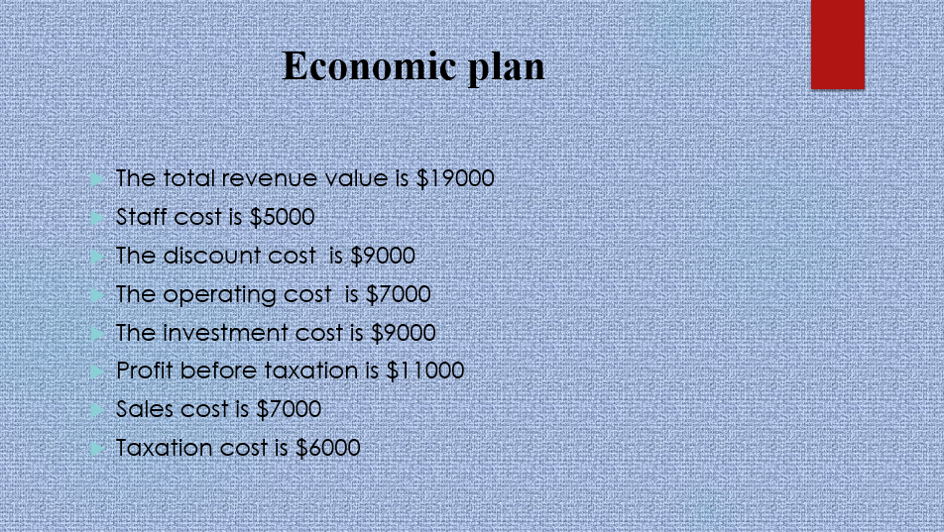
The development of the economic plan is highly effective for managing organisational activities. Without enough capital, it seems impossible to adopt innovative business strategies. Investors and supply providers both are responsible to maintain consistency in the workplace (Wibowo et al. 2020). This financial plan will help to invest economic resources for the modification of the business performances. It helps to make coordinate between income and investment. Taxation is a vital part to reopen the business.
The total revenue value is $19000
Staff cost is $5000
The discount cost is $9000
The operating cost is $7000
The investment cost is $9000
Profit before taxation is $11000
Sales cost is $7000
Taxation cost is $6000

Slide 12:
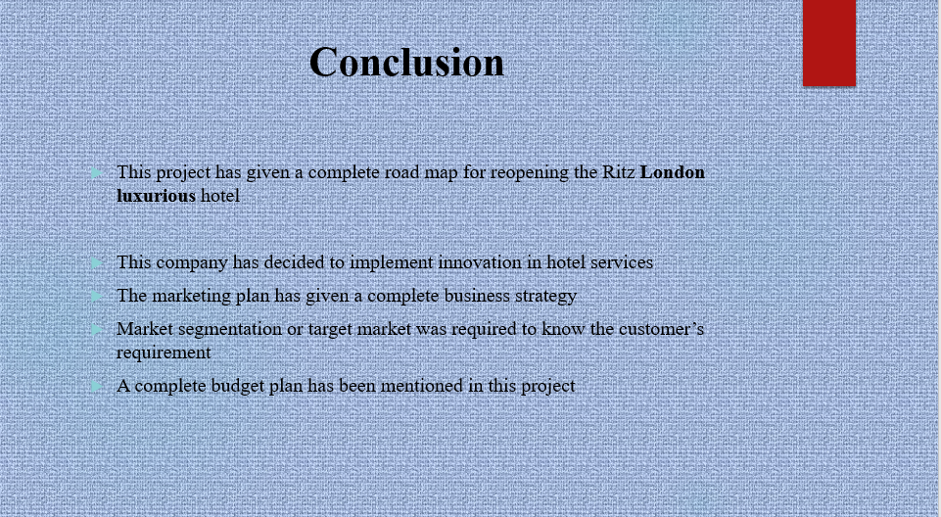
This project has given a complete road map for reopening the Ritz London luxurious hotel. Adaptation of the strategic approaches helped to increase the business performances. This company is giving a higher quality of facilities. This company has decided to implement innovation in hotel services. Team management helped to distribute work to all employees in this hotel. The marketing plan has given a complete business strategy for the reopening of this luxurious hotel. Market segmentation or target market was required to know the customer’s requirement. A complete budget plan has been mentioned in this project.

Slide 13:


