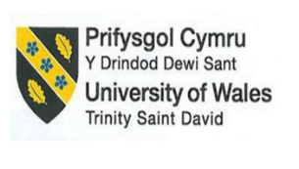

Assessment Title: Financial Management for the Hotel Industry
Module Code: BMIH5007
Student Name:Iulian Scarlat
Lecturer Name:Tristan Hawkins
Student ID Number: 2128802
Business Report – Comparison of Mandarin Oriental Hotel Group and Premier Inn

Table of Contents
1. Introduction 3
2. Background 4
3. Financial Management Strategies and Practices 5
3.1. Total Revenue 5
3.2. Market Position 8
3.3. Growth Potential 9
3.4. Financial Commitment to CSR (Corporate Social Responsibility) 10
4. Summary 11
5. Recommendations 11
6. References 12

Introduction
The competition within the services sector is comparatively high compared to the product industry (Jooss et al., 2023). The competition within the hospitality sector is on providing the best quality services to the guests at affordable prices, and competitors are using several strategies to attract the customers of other brands, such as price strategy and marketing strategy. Within the hospitality sector, most business has chosen price segmentation as a marketing strategy as most of the UK's population belong to the middle-class income group. As the service sector is consumer-centric and depends on the consumers for the revenues, brands make strategies to attract more customers and try to sell most of the services in order to be in a good financial position by the end of the year. However, the law of demand and supply states that if there is high demand, the prices tend to increase within the sector for the product and services, and if there is low demand, the prices tend to decrease; there is an inverse relationship between the price and demand. If the supply of the product or service increases, the prices decrease; if the supply is low, the prices tend to increase (Nasution et al., 2020). As the hotels within the hospitality sector have so many options within the industry, the hotel supply is high, and people have more options to go for. That is why hotels compete over the pricing strategy. Luxury hotels tend to have lower price elasticity. As the prices increase, the demand remains the same over the time period as the targeted segment is the upper class. However, within budgeted hotels, the price elasticity tends to be higher as the consumers are more price sensitive, and if the prices of rooms increase, the demand will decrease over the time period. With the changing technology, consumer preference has also changed due to increased consumer awareness over time. In today's business environment, hotels are adopting innovations and new technologies in order to remain compatible and maintain their market share. Moreover, the awareness regarding social causes and environmental issues has increased over time with increased accessibility. The business report will include a comparison of the two hospitality brands that are positioned within the same sector but are targeting different market segments; one of them is Mandarin Oriental Hotel Group (MOHG), and the other one is Premier Inn. The financial position of both the hotels will be discussed in detail, and the emphasis will be on assessing the current market position, the revenues generated by the brand, the initiative both the brands have taken to do something good for the social cause and for the environment and what the ways they have adapted to decrease the impact of their operations on the ecosystem.

Background
Premier Inn is a hotel chain in the UK which operates under the operations of Whitbread PLC since 1987. Further, it focuses on providing customers with budget-friendly options for accommodation while providing quality services. The target market for the hotel brand is the middle-income nation that is looking for affordable options. It has positioned itself in the customer's mind as the brand for middle-income people. The revenue generation streams for the brands are the international customers looking for budget-friendly accommodation options with good services. The brand has established itself over the period and has gained good market share by targeting the large market segment. Moreover, with profitability and brand repopulation, the brand has taken several initiatives for the good of the social cause and society as a whole.
The luxury hotel MOHG started its operation in late 1963 by targeting the upper-class segment. The brand's main objective is to pride the customers with exceptional quality and high-class services. The brand has gained popularity over a period of time, has gained brand regulation, and has positioned itself as a brand for high-class people. It is a world-recognized brand with operations in Europe, North America and Asia. The brand is generating revenues by targeting corporate businessmen and upper-class people who have enough income to spend on luxuries and experiences by providing luxury services. The brand has been highly involved in corporate social responsibility and in doing well for society and has taken several initiatives to reduce environmental pollution.

Financial Management Strategies and Practices

Total Revenue
The aggregate revenue is an important part of the financial statement, which tells about the overall organizational performance and organizational standing as compared to its competitors within the existing business market. The revenues are the most essential and significant part of the financial statement as they further help in assessing the company's financial well-being and operational effectiveness (Sharma 2022). As the formula for analyzing the total revenue generated by the brand is price*quantity sold, the hotels try to attract more customers to increase the quantity of the services sold to increase the overall revenue generated for the business. Both hotels have targeted the different customer segments of the same business market and sector and have been generating good revenues over the period of time within the targeted segments. This has not just helped them to attain financial stability but has also helped them to achieve effectiveness and success in their business operations and has helped the brands gain customer trust and loyalty as well (Ahmad 2021). Premier is famous for providing quality services to customers with affordable prices and budget-friendly options. Also, it earns a major portion of its total revenues by targeting the larger market segment. Most of the UK's population is middle class, and most people are price-conscious as well. The Hotel Premier Inn has targeted a large segment of the population within the current business market, which not only helped them attract more customers but also enabled them to earn good revenues through the guests coming and staying throughout the year. The main revenue streams for the Hotel Premier Inn are the lodging arrangements along with the food and beverage services. Premier Inn has distinguished itself from its competitors in the current business environment by providing people with affordable services. Figure 1 shows the revenue of the Hotel Premier Inn over the time period, and it can clearly be seen in the figure how the brand has evolved over the time period. The revenue for the Hotel Premier Inn has gone low as of all the time since it started its operations because of the lockdown restriction on travelling during the year 2020-21 (Li et al., 20220. And the year 2016-2017 was a good financial year for the hotel.
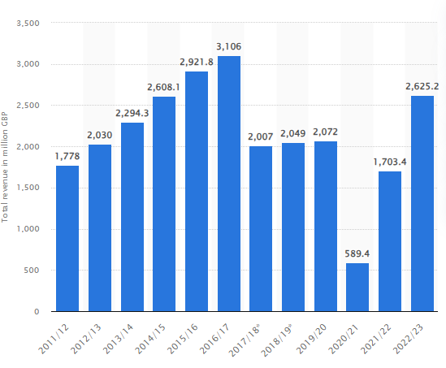
Figure 1: Revenue of Hotel Premier Inn
Source: Statista (2023)
In contrast, the MOHG is a luxury hotel chain which mainly focuses on providing the best service to its guests who belong to the upper class and who have money to spend on luxury and experiences. As the MOHG is targeting the niche segment of the market, the main revenue streams for the business are services that are provided to its customers, such as room rents, high-priced meals, and gym, pool and laundry services. The hotel has achieved segmented customer loyalty by providing them with exceptional and quality services over a period of time, which has not enabled the hotel to gain customer loyalty but has helped to achieve good revenues since the start. Figure 2 shows revenues generated by the MOHG in terms of geographical area and in terms of the service offered. Figure 3 shows the consolidated profit and loss statement of the MOHG.
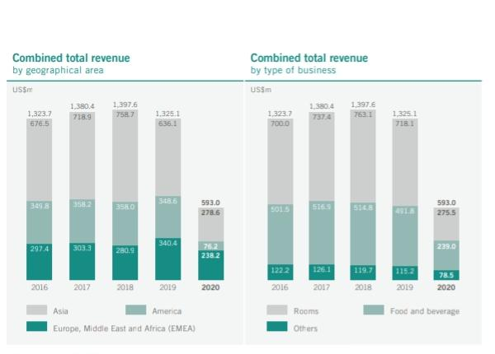
Figure 2: Revenue Generated By the MOHG
Source: Financial Reports 2021
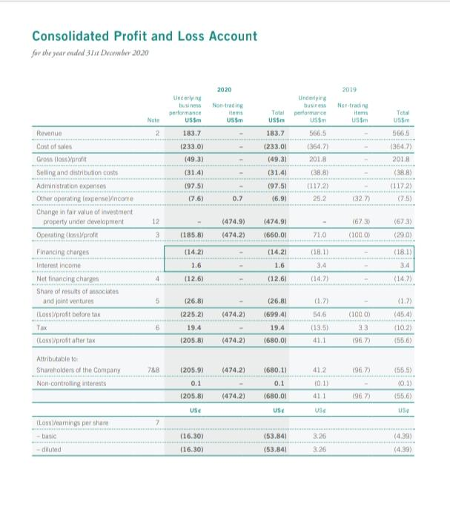
Figure 3: MOHG Profit and Loss Statement 2019-2020
Source: Financial Reports 2021

Market Position
The term market position refers to the brand's position within the existing market sector and the target market segment (Kalam and Kalam, 2020). It includes the reputation of the brand and brand image in the consumer's minds as compared to the competitors who are competing within the same industry over the same market segment by providing the same services. However, the service quality of the hotel brands may vary from one hotel to another. The main objective of the brand position is to establish the brand image in the eyes of customers as compared to the competitors. It further includes assessing the brand position and image in the current business environment and assessing if the brand is perceived in the same way it was positioned. The brands usually relate their business functions to something that is of value to the targeted segment (Heinberg et al., 2020). Both the hotel brands aim to provide the customers with quality services. However, the Hotel Premier Inn targets low-income customers and provides budget-friendly options, while the Mandarin Oriental has positioned itself as a brand for high-class people. Both hotels have gained a good market position within the respective market segments. The Hotel Premier Inn is among one of the top hotels in the UK.
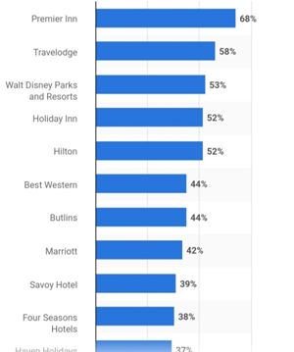
Figure 4: Popular Hotel Brands in the UK
Source: Statista (2023)

Growth Potential
Growth potential is described by Mutalimov et al. (2021) as the ability to grow within the existing business environment with the existing competition and the same economic conditions. It further includes the potential of businesses to generate high revenues by developing the workforce and increasing overall operational efficiency in the future. In order to remain competitive within the current business environment, where there is already severe competition, and hotels are competing for market share, it is very important to have significant growth in the current market and sector (Park et al., 2019). The price-to-earnings ratio is the financial stream for analyzing the company's growth and potential. It provides a detailed overview of the company and includes the examinations and details of the stock, which further helps in analyzing the current market share and growth potential for the upcoming future of the company (Silitonga et al., 2019). If the brand is not showing good potential for growth in the upcoming time, it is necessary to analyze its current marketing, targeting and positioning strategy. The overall view of growth potential is assessed by comparing the price-to-earnings ratio of the last year with the current year's P/E ratio (Artanto 2023).
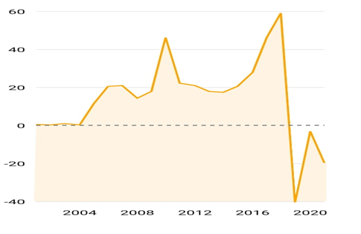
Figure 5: P/E Ratio of MOHG
Source: Companies Market Cap 2023

Financial Commitment to CSR (Corporate Social Responsibility)
Corporate social responsibility is defined as the company's commitment to running the business operations by following ethical business standards (Guzzo, et al., 2020). It further includes managing the business operations and functions in a way that they do not pose any risk or harm to the social, economic, human rights and the environment. This further includes businesses integrating social and environmental responsibility within the current business operations. In today's business environment, brands are more focused on social and environmental responsibility (Fatima and Elbanna, 2023). The hotel premier has focused on doing well for human rights and has initiated a program for the workers, which enables the organizations to provide the workers with a good working environment.
Moreover, it has incorporated the duty of doing well for the social cause and has donated meals to charity in the year 2020 for the good social cause to remove hunger and provide the underprivileged with food (Premier Inn, 2023). The brand MOHG has shown its commitment to the environment and society, making a financial contribution to the CSR community, and has reduced the intensity by reducing the regular audits within the hotel for energy. For the environmental cause and reducing the operations' impact on the environment, it has reduced the usage of plastic in business operations (Mandarin Oriental, 2023). Both brands have actively participated in CSR activities, have shown concern towards environmental responsibility and are focused towards working together for the good.

Summary
The business report includes a comparison of the two hotel brand that is market leader within the respective market segments. Further, it includes a discussion on the financial position, revenue, and market position of both the brands and the initiatives and strategies they have taken to do something for the social and environmental cause.

Recommendations
- It is recommended that the premier inn diversify the market risk and opt for the diversification strategy to develop some new little supermarket stores within the hotels, from where customers can get the necessary things at reasonable rates. This will not only diversify the risk but also create a competitive edge for the brand and add value to the hotel brand as the hotel adds value to the services provided (Zaman et al., 2022).
- For the MOHG, it is recommended to stay focused on improving the quality of services to have a competitive edge compared to the competitors. Further, it is recommended for the MOHG to diversify the business operations into something new and unique in order to attract more businessmen and people from corporate, such as introducing the workspace and meeting rooms within the hotels (Menz et al., 2021).

References
Ahmad, J., 2021. Investment and Development for Tourism and Hospitality Revenue Collection in Bangladesh. Tourism in Bangladesh: Investment and Development Perspectives, pp.325-336.
Artanto, A.V.N., 2023. Analysis of Financial Performance on Stock Price with Price Earning Ratio as a Moderation Variable (Case Study of Tourism and Hospitality Industries). SEIKO: Journal of Management & Business, 6(2), pp.321-335.
Corporate Site. (n.d.). Financial Reports. [online] Available at: https://www.mandarinoriental.com/en/investors/financial-reports.
Fatima, T. and Elbanna, S., 2023. Corporate social responsibility (CSR) implementation: A review and a research agenda towards an integrative framework. Journal of Business Ethics, 183(1), pp.105-121.
Guzzo, R.F., Abbott, J. and Madera, J.M., 2020. A micro-level view of CSR: A hospitality management systematic literature review. Cornell Hospitality Quarterly, 61(3), pp.332-352.
Heinberg, M., Katsikeas, C.S., Ozkaya, H.E. and Taube, M., 2020. How nostalgic brand positioning shapes brand equity: Differences between emerging and developed markets. Journal of the Academy of Marketing Science, 48, pp.869-890.
Jooss, S., Lenz, J. and Burbach, R., 2023. Beyond competing for talent: an integrative framework for competition in talent management in SMEs. International Journal of Contemporary Hospitality Management, 35(8), pp.2691-2707.
Kalam, K.K. and Kalam, K.K., 2020. Market segmentation, targeting and positioning strategy adaptation for the global business of Vodafone Telecommunication Company. International Journal of Research and Innovation in Social Science, 4(6), pp.427-430.
Li, R., 2022. Hong Kong's hospitality sector: the business case for quarantine hotels: the landmark mandarin oriental (Doctoral dissertation).
Menz, M., Kunisch, S., Birkinshaw, J., Collis, D.J., Foss, N.J., Hoskisson, R.E. and Prescott, J.E., 2021. Corporate Strategy and the Theory of the Firm in the Digital Age. Journal of Management Studies, 58(7), pp.1695-1720.
Mutalimov, V., Kovaleva, I., Mikhaylov, A. and Stepanova, D., 2021. Assessing regional growth of small business in Russia. Entrepreneurial Business and Economics Review, 9(3), pp.119-133.
Mandarin Oriental 2023. Sustainability. [online] Available at; https://www.mandarinoriental.com/en/our-company/sustainability [Accessed on 16th October 2023]
Mandarin Oriental (M04.SI) - P/E ratio (no date a) CompaniesMarketCap.com - companies ranked by market capitalization. Available at: https://companiesmarketcap.com/mandarin-oriental/pe-ratio.(Accessed: 16 October 2023).
Nasution, L., Ichsan, R.N., Dewi, M.A., Surya, B.P. and Sumastuti, E., 2020. Emerging Supply and Demand as a Mix of Social, Economic, and Psychological Factors. JOURNAL OF CRITICAL REVIEWS, 7(17), pp.421-424.
Premier Inn 2023. We’re a Force for Good. [online] Available at https://www.premierinn.com/gb/en/why/force-for-good.html [Accessed on 16th October 2023]
Park, W., Sung, C.S. and Byun, C.G., 2019. Impact of unlisted small and medium-sized enterprises’ business strategies on future performance and growth sustainability. Journal of Open Innovation: Technology, Market, and Complexity, 5(3), p.60.
Sharma, C., 2022. Total revenue management for hospitality in the digital age. In Developing hospitality properties and facilities (pp. 371-378). Routledge.
Statista Research Department and 7, S. (2023a) Most Popular Hotel Brands UK 2022, Statista. Available at: https://www.statista.com/statistics/951262/most-popular-hotel-brands-uk/ (Accessed: 16 October 2023).
Silitonga, W.P., Ramadhani, R.A. and Nugroho, R., 2019. The effect of economics value-added, market value-added, total asset ratio, and price-earnings ratio on stock return. Jurnal Akuntansi Trisakti, 5(2), p.239.
Zaman, M., Vo-Thanh, T., Hasan, R., Shams, S.R. and Vukovic, D.B., 2022. How can hotels create sustainable competitive advantages? A resource-based view. Journal of Strategic Marketing, pp.1-16.

