Title
Academic and Employability Skills
Name:Simona Ileana Feraru
Group 4
Id student:1906936
Lecture’s name:Peter Allen

Business plan
for the Simon's

Mr. Costa, we are writing to express our interest in working together ĺ you. We are on the market for 1 year but we want to expand, our current role is to have as much sales as possible. We have a small range of fresh products such as be donuts, noodles, and hot drinks
- Please do not hesitate to contact us as soon as possible to set up an interview to show you our business plan.
Sincerely Simon's Team

1. What means business? Business software translated in English would "state of busy", ie business To make your own money that you're busyProduct description: sandwiches with vegetables, pressed ham and cheese, chocolate donuts, chocolate pancakes. Hot drinks – coffee and tea.

- The advantage of my products will be: - prepared on the spot, fresh.
Tabel of contents
- I worked at the pastry shop and at a sanvori factory, so I decided to open this business working in this field. I learned how to prepare better sandwiches, donuts and pancakes.
- Student 2 Leonard worked in fast food and in the restaurant so I chose to work together because he helps me all the time, also having experience in the field.
- Student 3 Jan I chose this colleague because he has sales experience, he worked as a salesman at a pastry shop.
Business description
This business is small but in time it will become profitable this business is a street tune we sell products in constructions sites because in construction sites there are many workers who want to eat something hot and can drink tea or hot coffee, from this tonet we will sell pancakes, donuts, sandwiches and hot drinks.
My short-term goals are to have as many clients as possible. Medium-term goals are to become the best toner ever. Long-term goals are to have as many orders as possible and to further promote my fresh products.
Product and Services
The products and services we offer are quality.
- My target customers are construction workers because they come and buy products every day. Every day we have around 100-150 customers, sandwiches cost 1.80 pancakes 1, donuts 1 and hot drinks 1 RON.
Market and competition
I did not do any research I heard from a friend that he opened a street tune and so I started to open this business.
On the market a pancake costs 2 RON, a sandwich 2.5 RON, and hot drinks 2 RON so I chose to sell the cheaper products in order to have no competitors.
I promote my products on social media.

Objectives
- To establish a presence as a successful local fast food outlets and gain a market share in Singapore's fast food industry.
- To make Fresin Fries a destination spot for mall-goers.
- To expand into a number of outlets by year three, and sell the franchise to neighboring metropolitan cities, such as Jakarta, Kuala Lumpur, Bangkok and Manila.

1.2 Mission
Our main goal is to be one of the most successful fast food outlets in Singapore, starting with one retail outlet located inside a major shopping mall as a "market tester."
Fresin Fries will strive to be a premier local fast food brand in the local marketplace. We want our customers to have the total experience when visiting our outlet(s) and website as they will learn about this fascinating new "pop culture." We will sell merchandise from pre-packaged sauces and t-shirts, to potato cutters, all with our official brand attached to them.
Our main focus will be serving high-quality food at a great value.

Keys to Success
To succeed in this business we must:
- Create a unique, innovative, entertaining menu that will differentiate us from the rest of the competition.
- Control costs at all times, in all areas and implement a conservative approach to growth policy. Although, we provide more than enough fund to open more than one outlet, we want to be on the safe side of the business.
- Sell the products that are of the highest quality, as well as keeping the customers happy with all of our product categories from food to store merchandising.
- Provide 100% satisfaction to our customers and maintaining the level of excellent services among other competitors.
- Encourage the two most important values in fast food business: brand and image, as these two ingredients are a couple of main drivers in marketing communications.
- Get access to high-traffic shopping malls near the target market.
- Promote good values of company culture and business philosophy.

Competitive Edge
- Our unique dipping sauces blend local taste and international into one fusion recipe for the signature sauce.
- Enthusiastic and friendly staff
- Supporting merchandise items that support company's brand building.
- Our fries are made of 100% fresh potatoes, unlike the frozen fries used by competitors.
- Innovative packaging will position us at the same level with foreign fast food franchises.

Marketing Strategy
Our strategy is based on serving our markets well. We will start our first outlet as a "market tester" that could become a model of the expanding number of outlets in the future. Concentration will be on maintaining quality and establishing a strong identity in the local market.

A combination of local media and local store marketing programs will be utilized at each location. Local store marketing is most effective, followed by print ad. As soon as a concentration of stores is established in a market, then broader media will be explored. We believe, however, that the best form of advertising is still "buzz." By providing a fun and energetic environment, with unbeatable quality at an acceptable price in a clean and friendly outlet, we will be the talk of the town. Therefore, the execution of our concept is the most critical element of our plan. We will actively build our brand, through the selling of supporting materials, such as merchandise, promotional items and other marketing gimmicks

Brand Challenges
- Our logo is distinct as fresh, energetic and playful with color elements that are eye catching.
- Product names are geared toward the target market (teens),

Sales Strategy
The sales strategy is to build and open new locations in order to increase revenue. However, this plan will be implemented when the one "market tester" outlet showed potential growth. As each individual location will continue to build its local customer base over the first three years of operation, the goal of each store is S$104,250 in annual sales, with the original flagship store expected to earn almost S$200,000 per year.
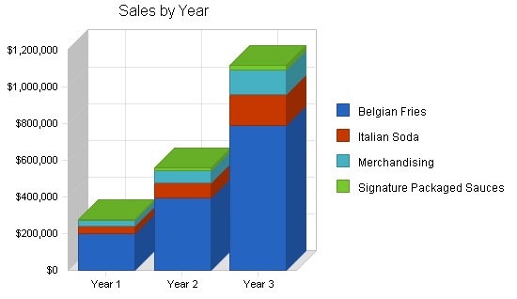
SALES FORECAST
YEAR 1 YEAR 2 YEAR 3
Unit Sales
Belgian Fries 49,464 98,928 197,856
Italian Soda 27,692 55,384 110,768
Merchandising 3,889 7,778 15,556
Signature Packaged Sauces 3,356 6,712 13,425
TOTAL UNIT SALES 84,401 168,802 337,605
Unit Prices Year 1 Year 2 Year 3
Belgian Fries $4.00 $4.00 $4.00
Italian Soda $1.50 $1.50 $1.50
Merchandising $8.50 $8.50 $8.50
Signature Packaged Sauces $2.00 $2.00 $2.00
Sales
Belgian Fries $197,856 $395,712 $791,424
Italian Soda $41,538 $83,076 $166,152
Merchandising $33,057 $66,114 $132,228
Signature Packaged Sauces $6,712 $13,425 $26,849
TOTAL SALES $279,163 $558,327 $1,116,654
Direct Unit Costs Year 1 Year 2 Year 3
Belgian Fries $0.80 $0.80 $0.80
Italian Soda $0.15 $0.15 $0.15
Merchandising $3.83 $3.83 $3.83
Signature Packaged Sauces $1.00 $1.00 $1.00
Direct Cost of Sales
Belgian Fries $39,571 $79,142 $158,285
Italian Soda $4,154 $8,308 $16,615
Merchandising $14,876 $29,751 $59,503
Signature Packaged Sauces $3,356 $6,712 $13,425
Subtotal Direct Cost of Sales $61,957 $123,914 $247,827

Web Plan Summary
The website will, of course, show visitors everything about Belgian food culture, including the history of french fries over time. To make the website interactive, Fresin Fries will offer gift cards and promotions via the Internet, so our visitors can print the promotional coupon in PDF

Website Marketing Strategy
We will leverage the visibility of our shopping mall's website by getting them to include a link to ours. We will also post banners on an official Singapore tourism website.

6.2 Development Requirements
To adequately serve our audience, the front end strategy of our website should be parallel with our corporate color. The front end design of our website will be entirely trusted to Mr. Guy Fry.

Management Summary
The initial management team depends on the founders themselves, with little back-up. As we grow, we will take on additional help in certain key areas. Part of our basic philosophy will be able to run our executive management as a "knowledge sharing" fellowship. We will not add additional overhead until absolutely necessary. This will mean that the initial staff support team will have to work extra. By doing this, we will keep our overhead as low as possible, allowing us to adequately staff our outlets. This will also allow us and future business partners to recoup investments as quickly as possible and enjoy a higher return.

Organizational Structure
Future organizational structure will include a director of store operations when the store locations exceed four units. We hope that this individual will come out of the ranks of our stores’ management. This will provide a supervisory level between the executive level and the store management level.

Personnel Plan
Our initial employees will include two cashiers, two cooks and two bus boys per location, with one of each on the premises during open hours. This is considered an ideal personnel number for a food outlet the size of our own. Each employee will work for 38-40 hours per week.
In the long run, as we expand our product category and retail outlets, we will employ more people in the middle management to ensure the focus of our work, including site managers.

PERSONNEL PLAN
YEAR 1 YEAR 2 YEAR 3
Site Managers $0 $60,000 $96,000
Cashiers $36,000 $80,000 $144,400
Cook $28,800 $66,000 $115,200
Busboy $23,400 $56,000 $94,000
TOTAL PEOPLE 12 26 40
Total Payroll $88,200 $262,000 $449,600

Start-up Funding
Currently, the company is owned by the original 4 founders, who each will contribute $200,000 for the same amount of share, 25%. This will more than cover start-up requirements, and provide the business with a cash cushion to use for expansion over the first three years.

Projected Cash Flow
The following chart and table show the Projected Cash
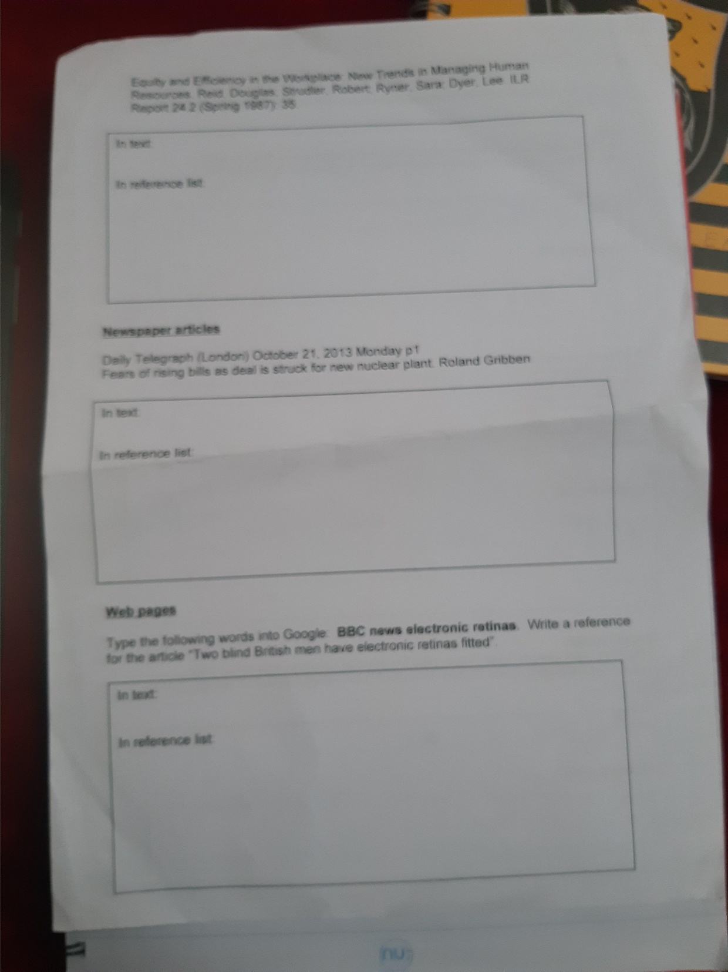
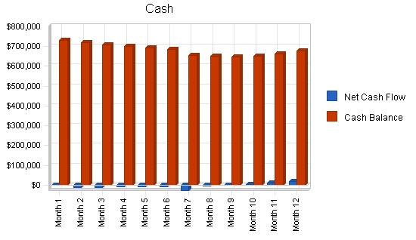
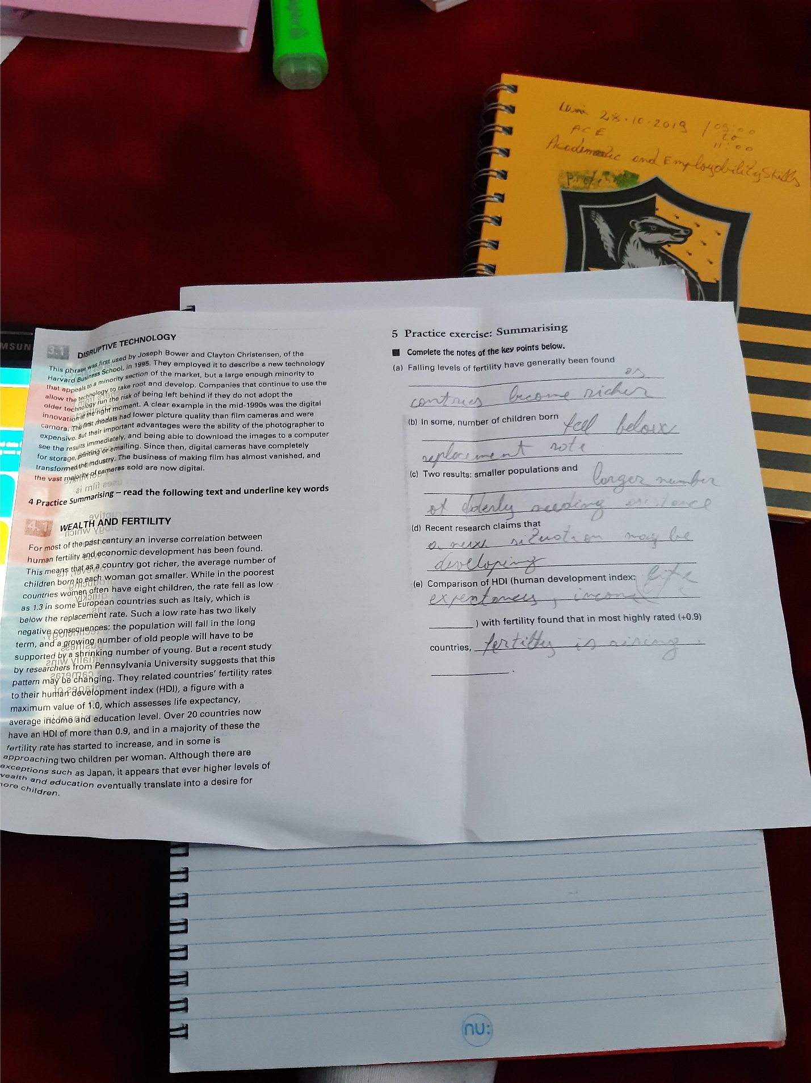
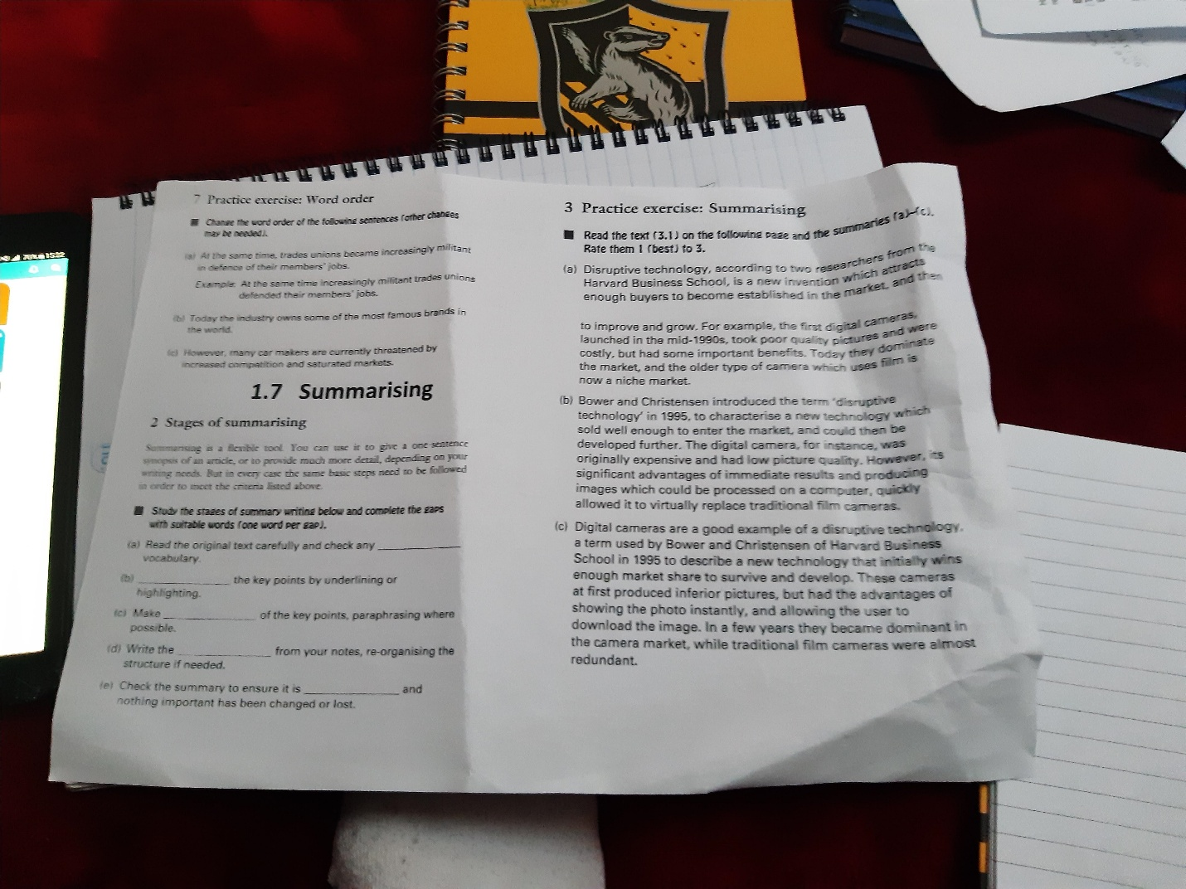
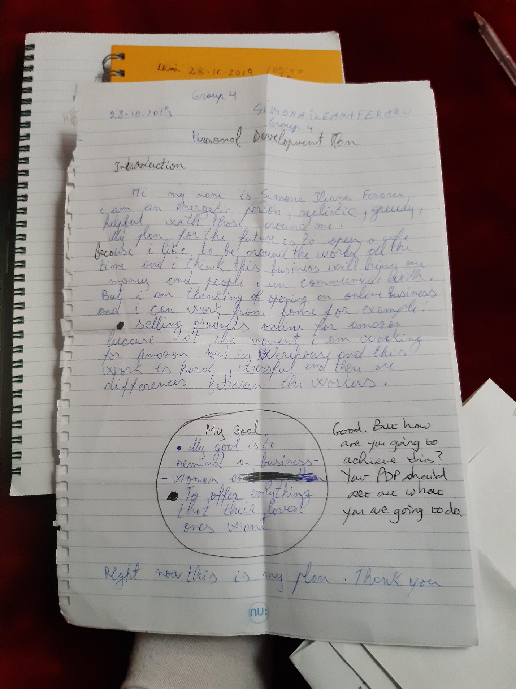
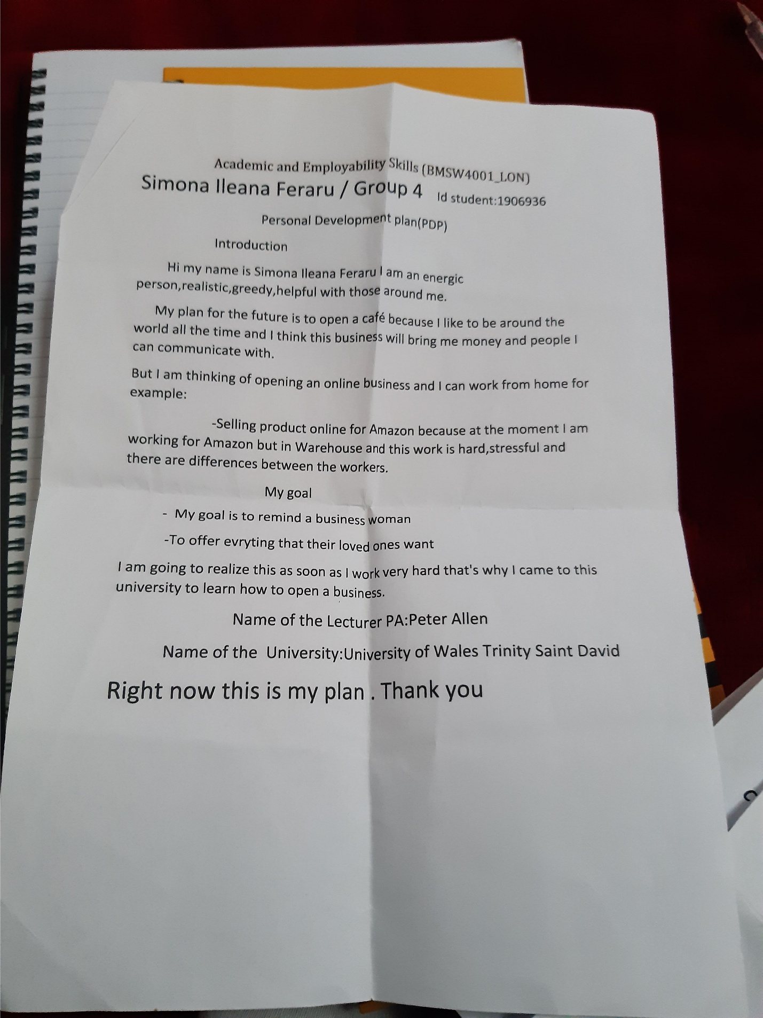
Appendi 619 743
Signature Packaged Sauces 1% 100 118 139 150 150 150 270 319 376 444 523 618
TOTAL UNIT SALES 1,850 2,218 2,659 3,161 3,751 4,476 6,976 8,244 9,747 11,529 13,641 16,147
Unit Prices Month 1 Month 2 Month 3 Month 4 Month 5 Month 6 Month 7 Month 8 Month 9 Month 10 Month 11 Month 12
Belgian Fries $4.00 $4.00 $4.00 $4.00 $4.00 $4.00 $4.00 $4.00 $4.00 $4.00 $4.00 $4.00
Italian Soda $1.50 $1.50 $1.50 $1.50 $1.50 $1.50 $1.50 $1.50 $1.50 $1.50 $1.50 $1.50
Merchandising $8.50 $8.50 $8.50 $8.50 $8.50 $8.50 $8.50 $8.50 $8.50 $8.50 $8.50 $8.50
Signature Packaged Sauces $2.00 $2.00 $2.00 $2.00 $2.00 $2.00 $2.00 $2.00 $2.00 $2.00 $2.00 $2.00
Sales
Belgian Fries $4,000 $4,800 $5,760 $6,912 $8,294 $9,953 $15,925 $19,110 $22,932 $27,519 $33,023 $39,627
Italian Soda $975 $1,170 $1,404 $1,685 $2,022 $2,426 $3,639 $4,185 $4,813 $5,535 $6,365 $7,320
Merchandising $850 $1,020 $1,224 $1,360 $1,530 $1,870 $2,538 $3,046 $3,655 $4,386 $5,263 $6,316
Signature Packaged Sauces $200 $236 $278 $300 $300 $300 $540 $637 $752 $887 $1,047 $1,235
TOTAL SALES $6,025 $7,226 $8,666 $10,257 $12,146 $14,549 $22,642 $26,978 $32,152 $38,326 $45,697 $54,498
Direct Unit Costs Month 1 Month 2 Month 3 Month 4 Month 5 Month 6 Month 7 Month 8 Month 9 Month 10 Month 11 Month 12
Belgian Fries 20.00% $0.80 $0.80 $0.80 $0.80 $0.80 $0.80 $0.80 $0.80 $0.80 $0.80 $0.80 $0.80
Italian Soda 10.00% $0.15 $0.15 $0.15 $0.15 $0.15 $0.15 $0.15 $0.15 $0.15 $0.15 $0.15 $0.15
Merchandising 45.00% $3.83 $3.83 $3.83 $3.83 $3.83 $3.83 $3.83 $3.83 $3.83 $3.83 $3.83 $3.83
Signature Packaged Sauces 50.00% $1.00 $1.00 $1.00 $1.00 $1.00 $1.00 $1.00 $1.00 $1.00 $1.00 $1.00 $1.00
Direct Cost of Sales
Belgian Fries $800 $960 $1,152 $1,382 $1,659 $1,991 $3,185 $3,822 $4,586 $5,504 $6,605 $7,925
Italian Soda $98 $117 $140 $168 $202 $243 $364 $419 $481 $553 $636 $732
Merchandising $383 $459 $551 $612 $689 $842 $1,142 $1,371 $1,645 $1,974 $2,368 $2,842
Signature Packaged Sauces $100 $118 $139 $150 $150 $150 $270 $319 $376 $444 $523 $618
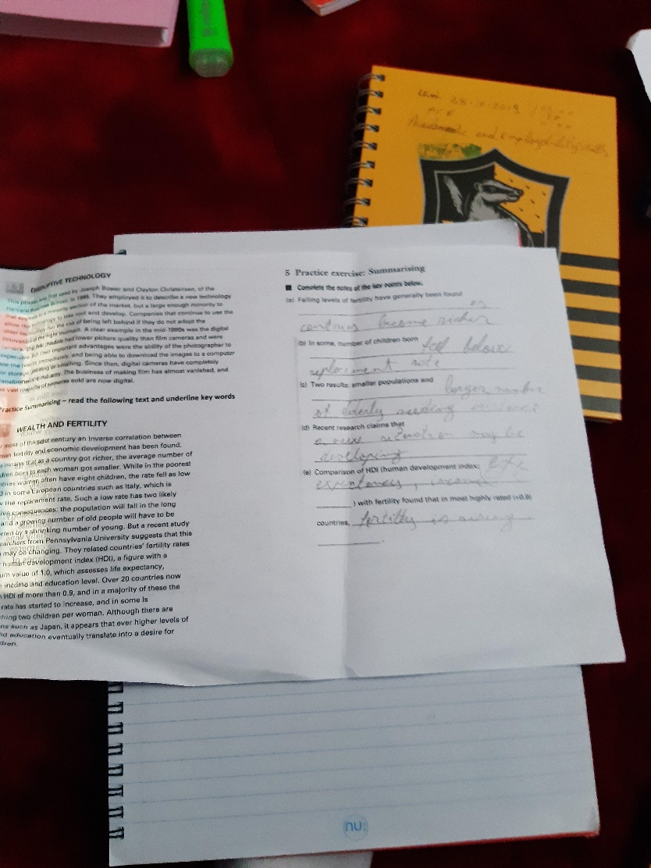
Subtotal Direct Cost of Sales $1,380 $1,654 $1,982 $2,313 $2,700 $3,225 $4,961 $5,930 $7,088 $8,474 $10,133
References https://www.bplans.com/fast_food_restaurant_business_plan/executive_summary_fc.php

