Understand the structure and function of the circulatory system

Task 1: Describe the function of the heart. (1.1)

The function of the heart is to act as a muscular pump that keeps blood circulating around the body. It pumps deoxygenated blood from the right side of the heart to the lungs through the pulmonary circulation, where gas exchange occurs and oxygen is absorbed. The heart the pumps oxygenated blood from the left side of the pumps oxygenated blood this ensures that all tissues especially the working muscles receive the oxygen and nutrients they need for energy production. At the same time, the heart helps remove waste products, such as carbon dioxide. By maintaining a continuous flow of blood, the heart supports all vital bodily functions and allows the body to meet increased demands during physical activity

Task 2: Using the image and space below, describe how blood moves through the four chambers of the heart and the stages of systemic and pulmonary circulation. (1.2, 1.3)
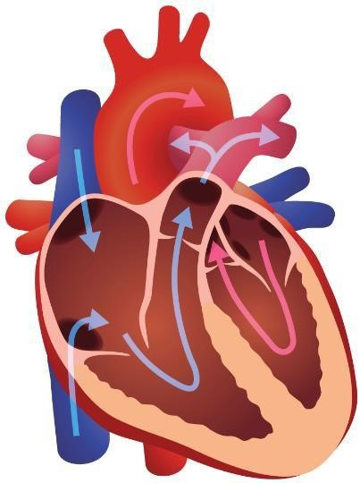
Description of blood flow: Blood flows through the heart in a specific sequence involving all four chambers. Deoxygenated blood from the body enters the right atrium through the vena cava. When the right atrium contracts, the blood moves through the tricuspid valve into the right ventricle. The right ventricle then contracts and pumps the deoxygenated blood through the pulmonary valve into the pulmonary artery, which carries it to the lungs.

Systemic and pulmonary circulation:
Pulmonary circulation is the movement of deoxygenated blood from the right sider of the heart to the lungs. In the lungs the blood becomes oxygenated before returning to the left atrium. This process allows gas exchange to occur, supplying the blood with oxygen.

Systemic circulation is the movement of oxygenated blood from the left side of the heart around the entire body. This blood delivers oxygen and nutrients to the muscles and organs. Once the oxygen has been used the blood becomes deoxygenated and returns through the veins to the right atrium to compete the cycle.

Task 3: Describe the structure and functions of blood vessels. (1.4)

Structure | Functions
Arteries;  . Thick, muscular and elastic walls  . Narrow lumen  . No valves  . Walls made of smooth muscle and elastic tissue to withstand high pressure  Veins;  . Thin walls with less muscle and elasticity.  . Wider lumen  . Contains valves to prevent backflow  . Low pressure vessels  Capillaries;  . Very thin walls  . Extremely narrow lumen just wide enough for one red blood cell.  . Found in networks close to tissues | Arteries;  Carry oxygenated blood away from the heart at high pressure.  Elastic walls help maintain blood pressure by stretching and recoiling.  Veins  Carry deoxygenated blood back to the heart at low pressure.  Valves ensure one way flow and prevent backflow of blood.  Capillaries  Allow gas exchange of oxygen, carbon dioxide and nutrients to tissues.  Thin walls allow quick diffusion.  Connect arteries to veins forming microcirculation.

Task 4: Explain what blood pressure is and identify the different types of blood pressure classifications. (1.5, 1.6)

Blood pressure
Blood pressure is the force that blood exerts against the walls of the arteries as the heart pumps it around the body. It is measured in millimetres of mercury and expressed using two numbers systolic pressure which is the pressure when heart contracts pushes blood out and diastolic pressure whne the heart relaxes and fills with blood. Blood pressure is important because it tells us how hard the heart is working and how much resistance there is in the blood vessels/

Blood pressure classifications
Blood pressure can be classified into several categories.
Normal blood pressure which is typically around 120/80 mmHg.
Elevated blood pressure is when systolic values are slightly higher, usually between 120-129 mmHg but diastolic remains below 80
Hypertension stage 1 is when the blood pressure ranges from 130-139 systolic or 80-89 diastolic,
Hypertension stage 2 is 140/90 mmHg or higher.
The most severe hypertensive crisis where systolic is above 180 or diastolic is above 120mmHg.
Low blood pressure hypotension is below 90/60mmHg

Learning outcome 2
Understand the structure and functions of the respiratory system
Task 1: Look at the image below. Using the image and spaces provided, label and describe the structure and function of the respiratory system. (2.1)

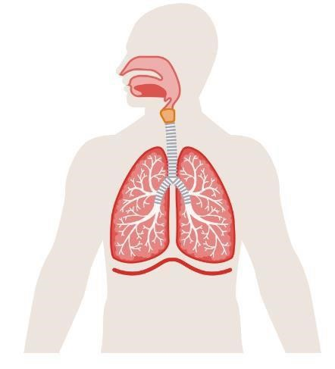

Labelled top to bottom
1 pharynx
2 larynx
3 trachea
4 bronchus
5 bronchioles
6 lung
7 diaphragm
Structure
The structure is made up of several parts that work together to help you breathe. It starts with the nose and mouth where air enters then goes through the pharynx and larynx. Next is the trachea which splits into two bronchi each leading to a lung. Inside the lung the bronchi dived into smaller tubes called bronchioles ending in tiny sacs called alveoli. The diaphragm a muscle below the lungs helps with breathing by moving up and down to push air in and out. All these parts work together to bring oxygen into the body and remove carbon dioxide.

Function
The job of the respiratory system is to help you breathe in oxygen and breathe out carbon dioxide. When you breathe in, the diaphragm pulls down and air dills the lungs. In the alveoli oxygen moves into the blood and carbon dioxide moves out. When you breathe out the diaphragm relaxes and pushes the air out of the body. The system also helps with speaking because air passed over the vocal cords.

Task 2: Identify the main muscles involved in breathing
- Diaphragm the primary muscle that contracts to allow air into the lungs by creating a vacuum
- Intercostal muscles are the muscles between the ribs that help expand and shrink the chest cavity during breathing
- Accessory muscles such as the sternocleidomastoid and scalene muscles which assist in deep or forceful breathing

Task 3: Describe the route of air through the respiratory system.
The respiratory system starts with the nose and mouth, where air enters the body where it is the warmed, filtered and moistened. It then passes into the pharynx and down through the larynx, where the vocal cords are located.
From here, air moves into the trachea a tube which is supported by a c shaped cartilage rings to keep it open. The trachea divides into two bronchi each leading to one lung inside the lungs the bronchi branch into smaller bronchioles which end in tiny air sacs called alveoli. The lungs sit in the chest cavity protected by the rib cage and the diaphragm below helps control breathing.

Task 4: Describe the process of gaseous exchange. (2.4)
Gaseous exchange is the process where oxygen and carbon dioxide are swapped between the air in the lungs and the blood. It happens in the alveoli which are tiny air sacs in the lungs. Oxygen from the air passes through the thin walls of the alveoli into the blood in nearby capillaries. At the same time, carbon dioxide from the blood passes into the alveoli to be breathed out. This exchange happens because oxygen concentration is higher in the alveoli and carbon dioxide concentration is higher in the blood so they move by diffusion

Learning outcome 3
Understand the structure and functions of the skeleton
Task 1: The skeleton provides vital structure to the human body. Below, describe the basic functions of the skeleton. (3.1)
- Support the skeleton holds the body upright and gives it shape.
- Protection bones protect vital organs from injury such as the brain, heart, lungs and spinal cord
- Movement bones work with muscles and joints to allow movements. Muscles attach bones and when they contract they pull on the bones to create movement
- Blood cell production certain bones contain bone marrow which produce red and white blood cells and also platelets.
- Mineral storage bones store important minerals mainly calcium and phosphorus these minerals can be released when the body needs them.
- Structural framework for the body bones provide attachment points for muscles, ligaments and tendons helping the body stay stable and balanced

Task 2: Using the images below, identify the bones of the axial and appendicular skeleton. (3.2)
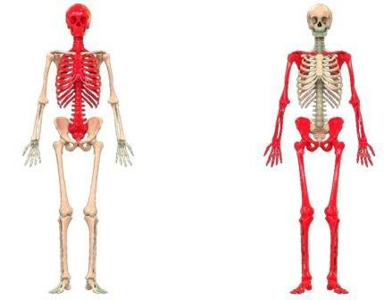

- Skull
2 manubrium
3 sternum
4 ribcage
5 spine
6 pelvis
7 coccyx
Image 2
1 clavicle
2 scalpula
3 humerus
4 ulna
5 radius
6 carpals
7 phalanges
8 Coxa
9 femur
10 patella
11 tibia
12 fibula
13 tarsals
14 phalanges
Task 3: Identify the different classification of bones. (3.3)
1. Long bones
2. Short bones
3. Flat bones
4. Irregular bones
5. Sesamoid bones

Task 4: Describe the main features of a long bone. (3.4)
Diaphysis the long middle part of the bone known as the shaft it is strong and helps support the body.
Epiphyses the wider ends of the bone they help form joints.
Articular cartilage a smooth covering on the ends of the bone that stops bones rubbing together.
Spongy bone found in the ends has small spaces and helps absorb shock.
Compact bone hard strong layer on the outside that gives the bone strength.
Medullary cavity the hollow space inside the shaft that holds bone marrow.
Bone marrow yellow marrow stores fat and red marrow makes blood cells.
Periosteum a thin outer layer around the bone that helps it grow and repair.

Task 5: Describe the stages of bone growth. (3.5)
- Cartilage model bones start off as soft cartilage when you are a baby. This gives the bone its basic shape.
- Ossification begins as you grow osteoblasts replace the cartilage with bone tissue
- Growth at the epiphyseal plate at each end of long bone is a growth plate new cartilage forms here and then it gets turned into bone which makes the bone longer.
- Bone continues to harden more minerals like calcium get added to the bone making it stronger and harder as you grow
- Growth plates close and harden stopping the bone from growing any more.

Task 6: Describe the varying types of posture in terms of: (3.6)
Postural term | Description
Curves of the spine | The spine has four natural curves that help absorb shock and keep the body balanced.  Cervical curve slight inward curve  Thoracic curve slight outwards curve  Lumbar curve inward curve  Sacral curve outward curve  These natural curves help keep the body upright distribute weight evenly and allow smooth movement
Neutral spine alignment | Neutral spine alignment is when all the natural curves of the spine are in their optimal healthy positions  In a neutral spine the head is balanced over the shoulders, the shoulders sit over the hips and the lumbar curve is neither overly no flattened.  A neutral spine reduces stress on the joints protects the discs and allows muscles to work efficiently.
Movement  potential of the spine | The spine can move in four main ways  Flexion- bending forward  Extension- bending backward  Lateral flexion- bending side to side  Rotation- twisting left or right  When posture is good and the spine is in neutral alignment these movements are smooth, controlled and pain free.
Postural deviations | Postural deviations are when the spine natural curves change too much common devotions include:  Kyphosis excessive outward curve of the upper back  Lordosis- Excessive inward curve of the lower back  Scoliosis- Sideways curve of the spine in an s or c shape.  Flat back-reduced lumbar curve causing the spine to appear straight.

Learning outcome 4
Understand joints in the skeleton
Task 1: Identify the classifications of joints. (4.1)
1. Fibrous joints these are the immovable joints where bones are joined by tough fibres.
2. Cartilaginous joints- these allow limited movement and are connected by cartilage.
3. Synovial joints these are freely moveable joints with a fluid filled cavity.

Task 2: Describe the structure of synovial joints. (4.2)
Synovial joints have a complex structure that allows free movement they include:
Articular cartilage: smooth tissue covering the ends of bones to reduce friction.
Synovial membrane: lines the joint capsule and produces synovial fluid.
Joint capsule: a tough flexible sleeve that surrounds the joint and holds it together.
Ligaments: strong bands of tissue that connect bones and provide stability.

Task 3a: Using the table below, identify the types of synovial joint and their range of motion.(4.3)
Synovial joint | Joint type | Range of motion available
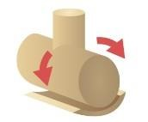 | Hinge joint | Flexion  Extension
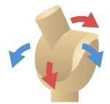 | Pivot joint | rotation
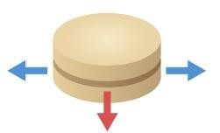 | Gliding joint | Gliding and sliding
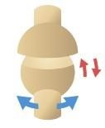 | Ball and socket joint | Flexion  Extension  Abduction  Adduction  Rotation  Circxumduction
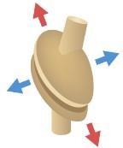 | Condyloid joint | Flexion  Extension  Adduction  Abduction  circumduction
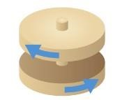 | Saddle joint | Flexion  Extension  Adduction  Abduction  circumduction

Task 3b: Describe joint movement potential and joint actions. (4.4, 5.6)
Joint action | Description | Joint example, eg wrist | Muscle example, eg quads
Flexion and extension | Flexion decreases the angle of a joint while extension increases it | elbow | biceps
Adduction and abduction | Adduction moves a limb towards the midline of the body while abduction moves it away | shoulder | deltoid
Circumduction | A circular movement of a limb | shoulder | deltoid
Supination and pronation | Supination is the rotation of the forearm and hand so that the palm faces forward or upward pronation is the opposite | Radioulnar joint | Biceps branchii
Plantar flexion and dorsiflexion | Plantar flexion is poiniting the toes downward while dorsiflexion is pointing the toes upwards | ankle | gastrocnemius
Lateral flexion and reduction | Lateral flexion is a movement where the beck bends sideways to either side decreasing the angle between the ribs and hip on one side.  Reduction is returning the neck from an sideways bend back to an upright central position | spine | obliques
Horizontal flexion and extension | Horizontal flexion is a movement where a limb moves across the body in a horizontal position bringing it closer to the midline.  Horizontal extension a movement where the limb moves away from the horizontal position increase distance from midline | Shoulder | deltoid
Elevation and depression | Elevation lifting a body part upwards moving towards the head  Depression moving it downwards from the head | Shoulder | trapezius

Task 4: Identify the body’s anatomical planes of movement. (4.5)
1. Sagittal plane divides the body into left and right halves
2. Frontal plane divides the body into front and back sections
3.Transverve plane divides the body to upper and lower section

Task 5: Define the anatomical terms of location. (4.6)
Table heading | Table heading
Distal | Further away from the point of attachment or the centre of the body
Proximal | Closer to the point of attachment or the centre of the body
Anterior | Towards the front of the body
Posterior | Towards the back of the body
Inferior | Below or lower than another body part
Superior | Above or higher than another body part
Deep | Located further inside the body away from surface
Superficial | Closer to the midline of the body
Medial | Closer to the midline of the body
Lateral | Further away from the midline of the body

Task 6: In the table below, describe the exercise variables and their effects on biomechanics and kinesiology. (4.7)
Exercise variable | Description | Effect on exercise
Levers | A lever is a system in the body made of a bone, a joint and muscles that work together to create movement | Different lever lengths change how hard a movement feels. A longer level increases difficulty because the muscle must work harder to move the weight
Centre of gravity | The point in the body where weight is evenly balanced in all directions | Changing your centre of gravity affects balance and stability. Lowering it makes exercise easier and more stable raising it or narrowing your base makes exercise harder and challenges core stability
Momentum | The amount of motion an object or body has created by mass and speed | Using momentum can make exercise easier by reducing muscle effort but controlling momentum increases muscle activation and improve technique too much momentum increases the injury risk
Force | A push or pull applied by muscles to create movement | Different forces act on the body and influence how we move including speed up, slowing down or even change direction.

Learning outcome 3
Understand the muscular system
Task 1: Describe the characteristics and functions of the body’s 3 types of muscle. (5.1)
Muscle cell | Muscle type | Function | Characteristic
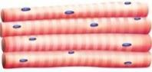 | Skeletal muscle | Moves the skeleton bones allowing for movement | Striated,  Multinucleated voluntary  Tires easily
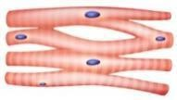 | Cardiac muscle | Pumps blood through the heart into the circulatory system | Straited usually one nucleus but can be two  Involuntary  Branched
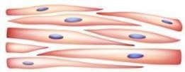 | Smooth muscle | Moves substances through internal passages | Non straited  Single nucleus  Involuntary  Spindle shaped

Task 2: Describe the basic structure of skeletal muscle. (5.2)
Skeletal muscle is made up of bundles of long, thin muscle fibres. The fibres are grouped into bundles called fascicles which are surrounded by connective tissues. Each muscle fibre contains myofibrils which are made up of protein filaments actin and myosin. These filaments slide over each other to create muscle contraction, The entire muscle is then wrapped in a connective tissue layer that protects and attach it to bones via tendons

Task 3: Using the images below, identify and locate the anterior and posterior skeletal muscles.
(5.3)
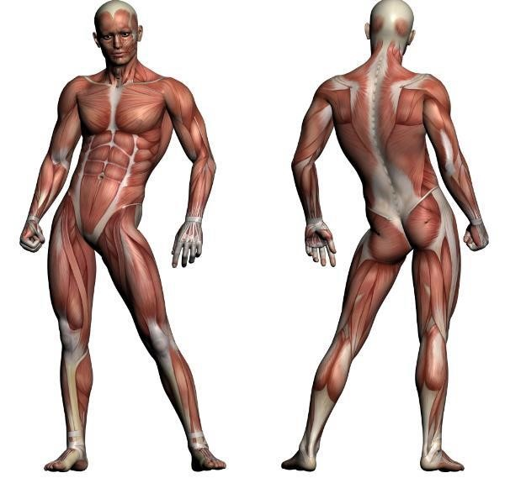
(
Muscles located within this
area under overlying
muscles)

Front body top to bottom

deltoid
pectoralis major
Biceps branchii
Abdomen
Rectus abdominis
External oblique
Tensor fasciae
Sartorious
Quadriceps femoris
Tibialis anterior

Back of the body
Trapezius
Deltoid
Latissimus dorsi
Triceps branchii
Gluteus maximus
Forearm extensors
Hamstring
Gastrocnemius
soleus

Task 4: Describe the structure and function of the pelvic floor muscles. (5.4)
Labelled from top to bottom
Front body
1
2
3
4
5

The pelvic floor muscles are a group of layers of muscle and connective tissue that stretch like a hammock across the bottom of the pelvis. They run from the pubic bone at the front to the tailbone at the back and from one sitting bone to the other. They form the base of the core and support the organs inside the pelvis.

Functions
Support pelvic organs they hold the bladder, bowel and in females the uterus in place.
Help control the release of urine and faeces by tightening or relaxing
They work with the deep abdominal and back muscles to maintain posture and core stability
They move with the diaphragm during breathing for pressure control
They help absorb pressure and force during exercise

Muscle action Muscle action type and description | Muscle action Muscle action type and description
Movement  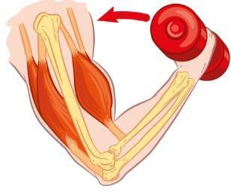 | Curling the weight upwards.  Concentric contraction  The muscle shortens while producing force. The biceps contract and get shorter as the arm flexes upwards to lift the weight.
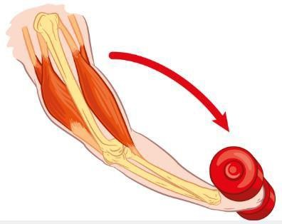  Movement | Lowering the weight downwards.  Eccentric contraction  The muscle lengthens while still producing force. The biceps control the movement as the arm extends downward, slowly lowering the weight
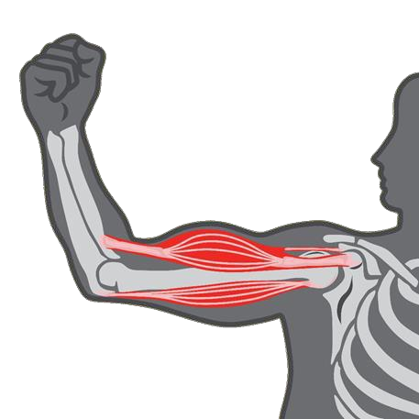  No m  ovement | Arm holding position with no movement.  Isometric contraction  The muscle produces force but stays the same length no joint movement happens. The biceps are working to hold the arm still without moving.

Muscle fibre | Description of characteristics
Type 1 | Type 1 muscle fibres contract slowly and are designed for long lasting activity. They use oxygen efficiently which gives them a high resistance to fatigue allowing them to work for a long time.
Type 2 | Type 2a fibres contract quickly and can produce good amount of force, but they also have slightly better endurance than the pure fast twitch fibres. They use both oxygen and stored energy which means they can work for shorts bursts while lasting a bit longer before getting tired.
Type 2 | Type 2b fibres contract the fastest and produce the most power but they fatigue very quickly. They rely on stored energy rather than oxygen making them ideal for short explosive movements.

Learning outcome 6
Understand the life course of the musculoskeletal system and its implications for special populations’ exercise
Task 1: Describe the life course of the musculoskeletal system and its implications for exercise for the below special populations: (6.1)
Special population | Life course changes | Implications for exercise
Young people (13-18 years) | Rapid bone growth and continued lengthening of long bones.  Growth plates still open and vulnerable to stress. I  increase in muscle mass and strength due to puberty hormones  Coordination and motor control still developing | Avoid heavy loads that stress growth plates use lighter weight and correct technique/  Include balance, coordination and skill based training,  Gradually increase intensity to match physical maturity  Encourage variety to prevent overuse injuries.
Antenatal and postnatal women | Hormonal changes increase joint laxity.  Shifted centre of gravity and increased spinal curve during pregnancy.  Pelvic floor muscles weakened during pregnancy and birth | Focus on low impact activities and avoid high risk movements.  Increase pelvic floor and core stability exercises.  Avoid lying flat on the back after the first trimester
Older adults (50+ years) | Reduction in bone density  Loss of muscle mass and strength  Decreased joint cartilage and increased stiffness  Slower recovery and reduced balance | Include resistance training to maintain muscle and bone strength.  Add weight bearing activities  Flexibility and mobility work to reduce stiffness  Balance training to reduce fall risk

Learning outcome 7
Understand energy systems and their relation to exercise
Task 1: Describe how carbohydrates, fats and proteins are used in the production of energy. (7.1)
Macronutrient | Description
Carbohydrate | Carbohydrates are the body’s main and quickest source of energy. They are broken down into glucose, which enters the bloodstream and is used in the muscles to produce ATP the body relies heavy on carbs because they can be broken down rapidly with or without oxygen
Protein | Protein is not the first choice of energy they are only used when carbohydrate and fat stores are low. Proteins are broken down into amino acids which can enter the energy systems to produce ATP their main role is growth and repair
Fat | Fats provide the largest energy store in the body and are mainly used during low intensity long duration exercise. Fats are broken down into fatty acids and glycerol which enter the aerobic energy system to create ATP. Fats take longer to break down so they are not useful for short burst exerxises.

Task 2: Explain the use of the 3 energy systems during aerobic and anaerobic exercise. (7.2)
Table Energy system | Explanation
ATP-PC | This system is used for very short, explosive, high intensity movements.  It uses stored ATP and phosphocreatine in the muscles to produce energy immediately.  Examples include sprinting, jumping, throwing and lifting heavy weight.
Aerobic | Used for lower intensity long duration exercise lasting more than 2-3 minutes.  It uses oxygen to break down carbs and fats to produce large amounts of ATP.  Examples include jogging, swimming and cycling.
Anaerobic glycolysis | Used for high intensity exercise lasting 10 seconds to about 2 minutes.  It breaks down carbohydrates without oxygen to produce ATP.  This system produces lactic acid which eventually causes fatigue and slows you down.  Examples 200-400 m sprint and fast cycling.

3: Identify the by-products of the 3 energy systems and describe their role in muscle fatigue. (7.3)
By-product | Role in muscle fatigue
ATP- PC System | When phosphocreatine runs out, the muscle cannot resupply ATP quickly.  This causes a drop in power and force leading to very quick fatgue during explosive movements.
Anaerobic Glycolysis | The build up of hydrogen ions makes the muscle more acidic.  This slows enzyme activity and reduces muscle contraction efficiency.  Causes the familiar burning feeling and loss of speed and power in high intensity exercise.
Aerobic System | Fatigue happens because glycogen stores run low, and the body struggles to maintain energy production.  CO2 can increase breathing rate but it does not cause muscle burning.

4. Define anabolism, catabolism and excess post-exercise oxygen consumption (EPOC).

Anabolism | Anabolism is the process where the body builds larger, more complex molecules from smaller ones. It uses energy to grow and repair tissues such as building muscle proteins after exercise
Catabolism | Catabolism is the process where the body breaks down larger molecules into smaller ones to release energy. An example is breaking down glycogen or fat stores to provide fuel during exercise.
EPOC | EPOC is the increased rate of oxygen intake after exercise. It happens because the body needs extra oxygen to restore energy stores remove waste products like lactic acid and returns the body to its natural state

Learning outcome 8
Understand the nervous system and its relation to exercise
Task 1: Describe the role and functions of the nervous system. (8.1)
Role | Functions
Allows communication between the brain and all parts of the body  Controls voluntary actions  Controls involuntary actions  Helps maintain balance and coordination  Allows you to think feel, remember and make decisions, | Sensory function- The nervous system collects information from inside and outside the body through sensory receptors.  Integrative function- The brain and spinal cord process the information received. They interpret what is happening and decide what response is needed.  Motor function- The nervous system sends messages to muscles and glands to produce a response.

Task 2: Describe the principles of muscle contraction. (8.2)
The sliding filament theory explains that muscles contract when the thin actin filaments slide over the thick myosin filaments inside the muscle fibre. The filaments themselves do not shorten instead they past each other causing the whole muscle to shorten and produce force. This movement allows movement and strength during any activity.

Role of calcium- Ions calcium plays a key role in switching muscle contraction on and off. When a nerve signal reaches the muscle calcium is released inside the fibre. This release uncovers binding sites on the actin filaments allowing myosin to attach and begin pulling. Without calcium the muscle cannot start contracting and will remain relaxed

Role of ATP- ATP provides the energy needed for muscle contraction. It fuels the cross bridge cycle which is the process of myosin attaching to actin pulling it and then releasing it. Every pull of the myosin head requires ATP.

Neuromuscular junction-muscle contraction begins when a motor neuron sends a signal to the muscle at the neuromuscular junction. Here the nerve releases acetylcholine which triggers an electrical impulse in the muscle fibre. This signal causes calcium to be released inside the muscle starting the contraction process.

All or nothing principle- states that a muscle fibre will either contract fully or not at all. If the stimulation from the nerve reaches the required threshold, the fibre contracts completely. If it does not meet the threshold there is no contraction.

Motor unit recruitment- controls how much force a muscle produces. A motor unit includes one nerve and all the muscle fibres it activates. For light activities only a few motor units are recruited producing small amounts of force. Fore heavier or faster movements, many more motor units are activated to allow greater strength.

Task 3: Explain the ‘all or none law’/motor unit recruitment. (8.3)
The all or nothing law states that a single muscle fibre or motor unit will either contract fully if the nerve signal reaches the threshold or not at all if the signal is too weak. However whole muscles can vary how much force they produce through motor unit recruitment which means activating more motor units when more strength is needed. Light movements use only a few motor units while powerful or quick movements take up more.

Task 4: Identify how exercise can enhance neuromuscular connections and improve motor fitness. (8.4)
Exercise helps the nerves and muscles work better together. When you practise movements your brain learns to send signals to your muscles more quickly and clearly. This makes it easier for your body to control your muscles and use them at the right time. Over time you can switch on more muscle fibres move more smoothly and react faster. This improves skills like balance, coordination, speed and power.

Learning outcome 9
Understand the structure and function of the digestive system
Task 1: Describe the function of each section of the digestive system. (9.1)
Table heading | Table heading
Mouth | The mouth starts the digestive process. Teeth break food into smaller pieces and saliva begins to soften and chemically digest it.  This makes the food easier to swallow and prepares it for further digestion
Oesophagus | The oesophagus is a muscular tube that moves food from the mouth to the stomach. It uses wave like muscle movements called peristalsis to push the food down.
Stomach | The stomach stores food and mixes it with strong stomach acids and enzymes. These break the food down into a liquid mixture called chyme. The stomach kills bacteria and begins protein digestion
Small intestine | The small intestine is where most digestion and absorption happens, Enzymes break food down even further and the nutrients are absorbed into the bloodstream.
Large intestine | The large intestine absorbs water and salts from the leftover waste. It turns the waste into solid stool and stores it until it is ready to be removed from the body.

Task 2: Describe how fats, proteins and carbohydrates are digested and absorbed. (9.2)
Macronutrient | Enzymes used | Time scale | Location
Fat | Bile  Pancreatic lipase | Mainly in the small intestine after leaving the stomach | Emulsification in the duodenum  Digestion and absorption in the small intestine
Protein | Pepsin  Trypsin and chymotrypsin  peptidases | Starts in the stomach  Continues and completes in the small intestine | Digestion stomach and small intestine  Absorption small intestine
Carbohydrate | Amylase  Maltase ,sucrase and lactase | Begins in the mouth.  Stops briefly in the stomach  Completes in the small intestine | Digestion mouth and small intestine  Small intestine

Task 3: Describe the role of dietary fibre in the maintenance of gut function. (9.3)
Fibre absorbs water and adds bulk to stools, making them softer and easier to pass. This helps prevent constipation and keeps bowel movements regular.

Some types of fibre act as a food source for beneficial gut bacteria. These bacteria ferment the fibre producing short chain fatty acids that help the colon healthy

Adequate fibres intake lowers the risk of conditions such as diverticular disease, haemorrhoids and irritable bowel symptoms by keeping the bowel moving efficiently

Soluble fibre slows that absorption of sugars helping maintain steady blood glucose levels and improving overall digestive function
Fibre rich foods keep you feeling full for longer which indirectly supports healthy digestion by encouraging balanced eating patterns
Task 4: Describe the role of the liver and pancreas in digestion.
The liver produces bile, which is stored in the gallbladder and released into the small intestine to emulsify fats, breaking them into smaller droplets so they can be digested more easily. The liver also helps regulate nutrients absorbed from the gut by storing glucose as glycogen and detoxifying harmful substances from the blood.

The pancreas supports digestion by releasing digestive enzymes amylase, lipase and proteases into the small intestine, where they break down carbs, fats and proteins. It also secretes bicarbonates to neutralise the acidic chyme arriving from the stomach creating an alkaline environment in which these enzymes can work efficiently. Together the liver and pancreas ensure food is broken down efficiently and nutrients can be absorbed properly

Task 5: Explain the importance of maintaining fluid levels for health and exercise performance.
(9.5)
Level of performance | Explanation | Role of water
Health | Maintaining fluid levels is essential for normal body functioning, Water helps regulates body temperature, supports digestion, transports nutrients, removes waste products through urine and keeps cells hydrated. Without enough fluid the body becomes dehydrated, leading to headaches, dizziness, poor concentration and reduced organ function | Helps control body temperature  Carries nutrients and oxygen around the body  Aids digestion and absorption  Flushes water and toxins out of the body  Keeps joints lubricated and tissues hydrated
Exercise performance | During exercise the body loses water through sweat which can reduce performance if not replaced. Dehydration leads to quicker fatigue, slower reaction times, muscle cramps, overheating and reduced endurance, Good hydration helps the muscles work efficiently and allows the heart to pump blood effectively | Replaces fluid through sweat  Prevents overheating by regulating temperature  Maintains blood volume and circulation  Supports muscle function and reduces cramping  Helps maintain energy levels during activity

