Strategic Management
Report: Developing a new landscape for customer care
Module Code: BMMB7013
Student: Dawid Walczak
Student Number: P1451687

Executive Summary
Nowadays, large oil and gas companies are associated with big money and large plants where oil and gas are mined. Many of these concerns have invested a lot of money in their infrastructure that enables them to run their businesses efficiently. Most of the companies in this industry commonly known as the energy industry rely on Oceaneering to inspect their plants, rigs and pipelines, which are usually made of metal, to help them safely carry out the processes of mining and processing raw material into a finished product. Oceaneering as a company dealing mainly with engineering and inspection, uses the latest technology that enables them to serve customers in every energy industry.
Looking at the actions of countries around the world, climate change has been so severe that the future production of fossil fuels is questionable. Oceaneering, however, does not intend to slow down and is looking for new solutions and industries in which it could prove itself and use its many years of experience to continue to satisfy customers all over the world.

Table of Contents
Introduction 1
SWOT Analysis 4
Strengths 6
Weaknesses 6
Opportunities 7
Threats 8

PESTEL Analysis 10
Political 11
Economical 12
Social 13
Technological 14
Environmental 15
Legal 17
Porter’s Five Forces Analysis 20
Threat of new entry 21
Threat of substitute 22
Supplier power 23
Buyer power 24
Rivalry 25
VRIO Analysis 26
Conclusion & Recommendations 29
References 31

Introduction
Oceaneering International Services Limited (OISL) is the main global provider of engineered inspection services and products to the Oil & Gas (O&G) industry but also expertise in defence, aerospace, science and renewable energy sectors (oceaneering.com,2021). OISL operates in 24 countries with over 70 operational bases, employing over 10.000 people globally.
Oceaneering as a company operating in O&G sector, highly relies on the global oil demand and its prices, to play a key role in the inspection sector. Like other O&G companies, OISL saw a significant reduction in services due to Covid-19 pandemic in 2020 (Investors Oceaneering, 2020) but according to prediction by Dr F. Birol, International Energy Agency (IEA) Executive Director ‘…oil demand is set to increase every year between now [2021] and 2026’ (IEA, 2021). The oil demand increase should give a good start to Oceaneering to recover from post-pandemic crisis.
Dr Birol’s words can be proved by looking at Oceaneering Earning Report for 2021. According to Roderick Larson, CEO of Oceaneering “commodity prices appear supportive to continued gradual growth in oil and gas markets…and we anticipate accelerating interest and growth in the market in 2022” (Inc,2021).
As OISL is mainly operating in O&G sector, it also supports other sectors such as renewable energy. According to Sadorsky (2011) renewable energy is seen as “future for the next several decades”. For OISL this can be the long-term challenge to increase its presence in this sector even more.
So far, OISL has successfully helped to complete over 100 renewables projects in key regions around the world, this includes 84 wind turbines located off Moray Coast of Northeast Scotland which is the largest UK offshore wind farm. (oceaneering.com,2021).
In the opinion of Chaltal et al (2021) “many companies are currently evaluating their strategic responses to the energy transition”. This means that companies are looking towards clean energy sectors to gain a stronger position in the new market.
Oceaneering as a global inspection provider, must care about its clients and customers to deliver the best possible service. This report will show the relationship between Oceaneering’s external and internal context and their impact on strategy. This report will also critically evaluate competitive and development strategies and assess the key factors for the shaping and implementing of innovating strategy for Oceaneering.
This report will be containing four strategic management tools to see what environment Oceaneering is operating in and what is the best strategy for this organisation.
The strategic management tools that are going to be used in this document are SWOT, PESTLE, Porter’s Five Forces and VRIO Analysis.
What is a strategy?
There are a couple of well-known theorists which defined a strategy in different ways. Michael Porter has defined the strategy as “…about being different. It means deliberately choosing a different set of activities to deliver a unique mix of value” (Porter,1996). Peter Drucker describes the strategy as “…a firm’s theory about how to gain competitive advantages” (Drucker,1994). To get a clear understanding what strategy is, the third strategy definition comes from Henry Mintzberg, who defines strategy as “…a pattern in a stream of decisions” (Mintzberg,2007).
Based on the above-mentioned definitions it can be noticed that, all definitions are correct but it’s reasonable to take that Henry Mintzberg’s definition is closest to today’s world where each organisation must be different to deliver the best result for the customer.
What is a Strategic Management?
Strategic management is an information and decision-making process that is supported by such functions of the enterprise as planning, organisation, motivation and control. It is to assist in solving problems related to its development and survival, considering the influence of the environment.
Popular theorists define strategic management as a “philosophy of management whose purpose is to achieve certain humanly determined moral values – for individuals, for organizations and for society” (Drucker,1994). Michael Porter defined the strategic management as “the means by which organizational managers seek to bolster the success of their businesses via a series of competitive manoeuvres” (Porter,1998).
From examining the definitions, I have considered above it’s acceptable to take that both definitions are correct and reflect what strategic management means and how important it is for the organisation.
SWOT Analysis
SWOT analysis is one of the basic methods of strategic analysis of a company. The method name is an acronym of the words Strengths, Weaknesses, Opportunities, Threats. The basic assumptions of the SWOT analysis were developed in the 1950s and 1960s by scientists and business consultants working at Harvard Business School and described in book written by Christensen et al (1965). Helms et al (2010) in their book described SWOT analysis as “a tool that helps organisations get visibility on their current status”
Below is the SWOT analysis carried out for Oceaneering International Services (OISL).
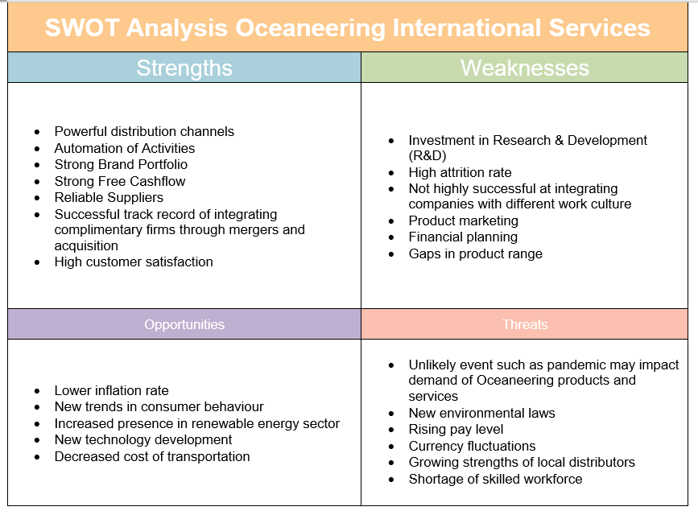
Figure 1. SWOT Analysis for Oceaneering International Services
Figure 1. shows internal and external analysis through OISL’s strengths, weaknesses, opportunities, and threats. Internal analysis is performed by looking at strengths and weaknesses of the organisation where external analysis is done by looking at opportunities and threats.

Strengths
‘Strengths’ section shows several points from where OISL can be proud of, e.g. powerful distribution channels. OISL have dozens of branches around the world, which means each customer can be easily satisfied and looked after. Customer care can be proved by last bullet point in the ‘strengths’ section which shows that high customer satisfaction is achieved.
Weaknesses
OISL has high staff attrition. This was calculated using the data and formula below:
Oceaneering employees in 2014 – 12400 (source www.macrotrends.net)
Oceaneering employees in 2020 – 8300 (source www.macrotrends.net)
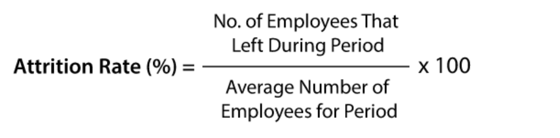
Attrition Rate: 4100/12400 x 100 = 33%
Figure 2. Attrition Rate Formula (www.callcentrehelper.com)
According to Zojceska (2018) average global employee attrition rate is around 10.9%. This shows what problem Oceaneering has in terms on keeping their employees.
Another weakness which Oceaneering have to face with, is the product gap. OISL has a big range of products and services but by looking at Greg Trauthwein interview (2019) with Martin McDonald, Oceaneering SVP, Remote Operating Vehicle (ROV) division business has big products gaps in terms of the technology. As the industry requires ROV’s that are working in much deeper waters on increasingly complex work scopes so it’s essential for OISL to have higher power units with high specification and reliable intervention capabilities.
Opportunities
One of the opportunities for OISL can be new trends in consumer behaviour. According to Kemp (2021) cost of oil per barrel has reached $75 which is the highest in the century. He thinks that “somewhere between $75 and $85, oil prices will start to become politically sensitive and have an impact on consumer behaviour and petroleum use”. Consumers will heavily reduce the use of petroleum and highly seek for renewable energy sources. This is a good chance for OISL to seek more opportunities in the renewable industry. This also connects with another opportunity for OISL which allows them to develop new technology to be more attractive in the renewable sector and low carbon future.

Threats
One of the threats for OISL is an event of pandemic. From 2020 until now, Covid-19 pandemic was a key discussion in global organisations planning and strategic management. According to Bartik et al (2020) during the first couple of months of the pandemic around 43% of small businesses had to temporarily close their businesses which was caused mostly by the reduction in demand and lack of workforce. In average in 2020 there was over 300 thousand new daily cases of Covid-19 worldwide. (worldometer.com,2020) This incurred a big problem for businesses like Oceaneering to keep up with their inspection schedule. As reported by Renews (2020), Oceaneering’s biggest client, Petrofac has mentioned in the interview that ‘the collapse in oil prices in 2020 because of pandemic has been the catalyst for clients to review their future investment plans” and that “..oil price has resulted in delays to current tenders”.
By looking at the Figure 1 above, another threat which OISL needs to look at in the future is the lack of skilled workforce. As an engineering company, OISL relies on its experienced workforce. Oppert and O’Keffe (2019) reports that 32% of the population is currently classed as an engineer with an average of 41 years of age. If Oceaneering does not start planning ahead for it, they may lose a lot of their internal valuable skills and knowledge.
There are some ways of retaining ageing workforce. Hirsch (2017) suggests that one of the ways to encourage an employee to stay with the company is to create a mentoring culture within the business. This means that an organisation can allow a ‘future retiree’ employee to take on coaching role. They transfer their knowledge and skills to younger generation while reducing their working hours gradually, so they don’t become overworked. This type of coaching and mentoring has a lot of benefits for the company and the employee itself. It reduces turnover, increases job satisfaction, and shows a ‘future retiree’ that the company is investing in them and in the future generation of specialists.
A new way of retaining employees is by giving them more flexibility. During the Covid-19 pandemic a lot of businesses introduced flexi-time scheme. This allows employees to take more time off work when needed. As people get older, they would like to invest more time in family and their hobbies. By providing them with more flexible working time they can get better work-life balance and concentrate on things they can’t do while working 9-5 shift pattern. This can improve their mental health and can be an overall success for the company for the future.

PESTEL Analysis
PESTEL analysis, also known as general segmentation of the environment, defines the basic areas that have a key impact on the functioning of the company as it determines the future strategy of its operation. Its acronym stands for Political,
Economic, Social, Technological, Environmental and Legal. This framework was founded by Francis Aguilar in 1967 who as a first has showed the world this wonderful tool (Frue,2017). It can be found in “Scanning the Business Environment” (1967) book that it was firstly known as EPTS (Economic, Technical, Political, Social) (Aguilar,1967). PESTLE Analysis can be very supportive for OISL to make many strategic decisions such as entering new foreign market or creating long-term business plans. The figure below presents the PESTEL analysis conducted for Oceaneering International Services where the main parts are discussed.
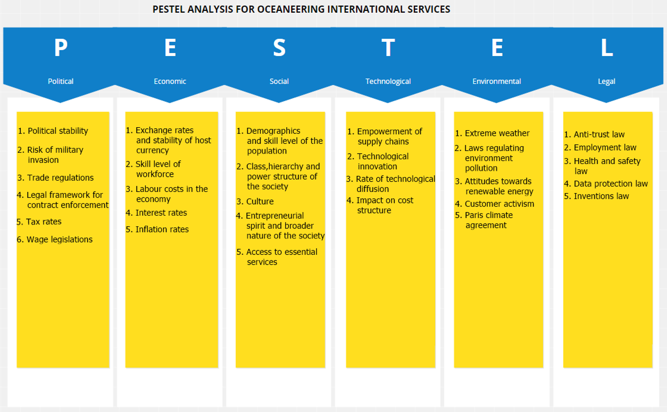
Figure 3. PESTEL Analysis for Oceaneering International Services
Political
Political Stability
Point 1. in the political section of the PESTEL analysis is showing that political stability is very important within the O&G industry because the natural resource extraction is being performed mostly in “developing countries”. For Oceaneering which has its presence in Middle East and Africa, political stability plays crucial role for their operations. As an example, Egypt is one of the locations where OISL has its own base and providing their services to the ‘local’ companies. By looking at the political stability index of Egypt where -2.5 is weak and 2.5 is strong, the political stability of Egypt was classed at -1.21 in 2020 (TheGlobalEconomy.com,2021). This means that this country may have their own rule of law and be highly susceptible to corruption. Oceaneering must regularly observe Egypt’s political grounds to make sure their business is running smoothly.
Risk of military invasion
Point 2. in the political column reveal that the risk of military invasion is one of the key factors that may have impact on the business. OISL has its own base in Nigeria which has the lowest political stability (-1.86%) on the continent, along with this there are many military groups which are looking to take over certain territories including crude oil production sites (Jibrin,2018).

Economical
Exchange rates
As one of the economical factors that Oceaneering must consider is the exchange rate and the stability of the local currency. As a global company OISL has a number of small branches in Southeast Asia. One of them is a branch in Batam, Indonesia. Back in the years Indonesia was famous for their massive reserves of oil and gas but over the years (2016-2020) the production was decreasing due to lack of investment in technology to explore and extract crude oil (statista,2021). Graph 1 below showing Indonesian currency (Rupiah), it can be noticed that there is a high currency unevenness between 2018 and 2021. Oceaneering gradually reduced their presence in Indonesia over years due to stability of the currency, decreased extraction in country and limited inspection contracts due to Covid-19 pandemic. (oceaneering.com,2021).
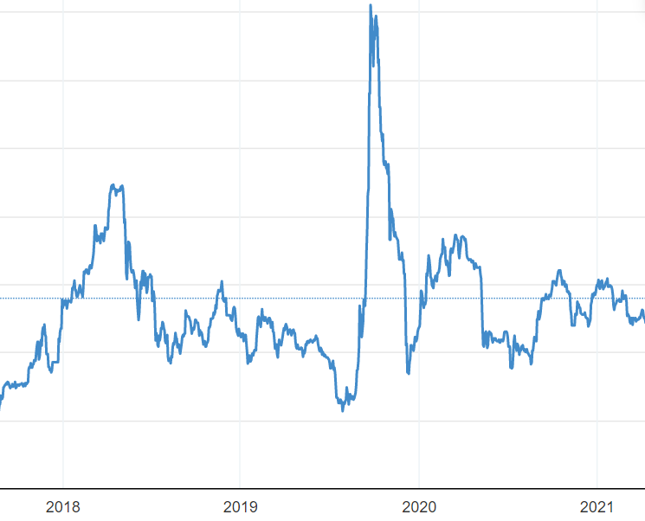
Graph 1. Indonesian Currency Stability Graph, source: tradingeconomics.com

Social
Access to essential services
Point 5. from the social column in the PESTEL analysis shows that the ‘access to essential services’ is crucial for the good prosperity of the business. For OISL operating in O&G sector, travel was nominated as an essential service which was disrupted during the Covid-19 pandemic. According to Gov.uk (2021) website OISL as a company operating in O&G sector was classed by the governments as the essential service company therefore it wasn’t much affected by the lockdown measures, but it highly relied on travel agencies to transport its workers to and off the platforms. Because of Covid-19, platforms faced high personnel turnover due to virus infections (BBC,2021). One of the examples which caused ‘mayhem’ for OISL, was collapsing of Horncastle, the main offshore travel agent which was responsible to transporting OISL employees to the North Sea platforms (Parsons,2020). Oceaneering was forced to immediately seek new ways to transport its workers to satisfy the clients.

Technological
Technological innovation & supply chains
The global pandemic showed that technology is the key especially in the product manufacturing countries which rely on the international supply chains. At the beginning of the Covid-19 pandemic where most flight were cancelled due to transferring of the virus, a lot of country supply chains were disrupted causing chaos and insufficient supplies of the most necessary products (Burkacky et al,2021). In this instance, for OISL it was microchips which are used in ROV manufacturing process. According to Martin McDonald Oceaneering SVP for Global ROV products, due to shortage of the ‘gold’ component which was supplied by the same manufacturer for years. OISL had to postpone an official ROV presentation in September 2020 due to extended manufacturing time caused by semiconductors (also known as microchips) shortage. OISL has since then been looking for new suppliers to reduce the risk of ‘non-supply’ and to strengthen its supply chain.

Environmental
Extreme weather
First point under ‘Environmental’ section of PESTEL analysis for OISL shows that extreme weather has an impact on OISL. This is caused by rapid climate change on the planet and raising temperatures. Gitz (2020) suggests that extreme weather and particularly hurricanes have ‘the potential to destroy oil and gas infrastructure”. According to article published by Reuters (2021), it shows that 88% of offshore oil production plants on Gulf Cost were closed and nearly 100 platforms had to become unoccupied after the Hurricane Ida landfall in August 2021. This had an enormous impact on Oceaneering’s operations due to lack of inspections in that region and income loss for a certain time (oceaneering.com,2021). This disaster also happened during the Covid-19 pandemic where most people have worked remotely and because of lack of electricity, couldn’t perform their duties. Duffy (2021) also communicates in her article that 13% fuel shortage in Louisiana state was recorded after the hurricane Ida landfall and over 1 million people in the state was without power. This had massive impact on people during the pandemic as they were not able to work.

Paris Climate Agreement
By looking at point 5 from environmental analysis it easy to see that Paris Climate Agreement is one of the parts where OISL must pay special attention to when planning their future strategy. The Paris Agreement is a United Nations accord signed in Paris during COP21 meeting on December 12, 2015, which established the principles of climate protection after year 2020 (European Commision,2020).
A similar but more important summit took place in 2021 where 200 nations representatives gathered together on COP26 to discuss and implement more important changes. One of the main topics was to cut greenhouse emissions and keep the temperature rising by minimum 1.5C (bbc.com,2021). It was agreed that all countries must further reduce supporting the fossil fuel extraction by minimizing the subsidies. As an addition, countries acknowledged the fact that they must start to invest more funds than ever before in renewable energy. It can be suggested that this is a big blow for the company like Oceaneering which mostly provide their services to ‘fossil fuel extraction companies’, and where majority of the countries agreed to slowly move away from it. But it may have its own advantages, where Oceaneering can use their O&G reputation to transfer its experience to renewable energy in the future.

Legal
Anti-trust Law
The main points in the Legal section of PESTEL analysis are points 1 and 3. According to Pace (2007) anti-trust law is a set of public law norms preventing the behaviour of entrepreneurs aimed at eliminating competition and establishing a private monopoly. For Oceaneering this law is very significant to be able to compete fairly in the market. A great example where this law was extremely significant and useful for Oceaneering can be found in the “Wright’s Wells Control Services (WWCS) vs Oceaneering” court case (casetext,2018) where OISL and WWCS worked together to develop a tool to remove hydrates from a pipeline on a specific project in 2008. After completion of the project, WWCS asked a third-party company “Gulf Coast Manufacturing” to remove Oceaneering’s logo from the equipment. WWCS then used a photo of the equipment (without OISL logo on it) in their presentations for new inspection bids. Anti-trust law does not allow companies to act this way and prevent from unfair competition.

Health and safety law
“All workers have a right to work in places where risks to their health and safety are properly controlled” (HSE,2009). This statement clearly defines how important health and safety law is for workers and businesses itself. Each company should have a policy which explains health and safety practices in the workplace (HSE,2019).
In the ‘pandemic era’ the biggest challenge for the company is to mitigate the risk of Covid-19 infections in the workplace. These days companies put a strict social distancing measures in their premises and allowing its employees to work from home where possible. BBC (2020) in their article shows that the number of people working offshore have reduced by the third from the time of the first lockdown in 2020. This runs with a connection to a Allas, Canal and Hunt (2020) article which shows that since the first lockdown 7.6 million jobs were at risk and that some companies had to permanently layoff some of their staff to keep the business going. With reduction of the workforce, customer care can be slightly neglected as there might not be enough hands in the business to fulfil all the customer orders with the highest possible quality, shortest lead time and lowest cost. According to Crawford Tennant, Director for UK & Europe Operations at Oceaneering (private conversation,2021) “nearly 30% of UK employees was registered for a furlough scheme in March 2020 which was offered by the UK government and less than 5% Oceaneering workers had to be re-trained in order to perform other work. This was the maximum amount of people we could temporarily lose to continue operations and provide the clients with the highest possible standard of service.”
By looking at the above, it is fair to say that businesses are following ‘Save to Thrive’ strategy (deloitte,2019). Cost reduction may have its impact on businesses health and safety culture in the future. As employees work longer hours to be able to complete their job, they are therefore exposed to enormous stress which may result in a lack of concentration and HSE procedures negligence. By looking at the HSE UK statistics for the offshore sector (hse.gov.uk,2020) it shows that there was a decrease in the overall injuries comparing to 2019 (-29). As reported by it is difficult to provide a realistic comparison figure due to the pandemic and many employees being furloughed. Even if the figures where accurate and up to date, there are many accessible articles which reveal that O&G companies undercount their accident report. As King and Walters (2021) suggest in their article the governments undercount the number of accidents and fatalities to show that the offshore O&G industry ‘appear safer than it is”.

Porter’s Five Forces
Porter’s five forces is a model that serves the most accurate examination of the competition, opportunities and threats that exist in the company's environment.
Porter describes the five forces in his interview for Harvard Business Review (2008) as “…a kind of holistic way of looking at any industry and understanding the structural underlying drivers of profitability and competition”.
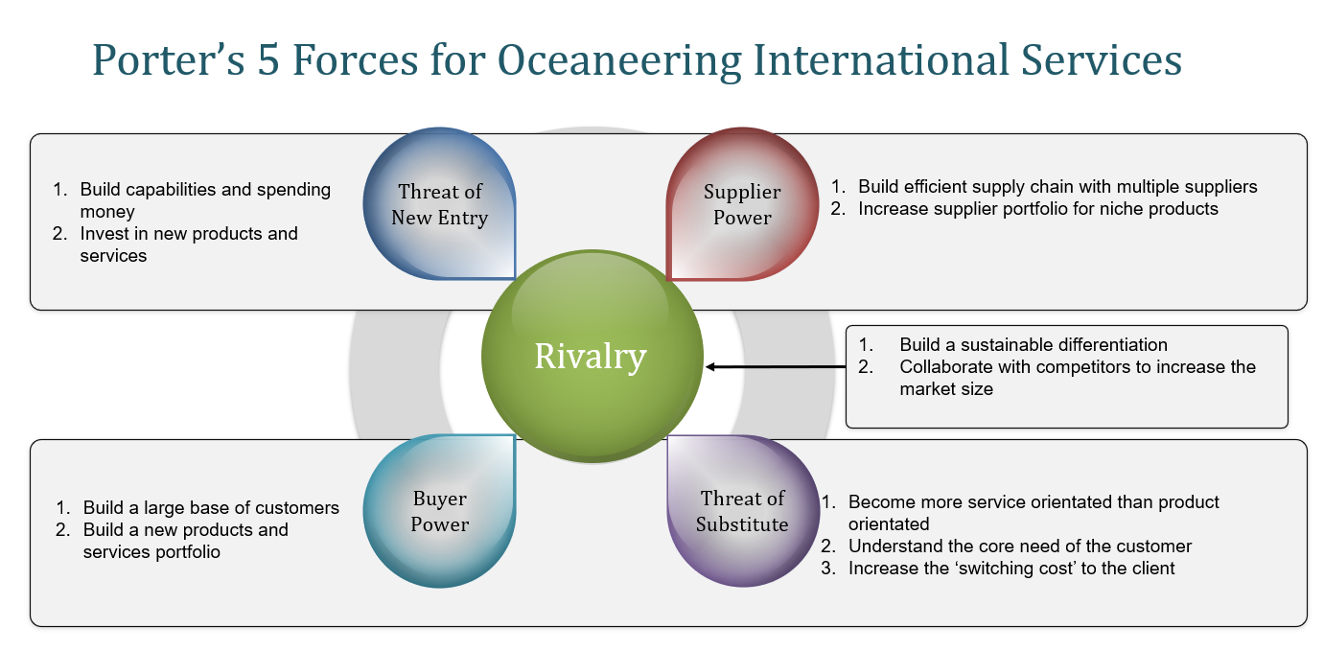
It is important for Oceaneering to perform a Porter’s Five Forces model to establish a strategic position within the O&G industry. Figure 5. presents Porter’s five forcers model conducted for Oceaneering International Services.
Figure 4. Porter’s Five Forces for Oceaneering International Services

Threat of New Entry
Investing in new products & services
Point 1. shows that for Oceaneering the threat of the new entry can be minimised by investment in new products and services. As an example, OISL have recently developed a new inspection technique called Trip Avoidance X-ray Inspection (TAXI) which is the unique system in Non-Destructive Testing (NDT) sector to digitally radiograph pressure piping and infrastructure (oceaneering.com,2021). Developing a new technique allows OISL to build a sustained competitive advantage over the competitors and minimise the risk of new entrees. Developing new techniques for companies in energy sector can take a lot of time and effort. This may require a specific type of equipment and knowledge and expertise to be able to analyse and approve the technique before it can reach the market.
Building capabilities on Research & Development (R&D)
OISL can build a bigger a human capital of specialists and engineers in all fields of the business to minimise new entrants coming to the market. With high volume of expertise and company experience, new entrees can feel the pressure and risk of ‘failing in the market’. By investing in research and development, OISL can gain a lot of strong new expertise and knowledge which will help to upgrade and improve current processes to increase efficiency and reduce cost (James,2019). Also, by building R&D, OISL can develop more techniques and range of services which will be a threat for new companies to enter the market.
Threat of Substitute
New orientation
By becoming more service orientated, OISL can provide customers with the complete inspection package. As an example, OISL can put more pressure on their global advanced inspection services than they currently do. At present, most of the company revenue comes from the Subsea Robotics division (oceaneering,2021). But, if OISL invest more time and effort in developing the advanced inspection it can provide the customer with the broad package of services at the lowest possible cost. By doing that, the threat of substitute can be reduced, and customers will not be willing to replace OISL for another company which only provides one service or product at the time. In other words, quoting McKinsey article title, OISL would be able to provide ‘Personalised, white-glove service for all” (www.mckinsey.com,n.d).

Supplier Power
Increasing supplier portfolio
O&G is a unique and complex industry, requiring a lot of knowledge, experience, and dedication. OISL’s Advanced NDT division is a small group of specialists within the organisation developing and providing special techniques for the very most complex NDT inspections to the energy clients. It requires a specialised equipment which is classed as a ‘niche’ and don’t have many providers. Olympus is one the main equipment provider for OISL Advanced NDT division. Olympus is mostly known for medical and photography equipment. They also have a small division (IMS) within the business which specialised in NDT products (olympus-ims.com,2015). OISL highly relies on Olympus equipment because of its reliability and product range. Olympus as one of the main NDT equipment suppliers for OISL have the power in the market and can control their prices because of limited competition. OISL needs to increase their supplier portfolio by researching new suppliers that can provide the same products, customer service for reduced cost.

Buyer Power
Increased base of customers
Buyer power (also known as consumer power) is very important for OISL as a service provider. It defines the pressure the client is putting on the business to provide higher quality inspections, better customer service and reliability for lower price (De Bruin, 2016).
OISL is one of the main engineering and inspection providers in the energy industry but to reduce the consumer power, OISL must build a larger base of customers. This can be achieved by investing more money in development of their products and services and providing the customer with the highest quality of inspections, wider range of techniques for lowest price. By doing this, it will give a huge advantage over competitors and encourage more customers to choose their services.
From psychological point of view, according to Henderson (2017) “people follow the crowd” so by getting a “reduced cost and high-quality advantage”, OISL will get a wider base of customers. Customers benchmark their rivals to keep up with the trend, therefore OISL would be in a winning position to reduce buyer power.

Rivalry
Building a sustainable differentiation
Competition in the market is very normal. Businesses compete against each other for years to win the market position and to provide the customer with the best product or service for the lowest possible price (Pettinger,2018). For OISL to compete in the energy sector, they must show differentiation and build a sustained competitive advantage, not only by cutting costs and developing new products but also by providing the best customer care.
Working with other competitors
By working with other competitors, OISL has a chance to increase the market size and to advertise the company even more. OISL could join their local competitor to use both sets of expertise and knowledge to develop a new product or service which would be available only to these two businesses. This would need to be done in a sustained and legal way to avoid any future conflict. As an example, Apple and Microsoft have successfully worked together to develop a mobile operating system (McLaughlin,2013).

VRIO Analysis
VRIO framework was developed by Jay Barney in 1991 as an internal business analysis tool to help analyse business internal resources and to find out if they can be a source of sustained competitive advantage (Jurevicius,2021). It stands for Value, Rarity, Imitability and Organisation. It was initially known as VRIN. The last point was changed from Non-substitutable to Organised to give more clarity for the analysts.
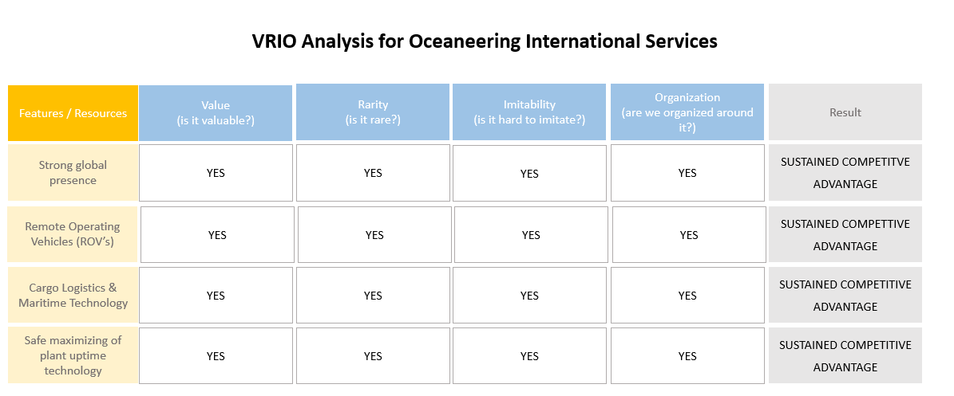
VRIO is a valuable tool to help discover, if OISL has a sustained competitive advantage against a backdrop of a pandemic and its competitors.
‌ Figure 5. VRIO Analysis for Oceaneering International Services
Figure 5. presents Oceaneering’s features and resources which are going to be analysed below.
OISL has a strong global presence in the O&G industry which is valuable for the customer as it can be reached easily from any part of the world. Not many businesses offer such a global presence. As an example, one of Oceaneering’s biggest competitor Oil States International operates in 62 locations across 11 comparing to Oceaneering which operates in 24 countries and has over 70 bases (source: www.oilstateintl.com). High presence in the world gives OISL a huge advantage but whilst connected with exceptional customer care, it may have no equal in its sector. Oceaneering is also a very rare in its O&G engineering field due to a complex portfolio of inspection techniques and equipment. Along with imitability and organisation, it gives OISL a sustained competitive advantage.
By looking at the table above, Remote Operating Vehicles (ROV’s) also give Oceaneering the advantage over other businesses. This is where Oceaneering has mainly built their reputation and what it’s known from. OISL has capability of manufacturing as also operating their own ROV’s. It is highly valuable for the business as it stands for 30% for a global ROV market share. (source: Offshore Engineer Magazine,2021). It is very unique that a company like OISL is able to manufacture and operate their ROV systems at the same time. It is very difficult to imitate these products by another company, due to high manufacturing and maintenance costs. ROV’s are usually made to customers’ needs and specifications. This is done by OISL engineers and specialists who know what the client needs and why they need it. As stated in McKinsey article “Hyperpersonalisation of Customer Care” (2020) companies need to start to deliver personalised care for its customers. In the world of pandemic and technological change, businesses are required to predict customer choice and to meet their quality and customer service expectations for the benefit of both parties. The example above is an excellent demonstration of how OISL values customer service.
OISL has also developed their own Cargo Logistics & Maritime technology called OceanSmart. It was developed in 2020 and is strictly organised by a group of professionals (source: www.globalunderwaterhub.com,2020). This tool allows cargo owners to reduce waste through cargo value chain. (source: oceaneering.com,2021). It is extremely valuable piece of software for the owner of the goods to see where their consignment, vessels, maritime assets are in real time. It also supports OISL as a business in day-to-day operations planning and ROV transportation. It is tremendously helpful and rare invention which can provide the cargo owner and shipper with smart analytic tools, transportation vessel information and precise location and ETA of cargo. This is the only system on the market and it’s very hard to imitate as it requires a lot of research, experience, and high financial contribution.

Conclusion & Recommendations
In a time of pandemic and slow economic rebound, where companies are willing to do whatever, it takes to win a customer, adopting the right strategy is crucial.
When choosing the right strategy, it is important to apply the appropriate analysis tools, showing where a given company is now, in order to be able to assess where it may be in the future. The popular saying that the customer is always right in the field of a pandemic can have even more importance in how companies must fight for and look after every customer in all respects.
Oceaneering current position can be defined as ‘strong and stable’ with the ability to be the strongest on the market.
By looking at the information contained in the report, SWOT analysis reveals that Oceaneering is a large company with a lot of experience in its field and trusted by its customers. The study found that OISL has product gaps that may result in losing some customers if nothing is done about it.
Due to climate change and new governmental laws, companies operating in the energy sector must look for new solutions and move towards renewable energy. For OISL, which mainly operates in the oil and gas sector, it is a great opportunity to transfer its skills and experience to this type of sector. As a company with massive experience, unfortunately, the study shows that its workforce is ageing, which may cause a decline in the quality of work performed in the future.
The PESTEL analysis reveals that OISL is highly dependent on supply chains, governments, laws, and the climate. In terms of the ‘customer service’ perspective, all of these factors affect whether OISL will be able to cope with increasing customer demands in the future. All these functions must work together at the appropriate level for OISL to achieve the highest goals and be able to satisfy its customers in every part of the process.
As technology moves forward, OISL needs to bring new products and services into circulation to reduce the likelihood of a new company entering the market. Not only products and services can discourage new entrants from entering the market, also research and development into new technologies are very important which OISL must concentrate on.

References
Aguilar,F. (1967). Scanning the business environment. New York, Macmillan.

Allas, T. Canal, M. and Hunt, V. (2020). COVID-19 in the UK: The impact on people and jobs at risk | McKinsey. [online] www.mckinsey.com. Available at: https://www.mckinsey.com/industries/public-and-social-sector/our-insights/covid-19-in-the-united-kingdom-assessing-jobs-at-risk-and-the-impact-on-people-and-places [Accessed 5 Dec. 2021].

Bartik et al. (2020). The Impact of COVID-19 on Small Business Outcomes and Expectations. Proceedings of the National Academy of Sciences, [online] 117(30). Available at: https://www.pnas.org/content/117/30/17656. [Accessed 5 Dec. 2021].

BBC. (2020). Covid: Offshore workforce fell by more than a third after lockdown began. BBC News. [online] 27 Oct. Available at: https://www.bbc.co.uk/news/uk-scotland-scotland-business-54692033. [Accessed 4 Dec. 2021]

BBC. (2021). COP26: What is the Glasgow climate conference and why is it important? BBC News. [online] 24 Sep. Available at: https://www.bbc.co.uk/news/science-environment-56901261 [Accessed 4 Dec. 2021]

BBC News. (2021). Covid: Offshore workforce fell by more than a third after lockdown began - BBC News. [ONLINE] Available at: https://www.bbc.co.uk/news/uk-scotland-scotland-business-54692033. [Accessed 04 December 2021].

Burtacky et al. (2021). Value creation: How can the semiconductor industry keep outperforming? | McKinsey. [online] Available at: https://www.mckinsey.com/industries/semiconductors/our-insights/value-creation-how-can-the-semiconductor-industry-keep-outperforming. [Accessed 3 Dec. 2021].
casetext.com (2018). Wright’s Well Control Servs., LLC v. Oceaneering Int’l, Inc., CIVIL ACTION NO. 15-1720 SECTION “R” (3) | Casetext Search + Citator. [online] Available at: https://casetext.com/case/wrights-well-control-servs-llc-v-oceaneering-intl-inc-12 [Accessed 4 Dec. 2021].
Chantal et al. (2021). How oil and gas is navigating the energy transition | McKinsey. [online] Available at: https://www.mckinsey.com/industries/oil-and-gas/our-insights/the-big-choices-for-oil-and-gas-in-navigating-the-energy-transition. [Accessed 5 Dec. 2021].
Christensen et al. (1965) Business Policy: Text and Cases, Homewood, Illinois: Irwin.
De Bruin, L. (2016). Porter’s Five Forces EXPLAINED with EXAMPLES | B2U. [online] B2U - Business-to-you.com. Available at: https://www.business-to-you.com/porters-five-forces/ [Accessed 5 Dec. 2021].

Deloitte. (2019). Deloitte’s 2019 Global Cost Survey: Save-to-Transform. [online] Available at: https://www2.deloitte.com/us/en/pages/operations/articles/global-cost-management-survey.html [Accessed 5 Dec. 2021].

Duffy, K. (2021). Fuel shortages are sweeping gas stations across Louisiana following Hurricane Ida. [online] Business Insider. Available at: https://www.businessinsider.com/hurricane-ida-louisiana-gas-stations-no-fuel-hurricane-ida-2021-9?r=US&IR=T [Accessed 4 Dec. 2021].
Drucker, P. (1994). “The theory of business”, p.95-104: Harvard Business Review
Drucker, P. (1994). “The theory of business”, p.95–106: Harvard Business Review.
European Commission (2020). Paris Agreement. [online] ec.europa.eu. Available at: https://ec.europa.eu/clima/eu-action/international-action-climate-change/climate-negotiations/paris-agreement_en [Accessed 4 Dec. 2021].

Frue, K. (2017). Who Invented PEST Analysis And Why It Matters. [online] PESTLE Analysis. Available at: https://pestleanalysis.com/who-invented-pest-analysis/. [Accessed 5 Dec. 2021].

Giltz, S. (2020). Hurricane Season and Offshore Drilling Are a Reckless Combination. [online] Available at: https://usa.oceana.org/blog/hurricane-season-and-offshore-drilling-are-reckless-combination/ [Accessed 4 Dec. 2021].
GOV.UK. (2021). Coronavirus (COVID-19): jobs that qualify for travel exemptions - GOV.UK . [ONLINE] Available at: https://www.gov.uk/government/publications/coronavirus-covid-19-travellers-exempt-from-uk-border-rules/coronavirus-covid-19-travellers-exempt-from-uk-border-rules. [Accessed 04 December 2021].
Harvard Business Review (2008) The Five Competitive Forces That Shape Strategy. [online video] Available at: https://www.youtube.com/watch?v=mYF2_FBCvXw&ab_channel=HarvardBusinessReview [Accessed 5 Dec. 2021]

Helms et al, (2010). Exploring SWOT analysis–where are we now? A review of academic research from the last decade. Journal of strategy and management.

Hirsch, A. (2017). 4 Ways for HR to Overcome Aging Workforce Issues. [online] SHRM. Available at: https://www.shrm.org/resourcesandtools/hr-topics/behavioral-competencies/global-and-cultural-effectiveness/pages/4-ways-for-hr-to-overcome-aging-workforce-issues.aspx. [Accessed 04 December 2021].

HSE. (2009). Health and Safety Executive. [online] Available at: https://www.hse.gov.uk/pubns/law.pdf [Accessed 4 Dec. 2021].

HSE. (2019). Prepare a health and safety policy - HSE. [online] Hse.gov.uk. Available at: https://www.hse.gov.uk/simple-health-safety/policy/index.htm [Accessed 4 Dec. 2021].

Hse.gov.uk. (2020). HSE Offshore: Statistics. [online] Available at: https://www.hse.gov.uk/offshore/statistics/index.htm [Accessed 3 Jan. 2020].

IEA (2021). Oil markets face uncertain future after rebound from historic Covid-19 shock - News. [online] Available at: https://www.iea.org/news/oil-markets-face-uncertain-future-after-rebound-from-historic-covid-19-shock. [Accessed 23 Nov. 2021].

Inc, O.I (2021). Oceaneering Reports Third Quarter 2021 Results. [online] www.prnewswire.com. Available at: https://www.prnewswire.com/news-releases/oceaneering-reports-third-quarter-2021-results-301410251.html [Accessed 23 Nov. 2021].

investors.oceaneering.com (2020). Oceaneering Reports First Quarter 2020 Results. [online] Available at: https://investors.oceaneering.com/financial-press-releases/press-release-details/2020/Oceaneering-Reports-First-Quarter-2020-Results/default.aspx [Accessed 23 Nov. 2021].

King, T.F. and Walters (2021). Study Finds Offshore Oil Rig and Gas Worker Fatalities Are Undercounted. [online] Tracey Fox King & Walters. Available at: https://www.traceylawfirm.com/posts/study-finds-offshore-oil-rig-and-gas-worker-fatalities-are-undercounted [Accessed 5 Dec. 2021].

Jibrin, I. (2018). Civilian-Led Governance and Security in Nigeria After Boko Haram. [ebook] Washington: United States Institute of Peace, pp.1-5. Available at: <https://www.usip.org/sites/default/files/2018-12/sr_437_civilian_led_governance_and_security_in_nigeria_0.pdf> [Accessed 2 December 2021].

James, S. (2019). What Is R&D? Research And Development In Business. [online] ForrestBrown. Available at: https://forrestbrown.co.uk/news/what-is-r-and-d/ [Accessed 5 Dec. 2021].

Jurevicius, O. (2021). VRIO Framework Explained - SM Insight. [online] Strategic Management Insight. Available at: https://strategicmanagementinsight.com/tools/vrio/. [Accessed 2 December 2021].

Kemp, J. (2021). Column: Rising oil price will draw response from consumers: Kemp. Reuters. [online] 1 Jul. Available at: https://www.reuters.com/world/middle-east/rising-oil-price-will-draw-response-consumers-kemp-2021-06-30/ [Accessed 25 Nov. 2021].

oceaneering.com (2021). About Us | Oceaneering. [online] Oceaneering.com. Available at: https://www.oceaneering.com/about/ [Accessed 23 Nov. 2021].

McLaughlin, K. (2013). How Microsoft And Apple Work Together. [online] Business Insider. Available at: https://www.businessinsider.com/how-microsoft-and-apple-work-together-2013-6?r=US&IR=T [Accessed 19 Dec. 2019]
‌Mintzberg, H. (2007).” Tracking Strategies: Towards a General Theory”, p.3: Oxford University Press.
Offshore Engineer Magazine. (2021). ROV Services Market Update. [online] Available at: https://www.oedigital.com/news/489804-rov-services-market-update [Accessed 30 Nov. 2021]
oceaneering.com (2021). Renewable Energy Solutions | Oceaneering. [online] Oceaneering.com. Available at: https://www.oceaneering.com/renewable-energy-solutions/ [Accessed 23 Nov. 2021].

Olympus-ims.com. (2015). Olympus - Non Destructive Ultrasonic Test Equipment, Ultrasonic, Phased Array, Microscopes, Thickness Gages, Flaw Detectors, Innov-X, NDT, Remote Visual Inspection, Eddy Current, X-ray Fluorescence, X-ray Diffraction. [online] Available at: https://www.olympus-ims.com/en/ [Accessed 5 Dec. 2021].

Oppert, O’Keeffe. (2019) The future of the ageing workforce in engineering: relics or resources?, Australian Journal of Multi-Disciplinary Engineering, 15:1 ,100-111, DOI:10.1080/14488388.2019.1666621

Pace, L. (2007). “European Anti-trust law” p.35: Edward Elgar Publishing

Parsons, M. (2020). Corporate Travel Saw a Rare Bright Spot in the Oil and Gas Industry: Why That’s Now Changing. [online] Skift. Available at: https://skift.com/2020/11/27/corporate-travel-saw-a-rare-bright-spot-in-the-oil-and-gas-industry-now-thats-even-changing/. [Accessed 3 Dec. 2021].

Pettinger, T. (2018). How firms compete - Economics Help. [online] Economicshelp.org. Available at: https://www.economicshelp.org/blog/143936/economics/how-firms-compete/ [Accessed 19 Dec. 2019].

Porter, M. (1996). “What is Strategy.” p.60: Harvard Business Review.
Porter, M. (1998) “Competitive strategy: techniques for analysing industries and competitors : with a new introduction.” p15-16: 1st Free Press ed. New York: Free Press.
Renews. (2020). COVID-19: Petrofac experiences “significant disruption.” [online] reNEWS - Renewable Energy News. Available at: https://renews.biz/60318/covid-19-petrofac-experiences-significant-disruption/ [Accessed 27 Nov. 2021].

Reuters (2021). Hurricane Ida: nearly 350 reported oil spills investigated in Gulf – Coast Guard. [online] the Guardian. Available at: https://www.theguardian.com/environment/2021/sep/06/hurricane-ida-oil-spills-gulf-coast [Accessed 4 Dec. 2021].
‌
Sadorsky, Perry. (2011). Some future scenarios for renewable energy. Futures. 43. 1091-1104. 10.1016/j.futures.2011.07.008.

Statista. (2021). Indonesia oil production 2020. [online] Available at: https://www.statista.com/statistics/609047/oil-production-in-indonesia/ [Accessed 3 Dec. 2021].

TheGlobalEconomy.com. (2021). Egypt Political stability - data, chart | TheGlobalEconomy.com. [online] Available at: https://www.theglobaleconomy.com/egypt/wb_political_stability/. [Accessed 25 Nov. 2021].

Trauthwein, G. (2019). One-on-One with Martin McDonald, SVP, ROV Division, Oceaneering. [online] Available at: https://www.maritimeprofessional.com/news/with-martin-mcdonald-division-oceaneering-344416 [Accessed 25 Nov. 2021].

www.oceaneering.com (2020). Latest News | Oceaneering. [online] Oceaneering.com. Available at: https://www.oceaneering.com/news-media/latest-news/Indonesia/ [Accessed 3 Dec. 2021].

www.globalunderwaterhub.com. (2020). Oceaneering launches OceanSMART to eliminate waste in bulk cargo logistics - Global Underwater Hub, Aberdeen, Scotland. [online] Available at: https://www.globalunderwaterhub.com/11380/oceaneering-launches-oceansmart-business-to-eliminate-waste-and-increase-transparency-within-bulk-cargo-logistics-industry [Accessed 1 Dec. 2021].

www.macrotrends.net. (n.d.). Oceaneering Number of Employees 2006-2021 | OII. [online] Available at: https://www.macrotrends.net/stocks/charts/OII/oceaneering/number-of-employees [Accessed 24 Nov. 2021].
www.mckinsey.com. (n.d.). The care of one: Hyperpersonalization of customer care | Operations | McKinsey & Company. [online] Available at: https://www.mckinsey.com/business-functions/operations/our-insights/the-care-of-one-hyperpersonalization-of-customer-care [Accessed 1 Dec. 2021].
www.mckinsey.com. (n.d.). The future of customer experience: Personalized, white-glove service for all | McKinsey. [online] Available at: https://www.mckinsey.com/business-functions/operations/our-insights/the-future-of-customer-experience-personalized-white-glove-service-for-all [Accessed 5 Dec. 2021].
www.oceaneering.com (2021). Oceaneering’s TAXITM Digital Radiography Solution to Provide Significant Cost Savings. [online] Oceaneering.com. Available at: https://www.oceaneering.com/oceaneering-develops-trip-avoidance-xray-inspection-taxi-system/ [Accessed 5 Dec. 2021].

www.oceaneering.com (2021). OceanSMART Home. [online] OceanSmart. Available at: https://oceansmart.com/ [Accessed 1 Dec. 2021].

www.trade.gov (2021). Energy Resource Guide - Indonesia - Oil and Gas. [online]. Available at: https://www.trade.gov/energy-resource-guide-indonesia-oil-and-gas. [Accessed 3 Dec. 2021].

www.worldometers.info. (n.d.). Coronavirus Graphs: Worldwide Cases and Deaths - Worldometer. [online] Available at: https://www.worldometers.info/coronavirus/worldwide-graphs/#case-timeline. [Accessed 3 Dec. 2021].

Zojceska, A. (2018). HR Metrics: How and Why to Calculate Employee Turnover Rate? [online] Blog. Available at: https://www.talentlyft.com/en/blog/article/242/hr-metrics-how-and-why-to-calculate-employee-turnover-rate. [Accessed 3 Dec. 2021].

Figures
Figure 1. SWOT Analysis for Oceaneering International Services, Walczak,2021
Figure 2. Attrition Rate Formula, (www.callcentrehelper.com),2021
Figure 3. PESTEL Analysis for Oceaneering International Services, Walczak,2021
Figure 4. Porter’s Five Forces for Oceaneering International Services, Walczak,2021
Figure 5. VRIO Analysis for Oceaneering International Services, Walczak,2021
Graph 1. Indonesian Currency Stability Graph, (www.tradingeconomics.com),Walczak,2021

