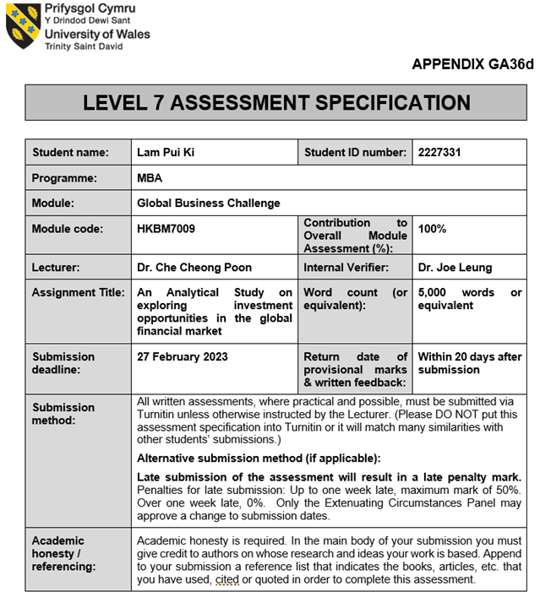

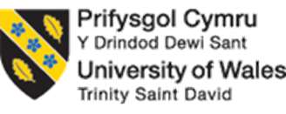

UWTSD MBA HKBM7009
(UWMBA-30013-2022-1-SS)
HKBM7009 Global Business Challenges

An Analytical Study on Exploring Investment Opportunities
in a Global Financial Market: France

Student Name | ： | Lam Pui Ki
Student ID Number | ： | 2227331
Date of Submission | ： | 27 February 2023
Lecturer | ： | Dr. Che Cheong Poon

UWTSD MBA (May/Nov 2022 intakes)
BMMB7009 Global Business Challenges
Assignment Title:
An Analytical Study on Exploring Investment Opportunities in a Global Financial Market: France

“I, Lam Pui Ki (2227331), certify this work is the result of my own investigations, except where otherwise stated. All references have been duly cited”

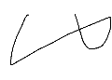

Signed: ____________

Date: 27 February 2023

Synopsis

The purposes of this report are to analyze a listed assets management company in Hong Kong, ABC Company Limited’s (ABC) current investment portfolio, its investment performance, and the opportunities and risks for making profit margin by investing in stock market CAC40 (FCHI) in France. This report also includes the study of Hang Seng Index (HSI) stock market characteristics in Hong Kong, CAC40 stock market characteristic in France, the analysis of investment return, investment risks, and limitations if ABC invests in CAC40 in France.

Table of Contents
 |  |  |  |  |  |  |  | Page
 | Chapter 1: Introduction |  |  |  |  |  |  | 1 - 2
 | 1.1 | Research motivation, aim, and objectives
 | 1.2 | Research framework
 | Chapter 2: Company Background of ABC Company Limited |  |  |  |  |  |  | 3 - 5
 | 2.1 |  | Company profile
 | 2.2 |  | Current investment portfolio and investment performance
 | 2.3 |  | The global business challenges and the rationale for exploring investment opportunities in some global financial markets
 | Chapter 3: Characteristics of the stock market CAC40 in France |  |  |  |  |  |  | 6–12
 | 3.1 |  | A comparison of the stock price index movement between Hang Seng Index in Hong Kong and CAC40 in France
 | 3.2 |  | The stock market profiles of Hang Seng Index in Hong Kong and CAC40 index in France
 | 3.3 |  | The economic prospect in France
 | Chapter 4: Analysis and discussion for identifying the opportunities and risks to invest in French stock market CAC40 |  |  |  |  |  |  | 13-20
 | 4.1 |  |  |  | Investment return in investing in Hang Seng Index in Hong Kong and CAC40 in France
 |  |  |  |  | 4.1.1 |  | Capital return in investing in Hang Seng Index and CAC40
 |  |  |  |  | 4.1.2  4.1.3 |  | Income return in investing in Hang Seng Index and CAC40  Interest rate in France
 | 4.2 |  |  |  | Investment risk in investing in Hang Seng Index Hong Kong and CAC40 in France
 |  |  |  |  | 4.2.1 | Stock price volatility of Hang Seng Index and CAC40
 |  |  |  |  | 4.2.2 | Market risk in France
 |  |  |  |  | 4.2.3 | Exchange rate risk of Euro of European Union
 | Chapter 5: Conclusion and recommendations |  |  |  |  |  |  | 21-22
 | 5.1 |  |  | Conclusion
 | 5.2 |  |  | Recommendations
References |  |  |  |  |  |  |  | 23-25

Chapter 1: Introduction

In this section, the research motivation, aim, and objectives of this study, and the research framework, the summarized objectives, key factors, variances, findings, and recommendation are included.

1.1 Research motivation, aim, and objectives

ABC is investing in Hong Kong and different foreign counties, United States, Malaysia Singapore, Cayman Islands, China Ireland, South Korea, and Australia, but there is no investment in France now.

In this difficult time of COVID-19 pandemic these 3 years, and the increased concerns on Environmental, Social and Governance (ESG) investment, ABC faced a lot of challenges on making profit and reducing the costs, it expands their operation in Singapore and the investment in China to serve the wealth management demand in South Asia.

As France’s economy was expected to be strong, the stock price was going up. Is French stock market also a good choice? Which stock is more appropriate for investing? This report aims to study the current capacity of ABC, and the market prospect, expected rate of return and market risks on investing CAC40 in France so that ABC can diversify its investment portfolio to gain the profit.

1
1.2 Research framework

In this report, the following research objectives are to be achieved:
1. To understand ABC’s company profile, current investment portfolio and performance
2. To compare the characteristics of French stock market CAC40 and Hang Seng Index in
Hong Kong, and to find out the correlation of coefficient between two indexes
3. To analyze the investment return and investment risk
4. To conclude the findings, recommend investing in France stock market or not and suggest
the stock for investing if the investment is profitable

For identifying the opportunities and risks to invest in French stock market, the following variances were studied:
- To identify the investment return: The capital return by measuring the expected return rate and standard deviation, the income returns by measuring the dividends, the interest rate.
- To identify the investment risk: The stock price volatility (VIX), the market risk by consumer price index (CPI), and the exchange rate risk of Euro.

Finally, the above factors and the findings indicated that there is French economic growth, French government still supports the healthcare sector, the French stock market is stable with relatively low risk in investing in CAC40.
SANOFI, a listed healthcare company in CAC40, was recommended for investing for 2 years but ABC must keep monitoring and reviewing the changes in France, the performance of SANOFI and its other investment components.

2
Chapter 2: Company background of ABC Company Limited

In this section, the company profile, current investment portfolio and investment performance of ABC Company Limited (ABC) are studied. It is an internal analysis for ABC to understand its company business directions, any capacity and feasibility to invest in French stock market, CAC40.

2.1 Company profile

ABC Company Limited (ABC) was established in Hong Kong in 1993, a listed independent asset management company on the Main Broad of the Hong Kong Stock Exchange in 2007. ABC’s headquarter is in Hong Kong with operations in Shanghai, Shenzhen, Beijing, Kuala Lumpur, Singapore, and London. Currently, ABC is also one of the leaders in ESG investing in Greater Bay Area in China.

ABC offers investment services and products, Equities, Fixed income, Alternatives, Multiple-asset, Quantitative investment solutions. The main types of its clients are institutions, statutory authorities, university endowment funds, charitable foundations, pension funds, high-net-worth individuals and retail investors in Asia Pacific, Europe and North American.

2.2 Current investment portfolio and investment performance

ABC’s investment philosophy is to apply a bottom-up approach to stock selection. It focuses on analyzing individual companies’ fundamentals intensively and reduces the considerations on industries, market cycles and macroeconomic environment.

Table 1 shows the investment portfolio and investment performance of ABC Company Limited from 2018 to 2021. It is found that ABC mainly invested in investment funds, loan note and some other small components in foreign countries, the total percentages of investment in foreign countries were 70.18% in 2018, 73.39% in 2019, 77.80% in 2020 and 64.17% in 2021. According to the annual reports, ABC invested in United States, Malaysia Singapore, Cayman Islands, China Ireland, South Korea, and Australia, and there is no investment in France now.

3
While ABC also mainly invested in investment fund and has no investment in loan note in domestic market, the total percentages of investment with other small components in domestic market were 29.1% in 2018, 26.62% in 2019, 22.19% in 2020 and 35.83% in 2022.
About the investment performance, the table 1 shows that ABC was better in investing in investment funds in foreign countries, like the year in 2020 but lose significantly in 2018 when investing included debt securities. The investment performance in 2019 to 2021 fluctuated due to the impact of COVID-19 pandemic.

Table 1: Investment portfolio and
investment performance of ABC Company Limited from 2018 to 2021
 | 2018 |  | 2019 |  | 2020 |  | 2021
Investment Items | Domestic | Foreign  countries | Domestic | Foreign  countries | Domestic | Foreign  countries | Domestic | Foreign  countries
Equity securities (%) | 2.86% | 0.09% | 2.87% | 0.13% | 0.44% | 0.09% | 0.27% | 0.06%
Debt securities (%) | 3.42% | 21.98% | 0.00% | 0.00% | 0.00% | 0.00% | 0.00% | 0.00%
Investment funds (%) | 23.53% | 26.73% | 23.75% | 40.44% | 21.75% | 52.53% | 35.56% | 39.83%
Loan note (%) | 0.00% | 21.38% | 0.00% | 32.82% | 0.00% | 25.18% | 0.00% | 24.28%
Total (%) | 29.81% | 70.18% | 26.62% | 73.39% | 22.19% | 77.80% | 35.83% | 64.17%
Net gains/  losses on investments  (HK$’000) | -189,721 |  | 191,015 |  | 257,608 |  | 112,644
Sources: Annual reports of ABC Company Limited

4
2.3 Global business challenges and the rationale for exploring investment opportunities in some global financial markets

As many countries and companies are concerned about ESG performance, the importance of ESG investment increases in the world. ABC is putting more effort on analyzing the ESG investment. It also joined the program organizing together with Hang Seng Bank to support ESG talent development in Hong Kong to show its concerns and values on the development of ESG investment.

Moreover, as Hong Kong is the gateway for the investors to invest in China, ABC is actively looking at the business opportunities in China, especially in Greater Bay Area. It also expands its operations in Singapore, to serve the increasing wealth management demands in South Asia.

Referring Section 2.2, ABC’s current investment portfolio is mainly in the investment funds and loan note in foreign countries, United States, Malaysia Singapore, Cayman Islands, China Ireland, South Korea, and Australia but no investment in France, ABC can consider exploring the investment in France, the stock includes more ESG components.

5
Chapter 3: Characteristics of the stock market CAC40 in France
In this section, the comparison, characteristics, stock market profiles of Hang Seng Index in Hong Kong ad CAC40 in France, and the economic prospect were studied.

3.1 A comparison of the stock price index movement between Hang Seng Index in Hong Kong and CAC40 in France

Figure 1 illustrates the same stock price index movement of Hang Seng Index and CAC40 from 1990 to Jan 2023.

Figure 1 Time plot of stock price index movements in HSI and FCHI
Sources: Data taken on 4 Feb 2023:
https://finance.yahoo.com/quote/%5EHSI/history?period1=536371200&period2=1675468800&interval=1mo&filter=history&frequency=1mo&includeAdjustedClose=true;
https://finance.yahoo.com/quote/%5EFCHI/history?period1=636249600&period2=1675468800&interval=1mo&filter=history&frequency=1mo&includeAdjustedClose=true
6
There were four selected cycles of indexes, the cycles were moving up from the low to the high, and down to the low during 1995 to mid-2022:
- Period from 1995 to 2003 in 8 years; With high at mid-2000.
- Period from 2003 to 2009 in 6 years; With high in 2007.
- Period from 2016 to 2019 in 3 years; With high in 2018.
- Period at the end of 2019 to mid-2022 in 2 years only; With high at in mid-2021.
It shows that the cycle becomes shortened over time and the market seems not to be predictable easily both in Hong Kong and France.

In 1998 to 2008, the line of CAC40 was upper than Hang Send Index; While 2009 to mid-2021, Hang Seng index was the upper one, and it was at the opposite that CAC40 became the upper one from mid-2021 to Jan 2023. The economy of France can be predicted to be better than that of Hong Kong.

In addition, Table 2 shows the correlation of coefficient between Hang Seng Index and CAC40 over 4 selected periods. In the business portfolio, the relationship between two indexes is high (low), the investment risk is high (low), then the efficiency of diversification investment is low (high).

In which, the correlations were in positive values and higher than 0.7 in periods of 1-1-2003 to 1-12-2009 and 1-1-2016 to 1-12-2019, the relationship between two indexes were strong. While the correlation in period of 1-1-2019 to 1-12-2022 was in negative value with in relative low relationship. That means the investment risk is low with high diversification investment when investing in France at the end of 2022.

Table 2: The correlation of coefficient between Hang Seng Index and CAC40
Selected Periods | Correlation of coefficient of  ^HSI Close price to ^FCHI Close price
1-1-1995 to 1-12-2003 | 0.63
1-1-2003 to 1-12-2009 | 0.71
1-1-2016 to 1-12-2019 | 0.80
1-1-2019 to 1-12-2022 | -0.25
Source: Created by author

7
3.2 The stock market profiles of Hang Seng Index in Hong Kong and CAC40 index in France

In this part, the stock market profiles of Hang Seng Index (HIS) and CAC40 are studied. Most constituents of HSI and CAC40 shares are different but they can be bought in the primary stock markets available to public, and the secondary market by acquiring the shares from other investors.

Hang Seng Index (HSI)
The Hang Seng Index ("HSI") was launched on 24 November 1969 with the base index 100 in HKD. It is normally considered as the most extensive indicator to reflect the stock market performance in Hong Kong. It is reviewed quarterly with dissemination in every 2 seconds.

The stocks of HSI are freefloat-adjusted to show the investability and 8% capping is adopted to prevent from a single stock domination. Four sector sub-indexes are available: Finance, Utilities, Properties, Commerce & Industry.

Table 3 illustrates that HSI consisted of 76 constituents in January 2023, included the greatest and most liquid stocks listed on the Main Board of the Stock Exchange of Hong Kong. They were found in four share types: The top one was Other HK-listed Mainland Companies (32 companies, contain 40.89% of HSI), the second was HK Ordinary (25, 33.92%), which the sums were 57 companies for 75% of HSI, the companies’ stocks performance had a significant influence on HSI’s performance. In addition, the third is H Share (12, 18.18%) and the fourth is Red Chip (7, 7.01%) respectively.

Table 3: Weightings by Share Types in Hang Seng Index in January 2023
Weightings by Share Types
Share Types | Weightings | No. of companies
HK Ordinary | 33.92% | 25
H Share | 18.18% | 12
Red Chip | 7.01% | 7
Other HK-listed Mainland Companies | 40.89% | 32
Total | 100.00% | 76
Source: Created by author

8
Regarding the industry weightings in HSI, Financials (34.04%), Information Technology (30.05%), Consumer Discretionary (9.95%) and Properties & Construction (6.90%) occupied over 80 % of Hang Seng’s weight, these sectors were occupied 60% the total no. of constituents.

Referring Table 4, Top 10 stocks represented 55.47% of index’s weight already. The Other HK-listed Mainland Companies under Information Technology sector and HK Ordinary under Financials sector represented 45.98% of index weight, they were the key influencers on HSI’s performance.
Table 4: Top 10 Stocks in the Hang Seng Index by Index Weight in January 2023
Top 10 Stocks in the Hang Seng Index by Index Weight
No. | Company Name | Share Type | Industry Classification | Index Weight %
1 | TENCENT | Other HK-listed  Mainland Companies | Information Technology | 8.95
2 | BABA-SW | Other HK-listed  Mainland Companies | Information Technology | 8.68
3 | HSBC-HOLDINGS | HK Ordinary | Financials | 8.38
4 | AIA | HK Ordinary | Financials | 7.77
5 | MEITUAN-W | Other HK-listed  Mainland Companies | Information Technology | 6.01
6 | CCB | H Share | Financials | 4.08
7 | HKEX | HK Ordinary | Financials | 3.15
8 | JD-SW | Other HK-listed  Mainland Companies | Information Technology | 3.04
9 | PING AN | H Share | Financials | 2.85
10 | CHINA MOBILE | Red Chip | Telecommunications | 2.56
Total | - | - | - | 55.47
Source: Created by author

9
CAC40 in France
The CAC 40 was launched on 31 December 1987 with the base index 1000, now is measured in Euro. It is also a freefloat-adjusted market capitalization weighted index with 15% capping adopted. This index is the most widely used indicator of the Paris stock market, consists of the 40 greatest and most actively traded shares listed on Euronext Paris. It is reviewed quarterly to reflect the stock market performance in France. The index serves as an underlying for structured products, funds, exchange traded funds, options, and futures.

Regarding the main industry weightings in CAC40, they were Consumer Discretionary (27.8%), Industrials (21.8%), Health Care (11.2%) and Energy (9.9%), the sum was over 70 % of CAC40 weight on 31 December 2022.

Referring Table 5, Top 10 stocks represented 59.38% of index’s weight on 31 December 2022, all are the French companies. In which, 50.63% of index weight came from the above mentioned four main industries and affected the market performance significantly.

Table 5: Top 10 Stocks in the CAC40 by Index Weight on 31 Dec 2022
Top 10 Stocks in the CAC40 by Index Weight
No. | Company Name | Cnty | Industry Classification | Index Weight %
1 | LVMH | FR | Consumer Discretionary | 11.65
2 | TOTALENERGIES | FR | Energy | 9.93
3 | SANOFI | FR | Health Care | 6.98
4 | L’OREAL | FR | Consumer Discretionary | 5.49
5 | SCHNEIDER ELECTRIC | FR | Industrials | 5.08
6 | AIR LIQUIDE | FR | Basic Materials | 4.72
7 | AIRBUS | FR | Industrials | 4.47
8 | BNP PARIBAS ACT.A | FR | Financials | 4.03
9 | ESSILORLUXOTTICA | FR | Health Care | 3.61
10 | VINCI | FR | Industrials | 3.42
Total | - | - | - | 59.38
Source: Created by author

10
3.3 The economic prospect in France
As France introduced the G-20, is the host of the Organization for Economy Cooperation and Development (OECD), and is a member of the G-7, the European Union, and the World Trade Organization, the movement ensures its leading economic position globally.

France also created a stable business environment with plenty of world-class hard and soft infrastructures. Moreover, its government offers the policy incentives, relax the corporation tax, promotion and supporting platforms to attract foreign investment.

However, the COVID-19 pandemic in 2020 affected the economy, French government provided an unprecedented support for business and households, the economic growth reached seven percent in 2021.

Now, France is the seventh-largest economy in the world and the third-largest economy in Europe after Germany and UK. The GDP were estimated $2.94 trillion in 2021 and $2.63 trillion in 2022 respectively.

Apart from the industry trend and the performance of listed companies, GDP is also one of the main factors that affects the stock markets and investor’s sentiments. GDP and stock markets reflect the economic state, affect each other, and they are generally in similar direction.

The following table 6 represents the GDP of Hong Kong and France in USD billions and the change rate in percentage. GDP in Hong Kong and France were going up, except the years in 2019 and 2020 with a lower or negative GDP under the impact of COVID-19 pandemic. It shows that the economy of Hong Kong and France was good in 2021, with the growth rates at 6.74% and 11.68% respectively.

Table 6:
GDP of Hong Kong and France in USD billions and change rate in percentage in 2017 to 2022
Gross Domestic Product (GDP) | 2017 | 2018 | 2019 | 2020 | 2021 | 2022
US$ billions
Hong Kong | 341.27 | 361.73 | 363.05 | 344.88 | 368.14 | -
Rate of change (%) | - | 6.00 | 0.37 | -5.01 | 6.74 | -
France | 2595.15 | 2790.96 | 2728.87 | 2630.32 | 2937.47 | -
Rate of change (%) | - | 7.55 | -2.22 | -3.61 | 11.68 | -
Source: https://worldcompetitiveness.imd.org/customsearchresults/criteriaresult#
11
Below Table 7shows the World Competitiveness for Overall and Factor Rankings, and Economic Performance Ranking from 2018 to 2022 Results (Out of 63 countries) in Hong Kong and France. The overall rankings of France were improved slightly and there was a dramatical improvement on the ranking of economic performance.

Table 7: World Competitiveness for Overall and Factor Rankings, and Economic Performance Ranking from 2018 to 2022 Results (Out of 63 countries)
Rankings of countries / Year | 2018 | 2019 | 2020 | 2021 | 2022
a. Overall and Factor Rankings
Hong Kong SAR | 2 | 2 | 5 | 7 | 5
France | 28 | 31 | 32 | 29 | 28
b. Economic Performance
Hong Kong SAR | 9 | 10 | 28 | 30 | 15
France | 30 | 34 | 32 | 28 | 17
Source: https://worldcompetitiveness.imd.org/

On the other hand, France is one of the close business partners of Hong Kong, in two-way of import and export markets. In 2020, France was the largest investors of European Union to invest in Hong Kong while Hong Kong was the fourth popular place in Asia invested by French investors. In 2021, Hong Kong became the third largest business partner in export and import market in the European Union.
There are key challenges of France in 2023, they affect French government’s directions on establishing the forthcoming polices:
1) France is going to overcome the impact of Ukraine War.
2) Due to the COVID-19 crisis, there were a lot of lockdowns in the world. The industries in
France was impacted and some of the factories were closed, French government is
reconsidering the degree of its supporting on businesses and households.
3) The concerns of green transition and decarbonization increase, France is more competitive
and remains its adaptabilities on handling with the changes.
4) France still maintains the support for innovation in healthcare and digital sectors, etc.
12
Chapter 4: Analysis and discussion for identifying the opportunities and risks to invest
in French stock market CAC40

In this section, (1) The investment return: the capital return by measuring the expected return rate and standard deviation, the income returns by measuring the dividends, the interest rate, and (2) The investment risk: the stock price volatility (VIX), the market risk by consumer price index (CPI), and the exchange rate risk of Euro, were analyzed for identifying the opportunities and risks to invest in French stock market.

4.1 Investment return in investing in Hang Seng Index I Hong Kong and CAC40 in France

4.1.1 Capital return in investing in Hang Seng Index and CAC40

The companies’ main purpose on investment is to gain more revenue with less risk. The expected return rate and the standard deviation are used to illustrate the opportunities to gain profit and the risk on making such investment decisions. A low standard deviation shows the stability and lower risk of an investment’ return over time.

Referring table 8, although the risk of investing Hong Kong was much lower than the previous years from 35.96% to 9.72% from 1995 to Jan 2023, the expected return rate went down from 2016 to Jan 2023 and a negative value -5.61% was recorded from 2019 to Jan 2023 during the COVID-19 pandemic.

While investing in France was recorded a positive return at 10.03% at 2019 to Jan 2023, the risk decreased from 26.24% in 1995 to 12.43% in 2019, and slightly increased to 16.25% from 2019 to Jan 2023.

13
Table 8: Hang Seng Index in Hong Kong and CAC40 in France in four periods
HSI | 1-1-1995  to 1-1-2003 | 1-1-2003  to 1-1-2009 | 1-1-2016  to 1-1-2019 | 1-1-2019  to 1-1-2023
Expected return rate | 8.02% | 10.41% | 14.81% | -5.61%
Standard  deviation (Risk) | 35.96% | 29.66% | 28.11% | 9.72%
CAC40 | 1-1-1995  to 1-1-2003 | 1-1-2003  to 1-1-2009 | 1-1-2016  to 1-1-2019 | 1-1-2019  to 1-1-2023
Expected return rate | 9.54% | 3.18% | 4.68% | 10.03%
Standard  deviation (Risk) | 26.24% | 25.02% | 12.43% | 16.25%
Source: Created by author

To consider investing in Hong Kong and France, the capital gains tax is also the factor for consideration, they are 16.5% when the capital gain is over HKD 2,000,000 or 8.25% below HKD 2,000,000, and 30% of the gain respectively.

14
4.1.2 Income return in investing in Hang Seng Index and CAC40

The income return is measured by the dividend of market stock investments. The current dividends point indexes of HSI & CAC40 are 0.45% and 2.92% respectively. The income returns by investing both of HSI and CAC40 are not attractive currently.

- HSI Dividend Point Index: 0.45%

- CAC40: Dividend Yield (%)
= Annual dividends per share / Current share price X 100% = 2.92%

15
4.1.3 Interest rate in France

The interest rate is one of the indicators to reflect the economic growth of a country. Normally, the purpose of rising the interest rate is for slowing down the level of inflation but it affects stock market.

When the interest rate and inflation go up, the cost of borrowing money increases in resulting that the investors make less profit, the demand of stocks decrease, the stock prices will drop, the economic growth is lower.

Figure 2 shows the interest rate of France from 1998 to 2023. The highest rate was in 2001 at 4.8% and the second was in mid-2008 at 4.3%, they were at 2% to 4% between two highs during the period from 2001 to mid-2008. The rate dropped from mid-2008 to 2015 and remained to close to zero or at zero from 2015 to 2022. Then, it increased sharply from the quarter 4 of 2022 at zero to Feb 2023 at 3% in this short period.

When interest rate changes, the investors consider adjusting their investment portfolios in short term or long term, the stock price in France is also affected that time.

Figure 2: Interest rate of France from 1998 to 2023
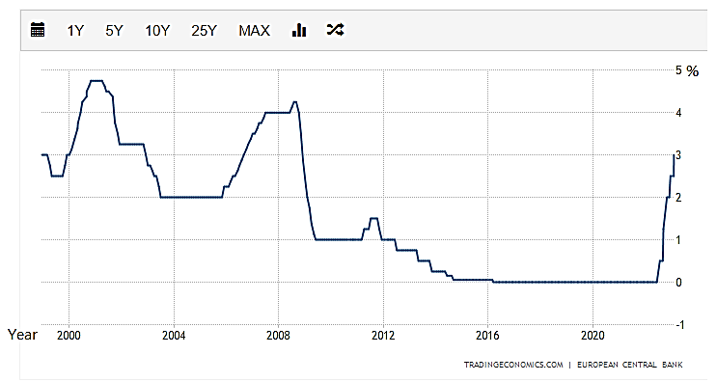

Source: https://zh.tradingeconomics.com/france/interest-rate on 25 Feb 2023

16
4.2 Investment risk in investing in Hang Seng Index in Hong Kong and CAC40 in France

4.2.1 Stock price volatilities of Hang Seng Index and CAC40

Stock price volatility can be defined by using the VIX which is sometimes also called “Fear Index”. The VIX moves in the opposite direction of the market. The VIX is up, the stocks market is down and vice versa.

When the VIX is 30 and over, the higher level of fear among investors, it means the volatility increase, the stock prices are moving quickly and steeply both upward and downward, the higher risk and uncertainty in the market as well as the stock market value generally falls. When the VIX is 20 and lower, it shows the stability of the market.

Whether volatility is good to investors, it depends on the directions of companies and their acceptance of risk taking. The volatility can be an opportunity for day traders but may be a trouble for long-term investors.

Figures 3 – 4 shows the volatilities of HSI in Hong Kong and CAC40 in France from 2001 till February 2023. The range of volatilities in previous 52 weeks for HSI in Hong Kong and CAC40 in France, were 21.93 to 50.83 in a fluctuating state and 18.72 to 22.64 in a stable state respectively.

It illustrates that the higher risk and uncertainty are expected when investing on market of HSI in Hong Kong while the risk and uncertainty of investment in France is relatively low.

17
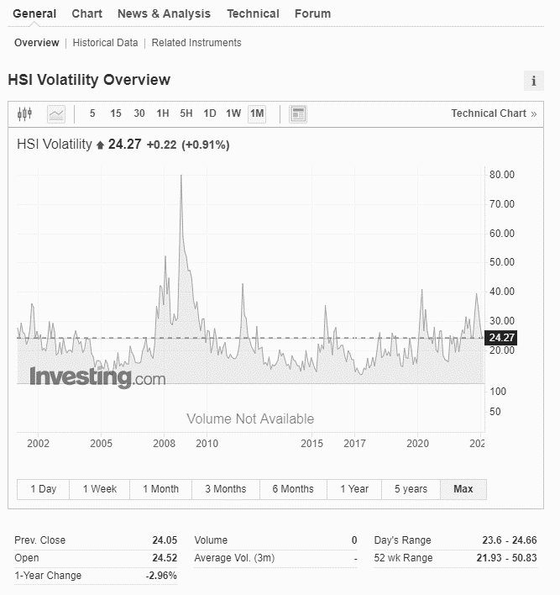
Figure 3: Volatility of stock price index movements in HSI in Hong Kong in 2002 to Feb 2023
Sources: https://www.investing.com/indices/hsi-volatility

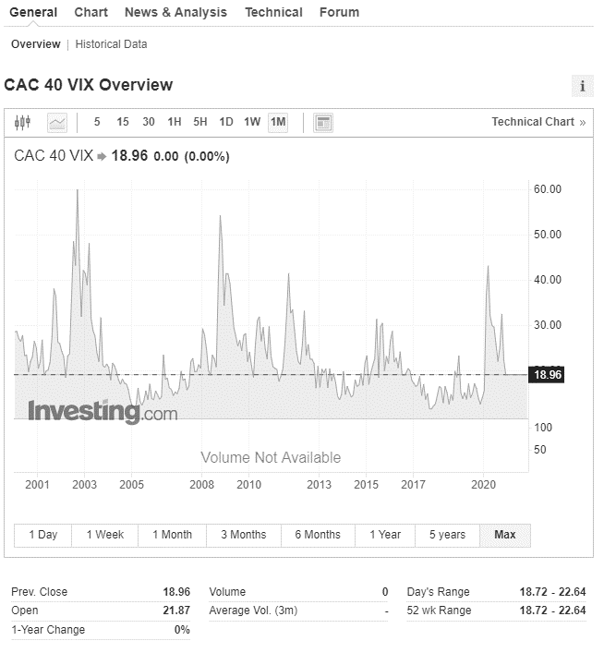
Figure 4: Volatility of stock price index movements in CAC40 in France in 2001 to Feb 2023
Sources: https://www.investing.com/indices/cac-40-vix
18
4.2.2 Market risk in investing in France
The consumer price index (CPI) is an indicator for measuring the rate of inflation. It reflects the households purchase of consumption on goods and services in prices over the certain period in a country. High inflation rate leads the increase of interest rate but the decrease of the purchasing power.

The following table 9 shows the inflation rates of French Consumer Price Index (CPI) from Dec 2014 to Dec 2022. They all were in positive values each year from 2014 (0.060%) to 2022 (5.851%), and showed the tendency of increase each year, except the year in 2020 with COVID-19 Pandemic (-0.019%). This stable status of inflation leads a stable economy in France.

Table 9: The inflation rate of French Consumer Price Index (CPI) from Dec 2014 to Dec 2022
Periods | Inflation rate
December 2022 | 5.851 %
December 2021 | 2.753 %
December 2020 | -0.019 %
December 2019 | 1.459 %
December 2018 | 1.591 %
December 2017 | 1.192 %
December 2016 | 0.610 %
December 2015 | 0.180 %
December 2014 | 0.060 %

Source: Tables - current and historic CPI France, https://www.global-rates.com/en/economic-indicators/inflation/consumer-prices/cpi/france.aspx

19
4.2.3 Exchange rate risk of Euro of European Union

The Euro is the official currency of 20 of the 27 member states of the European Union. The following figure 5 represents that the exchange rate moved up from 2001 to 2008, dropped from 2008 to 2015. The exchange rate from 2015 to 2023 was relatively stable.

Following figure 5 shows the low was in 2001 under the exchange rate of Euro 1 to HKD 7 while the high was in 2008 for Euro 1 to HKD 12.2 and had been keeping about HKD 8 – 10 in 2015 to 2023.

As the currency of CAC40 is measured in Euro and the exchange rate was kept from HKD 8 to 10 from 2015, investing in stock market in France is relatively stable.

Figure 5: Exchange rate of Euro to HKD: 2001 to 2023
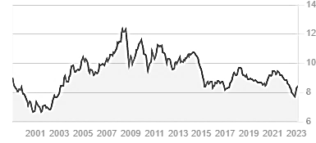
Sources: https://finance.yahoo.com/currency-converter?fr=sycsrp_catchall

20
Chapter 5: Conclusion and recommendations

5.1 Conclusion

After studying the characteristics of Hang Seng Index in Hong Kong (HSI) and CAC40 (FCHI) in France, as well as the opportunities and risks to invest in French stock market CAC40, it is found that Hang Seng Index consisted of the indexes from HK Ordinary and Other HK-Listed Mainland Companies, mainly in information technology and financial fields while CAC40 consisted of consumer discretionary, energy and healthcare sectors. The correlation of coefficient between HSI and CAC40 was in negative relationship in 2019 to 2023, means the risk was low with high diversity on investing in French stock market CAC40.

In France, the companies increased the concerns about the ESG factors on businesses and French government still supports the healthcare businesses. From the above studies, GDP of France is going up, the economic growth can be seen with improvements on world ranking in overall factors and economic performance.

Moreover, the expected return rate of CAC40 is going up and the risk on investment is relatively lower than HSI. Although the capital gains tax from investment in France is 30%, it is acceptable on income return at 2.92% X 70% = 2% when the risk is at the low level.

Furthermore, the interest rate was going sharply from the end of 2022 to Feb 2023, from zero to 3%, the impact is expected to be adjusted in the long run by the market. It is also found that VIX was low, CPI inflation rate was stable, and the exchange rate was kept from HKD 8 to 10. The economy in France is expected to be stable with economic growth.

If ABC invests in French stock market, the risk is relatively low but gets a stable return. It can also have the diversity of investment portfolio to reduce the risk on investment.

21
5.2 Recommendations

It is recommended that ABC to invest in French stock market CAC40 to diversify its business portfolio to reduce the risk on investment. But ABC should keep monitoring the changes and challenges in the economy in France.

As ABC expands the operation in Singapore and the investment in China currently, and it has no experience on investing in French stock market previously, it should consider keeping the current investments and the expansions and trying the market by investing a low investment amount for a certain period.

Then, which is the good choice from listed company in CAC40 for the investment? As the industry trend and company’s performance are some of the factors affecting the stock prices, SANOFI is a listed healthcare company in CAC40 and French government is still supporting the healthcare field, the benefit on SANOFI’s stock price should be expected.

According to the SANOFI’s annual report in 2022, it shows there was no material impact on the financial statement caused by the war in Ukraine, its’ Gross profit was recorded an increase from 2021 at Euro 37,761 million to Euro 42,997 million. SANOFI also considers ESG aspects which matches with ABC’s company value and the trend in the world. Investing in SANOFI is relatively a good choice.

ABC can try to invest 5% of total investment in SANOFI from now to the end of 2024 to test the market and gain the experience but ABC must keep monitoring and reviewing the performance of SANOFI and other investment components. Once there are any changes and issues, ABC can sell out SANOFI’s stock immediately.

22
References

1. Hang Seng Indexes Company Limited (N.D.)
Available at: https://www.hsi.com.hk/eng/indexes/all-indexes/hsi (Accessed: 19 February 2023).

2. Hang Seng Indexes Company Limited (N.D.) Hang Seng Indexes factsheet.
Available at: https://www.hsi.com.hk/static/uploads/contents/en/dl_centre/factsheets/hsie.pdf
(Accessed: 19 February 2023).

3.Euronext (N.D.)
Available at: https://live.euronext.com/en/product/indices/FR0003500008-XPAR/market-information (Accessed: 19 February 2023).

4. Monlouis, P.P (2023) ‘How to Buy Stocks in France in 2023?’, Pierre Perrin-Monlouis [blog]. 17 February. Available at: https://edubourse.com/en/buy-shares/ (Accessed: 17 February 2023).

5.HAYES, A. (2022) ‘CAC40’, ADAM HAYES [blog]. 27 May.
Available at: https://www.investopedia.com/terms/c/cac40.asp (Accessed: 12 February 2023).

6. International Trade Administration (2023) France - Market Overview.
Available at: https://www.trade.gov/country-commercial-guides/france-market-overview (Accessed: 10 February 2023).

7.HKTDC (2022) France: Market Profile.
Available at: https://research.hktdc.com/en/article/MzU3OTIyMjQx (Accessed: 20 January 2023).

8. TD (N.D.) Understanding VIX or Volatility Index.
Available at: https://www.td.com/ca/en/investing/direct-investing/articles/understanding-vix
(Accessed: 12 February 2023).

9. Standard Chartered Bank (N.D.) VIX: What you should know about the volatility index
Available at: https://www.sc.com/ae/wealth-insights/volatility-index-vix/
(Accessed: 12 February 2023).

10. HAYES, A. (2022) ‘Volatility: Meaning In Finance and How it Works with Stocks’,
ADAM HAYES [blog]. 23 August. Available at: https://www.investopedia.com/terms/v/volatility.asp
(Accessed: 12 February 2023).

11. KUEPPER. J. (2022) ‘CBOE Volatility Index (VIX): What Does It Measure in Investing?’,
JUSTIN KUEPPER [blog]. 3 November.
Available at: https://www.investopedia.com/terms/v/vix.asp
(Accessed: 12 February 2023).

12.Investing.com (N.D.) CAC 40 VIX (VCAC)
Available at: https://www.investing.com/indices/cac-40-vix (Accessed: 15 February 2023).

23
13. MasterClass (2022)
Learn About Inflation in Economics: Definition, Examples, and Pros and Cons of Inflation.
Available at: https://www.masterclass.com/articles/what-is-inflation-in-economics
(Accessed: 5 February 2023).

14. Investing.com (N.D.) HIS Volatility (VHSI)
Available at: https://www.investing.com/indices/hsi-volatility (Accessed: 15 February 2023).

15. McBride.G. (2022) ‘Average return on investment: What is a good return?’, McBride Greg [blog]. 22 August. Available at: https://www.bankrate.com/investing/good-return-on-investment/#:~:text=Now%2C%20think%20about%20a%20real,to%20accept%20any%20risk%20whatsoever. (Accessed: 1 February 2023).

16. IMD (N.D.) The reference database on World Competitiveness
Available at: https://worldcompetitiveness.imd.org/(Accessed: 12 February 2023).

17. global-rates.com (N.D.) Inflation France - consumer price index (CPI)
Available at:
https://www.global-rates.com/en/economic-indicators/inflation/consumer-prices/cpi/france.aspx
(Accessed: 10 February 2023).

18. SHAH. S. (2021) ‘Does the Consumer Price Index Measure Inflation?’, SARRAH SHAH [blog].
26 October. Available at:
https://www.investopedia.com/ask/answers/012115/consumer-price-index-cpi-best-measure-inflation.asp#:~:text=When%20there%20is%20an%20upward,a%20higher%20cost%20of%20living). (Accessed: 10 February 2023).

19. Stock a Ball (N.D.)
降低風險增加報酬的秘訣!什麼是相關係數(Correlation Coefficient)？越高還是越低
Available at: https://stockaball.com/correlation-coefficient/(Accessed: 5 February 2023).

20. BANTON. C. (2022) ‘What Does Standard Deviation Measure In a Portfolio?’
CAROLINE BANTON [blog]. 9 July 2022.
Available at:
https://www.investopedia.com/ask/answers/022015/what-does-standard-deviation-measure-portfolio.asp(Accessed: 5 February 2023).

21. HAYES, A. (2022) ‘Bottom-Up Investing: Definition, Example, Vs. Top-Down’,
ADAM HAYES [blog]. 1 January.
Available at:
https://www.investopedia.com/terms/b/bottomupinvesting.asp#:~:text=Key%20Takeaways-,Bottom%2Dup%20investing%20is%20an%20investment%20approach%20that%20focuses%20on,on%20the%20industry%20and%20economy. (Accessed: 10 February 2023).

22. Securities and Futures Commission (N.D.)
Public Register of Licensed Persons and Registered Institutions
Available at: https://apps.sfc.hk/publicregWeb/corp/ABN759/details(Accessed: 1 February 2023).
24
23. Value Partners Group Limited (N.D.)
Available at: https://www.valuepartners-group.com/en/(Accessed: 1 February 2023).

24. Yahoo! Finance (N.D.) Hang Seng Index (^HIS)
Available at:
https://finance.yahoo.com/quote/%5EHSI/history?period1=536371200&period2=1675468800&inte
rval=1mo&filter=history&frequency=1mo&includeAdjustedClose=true;
(Accessed: 4 February 2023).

25. Yahoo! Finance (N.D.) CAC40 (^FCHI)
Available at:
https://finance.yahoo.com/quote/%5EFCHI/history?period1=636249600&period2=1675468800&in
terval=1mo&filter=history&frequency=1mo&includeAdjustedClose=true
(Accessed: 4 February 2023).

26. Inland Revenue Department (N.D.) Profits Tax Rate
Available at: https://www.ird.gov.hk/eng/tax/bus_pft.htm (Accessed: 1 February 2023).

27. Blevins Franks Financial Management Limited (2022)
Capital gains tax in France – what you need to know
Available at: https://www.blevinsfranks.com/capital-gains-tax-
france/#:~:text=Gains%20made%20on%20securities%20like,and%20social%20charges%20(17.2%
25). (Accessed: 1 February 2023).

28.Sanofi (2022) 2022 Form 20-F
Available at:
https://www.sanofi.com/dam/jcr:17629df7-bfc7-4011-9ef9-fdb3408fb7d9/2022%20Sanofi%2020- F.pdf (Accessed: 1 February 2023).

29.DBS Bank (Hong Kong) Limited (N.D.) 利率上調時的投資之道
Available at: https://www.dbs.com.hk/treasures-zh/articles/investing-when-interest-rates-change
(Accessed: 5 February 2023).

30. IG International Limited (N.D.) What causes share prices to change?
Available at: https://www.ig.com/en/trading-strategies/what-causes-share-prices-to-change--190128
(Accessed: 2 February 2023).

31. IG International Limited (N.D.) What are the effects of rising interest rates?
Available at:
https://www.ig.com/en/trading-strategies/what-are-the-effects-of-rising-interest-rates 221223(Accessed: 1 February 2023).

32. Bhatt.M.(2022) ‘Relationship between GDP and stock markets’, Marisha Bhatt [blog]. 15
December. Available at: https://www.fisdom.com/relationship-between-gdp-and-stock-markets/
(Accessed: 8 February 2023).

25

