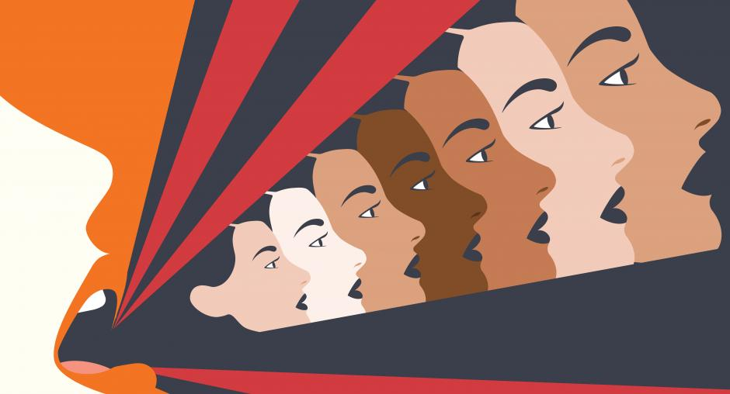
Rising Wave of Violence Against Women: Sparks Global Outrage and Demands for Change
Our Silence will not protect us!
Dru Sutherland

Discreet Agony: Understanding the Prevalence and Impact of Violence against Women.

Introduction

Our society has a prevalent and deeply ingrained problem with violence against women. Millions of women around the world continue to suffer in silence despite greater awareness and advocacy efforts. Violence against women has negative psychological and emotional impacts in addition to its physical ones. Long-term mental health effects like anxiety, depression, and PTSD may result from it. In order to effectively address violence against women, it is imperative to understand its prevalence and effects. In this post, we'll examine the prevalence and consequences of violence against women and talk about how to assist and empower victims. We want to bring attention to this significant problem and encourage action for its eradication.

Understanding the different forms of violence against women

There are many various types of violence against women, including physical, emotional, sexual, and psychological assault. Hitting, slapping, kicking, or any other act that results in bodily harm is considered physical violence. Any act that hurts someone's emotions is considered emotional violence, and examples include verbal abuse, manipulation, and tight control. Rape, sexual assault, and any unwelcome sexual contact are all examples of sexual violence. Threats, intimidation, and other methods used to exert control over a woman constitute psychological abuse. It's crucial to realize that violence against women encompasses more than simply physical assault. Abuse that is emotional or psychological can be equally as harmful as abuse that is physical, if not more so. Women who have been subjected to violence in any way may have sadness, anxiety, and other mental health problems. In the future, they might find it challenging to build good connections.
Recognizing the many types of violence against women is essential in order to take action to stop it. This entails teaching ourselves and others about positive interpersonal interactions and conduct, assisting victims of violence, and holding offenders responsible for their deeds. It is up to us all to join together to put an end to violence against women, a problem that affects the entire world.

The prevalence and impact of violence against women globally

Globally, violence against women is a problem that has wide-ranging effects. One in three women worldwide has experienced physical or sexual assault, mostly at the hands of an intimate partner, according to the UN. In other words, over a billion women worldwide have experienced violence at some point in their lives, and startlingly, 38% of all female homicides worldwide are committed by a male intimate partner. Violence against women has multiple, sometimes long-lasting effects that touch not only the victimized lady but also her family and the larger community. In addition to being more likely to endure physical injuries and long-term health consequences, women who encounter violence are also more likely to struggle with mental health conditions including sadness and anxiety. Children who see violence against their mothers are also more likely to have behavioral problems, developmental disorders, and to either become victims or perpetrators of violence themselves. A safer and more just society for all depends on ending violence against women. The core causes of violence against women, such as gender inequity, cultural norms that support violence, and lack of access to resources and education, must be addressed on a worldwide scale.

We can contribute to the development of a society in which everyone can live without fear and violence by uniting in efforts to increase awareness, encourage respect for women's human rights, and offer crucial support services to survivors.

The long-term effects of violence against women on mental health
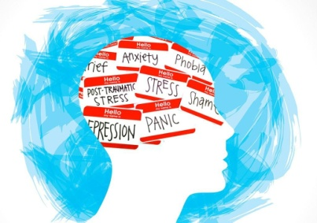

The mental health of women who have experienced violence can suffer greatly. Women who have experienced violence are more likely to face mental health issues such substance misuse, PTSD, anxiety, and depression. Long after the experience of violence has stopped, these mental health issues may still exist. The experience of violence can lead to PTSD, a frequent mental health problem. Flashbacks, nightmares, and intrusive thoughts about the experience are common in women with PTSD. It may also be difficult for them to live a regular life because they avoid things or people that make them think about the trauma. Another issue with mental health that can arise from violence against women is depression. Depression in women can cause them to feel depressed, despondent, and unmotivated.

Physical symptoms like exhaustion, trouble sleeping, and changes in appetite may also be present. Violence against women can lead to anxiety, another prevalent mental health issue. Excessive worry, fear, and panic attacks are common in anxious women. Physical manifestations including perspiration, shaking, and an accelerated heart rate are also possible.

Another problem that can arise from violence against women is substance misuse. To cope with the trauma, women may turn to drugs or alcohol, but doing so might result in further issues like addiction and physical health issues. If you or someone you know has been the victim of violence, it's critical to get assistance. To help women recover from the trauma and any resulting mental health issues, mental health specialists can offer support and treatment.

Ways to support and empower survivors of violence against women

Millions of women around the world are victims of the terrible issue of violence against women. Abuse can have terrible physical, emotional, and psychological effects, so it's critical to give survivors of violence against women support and empowerment. You may support and empower survivors of violence against women in a variety of ways. One strategy is to offer a secure and accepting environment where women can talk about their experiences. Support groups or counseling sessions can help with this. It's crucial to recognize women's stories and listen to them without passing judgment. Additionally, you can give money to charities and organizations that help women who have experienced assault.

These groups frequently provide a variety of services like counseling, legal assistance, and emergency shelter. Additionally, you can give these charities money or your time by volunteering. Lastly, it's critical to increase public awareness of violence against women and the effects it has no survivors. Speaking out against gender-based violence, disseminating educational materials, or joining advocacy campaigns are all effective ways to achieve this. We can fight to make the world a safer and more just place for all women by helping and strengthening survivors of violence against women.

Urgent Need to Address the Alarming Epidemic of Gender-Based Violence

In a chilling reminder of the persistent challenges women face worldwide, an alarming surge in violence against women has gripped societies across the globe. From rural communities to urban centers, women continue to bear the brunt of physical, psychological, and sexual abuse, prompting widespread outrage and demands for immediate action.

Recent incidents have shed light on the deeply rooted societal inequalities that perpetuate such violence, exposing the urgent need for comprehensive measures to protect and empower women. The collective voices of activists, survivors, and communities are calling for change, pushing governments, institutions, and individuals to confront this widespread epidemic.

One highly publicized case involved the brutal assault of a young woman walking home alone at night, sparking widespread protests and reigniting discussions about women's safety. The incident highlighted the fear and vulnerability many women experience while navigating public spaces, emphasizing the need for increased security measures, improved lighting, and efficient emergency response systems.

But violence against women extends beyond physical attacks. Emotional abuse, sexual harassment, and online stalking have become pervasive, leaving women traumatized and silenced. The digital sphere, once hailed as a platform for empowerment, has become a breeding ground for cyber bullying and non-consensual dissemination of intimate images, leaving women vulnerable to lasting harm. Experts stress the importance of comprehensive legislation and education to address these digital threats and hold perpetrators accountable.

Domestic violence remains a grave concern as well, with reports indicating a sharp rise in incidents during the global pandemic. Lockdowns and social isolation exacerbated existing power imbalances, leaving women trapped in abusive relationships with limited access to support networks or resources. Advocacy groups and shelters are straining to meet the increased demand for services, underscoring the crucial need for continued funding and expanded resources.

In response to the growing outcry, governments and organizations have begun implementing measures to combat gender-based violence. Some nations have introduced stricter laws, imposing harsher penalties for offenders and streamlining the legal process to ensure swift justice. Grassroots movements are flourishing, fostering community engagement, awareness campaigns, and the provision of support services.

Education emerges as a vital tool in challenging ingrained gender stereotypes and promoting gender equality. Schools and universities are increasingly incorporating comprehensive sex education and consent training, aiming to prevent violence by addressing its root causes and fostering respectful attitudes and behaviors.

Civil society organizations, both local and international, have been instrumental in mobilizing resources, providing safe spaces, and supporting survivors. Networks of survivors have emerged as powerful agents of change, challenging societal norms and inspiring others to speak out against violence.

As global attention intensifies, momentum is building to create a world where violence against women is no longer tolerated or excused. Concerted efforts from all sectors of society are imperative to dismantle the systems that perpetuate this violence and build a future where women can thrive without fear. Only by working together can we ensure a safer and more equitable world for all.

Child abuse and neglect
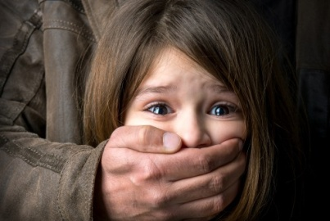

In all nations around the world, there are some instances of parental abuse and child neglect. Physical, sexual, psychological, and neglectful abuse are all examples of this type of violence. The result could be lethal, and the most frequent causes of death include head injuries, abdomen injuries, and deliberate asphyxia.

Non-fatal outcomes have been defined as various forms of maltreatment and neglect that necessitate medical attention and social services involvement. The type of violence used depends on a number of characteristics, including age and sex. In contrast to older girls who have reached puberty and adolescence, who are more at danger of sexual abuse, neglect, and being forced into prostitution, young children and boys are more likely to experience physical abuse.
It has been said that women chastise their children physically more frequently than men, yet when the effect is fatal, men are more frequently the abusers. Young girls are also more likely to be sexually abused by men. According to studies, parental stress, poor impulse control, social isolation, as well as elements like poverty and a lack of social capital, are all associated with child abuse. In most circumstances, when a father or brother sexually abuses his young daughter or sister, it is referred to as incest. Incest is the term used to describe rape or sexual assault that is committed by close blood relations.

Since girls and young women have been urged to report this form of familial violence, there has been an increase in public awareness of child sexual abuse, including incest, over the past 10 to 15 years. Even though it is less often, moms can also abuse their sons sexually. Although it has primarily been discussed in high-income countries up until now, this type of violence appears in many different nations and civilizations.

Conclusion

use to the significant contributions that public health workers could make if properly trained and because they are placed close to the victims and may be well acquainted with (G Krantz · 2005) "the community and its residents, violence against women is a serious violation of women's human rights and of direct concern to the public health sector." As a result, the public's knowledge of this violence can be raised largely by local health services and communities. It is possible to lower society's tolerance for violence against women by having an open discussion about it.

There is still little knowledge about the treatments that prevent gender-based violence, but evaluation and documentation are crucial steps in advancing this understanding, as are precise definitions. Human rights are also the rights of women, and vice versa. People dared to envision a more inclusive and compassionate 21st century when this idea was announced during the Fourth World Conference on Women in Beijing in 1995. (ichorii.com 2022) "We must act quickly to enhance women's rights because violence against women is once again on the rise."

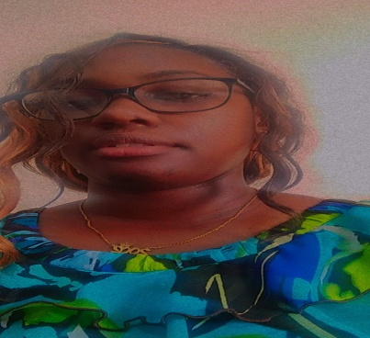
Dru Sutherland
Author

Reference List

- iChhori.com. (2022). We must act to stop the ‘shadow pandemic’ of violence against women. [online] Available at: https://www.ichhori.com/2022/10/we-must-act-to-stop-shadow-pandemic-of.html [Accessed 27 May 2023].
- Krantz, G. and Garcia-Moreno, C. (2005). Violence against women. Journal of Epidemiology & Community Health, [online] 59(10), pp.818–821. doi:https://doi.org/10.1136/jech.2004.022756.
- www.google.com. (n.d.). Child abuse images - Google Search. [online] Available at: https://www.google.com/search?q=child+abuse+images&sxsrf=APwXEdd18Gw_spjQK3w9-TLJpNuPmmwnBQ:1685142052999&source=lnms&tbm=isch&sa=X&ved=2ahUKEwi58turi5T_AhXdq4QIHVkXBa0Q_AUoAXoECAEQAw&biw=1366&bih=657&dpr=1#imgrc=51FShCMt2JJPaM [Accessed 26 May 2023].
- www.google.com. (n.d.). Violence against mental health images - Google Search. [online] Available at: https://www.google.com/search?q=violence+against+mental+health+images&sxsrf=APwXEdeeVIAU75q1E8VMcyfrJ9ciPWN9DQ:1685144941472&source=lnms&tbm=isch&sa=X&ved=2ahUKEwjEpIaNlpT_AhWej4QIHU7YA0QQ_AUoAXoECAEQAw&biw=1366&bih=600&dpr=1#imgrc=SNgAGhliBLNUEM [Accessed 26 May 2023].

