University of Wales Trinity Saint David
Wales Institute of Science and Art


Electronic Circuits Testing and Applications
Electrical Controls ACHA4010

Alex Griffiths
2104310

24/03/2003
Contents
1 Task 1 1
1.1 A 1
1.2 B 1
1.3 c (i) 1
1.4 c (ii) 1
1.5 c (iii) 1
1.6 c (iv) 1
1.7 d 1
1.8 e 1
1.9 f 1
1.10 g 1
2 Task 2 2
2.1 Scope Time Division Calculations 2
2.2 Function Generator output sine wave 2
2.3 Unsmoothed Rectifier Wave 2
2.4 Smoothed Rectifier Wave 2
2.5 Drop in Voltage Question 2
2.6 Rectifiers use in Automotive applications Question. 2
2.7 Probing Question 2
3 Task 3 3
3.1 Scope Time Division Calculations 3
3.2 Function Generator output sine wave 3
3.3 Capacitor charge and discharge wave marked at correct points. 3
3.4 Basic Capacitor Calculations 3
3.5 Capacitor discharge table 3
3.6 Gradient Plot and calculations 3
3.7 Inaccuracies Question 3
4 References 4

Task 1

A
Resistance of E=12/0.5= 24 Ohms $V=IR$

B
Current of B = Current of C = (0.5-03)/2= 0.1 Amps
1.3c (i)
$P=IV$
P=0.9 J
Current of A = 0.3 Amps
P/I = 0.9/0.3= 3 V = voltage at A

c (ii)
B=C
I=0.1 Amps V=12V P=0.9J $P=I^{2}x R$
=
$R of B=\frac{0.9}{0.1^2}$ = 30 Ohms
$Rtotal=\frac{1}{\left(\frac{1}{10}\right)+\left(\frac{1}{30}\right)+(\frac{1}{30})}$=6 Ohms

c (iii)
Va= 3v = Vb = Vc = 3v

c (iv)
Resistance at D- 5v-3v = 2v 2v-0.6v= 1.4v
V=IR 1.4/0.5= 2.8 Ohms

d
rvt = 12v + 5 v + 3V = 20 Volts I = 0.5/ 4 = 0.125 Vr= 20v + 2v= 22v
V=IR 22volts / 0.125 Amps = 176 Ohms
$$Rtotal=\frac{1}{(\frac{1}{176})+\left(\frac{1}{176}\right)+\left(\frac{1}{176}\right)+(\frac{1}{176})}=44 Ohms$$

e
Voltage of F
V=IR = 0.5 Amps x 6 ohms = = 3 volts

f
R of ABC = 6 Ohms R of D = 2.8 Ohms R of E = 24 Ohms R of F = 6 Ohms R total of r = 44 Ohms

R circuit total= 6 + 2.8 + 24 + 6 + 44 = 82.8 Ohms

g
EMF = 22V because ini

Task 2

Scope Time Division Calculations
1/10= 0.1 = 100ms

Function Generator output sine wave
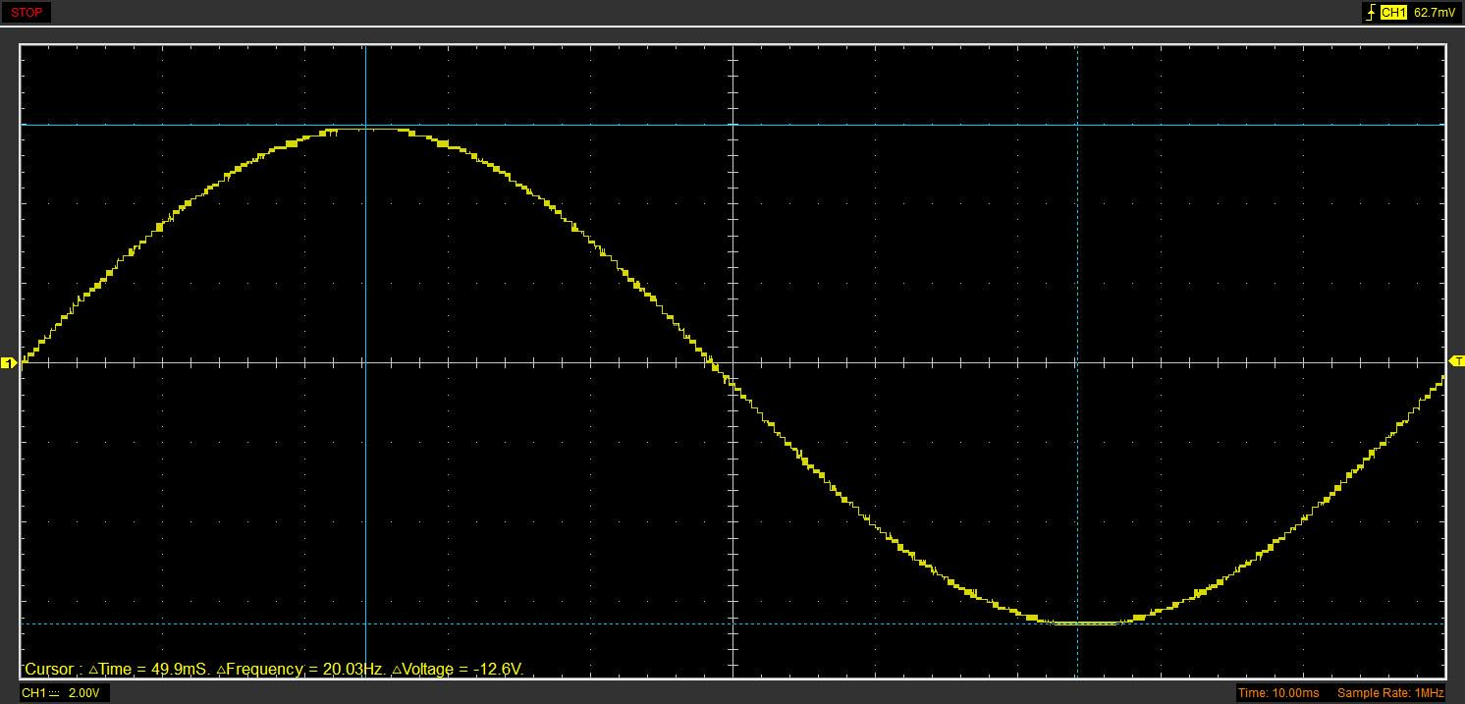

Unsmoothed Rectifier Wave
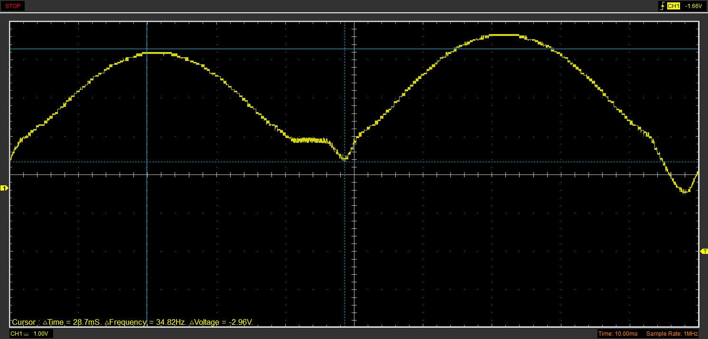

Smoothed Rectifier Wave
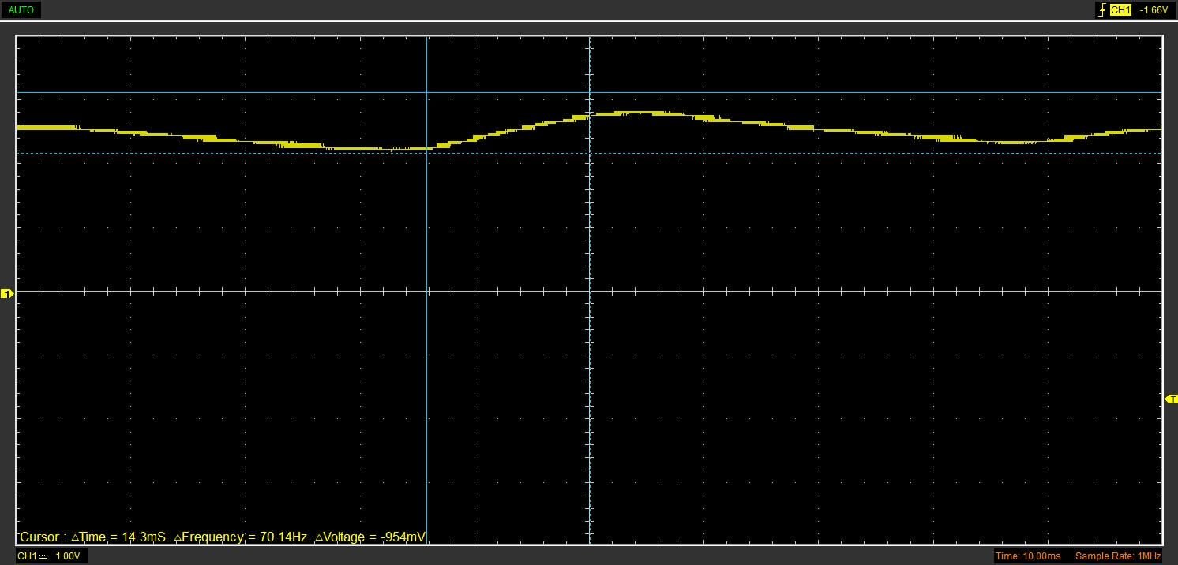

Drop in Voltage Question
According to Britannica (2022), a diode is an electrical component that allows the flow of current in only one direction. In circuit diagrams, a diode is represented by a triangle with a line across one vertex. The basic function of a diode is to allow current to flow in one direction while blocking it in the opposite direction. Last minute engineers states (2023) Diodes have potential blockers of roughly 0.7v, This causes voltage drop in the circuit meaning the output is always lower than the input.

Rectifiers use in Automotive applications Question.
Rectification in vehicles refers to the process of converting alternating current (AC) to direct current (DC) in order to power various electrical components of the vehicle. According to Green power (Green power 2017), this process is essential for the proper functioning of a vehicle's electrical system. The rectification process is typically performed by the vehicle's alternator, which generates AC as it spins. The AC is then converted to DC by a rectifier, which is typically made up of diodes arranged in a specific configuration. Once the AC has been rectified and converted to DC, it can be used to power various electrical components, such as the vehicle's lights, radio, and other accessories. Without proper rectification, the electrical components of a vehicle would not receive the correct voltage or current, leading to potential damage or malfunction. Therefore, rectification is a critical component of a vehicle's electrical system and is essential for proper vehicle operation.

Probing Question
Scoping is a crucial step that can help researchers define the research question, identify the key concepts, and establish the parameters for the study. However, it is also important to consider the importance of simultaneous scoping. A dual-trace oscilloscope is a powerful tool for measuring the electrical signals of a circuit. It is an essential piece of equipment for any electronics technician or engineer. According to Deshbandhu college (2020), a dual-trace oscilloscope allows the user to simultaneously view two different signals on the same screen. This feature is particularly useful when troubleshooting circuits that contain multiple signals. The manual also states that the user can adjust the horizontal and vertical scales independently for each signal, allowing for easy comparison of different waveforms.

Task 3

Scope Time Division Calculations

Capacitance x Resistance = 4.7x10^-6 farads x 100 Ohms= T = 4.7x10^-4 = T

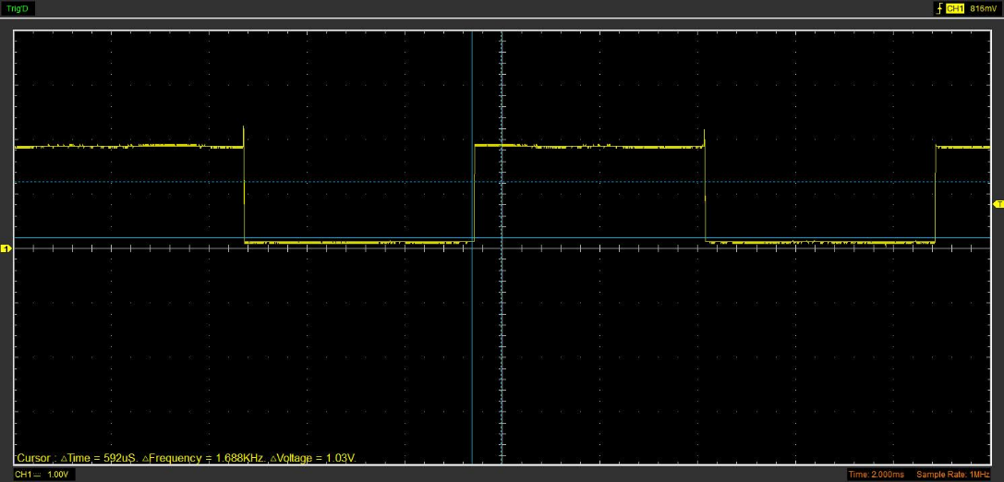
Function Generator output sine wave

Capacitor charge and discharge wave marked at correct points.
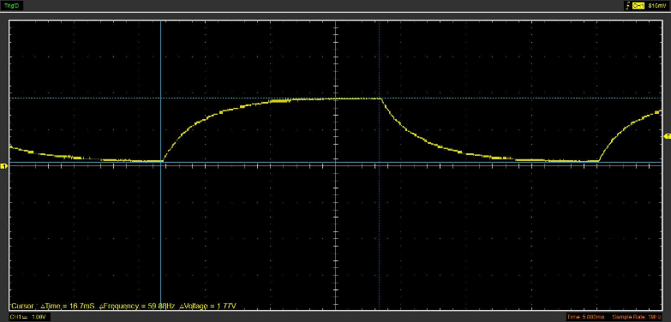

Basic Capacitor Calculations

Using t=RC and the relevant points explained in the lab sheet calculate the capacitance of the capacitor.

Capacitor discharge table
interval number | Period | Voltage (V) | Ln(Voltage) | time (s)
0 | 3500 | 0.502 | -0.689155159 | 0
1 | 4500 | 0.4078 | -0.896978421 | 0.000689
2 | 5500 | 0.3137 | -1.159318164 | 0.001534
3 | 6500 | 0.251 | -1.38230234 | 0.002223
4 | 7500 | 0.1882 | -1.670250052 | 0.002912
5 | 8500 | 0.1882 | -1.670250052 | 0.003601
6 | 9500 | 0.1569 | -1.852146619 | 0.00429
7 | 10500 | 0.1569 | -1.852146619 | 0.004979
8 | 11500 | 0.1569 | -1.852146619 | 0.005668
9 | 12500 | 0.1255 | -2.07544952 | 0.006357

Gradient Plot and calculations

Graphical capacitance calculations
Gradient = -207.81
RC = $\frac{1}{-gradient}=\frac{1}{207.81}=0.004812$= T T/R= C $=\frac{0.004812}{100}=(4.812 x 10^-5$)

Inaccuracies Question
As stated in the capacitance graph, the capacitor had a capacitance of $4.7 x 10^-6$ , however when comparing the calculated value to the given value for capacitance, it is out by a degree of X10. This could be due to experiment inaccuracies such as faulty equipment (cheap scope, dodgy battery and wires, slow computers ETC.) for the sake of argument, I am going to assume that the values are both to the power -6 in order to estimate the true % difference.

(4.7/4.812) x100 = 97.67 % accuracy

References
(Format to Harvard style as per handbook)
- Green power (November 2017) https://www.gprectifier.com/news/the-principle-of-action-of-automobile-rectifie-9558900.html
- Britannica, The Editors of Encyclopaedia. "diode". Encyclopedia Britannica, 25 Oct. 2022, https://www.britannica.com/technology/diode. Accessed
- Last minute Engineers , 2023, https://lastminuteengineers.com/the-half-wave-rectifier/?utm_content=cmp-true
- "DUAL TRACE OSCILLOSCOPE. "https://citeseerx.ist.psu.edu/document?repid=rep1&type=pdf&doi=db4d555bd8ec91603e693fd345e90b9e4eb7d272
- Deshbandhu college
(march 2020)https://www.deshbandhucollege.ac.in/pdf/resources/1585621423_BSc-PS-IV-SEC-Basic_Instrumentation_Skills.pdf

