System Verification and Demonstration
Ben McCarthy

Table of Contents
Verification Plan 2
Test Table 3
Project Review 4
User’s Perspective 4
Personal Perspective 5
Bibliography 6

Verification Plan
It has been decided that a use case testing method would be the best way to fully exam the functionality of the site. With use case testing, it is possible to define certain actions that need to be tested and each individual sets of test data and outcomes. By doing this it is easier to identify where the problem exactly is. The time scale for testing has been two weeks however this time could continue until the website is due to go live.
There were a few error reduction techniques implemented within the website. The most basic of these is the built in “required” attribute that can be added to input fields that uses client-side validation to ensure that the input fields have been filled in before submission. Another method used has been performed within the JavaScript functions. An example of this is in the form where the receptionist adds a player, when the button is clicked it runs a JavaScript function which includes…
if (contactNo.length != 11)
{
alert("Please provide a valid contact number.");
event.preventDefault();
}
else if (password.length < 8 || confirmPassword.length < 8)
{
alert("Passwords must be 8 characters or more.");
event.preventDefault();
}
else if (password != confirmPassword)
{
alert("Passwords do not match.");
event.preventDefault();
}
The following is a method of JavaScript validation to ensure that the contact number is equal to eleven characters, the password is greater than eight characters and the two passwords entered are the same accordingly.
After basic testing it is evident that there are no faults with the processes of the website. However, this testing has all been performed by the creator of the system. This could result in the testing being unreliable as the creator could subconsciously avoiding scenarios that they know will not result how they expect. Because of this, it would useful to perform the same testing by an outside source in order to gain a more thorough overall test.

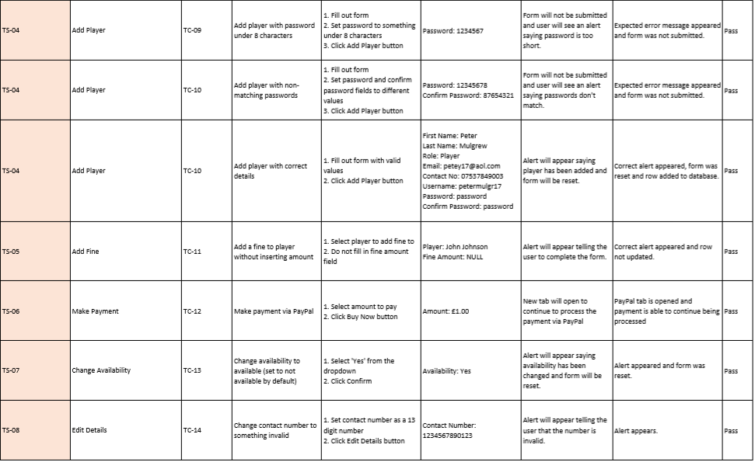
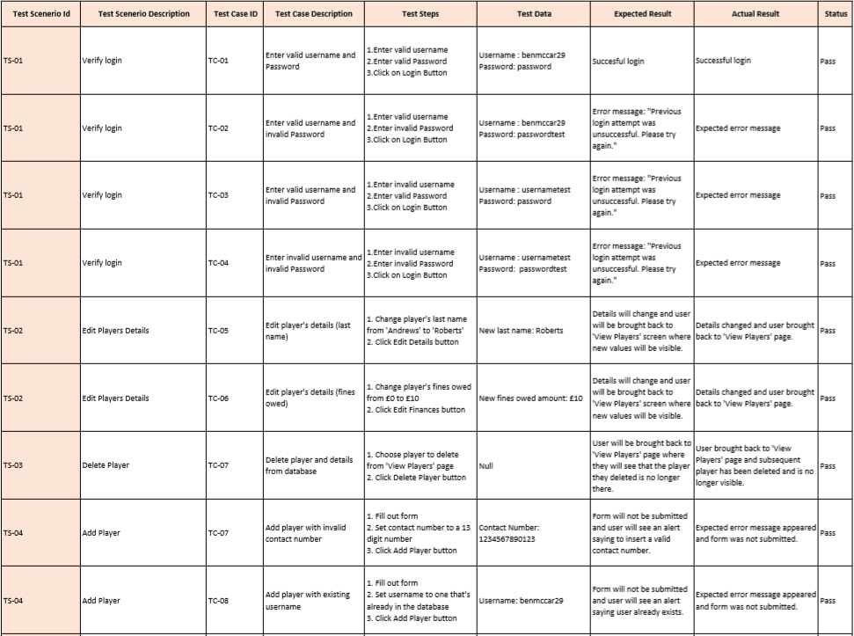
Test Table
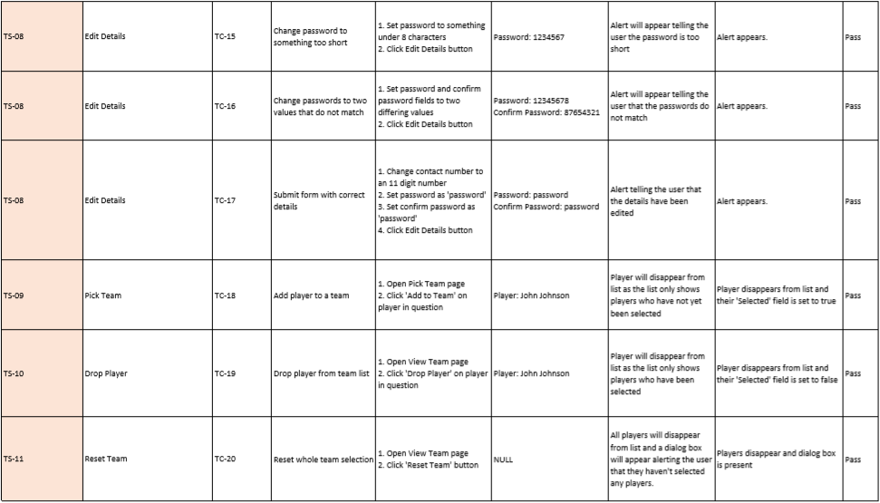

Project Review

User’s Perspective
Although the target user has not been available to share their initial perspective on the system, an appropriate third party has been able to give their views on the site. The user enjoyed the simplistic style to the website and the ease of use. It was mentioned how it is easy to identify what functions do what by how they are labelled and laid out. They enjoyed the integration of other news sources (BBC Sport) and the Twitter widget which made the website more interactive and dynamic. They were also impressed with the ability to pay with PayPal as it has gained a reputation as trusted, reliable way to pay for things over the internet and it made the user feel secure in what they were doing. Another aspect of the site that was pointed out was how all features of the website were accessible on every page so you don’t have to go through numerous pages to get to the one you want. The test user added that they enjoyed how instant the results of button clicks were, although this is very positive feedback as it is made possible through the use of jQuery, these actions will begin to get slower over time due to the size of the database increasing gradually.
However, something that was noted was how intermittent the feedback pop ups were as sometimes they would appear but if the exact same action was performed again, they would not appear. This is negative because the user may get confused as to whether or not a form was submitted or if a record was edited etc. The tester also believed that it would be a better idea to inform the player of the time, date and venue of the game before asking them if they would be available or not. Although this would be easier for the player, it is difficult to do this as there are three different teams and three different times and venues for games.
Looking back at the ‘Operational Requirements’ section of the Requirements Specification, most if not even, all requirements have been met by the system. One requirement that is mentioned across all sections is the method of the receptionist posting notices on the site which could be read by players and managers has been altered to make it easier. The initial idea was to create a newsfeed that is independent to the website, however this idea has been replaced by inserting a Twitter widget on the home page which shows the tweets from the club’s Twitter account which is run by the receptionist. In terms of the player being told what team they are playing for, this is implied by the notice they receive on the home page where it tells them what manager to contact for further details on the game. Another change that has been made is that teams are not posted by the manager, instead players are told individually if they have been selected. This has been decided as it would be too difficult to manage it with the prior method so it had been decided to go with a method that was easier to set up and maintain. One more requirement that hasn’t been fully implemented is that the receptionist should be able to keep track of who has paid subs/fines. This feature is not available through the system as the creator found there to be no need. This is due to the payments coming through PayPal, through PayPal the payee can easily see who has paid what amount. So, the receptionist would check their PayPal to see who has paid what, and then will use the website to edit the player’s details and change the amount of subs/fines they owe.
There are a few improvements that could be made to the system to make it better than it currently is. One of these would be to ensure that the feedback alerts appear in every instance that they should to make sure that the user gets the instant feedback to show them that they have performed a certain action. Another improvement would be to implement a transaction history feature on the site for the receptionist that would automatically update when a player makes a payment and would eliminate the need for the receptionist to look through their PayPal account and update the records accordingly. An ambitious improvement that could be made would be a text service that alerts the player when they have been selected which reduces the need to constantly check the website or it would be checked if they are unable to access it for any reason. Going off of that idea, the system could also be implemented into a mobile app which would make it more accessible for all of the members as some of them may not have access to computers at home or may need to perform a function of the system whilst they are away from home. A small improvement that also could be made is a redesign of the colour theme. It would be a good idea to implement the club’s colours onto the site to make it more personal to the members and the club.✓

Personal Perspective
I believe as though I managed to stick to the plans throughout the project to quite a good extent, especially when it came to the timeframes that were set to complete various tasks. However, some of the technical and design plans had changed during the course of creating the system. This was due to either finding a simpler solution to meeting a certain requirement or underestimating how difficult it would be to implement a certain feature. In hindsight, this should have been thought of beforehand so that everything was as streamlined as possible when it came to following the plan set. The design plans and requirements, as a whole, were all roughly met to the same extent as the plans set, apart from a few changes depending on the circumstances. This made the planning useful, as even though the plans weren’t followed exactly as they were designed, they did provide a good outline for what had to be accomplished and ultimately made it much easier when tackling this project.✓
The development methodology adopted, of agile development, worked very well during the creation of the project. Due to the nature of the system, this methodology is adopted naturally to ensure that everything is working before moving onto the next step, as these steps will often rely on the previous one in order to function. Because of this, the system is quite robust and thorough due to the constant testing that was applied during construction, which worked positively towards the final product.
The project incorporated a lot of the material studied during the course through both this year and last year. The main modules that helped were the Web Development modules, more specifically this year’s one that focused on PHP and HTML development as these are the languages that the system is made with. Another module that was helpful was the Database Management Systems module that taught me the basic SQL commands and syntax needed to manage the database behind the system.
In hindsight, I would approach the project differently by first doing a lot more research during the planning stage. I would do this because I often came across a lot of problems during the creation stage where I wasn’t able to produce the exact same product as designed in the plans. This resulted in more time being spent on redesigning on the spot or researching a new method to achieve what I had planned. I feel as though this would improve my productivity and time keeping as I would then have a strict plan to stick to that I know works and is possible to accomplish.
Overall, I am very satisfied with the outcome of the project as I feel as though it came out a lot better than I initially thought it would. Everything works as expected and to a high degree. The use of a bootstrap template saved a lot of time that would’ve been spent on styling the site and instead that time was spent elsewhere and allowed me to finish everything before I had first planned.

Bibliography
1. Use Case and Use Case Testing Complete Tutorial — Software Testing Help [Internet]. Softwaretestinghelp.com. 2018 [cited 25 April 2018]. Available from: http://www.softwaretestinghelp.com/use-case-testing/

