Susan Adele Hughes Year Three P148248
Photography in the Arts
Tutor: Caroline Thraves

CAN PSYCHOGEOGRAPHY BE USED
AS A ROUTE TO
WHAT HAS BEEN
WHAT IS
AND WHAT WILL COME?

Contents
Introduction - What is Psychogeography? 3
CHAPTER ONE - WHAT HAS BEEN 6
CHAPTER TWO WHAT IS 17
CHAPTER THREE WHAT WILL COME 25
Conclusion 27
Image References 28
Bibliography 29

Introduction - What is Psychogeography?

If you split the word psychogeography into two words you will find the first part means mind and the second part means place, and this describes a two-way link between mind and place. I am interested in using psychogeography as a way of investigating my past and how it links to my present and future.
The term psychogeography was first introduced by Guy Debord (1955, pg. 23) as "the study of the precise laws and specific effects of the geographical environment, consciously organized or not, on the emotions and behaviour of individuals." Guy Debord was a member of an artistic movement called The Situationist International. The Situationists used psychogeography as a tool for investigating the urban landscapes (Ford, 2005). One method they used was derive in which people take time out to walk about the urban areas and allow themselves to feel that they are being pulled to an area of curiosity.
The definition of psychogeography is not easy to agree on because people see it in different ways. Coverley (2012) notes that these different views are correct and together they make up what psychogeography is. Debord’s definition, above, focuses on the effects of landscape on people. The Situationists concentrated on cities (Ford 2005). Other practitioners have looked at the country side.
A more accessible definition is "a way of seeing, recognising and communicating with place" (Billingsley, 2017, p. 13). I prefer this definition because it feels more in line with my experience of psychogeography. I can see the three elements of Seeing, Recognising and Communicating in how I do psychogeography.
Seeing is a way of communicating with the world around you. Focus on the area around you, look at details that you might not have noticed before, pay extra attention. Take photos to record what you see. It helps you see things you would not normal look at when looking at an area.
Recognising is how do people make links with places they focus on. Recognising an area, you may be able to make links with how you feel when you look at certain objects or link with your memories. This can be the smell of fresh air, grass, flowers, or mountains that you see. You can also make links by the physical things by touching them, taking photos and making memories. One can pay attention and recognise a place by what they see and feel. It can be anything that can trigger a memory or a thought from the past.
Communication is “the imparting or exchanging of information” (Oxford Dictionaries, 2018). It’s a two-way process. When communicating with place you communicate with place and place communicates with you. A place speaks to you. You respond to the character of the place. By taking photos, I am asking questions of the place. This makes photography useful for psychogeography.
By taking photos you can ask questions about the place you are exploring, by doing this the photo also asking you a question about it. The photo for example could be asking to be explored more, exploring the photo you may have more questions and answers. This then will lead you into wanting to go back and research the area, so that you can learn more about the history or future of the area.
Lombardi (1999) states that photos have a “suggested truthfulness.” For me this is true as I have looked at a place where my family lived, the house has not changed but the landscape has, looking at this place has triggered memories that I had forgotten. The photos from my psychogeography walk in the area where my family lived, gave me a true sense of what I remembered from years ago. In a way, by taking these photos I am asking the land: ‘how do you feel about the changes to the land over the years?’ I am interested in this because no one really understands or knows the answer to the question. I am fascinated by the way land has changed over the years, some areas have changed for the better, and others change for the worse, you think psychogeography I can explore what has happened to the land over the years. By using psychogeography I have learnt the area that my family once lived in has changed quite a lot, I feel that I have a connection with my family in the past and in the future, by visiting this area the land has given me a new connection with my memory. By walking in this area, I am walking in my family’s footsteps. When I do this, I feel mixed emotions of the happy times that I spent there and also some sad times as well.
In this dissertation it’ll look into the past, the present and the future and how psychogeography can help you to connect all three together through your personal journey.

CHAPTER ONE - WHAT HAS BEEN

History contains many mysteries in which we are yet to learn about, a way of doing this is by using Psychogeography to understand the past- history is constantly in the making with all kinds of events happening around us. History can be very exciting as it can allow you to step into the footprints of others that you have never stepped in before. A lot can be learnt about a place by imagining yourself in the minds of lives past. You may choose an area that has special meaning to you or a place that means nothing to you, if you chose a place that has no meaning to you can learn a lot about the way that people have lived their lives and affected what happens in the future.
When I went to Budapest I found myself feeling a connection with what had happened in the past, around the cities you could feel the horror that they had a long time ago and they have worked hard to regain the spirit of the City. Budapest has a lot of history and has experienced a lot of destruction during World War 2 (Robertson, 2014). I found walking around Budapest helped me connect with the past- the contrast between and the old and new buildings and the architecture shows how much area was destroyed during the War. Harvey (2016, p. 3) notes how art has the “ability to pose new questions and provide new answers for our understanding of the past.” Also relating to the War there is a large number of monuments in memory of those who died. When I viewed the Shoes on the Danube monument the shocking sight of the various shoes including those of children allowed me to connect with the horrific past of the city. The connection with past is not made simply by looking at shoes, it is the range of different types of old fashioned shoes that is symbolic of the innocence of those who lost their lives.
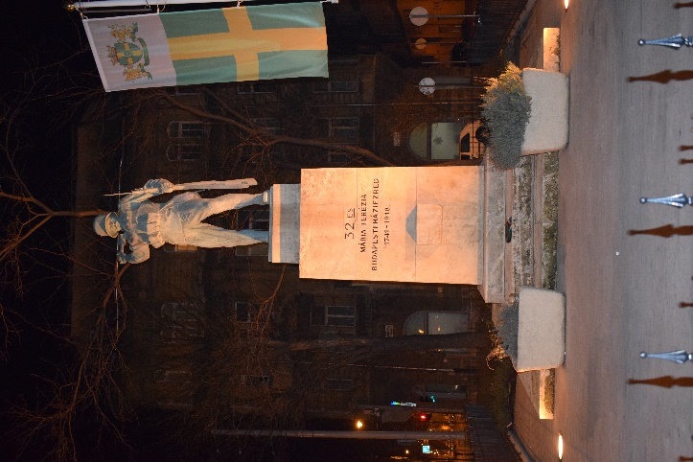
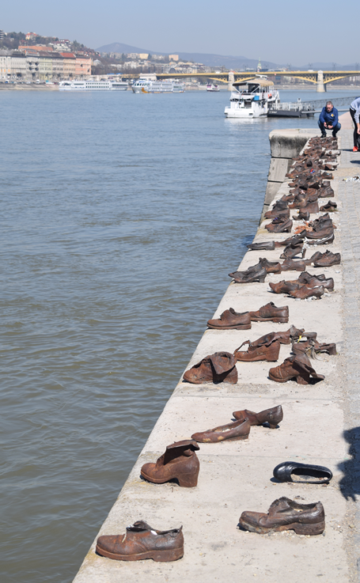

Fig. 1 Memorial of the Hungarian 32th Maria Theresia Infantry regiment (Hughes, 2017)
Fig. 2 Shoes on The Danube Bank (Hughes, 2017)
Psychogeography can be used as a tool to explore the information that we have been told. We can be told stories of the past and to find out if they are true or false. There are numerous ways that we can investigate this, such as- research, wandering, exploring ideas and imagining yourself in places long ago. Heidegger said that “art is the becoming and happening of truth” (Thomson, 2015). To me this means you can see what as happened and you can use art to look back and explore it at a different time.
Psychogeography can allow us to walk in the past and learn about lives before our own. It does not matter if you have never been to the place before, psychogeography helps us to gain connection in unlikely places through first-hand experience. Sandhu (2006, p. 46) notes that psychogeography can lead to “revolutionary insights and epiphanies opened up by the act of walking.” Allowing emotion to dictate the study allows you to learn in a very different way, opening yourself up for new experiences. As you have these encounters you begin to piece them together to create a collective of ideas and experiences- perhaps even developing your own narrative. Bula (2016, p. 205) suggests that narrative of place can “demonstrate the diversity of personal engagement with the feeling of loss.” Using psychogeography to connect to the past can create feeling of loss because areas have changed and what has been cannot be replaced.
Juana Gomez is an Artist and Photographer that works with embroidery to show the connections with her family generations. Juana uses symbolism to represent themes such as life, interconnectivity, ancestry and in particular the “matrilineal branch” (Michael Hoppen Gallery , 2017) within her family. The embroidery is important as it connects her with these women as the craft has been passed down through the generations and is therefore symbolic of this female bloodline. Juana shows ‘what has been’ through her embroidery and the link with the past women of her family. In the series of images entitled ‘Distaff’ we see photographs of herself and her daughter hand embroidered with bloodlines to show the interconnections between family (Michael Hoppen Gallery , 2017).
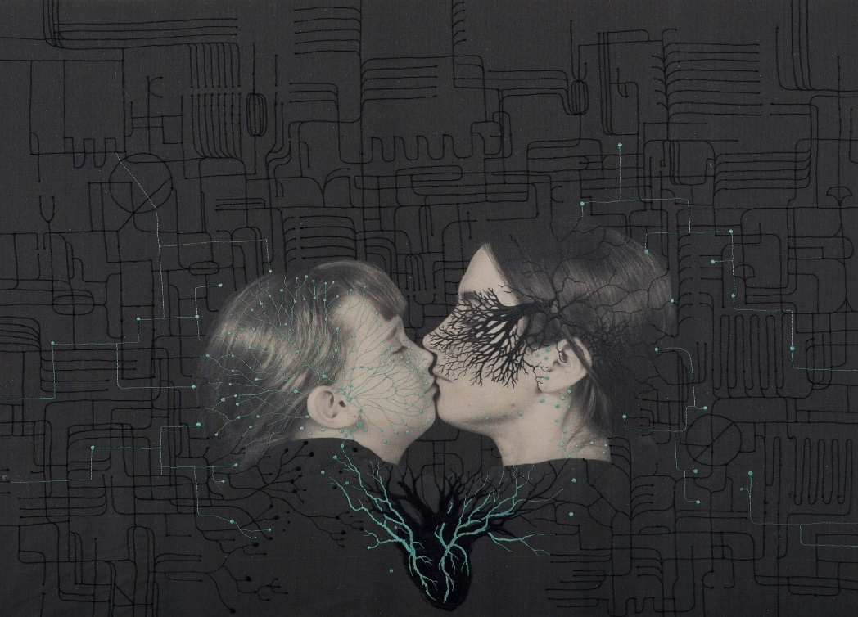
Fig. 3 Distaff by Juana Gomez (Michael Hoppen Gallery , 2017)
By connecting with the past, we can gain a new perspective to look at the present and the future. There are many reasons why we may want to do this- perhaps we will not make the same mistakes as we have done in the past, this will help us to learn and progress towards the future. Artists look into and connect with the past for ideas and inspiration as a means to develop new ways of creating, thinking and working. Photographer Freddy Fabris looks into works of the past to get his inspiration for his present works. Fabris researches classical paintings to re-create these paintings in his own modern way- in the image below he has recreated ‘The Last Supper’ by Leonardo Da Vinci by using mechanics as the subjects for his photography (Barnes, 2015).
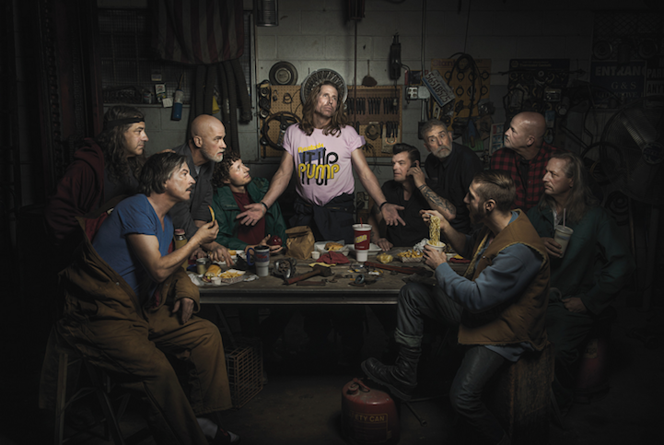
Fig. 4 The Renaissance Series: The Last Supper (Fabris, 2015)
As part of my research, I conducted a psychogeographic walk in order to trace my grandfather’s footsteps to see and to feel the things that he felt. This walk took me back to the early 1960s when he worked in a coal mine, he would come out of his house and garden path, go through the gates and walk about 200 yards to the Colliery where he worked. His job in the Colliery was to look after the pit ponies as well as take them into the mines and bring them out pulling ‘Gurneys’ filled with coal.
This walk led me to what has been in a number of different ways. One of the ways this was achieved was to pick up different objects that miners dealt with in the past, such as coal, iron, flint and slag. By picking up these objects I felt a connection with the area, my grandfather, the miners and time passed. Another way of connecting with the past was to observe the changes in the environment and imagine how it looked in the past. Walking up the old miner’s paths I saw coal dust mixed in amongst the mud which would tell me at some time in the past there was a mine nearby. While walking I felt drawn to certain directions for no apparent reason. Upon reflection I like to think perhaps it was the route my grandfather used to walk with the ponies- a route to what has been.
Richard Long also looks at changes on the land in a unique way. Long uses psychogeography by choosing a route from A-B walks the route and them walks back the same way. He then creates art by using stones from the areas in his in that the time: “He simply walks upon the earth and leaves temporary lines, circles, spirals, and rock piles in his wake” (Long, 2011). In his artist statement, long (2011) says “Art [is] about mobility, lightness and freedom. Simple creative acts of walking and marking about place.” This links with psychogeography because it can take you to area or place where you have the independence and to roam freely.
When carrying out a psychogeographic study or a derive research could be done after exploring an area. This allows you to collect your own thoughts and feelings without knowing anything about the history behind the place you are experiencing. Why is this important? If you have prior knowledge of the place you cannot have a purely independent experience- the research you have done will influence the way you see and understand your surroundings and ‘blur’ your vision. “Derives involve playful-constructive behaviour and awareness of psychogeographical effects and are thus quite different from the classic notions of journey or stroll” (Debord, 1956). The benefit of this approach is that it gives you a better sense of the place rather than move through a place purposely.
One way to learn more about an area is to research in local churches, schools, libraries and places where records are kept. You can also learn about an area by observing the land and the people who live there, doing investigation on the Internet or reading books of a certain place can help you in many ways. By doing this you can keep the area that you are looking at alive in your memory and the memories of the people you have talked to who can pass it on to their families and to the generations after. “Wandering the city by foot helps us look beneath ordinary conceptions of the face value of a place to the meanings built up and lost over time” (Lyons, 2017). Researching prior to a walk can help you to see if a connection can be made between what you felt and found and what is found when carrying out research. This could help inspire you to do further in-depth research and analysis; it is often the case that the more you uncover the more you want to explore and investigate the subject. No one would really know about the past if it was not for books and what people tell us- to find out about the forgotten we have to look into our own past and past of other people and land and explore our own ideas of what has been.
One way of collating your research on an area is ‘deep mapping’.
The deep map recalls eighteenth- and nineteenth-century antiquarian approaches to place, which included history, folklore, local traditions and natural history alongside geographical and geological data.
(LakesDeepmap, 2017)
In my previous work titled ‘Bloodline’ I did a form of ‘deep mapping’ by researching an area of my family’s past. Some of the elements used were archive photographs, new photographs, geographical maps, artefacts, literature, history, memories, stories and a family a tree. This method of working is an interesting way of presenting area to others that do not understand the different elements that make up an area. It can be said that psychogeography is an essential tool for creating a deep map. Deep mapping is a way of bringing together all the elements of the area to show the various connections and perspectives.
A way to keep a memory alive from the past is by looking at photographs, objects and old maps. Generations of family have taken photographs over the years of the areas they have lived in; this helps them keep the memory of the past alive. They may also keep objects from the land and pieces of their past lives for future generations to see, these items can be anything ranging from material things to nonmaterial things: - they may have kept things like walking sticks, old furniture, clothes, china, ornaments, even homes and perhaps items they have picked off the land- to remind them of the past. However sometimes the non-material information can be more interesting, such as: stories, mannerisms, ideas and knowledge.
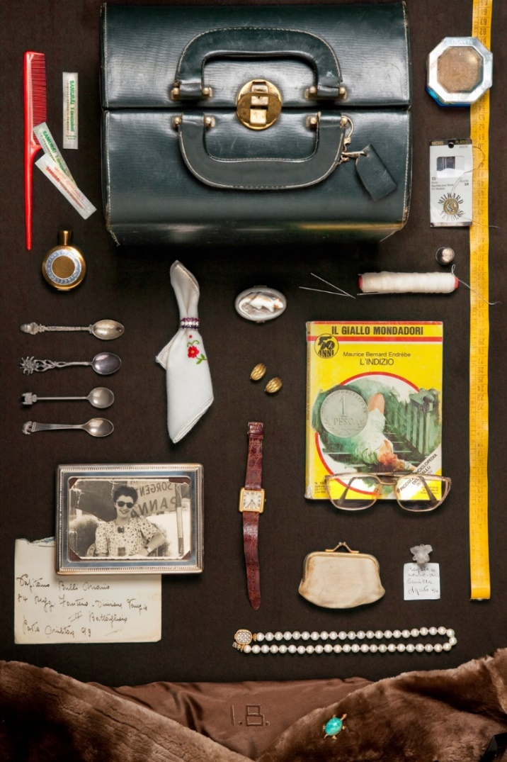
Fig. 5 Grandma Ilva - Mario's wife by Camilla Catrambone (Catrambone, 2013)
Similarly, to my ‘Bloodline’ project, the work of Camilla Catrambone looks into her family’s past by using family objects to recreate memories (Hosmer, 2013). For example, she uses personal belonging of her grandmother and arranged them in a photographic composition. By doing this she is making a connection with her grandmother. Though her work doesn’t deal directly with ‘place’, personal objects can connect you to a place through memory and emotions. These objects can be used as a n form of psychogeography in the way of placing them like a map.
Paul Seawright is an Irish Artist and Photographer whose work often looks at the past, present and future (Seawright, 2007). His works focus on area meaning and it could be argued that he uses psychogeography as a tool to explore subjects which often involve conflicts and violence.

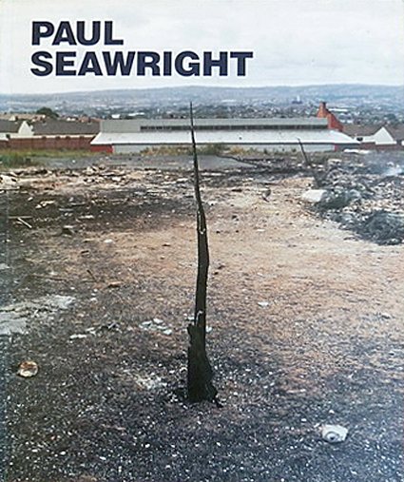
Fig. 6 The Black spike (Seawright, 1997)
This spike has lived through many years of turmoil, it once was a tree, and during the violence in Northern Ireland it was burnt and all that is left if this spike. It is still there today to represent what was, what is and how it might help change the future. During the violence many things were destroyed never to be replaced, but this tree has stood the test of time to show that good things may come in the future. This black spike has lived to tell the tale. Though things can be destroyed and never be rebuilt it may help us learn to change the future.
Paul Seawright often looks at specific areas where conflict has taken place. Paul would use psychogeographic tools when he would walk and explore an area and documenting things of interest, he would make a list of his findings and document anything that he found interesting in the area (Seawright, 2005). He would then reflect on his findings, this would then help him to research and then compare the connections in his findings. Having found these all-important connections Paul brings the work together to form a narrative for presentation.
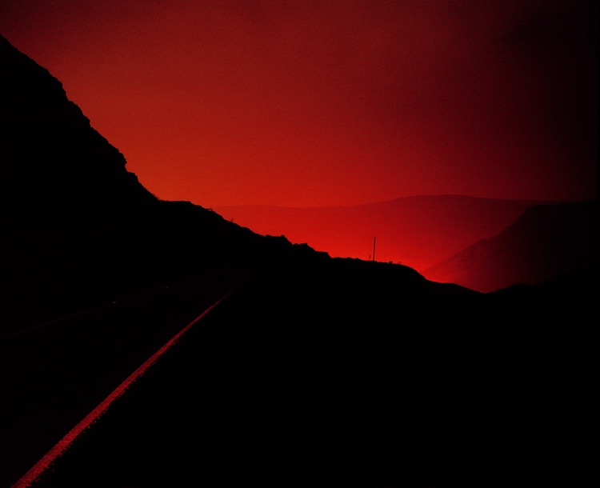
Fig. 7 Between VII (Seawright, 2003)
Paul Seawright carried out work called ‘Between VII’ and his methods could be considered a form of psychogeography. The work based on a writing by George Burrow written in 1862 about Merthyr Tydfil- a place known for its large ironworks. Seawright responded to this work by taking photographs of the area at night- recreating the red glow that Burrow wrote about and described as having a, “gloomy horrid satanic character” (Seawright, 2003). Using modern technology paired with the street lights from the valley towns and villages, Paul created powerful images of modern day Merthyr that remind us of the past and show how the ironworks may have looked in 1862 (Seawright, 2003). Through engaging with the land, he imagined how the landscape looked in the past and developed his own way of showing this.

CHAPTER TWO WHAT IS

By going back to a place that you have been before can show a new perspective about the old and the new in which the land has changed but can still look the same, as shown in the photograph below, the two photographs on the top is of a house taken some 60 years apart, the only thing that has changed under windows and the door area the rest of the outside house is the same. The bottom two photographs of the views from the said house, but this time a lot has changed over the 60 years the colliery has gone and houses have been built and trees have grown over the area.
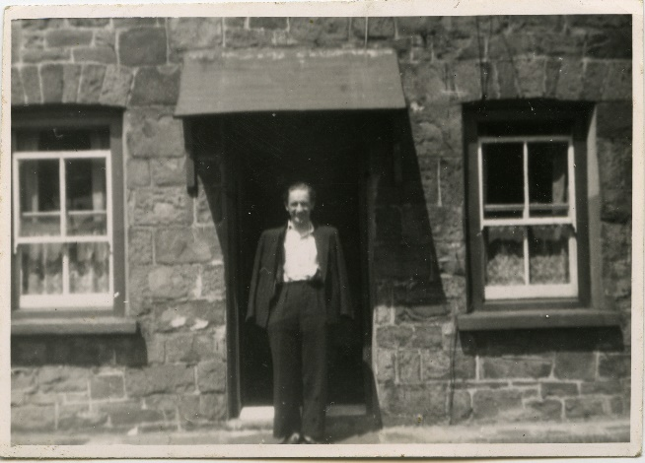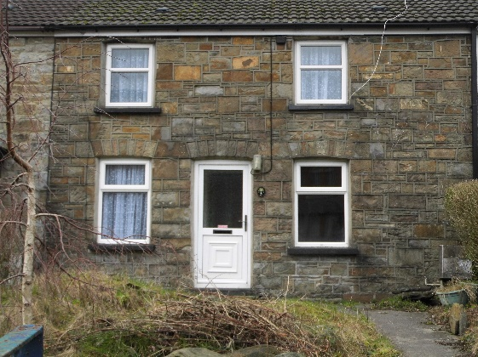
Old view 1950/60 New view 2018
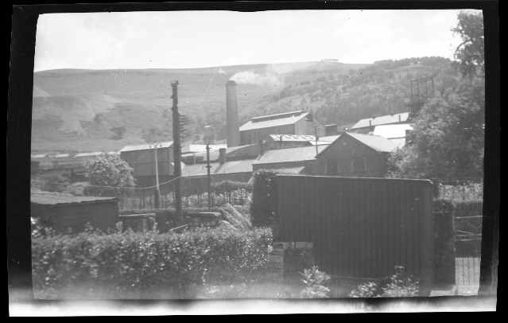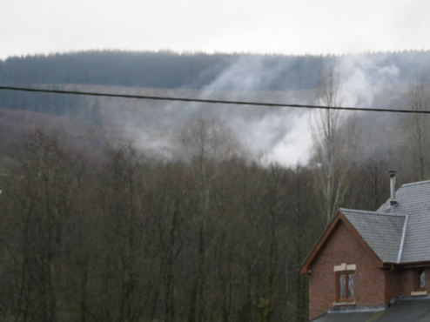
Old view about 1950/60 New view 2018
Figs. 8-11 Grandfather’s home (Hughes, 2018)
Things can still look familiar even though through time they have changed no end, but to the people who live say this is called progress.
People must be able to interact with these elements using more of their senses in order to experience physical and psychological benefits of nature, as well as to shift the collective baseline toward better understanding and appreciation of the natural world.
(Ma, 2016)
Using a camera can change your perspective of the ways you can look at any object that you see. Some photographers look for the unusual while others may look for the ‘normal’ and unnoticed, but both share in common the attention to detail that you may not have without a camera.
One can wonder aimlessly and not take anything in as they are too much of a hurry to see what is around them, in doing this they can miss things of importance. Smillie and Antinori (2017) describe this as inattentional blindness: “People experience this when they are so focused on one thing that they completely fail to see something else right before their eyes.” Some do not care and just want to get on with their lives, in doing this they fail to see the beauty around them, and the history of a place they are in. In doing this they can feel that they do not need to connect with the space they are in. Sometimes they feel there is no requirement for them to take time and take notice of what is around them.
They feel that their lives are too complicated and will therefore focus in their own world, disconnecting themselves from what is around them. In doing so they can lose the attachment with reality, in the entanglement of their daily lives there for become detached from the real world. They may see there the real world as they do not know anything different, to live in a domain like this is real to them as being connected is real to other people.
[Creative] people don’t just bring a different perspective to things, they genuinely see things differently to the average individual.
(Smillie & Antinori, 2017)
Psychogeography can let your mind wander creatively in any direction that you want to go in. Wandering aimlessly whether it be in town or city or countryside, you can explore things that you have never seen before even if you have lived in these areas for a very long time, to let your mind wander and take things that you have passed on a daily basis or you have never seen. You can go further and explore more deeply into the area that you are in, by doing so ambling along a road you can take more in than if you were rushing somewhat, if you take your time to absorb what is around you and can be pleasantly surprise on other things that you have missed in the past. “In a derive a person drop their usual action and let themselves be drawn by the attractions they find there. …From the derive point of view cities have a psychological aspect, with constant currents which strongly discourage entry into or exit from certain zones.” (Ford, 2005).
The Situationists used psychogeography as a tool connect and explore space. One of the methods they used is call derive which is exploring an area by walking and being pull in a new direction by what is the most inserting route (Coverley, 2006). To do a derive walk it is important to notice things such as the lay of the land and where it is taking you and you are concentrating on what you are seeing. By paying attention to your surroundings you will feel more connected with the area, these connections can take many different forms, from past, present or even the future. Psychogeography can help you understand and teach you how to connect with an area. By gaining a connection with a place you can learn to appreciate the area.
Brecon is a small town in many Mid Wales, I have lived year for nearly 40 years and it is only recently that I have stopped and looked around this small town and learn about the history, present day and the future. While I was doing a project on a small shop in Brecon on its history I learned a lot of things that I did not know that it happened here, do you psychogeography as help me understand the past can help the future, there are things. “Performance by itself is a social engagement and its adding to the much-needed sense of belonging to the space” (Janicijevic, 2008). Psychogeography can give you a sense of belonging to the area or areas that you are researching. I did not know about the town but I am looking forward to learning more about them.
I am doing research into buildings connected with the art gallery in Brecon, while doing this research and I am doing a derive, I have learnt that there are many tunnels under the streets and shops leading from many buildings: - Castle, Cathedrals and Churches, the tunnels were used by ministers, monks and dignitaries to escape when danger was around them, they would lead to the outskirts of the town, to a big house where they then could get away in safety. Some of these tunnels still exist today.
I found using psychogeography in the city was like walking around an area full of concrete buildings that reach to the sky with very or next to no view except buildings. With psychogeography is a person’s individual feelings when they explore the area that they are in. I found the cities claustrophobic and making me feel there was no escape from the concrete buildings. Billingsley (2017) argues that psychogeography can be used as a tool for rural areas as these need to be explored just as much as towns and cities do. Towns and cities have the hassle and bustle of everyday life, where us the rural areas have a calmness and more relaxed feeling about the area. When I walked in rural areas, I found that there was a lot more freedom to roam around and not feeling closed in wherever I went. This gave me a feeling of happiness and contentment.
The earth does not belong to man; man belongs to the earth. This we know. All things are connected like the blood which unites one family. All things are connected.
Chief Seattle (Kaiser, 1987)
Exploring nature can give you a feeling of peace and quiet with the grass under your feet, with this you can let your mind wander to wherever your surroundings are, you can explore the hills, the fields, the trees, the grass and can changes anything else you might find. By doing this you are creating a psychogeography map in your brain. This help you connect with your present surroundings and areas. Children can connect with nature and are more open-minded to what they see and feel, and adults may only want to connect with nature if they want to do so.
The way in which people react to area and why they do the things they do within a certain place can be observed and explored. Peter Ackroyd investigates not only why we act a certain way in regards to place but also the idea that our sensibilities and language may be explained:
Just as it seems possible to me that a street or dwelling can materially affect the character and behaviour of the people who live within them, is it not also possible that within our sensibility and our language there are patterns of continuity and resemblance which have persisted from the thirteenth or fourteenth centuries and perhaps even beyond that?
(Coverley, 2006)
An example of psychogeography exploring what is would be The Drifting Document (Paul+A, 2010).
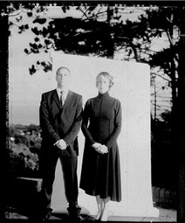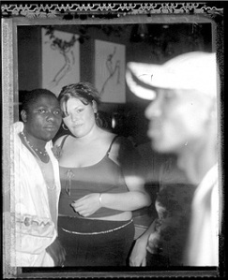
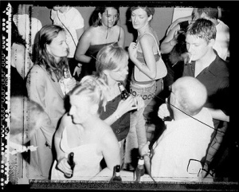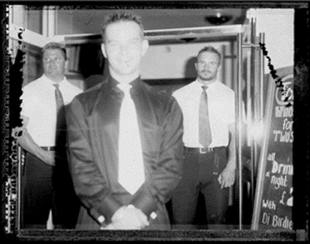
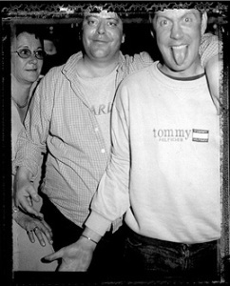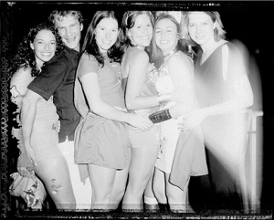

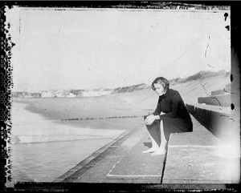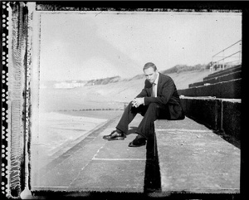
Figs. 12-19 The Drifting Document (Paul+A, 2010)
A derive was done over a 24-hour period, carried out in 2002 by two artist, the derive was based in Swansea, it was split into four sections of six hours, over a 24-hour period. While doing this they cover the past the present and the future. By drifting timelines, they encountered how people reacted to the four sections of a 24-hour period. They cover over 29 different places; these pictures show people how they react in everyday life over that 24-hour period. Some of the photos show how people can enter react with each other or how they can just be left on their own thinking about what they going to do next. The artists above did a derive around Swansea, a lot of different areas in a 24-hour period, this is call psychogeography which would let them wander around the city. By doing this you could get a feel of how the city respond to things that are going on the around them. It shows how people interact with each other in the nights. By doing this derive the artist shown how people can connect with the city or a place or each other. Psychogeography they may help them get a better feeling or sense of belonging to the area of Swansea and could have helped them recognise let me know to understand and connect to the area.

CHAPTER THREE WHAT WILL COME

By using psychogeography you can learn to respect and look the area for future generations to come, no one can tell what the future may bring, we can only hope that by using psychogeography we may be able to develop a new way of thinking and looking after the land surrounded us, we can do this by looking into the past and the present to try not to make the same mistake we have then before.
“Psychogeography is the only effective analytical technique […] in the arsenal of weapons of professional sustainable urban planners” (Janicijevic, 2008). By exploring a place, a planner can get a feeling for the area. By doing this they can learn what can work and what will not work in terms of changing the look of the region. The decisions they make will affect people’s view of the place.
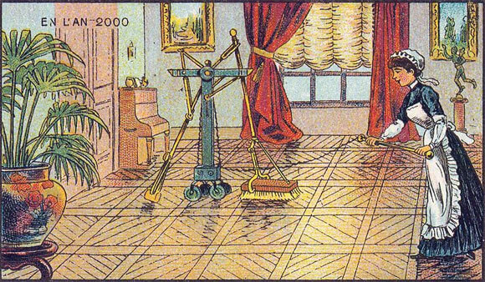
Fig. 20 Jean-Marc Côté (Hill, 2012)
Artists from a range of times have try to look into what the future may look like in years to come and their art as show this in their work. For example, artist Jean-Marc Côté in 1899 was ask by cigarette manufacturer to come up with a sequence of cards of what the future of France could look like (Hill, 2012). These illustrations show how technologies could change the future and make people live easier. Artists can use psychogeography as a tool to help them explore the future of a place. By imaging how a place could look in the future, artists would use their medium to share their idea of what will come. Positive visions of the future can give good vibes to a place and hope to people who live there.
The future depends on what you do today (Gandhi, 2018)

Conclusion
Chapter one explored how psychogeography can help you connect with the past and looked at artists who have worked in a similar way. This has shown how psychogeography as helped artists explore the past and their memories.
Chapter two investigated how psychogeography can be used as a tool to research the past can help understand the present, for you to discover new ways of looking at different areas. You can use psychogeography by looking at nature and towns to discover things that you may have missed. I looked into The Drifting Document and it showed me a different way of drifting around a town or a city. I felt that by drifting you can see and feel a lot of different things. I did a derive walk in Brecon and found out a lot of things I did not know about the town. I felt I’d missed out a lot by not observing what was around me, and doing a derive now makes me feel part of the town.
Chapter three looked at how, by using psychogeography, it may help you to see things in a new way and what might the future hold. It also may make you consider if you are doing the right thing in life. Psychogeography can allow you to engage with new ideas and appreciate what is yet to come. I have found that wandering aimlessly has allowed me to see the beauty that the future might hold.
I have used psychogeography to help me make my work more interesting, since I have been learning how you can use psychogeography as a path to making things more appealing to everyone. The future holds many prospects and opportunities psychogeography has yet to explore.

Image References

Fig. 1 Hughes, S. A., 2017. Memorial of the hungarian 32th Maria Theresia Infantry regiment. [Art].

Fig. 2 Hughes, S. A., 2017. Shoes on the Danube Bank. [Art].

Fig. 3 Michael Hoppen Gallery , 2017. Juana Gomez Distaff. [Online]
Available at: https://www.michaelhoppengallery.com/exhibitions/166/overview/#/artworks_standalone/10743
[Accessed 23 January 2018].

Fig. 4 Fabris, F., 2015. The Renaissance Series : The Last Supper. [Art] (One Eyeland Silver Award).

Fig. 5 Catrambone, C., 2013. Grandma Ilva - Mario's wife. [Art].

Fig. 6 Seawright, P., 1997. Black Spike. [Art].

Fig. 7 Seawright, P., 2003. Between. [Online]
Available at: http://www.paulseawright.com/between/
[Accessed 23 January 2018].

Figs. 8-11 Hughes, A., 2018. Grandfather's home. [Art] (UWTSD).

Figs. 12-19 Paul+A, 2010. The Drifting Document. [Online]
Available at: https://morebeautifulthangod.wordpress.com/2010/08/20/the-drifting-document/
[Accessed 7 March 2018].

Fig. 20 Hill, D. J., 2012. 19th Century French Artists Predicted The World Of The Future In This Series Of Postcards. [Online]
Available at: https://singularityhub.com/2012/10/15/19th-century-french-artists-predicted-the-world-of-the-future-in-this-series-of-postcards/#sm.001i3d35u12xifevsd517b0comizn
[Accessed 14 February 2018].

Bibliography
Barnes, S., 2015. Auto Mechanics Pose Dramatically to Recreate Renaissance Paintings. [Online]
Available at: https://mymodernmet.com/freddy-fabris-the-renaissance-series/
[Accessed 5 February 2018].
Billingsley, J., 2017. The City and the Country: Psychogeography -As we see it. Northern Earth, 1(150), pp. 13-18.
Bula, D., 2016. Narratives of Unwanted Change: Nostalgia in a Latvian Former Fishing Village. Journal of Folklore Research, 53(3), pp. 205-233.
Catrambone, C., 2013. Grandma Ilva - Mario's wife. [Art].
Coverley, M., 2006. Psychogeography.. 1 ed. Harpenden: Oldcastle Books..
Debord, G., 1956. Theory of the Derive. [Online]
Available at: http://www.cddc.vt.edu/sionline/si/theory.html
[Accessed 7 February 2018].
Fabris, F., 2015. The Renaissance Series : The Last Supper. [Art] (One Eyeland Silver Award).
Ford, S., 2005. The Situationist International: A User's Guide.. 1 ed. London: Black Dog.
Gandhi, M. i. G., 2018. Quotes About Future. [Online]
Available at: https://www.goodreads.com/quotes/16418-the-future-depends-on-what-you-do-today
[Accessed 23 February 2018].
Harvey, K. L., 2016. Envisioning the Past: Art, Historiography and Public History. Cultural and Social History, 12(4), pp. 527-543.
Hill, D. J., 2012. 19th Century French Artists Predicted The World Of The Future In This Series Of Postcards. [Online]
Available at: https://singularityhub.com/2012/10/15/19th-century-french-artists-predicted-the-world-of-the-future-in-this-series-of-postcards/#sm.001i3d35u12xifevsd517b0comizn
[Accessed 14 February 2018].
Hosmer, K., 2013. Intriguing Family Portraits Feature Treasured Objects - My Modern Met. [Online]
Available at: https://mymodernmet.com/camilla-catrambone-portraits-of-my-family/
[Accessed 24 January 2018].
Hughes, A., 2018. Grandfather's home. [Art] (UWTSD).
Hughes, S. A., 2017. Memorial of the hungarian 32th Maria Theresia Infantry regiment. [Art].
Hughes, S. A., 2017. Shoes on the Danube Bank. [Art].
Janicijevic, A., 2008. Psychogeography Now - Window to the urban future, Ontario: urbansquares.
Kaiser, R., 1987. Chief Seattle’s Speech(es): American Origins and European Reception. In: B. Swann & A. Krupat, eds. Recovering the Word: Essays on Native American Literature. Berkeley: University of California Press, pp. 525-530.
LakesDeepmap, 2017. Deep Mapping. [Online]
Available at: http://wp.lancs.ac.uk/lakesdeepmap/the-project/gis-deep-mapping/
[Accessed 22 January 2018].
Lombardi, D. D., 1999. ART; Communicating Through Photographs. [Online]
Available at: http://www.nytimes.com/1999/10/24/nyregion/art-communicating-through-photographs.html
[Accessed 21 February 2018].
Long, R., 2011. Richard Long: Sculptures. [Online]
Available at: http://www.shft.com.php56-20.dfw3-1.websitetestlink.com/reading/richard-long-sculptures
[Accessed 7 February 2018].
Lyons, S., 2017. Psychogeography: a way to delve into the soul of a city. [Online]
Available at: https://theconversation.com/uk/topics/walking-15756
[Accessed 7 February 2018].
Ma, M., 2016. Finding connections to nature in cities is key to healthy urban living. [Online]
Available at: https://www.washington.edu/news/2016/06/03/finding-connections-to-nature-in-cities-is-key-to-healthy-urban-living/
[Accessed 28 Fabruary 2018].
Michael Hoppen Gallery , 2017. Juana Gomez Distaff. [Online]
Available at: https://www.michaelhoppengallery.com/exhibitions/166/overview/#/artworks_standalone/10743
[Accessed 23 January 2018].
Oxford Dictionaries, 2018. Communication. [Online]
Available at: https://en.oxforddictionaries.com/definition/communication
[Accessed 21 February 2018].
Paul+A, 2010. The Drifting Document. [Online]
Available at: https://morebeautifulthangod.wordpress.com/2010/08/20/the-drifting-document/
[Accessed 7 March 2018].
Robertson, N., 2014. Eve of Destruction: the Siege of Budapest began 70 years ago. [Online]
Available at: https://welovebudapest.com/en/2014/12/24/eve-of-destruction-the-siege-of-budapest-began-70-years-ago/
[Accessed 24 January 2018].
Sandhu, S., 2006. Discovering the secrets of the city.. New Statesman, 135(4804), pp. 46-48.
Seawright, P., 1997. Black Spike. [Art].
Seawright, P., 2003. Between. [Online]
Available at: http://www.paulseawright.com/between/
[Accessed 23 January 2018].
Seawright, P., 2003. Between VII. [Art].
Seawright, P., 2005. Fields Notes. Antwerp: FotoMuseum.
Seawright, P., 2007. Invisible Cities. Cardiff: Ffotogallery Wales.
Smillie, L. & Antinori, A., 2017. Creative people really do see the world differently. [Online]
Available at: http://www.independent.co.uk/life-style/psychology-creative-people-see-world-differently-a7762596.html
[Accessed 28 February 2018].
Thomson, I., 2015. Heidegger's Aesthetics. [Online]
Available at: https://plato.stanford.edu/entries/heidegger-aesthetics/#HeiUndTruWorArt
[Accessed 31 January 2018].

