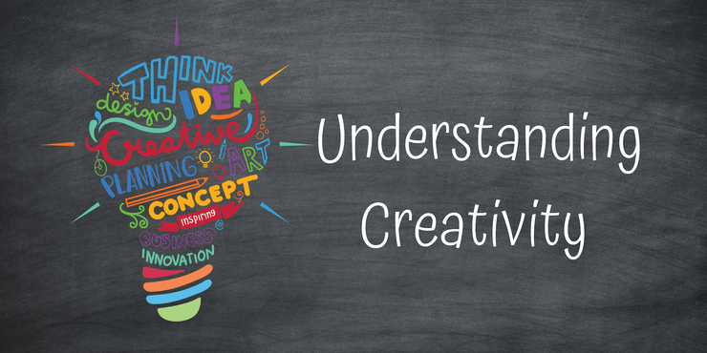
Project Outcome Written Assignment

Student Name: Jordan Glasgow -- Student Number: 1918303 -- Module Code: BMHP5014_BIRM
Module Name: Changemakers: Creativity and Value Creation – Lectures Name: Azora Hurd

Contents
Unit: 1 Topic 1 - Innovation And Creativity 2
Enterprising Mindset 3
Unit:2 Creative Solutions Topic 2 – Storytelling 4
Unit 3 Topic 1- Collaboration Not Competition 5
Unit 4 Topic 3 – Moving Forward 6
Reference list 7

Unit: 1 Topic 1 - Innovation And Creativity
Many people think of technological advancements when they hear the word innovation, me included before undertaking the module, changemakers creativity and value creation. This particular subject opened my eyes to a slightly different way of looking at innovation as a whole, I now understand that innovation can be defined in a variety of ways. The majority of them revolve around the development or implementation of new technologies in products, services, and processes that already exist. Nevertheless, innovation may take many forms, including social, societal, and most likely than other innovation regularly takes a business standpoint. But when studying in more depth the intertwining’s between innovation and creativity, my discovery was that it is very important to remain insightful and keep a level of intellectual curiosity when thinking about how far innovation has come, over the last decade and the possible hights it will reach in the next with creativity as its core driving force, whilst not only learning but exploring the theory of innovation and creativity, throughout the ten week period of the module changemakers creativity and value creation, the thing I myself can honestly say I have enjoyed the most and that I know that I will take away from this unit is that of a sense of adventure, and the evaluation of learning. Until now I was unaware these skills were also regarded as functions of creativity and assumed that to be creative it entailed the making of something from scratch. My opinions are based on the existing data, which aids in the development of new patterns and the construction of new patterns (Fisher & Williams, 2012).

Enterprising Mindset
My reflection of changemakers creativity and value creation has given me a greater grasp of what it means to be not just innovative and creative, but also to think in an enterprising mindset. I now understand that being innovative is a major part of having an enterprising mindset and it takes a mix of talents and a positive open attitude, as well as a great deal of tenacity to remain focused when faced by adversity. Another thing I have taken away from this unit is that people that are of an enterprising mindset tend to take a positive approach to problems and have the skills to move forward with a solution, in essence using their failure as motivation to come back stronger. It is commonly known that in order to survive harsh environments and the unpredictability’s of life, we as humans have had to constantly adapt and become enterprising with time e.g., during the 2020 Covid 19 global pandemic, with people being forced out of work a wave of online entrepreneur’s was birthed. Entrepreneurship and education are two critical opportunities that must be integrated and given special attention if we are to develop the human potential necessary to build stable and prosperous successful partnerships of the future (Schwab, 2009)

Unit:2 Creative Solutions Topic 2 – Storytelling
I chose topic 2 - Storytelling from unit 2 to reflect on in this section of my report because it has been most relevant to me personally throughout not only the changemakers creativity and value creation module but throughout many other modules I have undertaken, within level 5 science of health and social care, and that I can see will come in handy in future terms to come, and is a transferable skill I could use in a work environment to better paint a picture of events that may have happened e.g. writing an incident report. I was able to demonstrate this as It was also a skill I needed to draw upon whilst putting together my E-Portfolio assignment, as I had chosen to do my E-portfolio on an original campaign and idea that I created called the Each1Teach1Initiative, which was centred around gang prevention, following the dramatic growth of gang culture in the United Kingdom. I found that the creative solutions theory of storytelling played an important role in providing me with the ability and required skill set to let my mind run freely during the creation of my E-portfolio, giving me the opportunity of combining both theory and practice when creating all for parts of my E-portfolio from my Blog and Leaflet to my Conference poster, and surprisingly to me it even aided with a part I assumed it wouldn’t. That being the Mind map aspect, but it did. By my interpretation, the art of storytelling has to do with creating a link between, multiple things that would otherwise be just that thing, people, or places. The design of my Mind map as the six pictures taught me that ultimately the pictures alone would have told their own story with or without words to accompany them.

Unit 3 Topic 1- Collaboration Not Competition
By nature, humans are a competitive species. We compete against other teams or individuals in sports and other gaming activities, there is often a competition among siblings for their parents' attention, sometimes without even knowing subconsciously we compete with our peers over who has the best occupation or who appears to be doing the best financially, another place we find competition is within the workplace with colleagues for a raise or promotion. We become faster as we compete, but we improve through collaboration, that being said through my reflection I now understand that it is important to incorporate both when tackling a task as one will increase productivity and the other will surely improve efficiency it is also vital to have an established supportive system in place e.g., myself and a former colleague didn’t start off seeing eye to eye as they thought I was trying to make them look bad through going the extra mile at our job. After a lengthy conversation between us, I realised that me and my co-worker were actually pretty much alike. The only difference was our training period as mine had been longer, right there and then we decided to stop competing against one another and started collaborating together instead to get their level of training where it needed to be in doing so we built a long-term friendship which has crossed over from professional to personal.

Unit 4 Topic 3 – Moving Forward
What I have discovered about myself over the last ten weeks is that, before I may have been quick to make assumptions and that no matter how straight forward a subject looks on the surface from the outside looking in, you should never judge a book by its cover. Changemakers creativity and value creation taught me that there are so many layers to creativity, and there are even skills that I myself possess that can be classed as creative and innovative skills when applied correctly. The art of storytelling, has also allowed me the chance to refresh my vocabulary and better understand about having a level of engagement with my key audience, reader, or listener, honestly speaking it is a skill I would say I acquired since returning to university to continue with my studies. Whilst completing the four tasks included in my E-portfolio I was not only introduced to pre-existing skills that I had otherwise forgotten about, but my eyes were also opened to a variety of different skills that I was unaware were within my capability. My feelings moving forward after finishing this module is that of a sense of achievement for sticking with it even at times when I was struggling with my health due to contracting Covid 19. There are definitely skills that after taking this course I plan on implementing throughout the remainder of my studies, and that I will be able to carry with me as I go on to my chosen health care profession. Many of my newly found skills are transferable or adaptable given the right situation., after completing the duration of the course, I have a more in-depth understanding of the inner workings of having an enterprising mindset, entrepreneurship, innovation, and creativity. Keeping a curious intellectual set has allowed for me improve my preconceived notions about the components of innovation and creativity. Upon provision of the detailed information taught to myself and my class members by our lecturer Azora Hurd about enterprising mindsets and innovation and their various forms has also further shifted my previous perspective on these topics.

Reference list
Amabile, T., 2021. (e-book) Available at: <https://web.mit.edu/curhan/www/docs/Articles/15341_Readings/Group_Performance/Amabile_A_Model_of_CreativityOrg.Beh_v10_pp123-167.pdf> [Accessed 13 July 2021].
Dobni, C.B. (2008), "Measuring innovation culture in organizations: The development of a generalized innovation culture construct using exploratory factor analysis", European Journal of Innovation Management, Vol. 11 No. 4, pp. 539-559. https://doi.org/10.1108/14601060810911156 (Accessed on 18th June 2021)
Guthridge, L., 2021. Council Post: How You Can Thrive From Collaboration, Not Competition, At The Top. [online] Forbes. Available at: <https://www.google.com/amp/s/www.forbes.com/sites/forbescoachescouncil/2019/10/28/how-you-can-thrive-from-collaboration-not-competition-at-the-top/amp/> (Accessed 12 July 2021).
Giroud, Axèle, Ha, Yoo Jung; Yamin, Mo, & Ghauri, Pervez (2012). Innovation policy, competence creation and innovation performance of foreign subsidiaries: The case of South Korea, Asian Business & Management, suppl. Special Issue: Technology, innovation, and knowledge, 11(1), 56-78.
2021. (image) Available at: <https://www.sunflowerstudioct.com/post/understanding-creativity> (Accessed 9 July 2021).
2021. (online) Available at: <https://static1.squarespace.com › ...PDF Web results collaborating with competitors to advance ... - Squarespace> (Accessed 8 July 2021).
Schwab, k., 2009. The Global Competitiveness Report 2008- 2009. (e-book) Available at: <http://Www.3.weforum.org> (Accessed 13 July 2021).
Yasin, N. and Khansari, Z. (2021), "Evaluating the impact of social enterprise education on students' enterprising characteristics in the United Arab Emirates", Education + Training, Vol. 63 No. 6, pp. 872-905. https://doi.org/10.1108/ET-04-2020-0076

