

Programme: Master of Business Administration
Module: Strategic Management
Module code: LCMB7003
Student Name: Naima Nadimahmed Arab.
Student no.:2503320
Lecturer Name: Amare Desta Zulf Khan & Balendran Kandasamy.
Table of Contents
Section 1 4
1.Organisational Overview 4
1.1 Historical perspective, mission, vision, and business model of Apple 4
1.2 Key operating industry, competitors, and market position of Apple 4
2. External and Internal Environment Analysis 7
2.1 PESTEL analysis on Apple 7
2.2 Success factors and strategic challenges of Apple 10
2.3 Key resources, capabilities, and core competencies of Apple 11
2.4 Application of the VRIO Framework on Apple 12
2.5 The way internal strengths contribute to competitive advantage within Apple 13
3. CSR and Sustainability Objectives 15
4. Comprehensive and Holistic View of the Organisation: Balanced Scorecard 16
4.1 Financial Perspective 17
4.2 Customer Perspective 19
4.3 Internal Business Processes Perspective 21
4.4 Learning and Growth Perspective 22
5. Strategic Choices and Implementation 25
5.1 Business-Level Strategy 25
5.2 Corporate-Level Strategy 26
5.3 Managing Strategic Change 28
Recommended Strategic Choices 29
6. Strategic Evaluation and Recommendations 30
6.1 SWOT Analysis 30
6.2 Ansoff’s Matrix Analysis 32
6.3 Strategic Recommendations 34
6.3.1 Justification 35
Section 2: Reflective Account Using Gibbs’ Reflective Cycle 36
1. Description 36
2. Feelings 36
3. Evaluation 37
4. Analysis 37
5. Conclusion 38
6. Action Plan 38
Reference list 40

Section 1

1.Organisational Overview

1.1 Historical perspective, mission, vision, and business model of Apple
Historical perspectives
Apple is one of the largest and leading multinational technology companies in the world. The company is mostly famous for manufacturing and designing electronics, online, and software services such as iPhone, Apple Watch, iPad, and Mac laptops (EBSCO, 2023). The company was founded by 3 business enthusiasts Ronald Wayne, Steve Jobs, and Steve Wozniak in 1976 within California, US. The company had started its journey by producing personal computers like Apple ll and Apple I And gradually expanded to manufacture digital and electronics services like iPhone, iPod, and iPad since the 2000s (James, 2023).
Vision and Mission
The organisational vision that Apple follows is manufacturing the best sustainable, advanced-technology and innovation based products for consumers by establishing an integrated digital ecosystem and expanding their technology through using Artificial Intelligence (Apple, 2025). The main mission of Apple is to emphasise more on consumer experience and technological innovation through their offered products and services.
Business model
The business model that Apple follows is a closed loop ecosystem. It refers to the structured business model where organisations eliminate waste generation by making their products from materials that are recycled, reused, and repurposed in continuous circulation (Business Models, 2024).This business model helps Apple to ensure environmental sustainability and customer retention. In one way Apple has integrated their services, products, and software in a way so that it can deliver seamless user experience and in other way they manufacture products from their recycled and reused materials to ensure environmental sustainability (Elsey, 2025).

1.2 Key operating industry, competitors, and market position of Apple
Operating industry

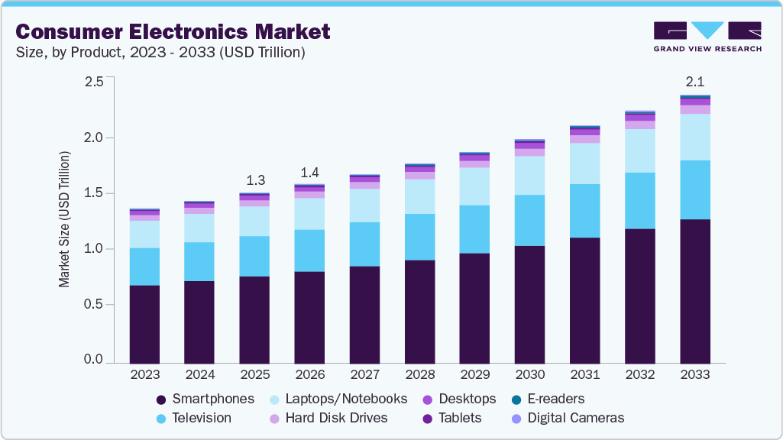
Figure : 1 Global Electronics Market
(Source :Grand View Research, 2024)
Apple operates in the global electronics and technology industry that majorly offers electronic compliances such as digital services, tablets, smartphones, computers, and wearables. The global electronics and technology industry is rapidly growing due to the enhanced digital ecosystems, AI development, and global competition (Grand View Research, 2024).
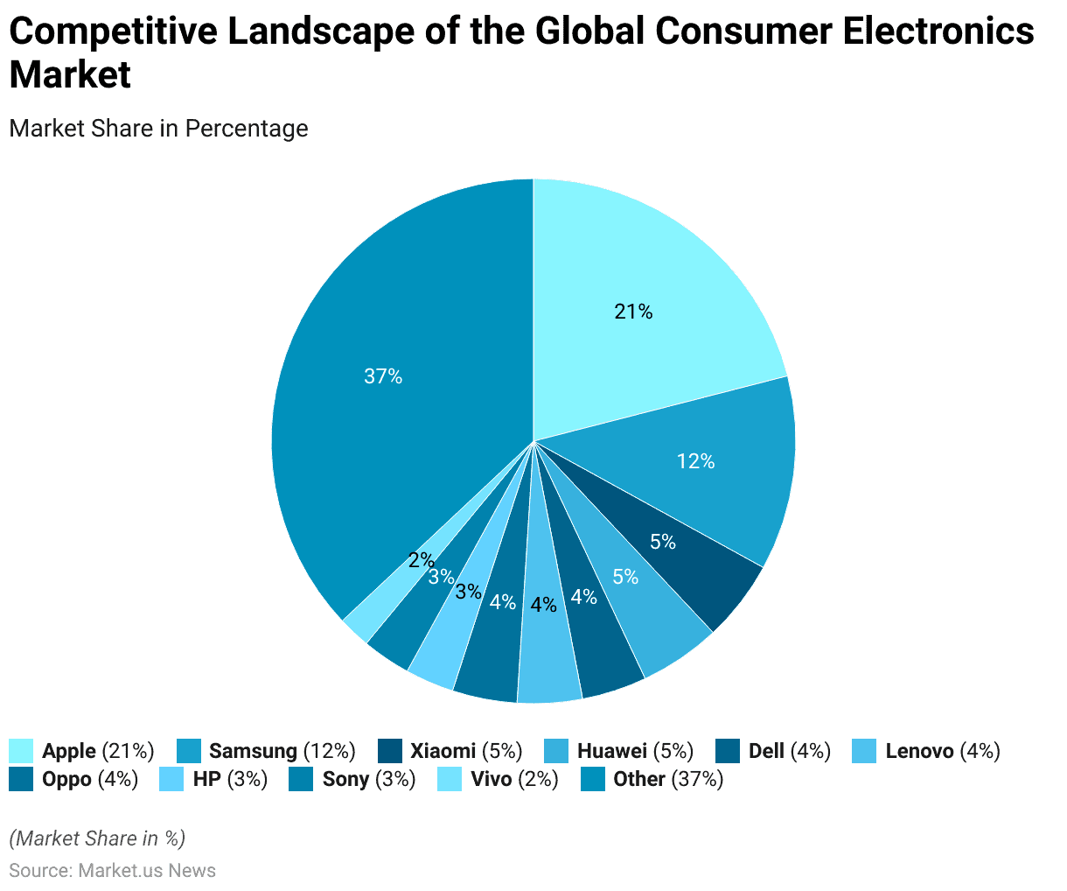
Figure : 2 Global Market Share of Apple
(Source : Pangarkar, 2025)
As per current report, the global electronics and technology market has reached $1.3 billion in 2025 and is expected to reach $2.1 billion within 2033 at 5.9% growth rate. The current report states that Apple holds a 20 to 21% market share of the global electronics and technology market in 2025 (Pangarkar, 2025).
Competitors
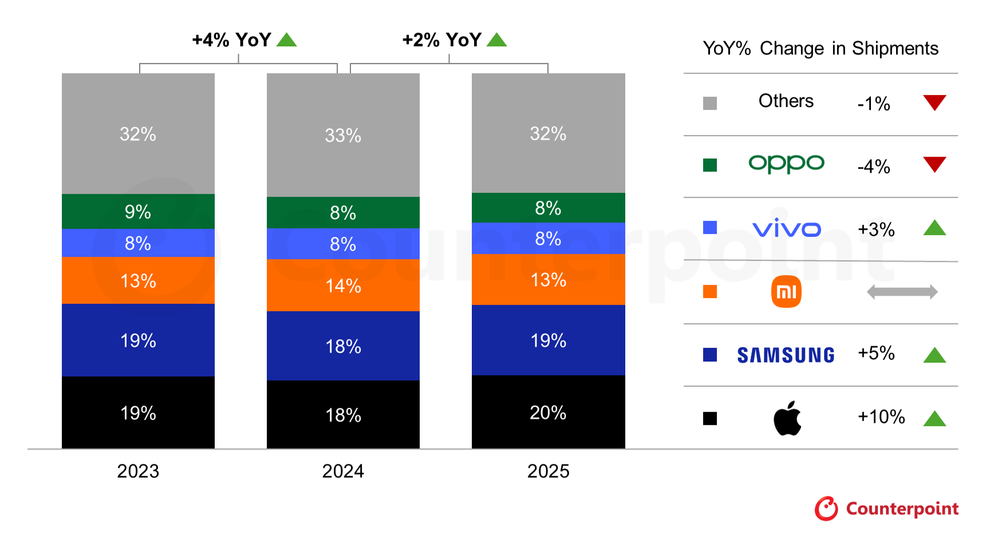
Figure : 3 Competitors in Smartphone segment
(Source : Counterpointresearch, 2025)
There are several competitors that can be seen of Apple in various product categories in the electronics and technology market including digital devices, personal computers, and smartphones. Within the smartphone and digital device product segments, Samsung is the key competitor of Apple which holds 19% of the Smartphone segment and 26% of the digital device segments in the global market (Counterpointresearch, 2025).
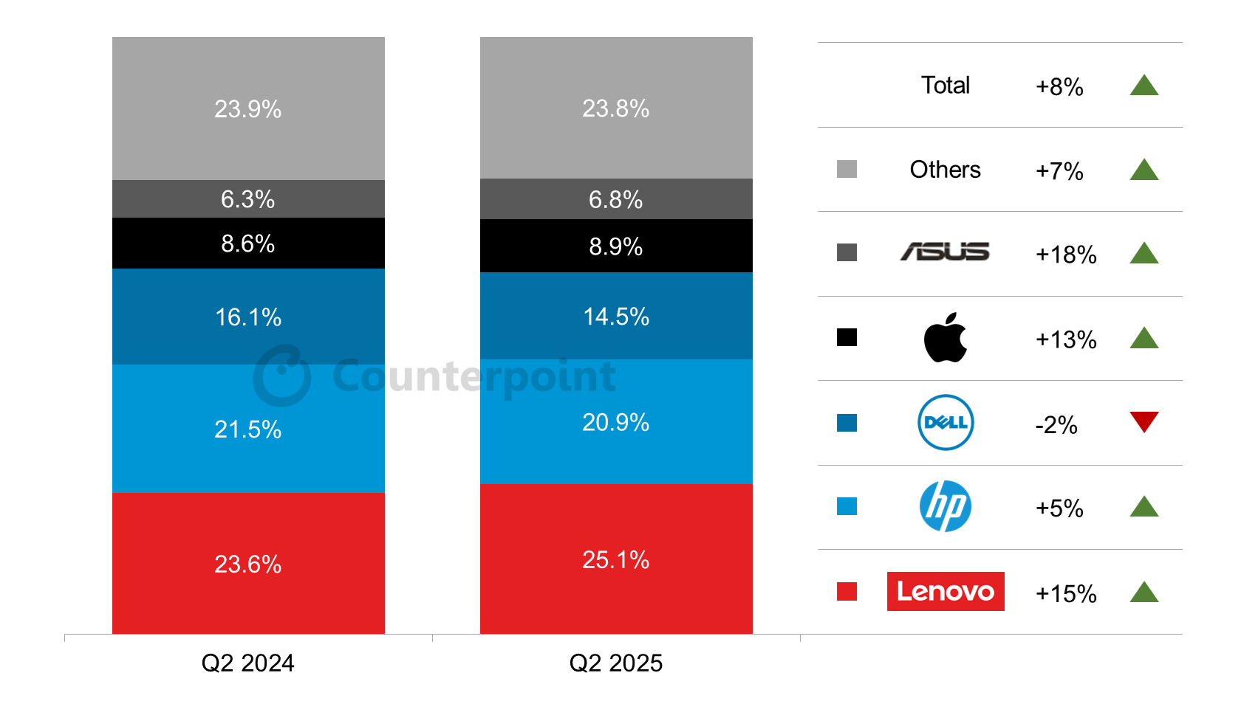
Figure : 4 Competitors in PC Product segment
(Source : Counterpointresearch, 2025d)
Within the personal computer segment Lenovo, HP, and Dell are the major competitors of Apple. As per report Lenovo holds 25%, HP secures 20%, and Dell captures 15% market share in the personal computer product segment in 2025 (Counterpointresearch, 2025d).
Market position
The global electronics and technology industry is a much larger industry with several segments such as smartphones, digital appliances, personal computers, semiconductors. Due to operating in a limited product segment in the total global electronics and technology industry, Apple holds approximately 3 to 5% of the total global electronics revenues.
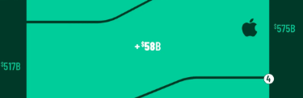
Figure : 5 Brand value of Apple
(Source : Conte, 2025)
However, Apple is one of the most profitable companies in the consumer technology device segments in the global market with a brand value of $574.5 billion (Conte, 2025).

2. External and Internal Environment Analysis

2.1 PESTEL analysis on Apple
Political factors
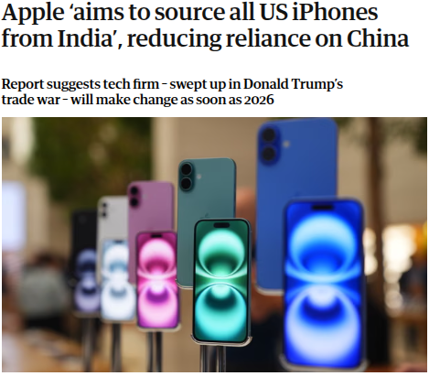
Figure : 6 Brand value of Apple
(Source : Milmo, 2025)
Political factors such as government incentive, trade policies, and geopolitical frictions have a crucial role in the business operations of Apple as it highly depends on their global supply chains for functional operations. For instance, the geopolitical tension between China-US and the higher tariffs in electronic products significantly impacted the manufacturing operations of Apple within China (Milmo, 2025). In order to navigate through these production challenges within China, Apple has expanded their production hub into emerging countries such as Vietnam and India. As per report, the iPhone production of Apple in India increased by 53% in 2025 which is the 25% of the global iPhone production (IANS, 2026). Apple has also benefited from the production linked incentives introduced by the Indian government.
Economic factors
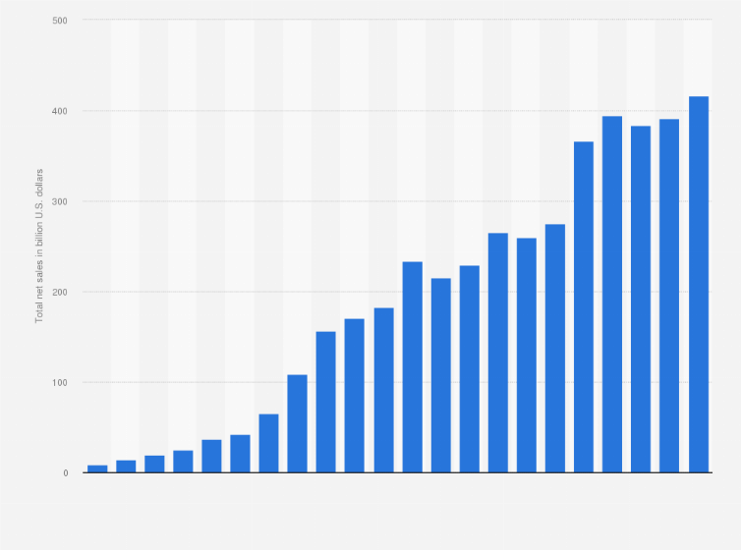
Figure : 7 Total revenue of Apple
(Source : Statista, 2025)
The expansion strategies of Apple are also highly influenced by several economic factors including inflation, economic downturn, and customer demands. Despite the economic slowdowns, Apple has witnessed a strong product and digital service demand among customers especially for their flagship items such as iPhone (Phartiyal, 2025). According to the current report Apple has generated revenue of $44.6 billion within the first quarter of 2025 through selling iPhone. Moreover, Apple has also witnessed a significant sales growth in the emerging economies such as India due to increasing disposable income of people and the economic growth. Within 2025, Apple has generated $9 billion from India, adding to the total revenue of $416 billion (Statista, 2025).
Social factors
The business performance and marketing strategies of Apple is also influenced by the social factors such as the changing customer preferences and brand perception. Within this digital age consumers are seen increasingly dependent on the digital devices and services for their financial transactions, communication, and entertainment. This rapidly growing digital trend effectively helps Apple and their integrated digital ecosystem strategies. For example, Apple records 850 million active users on the weekly basis in their Apple app store (Apple, 2025a).
Technological factor
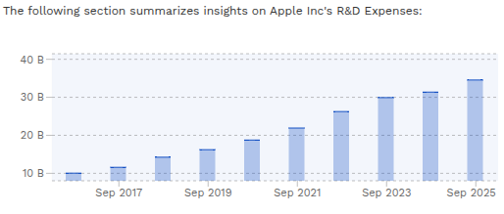

Figure : 8 R&D investment of Apple
(Source : Macrotrends, 2024)
Within the current times technological innovation is taking place rapidly which affects the overall functional operations and expansion strategy of technology-based companies like Apple. Due to the rapid development in the technology sectors like cloud computing, artificial intelligence, and semiconductor designs, Apple is needed to invest more in research and development to ensure their competitive advantage within the highly volatile and fast-evolving technology market. According to the report Apple has invested $34.55 billion in their R&D department within 2025 (Macrotrends, 2024).
Environmental factor
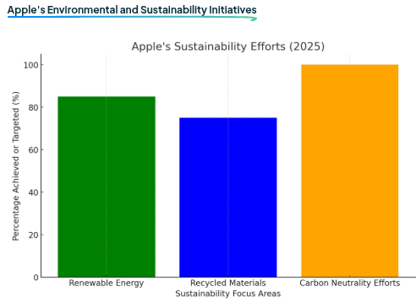
Figure : 9 Sustainable efforts of Apple
(Source : Gören, 2024)
The growing concern of environmental wellness among customers and governments necessitates Apple to take several measures towards their sustainable responsibilities. In order to address their sustainable commitments, Apple has started using recycled materials and using operational processes which can reduce carbon emissions (Jiagui, 2024). As per survey, Apple has used 83% renewal energy and 75% recycled materials in their operational functions within 2025 (Gören, 2024). It in one way helps them in strengthening their brand reputation and in other way adhere to the environmental regulations of the government, minimising the risk of regulatory complications.
Legal factors
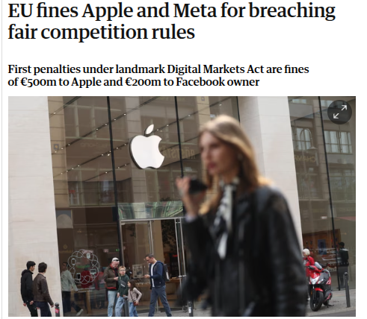
Figure : 10 EU fines on Apple
(Source : Rankin, 2025)
Due to the extensive usage of digital devices, governments and authoritarian bodies have started becoming more strict towards technology-based companies like Apple by introducing more robust digital platform regulations and competition laws. For instance, the European Union has announced a financial fine of €500 million on Apple in 2025 by accusing them for violating Digital Markets Act (Rankin, 2025). The European Union has accused Apple for restricting digital developers to promote their alternative payment methods outside their Apple app store. The strict legal regulations have forced Apple to optimise their existing business practices and App store policies as per the government guidelines.

2.2 Success factors and strategic challenges of Apple
Success Factors
- Apple's integrated digital ecosystem is a success factor of the company which enables them to provide high end customer engagement and experience which is difficult to imitate for their competitors (Petro, 2023).
- Another success factor of Apple is their effective capability of continuous product innovation and service differentiation. By using their capability, Apple can enhance their services, products and remain competitive in the volatile technology market.

Strategic challenges
- The most important strategic challenge for Apple is intense competition within the technology industry. The company faces intense competition in the pricing strategies, AI-Power technology, and technological innovation with their competitors (Gallagher, 2025b).
- Another significant challenge is the global supply-chain risk for Apple. As the company relies heavily on international manufacturing networks, their production operations are often affected by the geopolitical tensions.

2.3 Key resources, capabilities, and core competencies of Apple
Key resources
There are several key resources that can be found within Apple such as their financial resources and brand value. Apple has a very significant financial resources and revenue growth which help them heavily invest in acquiring advanced technologies, R&D and maintaining global operations. The company generated $143.8 billion in Q12026 (Apple, 2026). The strong brand reputation of Apple helps them maintain their premium pricing and Customer loyalty. As per study, customer satisfaction rate within Apple is 90% (Shah, 2023).
Main capabilities
One of the main organisational capabilities of Apple is their global supply chain and production capability. This internal capability enables them to conduct manufacturing across several regions which help them avoid geopolitical tensions and challenges caused by trade policies.It in one way provides them operational efficiency and in other way helps them in risk management by ensuring manufacturing flexibility. For instance, Apple has produced 55 million devices in India within 2025 (Tech Desk, 2026).
Core competencies
The core competency of Apple is their integrated digital ecosystem. The company has designed the ecosystem in a way so that all the hardware, software and digital devices of Apple are interconnected within a seamless ecosystem, providing customers better digital experience (Byte, 2023). It helps them in ensuring recurring revenues and increasing customer engagement rate.

2.4 Application of the VRIO Framework on Apple

Resources | Valuable | Rarity | Difficult to imitate | Organised | Competitive implications
Brand reputation | Yes | Yes | Yes | Yes | Competitive advantage
Global manufacturing network | Yes | Medium | Moderate | Yes | Competitive benefits
Integrated ecosystem | Yes | Yes | Yes | Yes | Long-term competitive benefits
Research and development power | Yes | Medium | Medium | Yes | Short-term competitive advantage

Table : 1 VRIO Analysis
(Source : Self-developed)
Evaluation
Apple has a significant brand reputation in the global electronics and technology market. Due to their strong brand value, a large number of customers prefer buying their premium range of products (Lacaze, 2024). It is one of the rare and valuable internal capabilities that they create over a long period of time which is difficult to imitate for their competitors (Ray, 2023). Apple's other significant internal capability is their global manufacturing network. As per report, Apple provides 2.9 million employment within the US (Apple, 2025b). It is a valuable capability but not completely rare as there are many competitors like Samsung, HP and Dell who also operate through global manufacturing systems. One of the most important internal capabilities of Apple is their integrated ecosystem of digital services, hardwares and softwares. Due to this effective connectivity across all their services and devices customers often feel reluctant to switch to other brands. It is a valuable capability and can be considered as rare and difficult to imitate as many of the competitors of Apple mainly operate through third-party software ecosystems (Nellis, 2025a). The significant power in research and development also provides a significant competitive advantage to Apple. It can be considered as a valuable asset as it enables the company to innovate new services and product ranges by using unique technologies.

2.5 The way internal strengths contribute to competitive advantage within Apple
There are several significant internal capabilities that can be identified within Apple which help them to differentiate their brand from their other competitors in the global electronic and technology market through ensuring competitive advantage.
Strong brand reputation
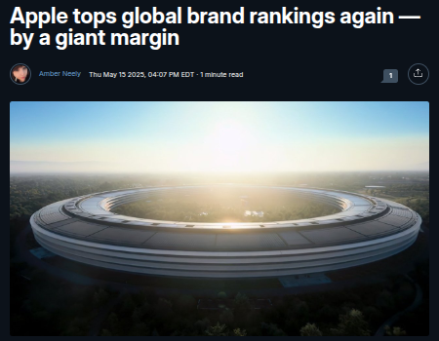
Figure : 11 Brand Value of Apple
(Source : Neely, 2025)
One of the most significant strengths of Apple is their strong brand reputation which helps them influence customers to purchase their premium products and maintain their market leadership. Their strong brand reputation makes them build a strong brand value of approximately $1.29 trillion In 2025 (Neely, 2025). It helps them ensure customer trust, loyalty and sustainable financial performances.
Integrated digital ecosystem
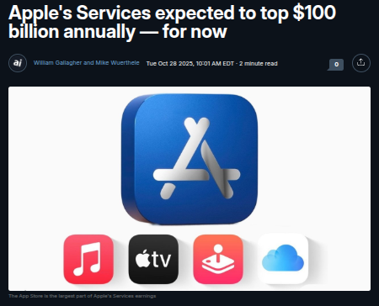
Figure : 12 Service Revenues of Apple
(Source : Gallagher, 2025)
Apple's integrated digital ecosystem across their softwares, hardwares, and devices significantly support their competitive advantage in the global market. It in one way helps in ensuring customer retention and in another way makes recurring revenue streams such as iCloud, Apple Music, and Apple Pay. The current report shows that the service revenue of Apple reached $108 billion In 2025 by contributing 25% of the total revenue generation (Gallagher, 2025).

3. CSR and Sustainability Objectives
Corporate social responsibilities or about the commitment by organisations to run it operations ethically and also contribute to economic development while enhancing the quality of life for employees, society, and communities (Fernando, 2025). One of the main components of CSR strategy of Apple is its Apple 2030 sustainability goal aiming to achieve carbon neutrality in all over its value chain by 2030. The company has minimised its carbon emission by more than 60% since 2015.
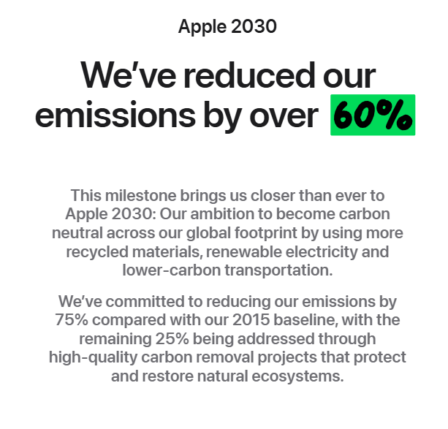
Figure: 13 Apple 2030
(Source: Apple, 2025)
To do this the company focused on renewable energy adoption end supply chain improvements. Apple has also motivated its suppliers to shift towards clean energy. As a result, over 300 manufacturing partners have committed to adopting 100% renewable electricity for production of Apple (Apple, 2023). With these initiatives, the importance of environmental sustainability in global business operations is reflected. Apple is increasingly dependent on recycled materials like recycled cobalt in batteries and 100% recycled rare earth elements in magnets which are used in many Apple devices (Apple, 2023).
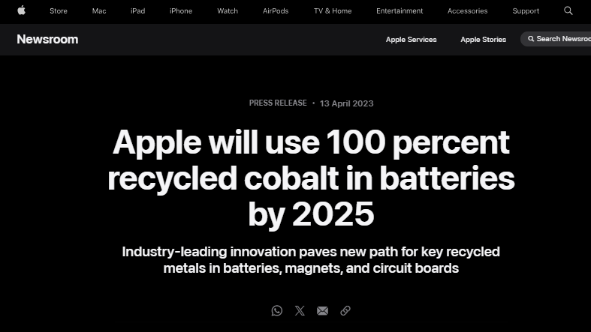
Figure:14 Recycled material use by Apple
(Source: Apple, 2023)
With this strategy the company can minimise environmental footprint caused by mining and it can also support circular economy approaches.
CSR contributes to the reputation of Apple and provide competitive advantages to the company. In a time when consumers are focusing more on environmentally responsible brands, the focus of Apple in sustainability initiatives can enhance its brand value and customer loyalty. However, CSR policy of Apple has also encountered criticism because concerns related to labour conditions in supplier factories is still present (WSR, 2024). The environmental impact of increasing electronic waste is also brought criticism. Despite all these challenges, Apple is focusing on expanding recycling programs like Daisy which is its robotic device-dissemble system which is successfully recovering valuable materials from old iPhones.

4. Comprehensive and Holistic View of the Organisation: Balanced Scorecard
The Balanced Scorecard was developed by Kaplan and Norton in 1992 which is a strategic management framework evaluating organisational performance with the help of both financial and non-financial indicators (Cote, 2023). Corporate mission of Apple emphasises on premium product design, innovation, offering excellent customer experience, and sustainability. With this Balanced Scorecard Apple’s strategic priorities can be converted into measurable performance indicators.

4.1 Financial Perspective
Contribution of Apple’s strategy to profitability and shareholder value can be evaluated through Financial Perspective. Apple is one of the most profitable technology companies in the world with around $416 billion in revenue and it also has a strong net income of $112 billion in 2025 (Elagina, 2026).
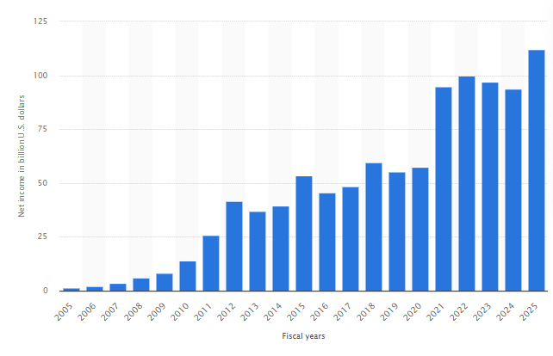
Figure: 15 Net income of Apple
(Source: Elagina, 2026)
Objectives
- Sustain revenue growth through innovation
- Increase high-margin services revenue
- Maintain strong profitability
Measures / KPIs
- Total revenue growth
- Gross profit margin (around 44%)
- Services revenue share
- Return on investment (ROI)
Targets
- Expand services revenue to reduce reliance on hardware
- Maintain high profit margins despite competitive markets
Initiatives
- Expansion of subscription services such as Apple Music, Apple TV, and Apple Pay, increasing its profit margin.
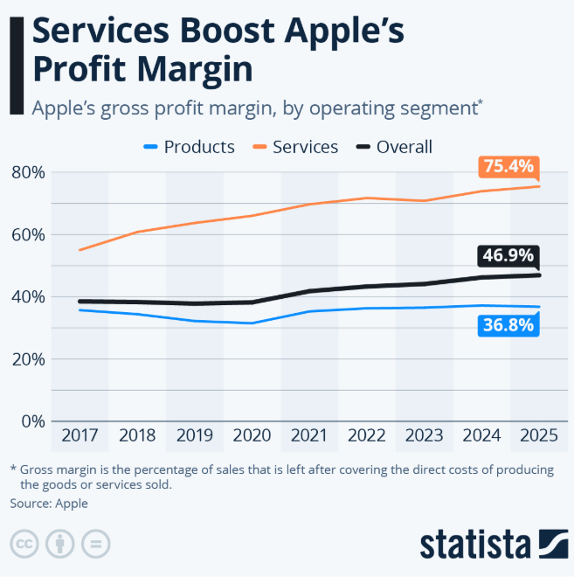
Figure: 16 Contribution of services in profit margin
(Source: Richter, 2025)
- Development of new technologies including augmented reality and artificial intelligence
- Investment in global retail and digital services infrastructure

4.2 Customer Perspective
The customer perspective is used to understand how well Apple can create value as well as satisfaction for its consumers. Strategy of Apple focuses on ecosystem integration, user experience, and premium design. Customer loyalty and ecosystem engagement with the company is highlighted with the fact that it has 2.5 billion active devices globally (Lee, 2026).
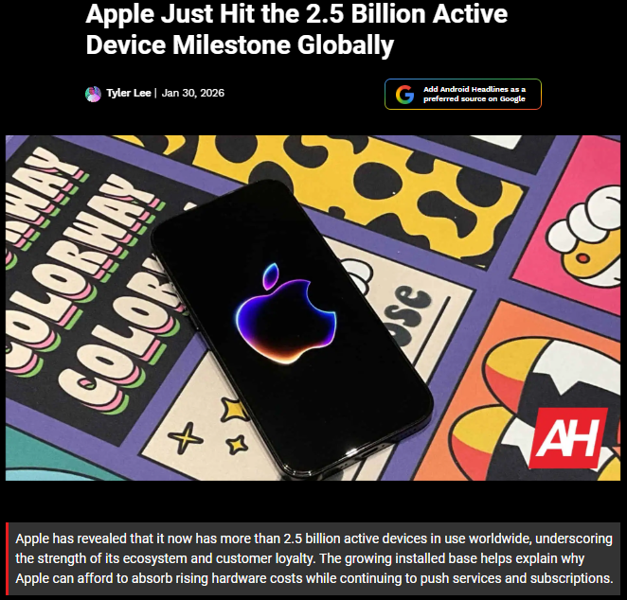
Figure: 17 Active devices globally
(Source: Lee, 2026)
Objectives
- Deliver high-quality innovative products
- Strengthen brand loyalty and trust
- Expand global market reach
Measures / KPIs
- Customer satisfaction ratings
- Global smartphone market share
- Active Apple device installations
- Growth in services subscriptions
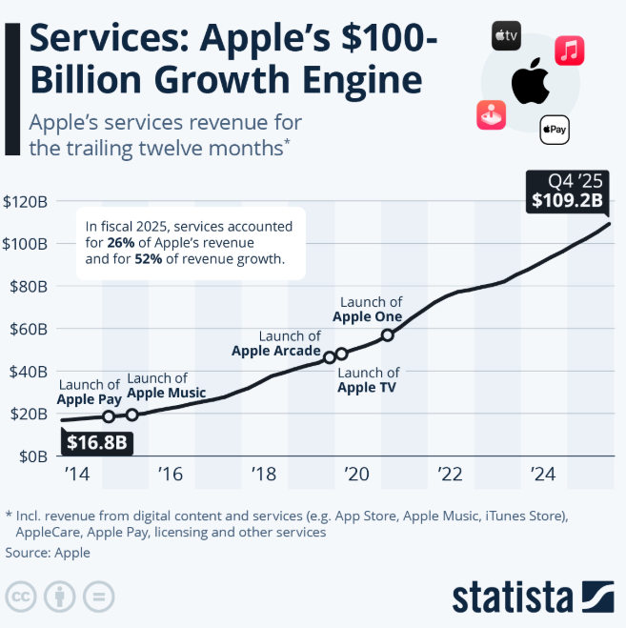
Figure: 18 Growth of Apple’s services
(Source: Richter, 2025)
Targets
- Increase ecosystem usage and cross-device integration
- Expand presence in emerging markets
Initiatives
- Continuous improvement of iPhone, Mac, iPad, and Apple Watch products
- Enhanced privacy protection features
- Expansion of Apple retail stores and online platforms

4.3 Internal Business Processes Perspective
Internal Business Process perspective focuses on supply chain management, operational efficiency, and innovation capability. To support the development of new products as well as technologies, Apple invests substantially in Research and Development with more than $34.6 billion in R&D in 2025 (Lakshkar, 2025).
Objectives
- Improve product innovation and development speed
- Strengthen sustainable supply chain management
- Enhance operational efficiency
Measures / KPIs
- R&D expenditure levels
- Product development cycle time
- Supply chain sustainability metrics
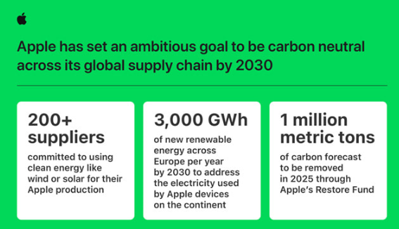
Figure: 19 Sustainable supply chain
(Source: Apple, 2022)
- Manufacturing efficiency
Targets
- Accelerate innovation cycles
- Reduce carbon emissions across supply chains
Initiatives
- Collaboration with suppliers to adopt renewable energy
- Expansion of recycling and resource recovery programmes
- Implementation of advanced manufacturing technologies

4.4 Learning and Growth Perspective
The Learning and Growth perspective evaluates organisational capabilities like innovation culture, employee skills, and leadership development. Success of Apple is highly reliant on its approaches and ability to attract designers, highly skilled engineers, and software developers and retain the 164,000 employees.
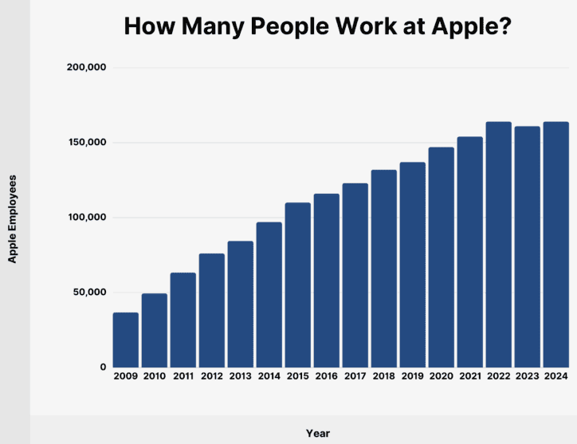
Figure: 20 Number of employees of Apple
(Source: Backlinko, 2024)
Objectives
- Foster innovation and creativity
- Improve employee engagement and diversity
- Strengthen technological expertise
Measures / KPIs
- Employee retention rates
- Diversity and inclusion metrics
- $500 Training and development investment (Thompson, 2025)
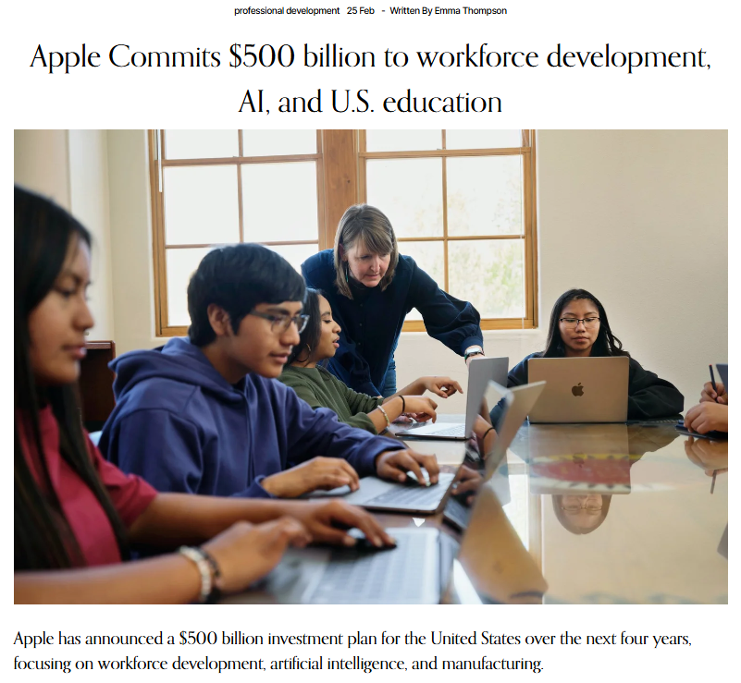
Figure: 21 Training and Development investment of Apple
(Source: Thompson, 2025)
- Number of patents and technological innovations
Targets
- Build a highly skilled and diverse workforce
- Maintain Apple’s reputation as an innovation leader
Initiatives
- Employee development and leadership training programmes
- Diversity and inclusion initiatives
- Partnerships with universities and research institutions

5. Strategic Choices and Implementation
Through strategic choices an organisation determines its competition in the industry and expansion of operation to achieve sustainable competitive advantage. These choices can be analysed at business and corporate level.

5.1 Business-Level Strategy
Apple follows a differentiation strategy at business-level. Apple focuses on innovation, premium design, high product quality, and a robust ecosystem integrating hardware, software, and services allowing increasing market share against competitors like Samsung or Xiaomi (Counterpointresearch, 2026).
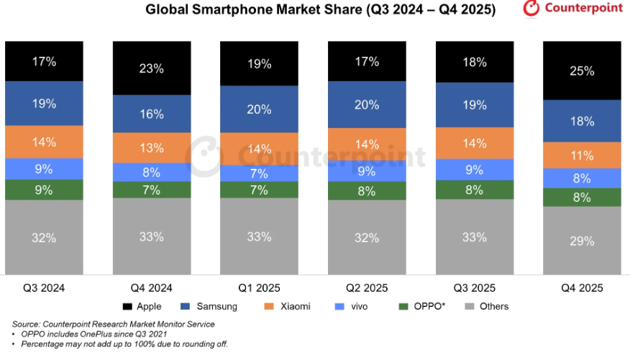
Figure: 22 Market share of Apple
(Source: Counterpointresearch, 2026)
This strategy of premium pricing can be seen in products like iPhone, Mac, iPad, Apple Watch and AirPods. Apple’s largest revenue source is iPhone generating $209.59 Billion revenue in FY2025 accounting 50.4% of the Apple’s total product sales, 4% increased from FY2024 (Johnston, 2026). Apple has services like Apple music, Apple Pay, Apple TV+, and iCloud strengthening its integrated ecosystem keep the customers within Apple’s environment.
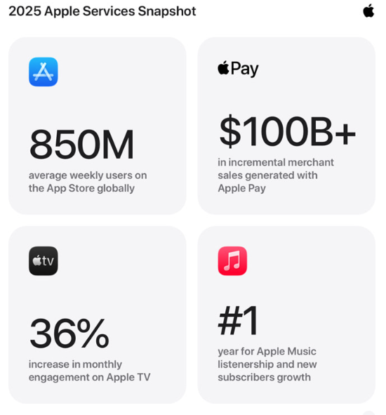
Figure: 23 Apple services
(Source: Apple, 2025)
In FY2025 this service segments generated revenue of $109.20 Billion, increased 14% from FY2024 (Sparks, 2026). Apple follows differentiation but shows elements of focused differentiation by targeting premium market segments against mass market. It helped Apple to maintain high profit margin through intense competition in the global technology industry.

5.2 Corporate-Level Strategy
Apple follows related diversification and international expansion strategy at the corporate-level. An important corporate strategy is diversification into services and digital ecosystem from hardware. Apple initially focused on personal computers and then expanded to Smartphone, wearable, and digital services. The service business includes subscription for platforms like Apple Music, AppleArcade, and Apple TV+ reducing over-reliance on hardware sales providing stable recursive revenue source. Another corporate-level strategy is international expansion as Apple sales products in 175 countries (Apple, 2023).Apple is expanding in emerging markets like India and Vietnam.
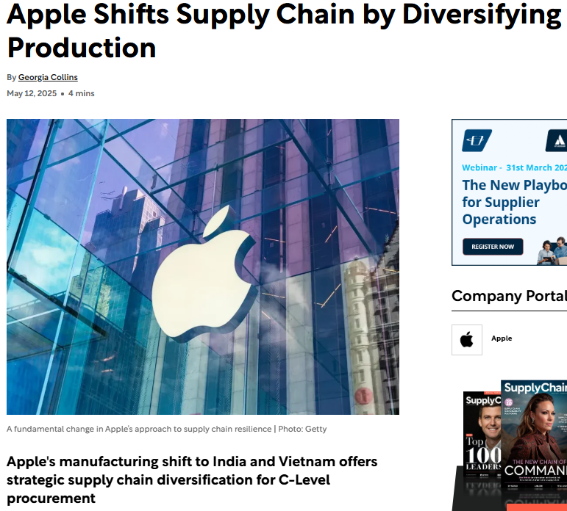
Figure: 24 Supply chain diversification
(Source: Collins, 2025)
India has become a strategic focus for its large population and rapidly growing smartphone market. In FY2024 Apple’s iPhone exports to USA from India crossed $10 Billion showing strong growth potential in the region (Pradhan, 2025).
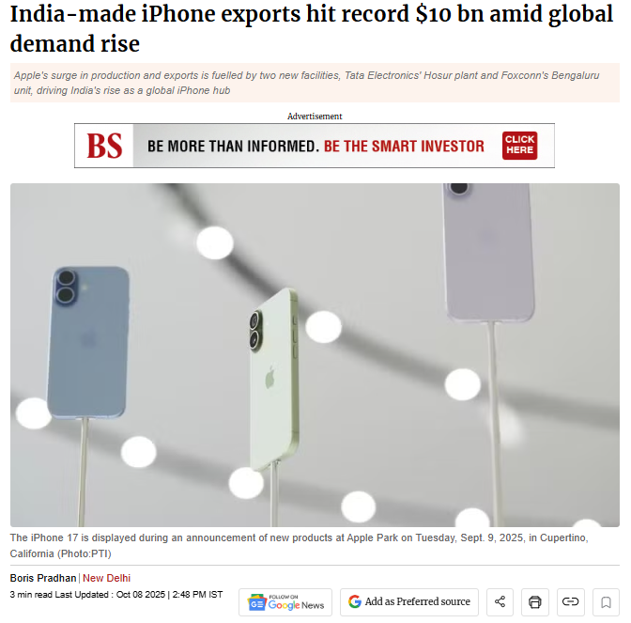
Figure: 25 iPhone export
(Source: Pradhan, 2025)

5.3 Managing Strategic Change
Apple has managed organisational changes effectively during major technological transitions. One example is the shift from computers to mobile devices during the launch of iPhone in 2007. Recently, Apple has implemented significant strategic changes like transitioning Mac computers from Intel processors to Apple Silicon Chips (M-Series). It has improved performance, battery efficiency, and integration in Apple devices and platforms. Apple has successfully adapted its business model by expanding the service ecosystem. This change needed investments in digital infrastructure, content creation, and global payment systems. These have strengthened the customer loyalty and increased recursive revenue sources.
The change management in Apple has challenges too. Apple is facing increased competition from technology firms like Google, Samsung, and Chinese manufacturers. The regulatory scrutiny in markets like the Europe and the USA has increased pertaining to App-Store policies and digital market dominance (Alphaspread, 2025).
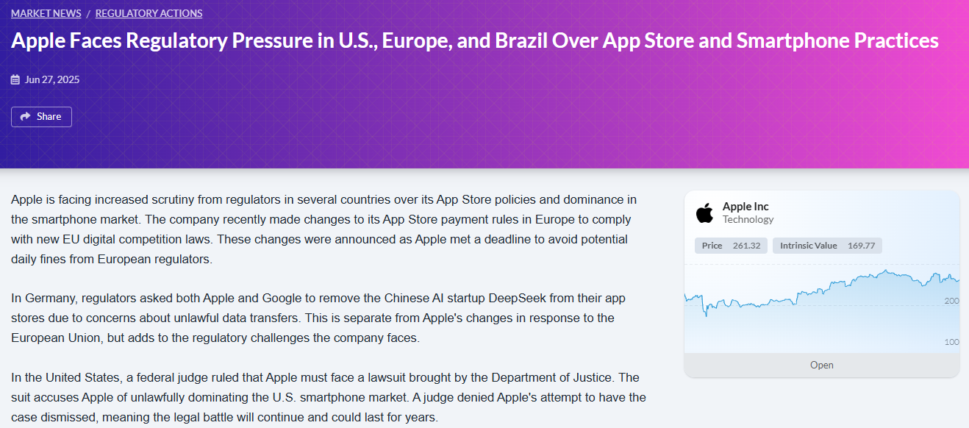
Figure: 26 Regulatory pressure
(Source: Alphaspread, 2025)

Recommended Strategic Choices
Apple should continue to prioritise its differentiation through innovation to sustain competitive advantage. It can expand service ecosystem with emerging technologies like Artificial Intelligence, Augmented Reality, and health technology. These have potential growth opportunity aligning with Apple’s strength in design, technology integration, and brand reputation. The company can invest in research and strategic partnerships to improve user experience, expand in new markets, enhance customer loyalty, and also reinforce its long-term innovation-focused growth strategy.

6. Strategic Evaluation and Recommendations
Strategic evaluation means analysing how strategies support an organisation for long-term competitive advantage. Frameworks like SWOT Analysis and Ansoff’s Matrix can help to evaluate Apple’s current strategic position.

6.1 SWOT Analysis
Strengths
Apple has robust brand reputation, innovation capability, and integrated ecosystem providing a long-term competitive advantage. Apple is the world’s most valuable brands with market valuation of $4 Trillion in FY2025-26 (Eadicicco, 2025).
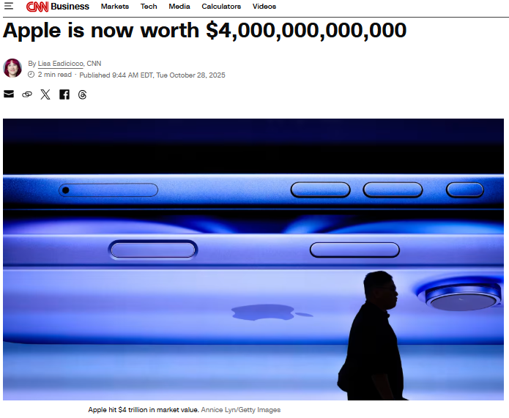
Figure: 27 Apple’s market valuation
(Source: Eadicicco, 2025)
Apple’s ecosystem of interconnected devices and services creates high customer switching costs. Its financial strength allows investing heavily in research and development with $31.40 Billion in FY2024 (Barnett, 2025).
Weaknesses
Apple has several weaknesses. One major weakness is Apple’s over-reliance on iPhone, which accounts more than half of revenue. Decline in Smartphone demand can affect the overall financial performance of Apple. Another weakness is Apple’s premium pricing strategy which limits its market penetration in price-sensitive regions like regions of Asia and Africa (Chen, 2026).
Opportunities
Apple has potential opportunities for growth. The wearable and health technology sector gives scope for products like Apple Watch having integrated health monitoring features like heart-rate tracking and ECG functions (Apple, 2024).
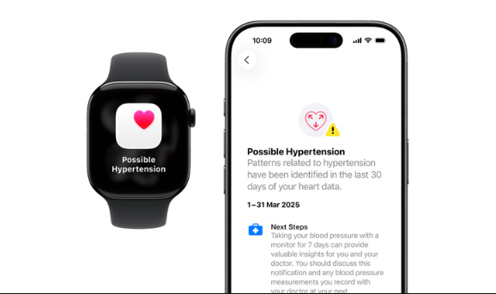
Figure: 28 Apple health app
(Source: Apple, 2024)
Artificial Intelligence and Augmented Reality give new growth opportunities. Apple is investing heavily in AI-powered technologies and spatial computing, including devices like Vision Pro Headset (Hackl, 2026).
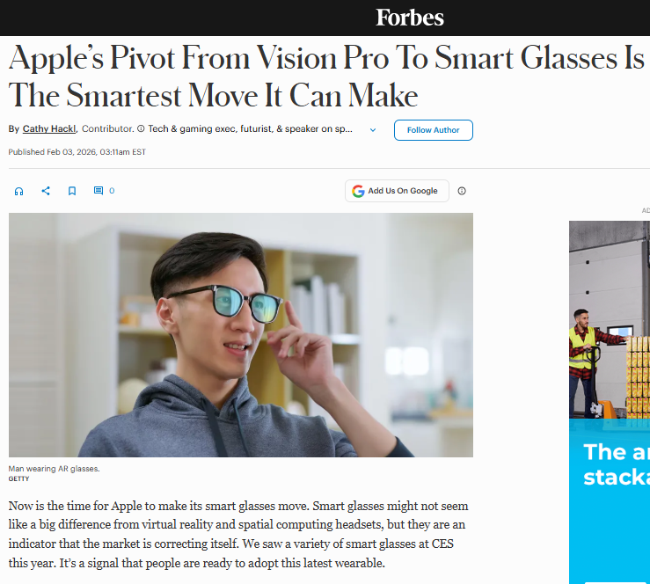
Figure: 29 Apple’s smart glasses
(Source: Hackl, 2026)
Emerging markets like India and Vietnam provide strong growth potential as Smartphone consumption is continuously increasing.
Threats
Apple is facing intense competition from companies like Samsung, Huawei, and Google. The competitors launch products with same technological features at low prices. Another threat is the regulatory pressures for Apple’s App-Store policies. The EU and the US governments are increasingly scrutinising the digital marketplace practises of Apple.

6.2 Ansoff’s Matrix Analysis
Market Penetration: By upgrading core products like the iPhone and Mac, leveraging its ecosystem of 2.5 Billion active devices worldwide to increase customer loyalty and repeat purchases, Apple strengthens its position (MC Tech Desk, 2026).
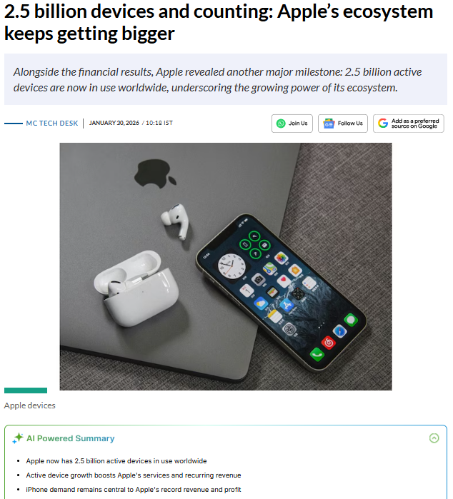
Figure: 30 Growth of Apple’s ecosystem
(Source: MC Tech Desk, 2026)
Product Development:Apple continuously launches improved version of products like iPhone-17 Series and M-Series Mac computers (Rabinowitz, 2026) showcasing innovation. Apple generated huge revenue of $209.59 Billion for iPhone sales in FY2025 (Johnston, 2026).
Market Development:Apple is expanding into emerging markets like India and Vietnam where revenue growth and expansion has huge potential (Phartiyal, 2026).
Diversification: Apple is diversifying services and new technologies where service revenue is crossing $109.20 Billion in FY2025 investing in spatial computing and AI-powered devices.

6.3 Strategic Recommendations
Expand the services ecosystem: Apple should continue its subscription-based services like Apple Music, Apple TV+, and iCloud generating huge revenue with strong potential for recursive income and improved customer retention.
Invest in Artificial Intelligence: Apple should increase investment in AI-technologies to enhance device functionality, improved user experience, and help to maintain innovation-leadership in the competitive technology industry.
Strengthen presence in emerging markets: Apple should expand in markets like India where iPhone exports to USA crossed $10 Billion in a FY2024 contributing heavily in global market share. It increased Indian production 53% which constitutes 25% of global iPhone (Banerjee, 2026).
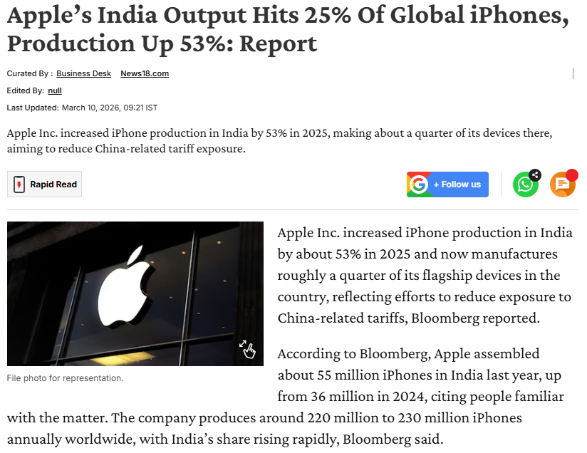
Figure: 31 Increase in iPhone production
(Source: Banerjee, 2026)
Enhance sustainability initiatives:
Apple should improve its logistics transparency and progress towards Apple-2030 Carbon Neutral Goal.

6.3.1 Justification
These recommendations are aligned with strategic management theories like differentiation and Ansoff’s Matix. Expanding services and AI-capabilities can support Apple’s product development and diversification enabling to create new revenue sources strengthening ecosystem. Apple’s increasing presence in emerging markets shows market development strategies allow acquiring new customers in fast-growing economies. Strengthening sustainability initiatives supports long-term brand reputation and stakeholder trust, required to maintain competitive advantage in global technology markets.

Section 2: Reflective Account Using Gibbs’ Reflective Cycle

1. Description
In carrying out the process of creating an analytical report on Apple Computer, there were numerous phases or cycles of academic research and analysis of quantitative data, as well as critical reflection on the results of those analyses. The final goal of the report was to provide an analysis of Apple’s organisational structure and some perspective on current events external and internal to the organisation with respect to its CSR activities, environmental sustainability initiatives, and performance variables and potential for making strategic decisions compliant with established strategic management theories or frameworks.
During the various cycles of data collection, I gathered information from various types of sources: academic literature like journals, books, industry reports, corporate website, and statistical data repositories (Sawtooth Software, 2024). These articles provided context for understanding Apple’s past development, organisational mission and vision, its business model, and the statistical data that I collected regarding Apple Computer’s market share, revenue growth, R&D investment, and current trends related to entering emerging markets.
In order to study the company environment, I utilized various strategic analysis frameworks including PESTEL, Balanced Scorecard, SWOT and Ansoff's Matrix. They allowed me to assess Apple's internal ability and market situation. For example, I used the PESTEL framework (Peterdy, 2025) to consider how political issues such as US-China trade issues may affect Apple's ability to succeed. I also used the SWOT framework to note that some of Apple's strengths included having a strong brand and being able to innovate. The Balanced Scorecard framework was beneficial in measuring Apple’s success from both financial, customer, internal process, and learning perspectives.

2. Feelings
My initial impression of conducting this research was a combination of excitement and fear because Apple is a very large multinational technology corporation that publishes an enormous amount of information. Determining which of this published information was appropriate for use in my research was very time-consuming as well as challenging. I initially found it difficult to identify the most appropriate statistics or frameworks for analysing Apple’s business strategy.
However, as I continued through the research process, I became much more confident in applying the theoretical frameworks I had learned in the strategic management course. The use of structured framework models such as PESTEL and SWOT analysis (CIPD, 2025) allowed me to simplify my analysis process and made my interpretation of complex business information much simpler. In addition, I became increasingly motivated due to the fact that I could link theoretical concepts directly with actual examples of Apple’s business strategies.
By the end of my period of preparing my report, I was pleased with my ability to link academic theory with the practice of doing business analysis. I also felt a boost in my self-confidence for doing independent research and critical analysis.

3. Evaluation
The research as well as the preparation process adds many positive sides. One of the main strengths was the use of strategic frameworks like pestle and SWOT which helped me to organise the analysis and also assisted me to ensure that the report followed a logical structure. By applying frameworks like balanced scoreboard as well as Ansoff matrix (Peterdy, 2025), I was able to evaluate strategy of Apple from several perspectives.
Another positive aspect of this process was the use of recent and credible data and statistics to support the discussion. I have enhanced the credibility of the report by including data and information about revenue, R&D investment, and service growth of Apple. In addition to this I also focused on CSR (Fernando, 2025) initiatives and sustainability goals of Apple which helped me to understand how contemporary organisations integrate environmental responsibility with their business strategy.
However, I have also faced some challenges during the process. One of the major difficulties I faced words filtering large amount of data and information to ensure that in the study only reliable as well as relevant data were used. Another challenge I faced was to make sure that the theoretical frameworks were applied critically rather than only describing them. I was needed to do additional reading in some cases to understand how those frameworks can we interpreted within the context of business model of Apple.

4. Analysis
The experience indicated that there is an importance of combining academic theories with practical business insights to analyse strategic management process. Several frameworks like sword crucial tools to understand strategic position of a company but they must be selected in a way that they can support the analysis and these frameworks should be disgust with real world evidence and industry data. For instance, how to analyse business level strategy of Apple Potters differentiation strategy helped me to explain how the company competes with the help of innovation and premium product design rather than cost leadership. In the same way, by applying Ansoff matrix (Peterdy, 2025) I have understood growth strategies of Apple like market expansion in to emerging economies and product development.
Another crucial insight from the analysis was the importance of sustainability and CSR in modern businesses. Apples focus on carbon neutrality by 2030 (Apple, 2025) and its increasing use of recycled materials reflect how brand reputation can be enhanced through environmental responsibility and how competitive advantage can be achieved through CSR initiatives.
This process also highlighted the importance of critical thinking while analysing business strategies because it is important to examine potential weakness and threats rather than only finding strengths and opportunities. For example, dependence of Apple on iPhone revenue and increasing regulatory scrutiny are major weakness and threat of Apple which can impact its market position.

5. Conclusion
Reflecting on the overall process, it can be said that I came to know that effective strategic analysis needs structured frameworks as well as careful interpretation of business data and information. With the help of strategic management models I organised complex information and provided a clear approach for analysing business environment and competitive position of Apple. The process has also enhanced my analytical skills and research skills and with this I became more confident in collecting data from several sources and evaluate its reliability. Now I also feel confident to apply theoretical concept to practical business situations. In addition to this, I also developed a better understanding of strategies that technology companies like Apple apply to maintain its competitive advantage with the help of ecosystem integration, sustainability initiatives, and innovation.

6. Action Plan
Moving forward while doing research and strategic analysis tasks, I will enhance my approach by improving critical evaluation and data interpretation skills. I will also try to analyse data and information more deeply rather than presenting them in a simplified and descriptive way. I will also use wider range of peer reviewed and academic journal sources to further enhance the theoretical foundation of my work. By enhancing my referencing and citation skills I will further improve the quality of my assignments (Vologianni, 2022). Finally, I will also practice the application of strategic frameworks like pestle and SWOT to real world business cases, developing stronger analytical skills. This can help me to prepare for future professional roles that will need strategic decision making as well as business analysis skills.

Reference list
Alphaspread (2025). Apple Faces Regulatory Pressure in U.S., Europe, and Brazil Over App Store and Smartphone Practices. [online] alphaspread.com. Available at: https://www.alphaspread.com/market-news/regulatory-actions/apple-faces-regulatory-pressure-in-us-europe-and-brazil-over-app-store-and-smartphone-practices.
Apple (2022). Apple calls on global supply chain to decarbonise by 2030. [online] Apple Newsroom (India). Available at: https://www.apple.com/in/newsroom/2022/10/apple-calls-on-global-supply-chain-to-decarbonize-by-2030/.
Apple (2023a). Apple advances supplier clean energy commitments. [online] Apple Newsroom (India). Available at: https://www.apple.com/in/newsroom/2023/09/apple-advances-supplier-clean-energy-commitments/.
Apple (2023b). Apple will use 100 percent recycled cobalt in batteries by 2025. [online] Apple Newsroom (India). Available at: https://www.apple.com/in/newsroom/2023/04/apple-will-use-100-percent-recycled-cobalt-in-batteries-by-2025/.
Apple (2023c). Small developers on the App Store grew revenue by 64 percent over the past two years. [online] Apple Newsroom (Tunisia). Available at: https://www.apple.com/tn/newsroom/2023/05/small-developers-on-the-app-store-grew-revenue-by-64-percent/.
Apple (2024). Health App. [online] Apple (India). Available at: https://www.apple.com/in/health/.
Apple (2025a). 2025 marked a record‑breaking year for Apple services. [online] Apple Newsroom (India). Available at: https://www.apple.com/in/newsroom/2026/01/2025-marked-a-record-breaking-year-for-apple-services/ [Accessed 10 Mar. 2026].
Apple (2025a). 2025 marked a record‑breaking year for Apple services. [online] Apple Newsroom (India). Available at: https://www.apple.com/in/newsroom/2026/01/2025-marked-a-record-breaking-year-for-apple-services/.
Apple (2025b). Apple will spend more than $500 billion in the U.S. over the next four years. [online] Apple Newsroom . Available at: https://www.apple.com/newsroom/2025/02/apple-will-spend-more-than-500-billion-usd-in-the-us-over-the-next-four-years/ [Accessed 10 Mar. 2026].
Apple (2025b). Environment. [online] Apple. Available at: https://www.apple.com/in/environment/.
Apple (2025c). Our Values. [online] Apple. Available at: https://investor.apple.com/our_values/default.aspx [Accessed 10 Mar. 2026].
Apple (2026). Apple reports first quarter results. [online] Apple Newsroom (India). Available at: https://www.apple.com/in/newsroom/2026/01/apple-reports-first-quarter-results/ [Accessed 10 Mar. 2026].
Backlinko (2024). Apple Statistics in 2024 - Users, Devices, and Revenue. [online] Backlinko. Available at: https://backlinko.com/apple-statistics.
Banerjee, A. (2026). Apple’s India Output Hits 25% Of Global iPhones, Production Up 53%: Report. [online] News18. Available at: https://www.news18.com/business/economy/apples-india-output-hits-25-of-global-iphones-production-up-53-report-ws-l-9951752.html.
Barnett, R. (2025). Apple: Valuation Requires Lots To Go Right. [online] Seeking Alpha. Available at: https://seekingalpha.com/article/4782658-apple-stock-valuation-requires-lots-to-go-right.
Business Models (2024). The business model of Apple. [online] Business Models Inc. Available at: https://www.businessmodelsinc.com/en/inspiration/blogs/the-business-model-of-apple [Accessed 10 Mar. 2026].
Byte, A. (2023). The Apple Ecosystem: Seamless Integration or Walled Garden? [online] Medium. Available at: https://medium.com/@AppleByte/the-apple-ecosystem-seamless-integration-or-walled-garden-f1a8c14767f7 [Accessed 10 Mar. 2026].
Chen, Z. (2026). Business Strategy Analysis: Evidence on Apple Inc. [online] Google.com. Available at: https://www.google.com/url?sa=t&rct=j&q=&esrc=s&source=web&cd=&ved=2ahUKEwi9xojzxJWTAxWir1YBHXHKBlYQFnoECDcQAQ&url=https%3A%2F%2Fwww.atlantis-press.com%2Farticle%2F126003146.pdf&usg=AOvVaw2BBKIhNgKvb3sjAe3pQuWa&opi=89978449.
CIPD (2025). CIPD | SWOT Analysis | Factsheets. [online] CIPD. Available at: https://www.cipd.org/en/knowledge/factsheets/swot-analysis-factsheet/.
Collins, G. (2025). Apple Shifts Supply Chain by Diversifying Production. [online] Supplychaindigital.com. Available at: https://supplychaindigital.com/procurement/apple-pivots-to-india-with-expected-us-22bn-output.
Conte, N. (2025). Ranked: The Brands That Gained the Most Value in 2025. [online] Visual Capitalist. Available at: https://www.visualcapitalist.com/ranked-the-brands-that-gained-the-most-value-in-2025/ [Accessed 10 Mar. 2026].
Cote, C. (2023). What Is a Balanced Scorecard? [online] Harvard Business School Online. Available at: https://online.hbs.edu/blog/post/balanced-scorecard.
Counterpointresearch (2025a). Global Smartphone Shipments Grew 2% YoY in 2025; Apple Emerged as Market Leader. [online] Counterpointresearch.com. Available at: https://counterpointresearch.com/en/insights/global-smartphone-shipments-grew-2-percent-YoY-in-2025 [Accessed 10 Mar. 2026].
Counterpointresearch (2025b). Q2 2025 Global PC Shipments: Growth Accelerates, Tariff Concerns Loom. [online] Counterpointresearch.com. Available at: https://counterpointresearch.com/en/insights/global-pc-market-q2-2025 [Accessed 10 Mar. 2026].
Counterpointresearch (2026). Counterpoint Insights | Technology Market Research and Industry Analysis Firm. [online] Counterpointresearch.com. Available at: https://counterpointresearch.com/en/insights/global-smartphone-share.
Eadicicco, L. (2025). Apple is now worth $4,000,000,000,000. [online] CNN. Available at: https://edition.cnn.com/2025/10/28/business/apple-worth-4-trillion.
EBSCO (2023). Jobs and Wozniak Found Apple Computer | EBSCO. [online] EBSCO Information Services, Inc. | www.ebsco.com. Available at: https://www.ebsco.com/research-starters/computer-science/jobs-and-wozniak-found-apple-computer [Accessed 10 Mar. 2026].
Elagina, D. (2026). Apple net income FY 2025| Statista. [online] Statista. Available at: https://www.statista.com/statistics/267728/apples-net-income-since-2005/?srsltid=AfmBOorMkidVO6u7zrZ7YsbRrzrqLLsnMNJ17LSDldrNklo5vz_jSNnn.
Elsey, W. (2025). Why Every Business Should Embrace Circular Practices. [online] Forbes. Available at: https://www.forbes.com/councils/forbesbusinessdevelopmentcouncil/2025/04/02/why-every-business-should-embrace-circular-practices/ [Accessed 10 Mar. 2026].
Fernando, J. (2025). What Is CSR? Corporate Social Responsibility Explained. [online] Investopedia. Available at: https://www.investopedia.com/terms/c/corp-social-responsibility.asp.
Gallagher, W. (2025a). Apple’s Services expected to top $100 billion annually — for now. [online] AppleInsider. Available at: https://appleinsider.com/articles/25/10/28/apples-services-expected-to-top-100-billion-annually----for-now [Accessed 10 Mar. 2026].
Gallagher, W. (2025b). New report about Apple’s 10 main challenges ignores two main factors. [online] AppleInsider. Available at: https://appleinsider.com/articles/25/06/12/new-report-about-apples-10-main-challenges-ignores-two-main-factors [Accessed 10 Mar. 2026].
Gören, C. (2024). Apple Statistics of Products, Sales & Estimations for 2025. [online] Maestra AI. Available at: https://maestra.ai/blogs/apple-statistics [Accessed 10 Mar. 2026].
Grand View Research (2024). Consumer Electronics Market | Personal Electronics Industry. [online] www.grandviewresearch.com. Available at: https://www.grandviewresearch.com/industry-analysis/personal-consumer-electronics-market [Accessed 10 Mar. 2026].
Hackl, C. (2026). Apple’s Pivot From Vision Pro To Smart Glasses Is The Smartest Move It Can Make. Forbes. [online] 3 Feb. Available at: https://www.forbes.com/sites/cathyhackl/2026/02/03/apples-pivot-from-vision-pro-to-smart-glasses-is-the-smartest-move-it-can-make/.
IANS (2026). Apple scales India output 53 pc, accounts for quarter of global iPhone production. [online] The Statesman. Available at: https://www.thestatesman.com/business/apple-scales-india-output-53-pc-accounts-for-quarter-of-global-iphone-production-1503568458.html [Accessed 10 Mar. 2026].
James (2023). The Apple Ecosystem: A Closer Look at Pros, Cons, and User Perspectives. [online] Medium. Available at: https://jmspdrrt.medium.com/the-apple-ecosystem-a-closer-look-at-pros-cons-and-user-perspectives-64a6b1ebb520 [Accessed 10 Mar. 2026].
Jiagui, L. (2024). Macao’s academic book publishing industry: A SWOT and PEST analysis. Learned Publishing. doi:https://doi.org/10.1002/leap.1598.
Johnston, M. (2026). How Apple Makes Money: over half of revenue comes from iPhone sales. [online] Investopedia. Available at: https://www.investopedia.com/how-apple-makes-money-4798689.
Lacaze, A.S. (2024). Adding value to the VRIO framework using DEMATEL. Management Decision, [online] 63(4). doi:https://doi.org/10.1108/md-10-2023-1935.
Lakshkar, A. (2025). Whalesbook: AI-Powered Stock Updates via WhatsApp, Financial Newspaper, Interactive Live Sessions and Screener! [online] Whalesbook. Available at: https://www.whalesbook.com/news/English/tech/Apple-Inc-Boosts-RandD-to-Develop-Proprietary-iPhone-Materials-for-Enhanced-Customer-Experience/691bcf2a9ea315aded47ec1e.
Lee, T. (2026). Apple Just Hit the 2.5 Billion Active Device Milestone Globally. [online] Android Headlines. Available at: https://www.androidheadlines.com/2026/01/apple-2-5-billion-active-devices-milestone.html.
Macrotrends (2024). Apple Research and Development Expenses 2006-2019 | AAPL. [online] www.macrotrends.net. Available at: https://www.macrotrends.net/stocks/charts/AAPL/apple/research-development-expenses [Accessed 10 Mar. 2026].
MC Tech Desk (2026). 2.5 billion devices and counting: Apple’s ecosystem keeps getting bigger. [online] Moneycontrol. Available at: https://www.moneycontrol.com/technology/2-5-billion-devices-and-counting-apple-s-ecosystem-keeps-getting-bigger-article-13798940.html.
Milmo, D. (2025). Apple ‘aims to source all US iPhones from India’, reducing reliance on China. [online] the Guardian. Available at: https://www.theguardian.com/technology/2025/apr/25/apple-source-us-iphones-india-china-trump-trade-war [Accessed 10 Mar. 2026].
Neely, A. (2025). Apple tops global brand rankings again — by a giant margin. [online] AppleInsider. Available at: https://appleinsider.com/articles/25/05/15/apple-tops-global-brand-rankings-again----by-a-giant-margin [Accessed 10 Mar. 2026].
Nellis, S. (2025). Apple plans $500 billion in US investment, 20,000 research jobs in next four years. Reuters. [online] 24 Feb. Available at: https://www.reuters.com/technology/artificial-intelligence/apple-plans-texas-factory-ai-servers-20000-research-jobs-2025-02-24/ [Accessed 10 Mar. 2026].
Pangarkar, T. ed., (2025). Consumer Electronics Statistics 2024 by Technology, Devices... [online] Market.us News. Available at: https://www.news.market.us/consumer-electronics-statistics/ [Accessed 10 Mar. 2026].
Peterdy, K. (2025a). Ansoff Matrix. [online] Corporate Finance Institute. Available at: https://corporatefinanceinstitute.com/resources/management/ansoff-matrix/.
Peterdy, K. (2025b). PESTEL analysis. [online] Corporate Finance Institute. Available at: https://corporatefinanceinstitute.com/resources/management/pestel-analysis/.
Petro, G. (2023). Apple’s Competency At Its Core. [online] Forbes. Available at: https://www.forbes.com/sites/gregpetro/2023/12/10/apples-competency-at-its-core/ [Accessed 10 Mar. 2026].
Phartiyal, S. (2025). Apple’s India Sales Hit Record $9 Billion in Last Fiscal Year (AAPL). [online] Bloomberg.com. Available at: https://www.bloomberg.com/news/articles/2025-09-05/apple-s-india-sales-hit-record-9-billion-after-big-retail-push [Accessed 10 Mar. 2026].
Phartiyal, S. (2026). Apple Now Makes About 25% of iPhones in India After China Pivot. [online] Yahoo Finance. Available at: https://finance.yahoo.com/news/apple-now-makes-25-iphones-024737834.html.
Pradhan, B. (2025). India-made iPhone exports hit record $10 bn amid global demand rise. [online] @bsindia. Available at: https://www.business-standard.com/india-news/apple-iphone-exports-india-record-10-billion-fy25-tata-foxconn-125100800643_1.html.
Rabinowitz, H. (2026). Apple Announces MacBook Neo, iPhone 17e, MacBook Air and More. [online] NBC News. Available at: https://www.nbcnews.com/select/shopping/apple-iphone-17e-macbook-neo-m5-launch-preorder-rcna261675.
Rankin, J. (2025). EU fines Apple and Meta for breaching fair competition rules. [online] the Guardian. Available at: https://www.theguardian.com/business/2025/apr/23/eu-fines-apple-and-meta-for-breaching-fair-competition-rules [Accessed 10 Mar. 2026].
Ray, S. (2023). Apple Wants To Make 25% Of Its Products In India, Minister Claims—Backing Up Analysts’ Projections. [online] Forbes. Available at: https://www.forbes.com/sites/siladityaray/2023/01/23/apple-wants-to-make-25-of-its-products-in-india-minister-claims-backing-up-analysts-projections/ [Accessed 10 Mar. 2026].
Richter, F. (2025a). Services Boost Apple’s Profit Margin. [online] Statista. Available at: https://www.statista.com/chart/33869/apple-gross-profit-margin/?srsltid=AfmBOopv8KzA2s2sYFS34L-QSiVSpNu9YDekqC8XrG9jdybAy3wbxro8.
Richter, F. (2025b). Services: Apple’s $100-Billion Growth Engine. [online] Statista. Available at: https://www.statista.com/chart/14629/apple-services-revenue/?srsltid=AfmBOooK-4WFFU0yVhjC-5-N9ZlerGp8pXE5s5t8hS9p5nStTkptoAkD.
Sawtooth Software (2024). Secondary Research: Definition, Methods, Sources, Examples, and More. [online] sawtoothsoftware.com. Available at: https://sawtoothsoftware.com/resources/blog/posts/secondary-research.
Shah, R. (2023). Apple Customer Loyalty Program. [online] Nector.io. Available at: https://www.nector.io/blog/power-of-apple-customer-loyalty [Accessed 10 Mar. 2026].
Sparks, D. (2026). Apple’s Services Business Was a Major Catalyst Last Year, and 2026 Will Likely Be Even Better. [online] Yahoo Finance. Available at: https://finance.yahoo.com/news/apples-services-business-major-catalyst-182600661.html.
Statista (2025). Apple revenue 2025| Statista. [online] Statista. Available at: https://www.statista.com/statistics/265125/total-net-sales-of-apple-since-2004/?srsltid=AfmBOoo85mUqtbmBD2aJnfS7cOy5pVJx69Ml2ijV8D-6Ay1uHhCE44_Z [Accessed 10 Mar. 2026].
Tech Desk (2026). iPhone production in India jumps 53% in 2025; Apple now assembles all versions of iPhone in the country. [online] The Times of India. Available at: https://timesofindia.indiatimes.com/technology/tech-news/iphone-production-in-india-jumps-53-in-2025-apple-now-assembles-all-versions-of-iphone-in-the-country/articleshow/129377415.cms [Accessed 10 Mar. 2026].
Thompson, E. (2025). EdTech Innovation Hub. [online] EdTech Innovation Hub. Available at: https://www.edtechinnovationhub.com/news/apple-commits-500-billion-to-workforce-development-ai-and-us-education.
Vologianni, E. (2022). Top tips for citing and referencing. [online] Academic & Employability Skills. Available at: https://blogs.bath.ac.uk/academic-and-employability-skills/2022/05/09/top-tips-for-citing-and-referencing/.
WSR (2024). Worker-Driven Social Responsibility Network. [online] Worker-Driven Social Responsibility Network. Available at: https://wsr-network.org/what-is-wsr/csr-and-msis/case-study-apple-inc/.

