Student name: Iulian Vasile Purice
Student id nr: 1919243
Module Lecturer: Nadeem Mirza

MODULE CODE/ COD Y MODIWL: LCBB4005
Global Business Environment
Assignment 2

Table of Contents

Introduction……………………………………………………………………………….. 1
Discussion………………………………………………………………………………… 1
Conclusion………………………………………………………………………………… 9
References………………………………………………………………………………... 10

Introduction
The global business environment can be termed as the cumulation of the different intrinsic and extrinsic market factors of the different countries considered individually and collectively in assessing the chances of the survival and revival of an organization belonging from a specific industrial segment. There are so many factors from so vividly different aspects that several analytical tools and theories are applied for the accurate evaluation and inferences. As stated by Stojanov (2020), Covid-19 pandemic has completely disrupted all the business fields worldwide. In this assignment study, the impact of this global pandemic on the famous luxury car company. Bentley Motors has been studied, discussed and analysed.
Discussion
Bentley Motors was established in the year 1919 and has been manufacturing luxury cars since its inception. After its merger and acquisition with the Volkswagen Group, it has been making SUVs alongside the luxury cars. The company still operates from Crewe in England and is still a British automobile company through and through. It produces top-notch handcrafted luxury cars that gets exported and sold worldwide (Marques, 2016). This automotive company has been extremely affected by the various restrictions and prolonged period of lockdowns. It is also preparing itself for another lockdown phase in the winter of 2020-2021 if that happens (Kandrashina and Aleshkova, 2020). The company’s global standing and current operational and marketing circumstances has been assessed with the help of various analytical tools below.

Figure: The official brand logo of the Bentley Motors
(Source: Marques, 2016)
PESTEL analysis has been made below for assessing all the exploratory variables.
Political- The international scenario has been exceedingly critical ever since the beginning of the Covid-19 pandemic. The international political circumstances have led a complete international flight bans and this has resulted in altercations of the logistic service providing situations of the Bentley Motors. Also, with country like China where it all started, the UK government has imposed up to 35% extra scrutiny even post Covid-19. This will increase the time-window for shipping anything to China and vice-versa. All the international trade agreements that the company was about to perform has been halted indefinitely. The trade agreements and policies has been affected by 17.3% owing to Covid-19 (Kandrashina and Aleshkova, 2020).
Economic- The whole world has suffered an acute economic downturn. The UK’s GDP has gone down by 20.4% in the second quarter of 2020 which is very alarming when analysed from a luxury car company’s perspective. The unemployment of UK has been 4.8% in the second half of 2020 which is the highest after Brexit decision of 2016 (source: economictimes.indiatimes.com, 2020). All these factors have created a massive gap in the product prices of the Bentley motors and the buying capacity of the common masses thus, affecting the sales volume negatively. It can also be said that economic condition has posed problem for the company to spend its regular amount for innovation and product development as the loan liability interest rates are higher by 3.8% in UK (Puhace and Dao, 2020).

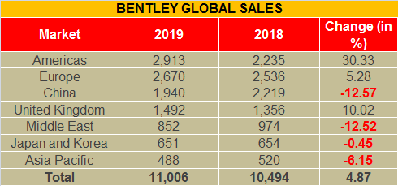
Figure: Global sales revenue of Bentley Motors
(Source: Puhace and Dao, 2020)
Social- The social factor that has greatly impacted this automobile company is the 2 meters social distancing norms imposed by the UK government (source:economictimes.indiatimes.com,2020). Also, many of the employees have been diagnosed with Covid-19 virus when they returned as workforce to the factories. This resulted in huge expense of the company management where they had to set-up isolation places for those staff who have been in contact with the employees who tested positive for Covid-19(Kopp, 2020). The fear of catching the virus has decreased the work efficiency of the mobile workforce to quite an extent. Also, in many countries, like India for example, people have reverted back to buying luxury cars from their home companies amidst this global epidemic. Many of the IT and marketing personnel of the company has been working remotely at a reduced salary.
Technological- Every technology requires fund and automobile industry is even more so. UK is renowned for scoring 89% in the global technology index but at present except the virology culture and research, every other research has been halted due to low working capital generation. The Bentley Motors had targeted to release their fully electric commercially viable economic car for the middle of the UK and other EU countries by 2025 (Stępień, 2020). It has already been pushed to end of 2026 and the management head has commented that if another bout of lockdown occurs, it might be pushed further. All the other prototype testing has also been halted.
Environmental- The environmental legislation of UK taken in 2008 has stated that all the GHC emissions must reduce by 42% within 2021. A major technological development that was undertaken by the company has been temporarily stopped which otherwise could have been effective in achieving the above stated emission reduction goal. This would lead in paying higher carbon and environmental taxes by the company to the UK government.
Legal- There has been major changes in the health and safety issues in the NHS act amended in 2020 due to Covid-19 virus. Any failure from an industrial organization to maintain and apply these legal norms would lead to extremely high monetary penalties. Bentley Motors now has incurred several huge daily expenses like providing PPE kit, free 3 ply masks, abundance of sanitizers and sanitization of every unit twice da day. All of these have negatively affected the company’s financial condition (Marrone, 2020).
Porter’s Five Forces theory is the most commonly used theory in the business and marketing strategical analysis. All five aspects of this theory have been discussed keeping in mind the existential new normal.
Bargaining power of customers- The usual negotiating power of the customers are generally moderate for Bentley Motors however, due to the Covid-19 crisis this power has increased at an exponential pace. As most of the companies’ cars are sitting back in the showroom and factory shelves due to either lack of transports or due to lack of people who can afford such cars (other than extremely affluent people), the company is being forced to reduce its profit margin per car and selling it to those few people who can still afford it or have the willingness to buy (Wu, 2020).
Bargaining power of the suppliers- This was quite high for the company owing to its exclusively made parts and complete hand assembling process (Raghavarapu, and Meier, 2016). But with the descending trend in the sales volume around the globe, the requirement for those supplier services has reduced by half thereby, automatically increasing the amount of those hand-made parts in the automobile market. This has in turn decreased the bargaining power of the suppliers by default as no business wants to see their products unsold.
Market competition- With higher consumer power, low sales volume, and the limited global market where the company can currently export and sell it cars, the market competition of the luxury car industry has risen by manifolds during the Covid-19 crisis and probably will remain so for the next few years.
Substitution threats- The threat from market substitutes is quite high in and after the immediate pandemic period. This has negatively affected the entire financial management of the company and Bentley Motors is being forced to reconsider their extremely high mileage to keep up with the contracted buying capacity of the public who can afford these ultra-luxury cars (Wu, 2020).

New entrants- For the first in the history of automobile industry, the threats from new entrants is absolutely nil. As all the businesses have suffered from severe recession and fund crunch, and the reluctant behaviour of the financial institutions to provide massive loan capital to any new entrants from the heavy industrial segments have rendered the possibility to new entry down to zero.

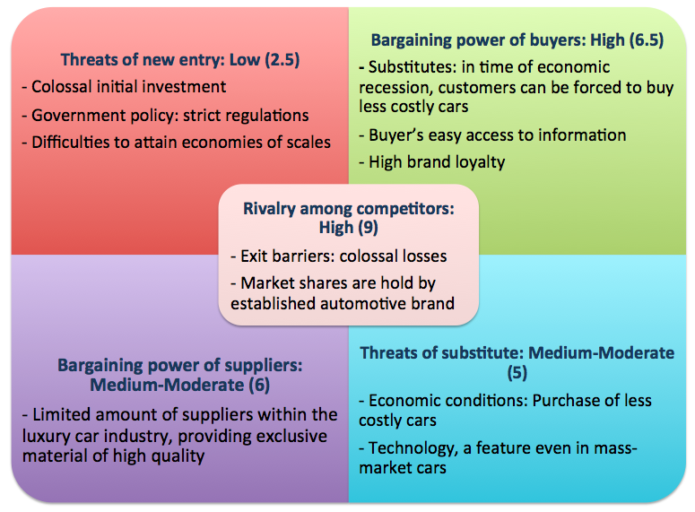

Figure: The usual Porter’s Five Forces analysis for highlighting the before and after Covid-19 difference
(Source: Raghavarapu, and Meier, 2016)

Porter’s Value Chain theory was given by Michael Porter for measuring and associating the different managemental and organizational aspects seamlessly by their co-relations (Simatupang et al., 2017).
Primary activities
Inbound logistics- The entire inbound logistics was shutdown by the management of Bentley Motors due to lockdown restrictions. The company has decided to reduce the number of channels for inbound logistics, has decided to evaluate the supply chain for all the raw-materials and may opt for local suppliers thereby, keeping the flow intact but increasing the supplier negotiating power.
Operations- The company closed all their operations 10days before the official lockdown announcement in UK to arrange and shuffle all the organizational processes for post Covid-19 openings and plans (source: europe.autonews.com, 2020). Although, the factories were effectives closed indefinitely and the materials and parts kept arriving, the company chose not to return any of the things and stored them away for future use. This proved effective in post lockdown situation where the company was able to open its doors before any other luxury automobile company like Rolls Royce.
Outbound logistics- The delivery was completely stopped by the UK government but when it reopened the company was ready to package and deliver from the early of the unlockdown. This came into effect because of the risk management initiative taken by the organizational committee when the Brexit decision was made and everything was disrupted (Rhemann, 2017). The Bentley Motors as a part of risk mitigating policy keeps a minimal of extra 10days at hand which was enough time to deliver the due products to their rightful places (Koc and Bozdag, 2017).
Marketing and sales- The sales volume of luxury cars in and post pandemic era is and will be down and the company’s management is well aware of it (Sari and Yuniarti, 2020). Thus, they are trying their best to produce a commercial prototype of high mileage luxury cars while maintaining their standards, and are escalating towards making the electric car a middle-class commercial reality. The marketing department is still visibly closed and the employees are working remotely to lower the chances of viral infection.

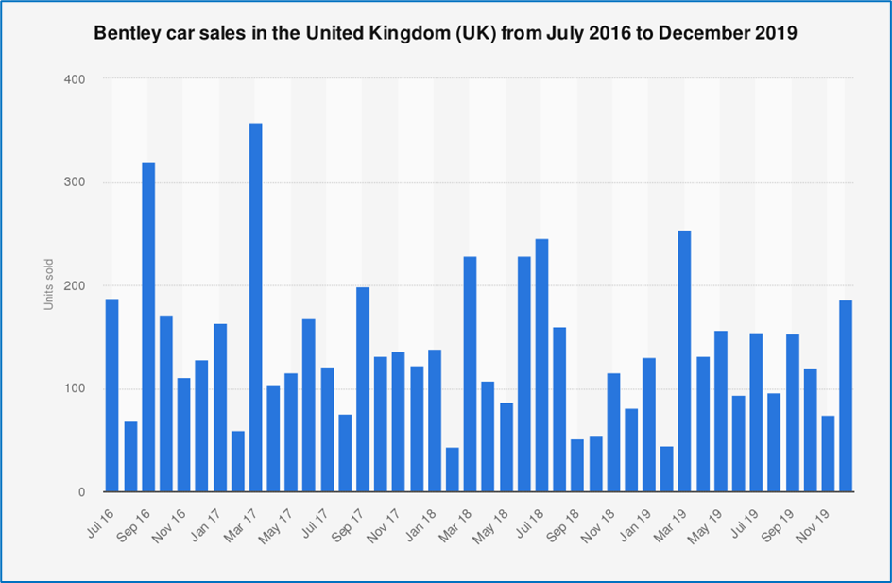
Figure: The sales volume statistics of Bentley Motors before 2020
(Source: statista.com, 2020)

Services- The after sales services has become difficult post lockdown because of the unavailability of the spare parts but as the company has resumed their operations and delivery from day 1, it will gain a competitive advantage and will lessen it substitution threat marginally.
Secondary activities
Infrastructure- The infrastructure remained the same as before, the only difference is the humungous proportions of sanitization facility being set-up for running the factor and production unit by complying with the governmental rules. Also, the emission labs were closed even after operational resumptions.
HR management- This is perhaps the most negatively affected segment. 66% employees have been furloughed, only 2000 workforces are presently working in Crewe out of which 1200 are working remotely. This has severely affected everyone, even the company (source: europe.autonews.com, 2020). Many of the skilled engineers had to be fired because of the financial crunch. The factories are running with only 800 people with 50% of them altering their duties. The firm has been laying low in its CSR in this segment for now.
Technology- The technological segment has been drastically affected due to the employee pool cutback. All the new innovations had to be pushed backward, the electric hybrid scheduled to be launched in 2023 has been pushed to 2025 (Seetharaman, 2020).
Procurement- Most of the procurement has been stopped for time being the Bentley Motors as the company has decided to utilize its loaded stockpile first. This has been a good analytical move that will enable the company for maintain a balance between sales volume and inventory.

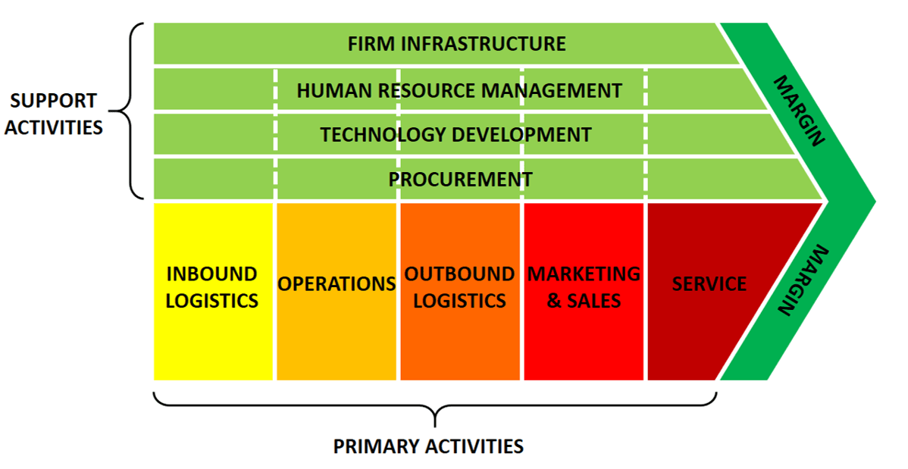
Figure: The key features of porter’s Value Chain
(Source: Sari and Yuniarti, 2020)
Recommendations- Almost all the strategies applied by the Bentley Motors has been in the right order and for the market benefit of the company. However, the company should think about producing SUVs like its market competitors to survive and thrive better in this post pandemic world of intense economic recession. Also, the company should think about their global market expansion to Southern Hemisphere in all potency as it has been least affected by this global crisis from buying capacity view point.
Conclusion
It can be concluded that Covid-19 pandemic has deeply impacted all the segments of the luxury industry in an excruciatingly negative way. It can also be deduced that the Bentley Motors has faced consequences of mountainous proportions during and after the covid-19 lockdown. However, it may be noted that the company has been able to amend all its policies with immediate effect which in turn has allowed its organizational management to organize every little detail in adjustment with the global market and economy phenomenon. It can be inferred that the company’s technological advancement has been pushed away for a few years.

References
economictimes.indiatimes.com (2020). UK GDP collapsed nearly 20% in Q2 in historic Covid hit (2020). Available at: https://economictimes.indiatimes.com/news/international/business/uk-gdp-collapsed-nearly-20-in-q2-in-historic-covid-hit/articleshow/78401592.cms> (Accessed: 24 November 2020).
europe.autonews.com (2020). Bentley CEO outlines post-coronavirus survival plan (2020). Available at: <https://europe.autonews.com/automakers/bentley-ceo-outlines-post-coronavirus-survival-plan> (Accessed: 24 November 2020).
Kandrashina, E.A. and Aleshkova, D.V., 2020, November. Interests of Russian Entrepreneurial Structure Participating in Automotive Strategic Alliances. In Innovative Economic Symposium (pp. 590-595). Springer, Cham.
Koc, T. and Bozdag, E., 2017. Measuring the degree of novelty of innovation based on Porter's value chain approach. European Journal of Operational Research, 257(2), pp.559-567.
Kopp, J., 2020. Literature and Research Review. In Success Factors for Future Growth of Car Sharing Services (pp. 5-29). Springer Gabler, Wiesbaden.
Marques, A.F.C.M.B., 2016. Exploration on the benefits and applicability of emotional segmentation for high-end luxury brands: the case of Bentley Motors Ltd (Doctoral dissertation).
Marrone, L., 2020. Alfa Romeo and Jeep brands: strategic direction in times of global change.
Puhace, I.C. and Dao, L.T., 2020. A Conceptual Framework for Strategy Selection in Supply Chains. A Case Study in The Automotive Industry.
Raghavarapu, D.S.N. and Meier, K.J., 2016. Methodology for Supply Chain Management. International Journal of Emerging Technologies in Engineering Research, 4(10), pp.29-41.
Rhemann, M., 2017. A Futurist revisit to the" Value Chain". Journal of Futures Studies, 21(3), pp.25-34.
Sari, O.Y. and Yuniarti, R., 2020. The Value Chain Analysis of Go-Jek. International Journal of Psychosocial Rehabilitation, 24(2).
Seetharaman, P., 2020. Business models shifts: Impact of Covid-19. International Journal of Information Management, 54, p.102173.
Simatupang, T.M., Piboonrungroj, P. and Williams, S.J., 2017. The emergence of value chain thinking. International Journal of value chain management, 8(1), pp.40-57.
statista.com (2020). Bentley car sales in the UK | Statista (2020). Available at: https://www.statista.com/statistics/385341/bentley-car-sales-in-the-united-kingdom/> (Accessed: 24 November 2020).
Stępień, B., 2020. Luxury Supply Side. In The Value of Luxury (pp. 127-193). Palgrave Macmillan, Cham.
Stojanov, M., 2020. The Labor Market in Economic Activity" Trade; repair of cars and motorcycles" in Conditions of Crisis Caused by COVID-19. Известия на Съюза на учените-Варна. Серия Икономически науки, 9(2), pp.95-102.
Wu, Y., 2020, February. The Marketing Strategies of IKEA in China Using Tools of PESTEL, Five Forces Model and SWOT Analysis. In International Academic Conference on Frontiers in Social Sciences and Management Innovation (IAFSM 2019) (pp. 348-355). Atlantis Press.

