MARKETING FUNDAMENTALS
Module ID: LCBB4004
Valentin Daniel Susanu 2019937
Case study on Zara

Contents
INTRODUCTION 3
MARKETING 4
MARKETING PROCESS 4
MARKETING PLAN OF ZARA 5
PESTLE ANALYSIS OF ZARA 5
SWOT ANALYSIS OF ZARA 7
PORTER’S FIVE FORCES MODEL 8
MARKETING MIX OF ZARA 10
STP ANALYSIS OF ZARA 11
CONCLUSION AND RECOMMENDATIONS 12
REFERENCES 13

INTRODUCTION
Marketing can be explained as the process of creating awareness among the population about the products and services offered by an organisation and also attracting the customers and stimulating them to purchase the company’s products and thus, help in boosting the business revenues. This report will discuss in detail about ZARA (clothing brand), its Pestle analysis, SWOT Analysis, Porter’s Five Model for Zara, marketing mix (4P’s) and its STP Analysis.
ZARA is a Spanish Brand, specialised in fashion and product including clothing, shoes, accessories, perfume, beauty, etc. Zara stores have men, women and kids clothing wear in all. The company was started in 1975 in Spain and has 2,270 outlets until date. Zara consumers are in age group between 15-45 years. Zara business strategy is providing best quality product at an affordable price (Seo and Suh, 2019).

MARKETING
Marketing is defined as the venture of showing company’s product and advertise it in the best feasible way. Marketing also needs series of steps to complete its process of advertising (Sharp, 2017).

MARKETING PROCESS
Marketing process refers to the step wise process which grants the organization to analyze problem of customer, analyze and evaluate market strategy and develop marketing goods to reach out large number of customers and audience (Sharp, 2017).
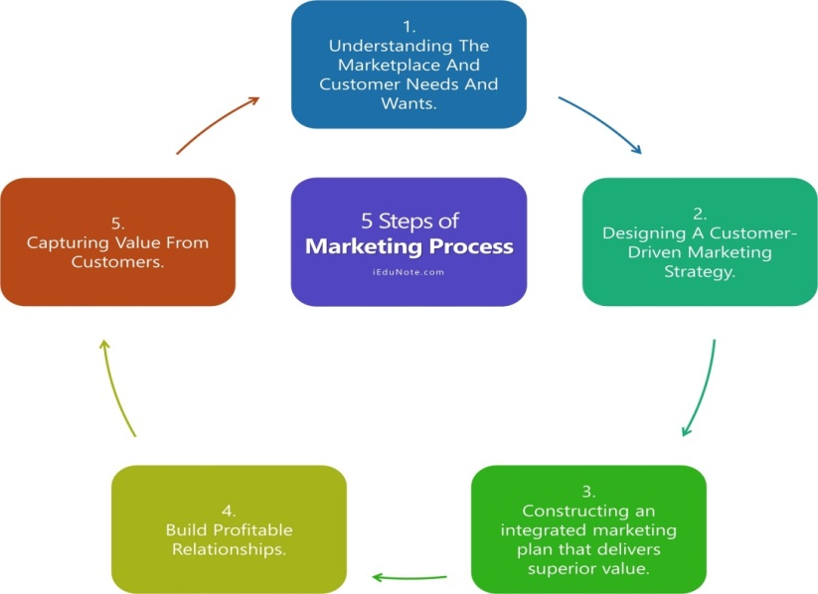
Figure 1: Marketing Process
- Understand market and customer's needs: It is important to acknowledge consumer's needs, desires, wants, and demands to construct convenient market offerings and positive customer relationships (Chunling, 2020).
- Designing Customer-Driven Marketing Strategy: Main areas which have to be focused on for designing market strategy are:
- Selection of customers and target market to serve.
- Best way to serve the targeted market and customers.
- Construction of Integrated Market Plan: It includes the marketing mix process (4P’s), which are varied tools used by the firm to execute the marketing strategy (Chunling, 2020).
- Build Profitable Relationship: To build and maintain a profitable relationship can be done by delivering high-ranking consumer value and satisfaction.
- Managing Marketing Process: The last step of the marketing process includes resource arrangement to carry out the process (Pratap, 2017).

MARKETING PLAN OF ZARA
Mission
Zara 2021 mission statement is to “provide the customers what they actually want, and to provide them faster than anybody else”. Zara’s main interest involves the client’s interest. Therefore, such simple, truthful and brief statement proves the reason behind company’s benefits and profits.
Objectives
- Increase purchase regularity of plus size consumers
- Increase growth rate by increasing the brand.
- To increase the number of stores in highly populated areas and continue to gain competitive advantage.
Situational analysis
The situational analysis can be understood as the consideration of internal as well as external analysis of the environment that influences or affects the decision making of the business. The internal analysis is undertaken with the help of SWOT and the external analysis is considered using PESTEL analysis further in the report.
Strategy
Marketing strategy of Zara include targeting of women of age between 15-45 years old who all are either pursuing education in big cities or working there and have wide range income. Their strategy also includes someone who has a sense of fashion at wide range. The company uses demographic, geographic as well as behavioural segmentation (Pratap, 2017).
Implementation and Control
Implementation and control of Zara’s marketing plan is done by Zara itself, though sometimes it needs help of the suppliers when they enter into a new market. Zara will implement the marketing plan with the help of efficient workforce and marketing team and the plan and actual results will be compared through key performance indicators and sales analysis for undertaking control measures (Pratap, 2017).

PESTLE ANALYSIS OF ZARA
POLITICAL FACTORS
Being a Spanish brand, Zara is indulged in enjoying the profit of operating business out of Europe. The biggest benefit of running the business in Europe is the country's trade agreement that is wide-ranging taxes, trade treaties, and tariffs. This makes the import of raw materials and the export of finished goods incredibly easy. This also means that Zara can send its product worldwide with fewer efforts and low costs (Farooq, 2019).
ECONOMIC FACTORS
Zara is a Spanish brand and Spain has one of the highest unemployment rates therefore, it has low-cost labour in comparison to Germany, UK, and France, and low-cost labour is favourable to the brand. Also, Zara is a well-known brand that has affordable and cheap products in comparison to other European brands which allows it to boom even in poorer countries which allows the brand to collect healthy profit margins. Zara has a significant strategic plan that is budget-friendly pricing (Cherrad, 2020).
TECHNOLOGICAL FACTORS
Zara is great at utilizing the power of technology to earn profit. Zara coupled with Toyota in 2014 for the application of JIT (Just-in-time) and Lean facilities across its production operation. This enables Zara to reply to the consumer's demand more quickly. The company has its popular website to interact with customers from the entire world. The company has applied RFID Technology to keep the eye on its inventories and goods. Thus, technological factors are also in the favour of the company (Bush, 2019).
LEGAL FACTORS
Zara implements copyright laws so that when new products are introduced in the market no one can reproduce them at any local shop so that they can be marketed only through their trademark and brand name. The company also gives living wages to their workers for which they have distinctive laws. Earlier the legal factors were not in favour of the company but now it seems to have some control over it (Farooq, 2019).
ENVIRONMENTAL FACTORS
As the government believes in the concept of a greener environment, therefore, Zara has its word of honour to make its store eco-friendly by the year 2020 and so invested about $7.5 Billion in maintaining its sustainability, which includes sustainable cloth production from organic clothing material and having energy-efficient and sustainable equipment’s in the store. Environmental factors are in favour of the company but sometimes due to customers changing trends may make it unfavourable (Bush, 2019).
SOCIAL FACTORS
Increasing desires of costumers to shop online due to its significant advantages like the ability to compare price, zero transportation cost, and ability to shop 24/7 has enforced Zara to open multiple online stores as a result of which Zara’s overall profit rate increased by 10%. Also, Zara operates in many different regions globally to have research on new markets and culture as a result of which it produces products altogether for every different culture (Farooq, 2019).

SWOT ANALYSIS OF ZARA
Swot analysis is an internal analysis that helps in assessing an organization by identifying its strong and weak areas and also seeking opportunities that can be grabbed by the business for achieving growth. The advantage of this analysis is that it is a cost-effective multi-level analysis and is simple to make. The main disadvantage of this analysis is that it is too subjective and the results can be affected if the information is overloaded.
STRENGTHS
- Being Child Company of the world's largest fashion retailer Inditex it has huge assets for its investment in over 93 countries with 7000 total stores globally, which has permitted it to reach more and more customers all over the world hence increasing its market share and sales (Mesa Pérez, 2017).
- Zara can style on and stoke brand new outfits in the international market within 20 days which is much earlier than other retailers who take nearly 6 months.
- Zara’s ability to make proper use of online shopping allowed it to reach massive customers in different countries which increased its sales by 41% thus, increased its profit margin (Cherrad, 2020).
WEAKNESSES
- Zara being slow in making use of the digital platform as compared to its other competitors has made gentle use of it for its development. With the increasing demand for technology use, consumers are more likely to see advertisements online rather than traditional advertisements on television, hoardings, and newspaper.
OPPORTUNITIES
- Zara can utilize an online shopping platform to have a growth in its market share margin. Zara can open more and more stores like its store in London which is primarily designed to order and collect online orders to reach massive customers and increase its sales (Cherrad, 2020).
- Zara can initiate and start its business in a new evolving market like South Africa, Brazil, and Nigeria. It can also open more new stores in its existing market of India, China, and UK. This will increase the number of its new outlets and can also help in penetrating new market.
THREATS
- Zara faces economic instability in many different regions and countries where it runs its business. For example, a huge expansion in UK resulted in an exit from European market which leads to an increase in prices and a decrease in sales and overall profitability of the industry.
- The fashion industry in many of the countries have copyright laws, therefore Zara's designs are most likely to be copied and reproduced by other local shops and brand and sold at cheaper prices which affects its sales directly (Cherrad, 2020).

PORTER’S FIVE FORCES MODEL
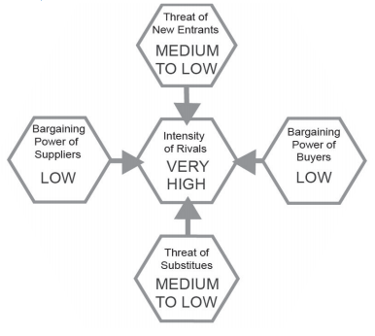
Figure 2: Porter's Five Model
INTENSITY OF RIVALS
The fashion industry has to fight for the market share, therefore, it has many competitors with firm rivalry. Zara not only has to compete with international brands like Gap and H&M but also national brands like Primark. The intensity of rivals is high (NURCAHYOWATI, 2019).
THREATS OF SUBSTITUTE
Threats of substitutes are low as being dressed is the basic need of the people and clothing products cannot be replaced ever. Handmade and some vintage clothes can be used as a substitute for the recent fashion trend.
THREAT OF NEW ENTRANT
The threat of new entrants is medium to low as there are numerous entry obstacles and initially very high capital is required for a start-up like this to cover creating, producing, and distributing costs. Also, it will be difficult for new entrants to compete with the offering of well-established retailers (NURCAHYOWATI, 2019).
BARGAINING POWERS OF SUPPLIERS
Zara is vertically integrated which means Zara produces, designs, distributes, and sells its products by itself as it’s the part of Inditex. Though there can be some moments where Zara has to count on its suppliers which mainly happen at the time of new market expansion in a new market and new country. Therefore, the bargaining power of suppliers is low (Mesa Pérez, 2017).
BARGAINING POWER OF BUYERS
The bargaining power of suppliers is relatively low for Zara as consumers hesitate as well as lack the ability to bargain for some quality product at lower prices and so the buying capacity is extremely low per customers (Saraswat, 2018).

MARKETING MIX OF ZARA
PRODUCT
Zara is a fashion brand known for selling the best quality clothes at affordable prices. Zara products can differ from place to place as Zara does complete market research before releasing its product in any new market. It sells the product which is more acceptable to the culture and taste of people (Bhasin, 2019).
PLACE
Zara has its name globally with a total of 7000 stores and it also sells its product online. However, online sales are not well established in all markets and are limited to specific areas. In India, people cannot shop online from websites though they can check the latest designs on its official website (Pratap, 2017).
PRICE
The pricing strategy is to focus on average customers who want a quality product at affordable prices. Its product is meant to please price-sensitive customers who demand the best quality product at lower prices. This pricing strategy helps address the needs and demands of a large consumer group. The latest and trending apparels are highly popular among the young generation (Bhasin, 2019).
PROMOTION
Brand loyalty is extremely high due to its variety of stylish products at affordable prices. Therefore, most of the marketing takes place through word of mouth. When it comes to promotion Zara uses social media effectively and skillfully. Zara also promotes its product on its official website to make it easier for consumers to know the new trend and latest designs available in the market (Bhasin, 2019).

STP ANALYSIS OF ZARA
ZARA
Segmentation | Demographic segmentation aims include both the genders aged between 15 to 45 and earning like middle class  Physiographic Segmentation includes the customers who are interested in the upcoming and new fashion trends  Geographic Segmentation includes the idea of opening stores in highly populated and traffic areas.
Targeting | ZARA targets men and women of age between 15-45 years, who all are educated, fashion-conscious, and middle-class.  Customers who are working and more fashionable and all who are very interested in new fashion trends.
Positioning | ZARA products are more fashionable as compared to its competitors or rivals.  ZARA follows the strategy of low cost but high fashion trends  ZARA believes in homogenizing and democratizing fashion globally.
(Source: Gaba, 2020)

CONCLUSION AND RECOMMENDATIONS
Thus it can be concluded that Zara is one of the leading companies in the fashion industry. The strategy taken and established has provided a firm and strong platform for the company. Critical analysis of the company has been done successfully keeping in mind every aspect and point. The above report, gives a brief knowledge about company's Pestle analysis, SWOT Analysis, marketing mix, and STP Analysis of the brand.
According to the above report, it is clear that Zara increases its growth by providing the best quality at affordable prices. To increase its growth further, it is recommended that Zara must use a strategic plan same as H&M which needs collaboration from designers. This should be done at least once a year. As a result of this can benefit itself as well as attract new consumers.

REFERENCES
Bhasin, H., 2019. Marketing Mix of Zara. (online available at https://www.marketing91.com/marketing-mix-zara/ ) (last accessed on 8th April 2021).
Bush, T., 2019. Pestle Analysis of Zara (online available at https://pestleanalysis.com/pestle-analysis-of-zara/ ) (last accessed on 8th april 2021)
Cherrad, L., 2020. Comparative financial analysis between Zara and Mango.
Chunling, L., 2020. Analysis on the Marketing Strategy of Fast Fashion Brand Zara Based on 4c Theory.
Farooq, U., 2019. Zara’s Pestle Analysis. (online available at https://www.marketingtutor.net/zara-pestle-analysis/) (last accessed on 8th April 2021).
Gaba, A.K., 2020. Unit-5 Market segmentation. Indira Gandhi National Open University, New Delhi.
Mesa Pérez, S., 2017. Creativity and Innovation in organizations. Case study: Inditex.
NURCAHYOWATI, N., 2019. INTERNATIONAL CLASS & JOINT DEGREE PROGRAM FACULTY OF ECONOMIC & BUSINESS (Doctoral dissertation, TRISAKTI UNIVERSITY).
Pratap, A., 2017. ZARA Marketing Mix and Marketing Strategy. (online available at https://notesmatic.com/2017/02/zara-marketing-mix-and-marketing-strategy/ ) (last accessed on 8th april 2021)
Saraswat, S., 2018. Strategies v/s Consumer Perception of Brand Zara-India. IITM Journal of Management and IT, 9(2), pp.68-80.
Seo, K. and Suh, S., 2019. A study on the characteristics and social values of vegan fashion in H&M and Zara. Journal of Fashion Business, 23(6), pp.86-100.
Sharp, B., 2017. Marketing: theory, evidence, practice. Oxford University Press,.

